- Start the MongoDB Shell and Connect to a Database

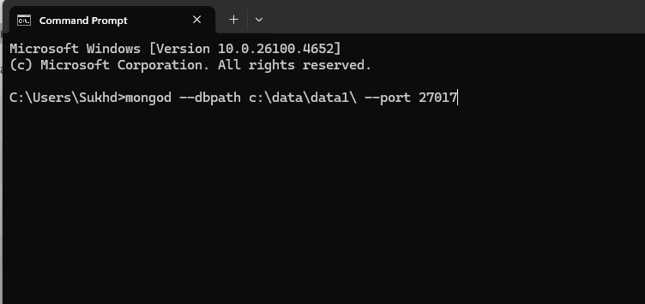

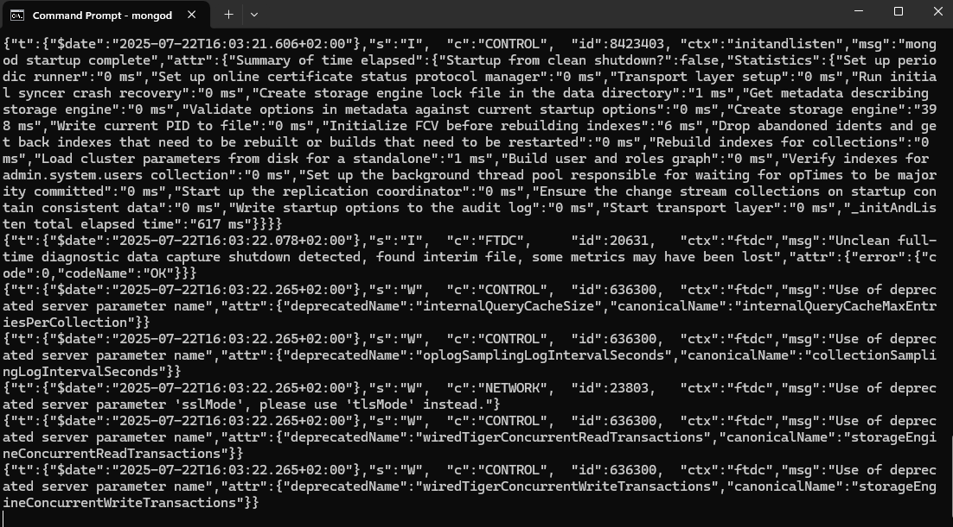

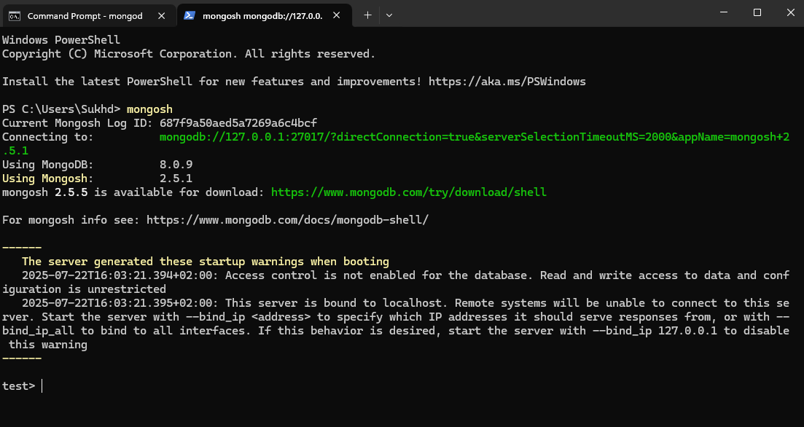

- Create Collections and Insert Sample Data
I will import sample data to create collections and insert sample data by running following commands:
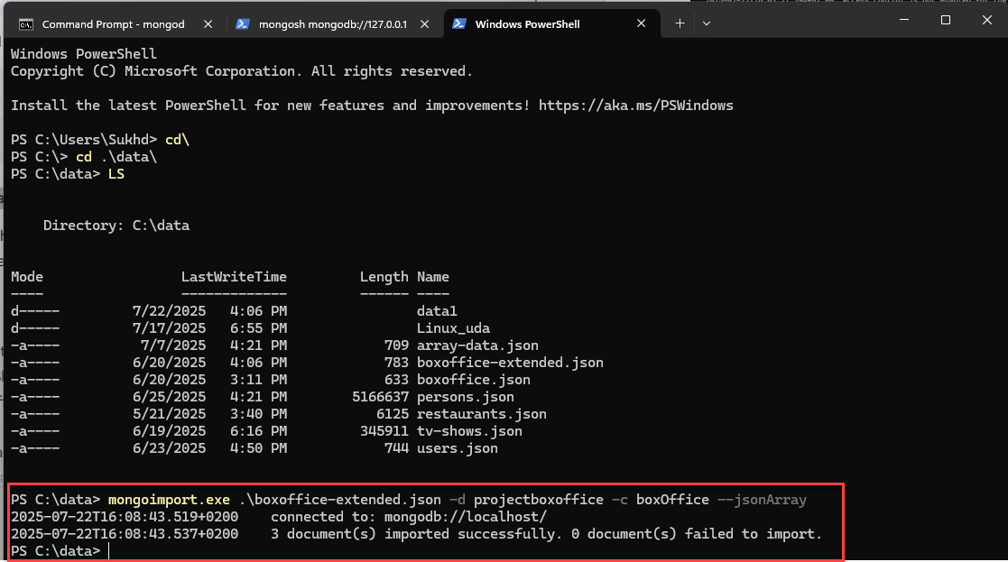
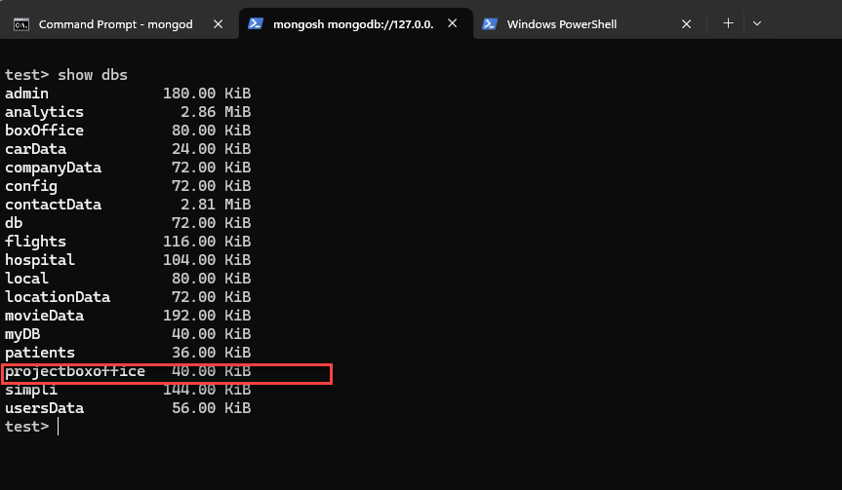
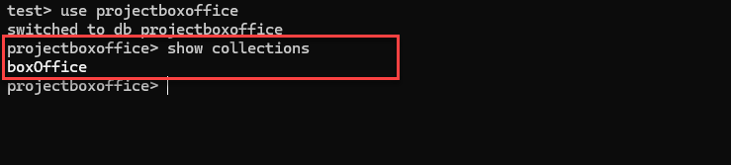

- Find the total revenue generated by each product category (such as clothing and electronics) for the past year : We are finding the total visitors in our Dataset:

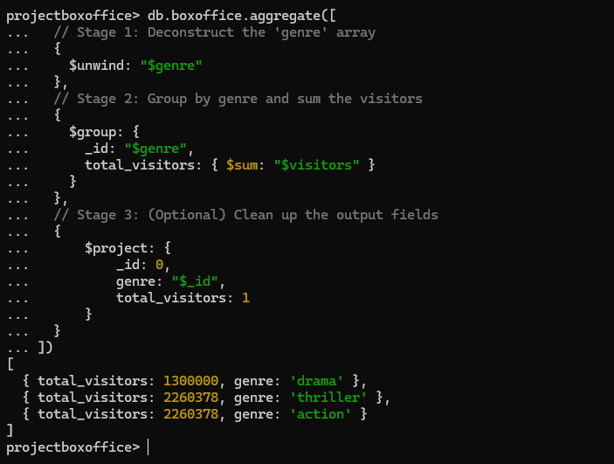

- Find the top 10 most popular products (by units sold) for the past quarter, along with their average rating : In our data set we are finding the top 10 movies with rating
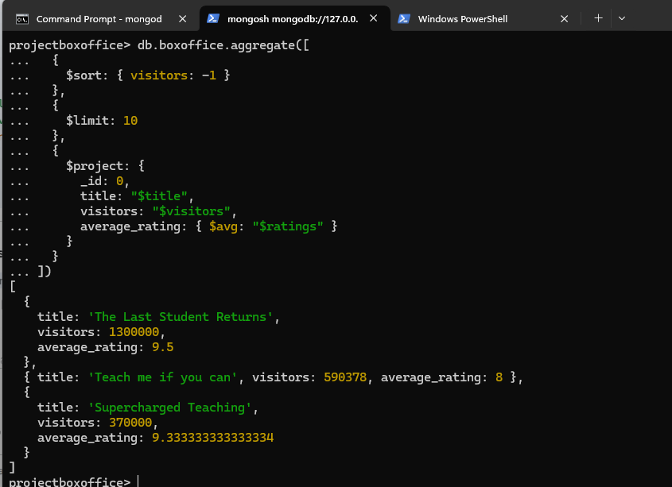

- Find the total number of orders or movies

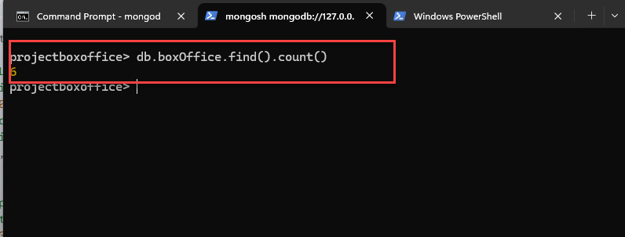

- We will find the average number of visitors per movie
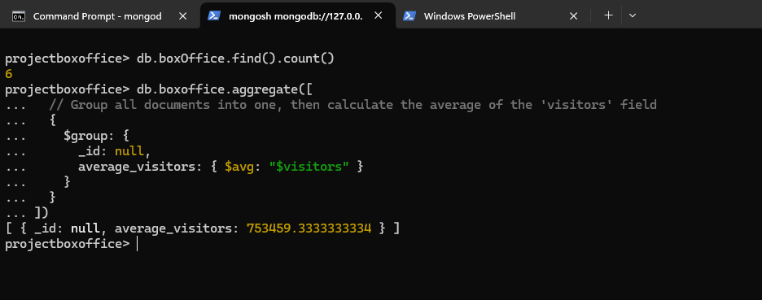

- We will find most frequent genre across all movies.
