**Passport Automation Mobile Application**

*Canadain Immigration, Refugees & Citizenship Department*

**Master Project Plan**

**Project Manager:** Sukhdeep Singh

**Creation Date:** 23/11/15

**Last Updated:** 23/12/05

**Document Number:** 6450-25/01

**Version: 1.0.0**

VERSION HISTORY

|  |  |  |  |
| --- | --- | --- | --- |
| **Version** | **Date** | **Responsible** | **Notes** |
| 1.0.0 | 11/11/2023 | PM & Team | Passport Application Mobile App |
|  |  |  |  |
|  |  |  |  |
|  |  |  |  |

# 

# Purpose of the Document

The Master Project Plan (MPP) defines the project in terms of objectives, scope, deliverables and stakeholders and describes how the project will be executed, monitored, and controlled. It is a primary deliverable in the planning phases of a project and links to the NRS Systems Development Life Cycle (SDLC) in the Initiation Phase of New Development. The detailed MS Project template is a companion to this document and provides a foundation for preparing a workplan and schedule based on project deliverables and the work breakdown structure (WBS).

The purpose of the MPP is threefold:

* To establish and ensure a common understanding between all parties of the objectives, scope and requirements this project will address;
* To ensure a common understanding of the work to be performed, the deliverables, the methodology to be used and the roles and responsibilities of all parties; and
* To provide the project team with a baseline document (scope, tasks, estimates and deliverables) from which to carry out the work, and to measure the progress and success of the project.

Related Documents:

* Communications Management Plan,
* Risk Management Plan,
* Work plan, WBS, Gantt chart,
* Budget and Cost Management Plan.
* E-R Diagram
* Project Charter
* Data flow Diagram
* Project Scope
* Quality Management Plan

Table of Contents

Purpose of the Document 3

1.0 Project Purpose 5

2.0 Background 5

3.0 Objectives 5

4.0 Scope 5

4.1 In Scope 6

4.2 Out of Scope 6

5.0 Major Deliverables 7

6.0 Milestones and Project Plan 7

7.0 Stakeholders 8

8.0 Links and Dependencies 8

9.0 Issues and Constraints 9

• Accrual of new human and technical resources for the successful implementation of the project. 9

• Assumption that a majority of the population has access to mobile devices, high-speed internet, and basic knowledge required to operate and adapt to the new application method. 9

• Legislative alignment of the new system and obtaining a No Objection Certificate (NOC) from the government. 9

• Maintenance of privacy for highly confidential user-entered data, contributing significantly to maintenance expenditure. 9

• Implementation and maintenance costs associated with High-Speed Database Servers are notably high. 9

• Ensuring access to Ministry staff during the project's duration and the allocated time for the resource. 9

10.0 Assumptions 10

11.0 Budget 10

12.0 Project Infrastructure 11

13.0 Project Review and Completion Criteria 12

Appendix A: Workplan 13

Gantt Chart 13

Prototypes…………………………………………………………………………………………………...15

Diagrams…………………………………………………………………………………………………….25

Reviews and Document Control 31

# Project Purpose

The "Passport Automation System" project aims to establish an automated framework that streamlines the passport application process, minimizing manual efforts, efficiently allocating resources, and enhancing overall efficiency in passport issuance. Providing users with an online platform for inputting details, monitoring application status, and receiving passports, the primary goal is to reduce time and intricacies associated with issuance. The project also seeks to foster shared understanding among stakeholders about system objectives, scope, and requirements, ensuring collective comprehension of tasks, expectations, methodology, and roles. Additionally, it aims to provide the team with a standardized document outlining scope, tasks, and expectations, empowering them to execute the work, assess progress, and measure project success.

# Background

Given the rapid pace of today's world, doorstep services have become essential. The project is designed to offer convenient online passport services, aiming to eliminate hassles for people. Moreover, upon examining the escalating expenses associated with offline passport services, it becomes evident that exploring avenues to reduce costs is imperative. Opting for an Online Passport Service emerges as the most practical solution, catering to a broader population and consequently reducing the per capita cost of a passport application.

# Objectives

The project aims to achieve the following objectives:

• Create a user-friendly Passport Mobile Application.

• Integrate a Secure Payment gateway into the application to facilitate a seamless payment process.

• Minimize expenses related to the infrastructure of offline passport offices.

• Transform the passport application into an on-the-go process.

• Enhance accessibility to passports, particularly for individuals with special needs or children unable to visit a Passport Centre.

# Scope

The project introduces a Mobile Application designed to streamline the passport application process in Canada. Users complete an application form, providing details such as their name, guardian's name, address, category, and uploading all required verification documents. Subsequently, a unique application number is generated to identify the received application. The provided information undergoes verification through a Police Verification process. Upon successful verification, the passport is printed and dispatched to the user via Canada Post. Users can track the overall application status using the assigned application number, while postal tracking is facilitated through the Canada Post Tracking ID. Upon receiving the passport, users must confirm receipt and validate their identity using the same identification proof submitted during the application process. The Project Manager of the Public Clients & Information Services Branch will conduct a concise post-project evaluation review. This assessment aims to evaluate the project management, identify "lessons learned," suggest improvements to methodologies and procedures, and pinpoint potential enhancements to the final product.

Given the short-term nature of the project, a singular evaluation to confirm completion suffices. However, a comprehensive project review and financial audit will occur after the completion of each Systems Development Life Cycle (SDLC) phase to ensure efficient resource utilization. In the event of a deadline extension for any reason, an interim project review will evaluate the cause, and if there are changes in financial requirements, an audit will be conducted.

A Post-Implementation Review is scheduled four months after implementation to thoroughly assess the system in full production.

The project will be considered successful upon achieving all objectives. Completion of the project involves:

• Fulfillment of all tasks in the project workplan.

• Completion and approval of all project documents by the project sponsor.

• Regular communication with all stakeholders.

• Resolution of all project issues.

• Completion of the project evaluation.

• Scheduling of the post-implementation review.

• Completion of all activities related to releasing project staff and physical resources.

• Finalization of all project-related contracts.

• Compilation and archiving of all project files and documentation.

## In Scope

The project encompasses the following scope:

• Creation and maintenance of an online Mobile App for Passport Services.

• Administration of a secure payment portal.

• Collaboration with the Police Department to facilitate user verification.

• Issuance of timely notifications to users for any application updates or changes.

• Establishment and maintenance of an efficient communication channel between Canada Post and IRCC to ensure secure passport delivery to rightful owners.

• Requesting customers to confirm passport delivery and updating the status with Canada Post and the Issuing Authority/Office.

## Out of Scope

The subsequent points are excluded from the project scope and are presented to delineate the boundaries:

• Canada Post is responsible for ensuring the secure delivery of the Passport.

• The Canada Post Tracking Number serves as the linkage between the application and its mailing procedure.

• Canada Post bears the exclusive responsibility for updating the mailing tracking status.

• The activities related to packing and dispatching of the Passport are not within the purview of this project.

# Major Deliverables

The major deliverable products for this project are:’

| **Major**  **Deliverable** | **Description** | **Target Date** |
| --- | --- | --- |
| Project Plan | Planning the overall pathway of the project and setting the goals to be achieved after the planned time. | Thu 12-10-23 |
| Software Requirements Specification | Observing and anticipating project requirements, along with preparing necessary documentation as part of project planning. | Mon 18-12-23 |
| Software Design Description | Designing every conceivable technical flow, regardless of the technology used for its execution. | Wed 20-12-23 |
| Development | A team of designers and programmers undertaking project development using specific programming language technologies decided during the planning and design phase. | Fri 08-03-24 |
| Implementation | Deploying the fully developed application onto servers, conducting final testing, and making the application ready for end-users. | Fri 08-03-24 |
| Project Management | After successful trial rounds of the application, addressing identified shortcomings, performing updates, and conducting general maintenance periodically to ensure smooth system operation. | Thu 11-04-24 |

# 

# Milestones and Project Plan

The major project milestones / targets / review points for the project are:

| **Milestone** | **Target Date / Completion Date** |
| --- | --- |
| Initiation | Thu 12-10-23 |
| Software Requirements Specification | Fri 12-11-23 |
| Decision Point for further approval | Wed 11-12-23 |
| Detailed Software Design Description | Fri 08-03-24 |
| Build | Thu 11-04-24 |
| Implementation | Fri 12-04-24 |

# Stakeholders

The following stakeholders’ (internal and external) interests, expectation, and potential concerns must be considered throughout the project:

|  |  |  |
| --- | --- | --- |
| ***Stakeholder*** | ***Represented by*** | ***Interests, Expectations, Concerns*** |
| Ministry Executive | Project Sponsor (Add Name) | * Ensure compliance with data protection laws * Future automated passport application systems must comply with government data protection laws |
| Ministry Public Clients | (Names of people that represent this group) | * Provide all passport services through one application * Charge the correct amount for passport payment * Ensure a user-friendly and easily navigable application to prevent difficulties for users |
| Ministry Management & Staff |  | * Centralized data systems * Notify users after every update or change * Build a secure payment portal to prevent breaches and ensure proper data management |
| Information Management Branch |  | * Keep information safe as public trust * Ensure the application asks necessary information under the Information Act of Canada |

# Links and Dependencies

This project is dependent on the following:

* For data storage a database will be needed.
* Justinmind has been selected for the construction of prototype.
* Access to Microsoft features.
* Access to cloud software for storage.

Projects and initiatives that depend on this project include:

* With the appropriate usage of mobile technology other methods of verification and authentication can be created.
* With the success of the project more innovative applications may be developed.
* After the success of the project, the concept of biometrics can be created.

Success of this project is linked to the following:

* If all the milestones are completed on time.
* If the project is completed within the given budget.
* If the user’s feedback is taken seriously and changes are made according to them.
* If the application is user friendly.

Future work dependent on the completion of this project includes:

* After the release of the application there may be plans for further enhancement to app based on user feedback, changing requirement or advancement in technology.
* After the release of the app regular maintenance and updates will be given for smooth working .

# Issues and Constraints

The following assumptions have been made for the project:

· Consideration of overhead costs for introducing the new system, in conjunction with the existing offline system until the complete transition to the new online system.

# · Accrual of new human and technical resources for the successful implementation of the project.

# · Assumption that a majority of the population has access to mobile devices, high-speed internet, and basic knowledge required to operate and adapt to the new application method.

# · Legislative alignment of the new system and obtaining a No Objection Certificate (NOC) from the government.

# · Maintenance of privacy for highly confidential user-entered data, contributing significantly to maintenance expenditure.

# · Implementation and maintenance costs associated with High-Speed Database Servers are notably high.

# · Ensuring access to Ministry staff during the project's duration and the allocated time for the resource.

# Assumptions

The project is based on the following assumptions:

* The User possesses a fundamental understanding of either English or French.
* The User is proficient in operating a mobile device and is adaptable to a new user interface.
* Ensuring the absence of data repetition, specific procedures are either in place or need to be developed to process any backlog efficiently.
* Government legislation supports the project and allows its implementation in accordance with established laws.
* The User has access to internet connectivity and possesses basic skills in scanning and uploading documents for verification.

# Budget

The project budget is summarized below:

# Project Infrastructure

The project infrastructure encompasses all the services, tools, and work environment facilities provided to the project team to facilitate their work. The project team will utilize standard facilities and tools readily available, such as meeting rooms and desktop computers. It is essential to have a designated Server Room to meet specific requirements.

The project entails special needs outlined as follows:

* Tools
* Work Environment
* Services Assistance
* Technical Environments and Special Requirements
* SharePoint for collaborative efforts
* MS Project for creating Work Breakdown Structure & Gantt Charts
* MS Visio for generating necessary diagrams and dataflow presentations
* Designated Servers for running the application and maintaining a database
* Project report and inventory management system

# Project Review and Completion Criteria

The Project Manager of the Public Clients & Information Services Branch will conduct a concise post-project evaluation review. The aim is to assess the project management, identify any "lessons learned," propose improvements to methodologies and procedures, and identify potential enhancements to the final product.

Given the short-term nature of the project, a single evaluation to confirm completion is deemed sufficient. However, a comprehensive project review and financial audit will occur after the completion of each SDLC phase to ensure efficient resource utilization. If the deadline is extended for any reason, the cause will be assessed through an interim project review. Similarly, any changes in financial requirements will prompt a necessary audit.

A Post-Implementation Review is scheduled four months after implementation to comprehensively assess the system in full production. The project will be considered successful upon the fulfillment of all objectives.

The project will be deemed complete when:

* All tasks in the project workplan have been completed.
* All project documents are complete and signed off by the project sponsor.
* Regular communication is maintained with all stakeholders.
* All project issues have been addressed.
* The project evaluation has been completed.
* The post-implementation review has been scheduled.
* All project staff and physical resource release activities have been completed.
* All project-related contract finalization activities have been completed.
* All project files are completed, and documentation is archived

# Appendix A: Workplan

# Gantt Chart

1.

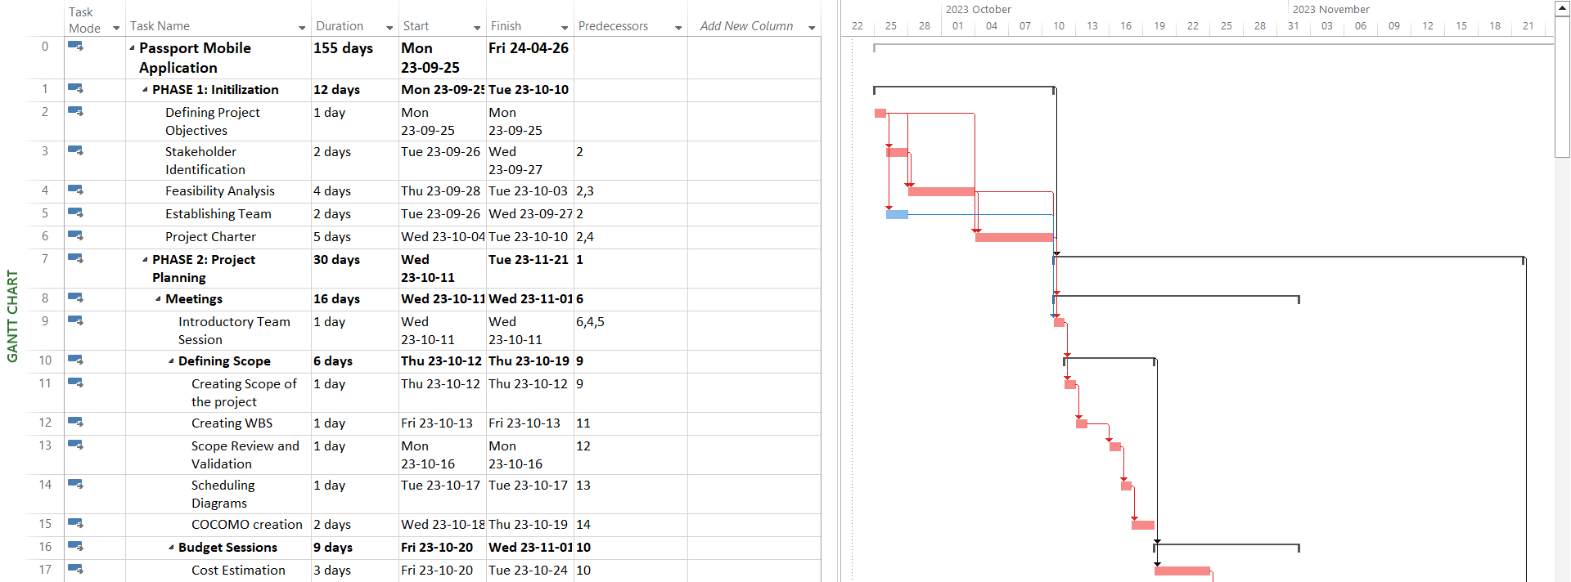

2.

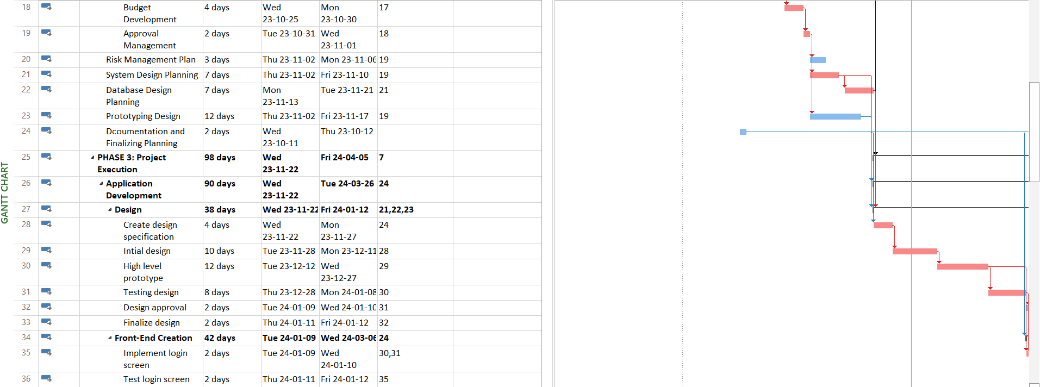

3.

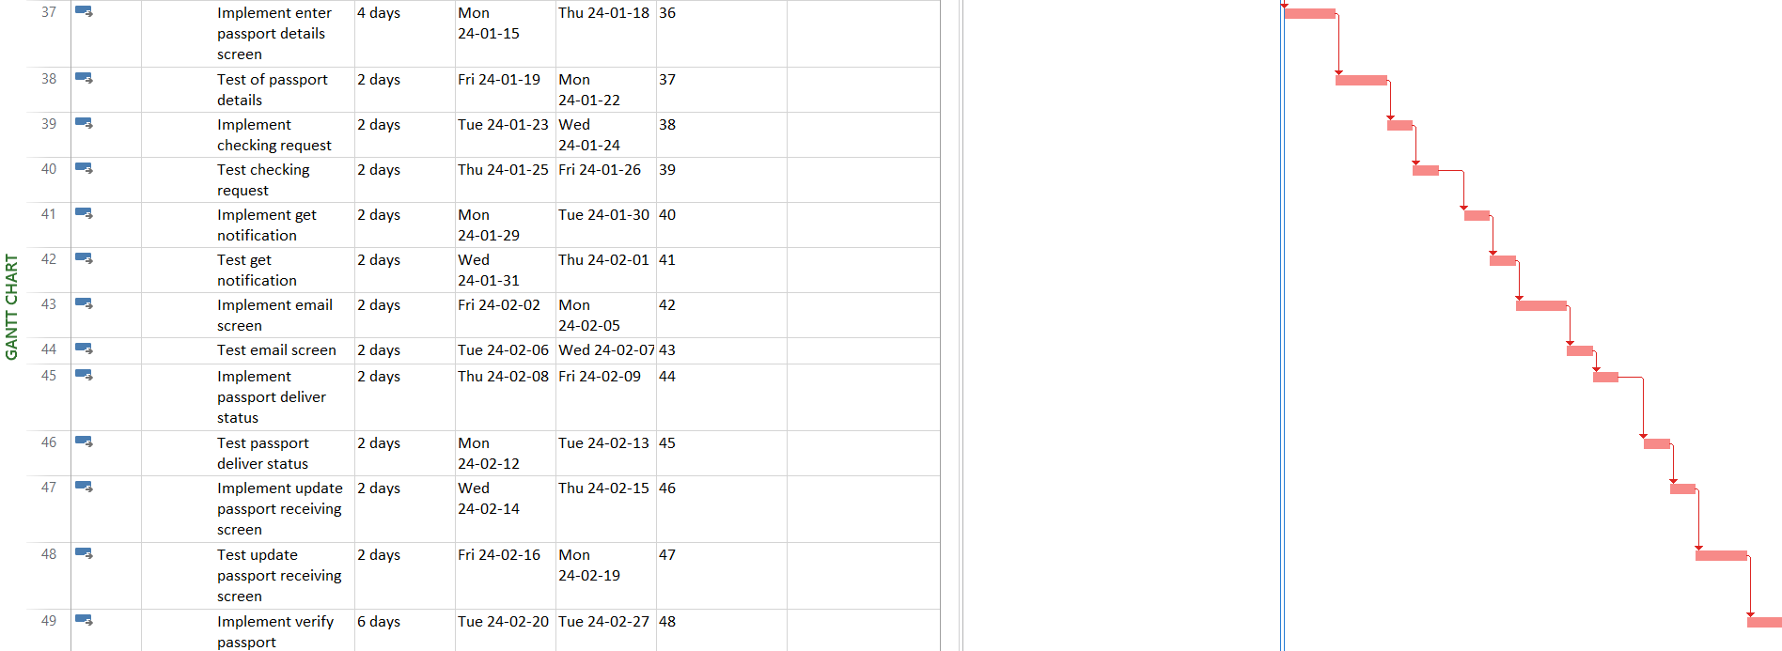

4.

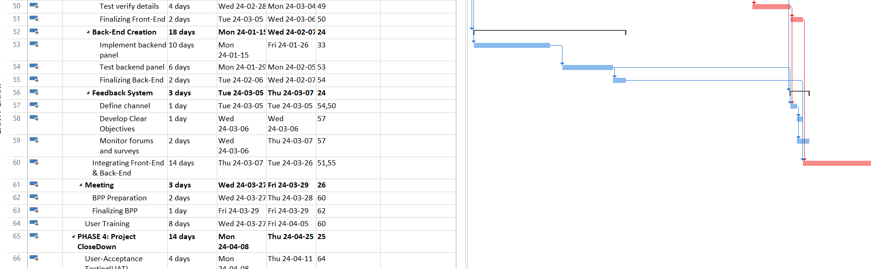

5.

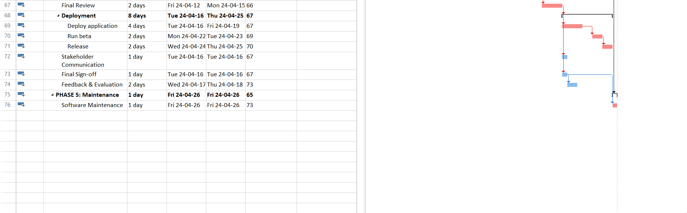

MS Project File project’s PDF accessible version through

PROTOYPES

# 

Diagrams

*CONTEXT DIAGRAM*

*DFD-0 DIAGRAM*

*NETWORK DIAGRAM*

*E-R DIAGRAM*

*WBS DIAGRAM*

# Reviews and Document Control

**Reviews**

This document has been sent to the following for their review and comment.

| **Name** | **Position** |
| --- | --- |
|  |  |
|  |  |
|  |  |
|  |  |
|  |  |
|  |  |
|  |  |
|  |  |
|  |  |
|  |  |
|  |  |

**Project Management**

| **Name** | Position |
| --- | --- |
|  |  |
| <name> | Project Manager |
|  |  |
|  |  |