EV Ride-Hailing

Operational Analysis, Efficiency and Risk Analysis
Business Case Report

Executive Summary
The lack of coordination in incorporating real-time battery levels, charging availability, and driver behavior into dispatch and pricing systems is a major opportunity that allows VoltRide to enhance its EV ride-hailing business. This loophole leads to huge unnecessary cancellations and loss of revenue.
There is a critical battery threshold: rides with 1019 battery displays 100% cancellation and in locations where there are no charging-points, cancellations occur at 86.54% of battery. This segment alone is a source of 29.66 revenue leakage ( 337937.60 lost of 1139549.39 potential revenue) which is a significant burden to operations.
Also, surging prices may not always decrease cancellations. The surge bucket of 2.0x has the highest cancellation rate (31.77) and the lost revenue (₹96,818.85) which explains a lack of alignment between the pricing strategy and the operational capacity.

Recommended Data-based Operational Risk Optimization Plan
Ride risk Index-Based Dispatch to be able to proactively manage and identify high-risk rides.
Minimum Battery Dispatch Battery Threshold.
Policy that dispatches are not allowed to have less than critical battery levels.
Battery-Adjustment Surge and Smart Charging Incentives decrease and increase prices and incentives in real-time driven by constraints.
The Minimum Dispatch Battery Threshold Policy alone is estimated to result in 3.48 percentage point decrease of the total cancellation rate (29.56% down to 26.08%) and regain ₹77,243.51 worth of revenue.
The interventions are to provide a significant boost to the reliability of the services, minimize operational pressure, improve the experience of drivers, and make sure that the resources are distributed optimally, which will lead to sustainable growth.

Problem & Approach

Problem
The problems that VoltRide is facing are operational inefficiencies, high cancellations on rides, and high revenue leakage, especially in the aspects concerning EV battery management, the availability of charging infrastructure and surge pricing policies and strategies. The existing system does not have an integrated, real time process to bring together these interdependent components that results in current sub-optimal performance and overall coordination breakdown in the system.

Approach
Data analysis was performed on a ride level, driver level and charging station level. The methodology involved:
- Preliminary data description and statistics.
- Computation of important operation statistics (completion rates, cancellation rates, revenue leakage).
- Correlation analysis to learn relationships among important factors.
- Determination of risk limits (critical levels of the battery, high-stress area/hours)
- Composite efficiency scores development.
- Cancellation prediction machine learning models.
- Simulations of the policies to measure the possible effects.

Task 1: Demand–Supply Stress
The examination of 2,500 requests to ride showed:
- Average daily requests: 23.81
- Cancellations per day: 7.04 on average.
- Total completed rides: 1,761
- Total cancelled rides: 739
Most importantly, 305 cancellations were caused by the lack of drivers, which means that there were huge supply shortages.

Zone-Level Insight
Pickup Zone 7 (Bengaluru):
- 276 rides
- 32.97% cancellation rate
- Exceeds benchmarks
The demand (per hour) varies differently according to the city.

Comparison of Average Daily Ride Requests and Cancellations:
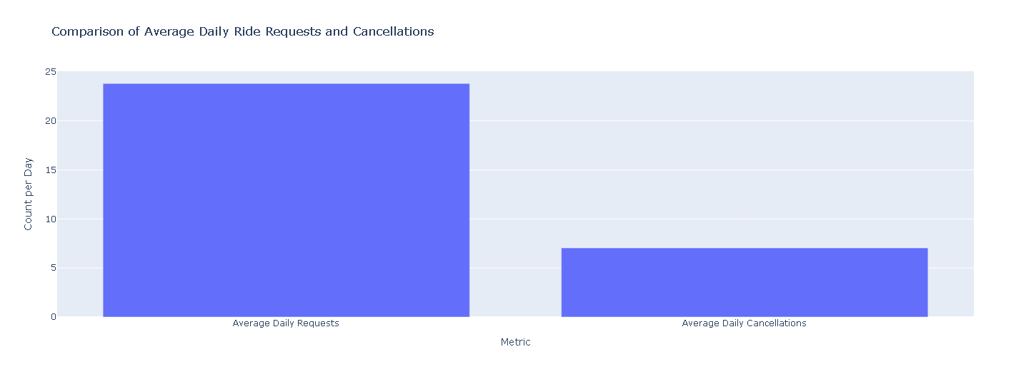

High-Demand, High-Cancellation Zones:
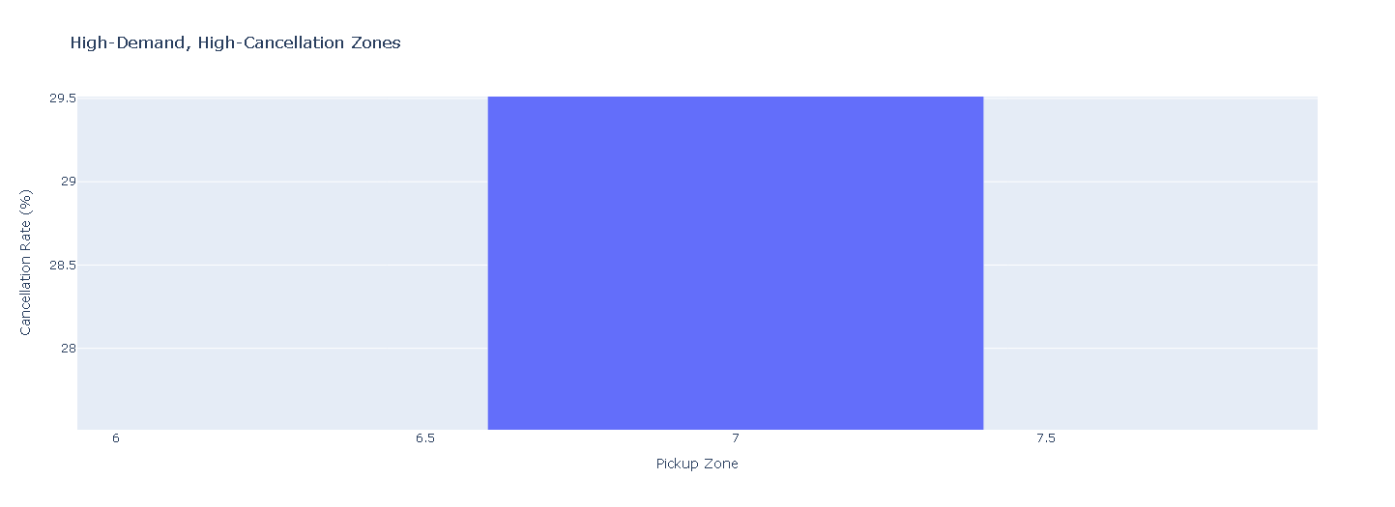

Hourly Ride Demand Trends by City: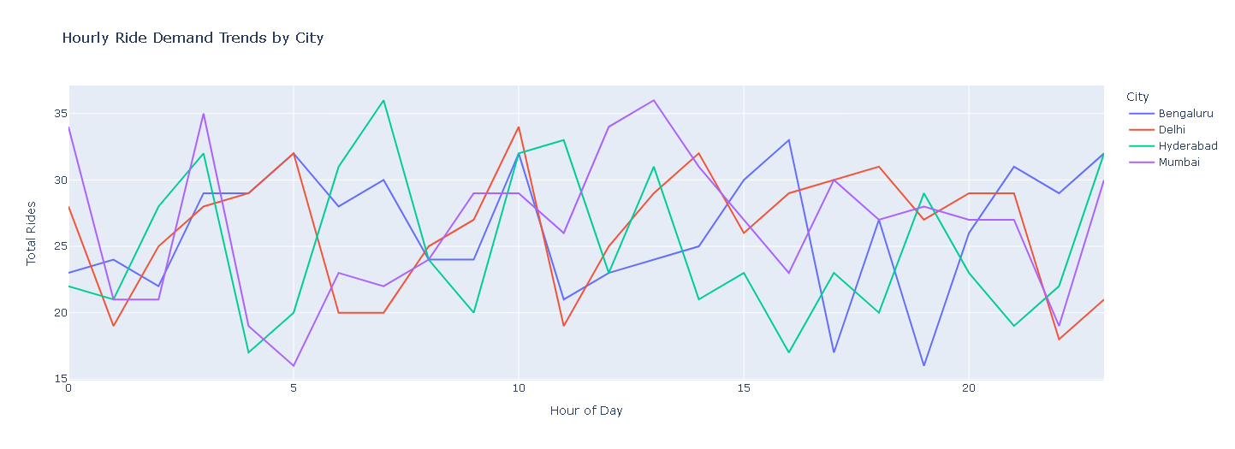
Overall Supply Gap: Ride Requests vs. Successful Assignments:

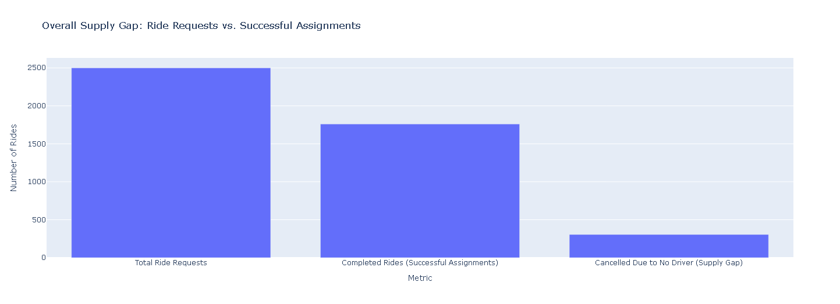

Insights
- Introduction of localized driver delivery in the areas of high demand during the peak periods.
- Implement price elasticity and incentives to close the supply gaps.

Task 2: Cancellation Driver Analysis
General performance indicators depict:
- 1,761 completed rides
- 739 cancelled rides
- 2.38 completed rides cancelled per ride.

Critical Battery Findings
- 10-19% battery range has 100% cancellation rates.
- Battery less than 20 per cent and without a nearby charger 86.54% cancellation.
- Long distances (>19 km) 10-20 per cent battery 100 per cent cancellation.
- Low-battery rides were also cancelled 100 per cent during peak hours.

Largest Cancellation Rates by City
- Hyderabad: 31.39%
- Bengaluru: 29.95%
- Delhi: 28.80%
- Mumbai: 28.21%

Peak Hours
- 7 AM: 37.96%
- 8 PM: 37.14%

Surge Pricing Paradox
- Multiplier = 2.0x is associated with the maximum cancellation rate (31.77%)
- ₹96,818.85 lost revenue
- Expresses that pricing is not subject to operational limitations.

Cancellation Rates by City (Descending Order):
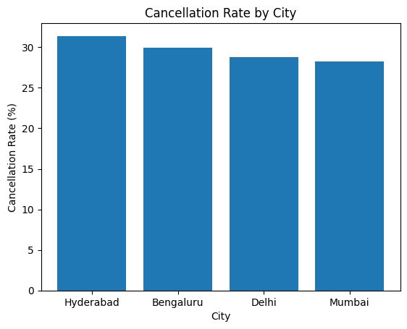

Cancellation Rates by Weather (Descending Order):

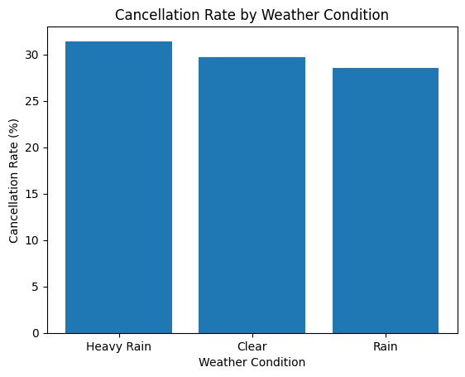

Cancellation Rates by Hour (Descending Order):
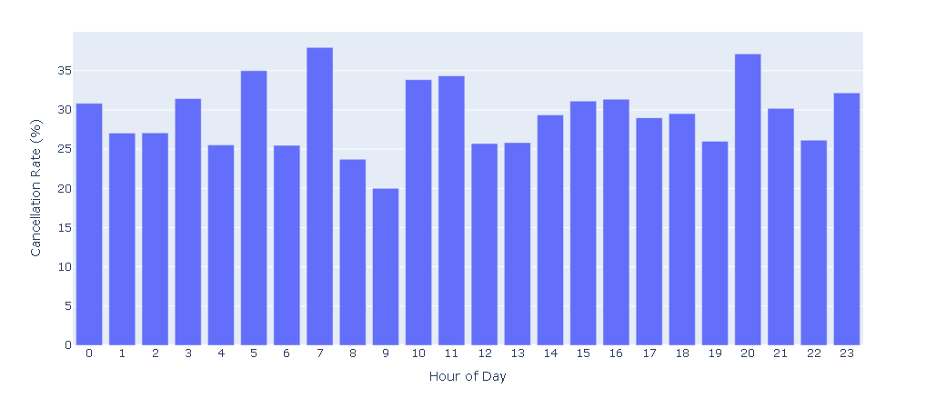
Cancellation Rate Vs EV Battery Percentage:
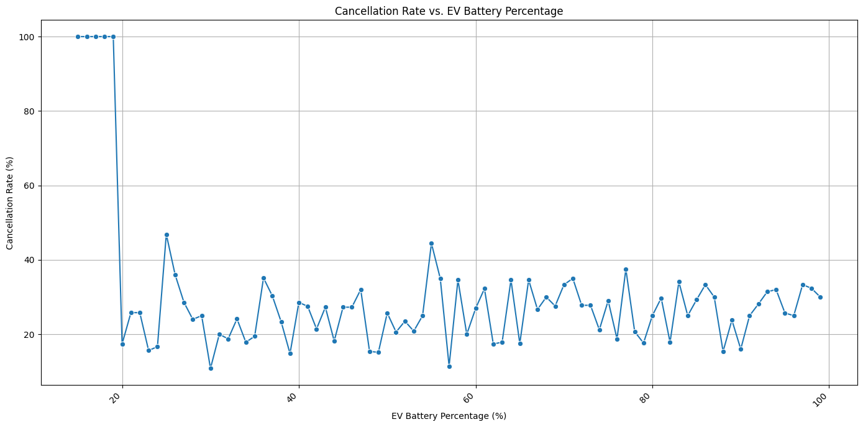
Cancellation Rates by Surge Multiplier (sorted in descending order):

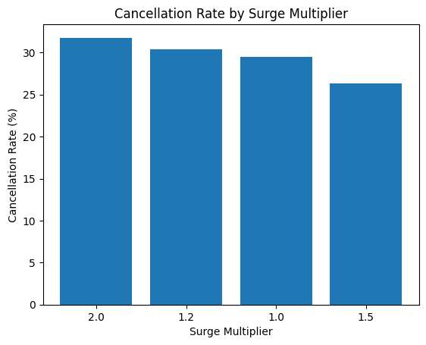

Cancellation Rate by EV Battery Bucket
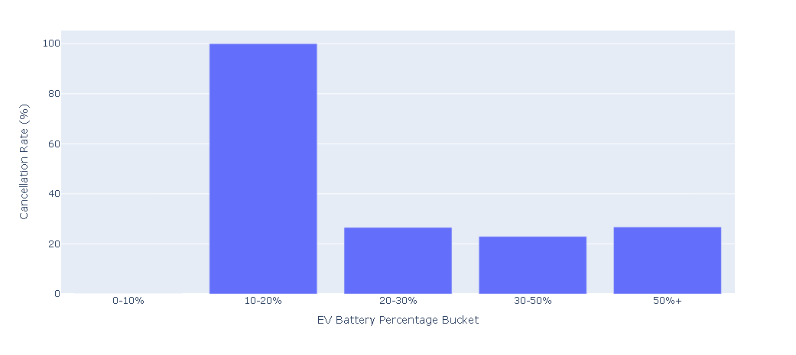
Cancellation Probability by EV Battery Percentage and Ride Distance

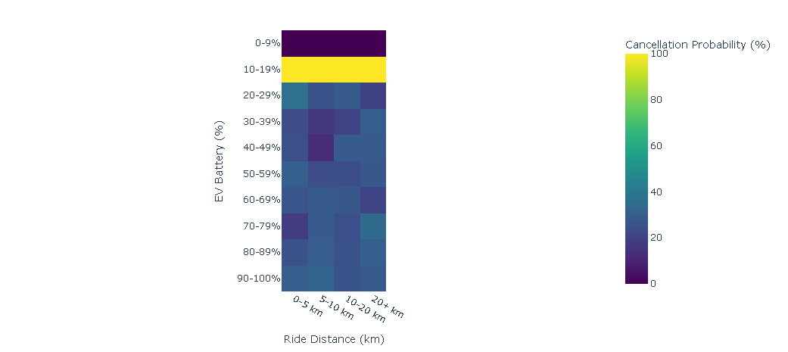

Insights
- Adopt serious low-battery ride refusal less than 20%
- Introduce battery based dynamic pricing.
- Remember to make proactive reminders at less than 30-35% battery.

Task 3: Redeployment
Experience and rating of the drivers have a very low relationship with the percentage of cancellations, and this indicates that experience is not a good measure of performance.

Top Six Performers
- Ratings ≥ 4.63
- Cancellations ≤ 7.37%
- Rides ≥ 230

High-Risk Drivers
- Ratings ≤ 3.96
- Cancellations ≥ 16.10%
- Rides ≤ 93

City Level Comparison of Efficiency

Delhi
- Efficiency Score: 3.78
- 52 chargers
- 19.08-minute wait time

Mumbai
- Efficiency Score: 2.00
- 27 chargers
- 23.33-minute wait time
This deviation is an indication that there are replicable best practices within the network.

Driver Experience vs. Average Rating: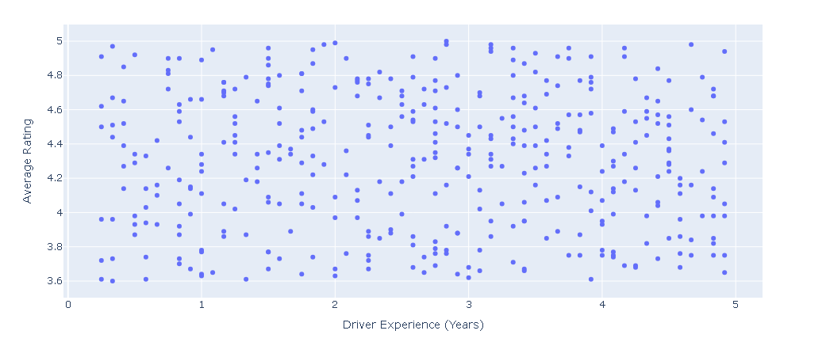
Driver Experience vs. Cancellation Rate:
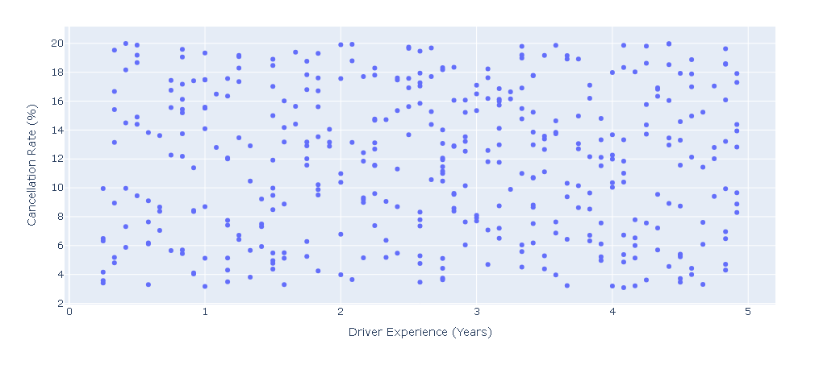

Average Battery Consumption vs. Total Rides Completed:
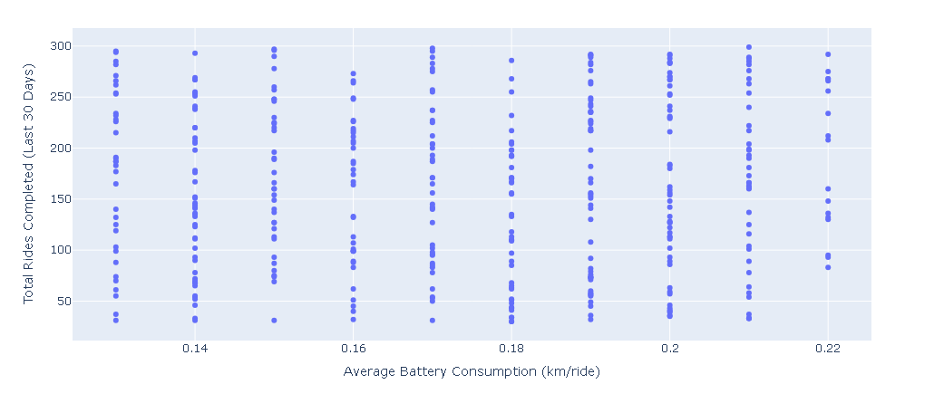
Top-Performing Driver Profiles:
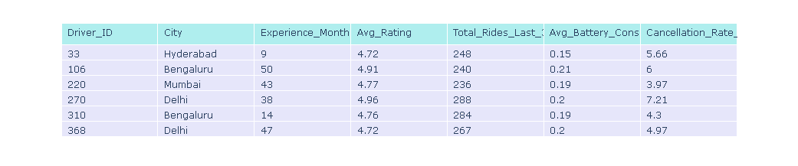
High-Risk Driver Profiles:
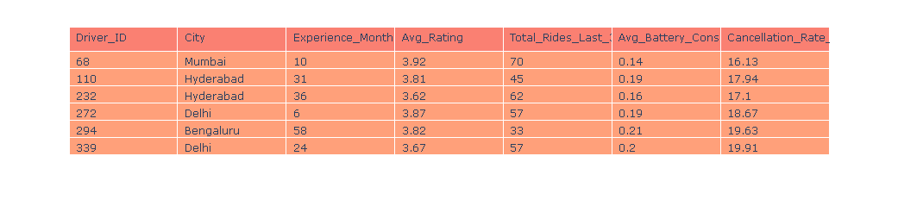
Operational Efficiency Score by City:
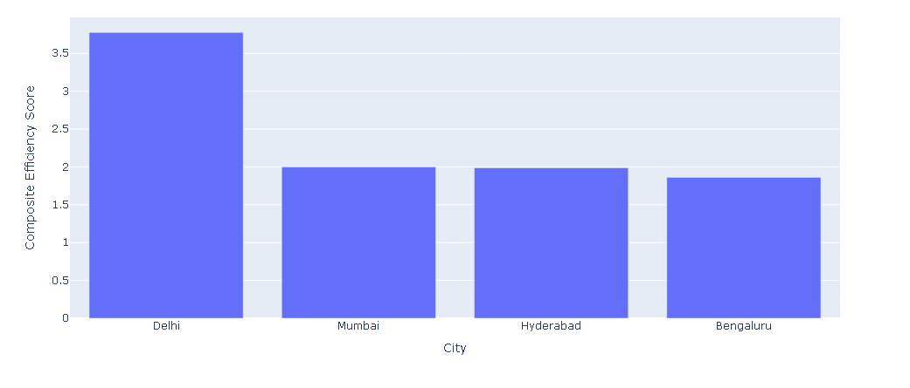
City Clusters by Operational Efficiency:

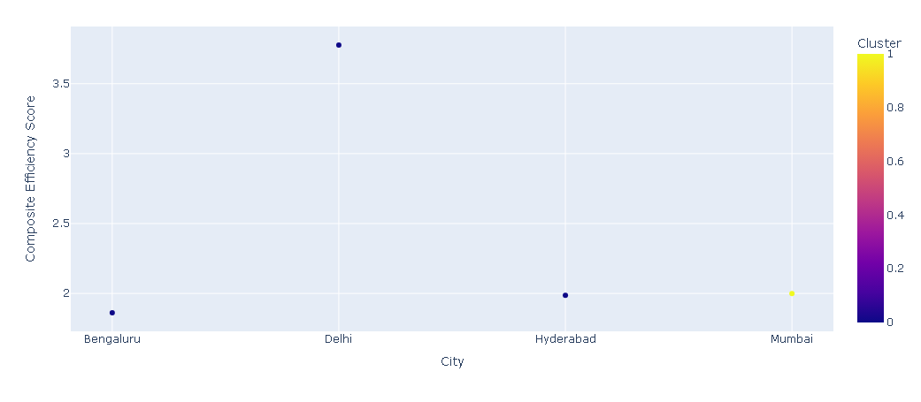

Insights
- Introduce special training of high-risk drivers.
- Expand the working strategies of Delhi to other cities.

Task 4: Charging Stress
Intuitively, the regions with close charging have a moderately better cancellation (29.93% vs 28.91%), indicating that wait time is a more important factor.
The positive relationship (0.77) between availability of chargers and wait times implies that the addition of infrastructure that is not accompanied by demand management does not reduce wait times.

Critical Battery Threshold
Acute changes in the cancellation rates are at 15-19 percent battery, up to 100 percent.

Revenue Impact
- Total lost revenue: ₹337,933.76
- 10–19% battery accounts for ₹59,766.20
- The highest loss was in clear weather: ₹217,003.31.
- Surge 2.0x led to ₹96,818.85 lost revenue

Revenue Risk by City
- Hyderabad: 146.20
- Bengaluru: 135.10

Identified Risk Zones
- Bengaluru Zone 7
- Delhi Zone 9

EV Gridlock Hours
Highest risk observed at:
- Mumbai Zone 10
- Hour 7
- Stress Score: 9.55

Cancellation Rate by 5% EV Battery Percentage Bin:
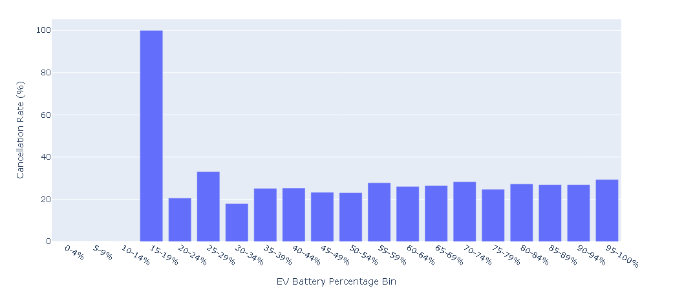

Top 50 City-Zone-Hour Combinations by Charging Stress Index:

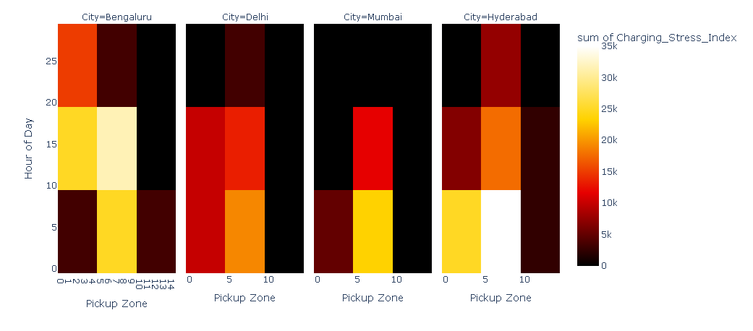

Hourly Percentage of Low Battery Rides (<25%) by City:
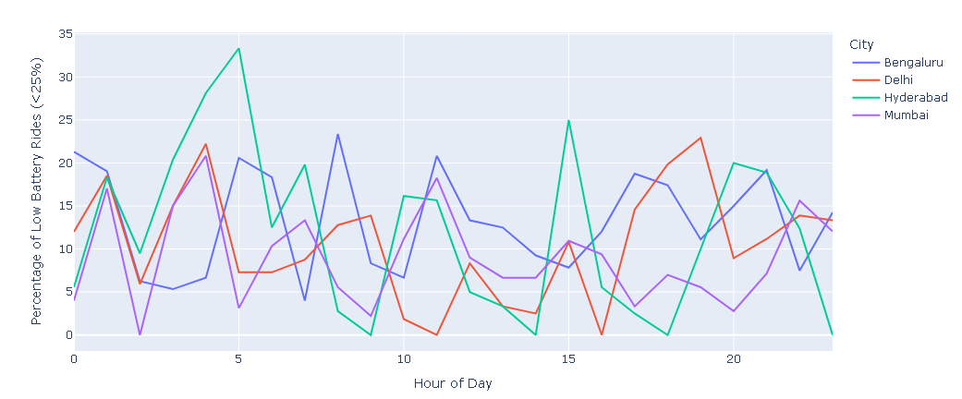

Insights
- Install high stress fast chargers.
- Introduce variable off-peak incentives.
- Automatize low battery rejection.
- Inquire about grid capacity improvement.

Task 5: 60–90 Day Scenario
Ride Risk Index was created, which classifies the rides into:
- Low Risk
- Medium Risk
- High Risk
Some of these risk factors are battery percentage, distance, surge, hour, and proximity to charge, and stress scores.

Minimum Dispatch Battery Threshold
- Prevent rides below 25% battery
- Do not ride when battery is less than 30 percent when travelling longer than 15 km.
- 322 rides prevented
- 171 were originally cancelled
- Cancellation reduction: 3.48 percentage points (29.56% to 26.08%)
- Revenue recovered: ₹77,243.51

Battery-Adjusted Surge Pricing
- Minimize surgeries among low-battery drivers.
- Surge high-battery drivers.
- Targets ₹96,818.85 of revenue lost when high-surge/low-battery situations occur.

Smart Charging Incentives
- Peak and off-peak incentives.
- Minimise low battery clustering.
- Alleviate gridlock hours
- Enable smoother operations
Distribution of Rides Across Risk Categories:

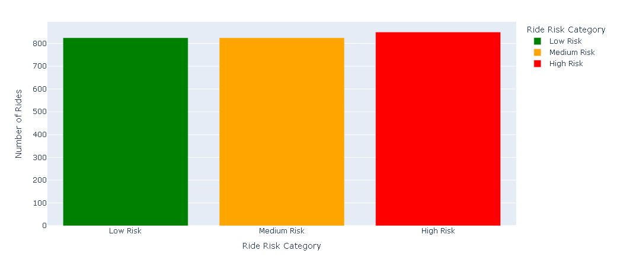
Simulation Results for Minimum Dispatch Battery Threshold Policy

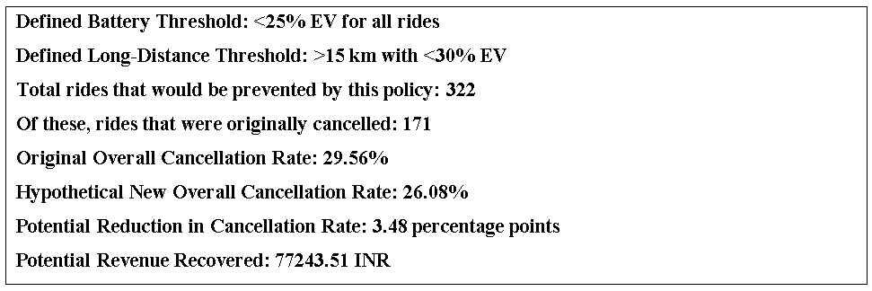

Quantified Business Impact of Proposed Policy:
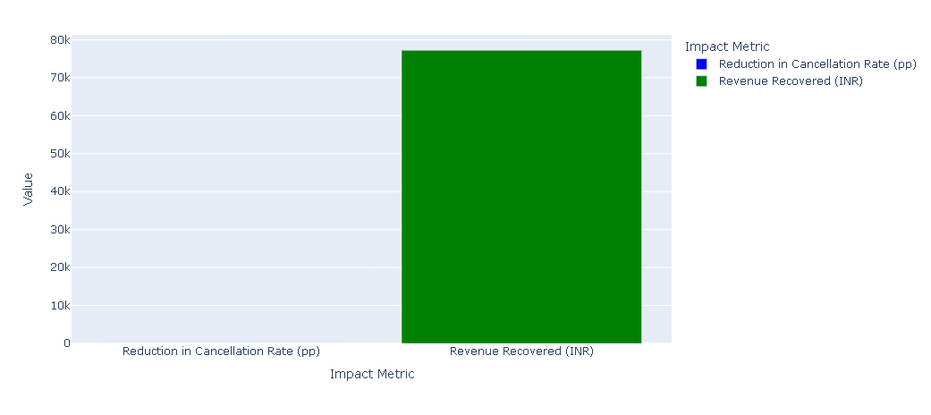

Strategic Insight
The battery threshold policy is a high-priority policy. Battery-adjusted surge pricing and smart charging incentive is an important complementary strategy that streamlines driver action and use of infrastructure.

Tools Used
- Python
- Pandas
- NumPy
- Scikit-learn (Logistic Regression, KMeans, StandardScaler)
- Plotly (Express & Graph Objects)
- Matplotlib
- Seaborn

Recommendations

1. Strict Low-Battery Ride Refusal (Immediate)
Block ride acceptance below 20% battery and redirect drivers to nearest fast-charging stations.
Impact: Reduce cancellations by 3.48 percentage points and recover ₹77,243.51 revenue.
2. Strategic Charging Infrastructure (3–12 Months)
Prioritize expansion in high-cancellation zones:
- Mumbai Zone 5
- Bengaluru Zone 7
- Delhi Zone 9
Integrate real-time charger availability and wait times into the driver app.
3. Dynamic Surge Pricing & Incentives (1–3 Months)
Adjust surge pricing based on battery levels and charging access. Incentivize high-battery drivers for surge rides and promote off-peak charging.
Impact: Reduce ₹96,818.85 revenue loss from high-surge/low-battery interactions.
4. Preventive Battery Monitoring (Ongoing)
Send alerts below 30–35% battery and train drivers on financial impacts of cancellations and best practices.
5. Predictive Dispatch & Smart Fleet Management (3–6 Months)
Use predictive models for demand, driver availability, and charging usage to proactively position drivers and optimize charging allocation.

Assumptions
- Dataset accurately reflects operations.
- Estimated Fare equals completed ride revenue.
- Cancelled rides result in full fare loss.
- Observed trends support policy decisions.
- Incentives influence driver behavior.

Conclusion
By integrating battery levels, charging infrastructure, and dispatch systems through data-driven policies, VoltRide can significantly reduce avoidable cancellations, recover lost revenue, and achieve sustainable operational efficiency and customer satisfaction.

