**Lab objectives:**

**- Update a master file with adds/changes and deletes from a transaction file**

**- Use a CLLE driver program to automate testing of the update program**

**- View the journaled changes made to the master file**

**Requirements to pass the lab:**

All the parts for this application will be handed out. The RPGLE program, the CLLE driver program, and the master and transaction files. You need to adapt this application so you can update a master file in your own collection. **Successfully run the CLLE program updating data in a collection created by you and be able to show the add, update and delete journaled changes.**

Call RunLab7

SALESSTAF2 – data comes from SALESSTAFF in BCI433LIB

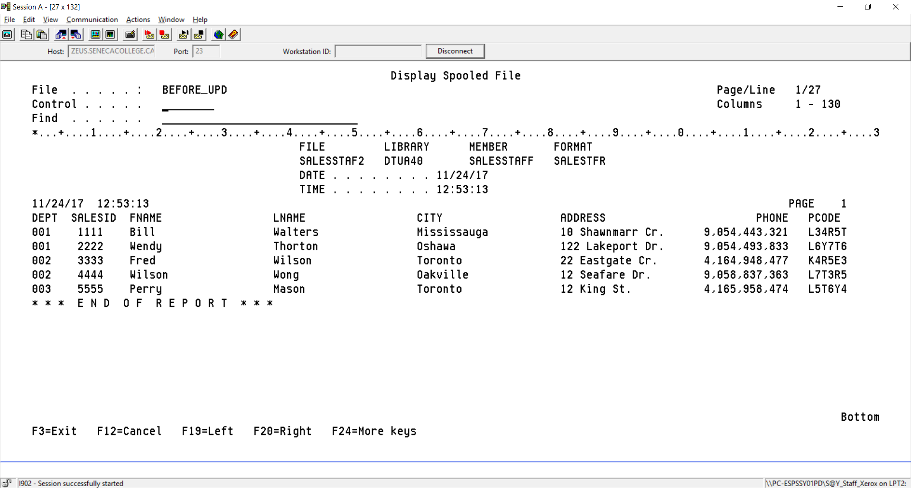

Transaction File SALESTRANS in BCI433LIB indicates adds, changes and deletes to your SALESTAFF table

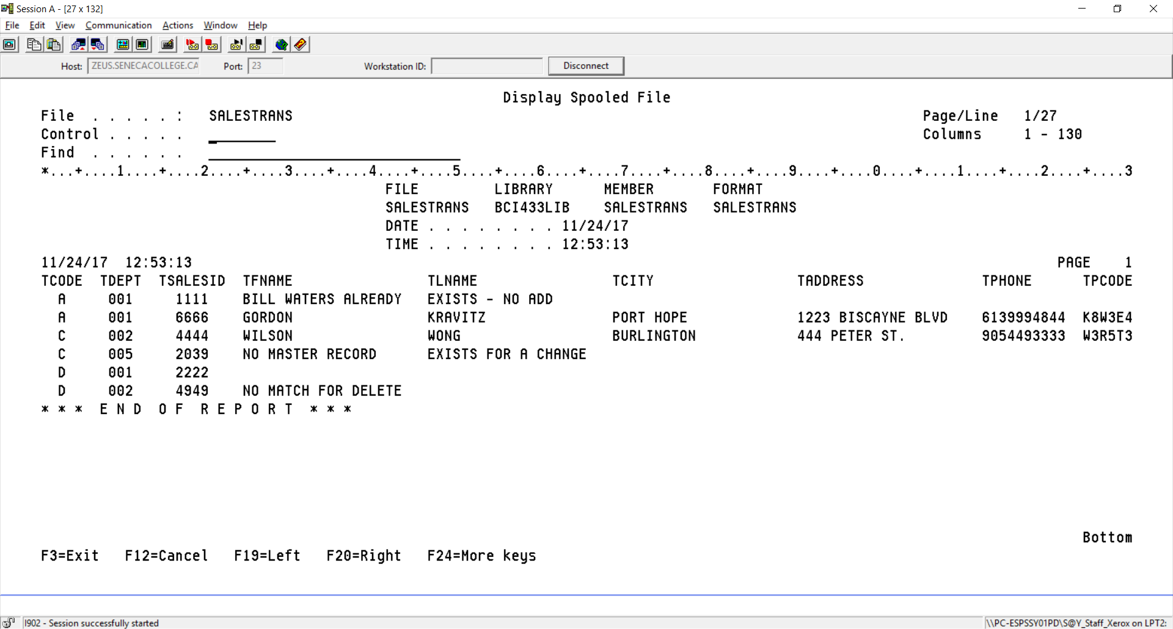

Report on what occurred when implementing the updates from the transaction file

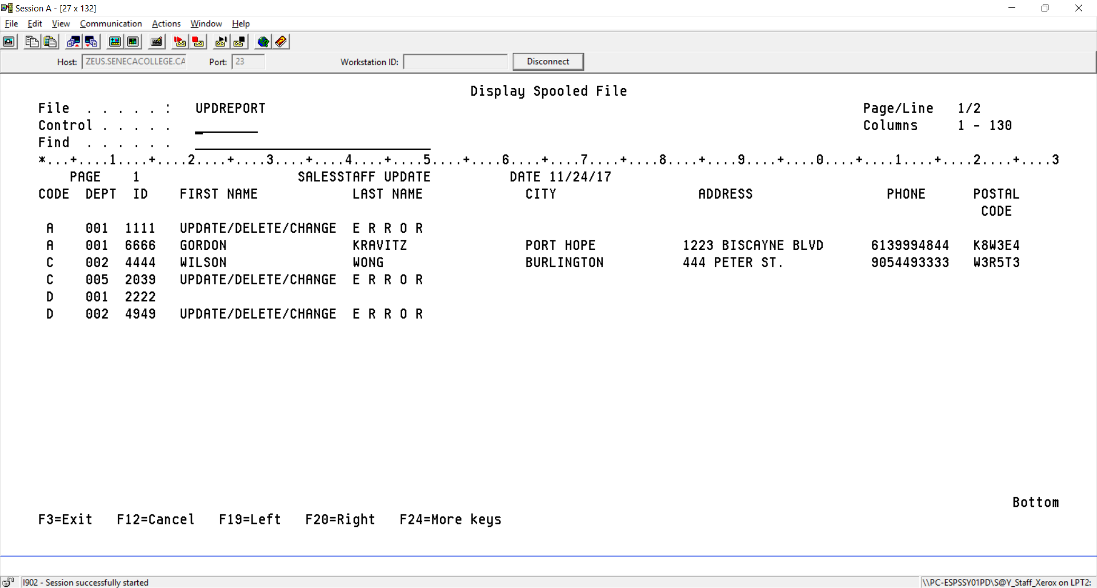

SALESTAFF after the updates were applied by your program

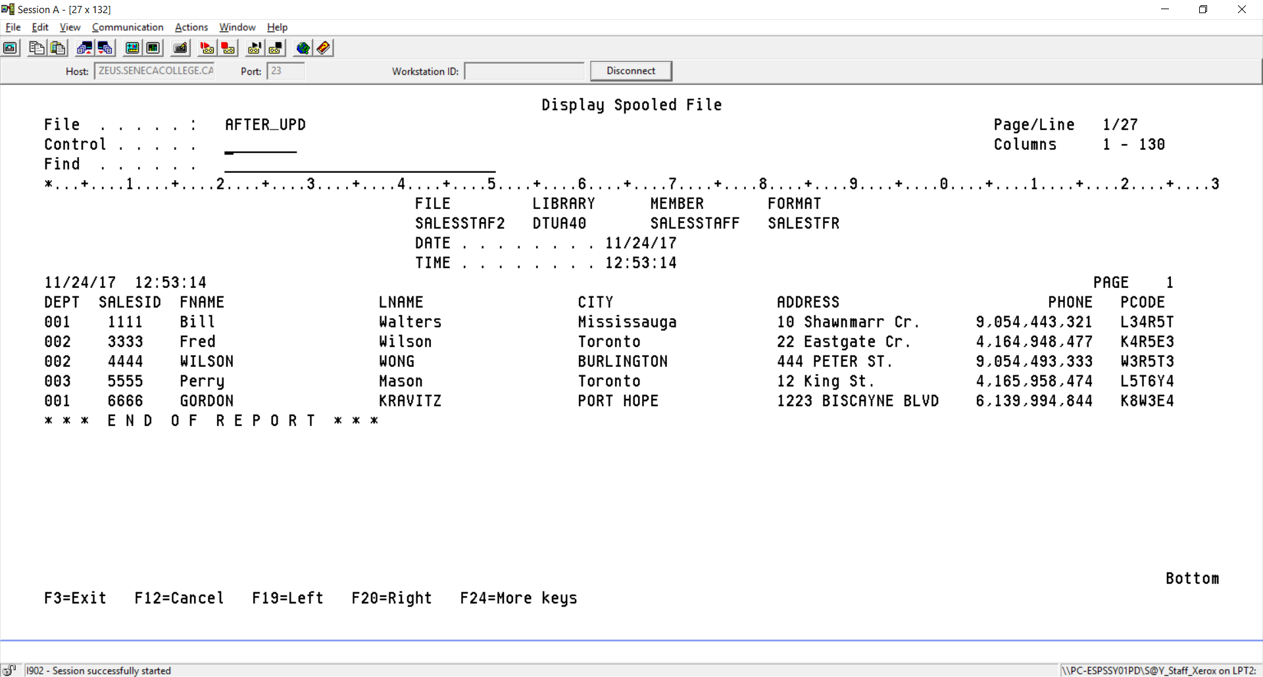

All the spooled files generated with meaningful names.

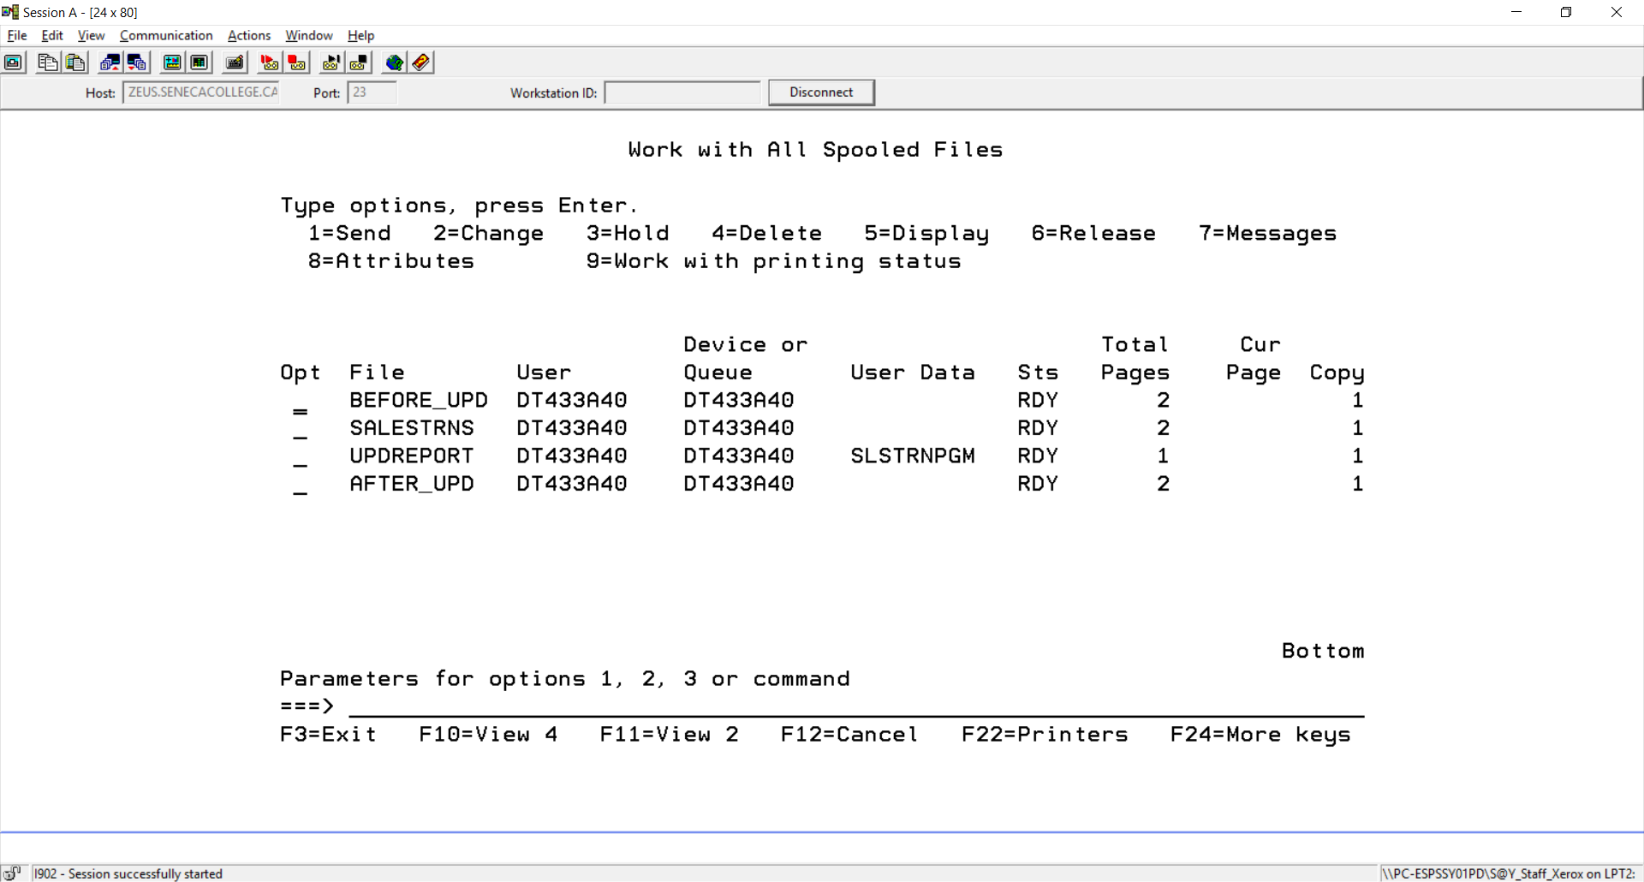

The transactions are journaled

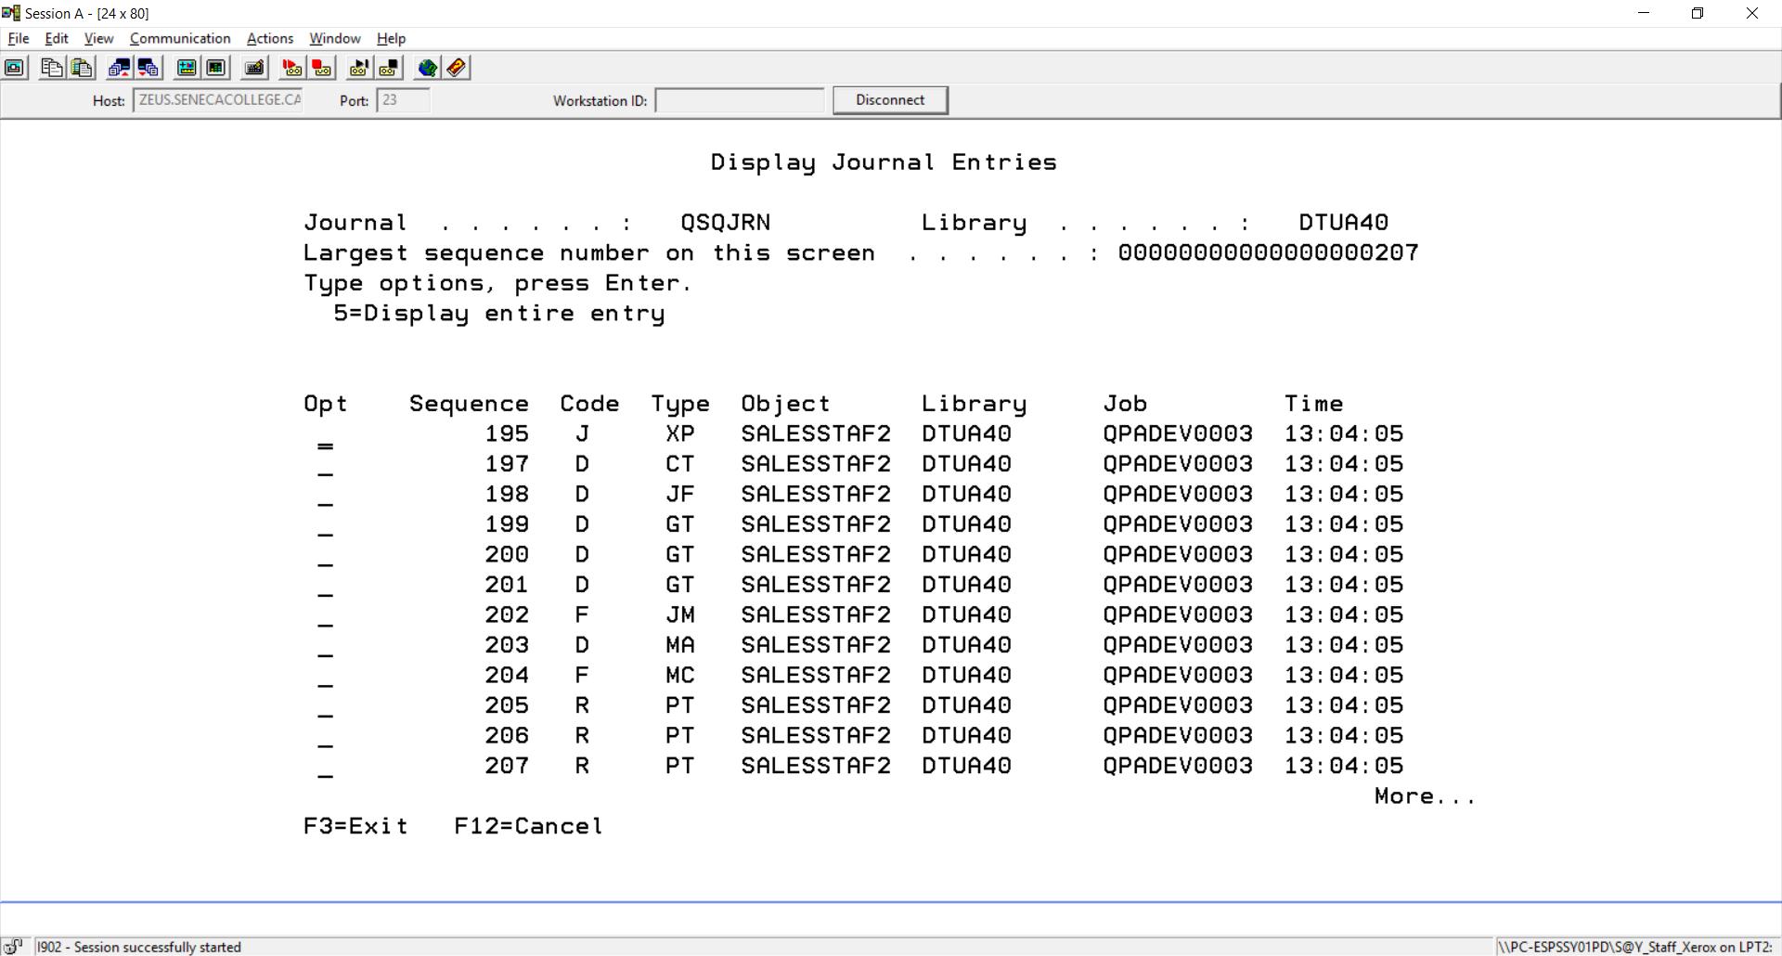

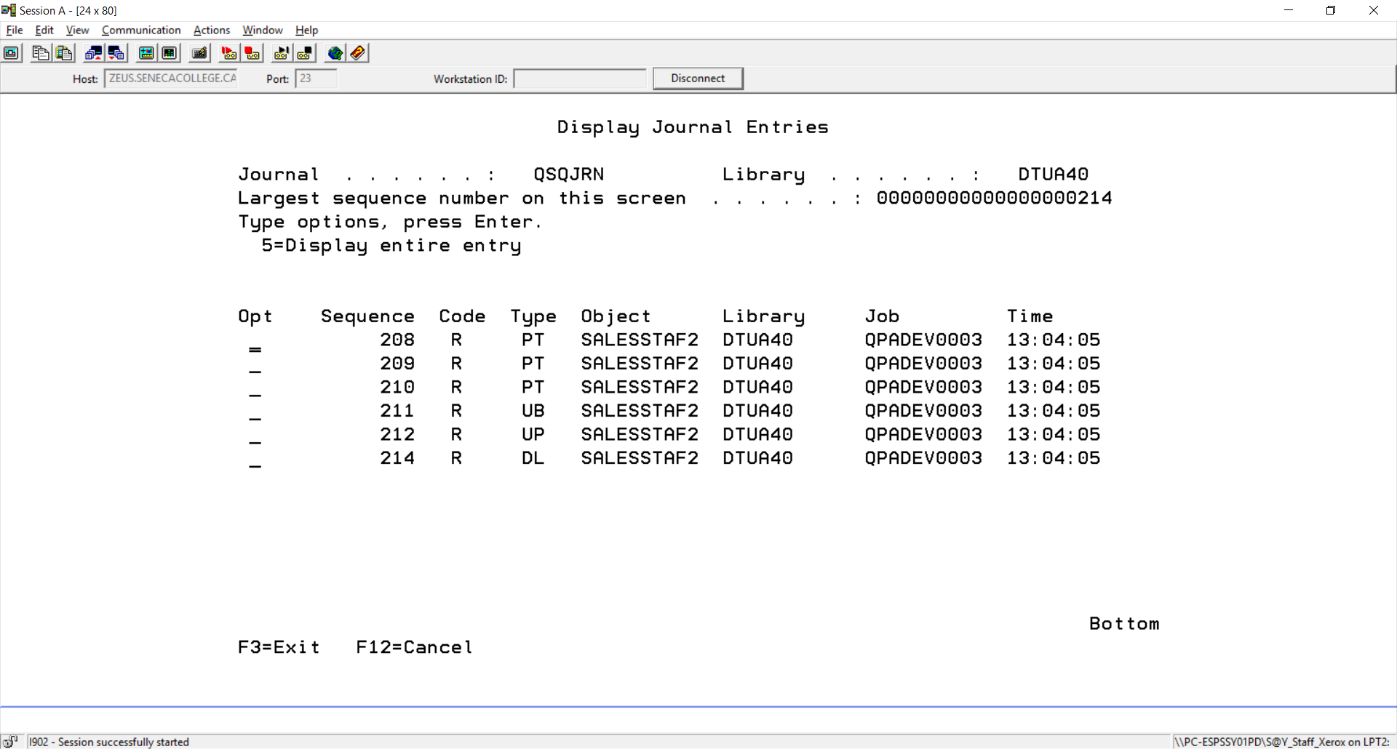

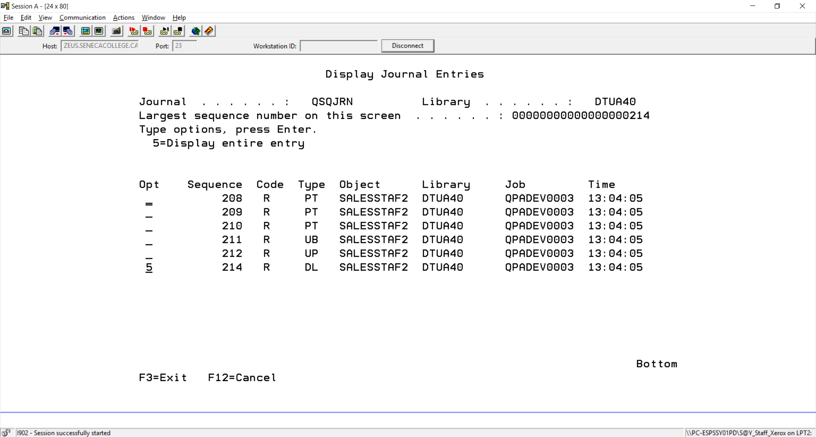

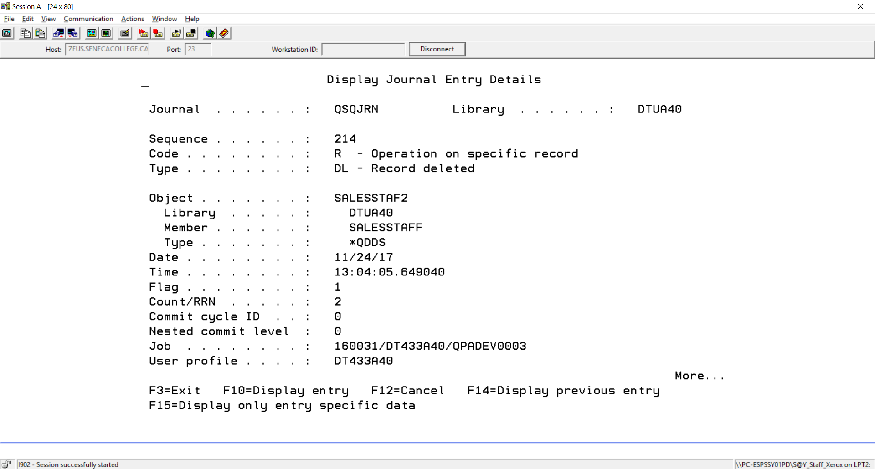

Steps to successfully run lab 7

1. Create a source physical file called LAB7
2. Create a collection using parts of your id (mine is DM433B40 so I will use DM and B40. The U stands for update and is common for all ids.

CREATE COLLECTION DMUB40

3. Copy the provided code in BCI433LIB/Lab7Code. The PRTF is called UPDREPORT and can be copied and compiled. The RPGLE program is called SLSTRNPGM and the CLLE program is called RUNLAB7. Only a few lines of code need to be added to the CLLE driver program and the RPGLE program. Study these programs. The code has been supplied for both on the next pages and your teacher will supply the missing few lines in class. You will also need to change the CLLE code so it refers to your data, journal and output queue.

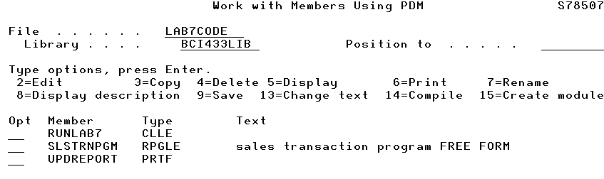

4. After you enter the missing code and make the necessary edits, you will compile the CLLE and RPGLE programs.

RPGLE program to apply the updates

DCL-F UPDREPORT PRINTER OflInd(*IN01);

DCL-F SALESTRANS DISK(*EXT) KEYED USAGE(*INPUT)

RENAME(SALESTRANS:SALESTRANR);

DCL-F SALESSTAF2 DISK(*EXT) KEYED

USAGE(*UPDATE : *OUTPUT : *DELETE);

DCL-DS FullKey ;

ADept CHAR(3);

ASalesId CHAR(4);

END-DS FullKey;

DCL-DS SalesTransDS;

TDept;

TSalesId;

TFName;

TLName;

TCity;

TAddress;

TPCode;

End-Ds SalesTransDs;

DCL-DS SalesStaf2DS;

Dept;

SalesId;

FName;

LName;

City;

Address;

PCode;

End-Ds SalesStaf2Ds;

WRITE HEADING;

READ SALESTRANS;

DOW NOT %EOF;

___________________________________________________

______________________________________________________

SELECT;

WHEN %FOUND(SALESSTAF2);

SELECT;

WHEN TCODE = 'C';

EXSR CHGREC;

WHEN TCODE = 'D';

EXSR DELREC;

OTHER;

EXSR ERROR;

ENDSL;

WHEN NOT %FOUND(SALESSTAF2);

IF TCODE = 'A';

EXSR ADDREC;

ELSE;

EXSR ERROR;

ENDIF;

WHEN %ERROR;

EXSR ERROR;

ENDSL;

IF *IN01 = *ON;

WRITE HEADING;

*IN01 = *OFF;

ENDIF;

WRITE DETAIL;

READ SALESTRANS;

ENDDO;

*INLR = *ON;

RETURN;

BEGSR ADDREC;

______________________________________________

______________________________________________

______________________________________________

ENDSR;

BEGSR CHGREC;

______________________________________________

______________________________________________

______________________________________________

ENDSR;

BEGSR DELREC;

DELETE SALESTFR;

ENDSR;

BEGSR ERROR;

TFNAME = 'UPDATE/DELETE/CHANGE';

TLNAME = 'E R R O R';

ENDSR;

CLLE driver program

/* This program will not work until have it refer to your own collection and userprofile */

PGM

DLTF **DMUB40**/SALESSTAF2

MONMSG MSGID(CPF2105)

______________________________________________________________________

______________________________________________________________________

______________________________________________________________________

______________________________________________________________________

CLROUTQ **DM433B40**

OVRPRTF FILE(QPQUPRFIL) SPLFNAME(BEFORE_UPD)

RUNQRY *NONE **DMUB40**/SALESSTAF2 *PRINTER

OVRPRTF FILE(QPQUPRFIL) SPLFNAME(SALESTRANS)

RUNQRY *NONE BCI433LIB/SALESTRANS *PRINTER

OVRPRTF FILE(QPRINT) SPLFNAME(UPDREPORT)

OVRDBF SALESSTAF2 **DMUB40**/SALESSTAF2

CALL SLSTRNPGM

OVRPRTF FILE(QPQUPRFIL) SPLFNAME(AFTER_UPD)

RUNQRY *NONE **DMUB40**/SALESSTAF2 *PRINTER

DSPSPLF BEFORE_UPD

DSPSPLF SALESTRANS

DSPSPLF UPDREPORT

DSPSPLF AFTER_UPD

WRKOUTQ **DM433A40**

DSPJRN JRN(**DMUB40**/QSQJRN) FILE((DTUB40/SALESSTAF2))

ENDPGM