Why Raw Keystreams Resist Neural Classification: Lessons from RC4, TRIVIUM, and ESPRESSO
Sukhman Singh Narula (sukhmannarula84@gmail.com)
Department of Computer Science Engineering, Maharaja Agrasen Institute of Technology, GGSIPU
ABSTRACT
This study investigates whether raw keystream outputs contain sufficient cipher-specific information for neural networks to distinguish between different stream ciphers, and whether increasing the available keystream length, model complexity, or feature representation improves classification performance. Cipher classification is an interesting task to do as these ciphers are designed to produce random looking strings but if they produce distinguishable statistical fingerprints, these can be learnt. Labeled datasets were constructed from RC4, TRIVIUM, and ESPRESSO keystreams at five lengths (8, 24, 32, 64, and 1024 bytes), with 2¹⁷ samples per cipher per length. ANNs, DNNs, 1D CNNs and FFNN were all tested, none broke past roughly 33% accuracy which is what random guessing looks like on a three-class problem. Neither increasing input length and changing the model family produce meaningful improvement under the experimental conditions. Raw keystream bytes, as it turns out, do not carry enough distinguishing statistical signal for neural classifiers to work with. What the results ultimately argue is that black-box end-to-end learning is not a viable strategy here, and that future work needs to fold in cryptographic domain knowledge rather than treating this as a standard pattern-recognition problem.
Index Terms: Machine Learning, Deep Learning, Neural Networks, ciphers, stream-ciphers, Cryptography
Corresponding Author: Sukhman Singh Narula (mail: sukhmannarula84@gmail.com)

<<Elaborate>>
I. INTRODUCTION
A stream cipher is a simple type of symmetric-key cipher that combines plaintext with a pseudorandom keystream, and is designed for use in real-time applications with low latency. While block ciphers work on fixed-size blocks of data, stream ciphers operate at the byte or bit level, making them well suited to environments with limited resources such as IoT devices, mobile systems, or embedded platforms. There are several popular members of this class, such as RC4, TRIVIUM, and ESPRESSO, which have different internal structures and statistics.
Beyond the recovery of plaintext or secret keys, another problem in cryptanalysis is the identification of the cryptographic primitive responsible for an observed output. Cipher identification seeks to determine which algorithm generated a given ciphertext or keystream without necessarily recovering the underlying plaintext or secret key. For stream ciphers, this presents a particularly challenging problem because the generated keystream is intentionally designed to exhibit pseudorandom behavior and to minimize observable statistical characteristics that could reveal the underlying construction. Nevertheless, differences in internal state structures, initialization procedures, and state-transition mechanisms may potentially introduce subtle statistical or sequential characteristics into the output. Determining whether such characteristics are sufficiently consistent to identify the generating cipher is therefore an important question in evaluating the information exposed by raw keystream data.
In the last 10 years, machine learning, especially deep learning, has garnered much interest in the field of cryptanalysis. Neural networks have powerful pattern-recognition capabilities, prompting researchers to investigate their ability to identify ciphers, detect anomalies, and analyze encrypted data. Machine learning provides a potential approach to cipher identification because, unlike conventional statistical distinguishers that rely on explicitly selected characteristics, neural networks can learn representations directly from observed data. In principle, a classifier trained on keystreams generated by different ciphers could learn subtle relationships or statistical dependencies that are difficult to identify manually. This motivates the question of whether similar learning approaches can distinguish stream ciphers using only their raw keystream outputs, without access to plaintext, secret keys, internal states, or additional information about the cipher construction.
The three ciphers considered in this study, RC4, TRIVIUM, and ESPRESSO, were selected to provide diversity in the underlying design and internal structure of the stream ciphers examined. RC4 represents a classical byte-oriented stream cipher based on a permutation of its internal state, whereas TRIVIUM and ESPRESSO employ distinct state-based constructions. By considering ciphers with substantially different internal architectures within a common classification framework, the study evaluates whether cipher-specific characteristics remain observable in their raw keystream outputs despite these outputs being designed to exhibit pseudorandom statistical behavior.
In this study, 2¹⁷ (131,072) samples per input size per cipher were generated using randomly generated keys and initialization vectors, and four types of models were evaluated: a feedforward artificial neural network (ANN), a deeper neural network (DNN) designed to capture higher-level representations, a one-dimensional convolutional neural network (1D-CNN) designed to identify local structure in byte sequences, and a feature-based feedforward neural network (FFNN) using handcrafted statistical features. These features include entropy, byte-frequency characteristics, N-gram frequencies, and statistical moments. The models were evaluated across five keystream lengths: 8, 24, 32, 64, and 1024 bytes.
Across the evaluated architectures and input lengths, the average classification accuracy remained approximately 33%, which corresponds to the chance-level accuracy for a three-class classification problem. The result remained consistent despite changes in model architecture, input length, and feature representation. This suggests that, under the experimental conditions considered in this study, the evaluated approaches were unable to extract a sufficiently discriminative signal from the raw keystream outputs of the three ciphers. Rather than establishing the absence of all possible distinguishing information, these results indicate that increasing the amount of raw keystream data or applying the evaluated neural architectures was insufficient to produce meaningful classification performance. The findings therefore motivate approaches that incorporate cryptographic domain knowledge, alternative representations, or other forms of statistical and structural analysis.

II. RELATED WORK
The initial applications of machine learning to cryptanalysis were based on manually engineered statistical features, such as entropy, frequency distributions of characters and correlation statistics [1]. They were rather moderately successful, but were strongly tied to domain knowledge and didn't generalize to other cryptographic primitives.
Gohr 2019 [8] confirmed that Deep Residual Network (DRN) outperforms the differential cryptanalysis on a Speck32/64, with reduced rounds, giving the field real confidence that there was real promise with neural methods. It was earlier suggested by Alani 2012 [7] that performing network traffic classification with multilayer perceptrons was one of the earlier applications. Later research focused on architectures that could be more sequence dependent – CNN, RNN or LSTM – due to the fact that there exists temporal structure in keystreams, which could be used, so on ESPRESSO, Payal et al. [3] tried CNN and RNN for Grain, and Mishra et al. [4] explored supervised approaches to RC4-like outputs. Still positive results continued to be obtained with limited keys, truncated ciphers, or with some statistical side information but no generalization approach for classifying secured ciphers has been demonstrated.

It is worth noting that RC4 output is not perfectly statistically indistinguishable from random, unlike the design goal assumed for modern stream ciphers. Mantin and Shamir [X] showed that the second byte of RC4 keystream output takes the value zero with probability approximately 2/256, twice the 1/256 expected under a uniform distribution. Fluhrer and McGrew [X] identified additional digraph (byte-pair) biases in the early keystream. AlFardan et al. [X], in their analysis of RC4 as used in TLS, documented further biases spanning the first 256 output bytes. These biases are well-established at the level of aggregate statistics computed over large sample counts, and are in fact exploitable in practice (e.g., in plaintext-recovery attacks against RC4-TLS). However, such biases are individually small in magnitude — a deviation on the order of 1/256 in a single byte position — and their detectability depends heavily on the number of samples aggregated over. This distinction between a bias that is detectable in aggregate across tens or hundreds of thousands of samples, and a bias that is exploitable by a classifier operating on a single keystream sample in isolation, is central to interpreting the results in this paper.

Cipher identification was evaluated in the context of learning between members of the same family of block ciphers, which was found to be learnable using neural networks, but determining which cipher a given primitive belongs to was quite a different problem as indicated by the results of Kopal et al. [5] and Leierzopf et al. [6]. Yuan et al. [14] and Rocha et al. [15] examined similar issues, where they obtained similar results for the block cipher designs and their post-quantum counterparts.
More recent efforts (2024–2025) now have a focus on hybrid techniques, with Kumar et al. [18] making use of deep learning to understand and analyze key scheduling algorithms besides utilizing output statistics, and building arguments which contended that the knowledge of the inner construction of the ciphers is important as opposed to merely relying on output statistics. Kim et al. [19] machine learning based information theoretic metrics demonstrated benefits when compared to so-called data-driven techniques. Sharma et al. [20] provided enhanced cryptanalytic performance on reduced-round ChaCha via structure analysis rather than black-box learning. Wu and Guo [22] combined integral cryptanalysis with a neural distinguisher for the lightweight cipher PRESENT, again showing that pairing structural cipher knowledge with learned models outperforms purely black-box approaches. Most recently, Shreyashi [23] demonstrated classical cipher family identification directly from ciphertext using binary encodings and deep learning, closely paralleling the keystream-classification approach adopted in this work.
Our study differs from most previous studies since it intentionally excludes any leakage from auxiliary information or structure, uses multiple cipher types in one and compares various classes of models under one well-controllable environment. All of these architectures fail this test as they do not succeed in achieving better than chance level accuracy. With this accuracy repeated across the board all of these architectures are failures in this setting as potential solutions. It's educational and it gets the field in the right direction for the hybrid/theory-guided approach to which some work in the last few years have been pointing.

<<ELABORATE>> << INTRODUCE FLOWGRAPH/ FLOWCHART>> <<EQUATIONS>> <<ALGORITHM>>
The overall pipeline is summarized in Fig. 1, and proceeds through four stages: keystream dataset generation, preprocessing, model training, and evaluation. Algorithm 1 gives the high-level procedure, and Eq. (1)–(3) define the per-cipher keystream generation used in Stage 1.
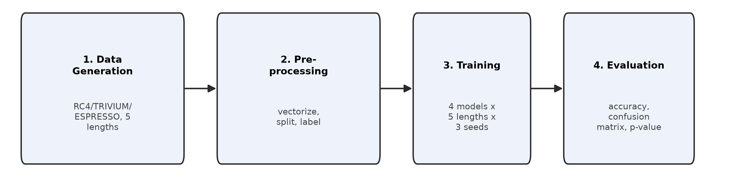
Fig. 1. Overview of the four-stage experimental pipeline.
Algorithm 1. High-level training and evaluation procedure.
Algorithm 1: Cipher-Classification Training & Evaluation
Input: ciphers C = {RC4, TRIVIUM, ESPRESSO}, lengths L in {8,24,32,64,1024}
1: for each L in lengths do
2: D_L <- generate 2^17 labeled keystreams per cipher in C, truncated to L bytes
3: split D_L into train/test (80:20, stratified)
4: for each model M in {ANN, DNN, 1D-CNN, FFNN} do
5: for each seed s in {0,1,2} do
6: train M on train split of D_L (Adam, categorical cross-entropy)
7: evaluate M on test split -> accuracy, confusion matrix
8: end for
9: aggregate seed accuracies (mean, std); run binomial test vs 1/3
10: end for
11: end for
Output: accuracy, macro-P/R/F1, p-value, and confusion matrix per (M, L)

III. PROPOSED METHODOLOGY
The methodology consists of four steps, namely: (i) generation of datasets, (ii) preprocessing, (iii) model development and (iv) training configuration.
A. Keystream Dataset Generation
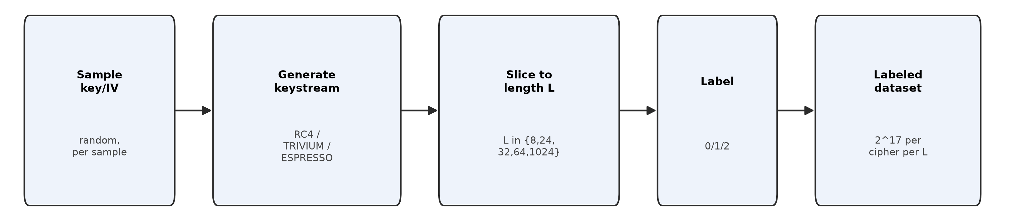
Fig. 2. Keystream dataset generation pipeline.
RC4 key-scheduling and pseudo-random generation (Eq. 1):
S[i] = i, i = 0..255
j = (j + S[i] + key[i mod keylen]) mod 256; swap S[i], S[j]
i = (i+1) mod 256; j = (j+S[i]) mod 256; swap S[i],S[j]; K_t = S[(S[i]+S[j]) mod 256]
TRIVIUM nonlinear feedback update (Eq. 2), over three shift registers (93,84,111 bits):
t1 = s66 XOR s93; t2 = s162 XOR s177; t3 = s243 XOR s288
z_t = t1 XOR t2 XOR t3 (output keystream bit at step t)
ESPRESSO nonlinear filter-generator output (Eq. 3):
z_t = f(x_{t,1}, x_{t,2}, ..., x_{t,k}) where f is a fixed nonlinear Boolean filter function
applied to k tapped positions of the internal LFSR state at step t.
RC4, TRIVIUM and ESPRESSO were used for keystream output. The three ciphers were chosen because of their variety of internal architecture and design ideology. Each cipher implementation was verified with their official test vectors. For each cipher, 2¹⁷ (131,072) samples were produced at five lengths: 8, 24, 32, 64, and 1024 bytes. Randomly-generated keys and IV were used for samples, to ensure statistical variety and to avoid any structural redundancy. The samples were collected and stored in csv format with numeric labels (0 for RC4, 1 for TRIVIUM and 2 for ESPRESSO), one row per sample.
B. Data Preprocessing
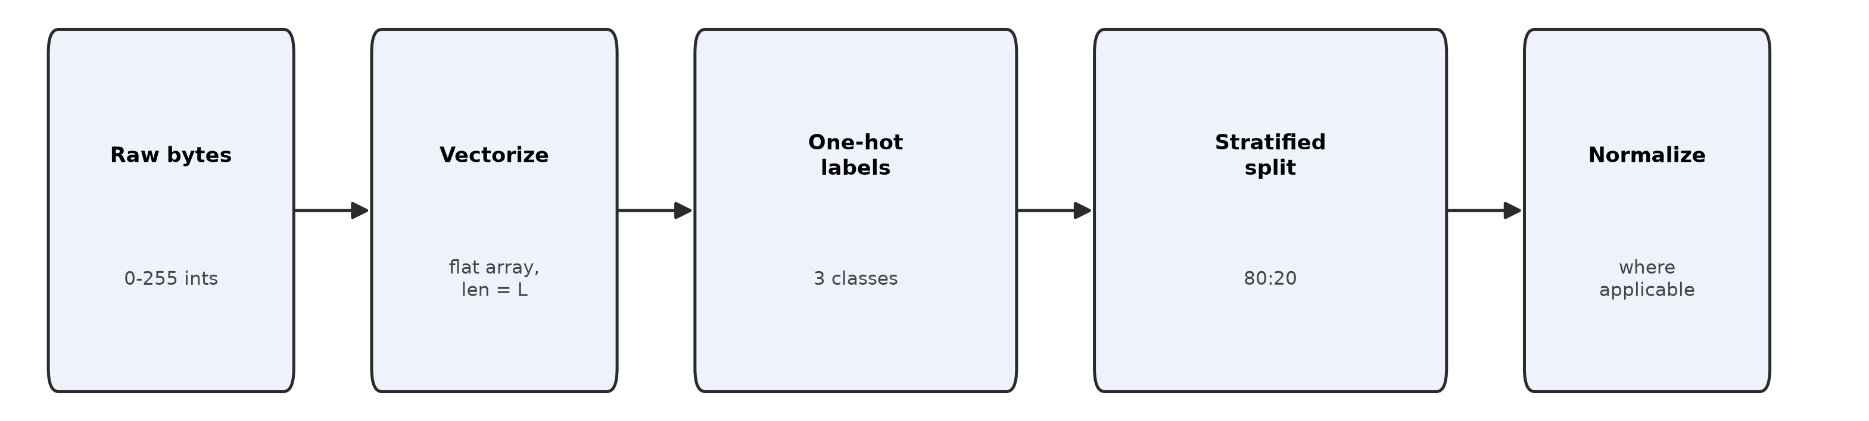
Fig. 3. Data preprocessing pipeline.
The bytes of each of the keystreams were converted to their integer equivalents (0-255), hence creating a flat numeric array. Sized vectors for input to the model were synchronized with the length of the keystream being used as the input. Cipher labels were one-hot encoded for multi-class classification. Data was split 80:20 for training and testing using stratified sampling, and input vectors were normalized where applicable to help convergence.
C. Classification Models
1) Artificial Neural Network (ANN): The ANN takes raw byte input directly, without any spatial filtering or temporal modeling, making it a natural baseline for the question of whether a fully connected network can learn cipher-distinguishing features at all. For a keystream of length L bytes, the input layer has L neurons, followed by two dense layers of 4L and 8L neurons with ReLU, a 30% dropout layer, then three further dense layers of 64, 32, and 16 neurons with ReLU, and a 3-neuron softmax output (Fig. 1).
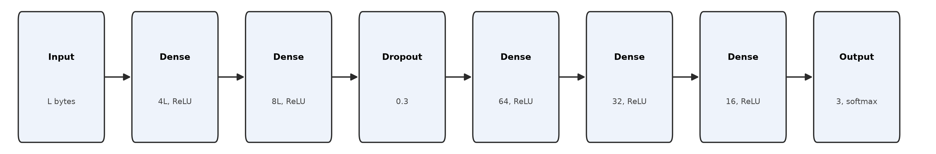
Fig. 4a. ANN architecture.
2) Deep Neural Network (DNN): The DNN extends the ANN concept with greater depth to see whether additional representational capacity changes anything. For a keystream of length L bytes, it processes the input through an input layer of L neurons, followed by dense layers of 256, 128, 64, and 32 neurons, each with ReLU and 30% dropout, and a 3-neuron softmax output (Fig. 2). The motivation was that distributional cues between ciphers, if they exist, might require more abstraction to surface.
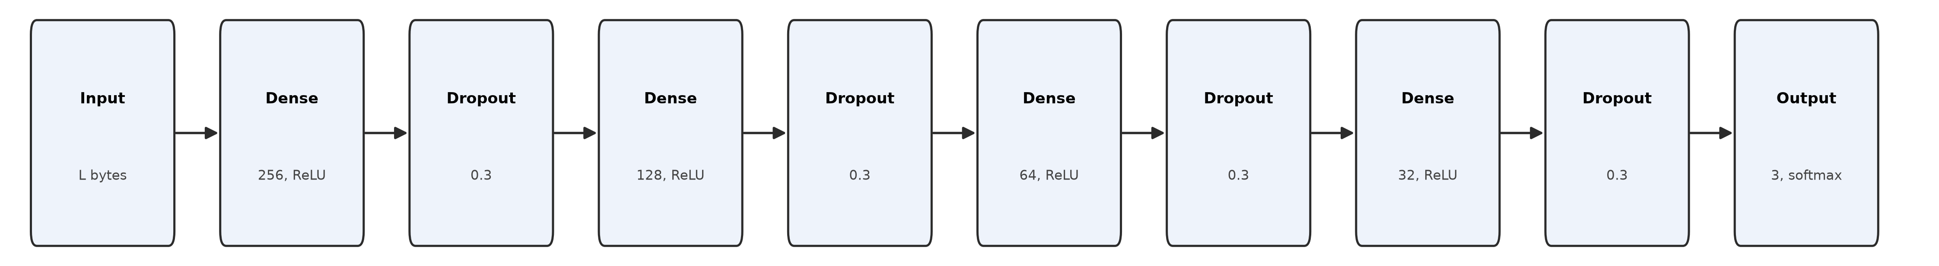
Fig. 4b. DNN architecture.
3) 1D Convolutional Neural Network (1D CNN): Rather than treating each byte independently, the 1D CNN looks for local patterns and translational structure within byte sequences. For a keystream of length L bytes, input is one-hot encoded to an (L, 256) tensor. The model runs two Conv1D layers (64 filters at kernel size 3, then 128 filters at kernel size 3) separated by MaxPooling1D with pool size 2, followed by global max pooling in place of flattening, so that the resulting feature vector has a fixed dimensionality of 128 regardless of L. This keeps model capacity constant across keystream lengths, so that any difference in accuracy across lengths reflects the input signal rather than a change in the number of model parameters. A 64-neuron dense layer with ReLU and a 3-class softmax output follow (Fig. 3).
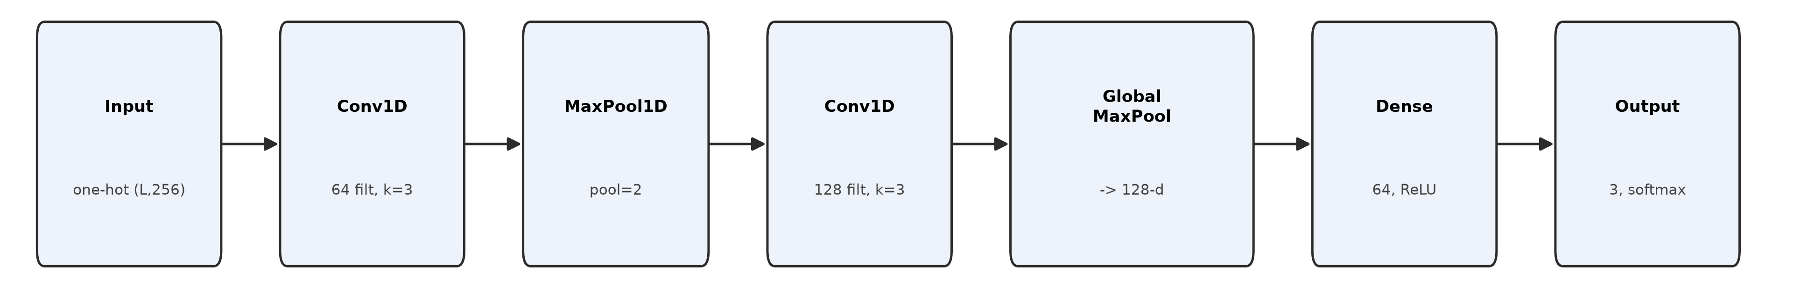
Fig. 4c. 1D-CNN architecture.
4) Feature-Based Feedforward Neural Network (FFNN): Instead of learning features end-to-end, this model receives manually engineered statistical features as input: Shannon entropy, byte frequency histograms, N-gram frequencies, statistical moments (mean, standard deviation, skewness, kurtosis), and run-length encoding statistics. Because these are aggregate statistics rather than raw sequence data, the resulting feature vector has the same fixed dimensionality at every keystream length L, so the model architecture itself required no adjustment across lengths. Two dense hidden layers with ReLU and 30% dropout each feed into a 3-class softmax output (Fig. 4). This setup is more interpretable than the CNN-based models and is suited to forensic settings where decision transparency matters.
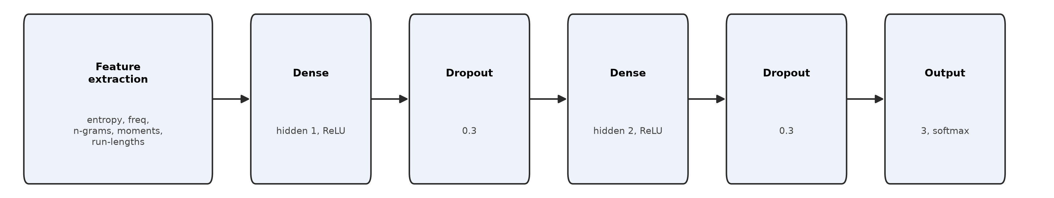
Fig. 4d. FFNN architecture.
FFNN input features (Eq. 9), computed per keystream sample x of length L:
Shannon entropy: H(x) = -sum_v p(v) log2 p(v), v over byte values 0..255
Mean: mu = (1/L) sum_i x_i
Skewness: gamma_1 = E[(x-mu)^3] / sigma^3
Kurtosis: gamma_2 = E[(x-mu)^4] / sigma^4 - 3

D. Training Configuration
All models were trained in TensorFlow using the Adam optimizer with categorical cross-entropy loss, batch size 64, and up to 50 epochs with early stopping at patience = 5. Accuracy and validation loss were the primary evaluation metrics. Separate training runs were conducted for each of the five keystream lengths.
<< MORE TABLES>> <<GRAPHS>>
The training and evaluation procedures are illustrated in Fig. 5 and Fig. 6; the objective, accuracy, and significance-testing formulae used throughout Section IV are given in Eq. (4)–(8).
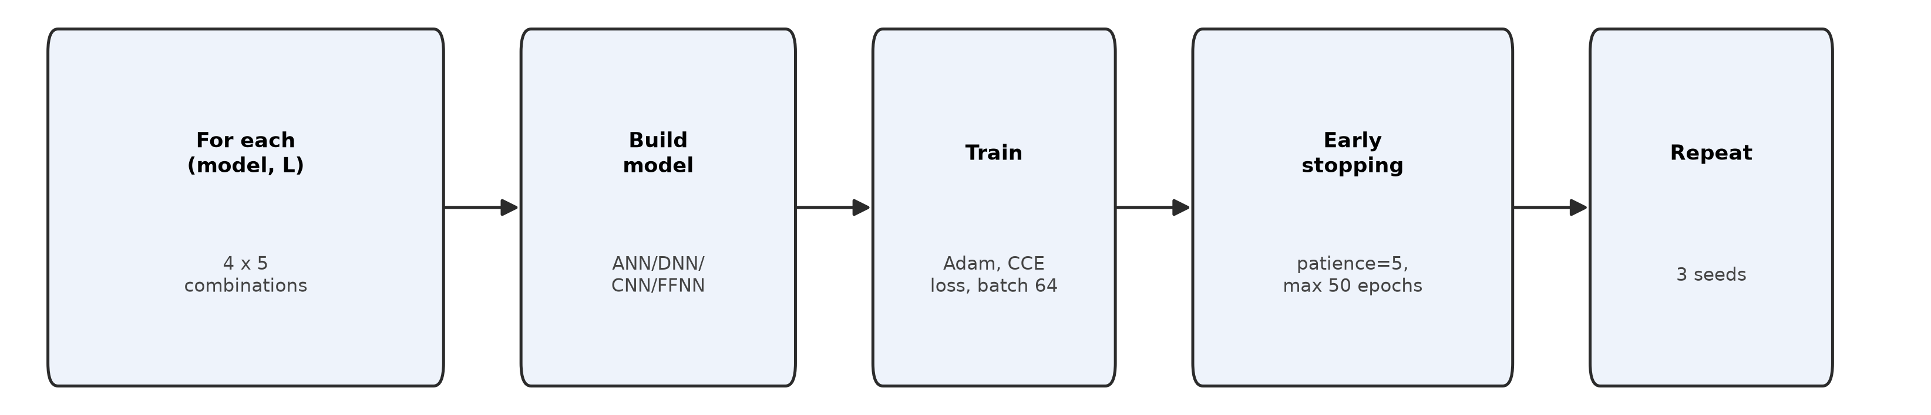
Fig. 5. Model training pipeline (repeated for every model x length x seed combination).
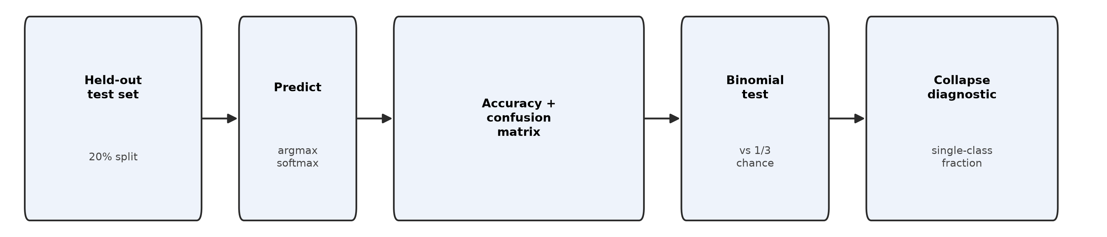
Fig. 6. Evaluation pipeline.
Softmax output (Eq. 4): p_k = exp(z_k) / sum_j exp(z_j)
Categorical cross-entropy loss (Eq. 5): L = -(1/N) sum_i sum_k y_{i,k} log(p_{i,k})
Accuracy (Eq. 6): Acc = (1/N) sum_i 1[argmax(p_i) = y_i]
Macro precision/recall/F1 (Eq. 7): P_k = TP_k/(TP_k+FP_k), R_k = TP_k/(TP_k+FN_k), F1_k = 2 P_k R_k /(P_k+R_k); macro-metric = (1/3) sum_k metric_k
Binomial significance test vs. chance (Eq. 8): under H0: p=1/3 per-sample correctness, p-value = P(X >= x_obs | n, p=1/3), X ~ Binomial(n, 1/3)
IV. EXPERIMENTS AND RESULTS
Each of the four architectures was trained and tested independently at every keystream length (8, 24, 32, 64, and 1024 bytes) across the RC4, TRIVIUM, and ESPRESSO datasets. The primary question was whether classification accuracy would vary meaningfully with input size or model complexity.
A. Artificial Neural Network (ANN)
Input layer with L neurons, then layers with 4L, 64 and 32 neurons each, ReLU throughout with a 30% dropout and a softmax output. Accuracy across all input lengths: 33.21%, 33.00%, 33.07%, 32.96%, 33.12%. No meaningful variation.
B. Deep Neural Network (DNN)
Input layer with L neurons, then hidden layers with 256, 128, 64 and 32 neurons each, ReLU throughout, 30% dropout after each. Results: 33.19%, 33.03%, 33.11%, 33.06%, 33.10%. Additional depth changed nothing.
C. 1D Convolutional Neural Network (1D-CNN)
Two 1D convolutional layers with kernel size 3 for both, max-pooling, dense layers, softmax output. Results: 33.28%, 32.91%, 33.00%, 32.88%, 33.04%. Spatially-aware processing did not help.
D. Feature-Based Statistical Analysis + Feed-Forward Neural Network (FFNN)
Shannon entropy, byte frequency histograms, N-gram frequencies, statistical moments (mean, standard deviation, skewness, kurtosis), and run-length encoding statistics passed into a shallow FFNN. Results: 33.30%, 33.02%, 33.00%, 33.09%, 33.00%. Handcrafted features performed no better than raw bytes.
E. Training Setup and Evaluation Metrics
Python/TensorFlow throughout, Adam optimizer, categorical cross-entropy loss, stratified 80:20 split, evaluated on accuracy, confusion matrices, and convergence plots. Across all experiments and all input lengths, accuracy held at approximately 33% — the models were not learning anything.

TABLE I: Classification Accuracy, Macro-Precision/Recall/F1, and Binomial p-value vs. Chance (1/3), by Model and Keystream Length
Model | Metric | L=8 | L=24 | L=32 | L=64 | L=1024
ANN | Accuracy | 33.33% ± 0.00 | 33.33% ± 0.00 | 33.33% ± 0.00 | 33.33% ± 0.00 | 33.33% ± 0.00
ANN | Macro-Precision | 0.111 ± 0.000 | 0.111 ± 0.000 | 0.111 ± 0.000 | 0.111 ± 0.000 | 0.111 ± 0.000
ANN | Macro-Recall | 0.333 ± 0.000 | 0.333 ± 0.000 | 0.333 ± 0.000 | 0.333 ± 0.000 | 0.333 ± 0.000
ANN | Macro-F1 | 0.167 ± 0.000 | 0.167 ± 0.000 | 0.167 ± 0.000 | 0.167 ± 0.000 | 0.167 ± 0.000
ANN | p-value (vs 1/3) | 1.000 | 1.000 | 1.000 | 1.000 | 1.000
DNN | Accuracy | 33.36% ± 0.03 | 33.33% ± 0.00 | 33.33% ± 0.00 | 33.33% ± 0.01 | 33.33% ± 0.00
DNN | Macro-Precision | 0.221 ± 0.089 | 0.111 ± 0.000 | 0.111 ± 0.000 | 0.185 ± 0.105 | 0.111 ± 0.000
DNN | Macro-Recall | 0.334 ± 0.000 | 0.333 ± 0.000 | 0.333 ± 0.000 | 0.333 ± 0.000 | 0.333 ± 0.000
DNN | Macro-F1 | 0.174 ± 0.008 | 0.167 ± 0.000 | 0.167 ± 0.000 | 0.211 ± 0.063 | 0.167 ± 0.000
DNN | p-value (vs 1/3) | 0.756 | 1.000 | 1.000 | 1.000 | 1.000
1D-CNN | Accuracy | 33.53% ± 0.26 | 33.31% ± 0.03 | 33.34% ± 0.00 | 33.40% ± 0.12 | 33.50% ± 0.35
1D-CNN | Macro-Precision | 0.358 ± 0.020 | 0.148 ± 0.052 | 0.181 ± 0.099 | 0.149 ± 0.053 | 0.229 ± 0.099
1D-CNN | Macro-Recall | 0.335 ± 0.002 | 0.333 ± 0.000 | 0.333 ± 0.000 | 0.334 ± 0.001 | 0.335 ± 0.003
1D-CNN | Macro-F1 | 0.265 ± 0.039 | 0.180 ± 0.019 | 0.173 ± 0.008 | 0.195 ± 0.040 | 0.220 ± 0.040
1D-CNN | p-value (vs 1/3) | 0.206 | 1.000 | 1.000 | 1.000 | 0.305
FFNN | Accuracy | 33.33% ± 0.00 | 33.33% ± 0.00 | 33.33% ± 0.00 | 33.33% ± 0.00 | 33.33% ± 0.00
FFNN | Macro-Precision | 0.111 ± 0.000 | 0.111 ± 0.000 | 0.111 ± 0.000 | 0.111 ± 0.000 | 0.111 ± 0.000
FFNN | Macro-Recall | 0.333 ± 0.000 | 0.333 ± 0.000 | 0.333 ± 0.000 | 0.333 ± 0.000 | 0.333 ± 0.000
FFNN | Macro-F1 | 0.167 ± 0.000 | 0.167 ± 0.000 | 0.167 ± 0.000 | 0.167 ± 0.000 | 0.167 ± 0.000
FFNN | p-value (vs 1/3) | 1.000 | 1.000 | 1.000 | 1.000 | 1.000

TABLE II: Fraction of Test Predictions Landing on the Single Most-Predicted Class (Class-Collapse Diagnostic)
Model | 8 bytes | 24 bytes | 32 bytes | 64 bytes | 1024 bytes
ANN | 1.00 | 1.00 | 1.00 | 1.00 | 1.00
DNN | 0.97 | 1.00 | 1.00 | 1.00 | 1.00
1D-CNN | 0.92 | 1.00 | 1.00 | 1.00 | 0.80
FFNN | 1.00 | 1.00 | 1.00 | 1.00 | 1.00

TABLE III: Confusion-Matrix Summary – Dominant Predicted Class per Model and Keystream Length (single run, seed 0)
Model | L=8 | L=24 | L=32 | L=64 | L=1024
ANN | ESPRESSO (100%) | ESPRESSO (100%) | ESPRESSO (100%) | ESPRESSO (100%) | ESPRESSO (100%)
DNN | ESPRESSO (97%) | ESPRESSO (100%) | ESPRESSO (100%) | ESPRESSO (100%) | ESPRESSO (100%)
1D-CNN | TRIVIUM (92%) | ESPRESSO (100%) | ESPRESSO (100%) | ESPRESSO (100%) | ESPRESSO (80%)
FFNN | ESPRESSO (100%) | ESPRESSO (100%) | ESPRESSO (100%) | RC4 (100%) | ESPRESSO (100%)

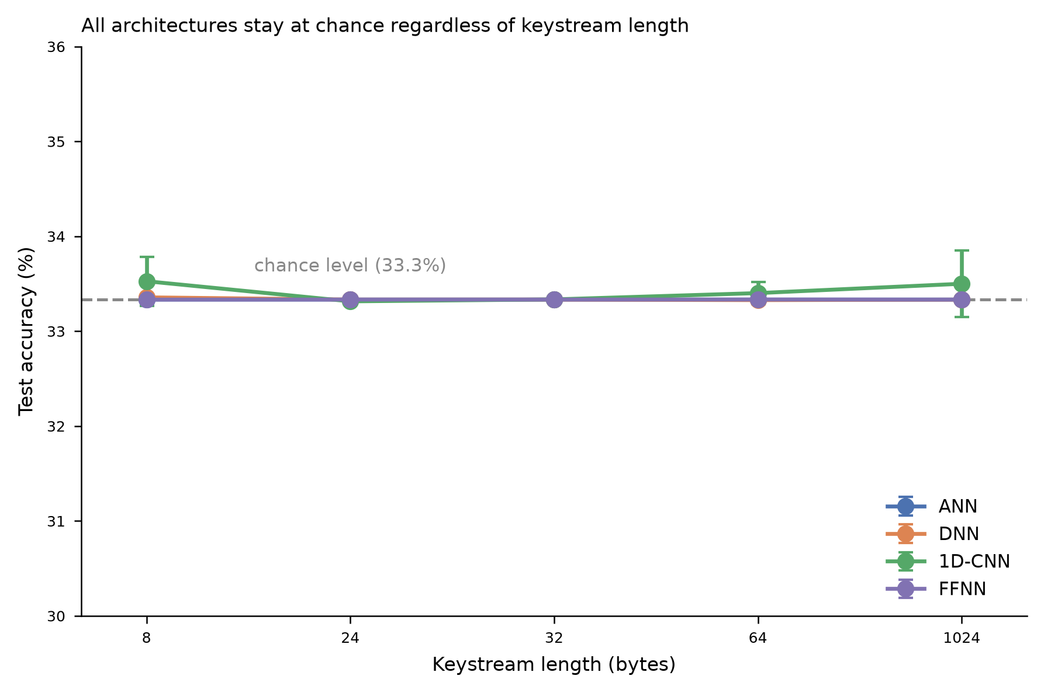
Fig. 5. Test accuracy vs. keystream length for all four architectures, with the 1/3 chance baseline. Error bars show ± 1 std across 3 seeds.
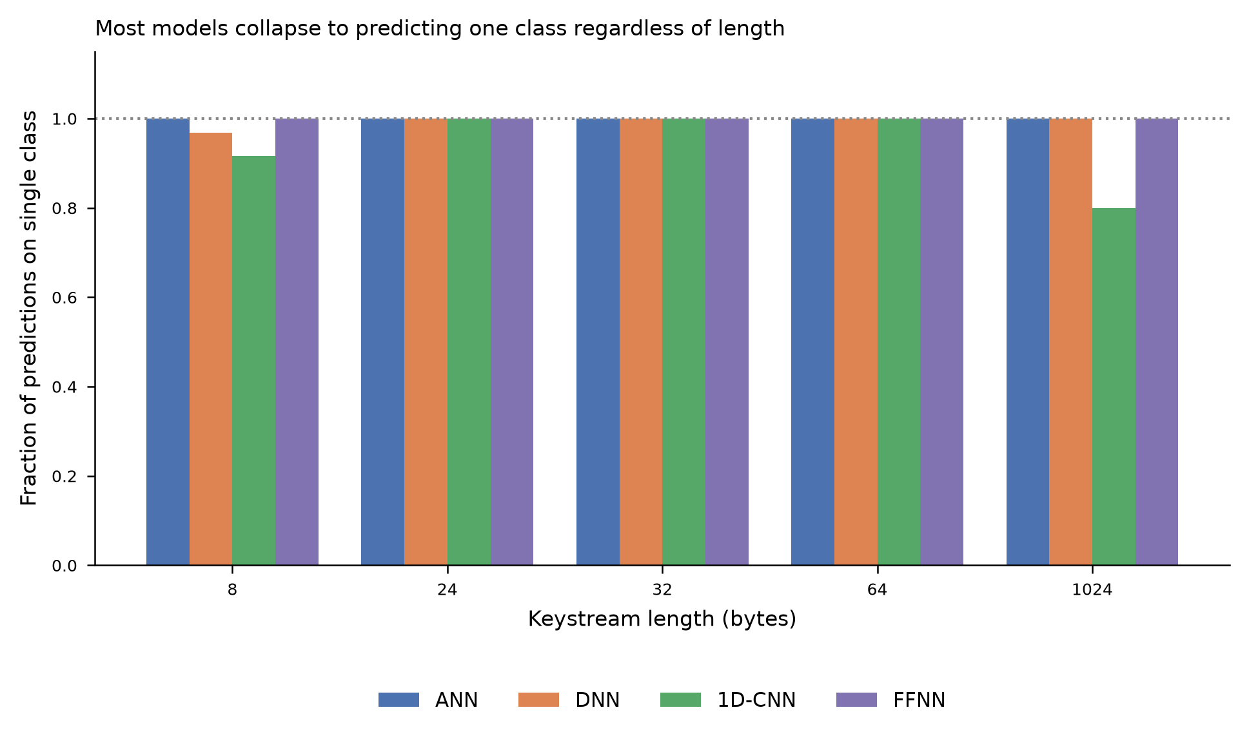
Fig. 6. Fraction of test-set predictions landing on a single dominant class, by model and keystream length (seed 0).
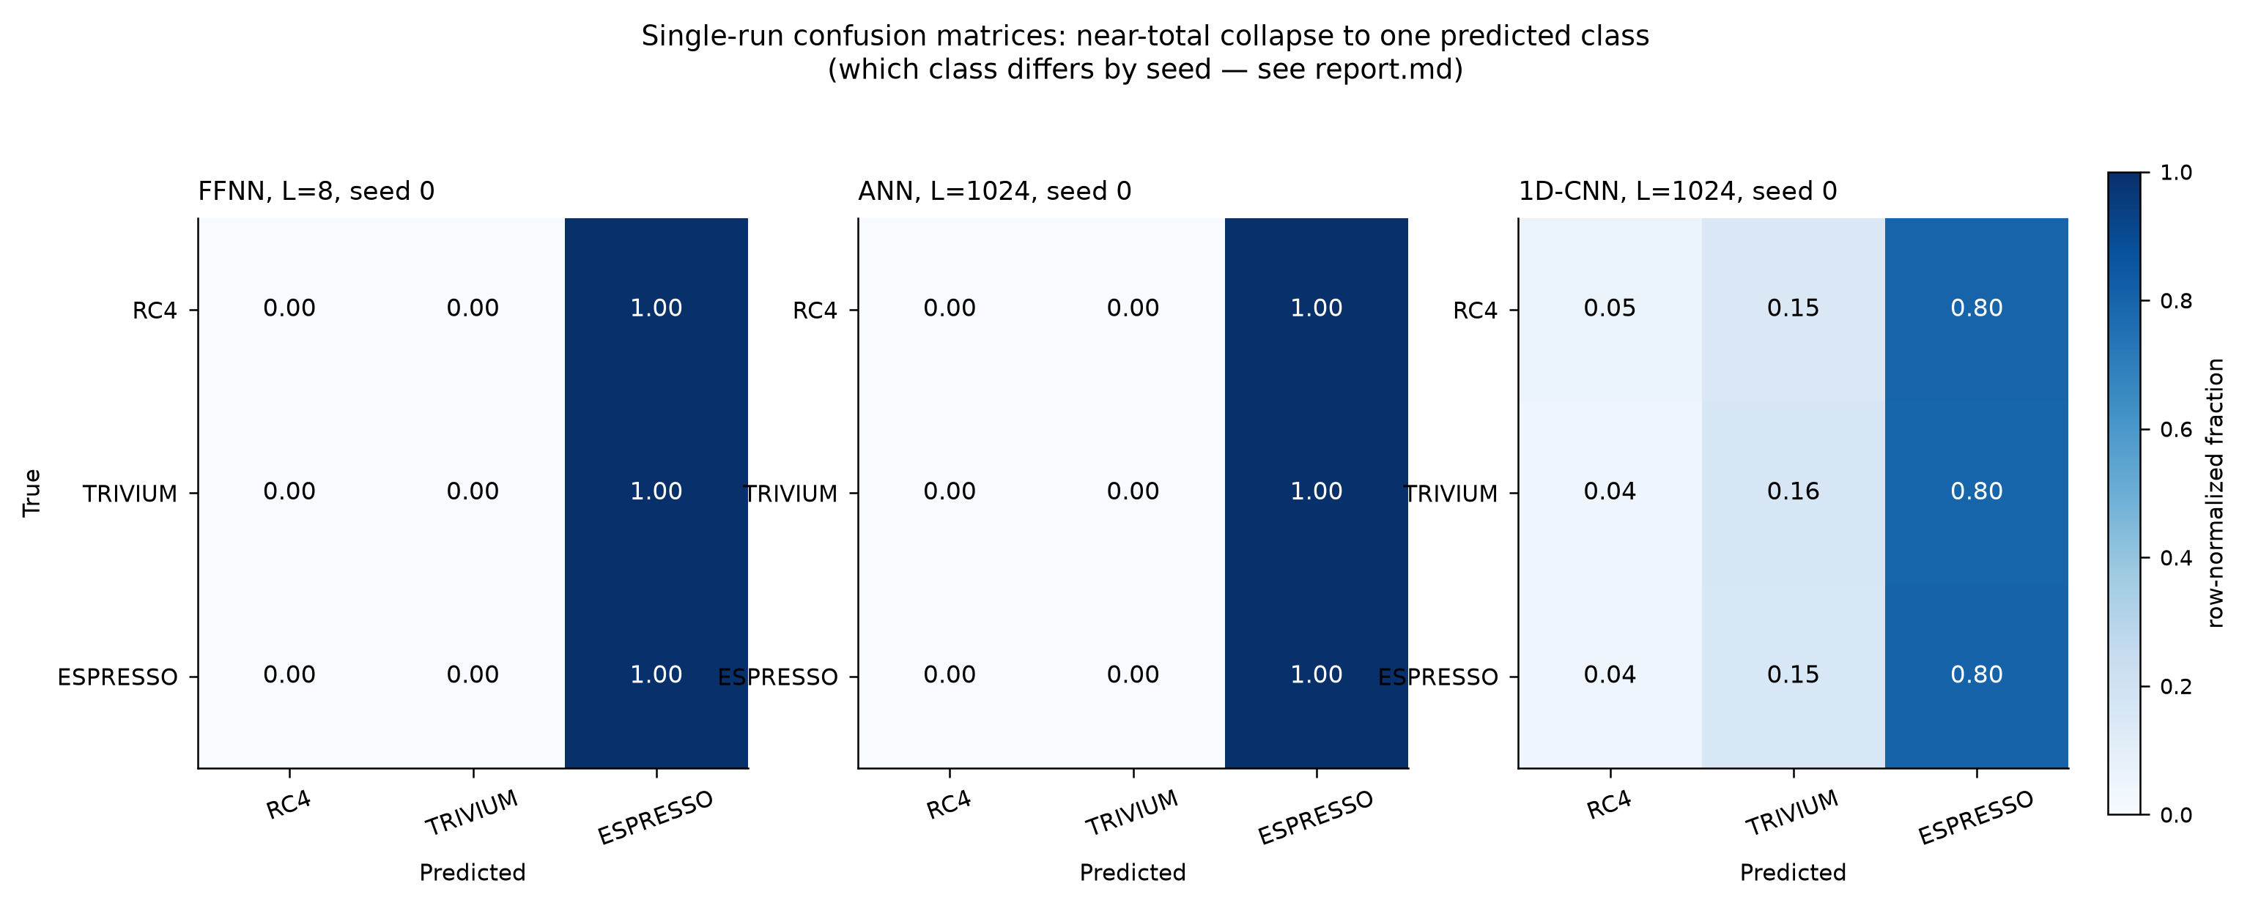
Fig. 7. Representative single-run confusion matrices illustrating near-total collapse onto one predicted class; the identity of that class varies arbitrarily across seeds (Table III, seed 0).

V. Discussion
Every architecture hit the same ceiling: roughly 33%, which is exactly what uniform random guessing produces on a three-class problem. The result held across shallow and deep networks, raw bytes and engineered features, short keystreams and long ones. Nothing changed the outcome.
RC4, TRIVIUM, and ESPRESSO are all designed to produce byte distributions that are statistically close to uniform and mutually indistinguishable, which is precisely what makes them good ciphers in the first place, and a neural model operating on output alone, with no access to internal state or initialization structure, simply has nothing to grab onto. At shorter lengths, say 8 bytes or 24 bytes, the same becomes even more of an issue because there is not enough data per sample to allow for a distributional signature to build up. And where the length was 1024 bytes long, and although it would seem that some type of aggregate statistical property might emerge there, none did.
The most striking result of this is the fact that the well-known descriptors of entropy, frequency distributions, and the higher order moments, which would be one would consider in a statistical distinguisher test, still fail to separate the classes, suggesting that on these common measures the ciphers are indeed secure– at the raw-byte level. Intuitively, the idea behind the convolutional models was that there possibly could be some patterns in the correlations at the local level of the bytes that might be present in the cipher, but this is not the case either: Keystream output is simply too spatio-temporally unstructured to be captured by the CNNs.
All four models stumble in the same way: none of them takes into account how the ciphers operate internally — how they are initialized, the role of the IV, or their internal state-transition properties. Any purely data-driven approach that bypasses this structural information is likely to run into the same barrier. More frequency-domain transformations may help as there is some evidence of utility of frequency domain features in another context, longer keystream sequences to allow the signature to expand (as in Transformers) and architectures that are suitable for long-range, as opposed to local, dependence.
The 33% accuracy provides a clean empirical lower bound on the difficulty of this problem for standard systems based on a neural approach, and it reveals where the field needs to head next.

VI. CONCLUSION AND FUTURE WORK
ANNs, DNNs, CNNs and FFNNs with feature engineering were used on the problem of keystream classification over RC4, TRIVIUM and ESPRESSO at five lengths of bytes (8, 24, 32, 64 and 1024) and 2¹⁷ samples per cipher were used. The training results for the four models were at around 33% accuracy, with no significant differences between them in regard to model architecture or input size, as these results would be random guesses on a 3-class problem.
The output of these ciphers is currently seen as being a priori free of such statistical patterns as could be exploited by any standard neural architectures. This is in line with what good cipher design should endeavour to attain (statistically indistinguishable output) and should be perhaps interpreted as confirmation of these properties rather than a weakness in the models. Further research into this area, with the exploration of RNNs, Transformers, more targeted feature engineering, or other ciphers, could enable the identification of cryptographic properties that give rise to a learnable attack; however, such work must include some knowledge of the domain that is currently lacking with purely data-driven approaches.
The full codebase and dataset generation scripts are available at: https://github.com/Sukhman-Singh-Narula/CipherClassification.git

ACKNOWLEDGMENT
The author thanks Mr. Girish Mishra, Scientist at DRDO, and Dr. Prerna Mann, Assistant Professor, CSE department at MAIT, for their guidance and mentorship throughout this research, which was conducted as part of a research internship at DRDO.

REFERENCES
[1] Y. Xiao, Q. Hao, and D. D. Yao, "Neural Cryptanalysis: Metrics, Methodology, and Applications in CPS Ciphers," arXiv preprint arXiv:1911.04020, 2019. Also published in 2019 IEEE Conference on Dependable and Secure Computing (DSC), doi: 10.1109/dsc47296.2019.8937659.
[2] A. Akhilesh, H. Singh, and G. Mishra, "LSTM-Based Cryptanalysis of Stream Cipher Espresso," in Cryptology and Network Security with Machine Learning, Lecture Notes in Networks and Systems, vol. 918, Springer, 2024.
[3] Payal, Pooja, and G. Mishra, "Enhancing Data Security: A Study of Grain Cipher Encryption using Deep Learning Techniques," IACR Cryptology ePrint Archive, Paper 2023/1292.
[4] G. Mishra, I. Gupta, S. V. S. S. N. V. G. Krishna Murthy, and S. K. Pal, "Deep Learning based Cryptanalysis of Stream Ciphers," Defence Science Journal, vol. 71, no. 4, pp. 499–506, 2021, doi: 10.14429/dsj.71.16209.
[5] N. Kopal et al., "Of Ciphers and Neurons: Detecting the Type of Ciphers Using Artificial Neural Networks," in Proceedings of the 3rd International Conference on Historical Cryptology (HistoCrypt 2020), pp. 77–86.
[6] F. Leierzopf, N. Kopal, B. Esslinger, H. Lampesberger, and E. Hermann, "A Massive Machine Learning Approach for Ciphertext Classification," in Proceedings of the 4th International Conference on Historical Cryptology (HistoCrypt 2021), pp. 111–120, doi: 10.3384/ecp183164.
[7] M. M. Alani, "Network traffic classification using machine learning and port-based and flow-based features," in 2012 International Conference on Innovations in Information Technology (IIT), Abu Dhabi, UAE, pp. 198–202. IEEE.
[8] A. Gohr, "Improving attacks on round-reduced Speck32/64 using deep learning," in Annual International Cryptology Conference (CRYPTO 2019), pp. 150–179. Springer, Cham.
[9] A. Prajapati, "Deep Learning Based Analysis of Stream Ciphers A5/1 and RC4," International Journal of Computer Applications, vol. 185, no. 20, 2023, doi: 10.5120/ijca2023923028.
[10] A. Alamer and B. Soh, "A new neural-network-based model for measuring the strength of a pseudorandom binary sequence," International Journal of Advanced and Applied Sciences, vol. 7, no. 4, pp. 39–48, 2020, doi: 10.21833/ijaas.2020.04.005. Preprint: arXiv:1910.04195.
[11] B. Y. Chong and I. Salam, "Investigating Deep Learning Approaches on the Security Analysis of Cryptographic Algorithms," Cryptography, vol. 5, no. 4, 30, MDPI, 2021, doi: 10.3390/cryptography5040030.
[12] C. Brunetta and P. Picazo-Sanchez, "Modelling Cryptographic Distinguishers Using Machine Learning," Journal of Cryptographic Engineering, vol. 12, pp. 123–135, Springer, 2022, doi: 10.1007/s13389-021-00262-x.
[13] M. Abadi and D. G. Andersen, "Learning to Protect Communications with Adversarial Neural Cryptography," arXiv preprint arXiv:1610.06918, 2016.
[14] K. Yuan, D. Yu, J. Feng, L. Yang, C. Jia, and Y. Huang, "A block cipher algorithm identification scheme based on hybrid k-nearest neighbor and random forest algorithm," PeerJ Computer Science, vol. 8, e1110, 2022, doi: 10.7717/peerj-cs.1110.
[15] B. S. Rocha, J. A. M. Xexeo, and R. H. Torres, "Post-Quantum Cryptographic Algorithm Identification Using Machine Learning," Journal of Information Security and Cryptography (Enigma), vol. 9, no. 1, 2022, doi: 10.17648/jisc.v9i1.81.
[16] W. Stallings, Cryptography and Network Security: Principles and Practice, Pearson, multiple editions (6th ed., 2014; 7th ed., 2017; 8th ed., 2020).
[17] A. Nitaj and T. Rachidi, "Applications of Neural Network-Based AI in Cryptography," Cryptography, vol. 7, no. 3, 39, MDPI, 2023, doi: 10.3390/cryptography7030039.
[18] H. Kumar, A. Kumar, and H. Sinha, "Deep Learning Based Analysis of Key Scheduling Algorithm of Advanced Ciphers," IACR ePrint Archive, Report 2024/272. https://eprint.iacr.org/2024/272
[19] B. D. Kim et al., "Cryptanalysis via Machine Learning Based Information Theoretic Metrics," arXiv preprint arXiv:2501.15076, 2025.
[20] N. K. Sharma, S. Dey, S. Sarkar, and S. Maitra, "On Improved Cryptanalytic Results against ChaCha for Reduced Rounds ≥7," IACR ePrint Archive, Report 2025/428. https://eprint.iacr.org/2025/428
[21] S. Dey, S. Maitra, S. Sarkar, and N. K. Sharma, "Significantly Improved Cryptanalysis of Salsa20 with Two-Round Criteria," IACR Transactions on Symmetric Cryptology, vol. 2025, no. 1, pp. 420–443, doi: 10.46586/tosc.v2025.i1.420-443.
[22] W. Wu and M. Guo, "Improved integral neural distinguisher model for lightweight cipher PRESENT," Cybersecurity, vol. 7, 2024, doi: 10.1186/s42400-024-00258-0.
[23] Shreyashi, "Classical Cipher Identification Using Binary Encodings and Deep Learning," Procedia Computer Science, vol. 282, pp. 894–903, 2026, doi: 10.1016/j.procs.2026.05.133.

