**What is Geth?**

* Go Ethereum, written in Google’s Go language, is one of the three original implementations of the Ethereum protocol, alongside C++ and Python.
* Geth is Go Ethereum’s standalone CLI client and is the most popular software client for running a node on the Ethereum network.
* Running a node allows users to perform transactions and interact with smart contracts on the Ethereum blockchain.
* Go-Ethereum, and subsequently Geth, are built and maintained by the Ethereum community. It’s open source which means anyone can contribute to Geth through its [Github](https://github.com/ethereum/go-ethereum).

### Why run an Ethereum node with Geth?

When you run a node, you’re helping run the Ethereum network! Ethereum exists as a network of nodes relaying valid blocks to their peers. By running your own node, you maintain a local copy of the Ethereum blockchain. And, your node secures the network by validating blocks against its copy of the blockchain.

And so, when you want to send ETH to a friend or even trade on your decentralized exchange, you don’t have to rely on a third party to relay your message to the network. Instead, you can send, receive, and/or verify transactions on the Ethereum network for yourself!

**Geth installation**

**Step 1 Installation and set up**

Step 1.1: download latest version of geth

Step 1.2: Create a folder in a drive D:/example , unzip or put the installer geth.exe in this folder. Double click it to start installation.

Step 1.3: Create short cut for geth.exe on desktop, rgt click the shortcut and go to properties, in target option specify the path as "D:/example \geth.exe" -fast -cache=1024 click apply then click ok.

Step 1.4: Double click shortcut icon to start syncing

Step1. 5: Open command prompt, go to drive path where geth is installed and check version

D:/example>geth version

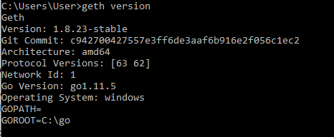

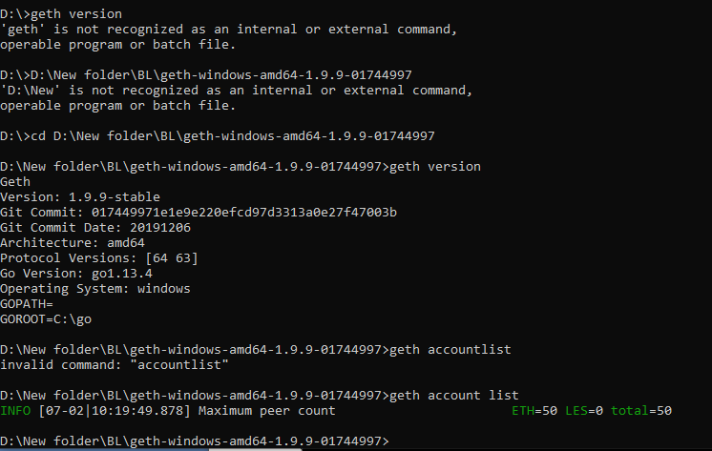

**Step 2: To create accounts**

To check the accounts available

Command: geth account list

Step 2.1 When no accounts are created



Step 2.2 To create a new account

Command: geth account new

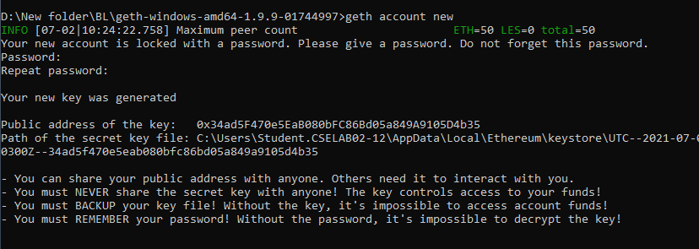

One account created



Many accounts

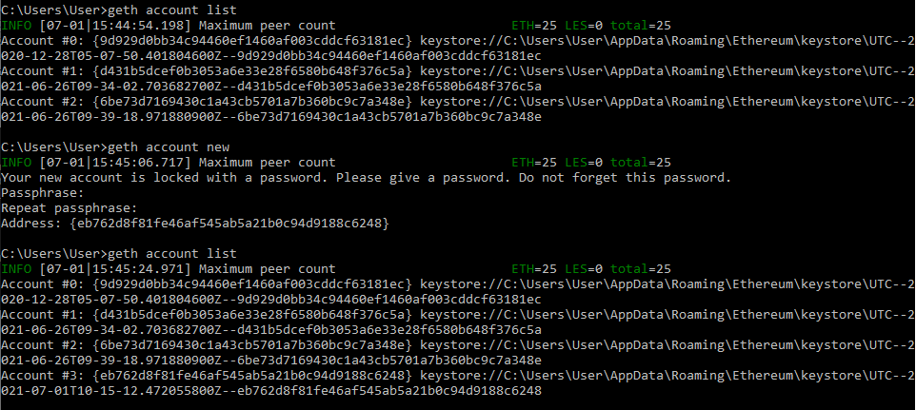

**Step 3: To import metamask account to geth**

3.1 goto metamask ,select an account, click on export private key, copy the key.

3.2 Copy the private key in a notepad,in a folder then import the account to geth by providing the path to the key.

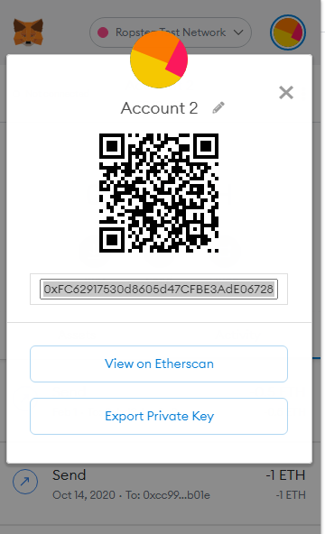

### Full node on the main Ethereum network

By far the most common scenario is people wanting to simply interact with the Ethereum network: create accounts; transfer funds; deploy and interact with contracts. For this particular use-case the user doesn't care about years-old historical data, so we can fast-sync quickly to the current state of the network. To do so:

$ geth console

This command will:

* Start geth in fast sync mode (default, can be changed with the --syncmode flag), causing it to download more data in exchange for avoiding processing the entire history of the Ethereum network, which is very CPU intensive.
* Start up geth's built-in interactive [JavaScript console](https://geth.ethereum.org/docs/interface/javascript-console), (via the trailing console subcommand) through which you can interact using [web3 methods](https://web3js.readthedocs.io/en/) (note: the web3 version bundled within geth is very old, and not up to date with official docs), as well as geth's own [management APIs](https://geth.ethereum.org/docs/rpc/server). This tool is optional and if you leave it out you can always attach to an already running geth instance with geth attach.

Need to start the blockchain

To do that go to the path where geth is installed and then give command

>geth console

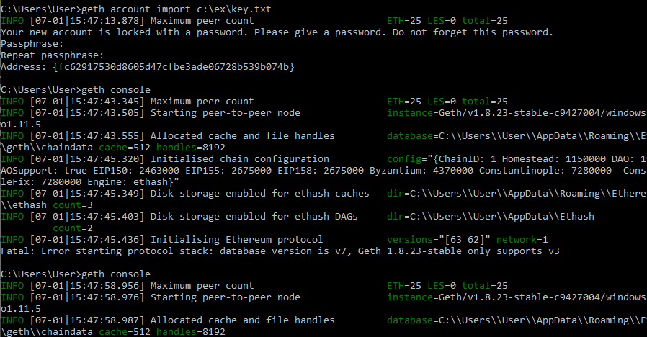

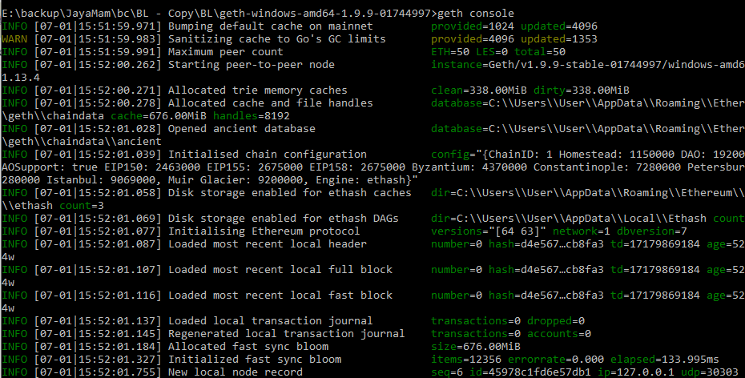

To list accounts

Command > personal.listAccounts

1st account is one that created in geth, 2nd is imported from metamask



To check balance

>eth.getBalance(eth.accounts[position])

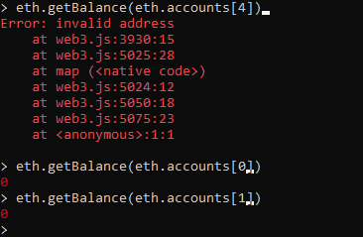

**With more no: of accounts**

