Mini Project Report
CSV Data Analyzer in C
Statistical Summary Engine for Dataset Processing

Programming Language: C (C11 Standard)
IDE: Visual Studio Code
Compiler: GCC (MinGW-w64)

Table of Contents

1. Introduction
2. Prerequisites & Technical Tools
3. VS Code Environment Setup
4. Project Structure
5. Functional Requirements
6. Module Descriptions
7. Data Structures Used
8. API & External Libraries
9. Project Flowchart
10. Testing Strategy
11. Future Enhancements

0. Course Reference / Learning Resource
This project was built while completing the following two-course specialization from the University of California, Santa Cruz on Coursera. The concepts and programming techniques taught in both courses — pointers, dynamic memory, file I/O, structs, and modular design — directly informed every implementation decision in this project.
Course Name | Platform / Institution | Completed
C for Everyone, Part 1: Programming Fundamentals | University of California, Santa Cruz — Coursera | July 2024
C for Everyone, Part 2: Structured Programming | University of California, Santa Cruz — Coursera | July 2024

Topics from Part 1 applied here: variables & data types, pointers, dynamic memory (malloc/realloc/free), functions, and file I/O.
Topics from Part 2 applied here: structs, modular programming with header files, sorting algorithms (qsort), and structured I/O design patterns.

1. Introduction
This project implements a CSV Data Analyzer in C that reads comma-separated value files, parses their contents into structured data, and computes statistical summaries for each numeric column. The analyzer calculates mean, median, minimum, and maximum values, presenting results in a clean tabular format. Built using modular functions and proper file handling, it demonstrates core C programming competencies including dynamic memory allocation, pointer manipulation, and structured I/O operations.
The project is designed as a command-line tool that accepts a CSV file path as input and produces formatted statistical output, with an optional export feature to save summaries to a text file.

2. Prerequisites & Technical Tools

2.1 Knowledge Prerequisites
Area | Topics Required
C Fundamentals | Variables, data types, operators, control flow (if/else, loops), functions
Pointers & Memory | Pointer arithmetic, malloc/calloc/realloc/free, dynamic arrays
File I/O | fopen, fclose, fgets, fprintf, fscanf, error handling with errno
Strings | strtok, strcmp, strcpy, strlen, string parsing techniques
Structs | Defining structs, nested structs, arrays of structs, typedef
DSA Concepts | Sorting algorithms (for median), arrays, basic complexity analysis

2.2 Technical Tools
Tool | Version | Purpose
GCC Compiler | 13.x+ (MinGW-w64) | C11 compilation with warnings
VS Code | Latest | Code editor with C/C++ extension
Git | 2.x+ | Version control
Make (optional) | 4.x+ | Build automation via Makefile
Valgrind (Linux) | 3.x+ | Memory leak detection

3. VS Code Environment Setup

Step 1: Install MinGW-w64 (GCC for Windows)
- Download MSYS2 from https://www.msys2.org/ and install it.
- Open MSYS2 terminal and run: pacman -S mingw-w64-ucrt-x86_64-gcc
- Add C:\msys64\ucrt64\bin to your system PATH environment variable.
- Verify: open Command Prompt and run gcc --version.

Step 2: Install VS Code Extensions
- C/C++ (Microsoft) — IntelliSense, debugging, code navigation
- C/C++ Extension Pack — includes CMake Tools, themes
- Code Runner — one-click compile and run from the editor

Step 3: Configure tasks.json (Build Task)
Create .vscode/tasks.json in your project folder with a build task that runs: gcc -Wall -Wextra -std=c11 -g src/*.c -o build/csv_analyzer. This enables Ctrl+Shift+B to compile your project with all warnings enabled and debug symbols included.

Step 4: Configure launch.json (Debugger)
Create .vscode/launch.json with a configuration pointing to build/csv_analyzer.exe, using the gdb debugger from your MinGW installation. Set the args field to pass a sample CSV file path for testing.

4. Project Structure
The project follows a modular directory layout separating source code, headers, build artifacts, test data, and documentation:
csv-data-analyzer/├── src/│ ├── main.c (Entry point, CLI argument handling)│ ├── csv_parser.c (File reading, CSV parsing logic)│ ├── stats.c (Statistical computation functions)│ ├── display.c (Formatted output & export)│ └── utils.c (Memory helpers, string utilities)├── include/│ ├── csv_parser.h (Parser struct & function declarations)│ ├── stats.h (Stats function prototypes)│ ├── display.h (Display/export prototypes)│ └── utils.h (Utility prototypes & macros)├── data/ (Sample CSV test files)├── build/ (Compiled binaries)├── docs/ (Documentation)├── Makefile (Build automation)└── README.md (Project overview & usage)

5. Functional Requirements

5.1 Core Functional Requirements
ID | Requirement | Description
FR-01 | CSV File Reading | Read any valid CSV file via command-line argument using fopen/fgets
FR-02 | Dynamic Parsing | Parse header row and data rows into dynamically allocated arrays using strtok
FR-03 | Mean Calculation | Compute arithmetic mean for each numeric column
FR-04 | Median Calculation | Sort column values and find median (handles odd/even count)
FR-05 | Min/Max Detection | Find minimum and maximum values per numeric column
FR-06 | Formatted Output | Display results in aligned tabular format on the console
FR-07 | Export Summary | Optionally write statistical summary to a .txt output file
FR-08 | Error Handling | Handle missing files, empty datasets, non-numeric values, memory failures

5.2 Key Concepts Used
Structured Programming: The project is organized into separate modules with clear interfaces defined through header files. Each module has a single responsibility (parsing, computation, display), following the principles taught in the UC Santa Cruz C specialization.
DSA — Sorting: Median computation requires sorting column data. The project implements a comparison-based sort (qsort from stdlib.h with a custom comparator), demonstrating practical DSA application.
Dynamic Memory Management: All data arrays are heap-allocated using malloc/realloc with explicit free calls, demonstrating proper memory lifecycle management and leak prevention.
File Handling: Robust file I/O with error checking at every stage — open, read, write, close — using standard C library functions.

6. Module Descriptions
Module | Key Functions | Responsibility
main.c | main(), parse_arguments() | CLI entry point, orchestrates the analysis pipeline
csv_parser.c | csv_open(), csv_parse_header(), csv_parse_row(), csv_close() | Opens file, tokenizes header and data rows, stores in structs
stats.c | compute_mean(), compute_median(), compute_min(), compute_max() | Statistical computations on numeric column arrays
display.c | print_summary(), export_summary() | Console output formatting and file export
utils.c | safe_malloc(), trim_whitespace(), is_numeric() | Memory allocation wrappers, string utilities

7. Data Structures Used
The project uses custom structs to organize CSV data and statistical results:
CSVData: The primary struct holding the parsed dataset. Contains a headers array (char**), a 2D data array (double**), row_count, and col_count. Memory is dynamically allocated based on actual file dimensions.
ColumnStats: Holds computed statistics for a single column: mean (double), median (double), min (double), max (double), and the column name (char*). An array of ColumnStats is generated — one per numeric column.
Arrays & Sorting: Temporary double arrays are allocated for each column when computing the median. These are passed to qsort() with a custom comparator before extracting the middle value.

8. API & External Libraries
This project intentionally uses only the C Standard Library (C11) with no external dependencies, keeping it lightweight and portable. The key standard library headers used are:
Header | Functions Used
<stdio.h> | fopen, fclose, fgets, fprintf, printf, snprintf
<stdlib.h> | malloc, calloc, realloc, free, atof, qsort, exit
<string.h> | strtok, strcmp, strcpy, strlen, memset
<math.h> | isnan, isinf (for numeric validation)
<errno.h> | errno, perror (for file error reporting)

If you want to extend the project with external APIs in the future, consider libcurl for fetching remote CSV files from URLs (install via MSYS2: pacman -S mingw-w64-ucrt-x86_64-curl), or cJSON for exporting summaries in JSON format (single-header library from https://github.com/DaveGamble/cJSON).

9. Project Flowchart
The following flowchart illustrates the complete execution pipeline of the CSV Data Analyzer, from input validation through statistical computation to output:
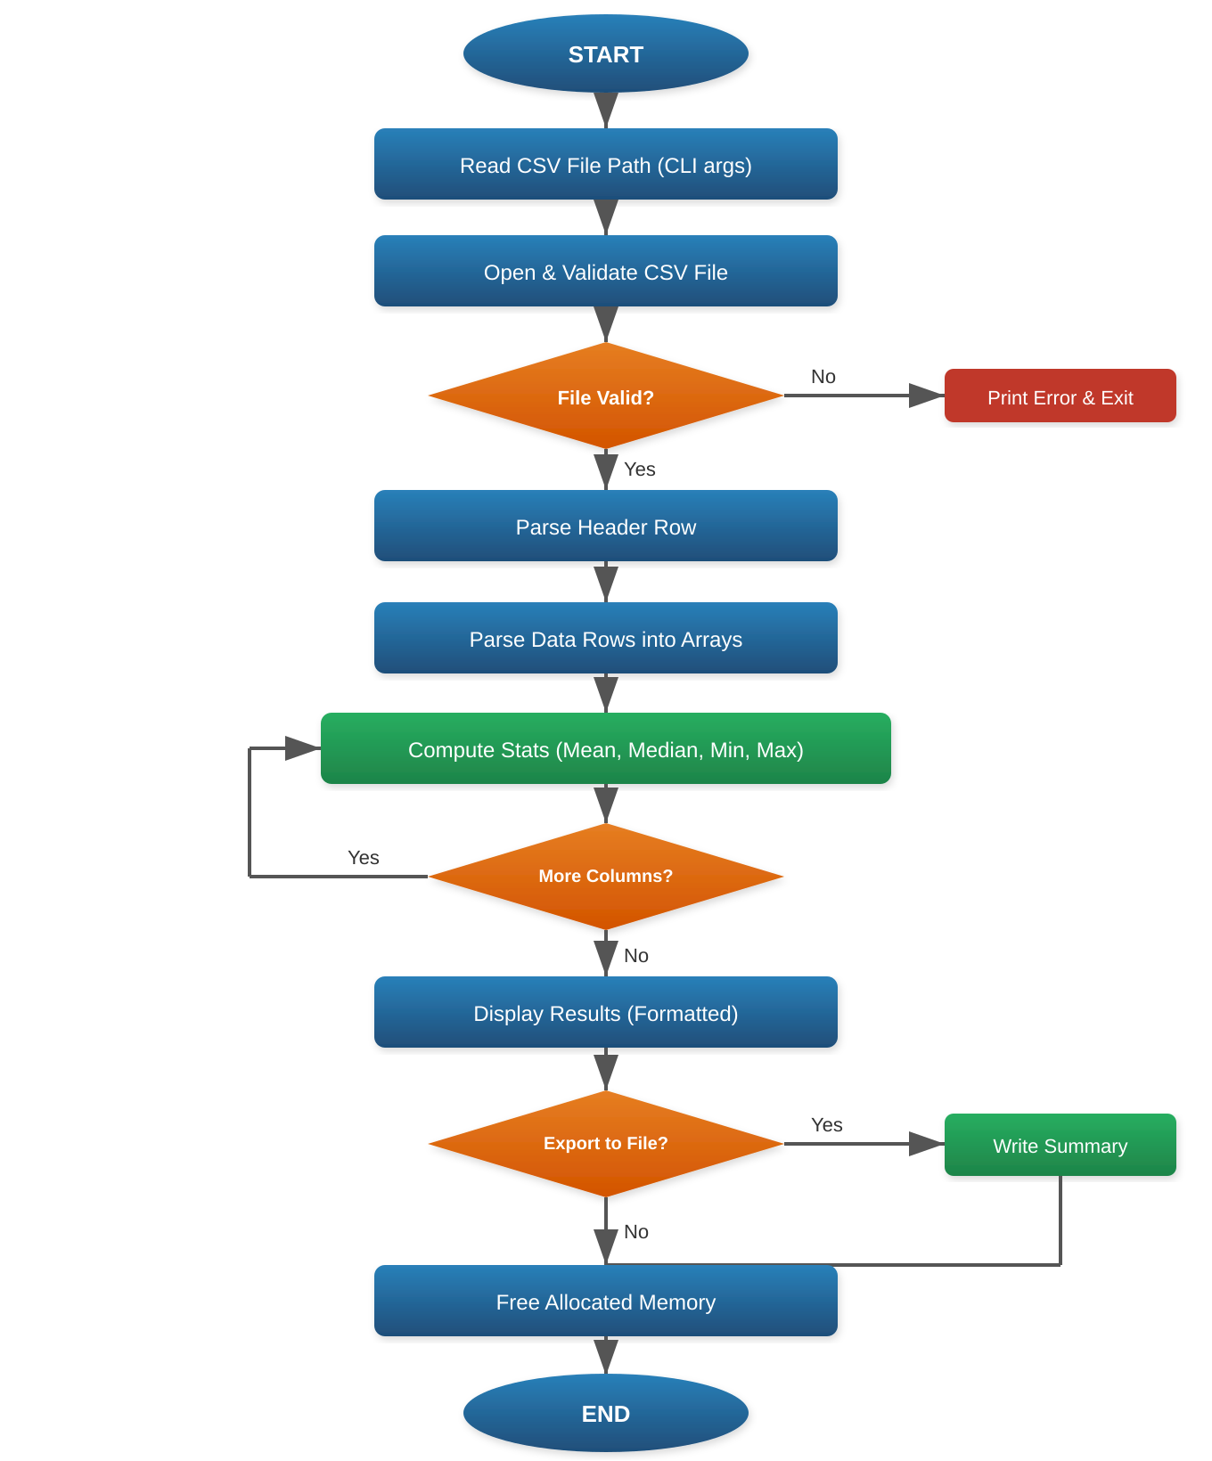

10. Testing Strategy
Test Case | Description
Valid CSV | Standard CSV with numeric and mixed columns; verify all stats are correct
Empty File | CSV with only headers or completely empty; should print a meaningful error
Missing Values | Rows with empty cells; analyzer should skip or handle gracefully
Non-Numeric Columns | Columns with text data should be skipped during statistical computation
Large Dataset | 10,000+ row CSV to test performance and memory handling
Special Characters | Quoted fields with commas, newlines inside quotes
Memory Leak Check | Run with Valgrind (Linux) or Dr. Memory (Windows) to verify zero leaks

11. Future Enhancements
- Add standard deviation and variance calculations to the statistical engine.
- Support additional delimiters (TSV, pipe-separated) via a command-line flag.
- Implement column filtering to analyze only user-specified columns.
- Add JSON/CSV export formats alongside the current text output.
- Integrate libcurl to fetch and analyze remote CSV files from URLs.
- Build a simple ncurses-based interactive TUI for browsing results.

End of Report

