Problem Statement 1: Employee Salary Calculator
Title: Calculate Net Salary Using Functions

Problem Statement:
A company wants to calculate the net salary of its employees. Write a Python program that uses functions to calculate the net salary based on the employee&#39 basic salary.

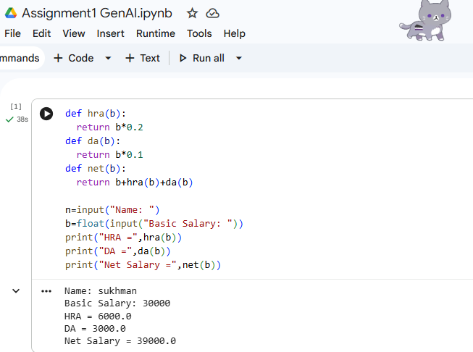

Problem Statement 2: Student Grade Management System
Title: Calculate Student Grade Using Functions
Problem Statement:
A school wants to automate the process of calculating students&#39; grades. Write a Python program using functions to calculate the total marks, percentage, and final grade.

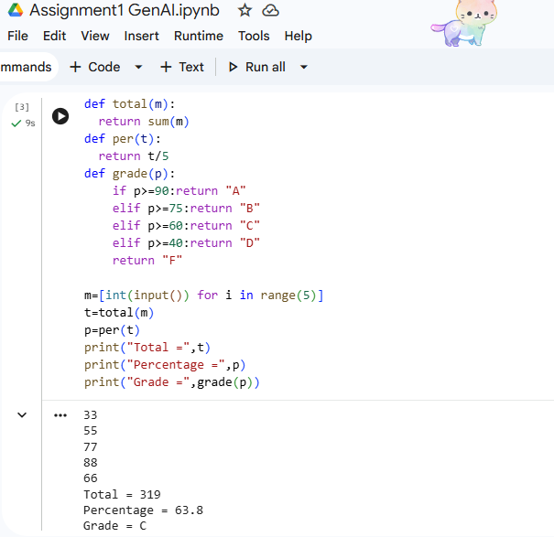

Practical : Student Performance Management System
Problem Statement
A school wants to automate the process of managing student records. Develop a Python program that stores student details and marks, calculates percentages, assigns grades, and displays the topper.

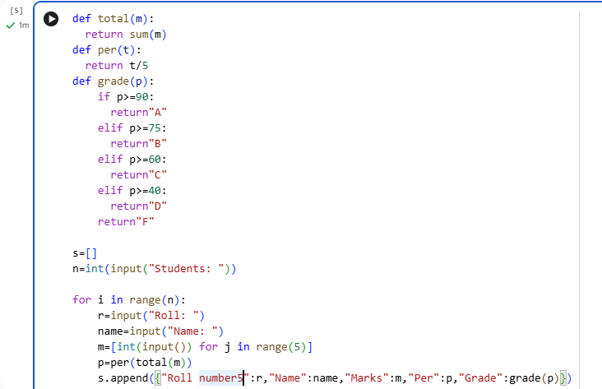
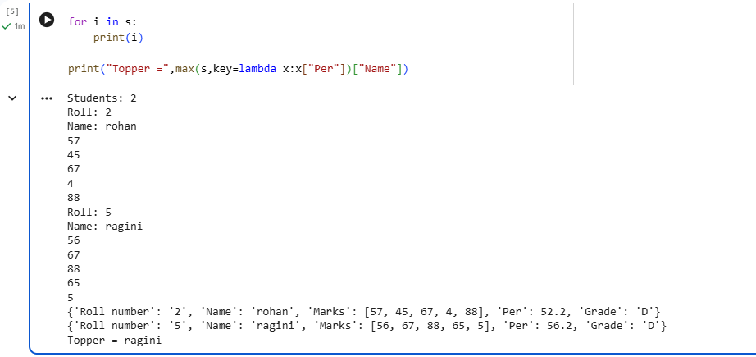

File Handling
Q1. Create a program that reads student marks from a file (filename.txt). Display
the names of students who have passed (marks &gt; 45) and those who have failed.
Count the total number of passed and failed students.
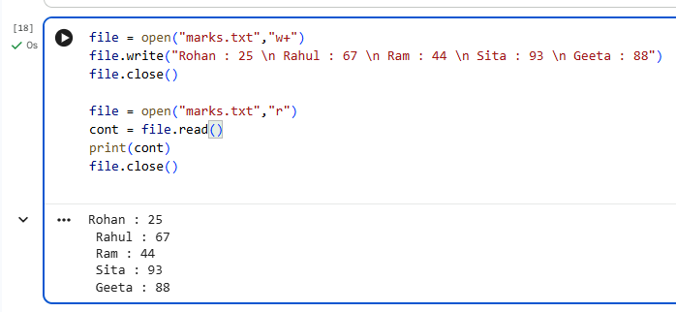

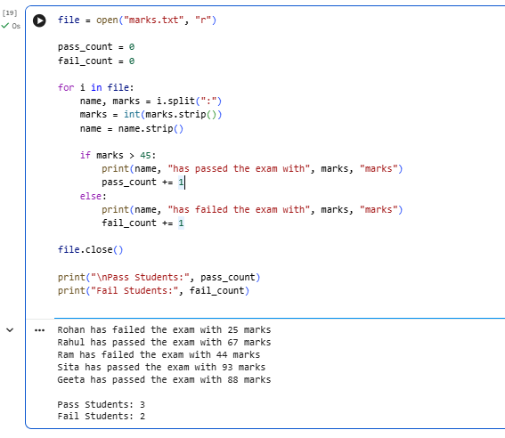

Q2. A file (salary.txt) contains employee names and salaries. Read the file and display only those employees whose salary is greater than ₹50,000. Also count how many employees satisfy this condition.
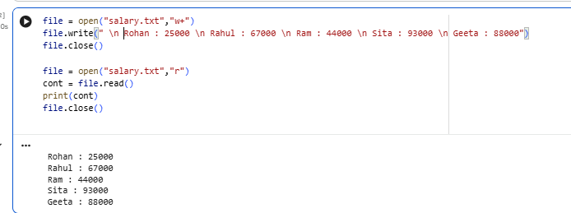

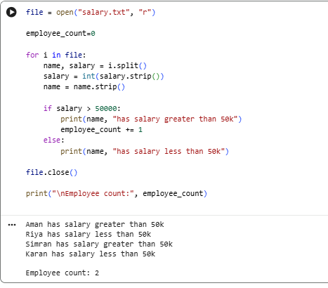
Q3. A file (attendance.txt) contains the attendance status of students
(Present/Absent). Read the file and display only the names of absent students. Also
calculate the total number of present and absent students.

