1. String Related Programs (a) Write a program to concatenate one string to another string. (b) Write a program to reverse a string. (c) Write a program to delete all the vowels from the string. (d) Write a program to sort the strings in alphabetical order. (e) Write a program to convert a character from uppercase to lowercase.

#include <iostream>

#include <string>

using namespace std;

int main() {

string str1, str2;

cout << "Enter first string: ";

getline(cin, str1);

cout << "Enter second string: ";

getline(cin, str2);

str1 += str2;

cout << "Concatenated string: " << str1 << endl;

return 0;

}

OUTPUT :



#include <iostream>

#include <string>

using namespace std;

int main() {

string str;

cout << "Enter a string: ";

getline(cin, str);

int n = str.length();

for (int i = 0; i < n / 2; i++) {

char temp = str[i];

str[i] = str[n - i - 1];

str[n - i - 1] = temp;

}

cout << "Reversed string: " << str << endl;

return 0;

}

OUTPUT :



#include <iostream>

#include <string>

using namespace std;

bool isVowel(char ch) {

ch = tolower(ch);

return (ch == 'a' || ch == 'e' || ch == 'i' || ch == 'o' || ch == 'u');

}

int main() {

string str, result = "";

cout << "Enter a string: ";

getline(cin, str);

for (char ch : str) {

if (!isVowel(ch)) {

result += ch;

}

}

cout << "String after removing vowels: " << result << endl;

return 0;

}

OUTPUT :



#include <iostream>

#include <string>

using namespace std;

int main() {

int n;

cout << "Enter number of strings: ";

cin >> n;

cin.ignore();

string arr[100];

cout << "Enter " << n << " strings:" << endl;

for (int i = 0; i < n; i++) {

getline(cin, arr[i]);

}

// Sorting

for (int i = 0; i < n - 1; i++) {

for (int j = 0; j < n - i - 1; j++) {

if (arr[j] > arr[j + 1]) {

string temp = arr[j];

arr[j] = arr[j + 1];

arr[j + 1] = temp;

}

}

}

cout << "\nStrings in alphabetical order:" << endl;

for (int i = 0; i < n; i++) {

cout << arr[i] << endl;

}

return 0;

}

OUTPUT :

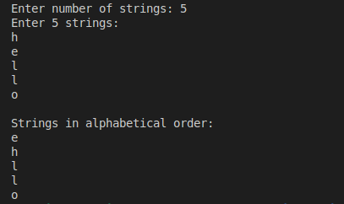

#include <iostream>

using namespace std;

int main() {

char ch;

cout << "Enter an uppercase character: ";

cin >> ch;

if (ch >= 'A' && ch <= 'Z') {

ch = ch + 32; // Convert to lowercase

cout << "Lowercase: " << ch << endl;

} else {

cout << "The entered character is not uppercase." << endl;

}

return 0;

}

OUTPUT :

