Sukhraj Nijjar

1014232

Does gender or immigration status play a role in returns from two or four-year degrees.

**Changes made in response to the proposal comments:**

1. I clearly re-define status to mean immigrant or non-immigrant.
2. Created indicators for 2 and 4 year degrees.
3. Made a discrete immigrant indicator.
4. Will introduce sensitivity analysis based on running 2 regressions. One with a 2-year degree and one with only a 4-year degree held constant.

**Introduction:**

The topic of this research project is to understand any discrepancy between hourly wages of two- and four-year degrees based on gender or immigration status. The approach we will consider is to create various regression models to display if there is a discrepancy in these wages. Firstly, I will introduce you to the data and how the variables will be manipulated. Secondly, a sensitivity analysis will occur. Thirdly, the results of our findings will be shown. Lastly, we will conclude our topic.

**Data:**

The data is from the public Labour Force Survey data from February 2023.

The data was collected across Canada by Statistics Canada.

For the first data cleaning I will only consider ages 20 to 64 years old. I do this because you can complete a two-year degree by age 20. (Appendix 1)

Secondly, we will create a factor variable edu such that, when edu == 1, represents no degree, edu == 2, represents a two-year degree, edu == 3, represents a four-year degree.

I can achieve this by grouping the factor variable EDUC in a certain way: [0,3]; [4]; [5,6] (Appendix 2)

Thirdly, creating a 0/1 indicator on whether a person is an immigrant or not. In our case immigrant == 0, represents a non-immigrant (Appendix 3)

For my sensitivity analysis I will create two data subsets with EDUC held constant at either a two-year or a four-year degree (Appendix 5)

There are a total of 70924 observations in the sample.

4994 are classified as immigrant while 65930 are non-immigrant. (Appendix 4)

Initially there is a massive gap in observations between immigrant people and non-immigrant people. Will this gap have any effect on returns will be seen in the next sections.

**Methodology:**

The first assumption is that we are grouping all immigrants into one category. Our data groups them by if they landed 10 or less years earlier or if they landed more than 10 years earlier. Secondly, we have included people who have an education above a four-year degree in our four-year degree classification. This can skew our results to favour the number of immigrants or non-immigrants who have achieved this classification.

The estimation equation I will consider is:

log(HRLYEARN) = beta_0 + beta_1(immigrant) + beta_2(factor(edu)) + beta_3(factor(edu))*(immigrant) + beta_4(factor(AGE_12)) + beta_5(SEX) + u

The sensitivity analysis I will consider is creating two estimation equations. One with only two-year degrees and one with only four-year degrees. I will do this by using two different subsets of my data. (See Appendix 5)

1: log(HRLYEARN) = beta_0 + beta_1(immigrant) + beta_2(factor(AGE_12)) + beta_3(SEX) + u

2: log(HRLYEARN) = beta_0 + beta_1(immigrant) + beta_2(factor(AGE_12)) + beta_3(SEX) + u

**Results:**

The results are tabulated in (Appendix 6)

Statistical significance:

Mostly all coefficients are statistically significant at a 99% level of significance as p-values are <0.01.

Interpretation of main coefficients:

From our main estimation equation:

All else equal people who obtain two-year degrees receive 17.4% more hourly wages than people with no degrees. Also, people with four-year degrees receive 43.6% more hourly wages than people with no degrees.

Based on gender, women earn 17.7% less than males.

All else equal an immigrant earns 13.7% less than a non-immigrant.

An immigrant who receives a two-year degree earns 0.52% less than a non-immigrant who receives a two-year degree.

An immigrant who receives a four-year degree earns 0.8% less than a non-immigrant who receives a four-year degree.

From the sensitivity analysis:

We see that holding education constant at a two-year degree with all else equal immigrants earn 19.3% less than non-immigrants and holding education constant at a four-year degree with all else equal immigrants earn 23.1% less than non-immigrants. This is much higher than our original estimation equation suggested at 13.7%.

From our results we understand that females are underpaid compared to males. This wage cut is lessened with a four-year degree compared to other categories. Further, immigrants compared to non-immigrants are underpaid by less than 1% based on either a two- or four-year degree.

**Conclusion:**

Gender does in fact play a role in returns. Females earn 17.5% less on average than males. Further, obtaining a two- or four-year degree as an immigrant has a negative return of less than 1% compared to a non-immigrant.

Appendix

1.

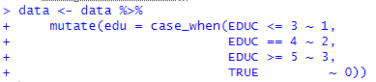2.

3.



4.

5.

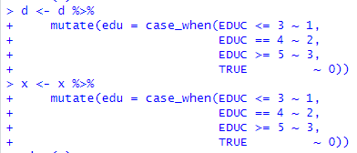

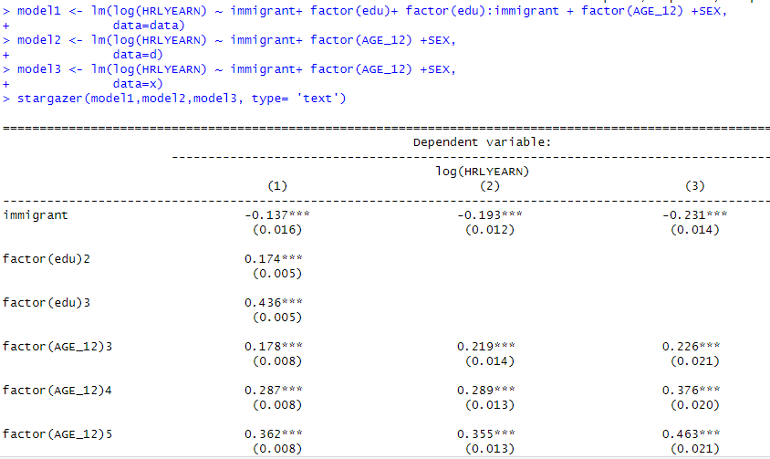6.

