SUKHVINDER SINGH

Project 1 – CS 155 02

1. Format of the first statement in the output

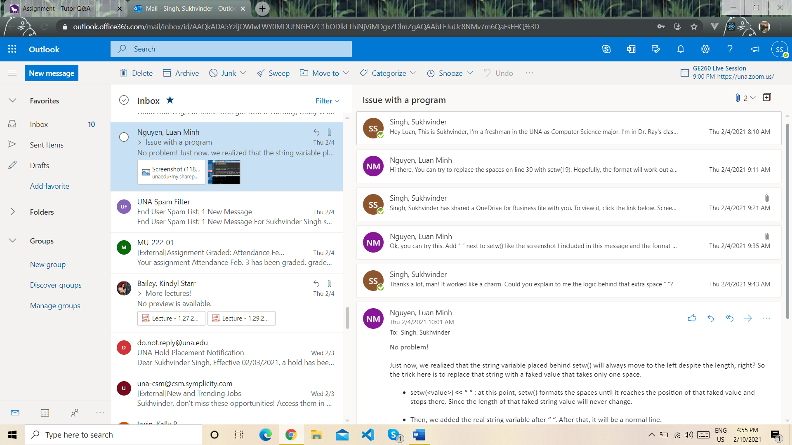

**Solution of the problem given by Tutor**

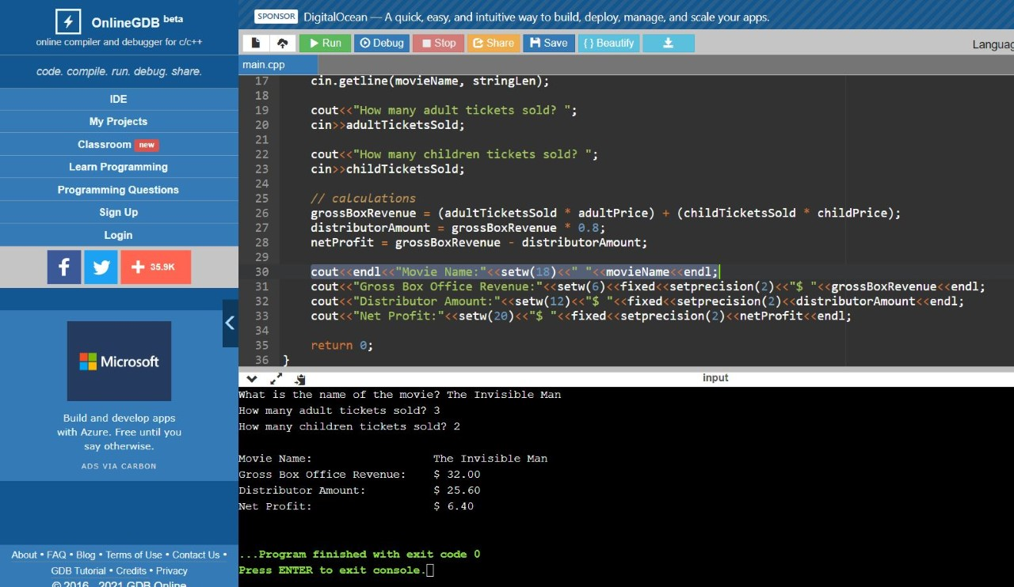

I asked the doubt through mail.

**Tutor Name: Luan Minh Nguyen**

He has a good knowledge of core CPP.

1. Code Refactor

Code: <https://github.com/Sukhvsin2/CS-155-Assignments/blob/master/A6Code.cpp>

**Tutor: Josh Brown**

Reviewed my code, nothing like doubt specific.

Time: 12-12:30pm | Feb. 10 2021 | Lab 234