CS 470 Artificial Intelligence Fall, 2022
Assignment #4
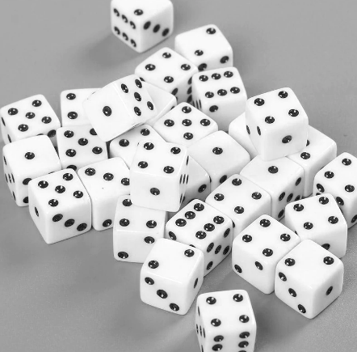
Value: 20 points

In this assignment, you will gain some practice developing Python functions to build a game.

The game is a dice game that can be played with any number dice. As long as you continue rolling dice that aren’t threes, the game continues, and you keep accumulating points. If all the dice turn into threes, though, you got too greedy, you lose all of your points, and the game is over.

Your program must contain the following six functions:
- main – Ask user how many dice will be used for the games. Then, loop allowing user to play multiple games – call init and game each time
- init – initialize each die to zero and the total score to 0
- game – loop for each dice roll, each time asking the user if he would like to roll again
- display – print the column headings, dice rolls, and sum. Print “Stuck” if die was eliminated on previous rolls
- roll – generate new dice rolls for each die that isn’t stuck
- gameover – check to see if all of the dice are stuck. Return a Boolean.

Your program must use parameters and return values to exchange data between functions. Global variables are not allowed.

Look at the reverse side of this sheet to see how the game is played and how the screen should look during game play.

Note: This is all code that is 100% written by you. Do not share code with classmates. Do not download code from the Internet.

Be sure that you use meaningful variables in your code and include appropriate documentation. You should have a comment block at the top of your program and comment blocks above each function. Be sure your comment blocks give thorough descriptions of your program and functions, respectively.

Submit your Python program in Canvas under Assignment #4.
SAMPLE INTERACTIONS:

How many dice in this game? 5
Roll the dice (Y/N)? y

Die #1 Die #2 Die #3 Die #4 Die #5 Sum
5 3 1 3 3 6
Roll the dice (Y/N)? y

Die #1 Die #2 Die #3 Die #4 Die #5 Sum
3 STUCK 3 STUCK STUCK 6

Die #1 Die #2 Die #3 Die #4 Die #5 Sum
STUCK STUCK STUCK STUCK STUCK => YOU LOSE!

Play another game (Y/N)? y
Roll the dice (Y/N)? y

Die #1 Die #2 Die #3 Die #4 Die #5 Sum
1 2 4 4 5 16
Roll the dice (Y/N)? y

Die #1 Die #2 Die #3 Die #4 Die #5 Sum
1 3 5 3 4 26
Roll the dice (Y/N)? y

Die #1 Die #2 Die #3 Die #4 Die #5 Sum
4 STUCK 2 STUCK 2 34
Roll the dice (Y/N)? n

YOU WIN. YOUR SCORE IS: 34
Play another game (Y/N)? n

>>>

How many dice in this game? 8
Roll the dice (Y/N)? y

Die #1 Die #2 Die #3 Die #4 Die #5 Die #6 Die #7 Die #8 Sum
6 3 5 4 5 5 6 6 37
Roll the dice (Y/N)? y

Die #1 Die #2 Die #3 Die #4 Die #5 Die #6 Die #7 Die #8 Sum
3 STUCK 6 2 6 4 4 1 60
Roll the dice (Y/N)? y

Die #1 Die #2 Die #3 Die #4 Die #5 Die #6 Die #7 Die #8 Sum
STUCK STUCK 6 5 6 6 4 2 89
Roll the dice (Y/N)? y

Die #1 Die #2 Die #3 Die #4 Die #5 Die #6 Die #7 Die #8 Sum
STUCK STUCK 2 3 6 1 1 3 99
Roll the dice (Y/N)? y

Die #1 Die #2 Die #3 Die #4 Die #5 Die #6 Die #7 Die #8 Sum
STUCK STUCK 4 STUCK 3 2 1 STUCK 106
Roll the dice (Y/N)? n

YOU WIN. YOUR SCORE IS: 106
Play another game (Y/N)? n
>>>

