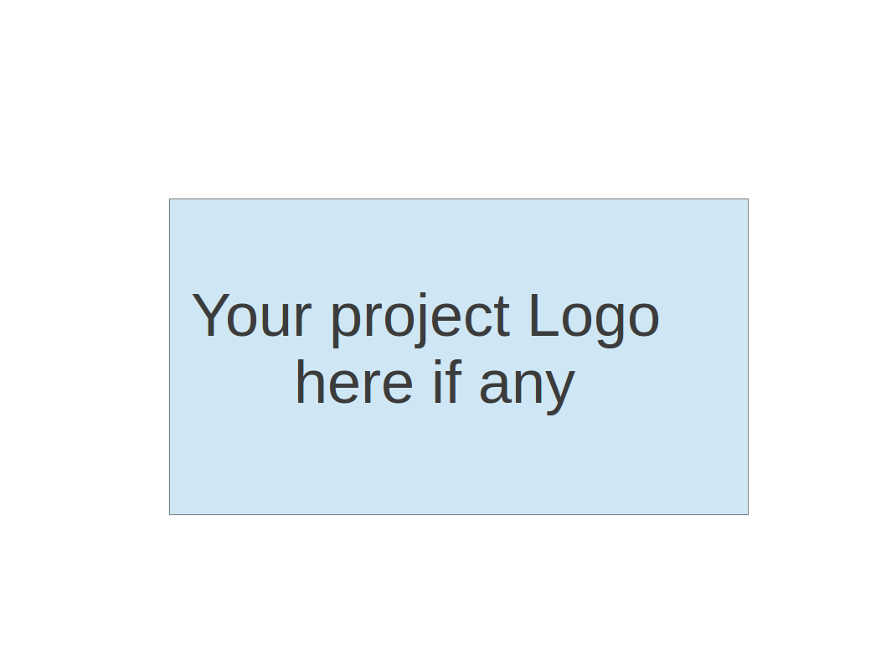
CS673 Software Engineering
Team 2 - Rental Ninja
Software Test Document

Team Member | Role(s) | Signature | Date
Yongjing Wu | Team Lead | Yongjing wu | 09/08/2024
Jiacheng Ding | Security Lead | Jiacheng Ding | 09/08/2024
Yueyang He | Design and Implementation Lead | Yueyang He | 09/08/2024
Xueqi Zhou | Requirement Lead | Xueqi Zhou | 09/09/2024
Rundong Zhong | Configuration Lead | Rundong Zhong | 09/08/2024
Xiang Zhang | QA Lead | Xiang Zhang | 09/09/2024

Revision history
Version | Author | Date | Change

Testing Summary
Manuel Tests Reports
Automated Testing Reports
Testing Metrics
References
Glossary

Testing Summary
Jiacheng Ding and Xiang Zhang are the primary contributors responsible for completing the testing tasks. Their focus includes Unit Testing, Integration Testing, System Testing, Acceptance Testing, and Regression Testing, ensuring that all components of the project are thoroughly tested and meet the quality standards required.

Manual Testing Report
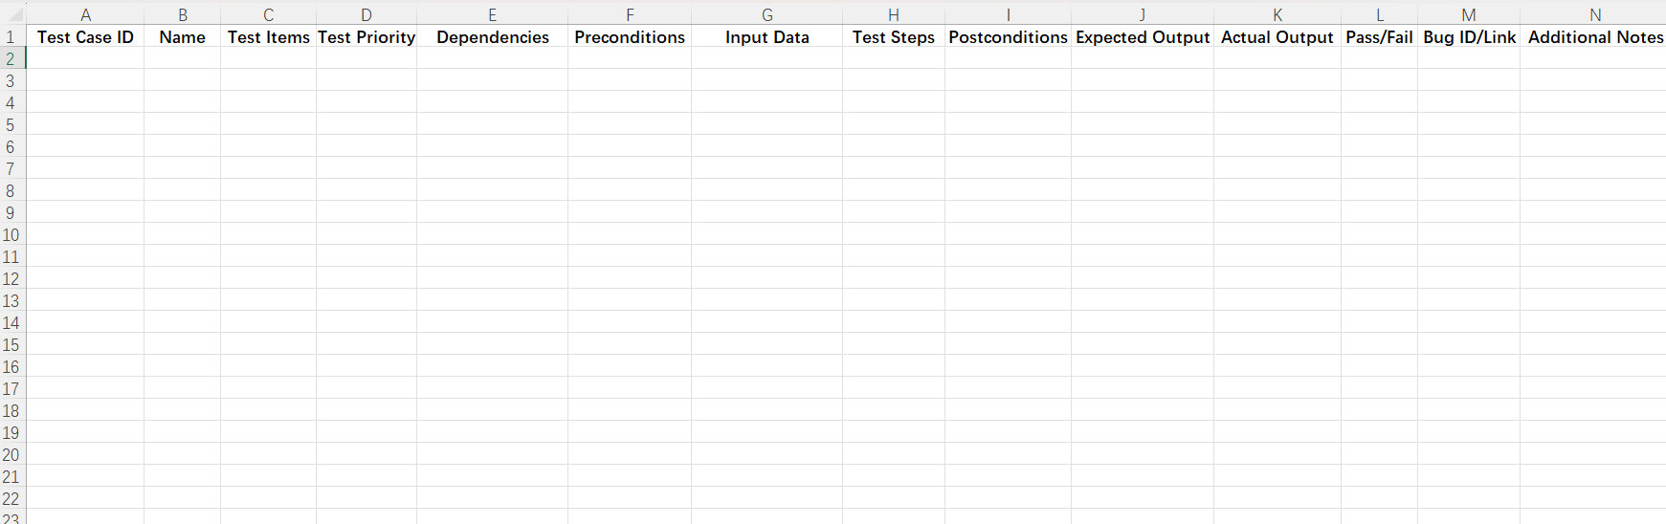

Automated Testing Report
Unit Tests: JUnit for backend tests and Jest for frontend components.
Integration Tests: Postman for API testing.
E2E Tests: Cypress for testing the complete user flow.

Testing Metrics
Number of test cases: 20 test cases
Test coverage: 85% code coverage
Defect rate: 5%
Resolution rate: 100% of identified defects were resolved.

References

Glossary

