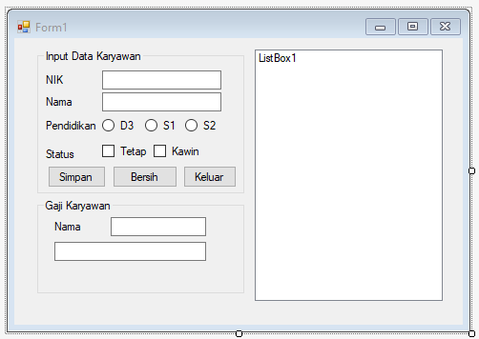

Public Class Karyawan

Private _nik As String

Private _nama As String

Private _pendidikan As Integer

Private _status() As Boolean

Public Sub New(ByVal nik As String, ByVal nama As String,

ByVal pendidikan As Integer,

ByVal status() As Boolean)

_nik = nik

_nama = nama

_pendidikan = pendidikan

_status = status

End Sub

Public Function getNama() As String

Return _nama

End Function

Public Function getStatus(ByVal idx As Integer) As String

Return _status(idx)

End Function

Public Function getGajipokok() As Double

'ini adalah switch case

Select Case _pendidikan

Case 0 : Return 1500000

Case 1 : Return 2000000

Case 2 : Return 3500000

Case Else : Return 0

End Select

End Function

Public Function getPegawai() As String

Select Case _pendidikan

Case 0 : Return "Diploma"

Case 1 : Return "S1"

Case 2 : Return "Magister"

Case Else : Return 0

End Select

End Function

Public Function getTunjangan() As Double

Dim tunjangan As Double = 0

If (_status(0)) Then

tunjangan += 0.1 * getGajipokok()

End If

If (_status(1)) Then

tunjangan += 0.25 * getGajipokok()

End If

Return tunjangan

End Function

End Class

Public Class Form1

Private karyawan(20) As Karyawan

Private idx As Integer = 0

Private rdb(3) As RadioButton

Private Sub WriteToTextFile(ByRef file As String)

Dim Writer As New IO.StreamWriter(file)

For i As Integer = 0 To ListBox1.Items.Count - 1

Writer.WriteLine(ListBox1.Items.Item(i))

Next

Writer.Close()

End Sub

Private Sub bsimpan_Click(ByVal sender As Object, e As EventArgs) Handles bsimpan.Click

Dim status(2) As Boolean

Dim pendidikan As Integer = -1

rdb(0) = rdbD3

rdb(1) = rdbS1

rdb(2) = rdbS2

For i As Integer = 0 To 2

If (rdb(i).Checked) Then

pendidikan = i

End If

Next

status(0) = ckawin.Checked

status(1) = ctetap.Checked

karyawan(idx) = New Karyawan(tNik.Text, tNama.Text, pendidikan, status)

ListBox1.Items.Add(tNik.Text & "_" & tNama.Text & "_" & karyawan(idx).getPegawai)

idx += 1

WriteToTextFile("latihanuts.txt")

End Sub

Private Sub bbersih_Click(ByVal sender As Object, e As EventArgs) Handles bbersih.Click

tNama.Text = ""

tNik.Text = ""

tNama1.Text = ""

tGaji.Text = ""

rdbD3.Checked = False

rdbS1.Checked = False

rdbS2.Checked = False

ckawin.Checked = False

ctetap.Checked = False

End Sub

Private Sub Button1_Click(sender As Object, e As EventArgs) Handles Button1.Click

Me.Close()

End Sub

Private Sub ListBox1_SelectedIndexChanged(sender As Object, e As EventArgs) Handles ListBox1.SelectedIndexChanged

tNama1.Text = karyawan(ListBox1.SelectedIndex).getNama

tGaji.Text = "Rp " &

karyawan(ListBox1.SelectedIndex).getGajipokok +

karyawan(ListBox1.SelectedIndex).getTunjangan

End Sub

End Class