**CS5694 Advanced Compiler Design**

**Language Definition:**

**L = { w ∈ {a, b} | count(a) mod 3 = 0 and count(b) is odd }**

The regular language consists of strings over the alphabet {a, b} where:

* The number of 'a' characters is divisible by 3.
* The number of 'b' characters is odd.

**RegEx:** ^(aaa)*(b(aaa)*(b(aaa)*)*)$

**Example Accepted Strings:**

* abb → 1 'a' (not divisible by 3) and 2 'b's (not odd) → Rejected
* aaabb → 3 'a's (divisible by 3) and 2 'b's (not odd) → Rejected
* aaabbb → 3 'a's (divisible by 3) and 3 'b's (odd) → Accepted
* aaa → 3 'a's (divisible by 3) and 0 'b's (not odd) → Rejected
* aaab → Accepted

**Finite Automaton Diagram:**

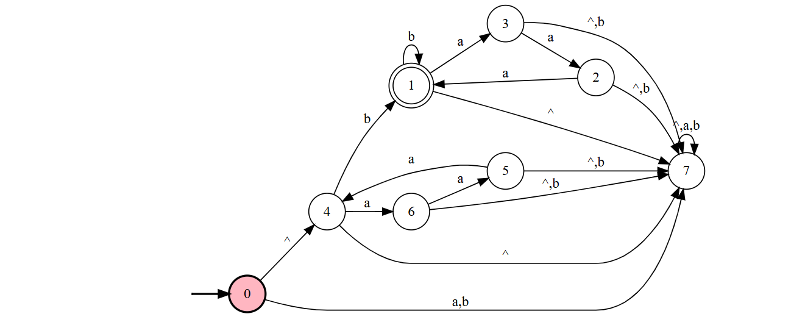

**Coded Implementation:**

#include <stdio.h>

#include <string.h>

enum State { Q0, Q1, Q2, Q3, Q4, Q5 };

// Function to simulate finite automaton

int simulateFA(char *input) {

    enum State currentState = Q0; // Start state

    for (int i = 0; i < strlen(input); i++) {

        char c = input[i];

        switch (currentState) {

            case Q0:

                if (c == 'a') currentState = Q1;

                else if (c == 'b') currentState = Q3;

                break;

            case Q1:

                if (c == 'a') currentState = Q2;

                else if (c == 'b') currentState = Q4;

                break;

            case Q2:

                if (c == 'a') currentState = Q0;

                else if (c == 'b') currentState = Q5;

                break;

            case Q3:

                if (c == 'a') currentState = Q4;

                else if (c == 'b') currentState = Q0;

                break;

            case Q4:

                if (c == 'a') currentState = Q5;

                else if (c == 'b') currentState = Q1;

                break;

            case Q5:

                if (c == 'a') currentState = Q3;

                else if (c == 'b') currentState = Q2;

                break;

        }

    }

    // Accept if in state Q3 (a count % 3 == 0 and odd b count)

    return (currentState == Q3);

}

int main() {

    char input[100];

    printf("Enter a string over {a, b}: ");

    scanf("%s", input);

    if (simulateFA(input)) {

        printf("String '%s' is ACCEPTED.\n", input);

    } else {

        printf("String '%s' is REJECTED.\n", input);

    }

    return 0;

}

**Sample Outputs:**

1. **aaabbb:**



1. **abb:**



1. **aaab:**



1. **aaa:**

