**Deploy a Prototype Webapp of a Bank Login Page Using Docker**

**Practice Project**

**Aim:**

To build an ASP.NET website consisting of two pages – a login page and a dashboard page and to deploy this to a Docker container running IIS.

**GitHub link:**

[**https://github.com/Sukirthalakshmanan1/Loginpage**](https://github.com/Sukirthalakshmanan1/Loginpage)

**Procedure:**

* Create an asp.net core web application.
* Select the framework and enable the docker and create the project.
* Create a model class and write the properties.
* Create a LoginController and write necessary properties
* Create views Login.cshtml and LoginSuccess.cshtml
* On successful login it redirects to Dashboard page.
* On clicking Log off it redirects to Login page.

**Docker commands:**

* docker build –t dockerid/loginpage:latest .
* docker run -p 9091:80 dockerhubid/projectname –p
* docker images

**Output:**

**Login Page:**

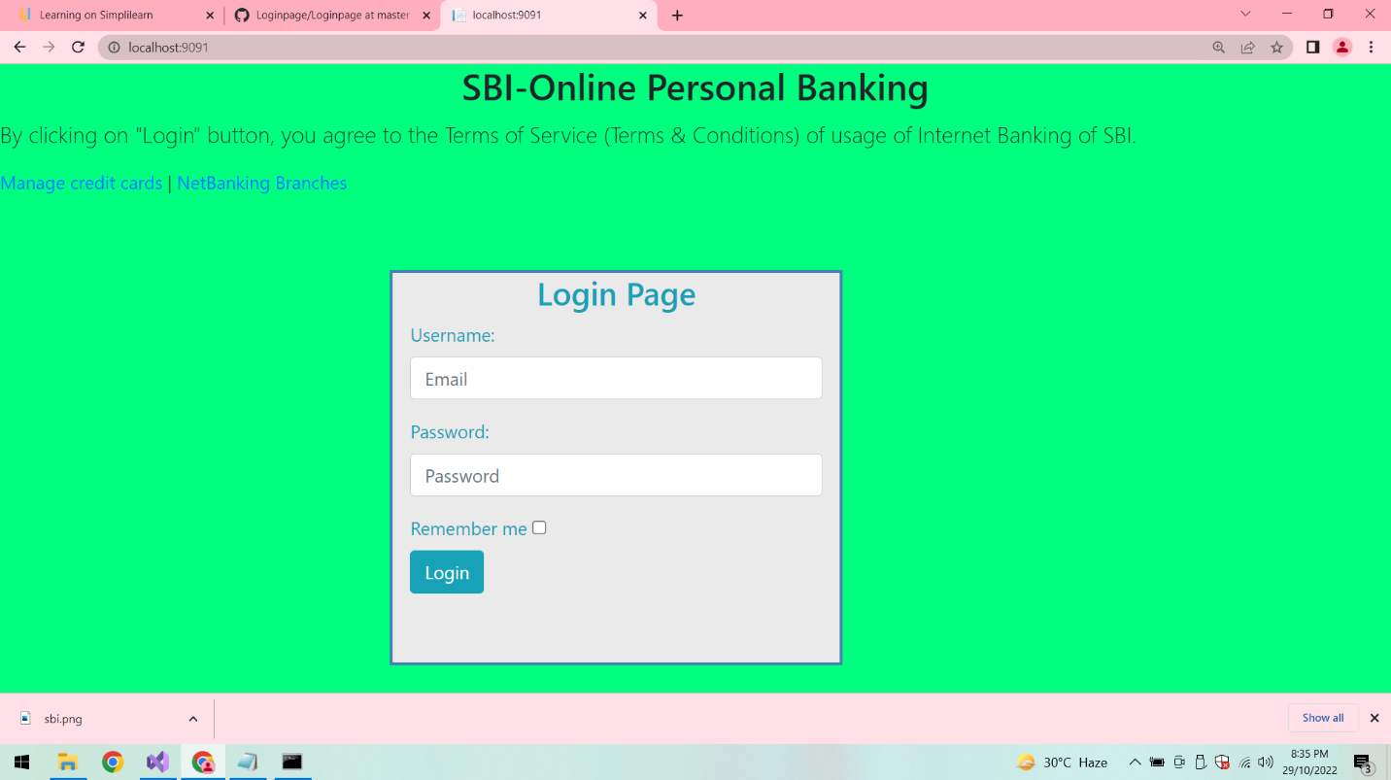

**On Successful Login:**

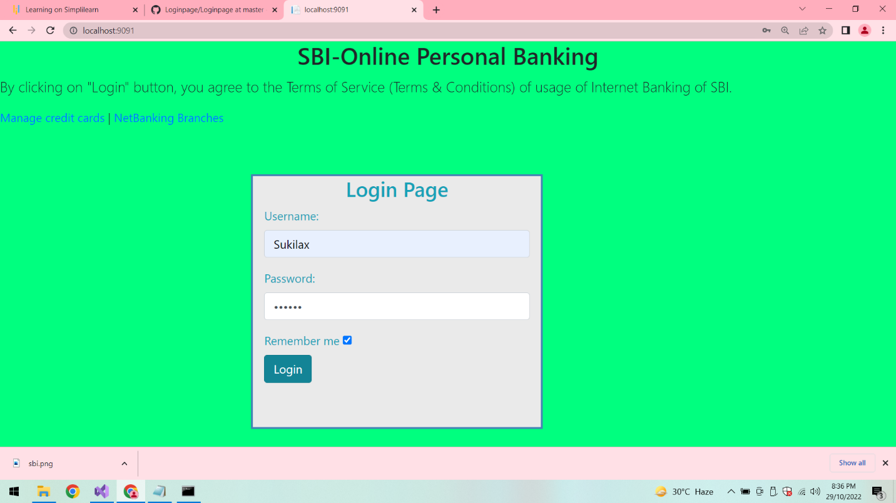

**Dashboard:**

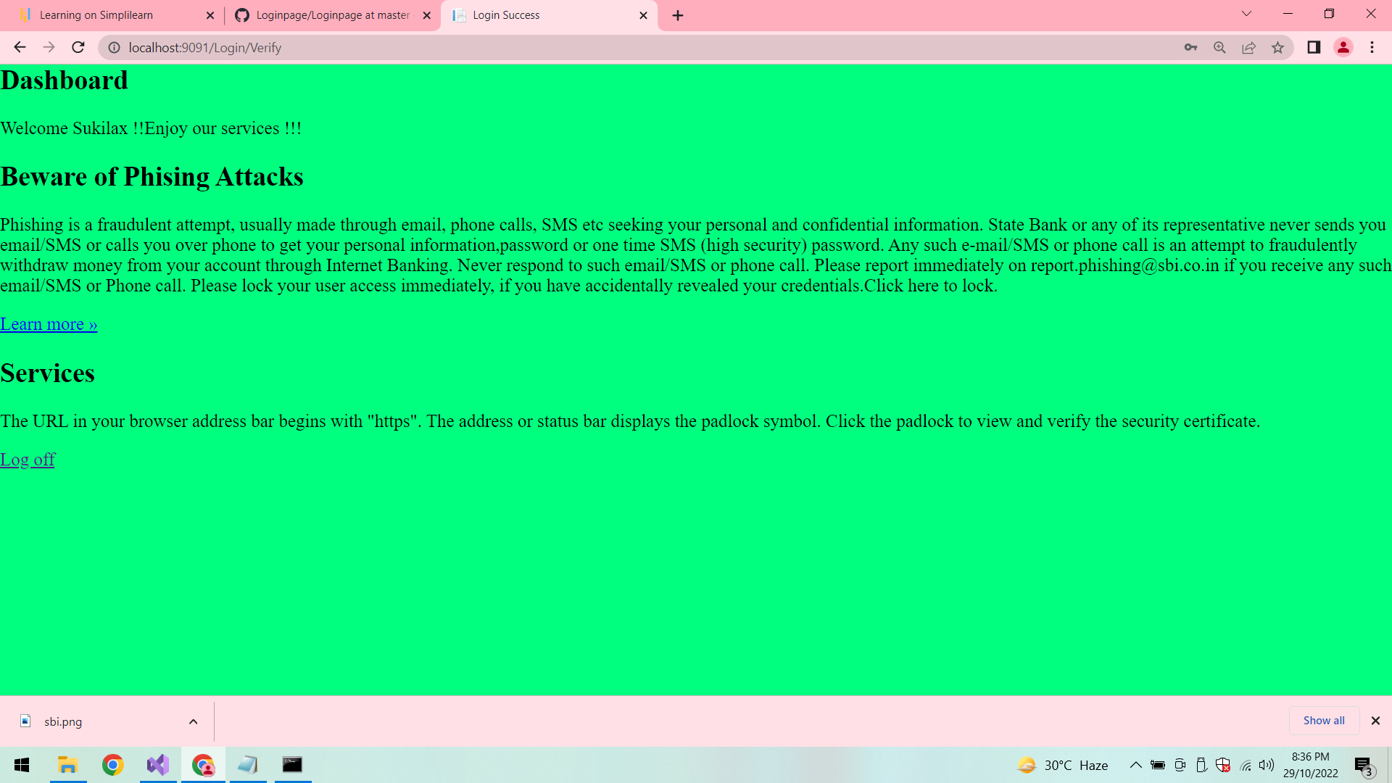

**Log Off:**

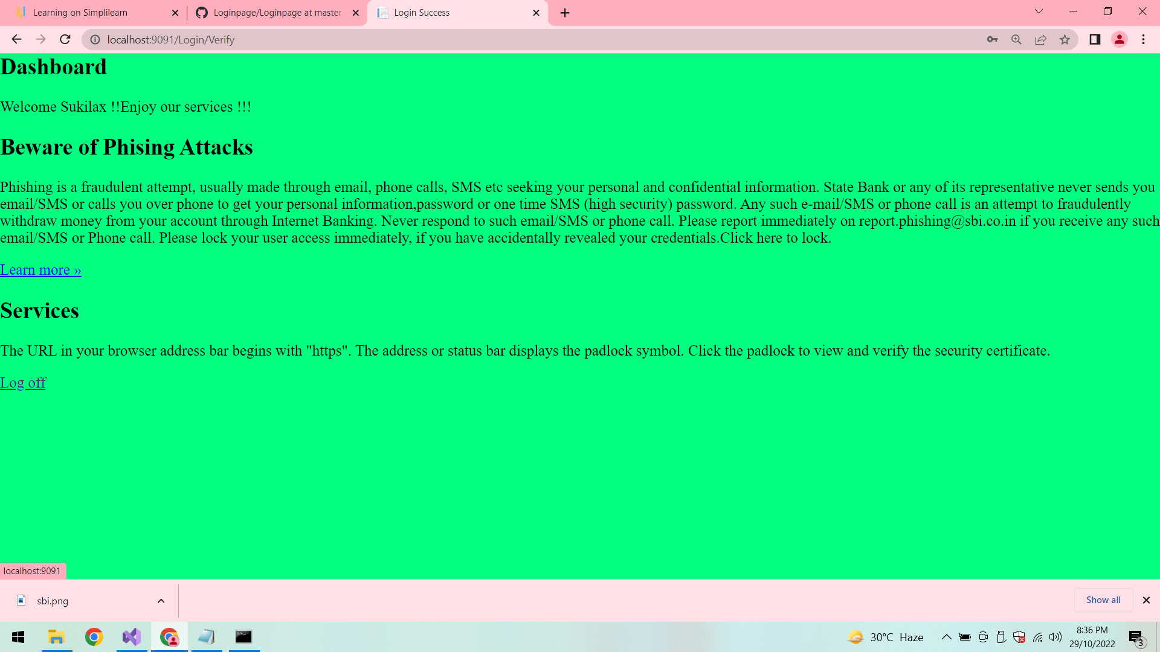

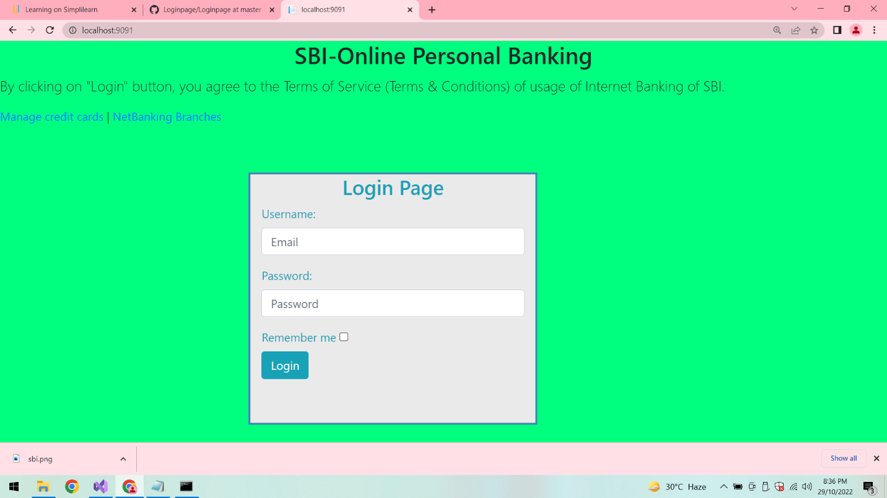

**Login validations:**

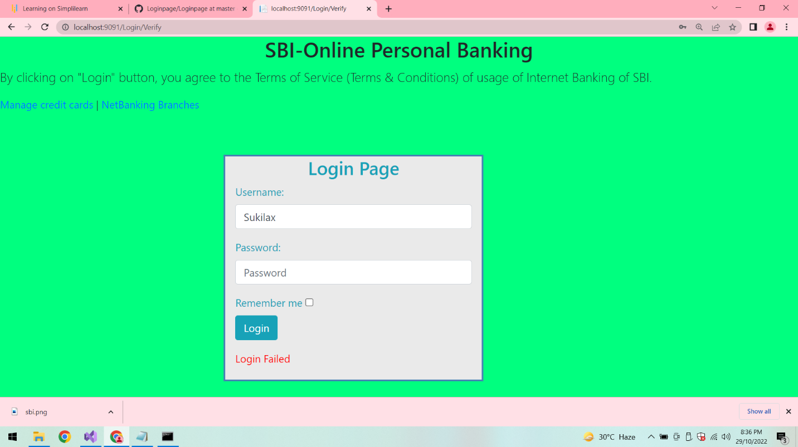

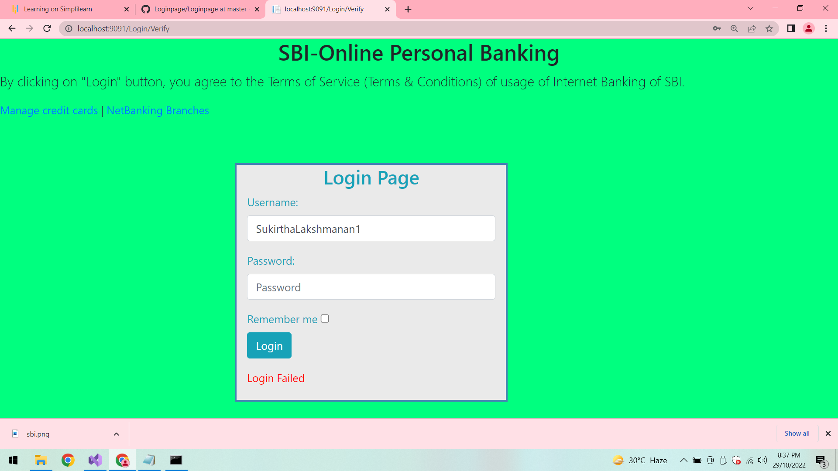

**Command Prompt:**

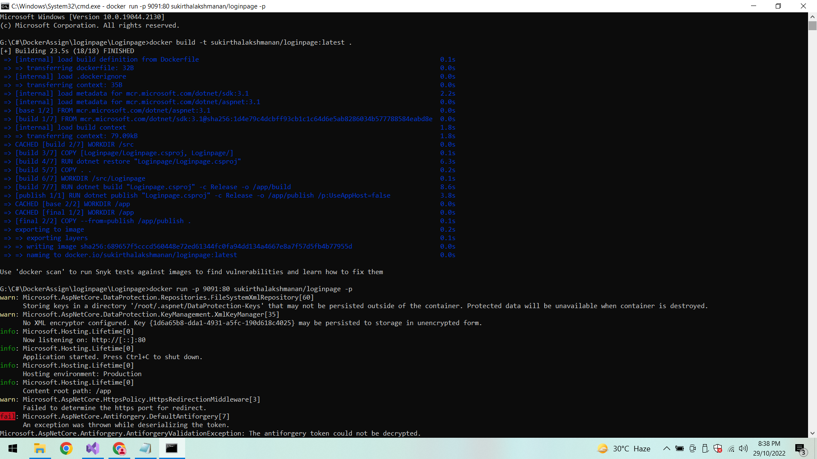

**Docker:**

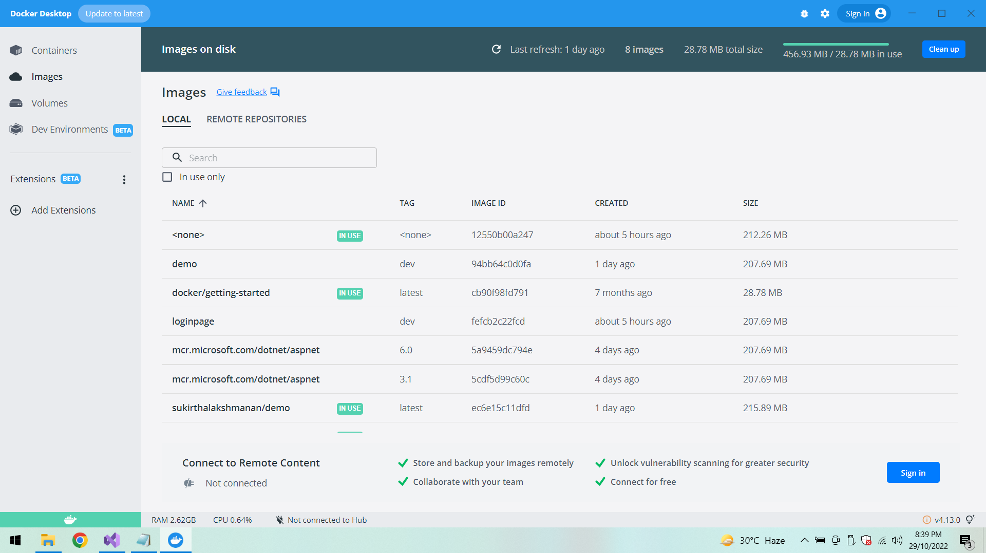

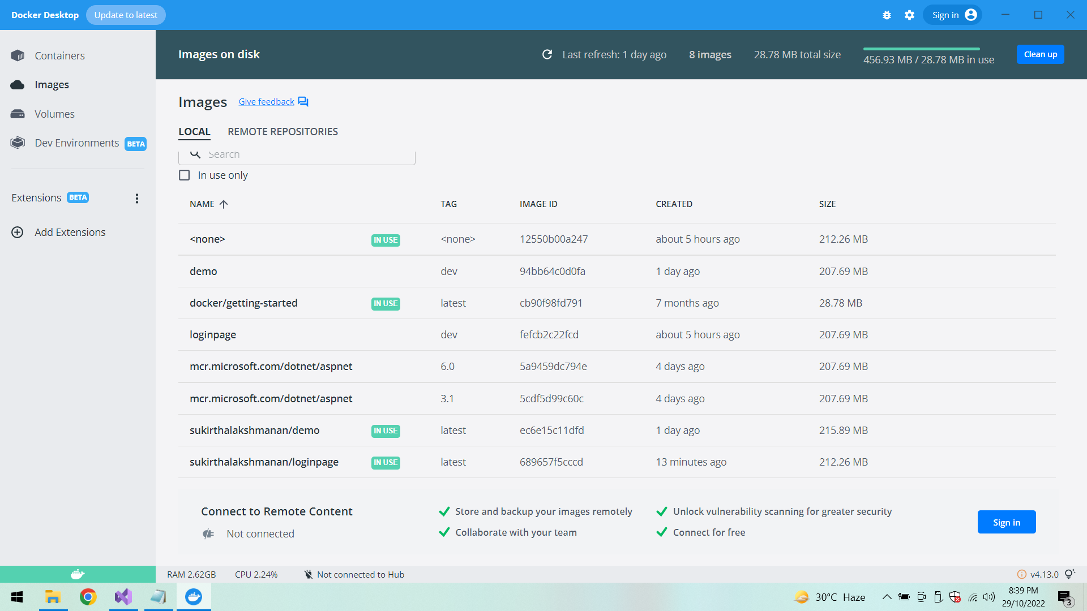

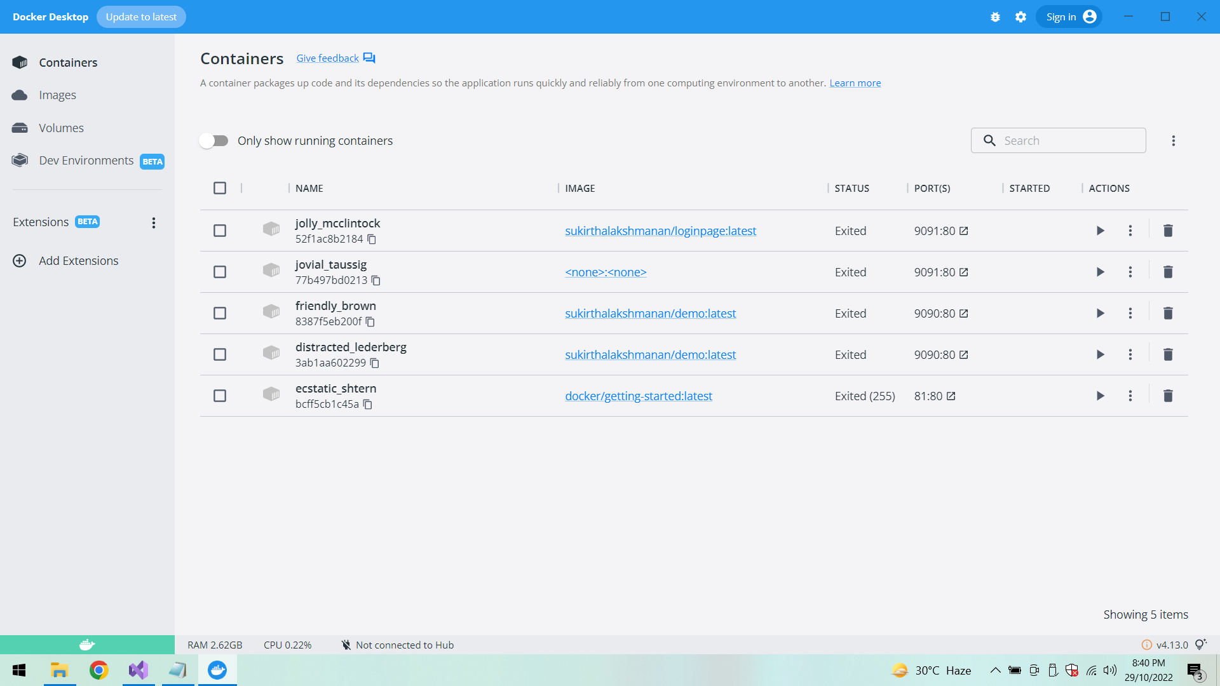

**In IIS:**

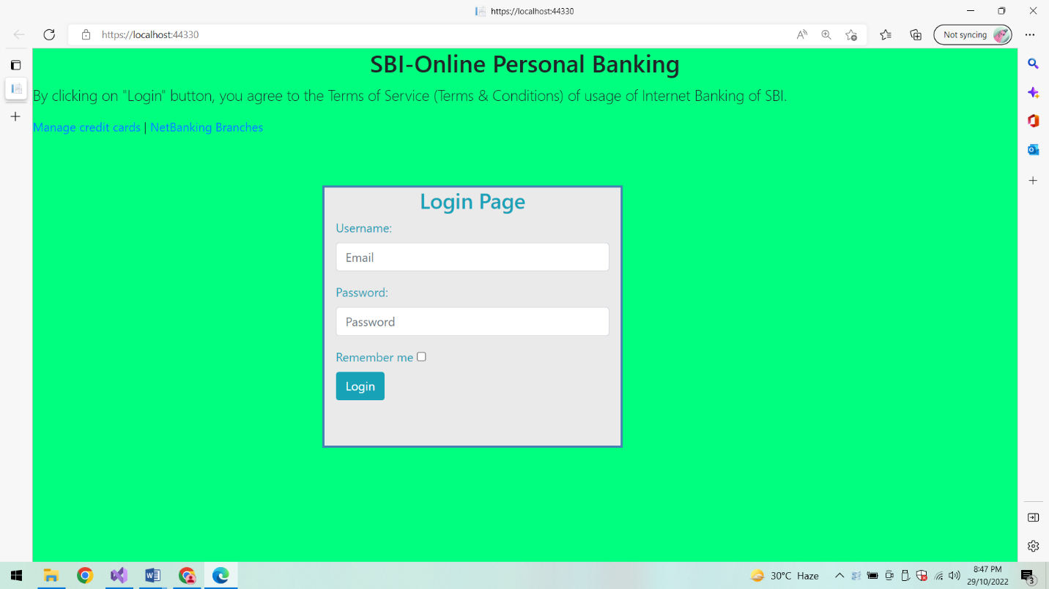

**Dashboard:**

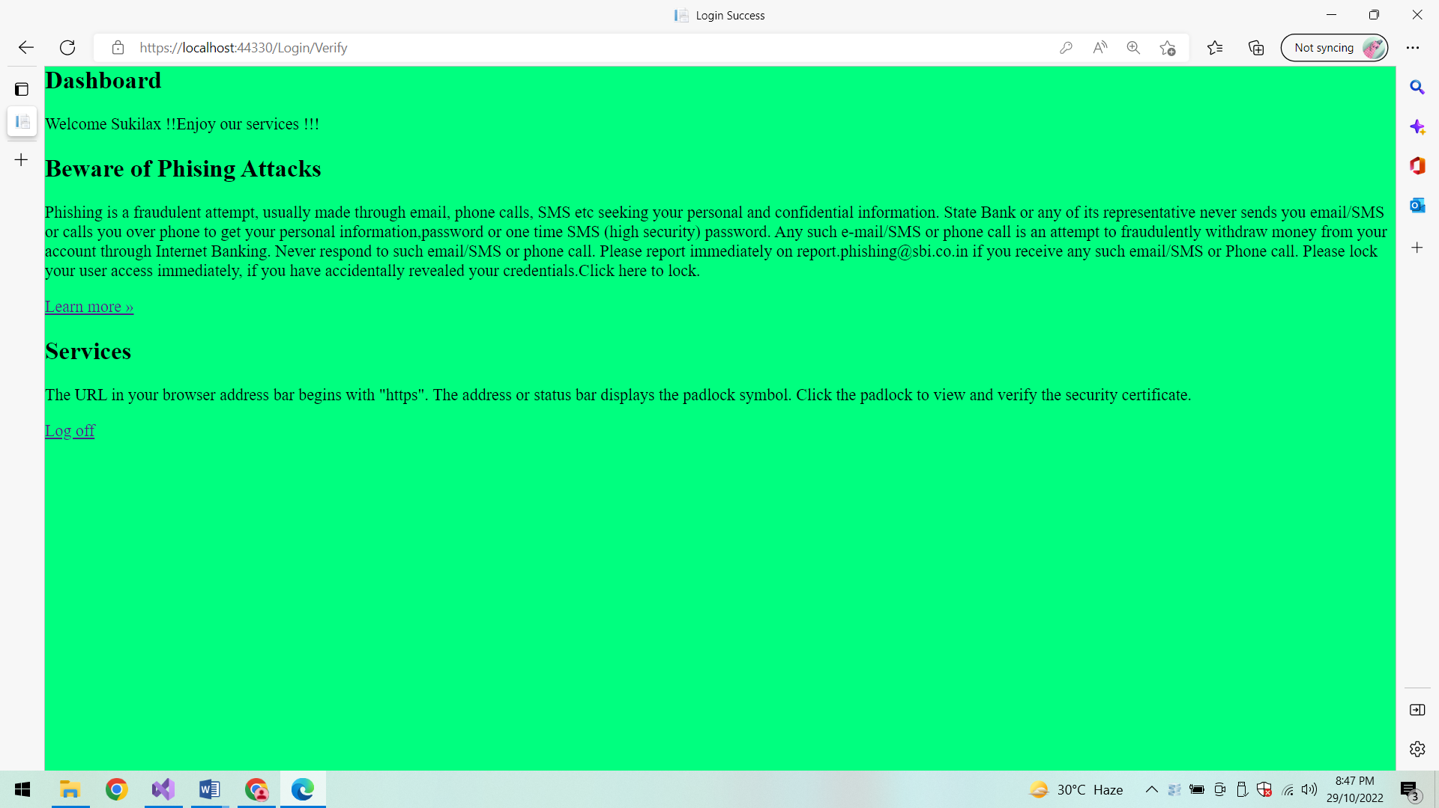

**Log Off:**

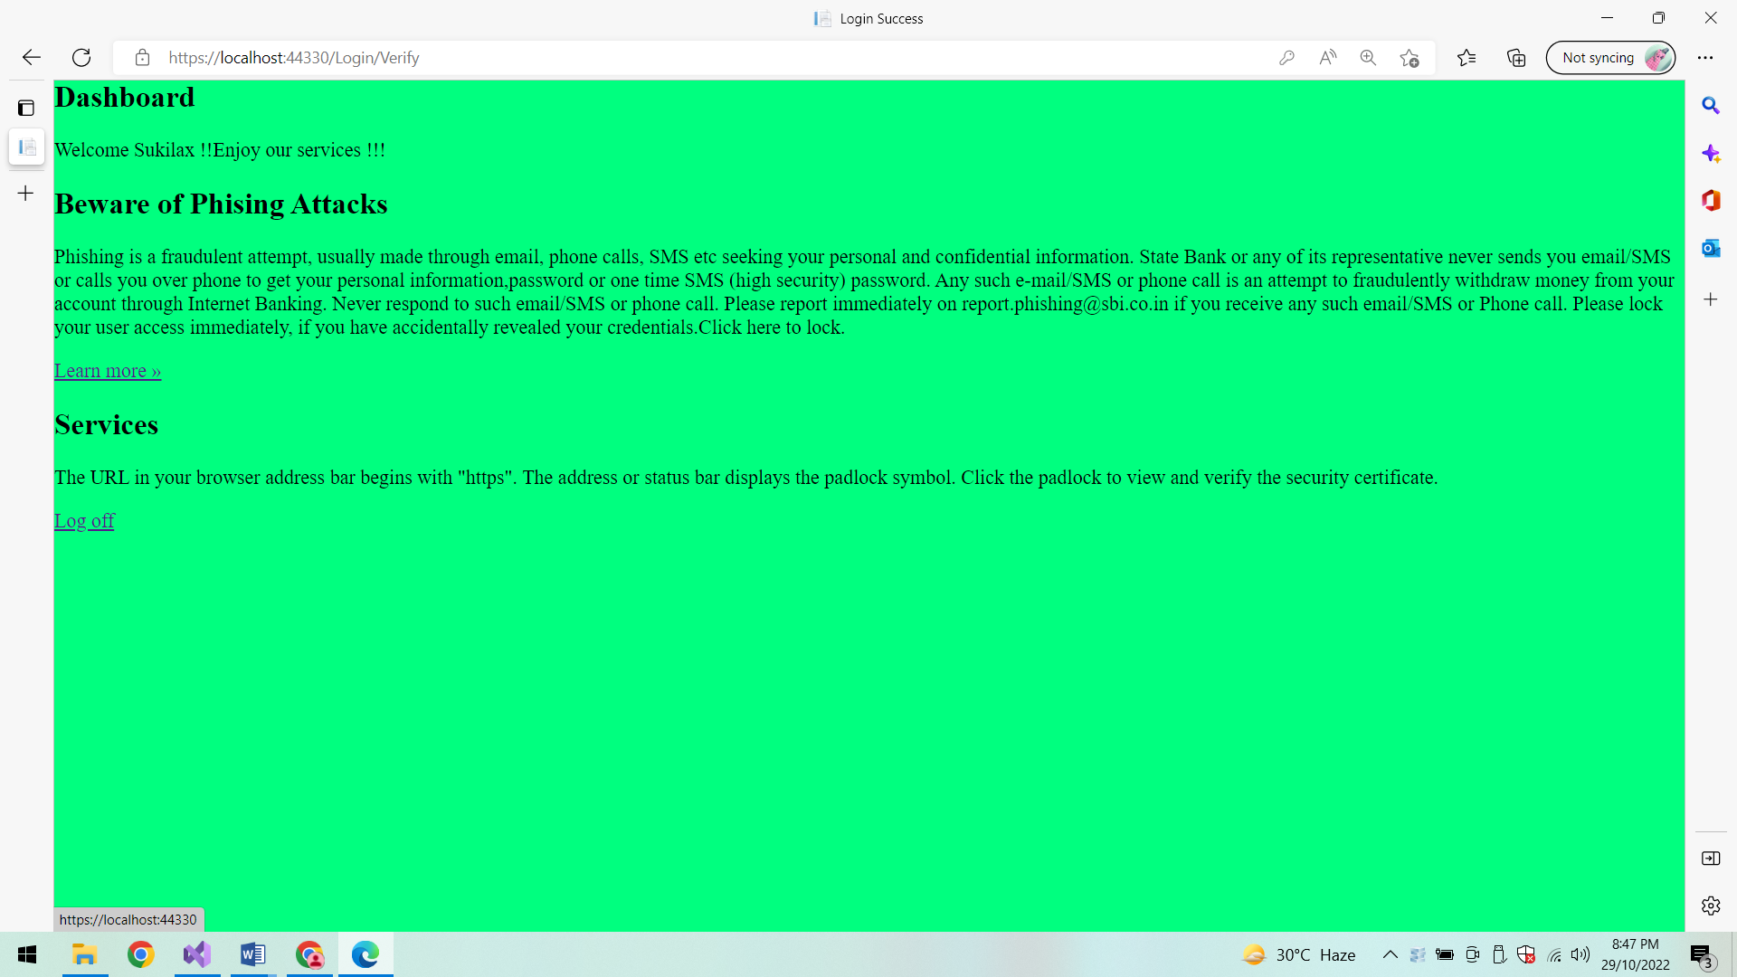

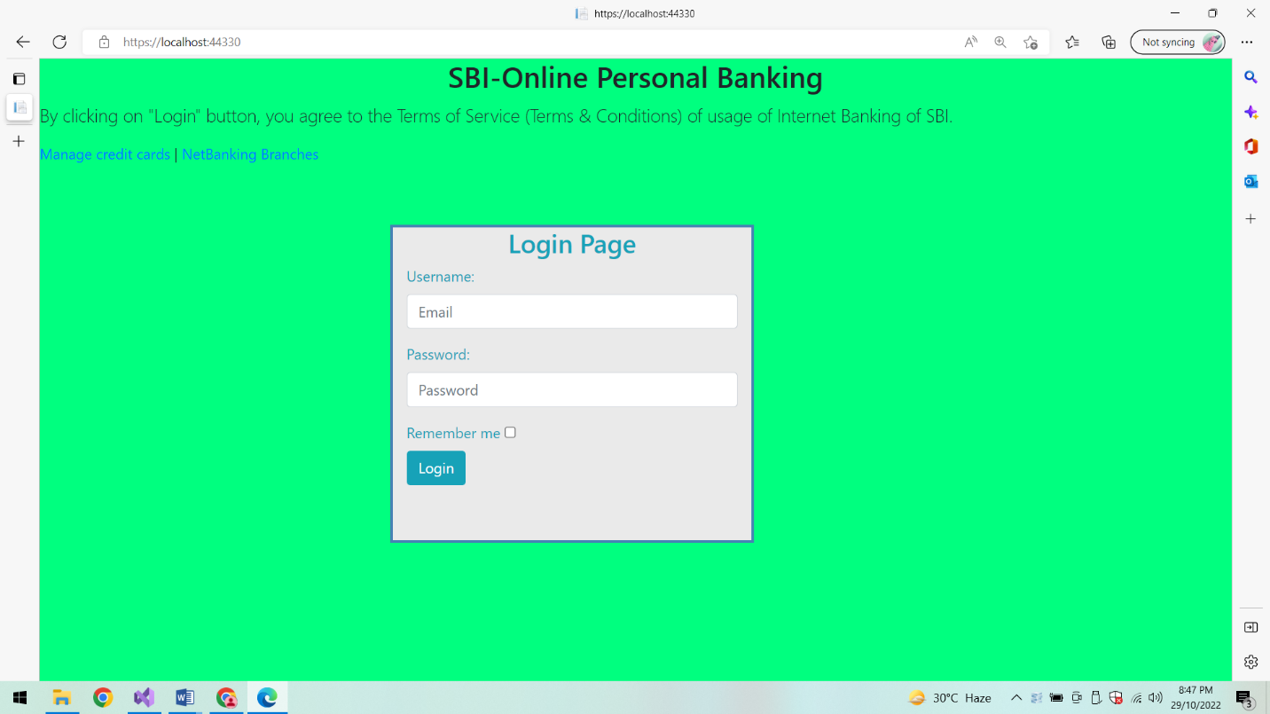

**Login Validations:**

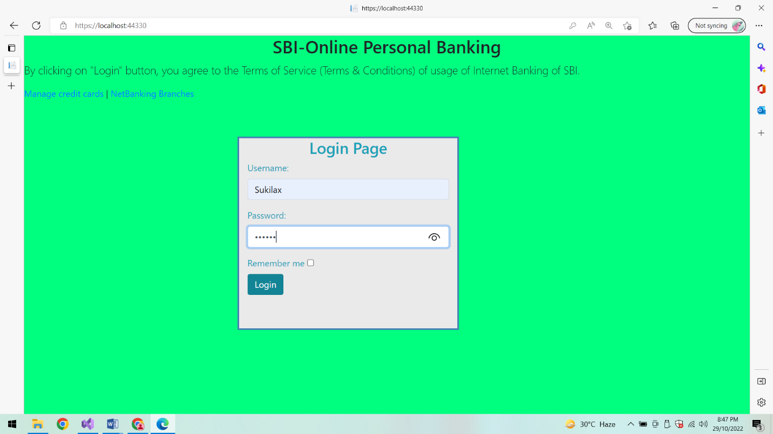

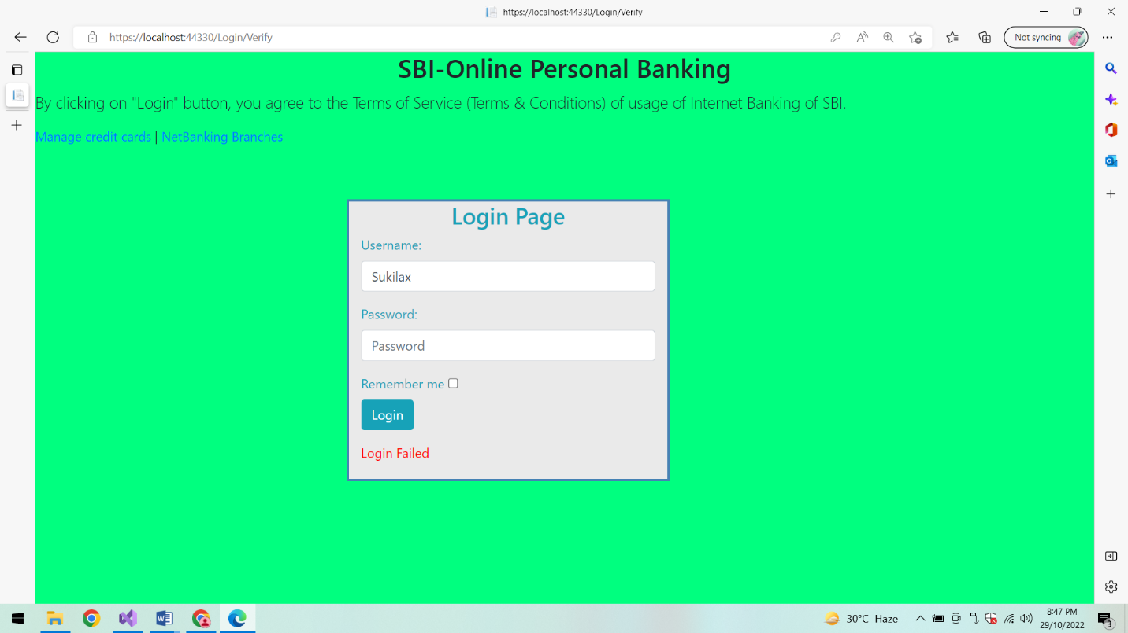

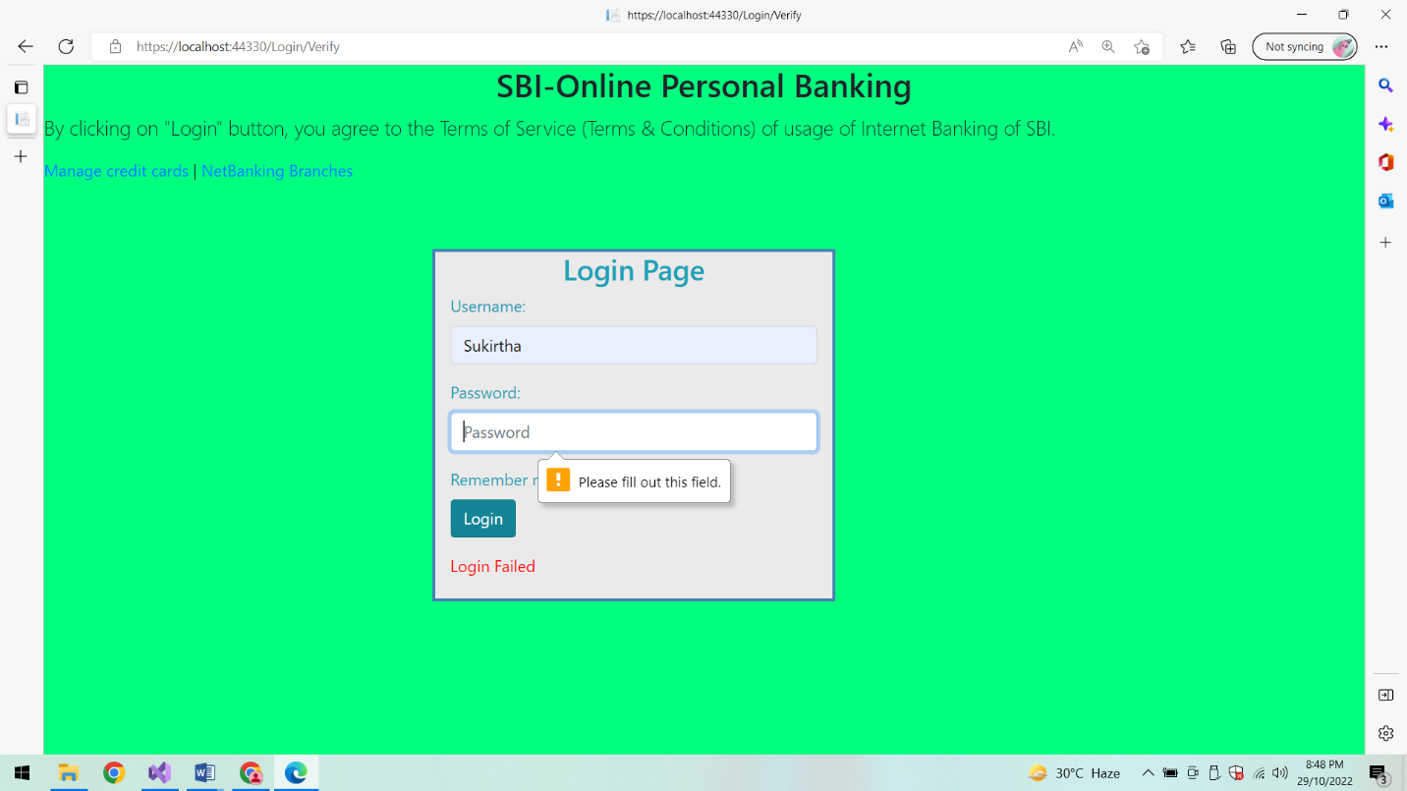

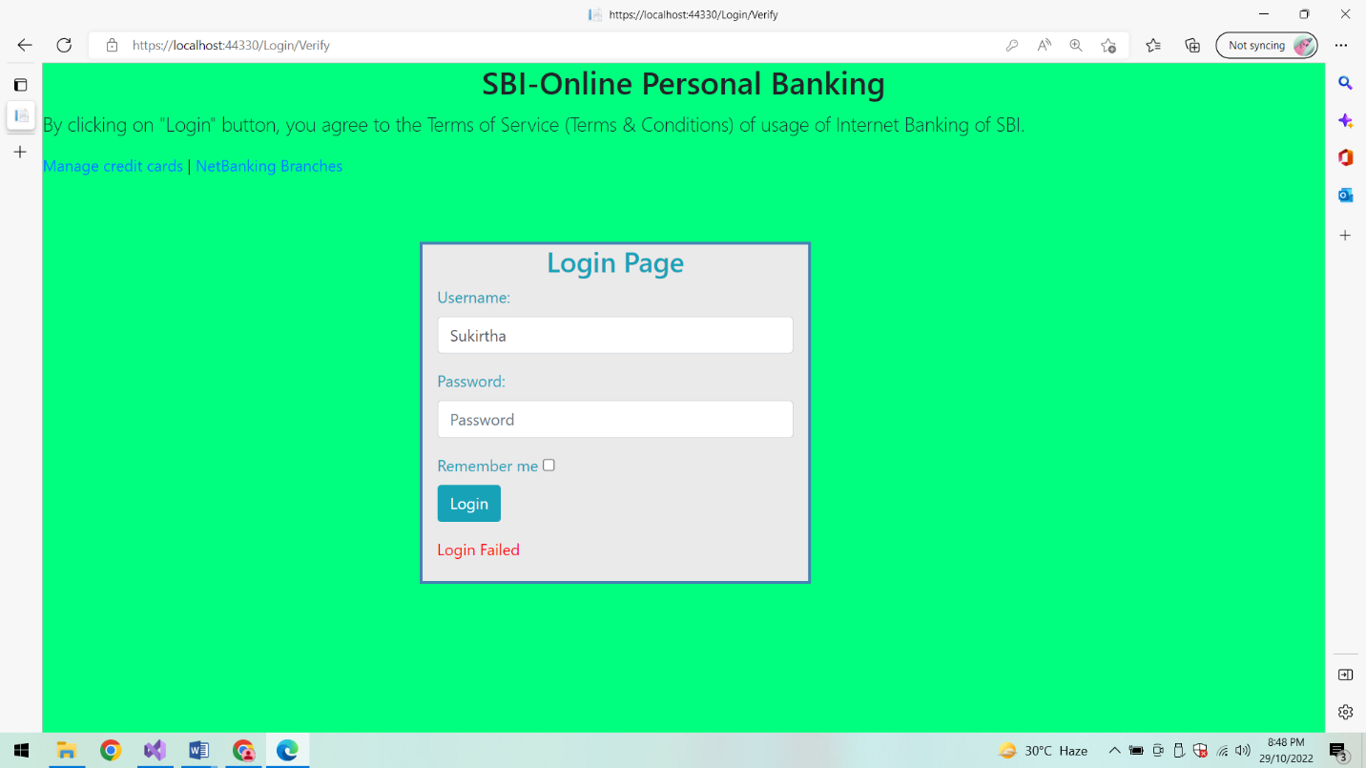

**Conclusion:**

Thus the WebApp of a Bank Login page using Docker is executed successfully.