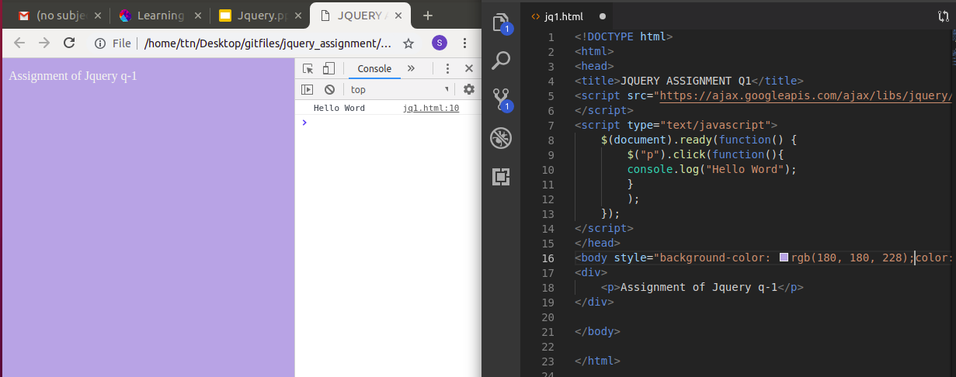
- Console "Hello Word" in document.ready function

2. Select a ID name "#test" and add class "load" when DOM is loaded
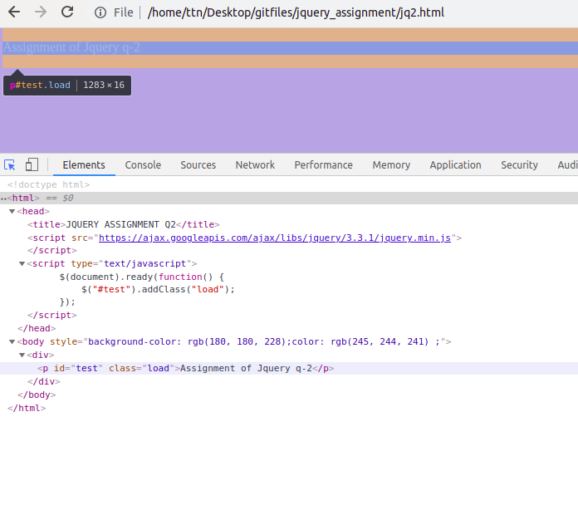
3. Change the color of element which class name end with "-new"
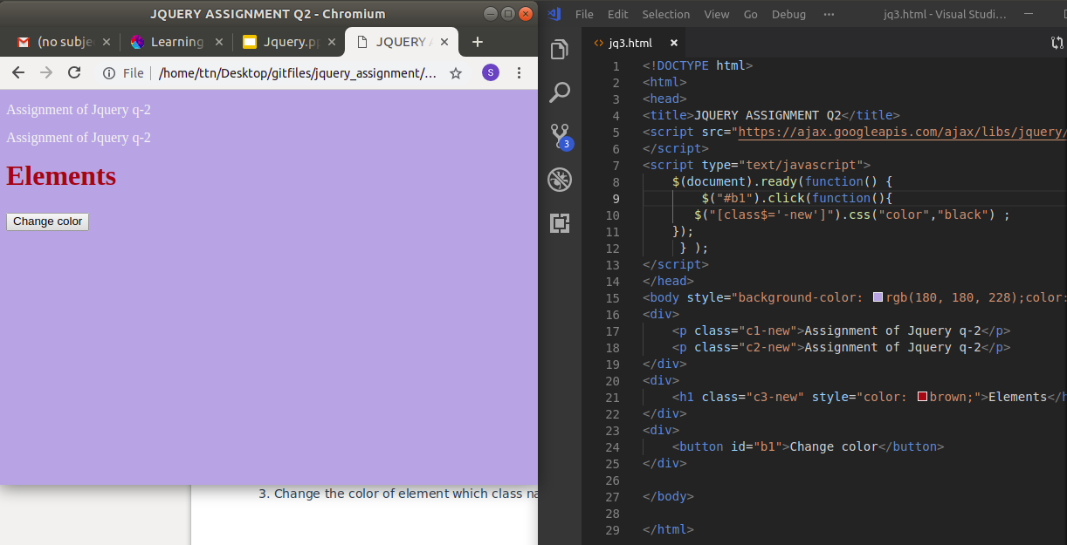
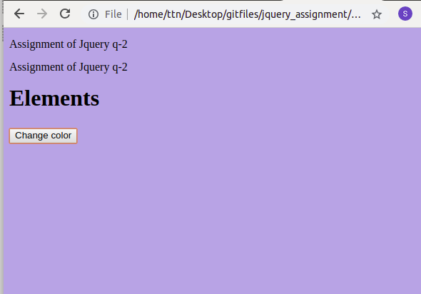

4. Disable submit button using jquery attr method

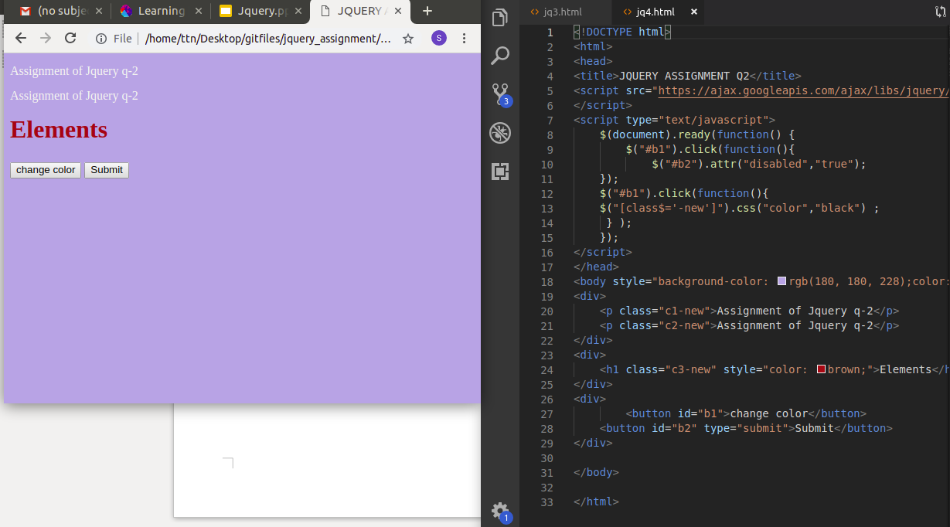
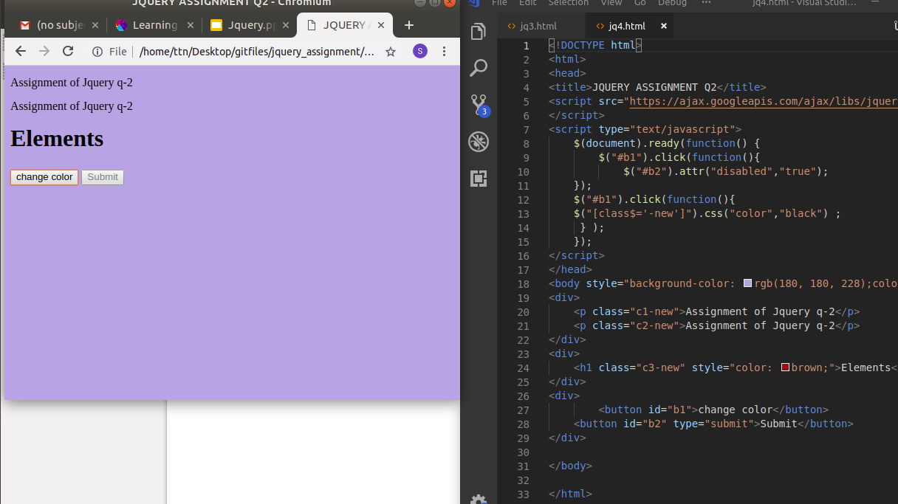

5. Change the font size of ".target" which has parent element with id name "#main"

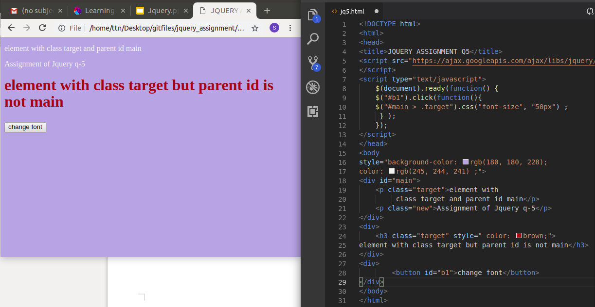
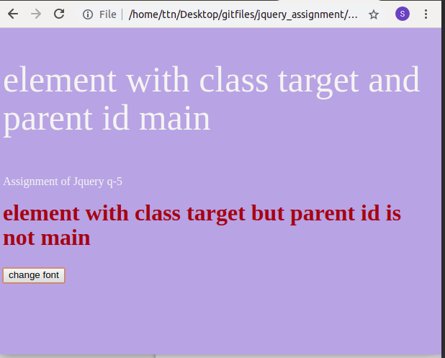

6. After page load change the HTML of div element with "p" element
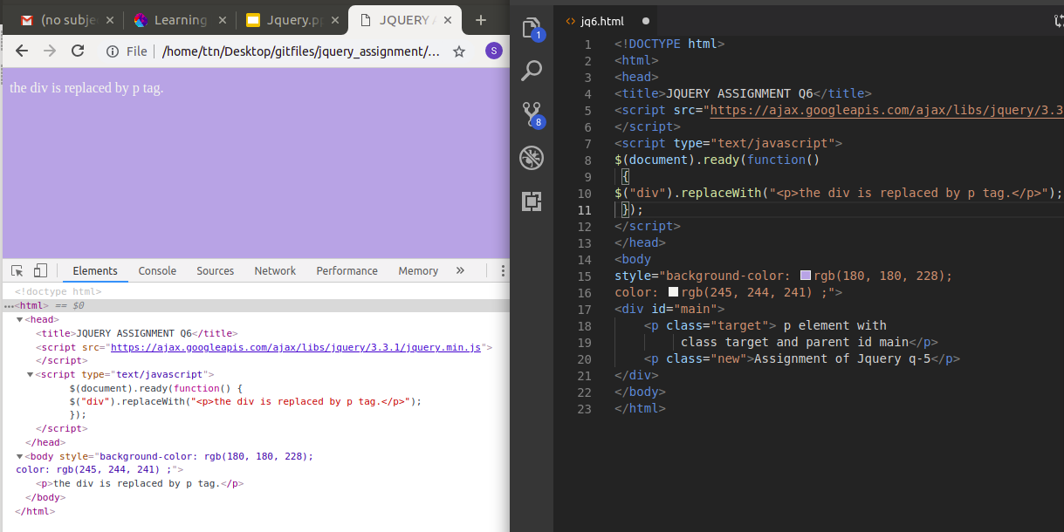

7. Bind a click function to an "click" element and append next "click" next to it.
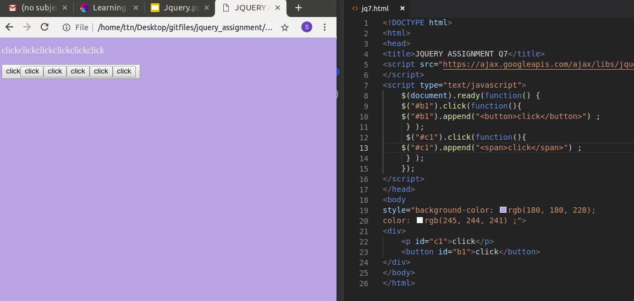

8. Click event not working on element which added dynamicly or via script, make it work using .on method
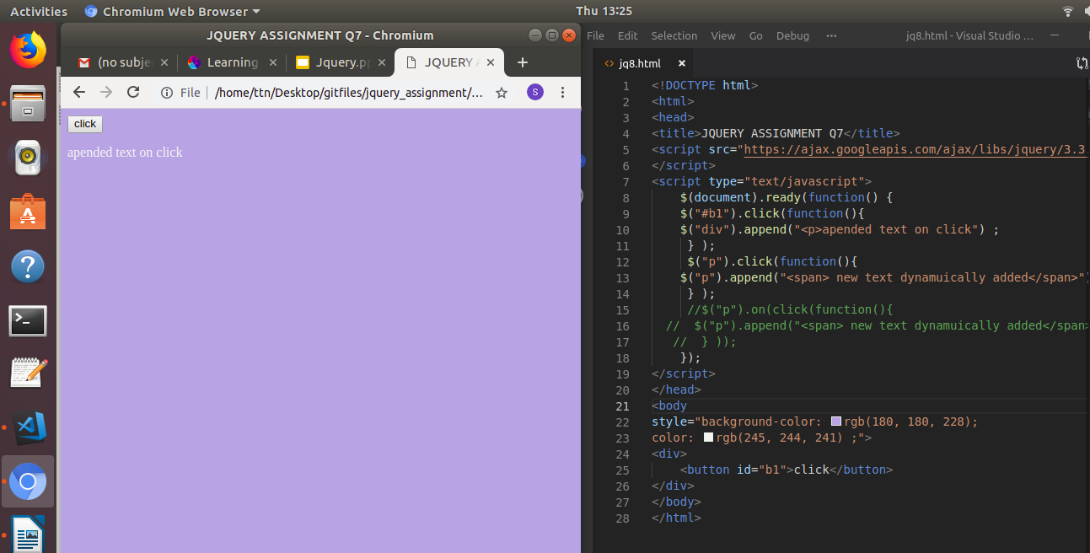
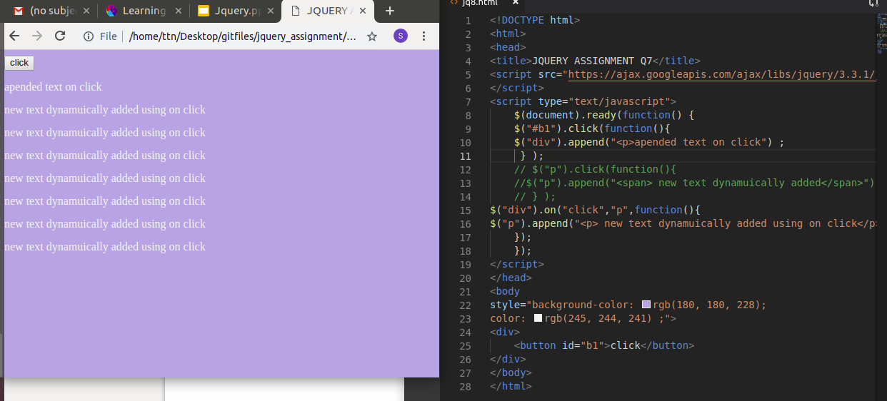

9. Get dropdown selected value on onchanage event and append in div container
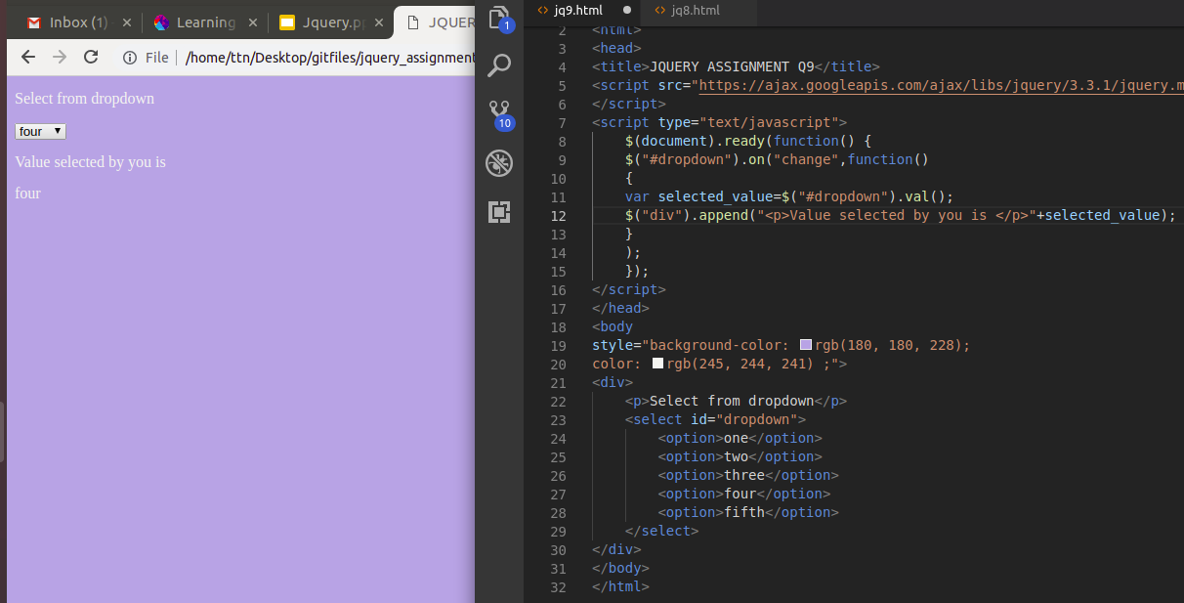
10. Create a dropdown menu using hover method in jquery
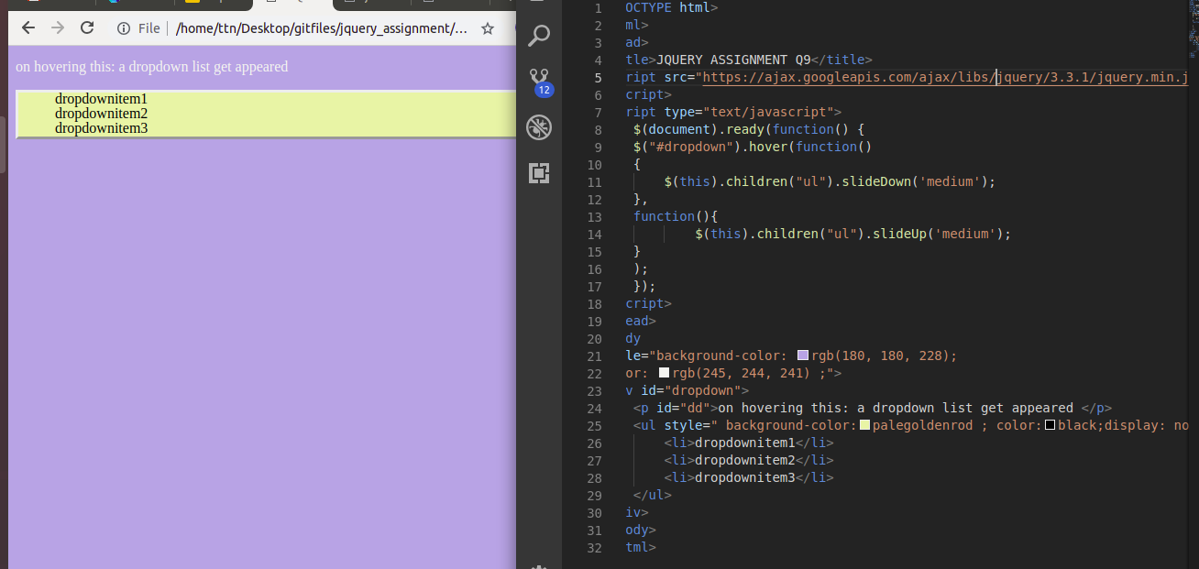

11. On clicking on "google" tag. It is taking us to google home page. Stop it from happening.
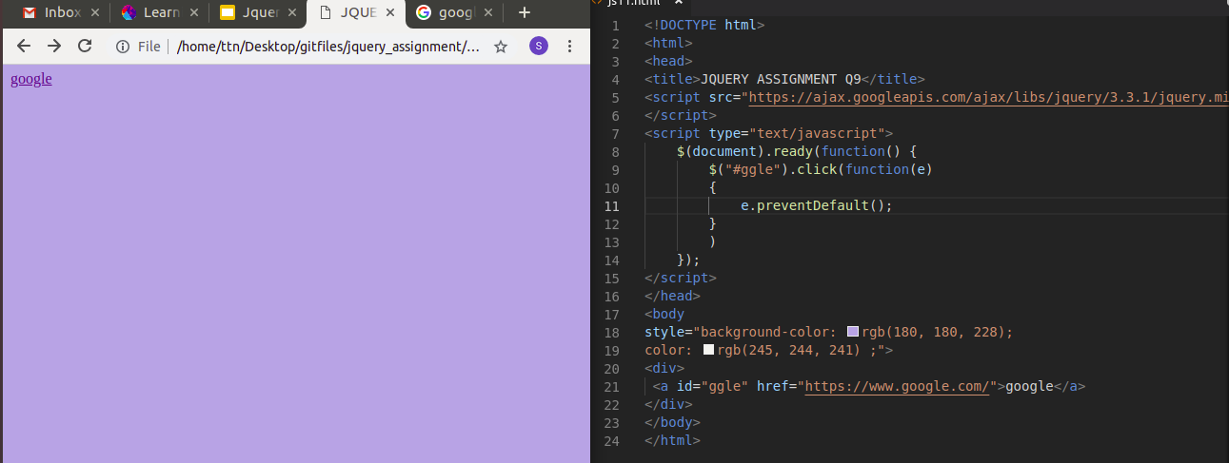
12. We have bind a click funtion to parent div but we want stop it from performing when user clicks on its child li
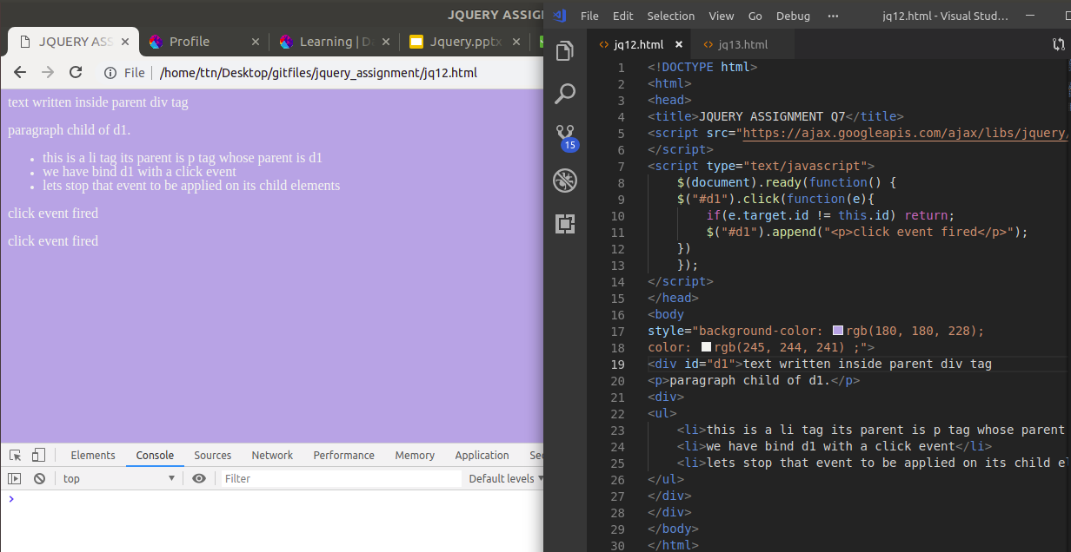

13. Get the max height of elements using jquery each method
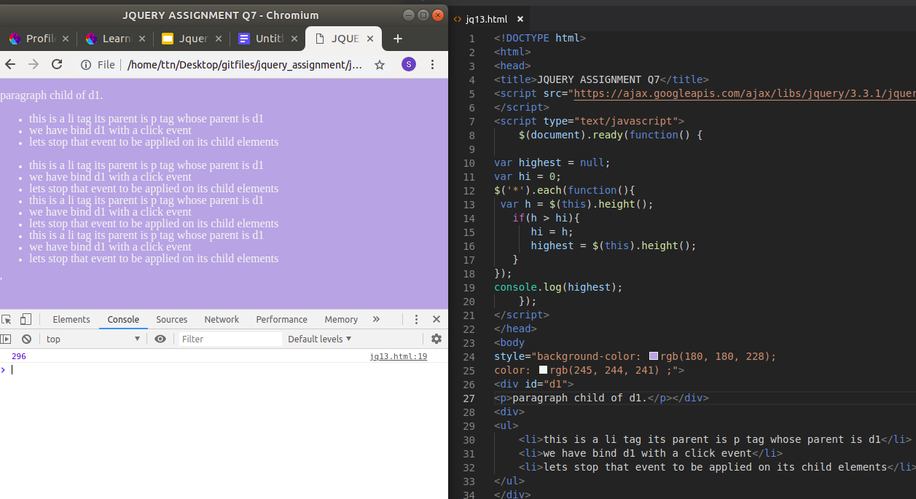

14. Chagne color of every cell which has numberl larger than 10.
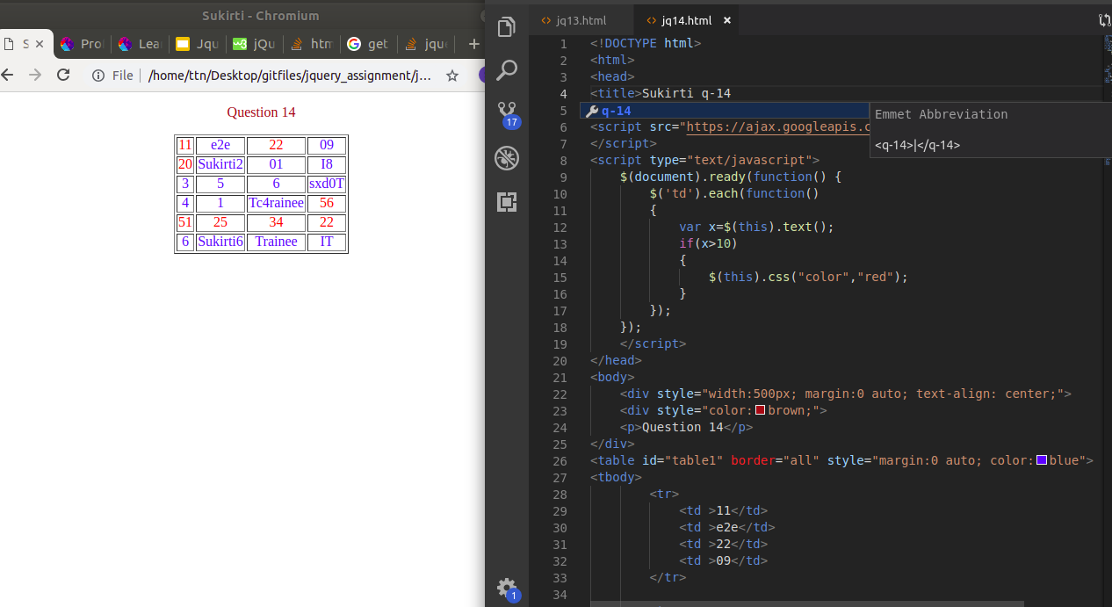

15. Retrive the data from server using ajax get call
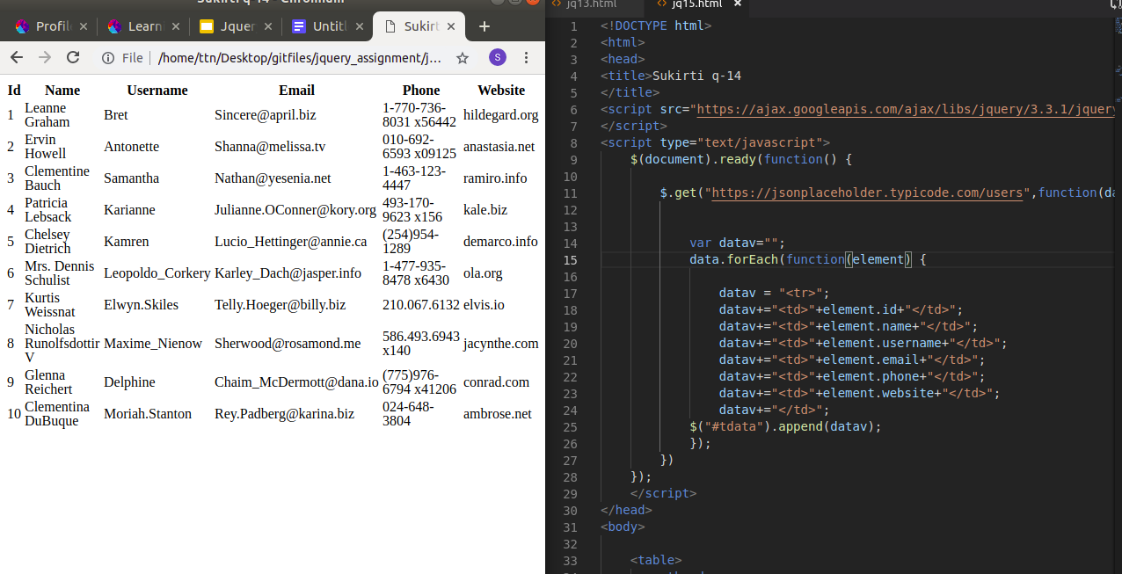
17. Create a image array and in div create a slide show to animate images of delay of 500ms.
