Problem Statement: There can be multiple customers, who can place multiple orders on the site. Now a sales person can handle these orders will distribute into multiple sales persons (One order will be assign to one salesperson only). So a sales person can have multiple orders of multiple customers
- Create Database
- Design Schema
- Create tables
- Insert sample data
- Find the sales person have multiple orders.
- Find the all sales person details along with order details
- Create index
- How to show index on a table
- Find the order number, sale person name, along with the customer to whom that order belongs to

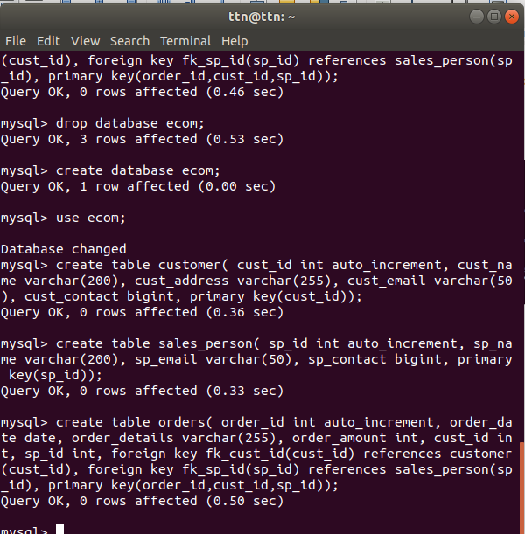

Insertion of sample data:
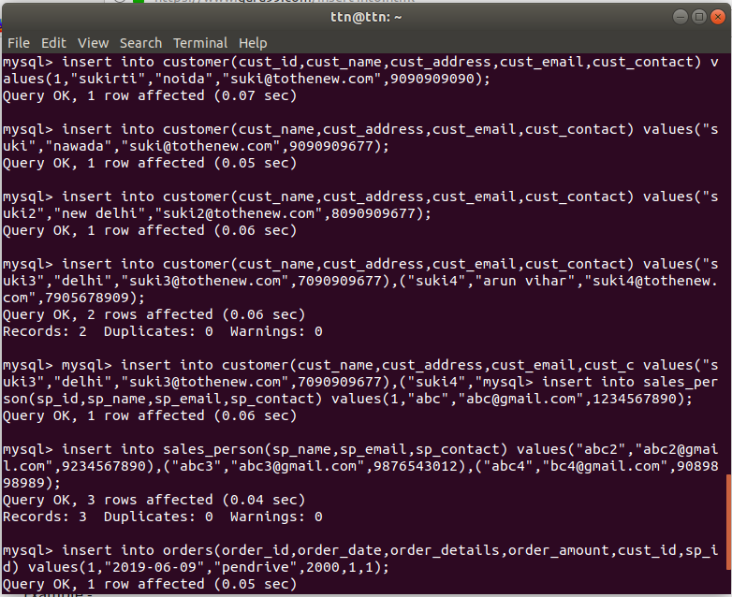
Find the sales person have multiple orders.
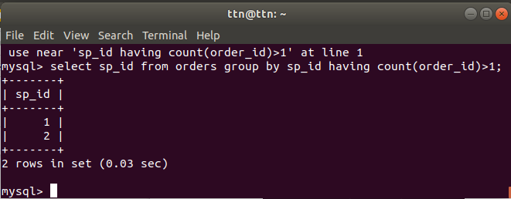
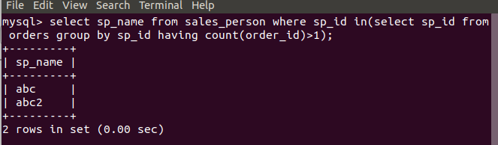

Find the all sales person details along with order details

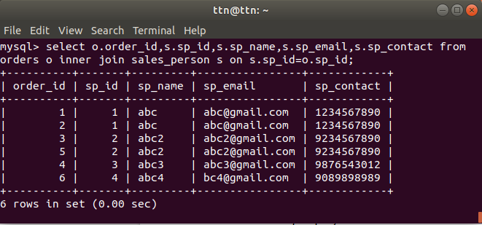
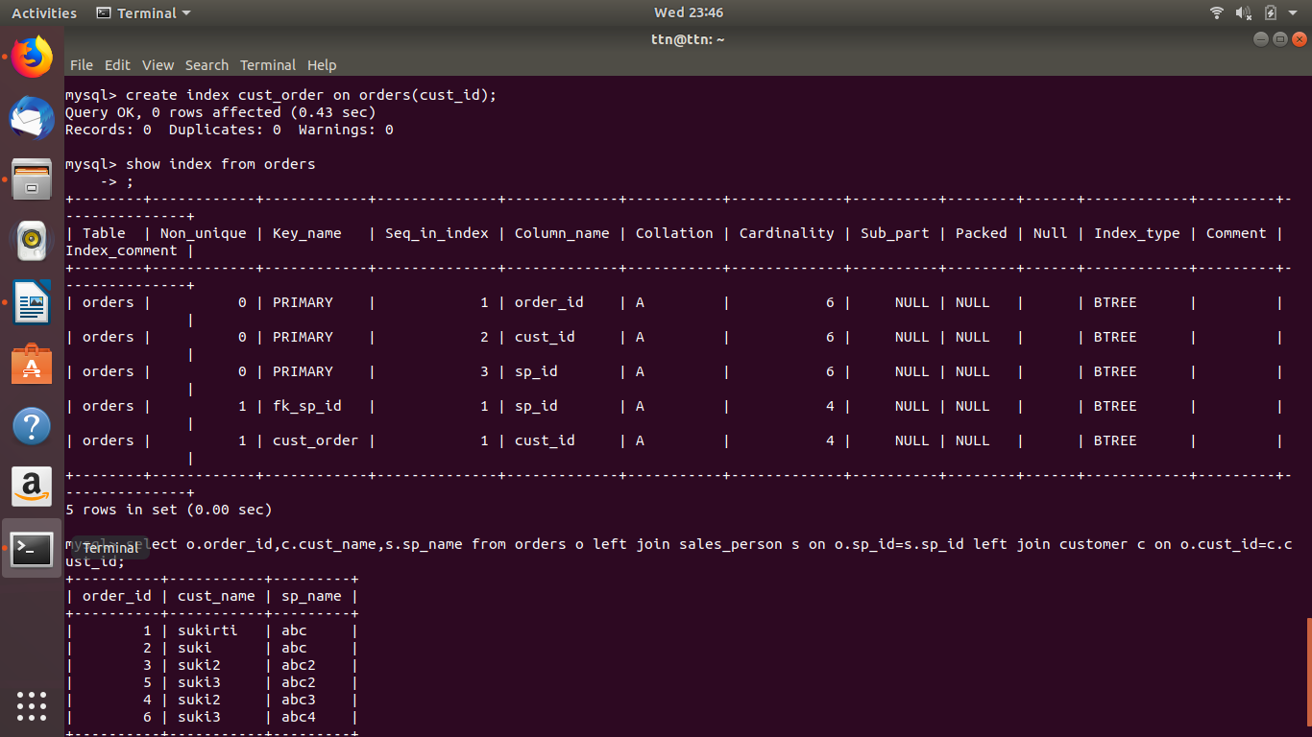
Create index

How to show index on a table

Find the order number, sale person name, along with the customer to whom that order belongs to
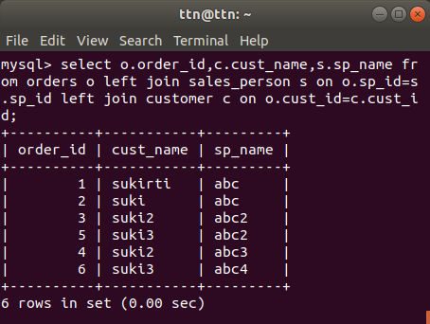

design schema
