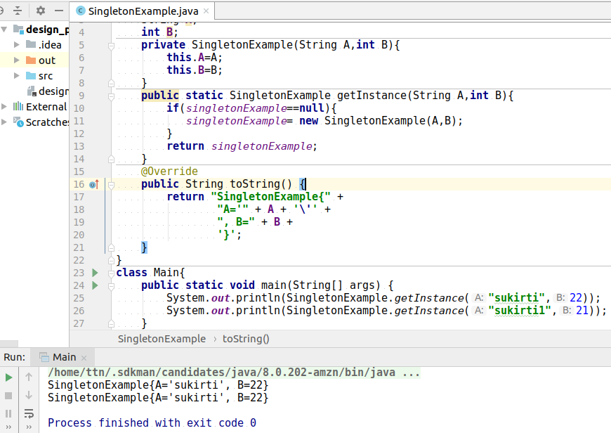
1. Implement Singleton Design Pattern on a dummy class.

2. Implement Factory Pattern to get the Polygon of differnt type.

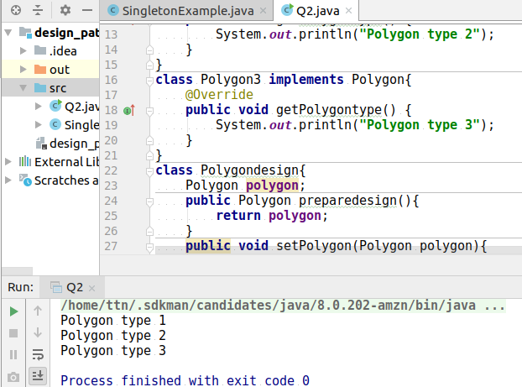

3.Implement Abstract Factory Pattern to create cars of different categories from different countries.
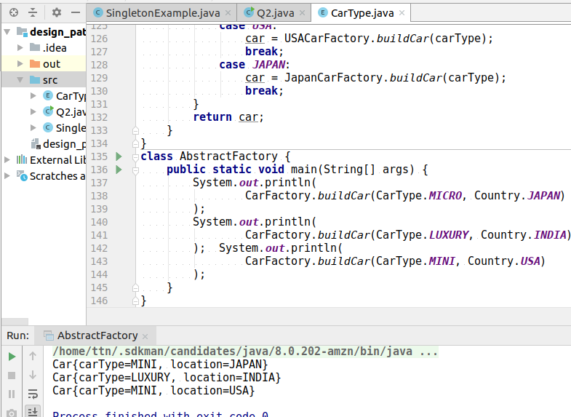
4. Implement Builder pattern to create a student object with more than 6 fields.
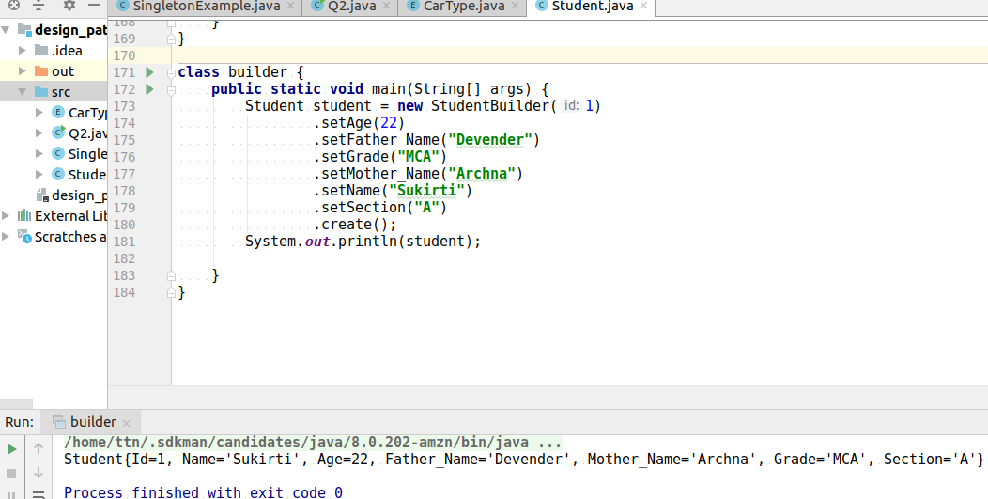

5. Implement Bridge Design Pattern for Color and Shape such that Shape and Color can be combined together e.g BlueSquare, RedSquare, PinkTriangle etc.

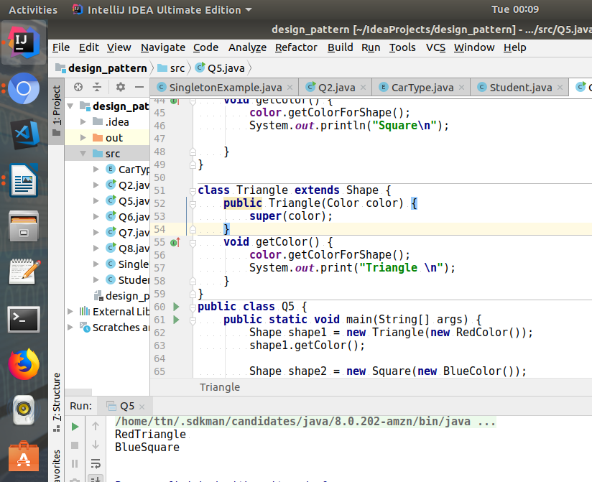
6. Implement Decorator pattern to decorate the Pizza with topings.
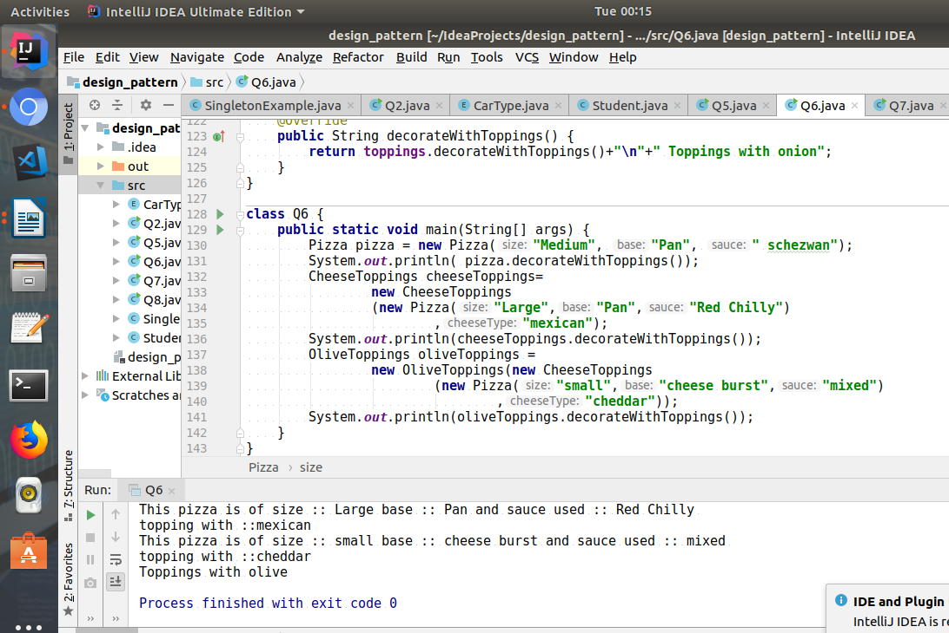

7.Implement Composite Design Pattern to maintaing the directories of employees on the basis of departments.
