1.How are inline and block elements different from each other?
Ans.
An inline element does not cause a start on a new line and does not take up the full width of a page. It only take the space bounded by its opening and closing tag.
Ex:
- <a>anchor tag</a>
- <span>span tag</span>
- <img>image tag</img>
whereas block elements are the elements which take up the full width of a page.
These elements always starts on a new line. These element has a line break before and after the element.
Ex:
<div>div tag</div>
<p>paragraph tag</p>
<input> input tag</input>
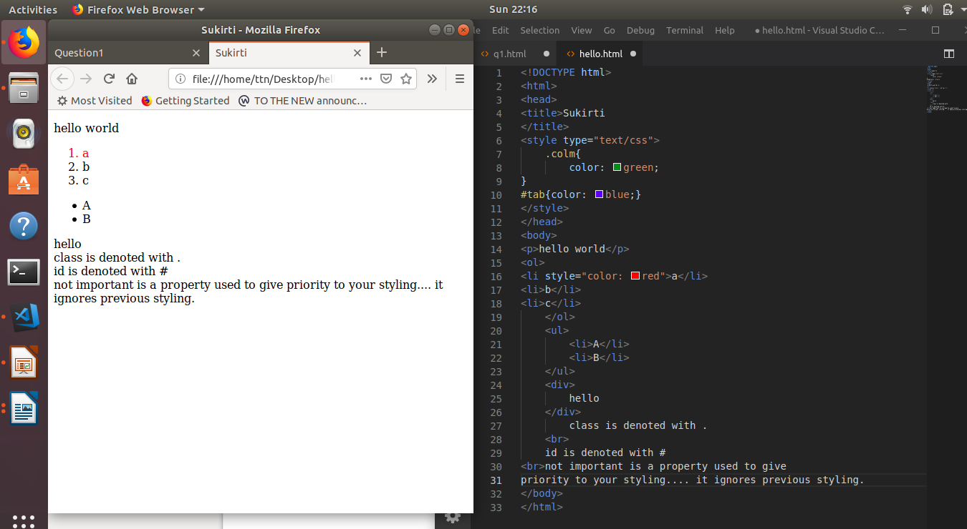
2.Explain the difference between visibility:hidden and display:none
Ans.
Visibility hidden: The visibility hidden styling of any element makes that element hidden but it wll take the same space as before and it will also effect the layout of the page.
Display none: This styling also makes the element hidden but the benefit is that this styling does not take space and even don’t effect the page layout.
3. Explain the clear and float properties.
Ans.
Float: The float property is used for positioning and formatting content. For e.g. , positioning an image to left or right.
Float properties:
1. left - The element floats to the left of its container
2. right- The element floats to the right of its container
3. none - The element be displayed just where it occurs in the text. This is default.
4. inherit - The element inherits the float value of its parent
Clear:
The clear property specifies what elements can float beside the cleared element and on which side.
Clear properties:
1. none - Allows floating elements on both sides. This is default
2. left - No floating elements allowed on the left side
3. right- No floating elements allowed on the right side
4. both - No floating elements allowed on either the left or the right side
5. inherit - The element inherits the clear value of its parent
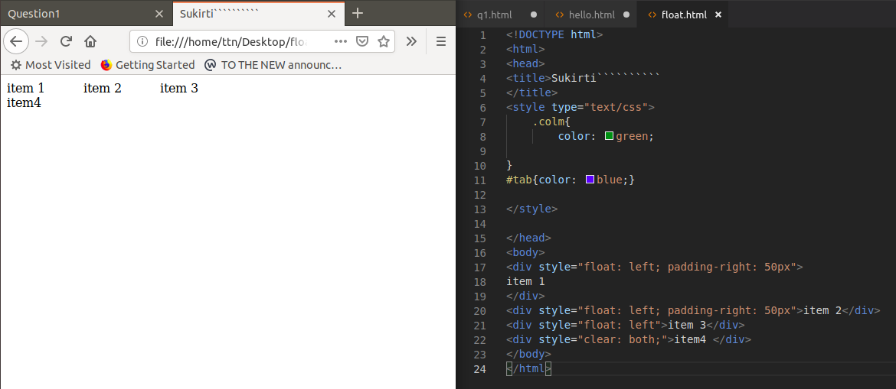
4. explain difference between absolute, relative,fixed and static.
Ans.
These are position property which specifies the position of any element in the page
1. position:absolute- the element position is relative to its ancestoral element.
2. position:relative- It moves an element relative to its orginal position.
3. position:fixed- It makes the element positioned relative to browser window.
4. position:static- It is by default set property, it makes element static.

5. Write the HTML code to create a table in which there are 4 columns( ID , Employee Name, Designation, Department) and at least 6 rows. Also do some styling to it.
Ans.
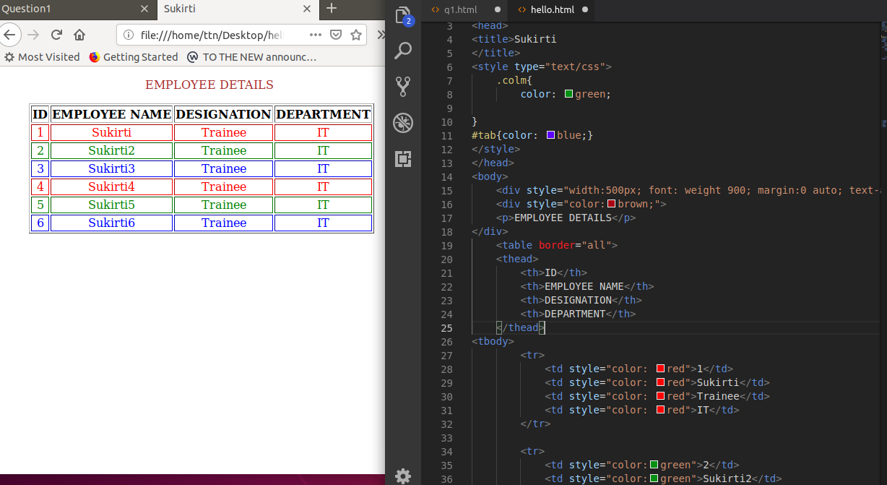
6. Why do we use meta tags?
Ans. Meta tags are mainly used to specify some SEO realted infrmation to the browser like title, description, author, that can be used yto increase the rank of the web page. Meta information is not shown on the webpage it just act as some information about the webpage to the search engines and crawlers.
<meta> tags always go inside the <head> element. Metadata is always passed as name/value pairs.

Example:
- <meta name="description" content="html assignment">
- <meta name="keywords" content="HTML, ttn">
- <meta name="author" content="Sukirti">
- <meta name="viewport" content="width=device-width, initial-scale=1.0">

7. Explain box model.
Ans.
Box model is a term used in CSS to describe design and layout.
It considres all elements as boxes.
Basically it act as a wrapper around every html element.
It consists of:
Content - Text, images and other media.
Padding - The padding is transparent and it clears an area around the content..
Border – A border that is put around padding and content together.
Margin - The margin is transparent and it clears an area outside the border.

8. What are the different types of CSS Selectors?
Ans.
Selectors are the elements which select the elements to be styled.
Ex:
#id-selects element with specific id.
.class_name- select element with specific class name.
element_name- select all element of specified element-name.
*- selects all elements.
We can use ther combinations as well.

9. Define Doctype.
Ans.
This is the declaration tag which must be written before html tag.
It is an instruction to the web browser about the version of html the page is written in.

10. Explain 5 HTML5 semantic tags.
Ans.
Semantic elements are the elements with meaning.
1. <nav>: it defines a set of navigaton links.
2. <article>: It is used to define text in and independent form which should be readable irrespective of other text.
3. <section>: This element defines a group of related elements in a document.
4. <aside>: This element defines some content aside from the content where it is placed in.
5. Figure and Figcaption: These elements are used to add a visual explanation to an image.4

11.
ans.
