- Git Setup https://confluence.atlassian.com/bitbucket/set-up-git-744723531.html
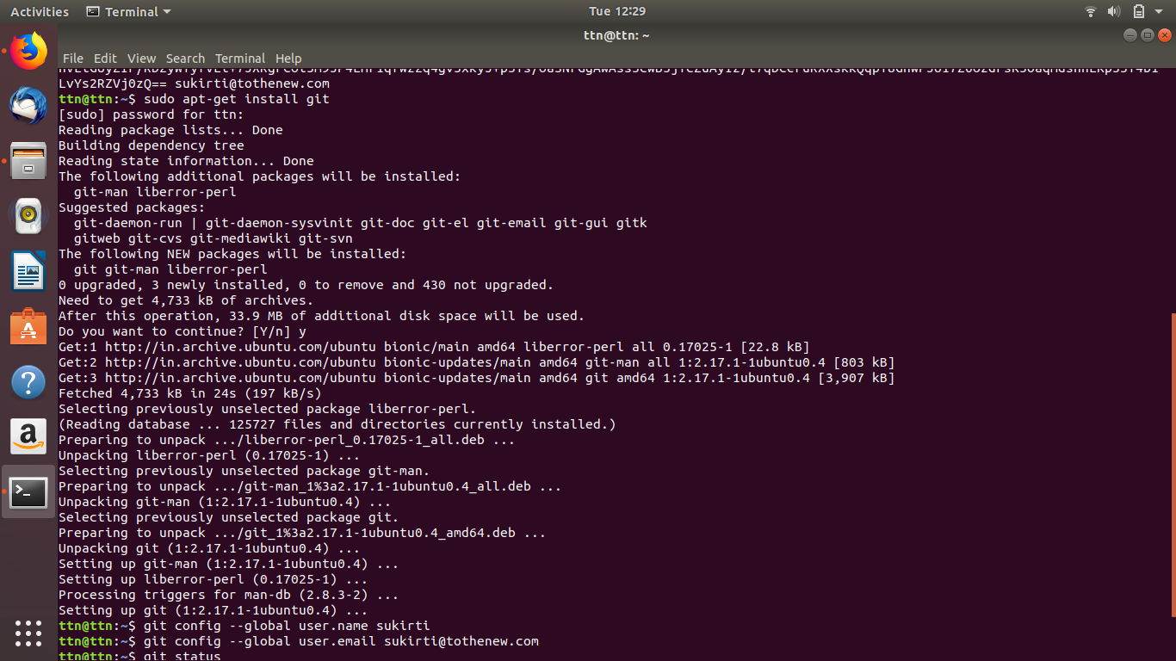

- Initialize a Git Repository
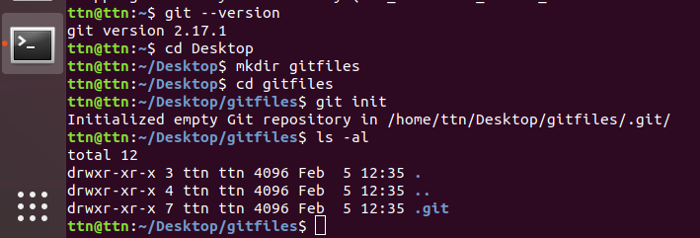

- Add files to the repository

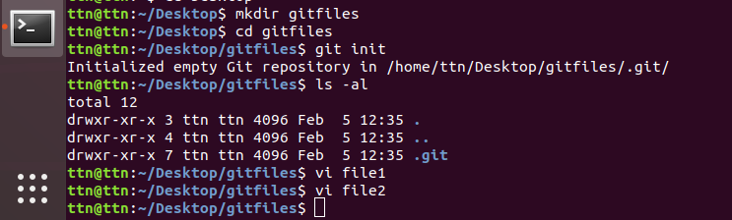

4. Unstage 1 file
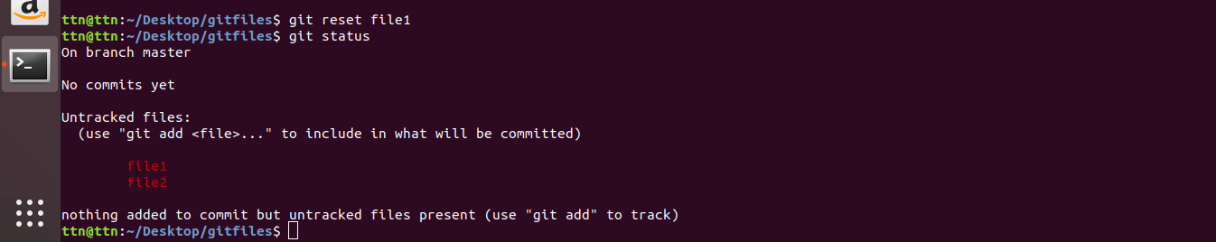
5. Commit the file
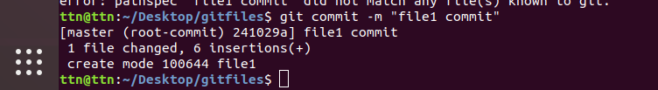
6. Add a remote
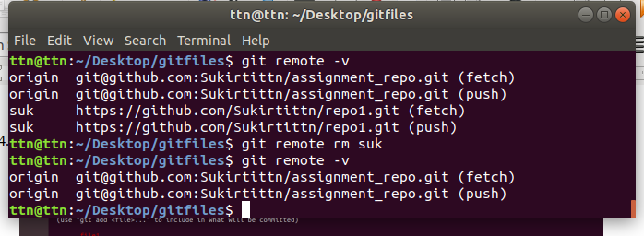

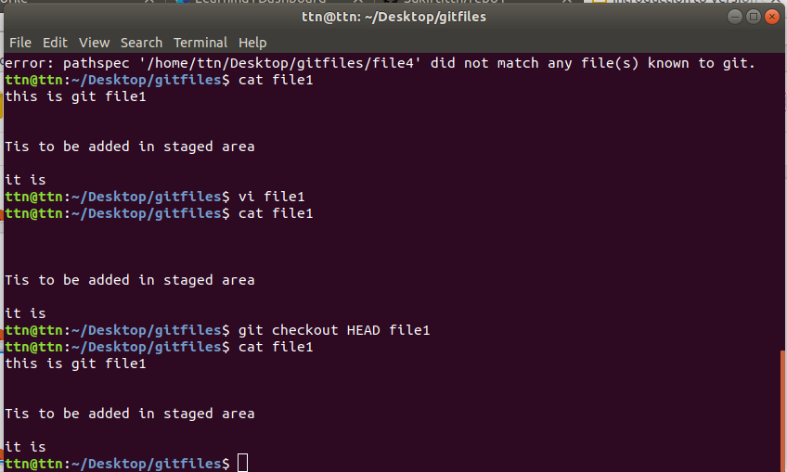
7. Undo changes to a particular file

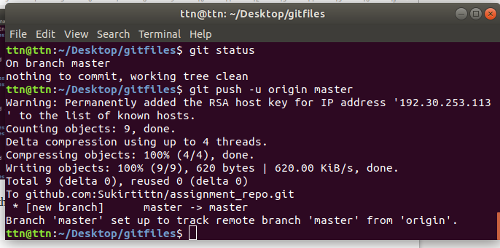
8. Push changes to Github

9. Clone the repository
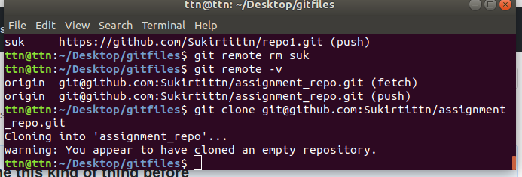
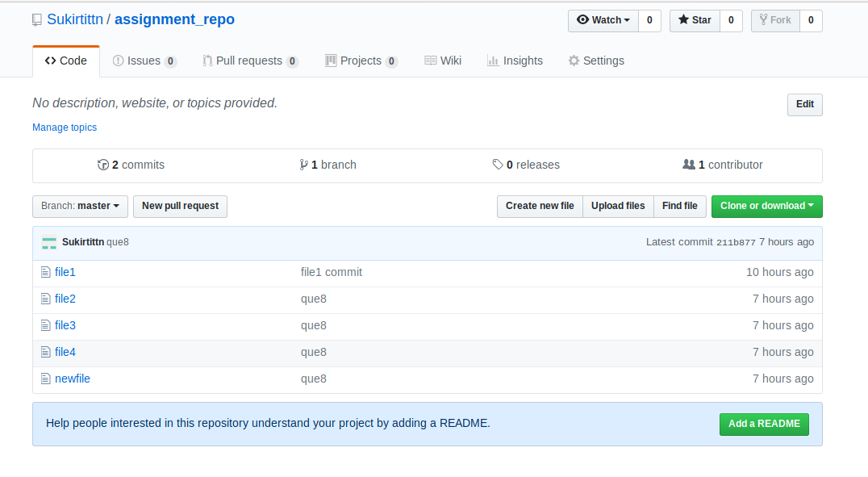

10. Add changes to one of the copies and pull the changes in the other.

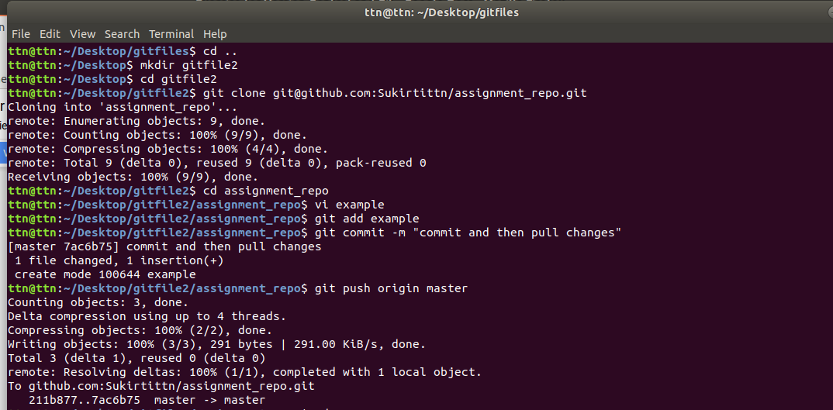
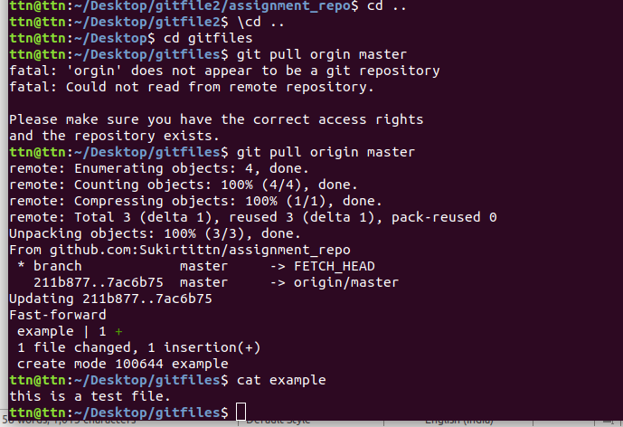

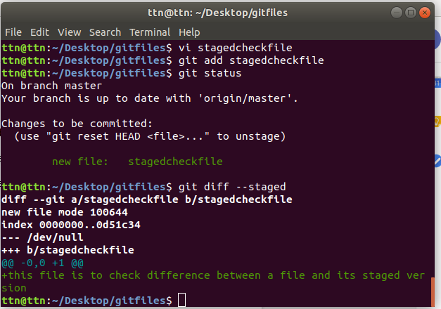
11. Check differences between a file and its staged version

12. Ignore a few files to be checked in.

Create a .gitignore file in project repository.
Then add those file names in .gitignore that you want to be ignored while commiting.

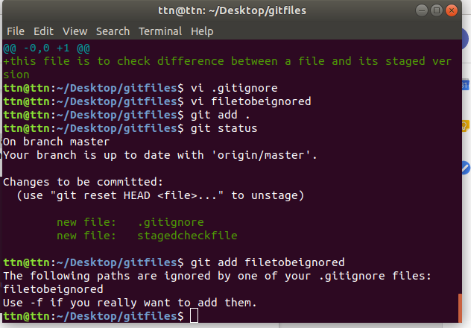

13. Create a new branch.
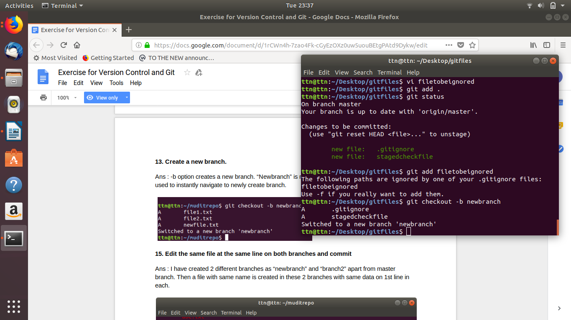
14. Diverge them with commits.

15. Edit the same file at the same line on both branches and commit.

Create 2 different branches as “newbranch” and “newbranch2” apart from master branch. Then a file with same name is created in these 2 branches with same data on 1st line in each.

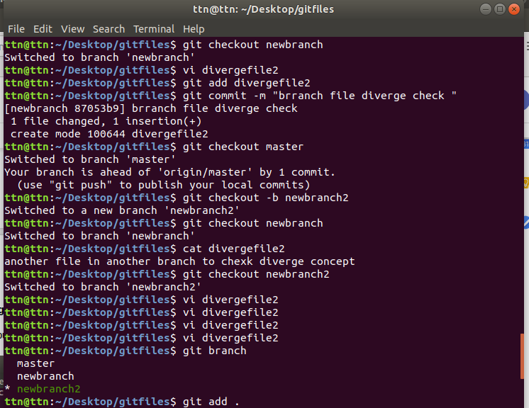
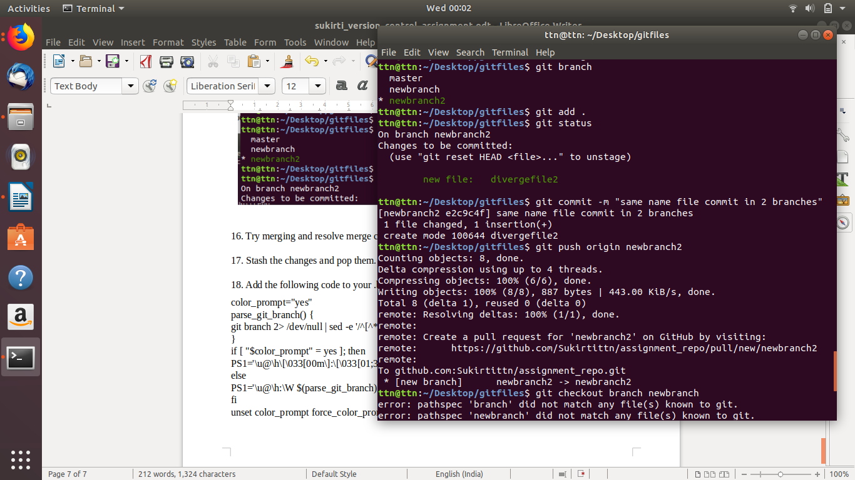

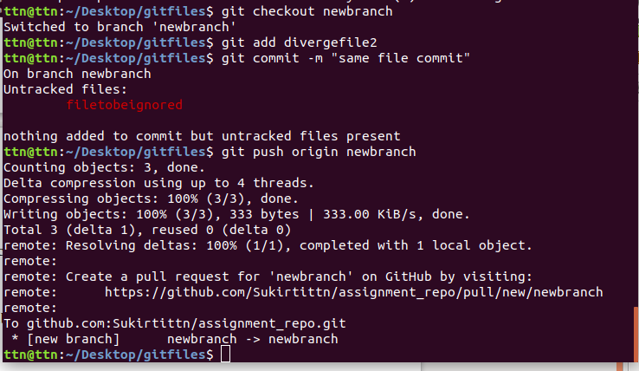

16. Try merging and resolve merge conflicts.
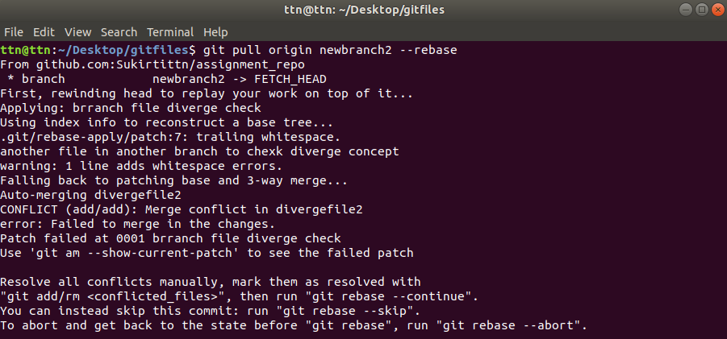
Conflict:

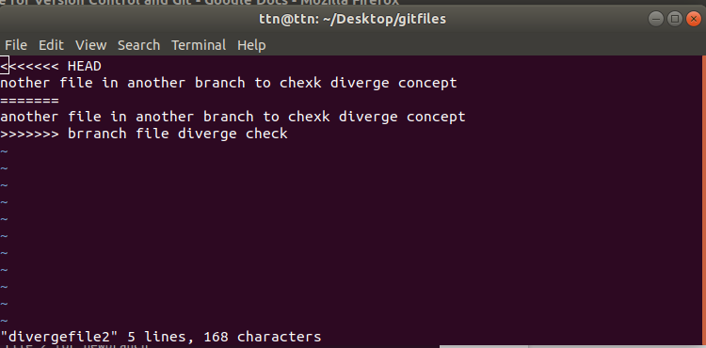

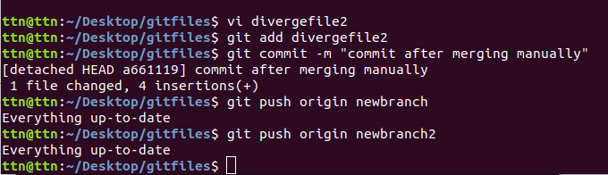

17. Stash the changes and pop them.

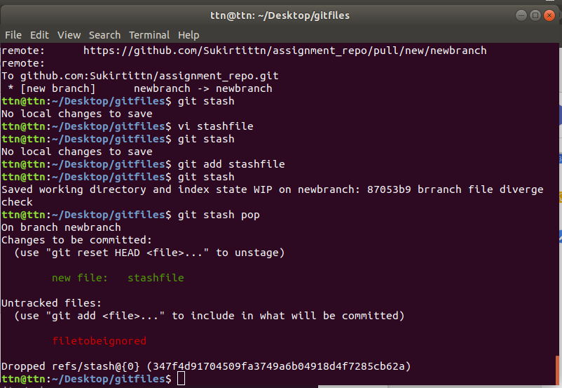
18. Add the following code to your .bashrc file :
color_prompt="yes"
parse_git_branch() {
git branch 2> /dev/null | sed -e '/^[^*]/d' -e 's/* \(.*\)/(\1)/'
}
if [ "$color_prompt" = yes ]; then
PS1='\u@\h\[\033[00m\]:\[\033[01;34m\]\W\[\033[01;31m\] $(parse_git_branch)\[\033[00m\]\$ '
else
PS1='\u@\h:\W $(parse_git_branch)\$ '
fi
unset color_prompt force_color_prompt

