Q-4: Copy information of one object to another and log it to console.
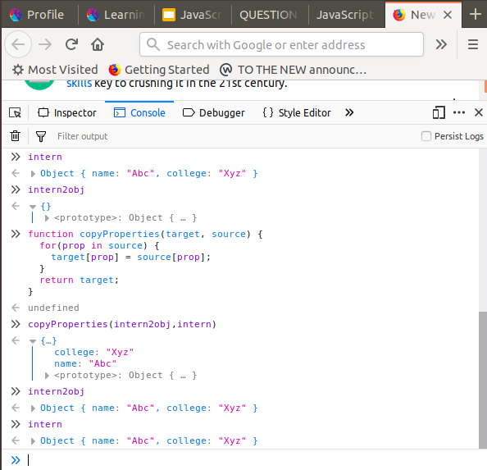
With function:

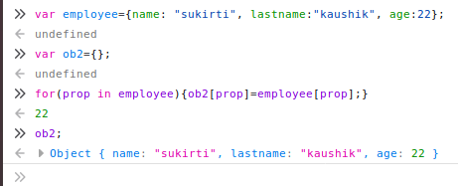

Withoutmaking function:

