Artificial Intelligence HW2 summary

2023-11398 Sukmin Yun

**1. Introduction**

In this homework, we extract HOG feature from the given images. And using HOG descriptor, we will design a face detection algorithm. The results are as follows.

**2. HOG visualization**2.1.1 Differential image along x and y directions.   
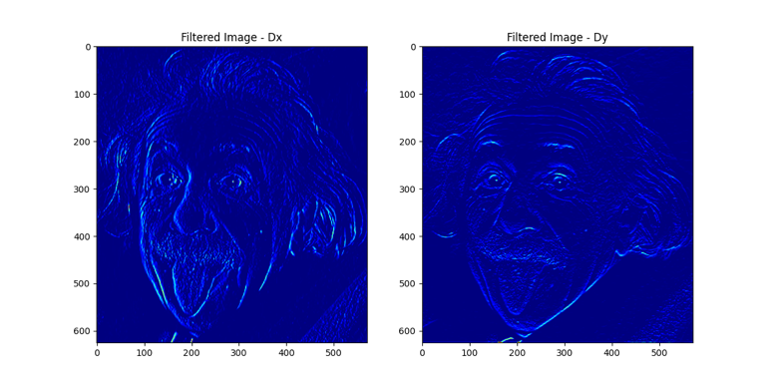

2.1.2 magnitude and orientation of image gradients.   
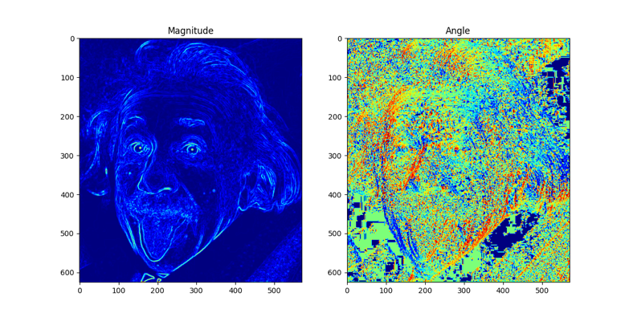

2.1.3 HOG of “einstein.png”  
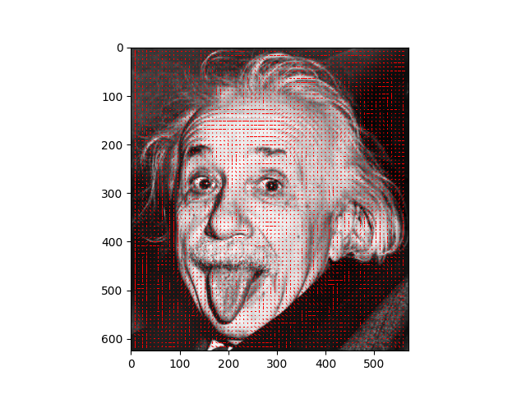

2.2 HOG of “cameraman.tif”   
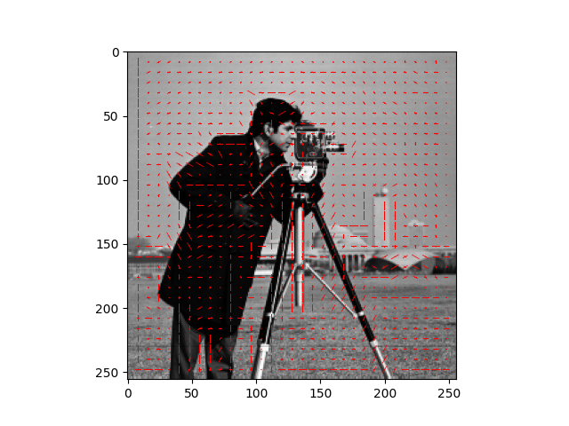  
2.3 HOG of “twins.tif”  
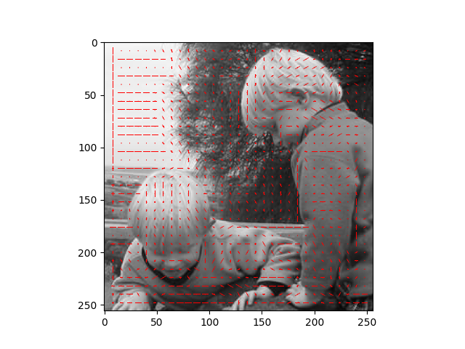  
2.4 HOG of “cat.tif”  
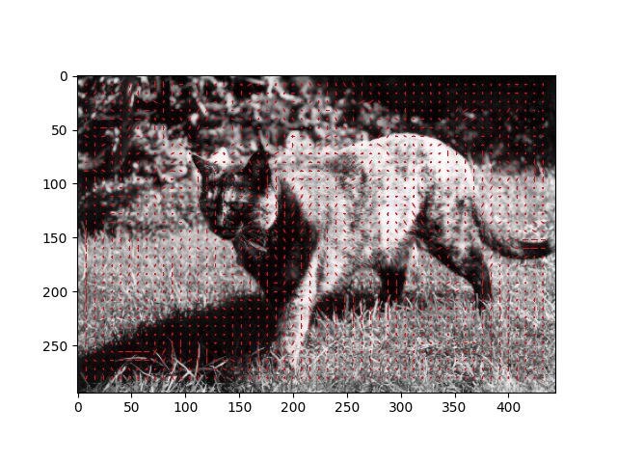

**3. Application: Face Detection**