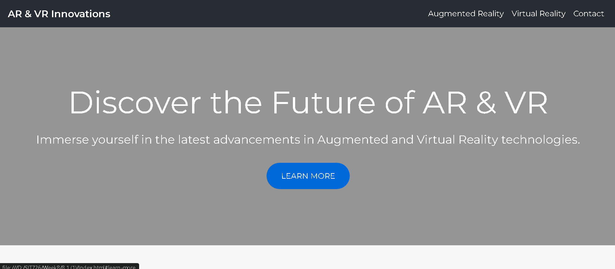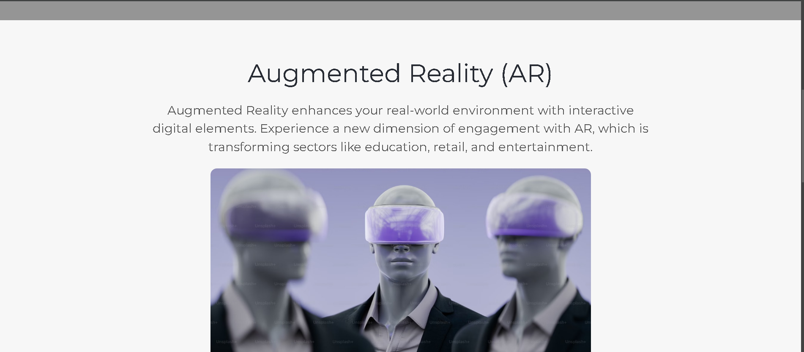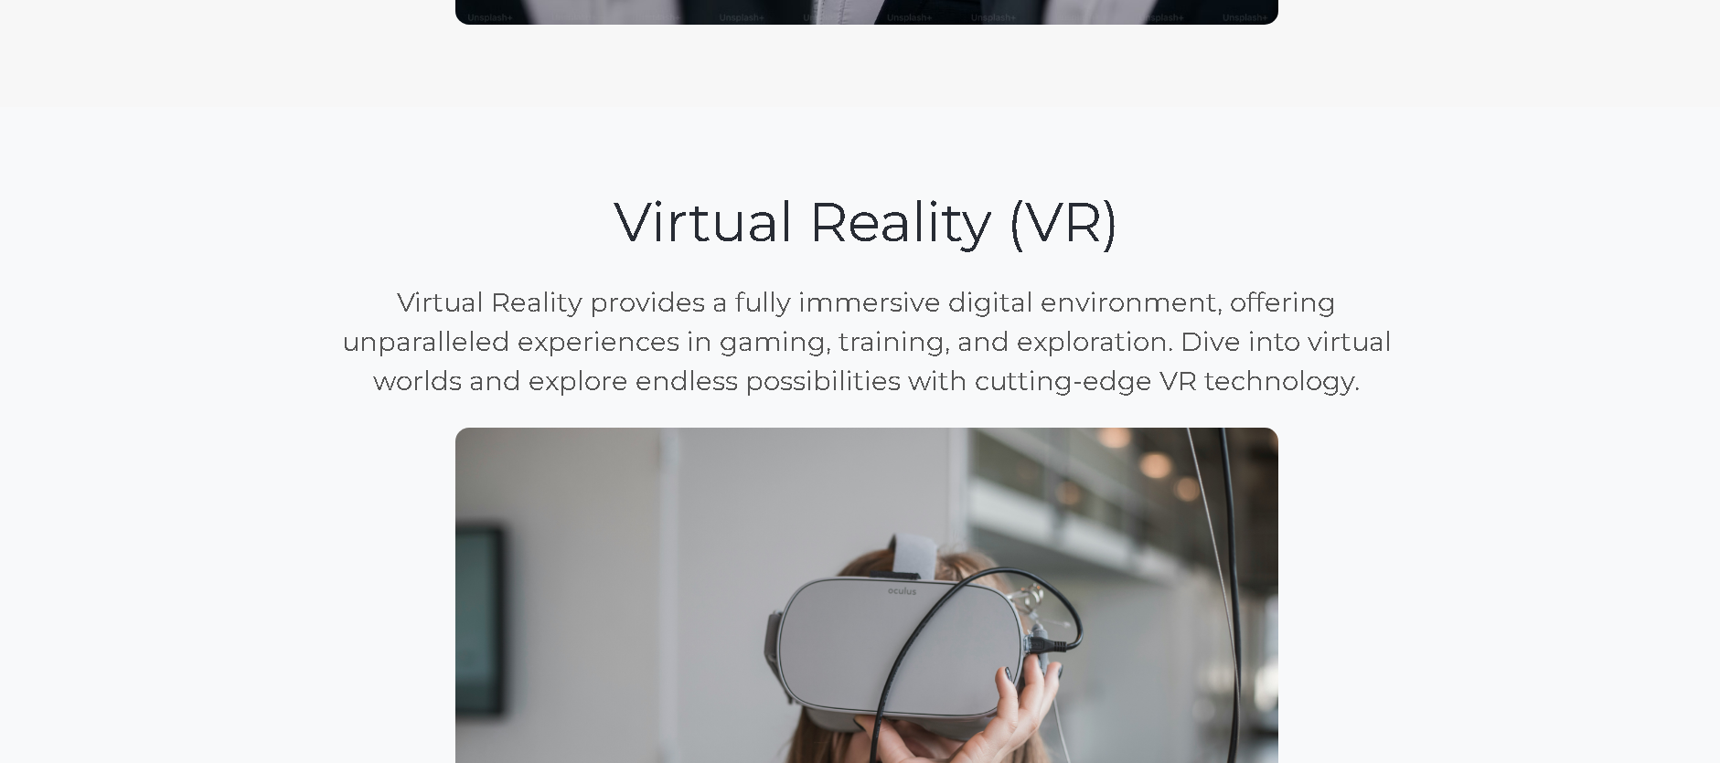

1. **Prototype Design Explanation and Annotation**

An exciting web page for events, sports, and is performing is what the prototype was created for creation. It is responsive to and comes in a range of viewing techniques (VR, AR, 2D). Speedy optimization, easy transportation, and a user interface that is clear are the top design focuses.

1. **Prototype Design**

An HTML and CSS sample that conforms to the key characteristics specified is shown underneath. Given your unique requirements and the input, you can enhance this.

1. **Explanation and Annotation**

**Accessibility**

Virtual reality, augmented reality, and two-dimensional displays are all facilitated by this structure. In order enable users to use this platform from any platform, it is also adaptive to mobile devices as well.

**Annotation**

* Option for VR/AR/HD: You may vary the format of the screen with selections or icons.
* Design for Being open: Bootstrap's grid layout assures device connectivity.

**Event Discovery**

Explorers attract in and inspired to go further into the Hero Area. A carousel of upcoming events points out those that are most popular events, and consumers can examine categories in the Prominent Events location.

**Annotation**:

* Hero Section: Includes an event investigation call-to-action buttons.
* Featured Things: Short phrases and images are used for drawing notice to specific categories, such performing: sports, and concerts.
* Attractions to Come Carousel: Displays the most thrilling occasions and allows quick booking of tickets.

**Simple and Intuitive UI**

Explanation : Navigation is straightforward and easy since to the UI's simple and clean design. There are clear indicators of the key controls.

**Annotation**:

* Basic relationships to the numerous sections of this site are included in the menu for navigating.
* Keys: With prompts like "Explore Events" and "Paid Now," these choices are obvious.

**Performance Optimization**

**Explanation**: For fast downloading times, the working model made use of light-weight materials with optimized colors.

Annotation :

* Bootstrap Elements: Employed because they operate well.
* Image dimensions must be changed correctly to prevent sluggish load.

1. **Testing Strategy**

**User Testing :**

* Watch folks using the model and note what happens. Gather opinions by use of polls.
* The ultimate objective is to locate challenges with usability and enhance management and design pursuant to patron engagement.

**Beta Testing**

Method: Provide a restricted population of users with a beta copy. Keep an eye out for errors and issues with your system.  
Final outcome is that Before the release, fix faults and issues with performance.

**Performance Testing**

* Approach: To simulate many users and evaluate response rates and load times, utilize technology such as Apache JMeter.
* How to Insure that the system can cope with high usage while maintaining an enjoyable experience for users.