**Application functionality:**

Microservice can add, update, delete and retrieve the flights.

Provided Airline, Source and Destination. Application will retrieve the flights if there is direct route or will show connecting routes or throw error in any other case. Application shows flights for specific airline selected.

**Some Test scenarios**

Create flight

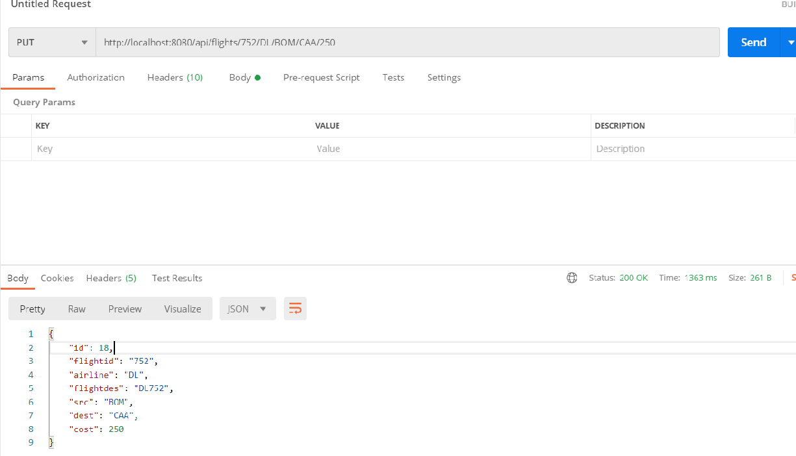

Update cost to 300

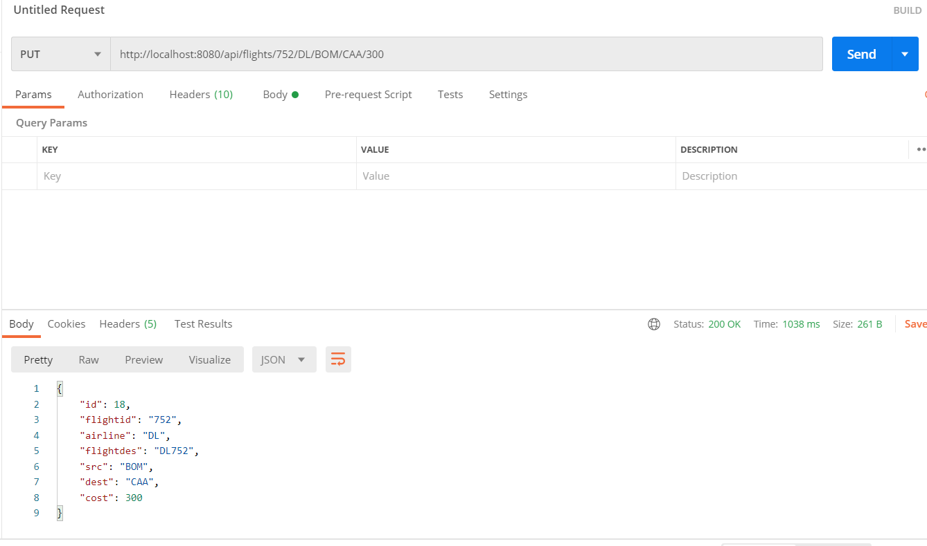

Creating again will throw error (Already present)

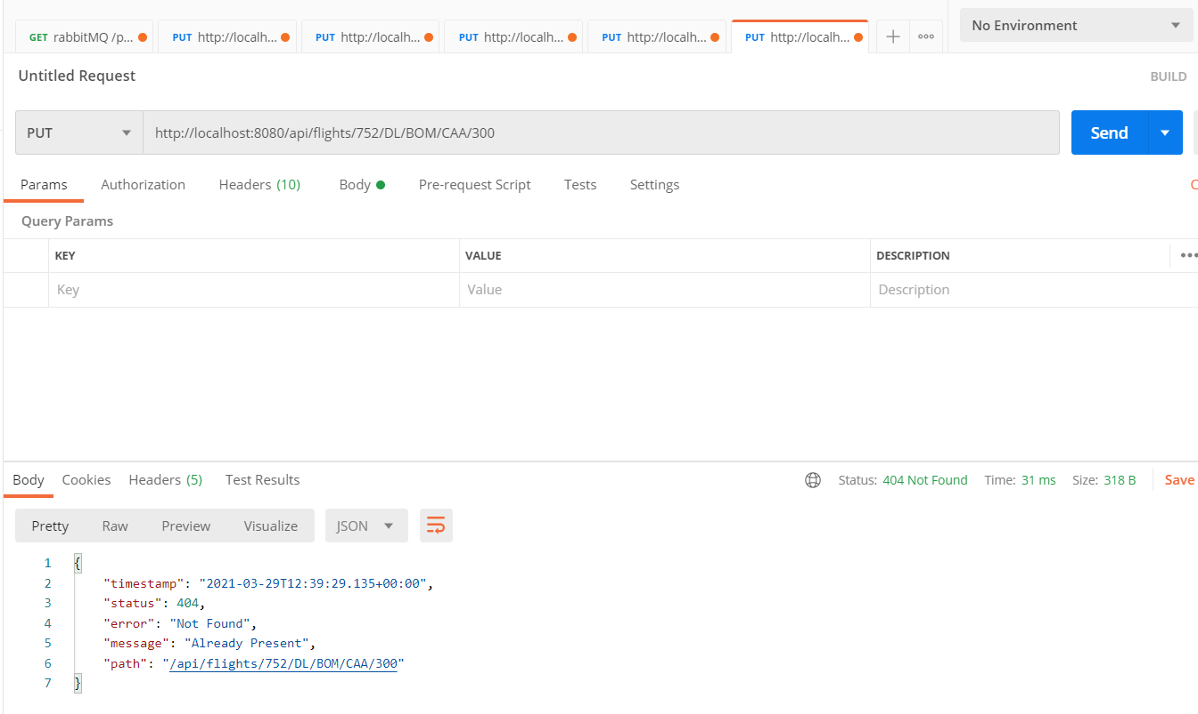

Delete the same flight

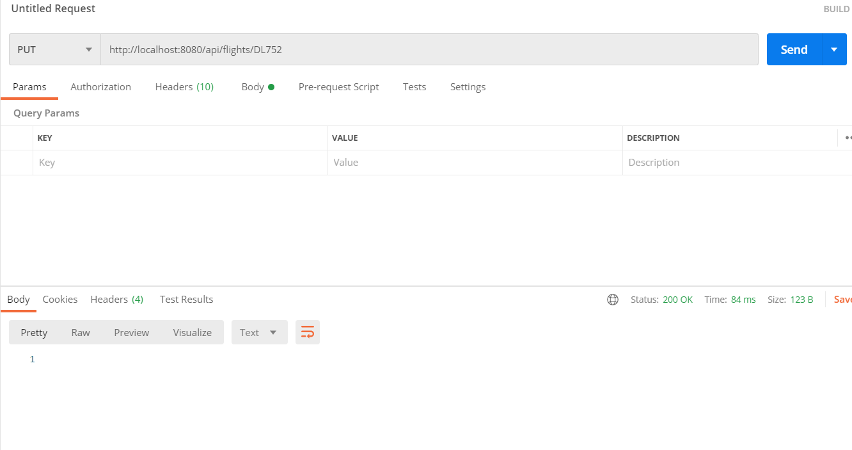

Try to delete again, throws error (No flights)

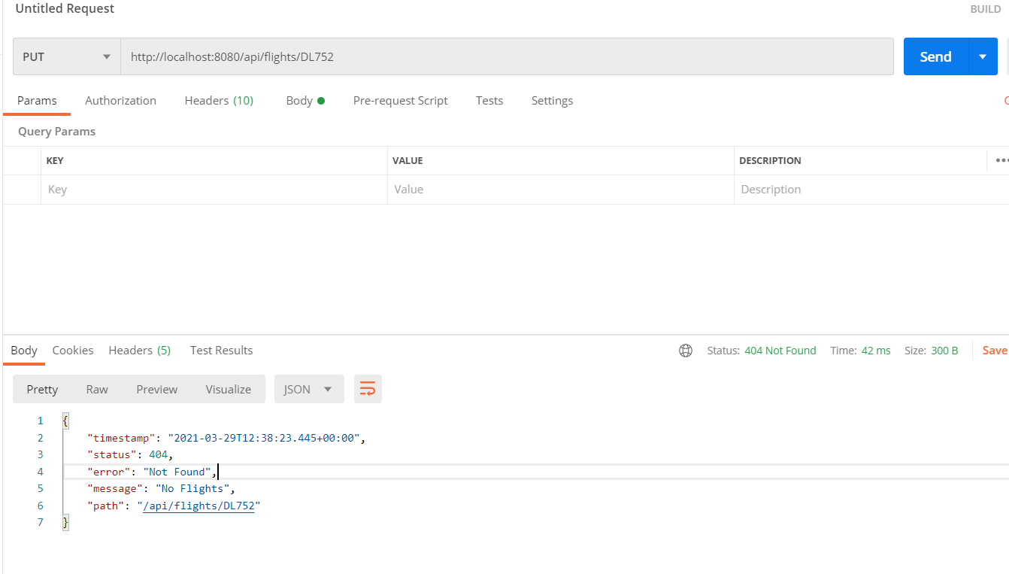

Retrieve the flight by giving the information

{Airline}/{Source}/{Destination}

The information includes

Cost: total cost

Path: Airports including source intermediate airport and destination

Flights: List of flights

