CISCO PACKET TRACER MINI PROJECT
SECURE CAMPUS NETWORK
Using Cisco Packet Tracer

Student Name | P.SUKUMAR
Roll Number | 24P31A05C3
Course / Branch | Cybersecurity/CSE
Institution | ACET
Submission Date | 28 September 2026

Project Report

1. Introduction
This project implements a small secure campus network in Cisco Packet Tracer. The network uses one Cisco 2911 router, two Cisco 2960 switches, and six PCs. The router connects two IPv4 networks, while the switches provide LAN connectivity and are secured using console and privileged EXEC protection, password encryption, SSH remote access, switch port security, sticky MAC learning, and shutdown of unused ports.

2. Project Objectives
- Configure the router interfaces and provide connectivity between two IPv4 networks.
- Configure switch management interfaces and default gateways.
- Secure console access and privileged EXEC mode.
- Enable password encryption for line passwords.
- Configure SSH version 2 for secure remote administration.
- Enable port security on user-facing switch ports with a maximum of one MAC address.
- Use sticky MAC learning and shutdown violation mode.
- Demonstrate an unauthorized-MAC violation.
- Disable unused switch ports.
- Verify connectivity, SSH access, port security, and save the final configurations.

3. Network Topology
The topology contains R1, S1, S2, and six PCs. R1 G0/0 connects to S1 G0/1 and R1 G0/1 connects to S2 G0/1. Each switch connects three PCs through FastEthernet ports 0/1–0/3.
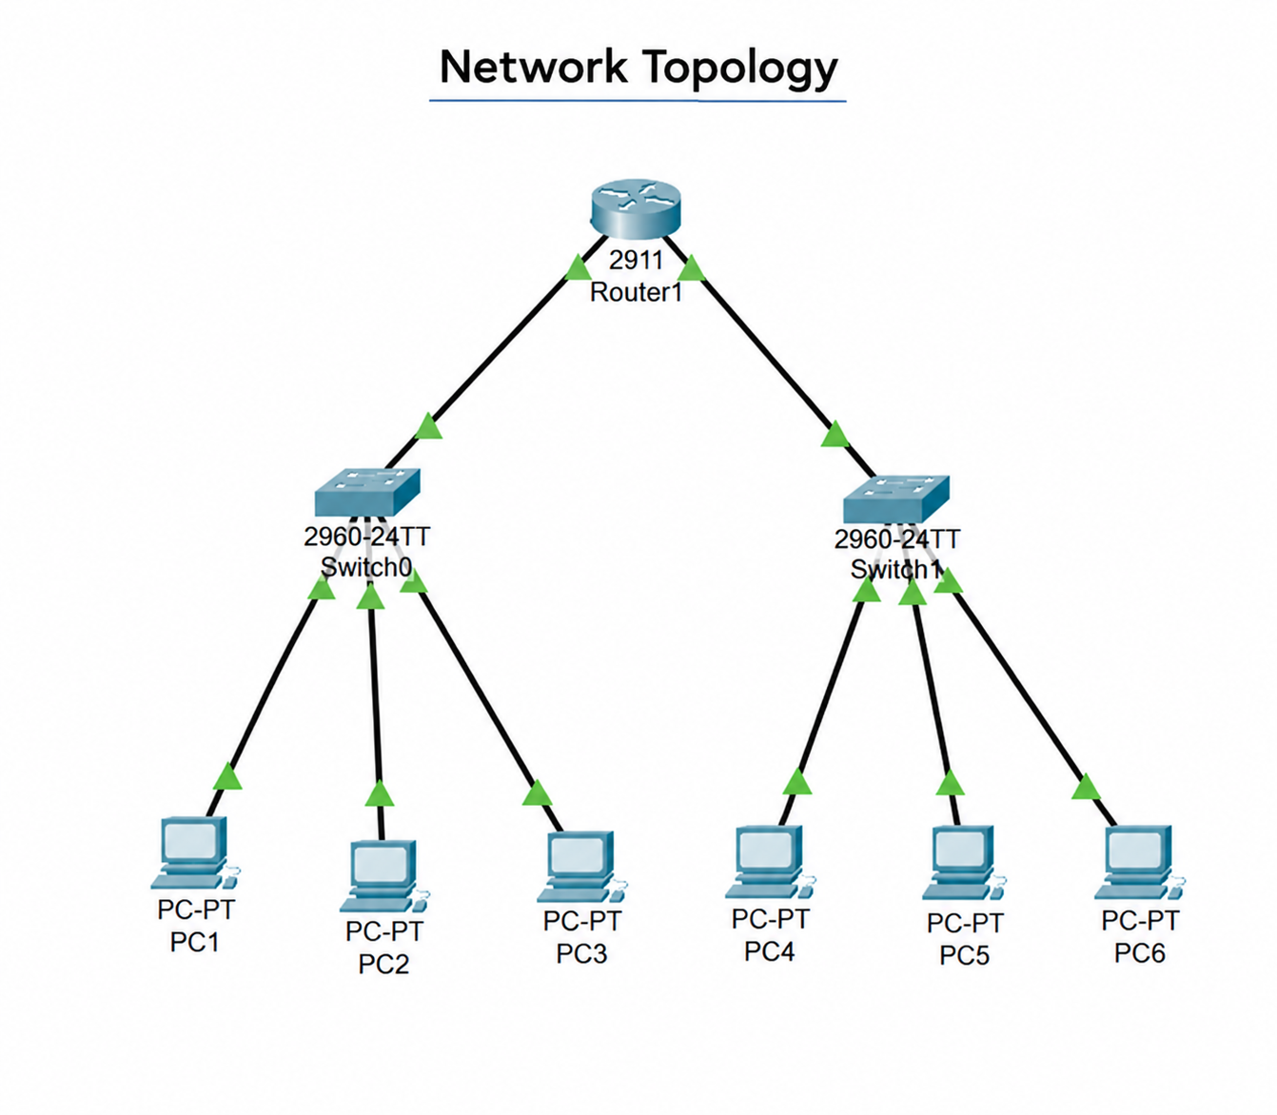
Figure 1. Network topology

4. Devices and IP Addressing Plan
Device | Interface | IP Address | Subnet Mask | Default Gateway
R1 | G0/0 | 192.168.10.1 | 255.255.255.0 | —
R1 | G0/1 | 192.168.20.1 | 255.255.255.0 | —
S1 | VLAN 1 | 192.168.10.2 | 255.255.255.0 | 192.168.10.1
S2 | VLAN 1 | 192.168.20.2 | 255.255.255.0 | 192.168.20.1
PC1 | NIC | 192.168.10.10 | 255.255.255.0 | 192.168.10.1
PC2 | NIC | 192.168.10.11 | 255.255.255.0 | 192.168.10.1
PC3 | NIC | 192.168.10.12 | 255.255.255.0 | 192.168.10.1
PC4 | NIC | 192.168.20.10 | 255.255.255.0 | 192.168.20.1
PC5 | NIC | 192.168.20.11 | 255.255.255.0 | 192.168.20.1
PC6 | NIC | 192.168.20.12 | 255.255.255.0 | 192.168.20.1
Physical connections:
- R1 G0/0 → S1 G0/1
- R1 G0/1 → S2 G0/1
- S1 Fa0/1 → PC1; S1 Fa0/2 → PC2; S1 Fa0/3 → PC3
- S2 Fa0/1 → PC4; S2 Fa0/2 → PC5; S2 Fa0/3 → PC6

5. Router R1 Configuration
The following commands were used to configure the router hostname and both routed interfaces:
enable
configure terminal
hostname R1
interface gigabitEthernet 0/0
ip address 192.168.10.1 255.255.255.0
no shutdown
exit
interface gigabitEthernet 0/1
ip address 192.168.20.1 255.255.255.0
no shutdown
exit
show ip interface brief
Console and privileged EXEC security were configured as follows:
line console 0
password <CONSOLE_PASSWORD>
login
exit
enable secret <ENABLE_SECRET>
Password encryption and SSH were then enabled:
service password-encryption
show running-config
ip domain-name campus.local
username admin privilege 15 secret <SSH_ADMIN_PASSWORD>
crypto key generate rsa
ip ssh version 2
line vty 0 4
login local
transport input ssh
exit
show ip ssh

6. Switch S1 Configuration
enable
configure terminal
hostname S1
enable secret <ENABLE_SECRET>
service password-encryption
interface vlan 1
ip address 192.168.10.2 255.255.255.0
no shutdown
exit
ip default-gateway 192.168.10.1
line console 0
password Switch<CONSOLE_PASSWORD>
login
exit
ip domain-name campus.local
username admin privilege 15 secret <SSH_ADMIN_PASSWORD>
crypto key generate rsa
ip ssh version 2
line vty 0 4
login local
transport input ssh
exit
Port security was applied to S1 Fa0/1–Fa0/3:
interface fastEthernet 0/1
switchport mode access
switchport port-security
switchport port-security maximum 1
switchport port-security mac-address sticky
switchport port-security violation shutdown
exit
interface fastEthernet 0/2
switchport mode access
switchport port-security
switchport port-security maximum 1
switchport port-security mac-address sticky
switchport port-security violation shutdown
exit
interface fastEthernet 0/3
switchport mode access
switchport port-security
switchport port-security maximum 1
switchport port-security mac-address sticky
switchport port-security violation shutdown
exit

7. Switch S2 Configuration
enable
configure terminal
hostname S2
enable secret <ENABLE_SECRET>
service password-encryption
interface vlan 1
ip address 192.168.20.2 255.255.255.0
no shutdown
exit
ip default-gateway 192.168.20.1
line console 0
password Switch<CONSOLE_PASSWORD>
login
exit
ip domain-name campus.local
username admin privilege 15 secret <SSH_ADMIN_PASSWORD>
crypto key generate rsa
ip ssh version 2
line vty 0 4
login local
transport input ssh
exit
Port security was applied to S2 Fa0/1–Fa0/3:
interface range fastEthernet 0/1-3
switchport mode access
switchport port-security
switchport port-security maximum 1
switchport port-security mac-address sticky
switchport port-security violation shutdown
exit

8. PC Configuration
Each PC was configured through Desktop → IP Configuration using the IP addressing plan in Section 4.
PC1 192.168.10.10 255.255.255.0 192.168.10.1
PC2 192.168.10.11 255.255.255.0 192.168.10.1
PC3 192.168.10.12 255.255.255.0 192.168.10.1
PC4 192.168.20.10 255.255.255.0 192.168.20.1
PC5 192.168.20.11 255.255.255.0 192.168.20.1
PC6 192.168.20.12 255.255.255.0 192.168.20.1

9. Connectivity Testing
Connectivity was tested from PC1 using:
ping 192.168.10.1
ping 192.168.20.10
ping 192.168.20.11
ping 192.168.20.12
All tested destinations returned successful replies. This verified local gateway connectivity and routing between the 192.168.10.0/24 and 192.168.20.0/24 networks.

10. SSH Testing
SSH remote access was tested using the following commands:
ssh -l admin 192.168.10.2
ssh -l admin 192.168.10.1
ssh -l admin 192.168.20.2
The three tests verified SSH access to S1, R1, and S2 respectively using the configured local admin account.

11. Port-Security Verification
The following verification commands were used:
show port-security
show port-security address
show port-security interface fastEthernet 0/1
show mac address-table
The switches showed port security enabled on the protected access ports, a maximum of one secure MAC address, sticky MAC learning, and shutdown as the violation action.

12. Port-Security Violation Demonstration
PC1 was initially connected to S1 Fa0/1 and generated traffic so that its MAC address was learned. PC1 was then disconnected and another PC was connected to the same protected port. Because the port allowed only one secure MAC address, S1 generated a port-security violation and placed the port into secure-shutdown.
show port-security interface fastEthernet 0/1
The captured verification showed: Port Security = Enabled, Port Status = Secure-shutdown, Violation Mode = Shutdown, Maximum MAC Addresses = 1, Sticky MAC Addresses = 1, and Security Violation Count = 1.
The interface was recovered using:
configure terminal
interface fastEthernet 0/1
shutdown
no shutdown
exit

13. Unused Port Security
Unused FastEthernet ports 0/4–0/24 were disabled on both switches:
interface range fastEthernet 0/4-24
shutdown
exit
This reduces the risk of an unauthorized device being connected to an unused active switch port.

14. Configuration Verification and Saving
Configuration output was reviewed with:
show running-config
show ip interface brief
show ip ssh
show port-security
show port-security address
show port-security interface fastEthernet 0/1
show mac address-table
show interfaces status
The final running configurations were saved on R1, S1, and S2 using:
copy running-config startup-config

15. Complete Command Reference
For quick revision and viva preparation, the commands used in the project are consolidated below. The list includes configuration, verification, testing, recovery, and save commands.
enable
configure terminal
hostname R1
hostname S1
hostname S2
interface gigabitEthernet 0/0
interface gigabitEthernet 0/1
ip address 192.168.10.1 255.255.255.0
ip address 192.168.20.1 255.255.255.0
no shutdown
exit
show ip interface brief
line console 0
password <CONSOLE_PASSWORD>
password Switch<CONSOLE_PASSWORD>
login
enable secret <ENABLE_SECRET>
service password-encryption
show running-config
ip domain-name campus.local
username admin privilege 15 secret <SSH_ADMIN_PASSWORD>
crypto key generate rsa
ip ssh version 2
line vty 0 4
login local
transport input ssh
show ip ssh
interface vlan 1
ip address 192.168.10.2 255.255.255.0
ip address 192.168.20.2 255.255.255.0
ip default-gateway 192.168.10.1
ip default-gateway 192.168.20.1
interface fastEthernet 0/1
interface fastEthernet 0/2
interface fastEthernet 0/3
interface range fastEthernet 0/1-3
switchport mode access
switchport port-security
switchport port-security maximum 1
switchport port-security mac-address sticky
switchport port-security violation shutdown
interface range fastEthernet 0/4-24
show port-security
show port-security address
show port-security interface fastEthernet 0/1
show mac address-table
show interfaces status
ping 192.168.10.1
ping 192.168.20.10
ping 192.168.20.11
ping 192.168.20.12
ssh -l admin 192.168.10.2
ssh -l admin 192.168.10.1
ssh -l admin 192.168.20.2
shutdown
copy running-config startup-config

16. Test Results
Test | Expected Result | Observation
PC1 → Router | Successful ping | Successful
PC1 → PC4 | Successful ping | Successful
SSH → R1 | Successful login | Successful
SSH → S1 | Successful login | Successful
SSH → S2 | Successful login | Successful
Port Security | Enabled | Verified
Sticky MAC | MAC learned | Verified
Unauthorized MAC | Violation detected | Verified
Unused Ports | Shutdown | Verified

17. Evidence Screenshots
The following project evidence was captured during implementation. These figures correspond to the required submission evidence: topology, configuration, SSH, port security, violation, and connectivity.
Figure 2. Final network topology

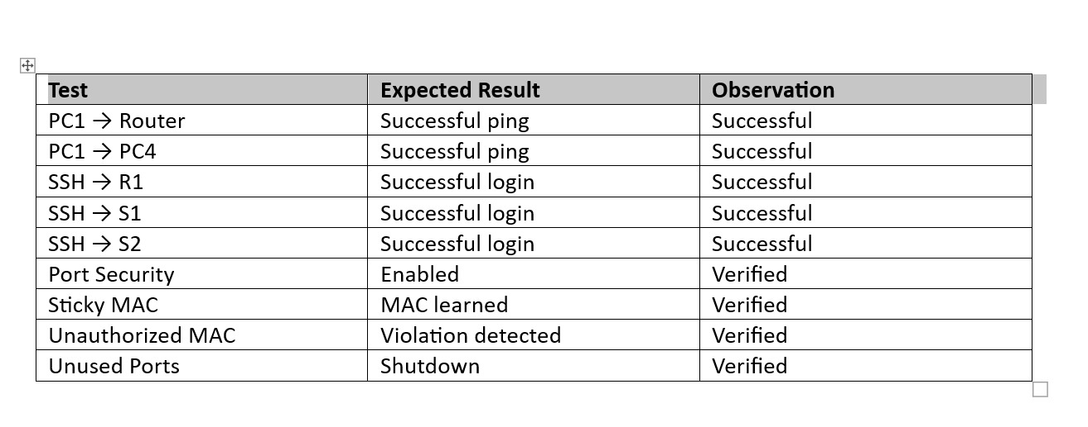
Figure 3. Final verification / observation table

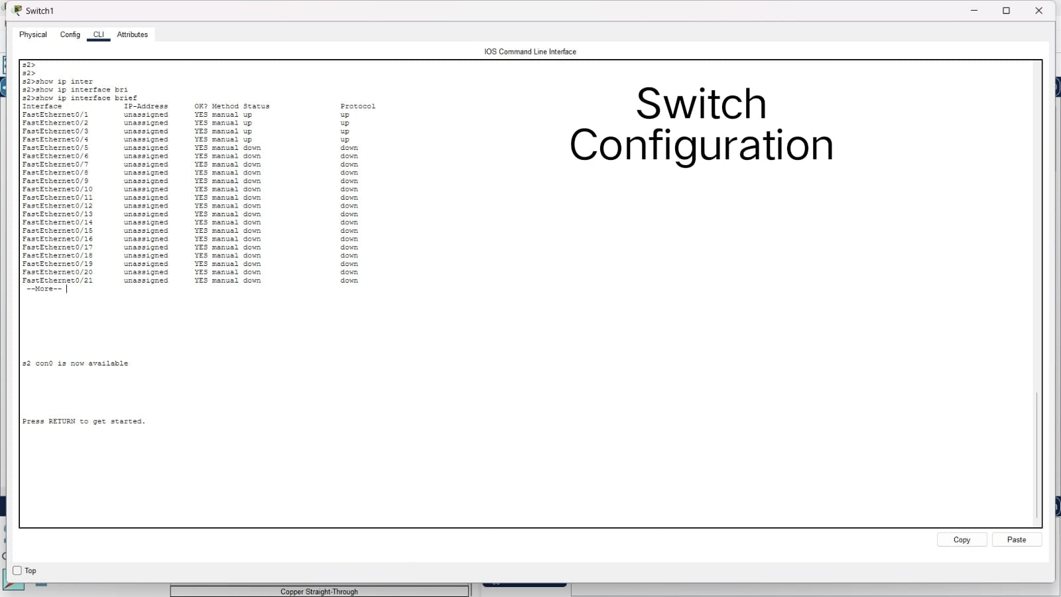
Figure 4. Switch interface status / switch evidence

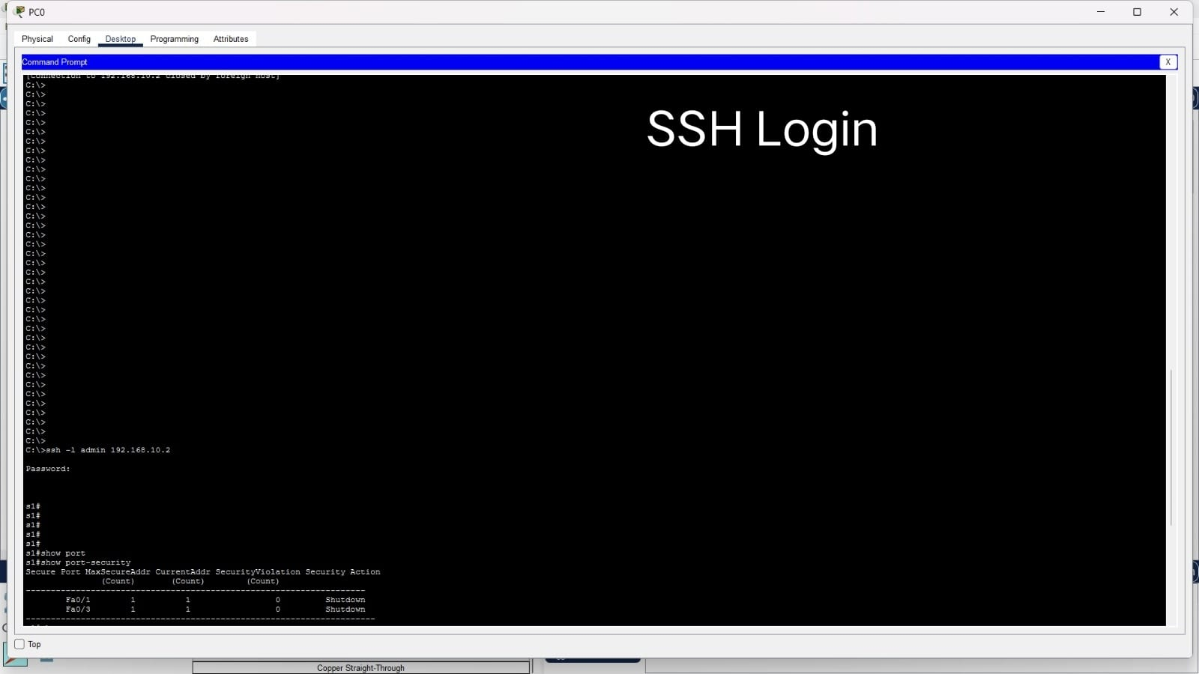
Figure 5. SSH login and port-security verification

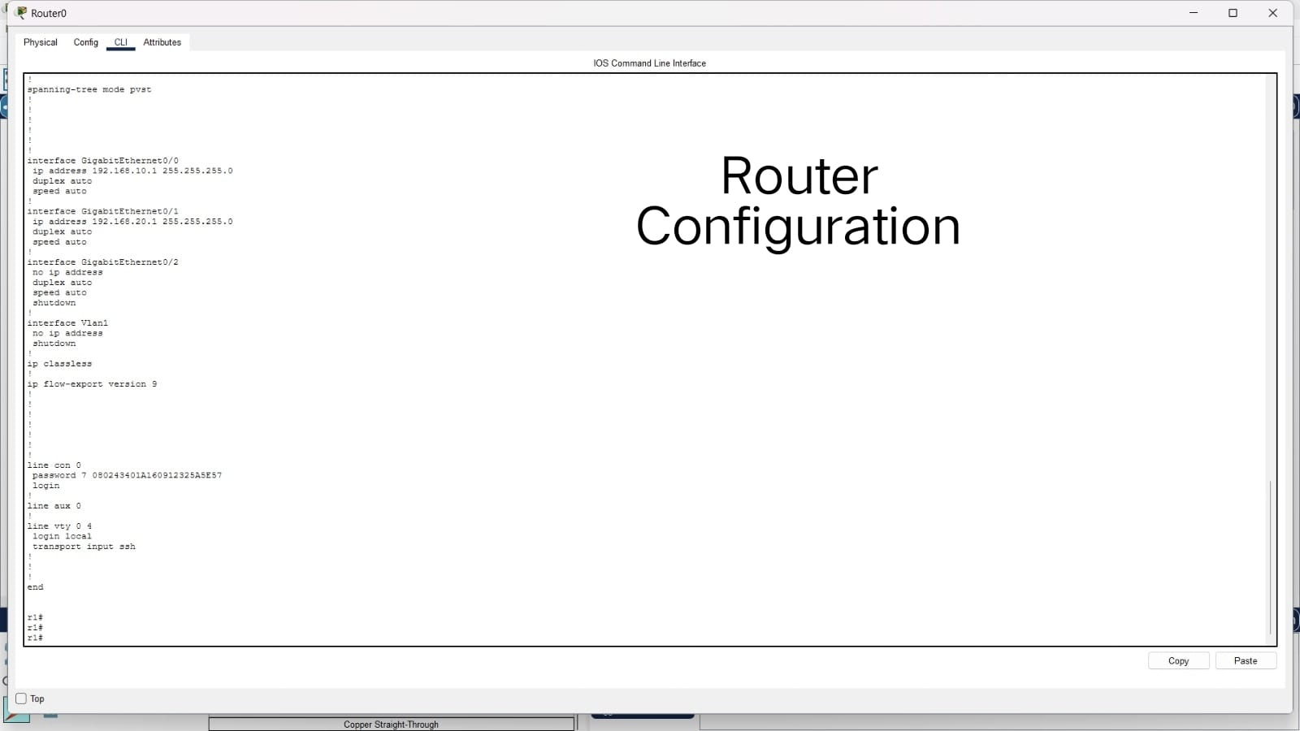
Figure 6. Router configuration evidence

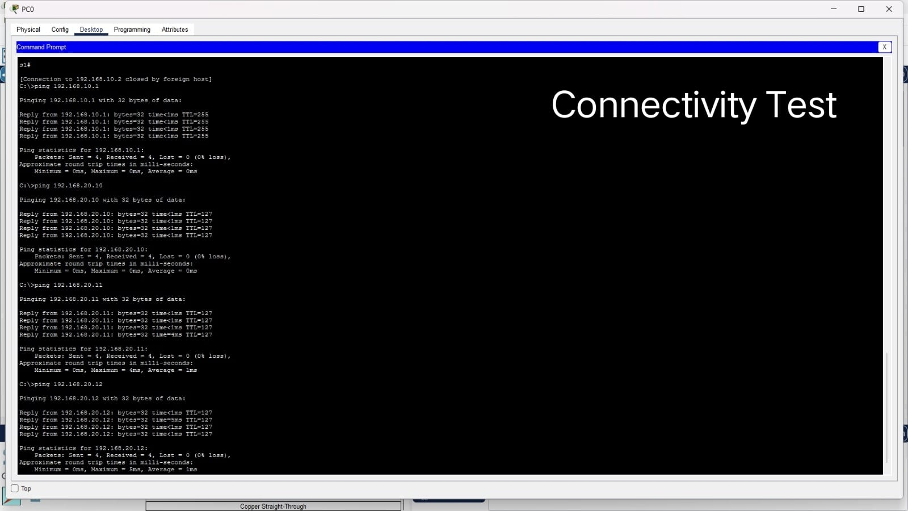
Figure 7. Connectivity test results

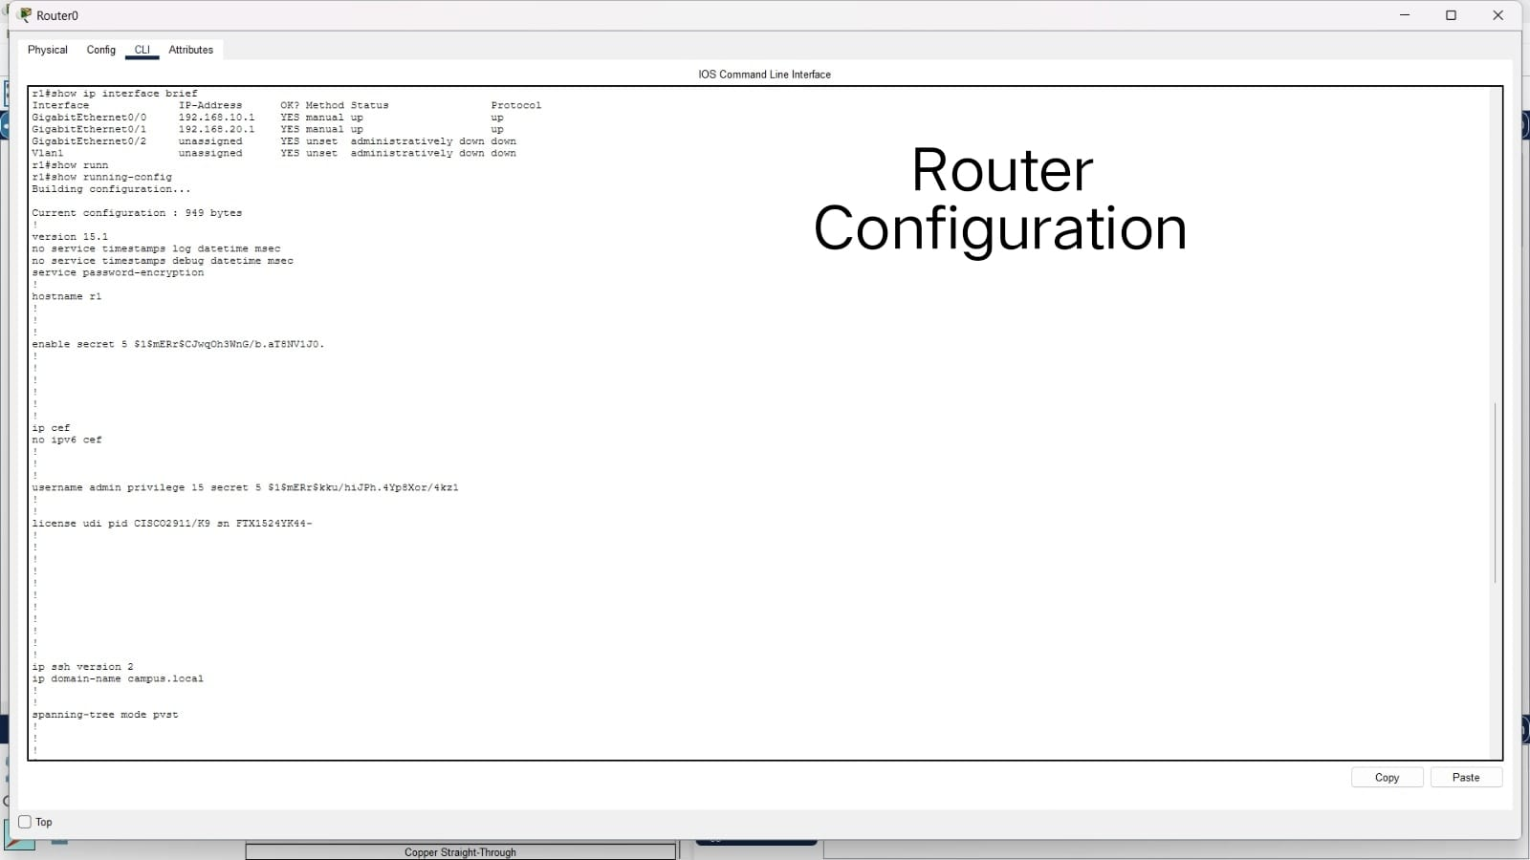
Figure 8. Router configuration and interface verification

18. Observations
- R1 successfully routed traffic between the two /24 networks.
- S1 and S2 were configured with management IP addresses and default gateways.
- Console access and privileged EXEC mode were protected with configured passwords/secrets.
- Password encryption was enabled for line passwords, while enable secret and local SSH credentials were stored in hashed form in the configuration.
- SSH version 2 provided remote management access to R1, S1, and S2.
- Port security limited the protected access ports to one MAC address and learned the permitted MAC using sticky learning.
- An unauthorized MAC address caused a port-security violation and secure-shutdown, demonstrating the configured protection.
- Unused switch ports were shut down.
- The final configuration was saved to startup configuration on the network devices.

19. Conclusion
The Secure Campus Network mini project was successfully implemented in Cisco Packet Tracer. The completed topology provides connectivity between two IP networks while applying multiple basic network-security controls. Router and switch management access was secured, SSH version 2 was enabled, password encryption was configured, and switch port security was used to restrict unauthorized devices. Connectivity and SSH tests were successful, and the port-security violation demonstration confirmed that the configured shutdown policy operated as expected. The final configurations were saved for submission.

20. Submission Checklist
☑ Cisco Packet Tracer (.pkt) file
☑ Network topology screenshot
☑ IP addressing table
☑ Router configuration screenshots
☑ Switch configuration screenshots
☑ SSH login screenshot
☑ Port-security verification screenshot
☑ Port-security violation screenshot
☑ Connectivity test screenshot
☑ Final verification table
☑ Short report with observations and conclusion

