1). Write a Java program that takes an array of integers as input from the user and then calculates the sum and average of the elements in the array. The program should output the sum and average.

**CODE**

package array;

import java.util.Scanner;

public class SumOfAvg {

public static void main(String[] args) {

Scanner scanner = new Scanner(System.***in***);

// Input: Size of the array

System.***out***.print("Enter the number of elements in the array: ");

int n = scanner.nextInt();

int[] array = new int[n];

int sum = 0;

// Input: Array elements

System.***out***.println("Enter the elements of the array:");

for (int i = 0; i < n; i++) {

array[i] = scanner.nextInt();

sum += array[i];

}

// Calculate average

double average = (double) sum / n;

// Output: Sum and Average

System.***out***.println("Sum: " + sum);

System.***out***.println("Average: " + average);

scanner.close();

}

}

**OUTPUT**

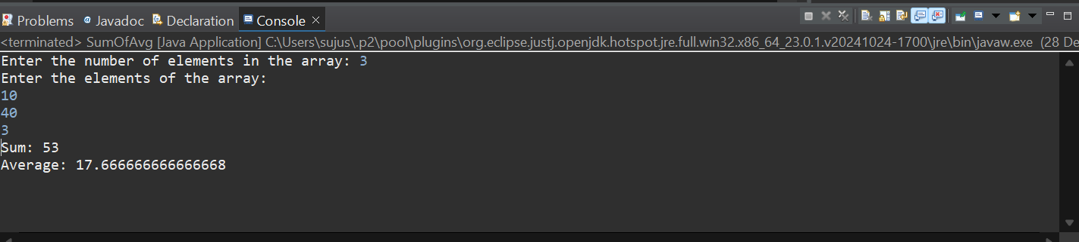

2). Write a Java program that takes an array of integers as input and sorts it in ascending order using any sorting algorithm of your choice. Print the sorted array.

**CODE**

package sorting;

import java.util.Scanner;

import java.util.Arrays;

public class AssendingSort {

public static void main(String[] args) {

Scanner scanner = new Scanner(System.*in*);

// Input: Size of the array

System.*out*.print("Enter the number of elements in the array: ");

int n = scanner.nextInt();

int[] array = new int[n];

// Input: Array elements

System.*out*.println("Enter the elements of the array:");

for (int i = 0; i < n; i++) {

array[i] = scanner.nextInt();

}

// Sort the array in ascending order

Arrays.*sort*(array);

// Output: Sorted array

System.*out*.println("Sorted Array:");

for (int num : array) {

System.*out*.print(num + " ");

}

scanner.close();

}

}

**OUTPUT**

