**Assignment-1.**

• Write a Java program named Car

• The Car class should have the following attributes: make (String), model (String), year (short), and price(int).

• The car class should have a constructor that takes all the attributes.

• Add a main method to instantiate car objects.

• The program should allow the user to create and display objects of each Car Class.

**CODE:-**

package car;

class Car {

String make;

String model;

short year;

int price;

void displayDetails() {

System.*out*.println("Make: " + make);

System.*out*.println("Model: " + model);

System.*out*.println("Year: " + year);

System.*out*.println("Price: $" + price);

}

}

public class MainCar {

public static void main(String[] args) {

Car car = new Car();

car.make = "MG";

car.model = "Hector";

car.year = 2020;

car.price = 1400000;

System.*out*.println("Car Details:");

car.displayDetails();

}

}

**OUTPUT**

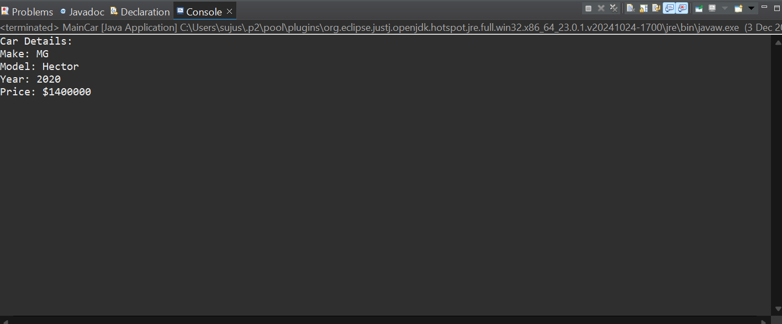

**Assignment-2.**

• Write a Java program that demonstrates method overloading by creating a class called Calculator.

Add three methods called add().

• The first add() method should take two int variables as arguments

and return their sum as int.

• The second add() method should take three int variables as arguments and return their sum as int.

• The third add() method should take two doubles as arguments and return their sum as double.

• The program should allow the user to display the results of each method.

**CODE:-**

package car;

class Calculator1 {

int firstadd(int a, int b) {

return a + b;

}

int secondadd(int a, int b, int c) {

return a + b + c;

}

double thirdadd(double a, double b) {

return a + b;

}

}

public class Calculator {

public static void main(String[] args) {

Calculator1 calc = new Calculator1();

int sum1 = calc.firstadd(10, 20);

int sum2 = calc.secondadd(10, 20, 30);

double sum3 = calc.thirdadd(12.5, 7.3);

System.*out*.println("Sum of two integers: " + sum1);

System.*out*.println("Sum of three integers: " + sum2);

System.*out*.println("Sum of two doubles: " + sum3);

}

}

**OUTPUT:-**

