1. Create a Java program that acts as a simple calculator.

* The program should prompt the user to enter two numbers and an operator (+, -, *, /).
* Perform the corresponding calculation based on the operator.
* Handle potential exceptions, such as division by zero or invalid operator input.
* Display the result or an appropriate error message

**CODE**

package exception;

import java.util.Scanner;

public class SimpleCalculator {

public static void main(String[] args) {

Scanner scanner = new Scanner(System.*in*);

// Prompt user for input

System.*out*.print("Enter first number: ");

double num1 = scanner.nextDouble();

System.*out*.print("Enter an operator (+, -, *, /): ");

char operator = scanner.next().charAt(0);

System.*out*.print("Enter second number: ");

double num2 = scanner.nextDouble();

// Perform calculation

try {

double result = 0;

switch (operator) {

case '+':

result = num1 + num2;

break;

case '-':

result = num1 - num2;

break;

case '*':

result = num1 * num2;

break;

case '/':

if (num2 == 0) {

throw new ArithmeticException("Cant Division by zero");

}

result = num1 / num2;

break;

default:

throw new IllegalArgumentException("Invalid operator");

}

// Display result

System.*out*.println("Result: " + result);

} catch (Exception e) {

// Handle errors

System.*out*.println("Error: " + e.getMessage());

}

scanner.close();

}

}

**OUTPUT**

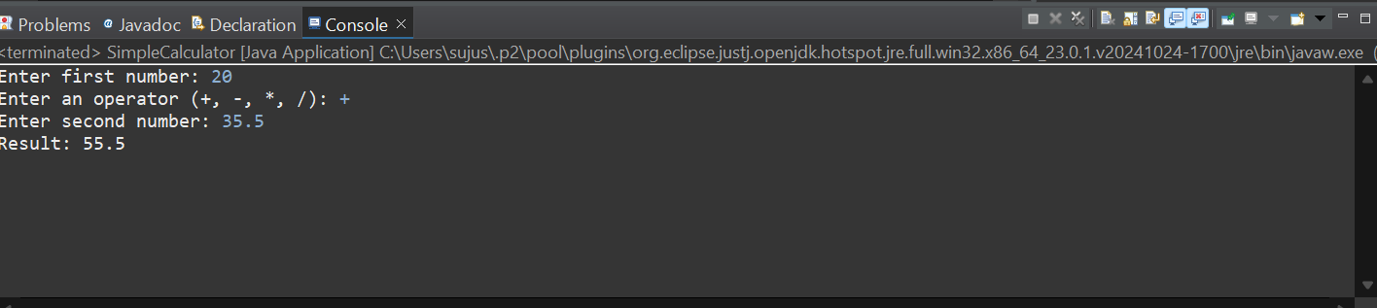

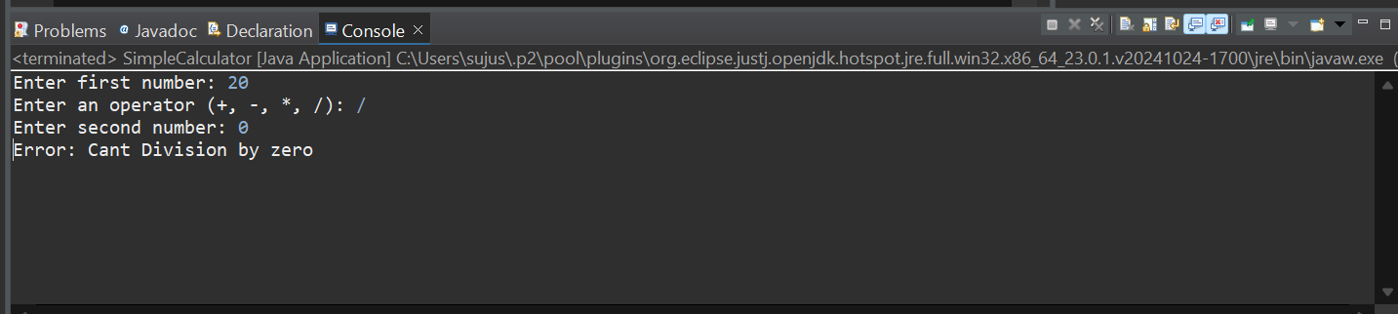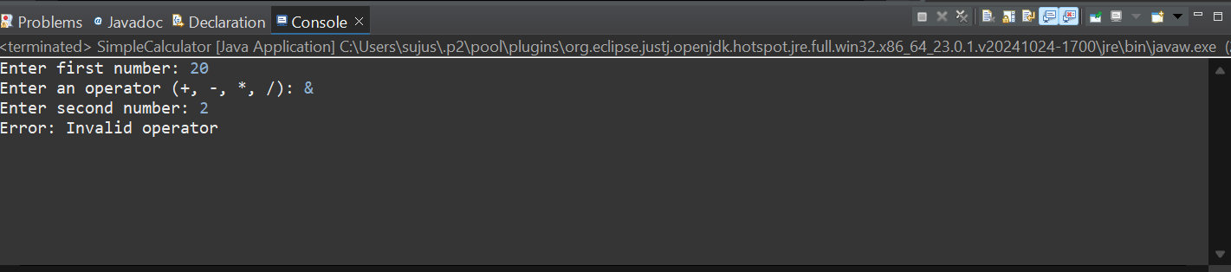

1. Write a Java program to simulate a simple banking application.

* Create a class BankAccount with a balance and methods for deposit and withdrawal.
* Implement exception handling for withdrawal operations to prevent overdrawing.
* Handle the scenario when the withdrawal amount is greater than the balance.

**CODE**

package exception;

import java.util.Scanner;

class BankAccount {

private double balance;

// Constructor

public BankAccount(double initialBalance) {

this.balance = initialBalance;

}

// Deposit method

public void deposit(double amount) {

if (amount > 0) {

balance += amount;

System.*out*.println("Deposit successful. New balance: " + balance);

}

else {

System.*out*.println("Invalid deposit amount.");

}

}

// Withdrawal method

public void withdraw(double amount) {

try {

if (amount > balance) {

throw new Exception("Sorry Insufficient balance.");

}

else if (amount <= 0) {

System.*out*.println("Invalid withdrawal amount.");

}

else {

balance -= amount;

System.*out*.println("Withdrawal successful. Remaining balance: " + balance);

}

}

catch (Exception e) {

System.*out*.println("Error: " + e.getMessage());

}

}

// Display balance

public void displayBalance() {

System.*out*.println("Current balance: " + balance);

}

}

public class BankApl {

public static void main(String[] args) {

Scanner scanner = new Scanner(System.*in*);

// Create a BankAccount object

BankAccount account = new BankAccount(1000); // Initial balance = 1000

// Menu-driven program

System.*out*.println("Banking Application");

System.*out*.println("1. Deposit");

System.*out*.println("2. Withdraw");

System.*out*.println("3. Check Balance");

System.*out*.println("4. Exit");

while (true) {

System.*out*.print("Choose an option: ");

int choice = scanner.nextInt();

switch (choice) {

case 1:

System.*out*.print("Enter deposit amount: ");

double depositAmount = scanner.nextDouble();

account.deposit(depositAmount);

break;

case 2:

System.*out*.print("Enter withdrawal amount: ");

double withdrawAmount = scanner.nextDouble();

account.withdraw(withdrawAmount);

break;

case 3:

account.displayBalance();

break;

case 4:

System.*out*.println("Thank you for using the Banking Application. Goodbye!");

scanner.close();

return;

default:

System.*out*.println("Invalid option. Please try again.");

}

}

}

}

**OUTPUT**

