1). Write a program that prompts the user to enter an integer. Handle the InputMismatchException that might occur if the user enters a non-integer value.

**CODE**

package missmatch;

import java.util.Scanner;

import java.util.InputMismatchException;

public class InputMissMatch {

public static void main(String[] args) {

Scanner scanner = new Scanner(System.*in*);

try {

System.*out*.print("Enter an integer: ");

int number = scanner.nextInt();

System.*out*.println("You entered: " + number);

} catch (InputMismatchException e) {

System.*out*.println("Error: Please enter a valid integer.");

} finally {

scanner.close();

}

}

}

**OUTPUT**

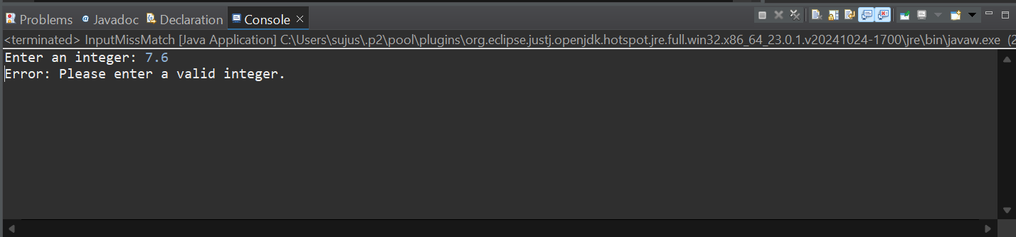

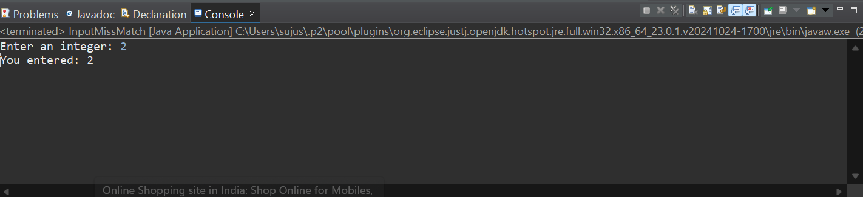

2). Write a program that takes user input and converts it to an integer using Integer.parseInt(). Handle the NumberFormatException and NullPointerException that might occur during the conversion.

**CODE**

package missmatch;

import java.util.Scanner;

public class HandleNum {

public static void main(String[] args) {

Scanner scanner = new Scanner(System.***in***);

try {

System.***out***.print("Enter a number as a string: ");

String input = scanner.nextLine();

int number = Integer.*parseInt*(input);

System.***out***.println("Converted number: " + number);

} catch (NumberFormatException e) {

System.***out***.println("Error: Invalid format. Please enter a valid integer string.");

} catch (NullPointerException e) {

System.***out***.println("Error: Null input is not allowed.");

} finally {

scanner.close();

}

}

}

**OUTPUT**

