**Assignment-1.**

• **1.** Create a base class called Vehicle with the following methods:

void start(): This method should print "Vehicle started." Create two subclasses of Vehicle called Car and Motorcycle. Override the start() method in each subclass to provide a specific implementation:

• Car: Print "Car started."

• Motorcycle: Print "Motorcycle started."

Create a class called Garage with a method named serviceVehicle(Vehicle vehicle). Inside this method, call the start() method of the provided vehicle object and print "Vehicle serviced." In the Main class, create instances of Car and Motorcycle. Create an instance of the Garage class.

Call the serviceVehicle() method of the Garage class with instances of both Car and Motorcycle.

**CODE:-**

class Vehicle {

public void start() {

System.out.println("Vehicle started.");

}

}

class Car extends Vehicle {

@Override

public void start() {

System.out.println("Car started.");

}

}

class Motorcycle extends Vehicle {

@Override

public void start() {

System.out.println("Motorcycle started.");

}

}

class Garage {

public void serviceVehicle(Vehicle vehicle) {

vehicle.start();

System.out.println("Vehicle serviced.");

}

}

public class Main {

public static void main(String[] args) {

Car car = new Car();

Motorcycle motorcycle = new Motorcycle();

Garage garage = new Garage();

garage.serviceVehicle(car);

garage.serviceVehicle(motorcycle);

}

}

**OUTPUT**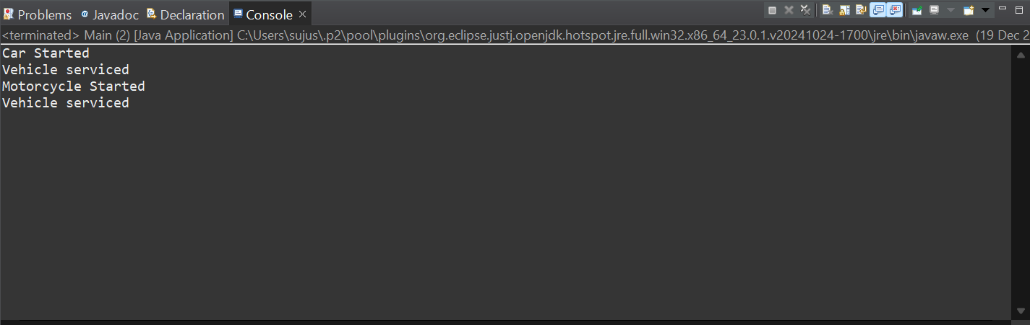

**Assignment-2.**

**2.** Create a class called Student.

Inside the Student class, implement the following instance variables (fields):

• String name

• int age

• String department

Implement the following constructors in the Student class: A default constructor that initializes the name to "Unknown", age to 20, and department to "Unassigned".

• A constructor that takes two parameters: name and age, and initializes the department to "IT".

• A constructor that takes three parameters: name, age, and department.

In the Main class, create instances of the Student class using each constructor.

Print out the details of each student, in cluding their name, age, and department.

**CODE:**

package poly;

class Student {

String name;

int age;

String department;

// Default constructor

public Student() {

this.name = "Unknown";

this.age = 20;

this.department = "Unassigned";

}

// Constructor with name and age

public Student(String name, int age) {

this.name = name;

this.age = age;

this.department = "IT";

}

// Constructor with name, age, and department

public Student(String name, int age, String department) {

this.name = name;

this.age = age;

this.department = department;

}

// Method to display student details

public void displayDetails() {

System.out.println("Name= " + name);

System.out.println("Age= " + age);

System.out.println("Department= " + department);

System.out.println();

}

}

public class Mainp {

public static void main(String[] args) {

// Create instances of Student class using different constructors

Student s1 = new Student();

Student s2 = new Student("sukumar", 22);

Student s3 = new Student("Saanu", 22, "Information Science");

// Display details of each student

s1.displayDetails();

s2.displayDetails();

s3.displayDetails();

}

}

**OUTPUT:-**

