**Session 5-LAB**

1).Write a Java program that demonstrates various operations on a 3D array:

1. Initializing the 3D array with random values.

2. Finding the maximum value in the array.

3. Calculating the average of all elements.

4. Displaying the array.

**CODE:**

package ThreeDArray;

import java.util.Random;

public class ThreeDArrayOperations {

public static void main(String[] args) {

// Initialize 3D array

int[][][] array = new int[3][3][3];

Random random = new Random();

int maxValue = Integer.MIN_VALUE;

int sum = 0;

int count = 0;

//Fill the array with random values and calculate max, sum, and count

for (int i = 0; i < 3; i++) {

for (int j = 0; j < 3; j++) {

for (int k = 0; k < 3; k++) {

array[i][j][k] = random.nextInt(100) +1; // Random values 1-100

maxValue = Math.max(maxValue, array[i][j][k]);

sum += array[i][j][k];

count++;

}

}

}

// Display the 3D array

System.out.println("3D Array:");

for (int[][] layer : array) {

for (int[] row : layer) {

for (int value : row) {

System.out.print(value + " ");

}

System.out.println();

}

System.out.println();

}

// Display results

System.out.println("Maximum Value: " + maxValue);

System.out.println("Average Value: " + (double) sum / count);

}

}

**O/P**

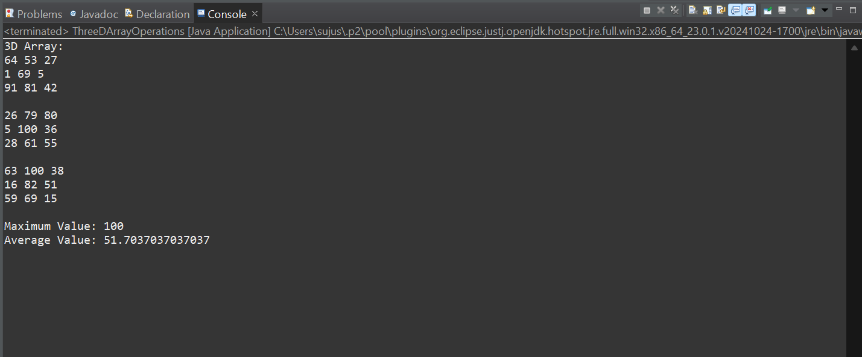

**2**. Write a Java program that performs addition of two matrices. The program should use a 2D array of wrapper class objects (e.g., Integer) for the matrix elements. Take two matrices as input, perform the addition operation, and display the resulting matrix.

**CODE**

package ThreeDArray;

import java.util.Scanner;

public class MatrixAddition {

public static void main(String[] args) {

Scanner scanner = new Scanner(System.in);

// Take dimensions of the matrices

System.out.print("Enter the number of rows: ");

int rows = scanner.nextInt();

System.out.print("Enter the number of columns: ");

int cols = scanner.nextInt();

// Initialize two matrices and the result matrix

Integer[][] matrix1 = new Integer[rows][cols];

Integer[][] matrix2 = new Integer[rows][cols];

Integer[][] resultMatrix = new Integer[rows][cols];

// Input elements for the first matrix

System.out.println("Enter elements for the first matrix:");

fillMatrix(scanner, matrix1);

// Input elements for the second matrix

System.out.println("Enter elements for the second matrix:");

fillMatrix(scanner, matrix2);

// Perform addition of the two matrices

addMatrices(matrix1, matrix2, resultMatrix);

// Display the result matrix

System.out.println("Resultant Matrix:");

displayMatrix(resultMatrix);

scanner.close();

}

private static void fillMatrix(Scanner scanner, Integer[][] matrix) {

for (int i = 0; i < matrix.length; i++) {

for (int j = 0; j < matrix[i].length; j++) {

System.out.print("Enter element [" + i + "][" + j + "]: ");

matrix[i][j] = scanner.nextInt();

}

}

}

// Method to add two matrices and store the result in the result matrix

private static void addMatrices(Integer[][] matrix1, Integer[][] matrix2, Integer[][] resultMatrix) {

for (int i = 0; i < matrix1.length; i++) {

for (int j = 0; j < matrix1[i].length; j++) {

resultMatrix[i][j] = matrix1[i][j] + matrix2[i][j];

}

}

}

private static void displayMatrix(Integer[][] matrix) {

for (Integer[] row : matrix) {

for (Integer element : row) {

System.out.print(element + " ");

}

System.out.println();

}

}

}

**O/P**

