Heart Disease Prediction — Project Report

Overview
This repository implements a FastAPI service for predicting heart disease from structured patient data, trained and packaged with scikit-learn and deployed via Docker and Kubernetes. The project includes monitoring (Prometheus metrics), structured JSON logging, and CI/CD-ready manifests.

Contents
- Code: api/, src/, src/model packaging & reprd.py
- Data: data/raw/, data/processed/
- Models: models/model_pipeline.pkl
- Docker and k8s manifests: Dockerfile, k8s/ and deployment/
- Tests: tests/
- Screenshots: screenshots/

Setup & Install Instructions
Prerequisites: Docker, kubectl (for local Kubernetes), Python 3.9+ (conda recommended).
- Create the project conda env (optional):
conda create -n heart-api python=3.9 -y
conda activate heart-api
pip install -r requirements.txt
- Run locally (development):
# from repo root
uvicorn api.main:app --host 0.0.0.0 --port 8001
# then
curl http://127.0.0.1:8001/health
curl http://127.0.0.1:8001/metrics
- Build production image:
docker build -t heart-api:1.0 .
- Deploy to local Kubernetes (Docker Desktop):
kubectl apply -f k8s/deployment.yaml
kubectl apply -f k8s/service.yaml
kubectl apply -f k8s/ingress.yaml # if using ingress
- Prometheus (local): use the provided prometheus.yml or ServiceMonitor if using the Prometheus Operator. The API exposes /metrics.

Data, EDA & Modelling Choices
- Dataset: coronary heart disease dataset (provided in data/raw/heart.csv). Cleaned/preprocessed csv at data/processed/heart_cleaned.csv.
- EDA: key distributions examined (age, chol, thalach). Correlations used to inform feature selection — numeric columns standardized: age, trestbps, chol, thalach, oldpeak.
- Model: RandomForestClassifier with a preprocessing pipeline (StandardScaler for numeric features) saved as models/model_pipeline.pkl.
- Rationale: pipeline ensures consistent preprocessing at training and inference. Random forest chosen for robustness and interpretability of feature importance.

EDA screenshots
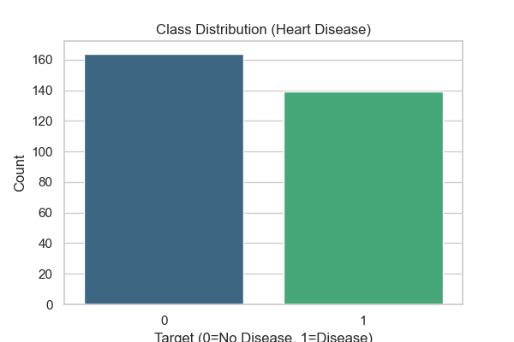
Class distribution
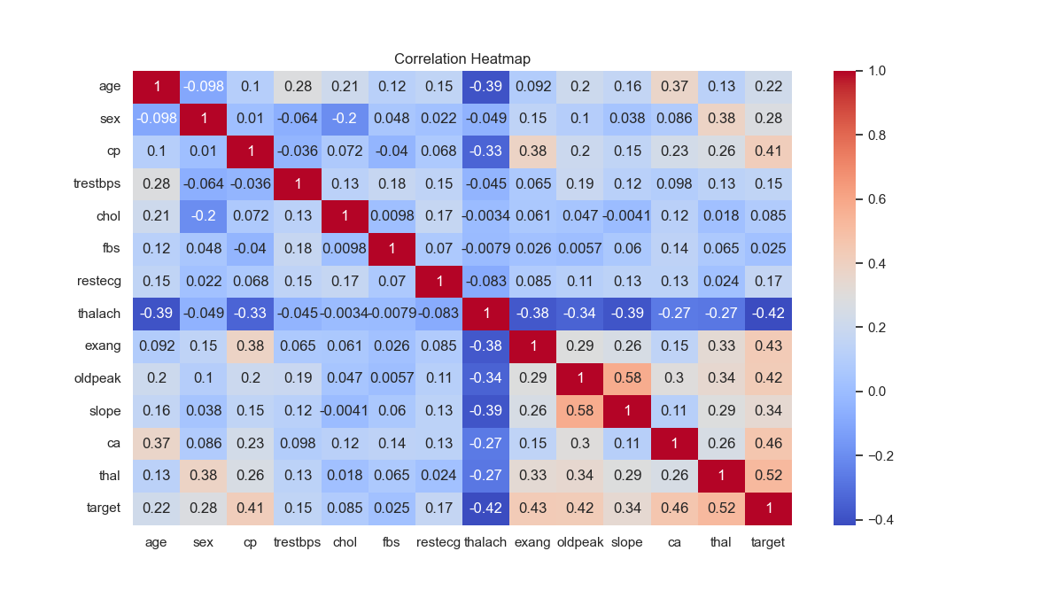
Correlation heatmap
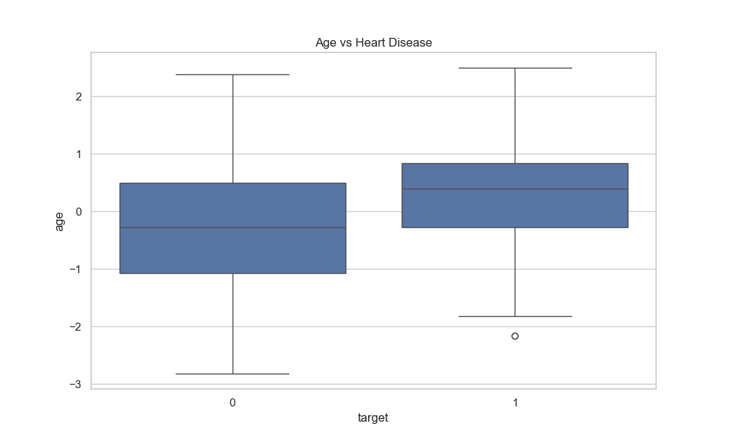
Age vs Heart Diesease
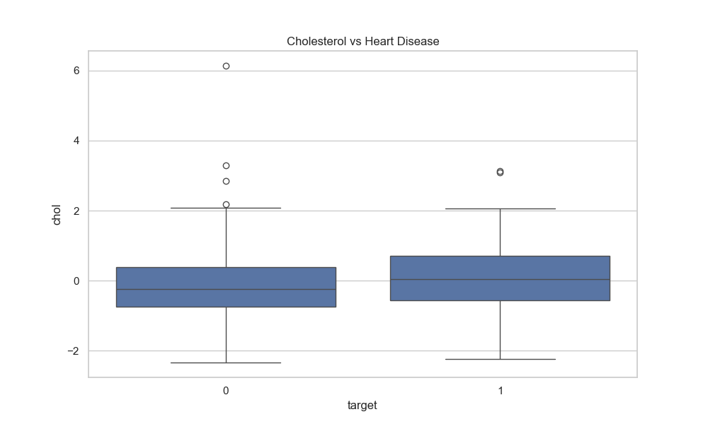
Cholestral vs Heart diesease

Experiment Tracking Summary
- Experiments were tracked with MLflow (see mlruns/ folder). Tracked artifacts include model artifacts, roc_curve.png, and feature_importance.png.
- Notable metrics: accuracy and ROC AUC saved in MLflow runs located under mlruns/.

Packaging & Deployment
- Dockerfile builds a slim Python image, installs pinned production dependencies, copies the app, and runs uvicorn as a non-root user.
- Kubernetes manifests provided under k8s/ include liveness and readiness probes targeting /health, resource requests/limits, and service annotations for Prometheus scraping.
Key deployment commands
# build and push (if using remote registry)
docker build -t <registry>/heart-api:1.0 .
docker push <registry>/heart-api:1.0
# update deployment
kubectl set image deployment/heart-api heart-api-container=<registry>/heart-api:1.0

Observability (Logging & Metrics)
- Structured JSON logging with python-json-logger (configured in api/main.py).
- Prometheus metrics: request count and latency exposed via /metrics (implemented with prometheus_client).
- Local verification steps:
# run the app locally then
curl http://127.0.0.1:8001/metrics
# or, when deployed, ensure Prometheus scrapes the service target

Architecture Diagram
graph LR
A[Users / Clients] -->|HTTP| B[Ingress / Service]
B --> C[FastAPI app (Pod)]
C --> D[Model artifact on FS]
C --> E[Prometheus scrape /metrics]
C --> F[Logging -> stdout]
Place the final, high-resolution architecture image in screenshots/architecture.png and replace this mermaid block if desired.

CI/CD & Deployment Workflow (screenshots)
- Include screenshots of GitHub Actions or Jenkins pipeline runs in screenshots/ci_cd/.
- Recommended pipeline steps: lint, tests, build image, push image, deploy to cluster.
Included screenshots:
- screenshots/ci_cd/ci_pipeline.png — CI pipeline steps (lint/tests/build/deploy).
- screenshots/ci_cd/deployment_rollout.png — Deployment and pod rollout illustration.
- screenshots/ci_cd/prometheus_dashboard.png — Prometheus/Grafana dashboard placeholders to be replaced with real screenshots.
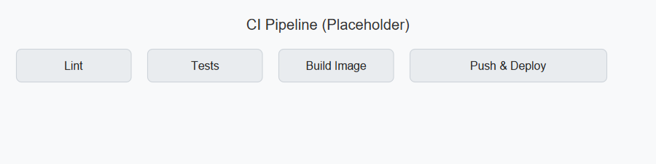
CI pipeline
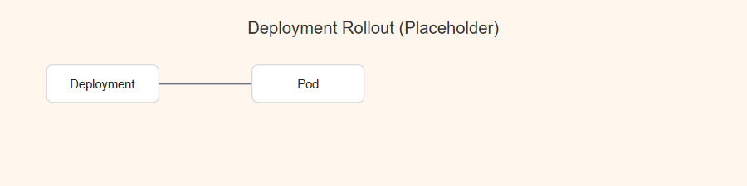
Deployment rollout
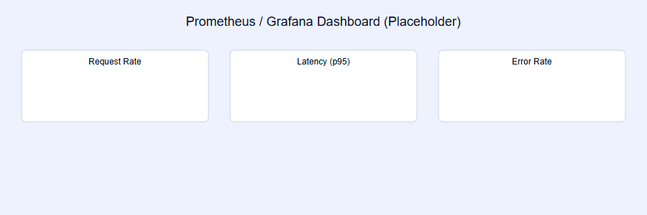
Prometheus dashboard

Tests & Quality
- Unit tests located in tests/ covering preprocessing and model inference.
- Run tests:
pytest -q

Results & Validation
- The service exposes /predict for inference; example payload listed in tests/test_model.py.
- Model performance metrics (accuracy, ROC AUC) logged in MLflow runs under mlruns/.

Deliverables Checklist
- Code, Dockerfile, requirements.txt
- Cleaned dataset in data/processed/
- Notebooks / scripts in src/
- tests/ with unit tests
- Kubernetes manifests in k8s/ and deployment/
- CI/CD workflow screenshot(s) in screenshots/
- Monitoring configured (/metrics, prometheus.yml)

Repo Access
This report corresponds to the repository at the workspace root. Replace the placeholder below with your repository URL:
Project repository (placeholder)

Next steps (suggested)
- Add CI/CD run screenshots to screenshots/ci_cd/ and mark them in the checklist.
- Replace the mermaid architecture diagram with a PNG export for final submission.
- Optionally generate a PDF:
# requires pandoc
pandoc report.md -o report.pdf --from markdown

Appendix: For any questions or if you want me to generate report.pdf and embed actual screenshots, tell me and I will produce them. # Project Report

