Agile Tutorials | Absolute Beginner Guide | Tamil | Introduction | 01 | LAO

Agile is one of the widely used in Software development industry and having knowledge on Agile is one of the most expected out of candidates.
Most people believe that Agile means faster development and delivery of software, but that is not the case. In this video, I tried to debunk several assumptions on Agile and tried my best make the audience understand the different types of Software Development Lifecycle (SDLC) like Waterfall, Win-Win, Spiral, and Agile.
In short this video is all about a detailed introduction to the Agile software development.

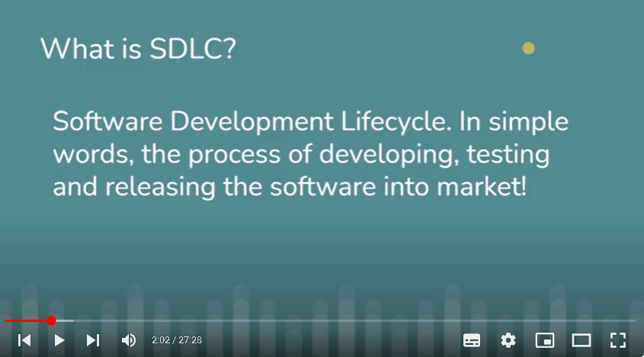
Waterfall and agile enough to read
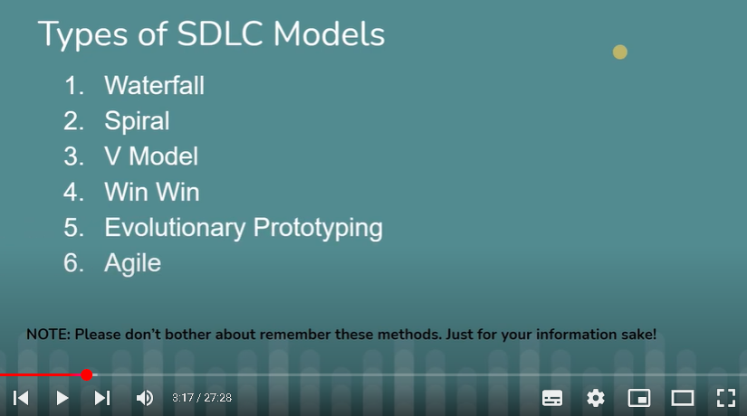
In waterfall, testing will come once product fully read, where as agile testing parallel with development
Customer wil not happy by seeing the product at the last..difficult to change the product once fully ready whereas agile each small story we are interacting with customer and reaching the feedback and easy to change
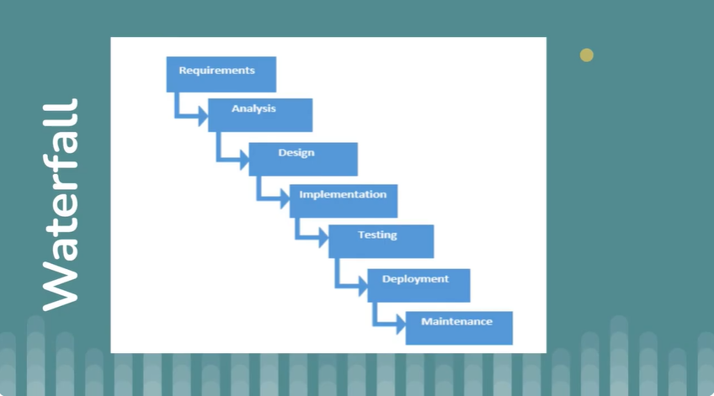

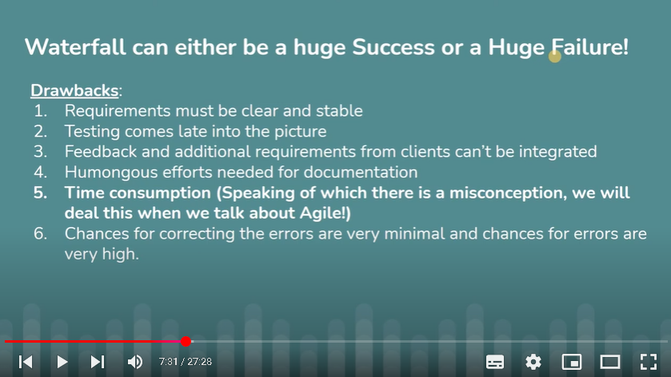
Agile ->general google meaning - able to move quickly and easily
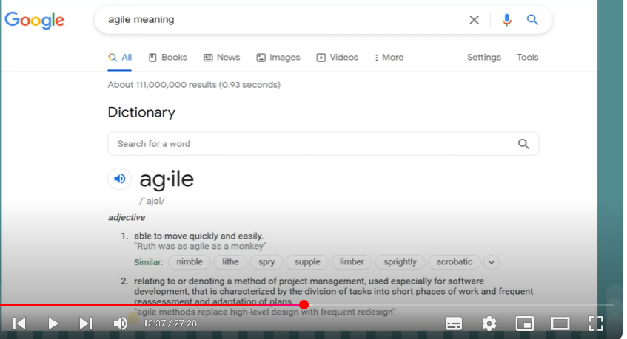

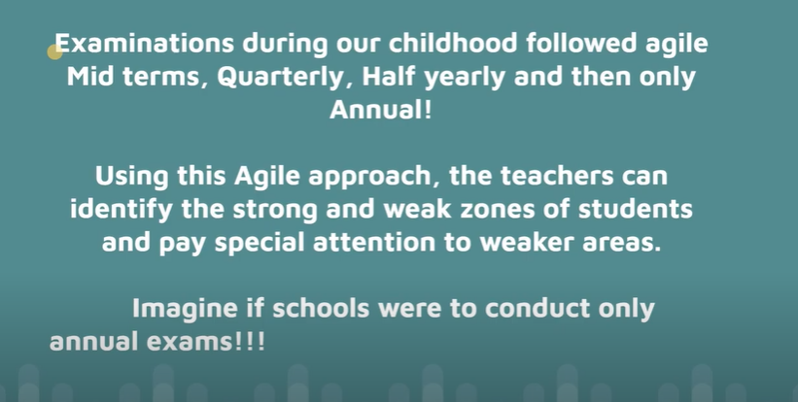

Agile manifesto
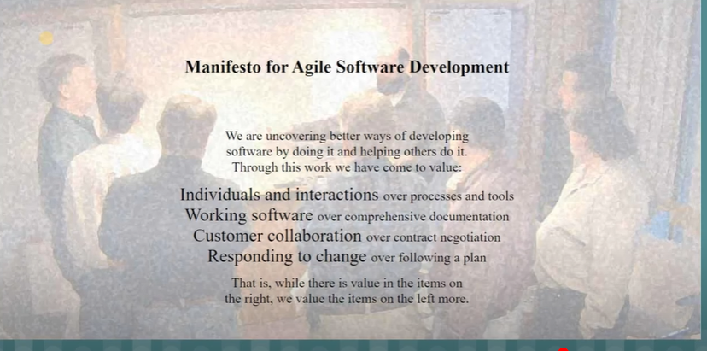

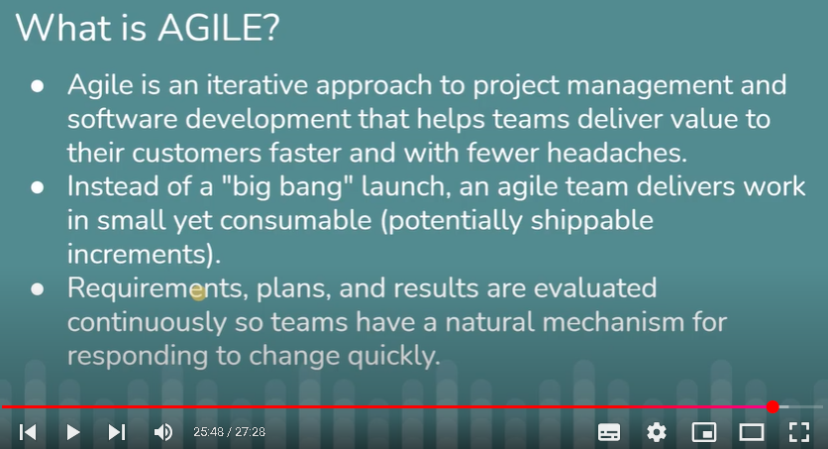

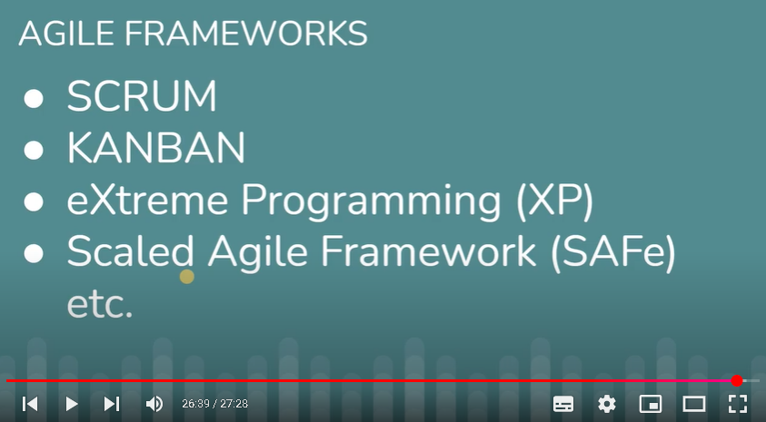

Agile Methodology principles:
Agile methodology is a modern approach to project management that emphasizes flexibility, collaboration, and incremental delivery. It is designed to respond to unpredictability through iterative cycles of planning, executing, and evaluating. Below are Agile Methodology Principles.

- Iterative and Incremental: Agile projects are divided into small iterations or sprints, typically 1-4 weeks long. Each iteration results in a potentially usable product feature.
- Customer Collaboration: Agile teams prioritize customer collaboration and feedback. They work closely with stakeholders to understand and deliver what the customer truly needs.
- Adaptive to Change: Agile embraces changes in requirements throughout the project lifecycle. It encourages continuous adaptation and flexible responses to change.
- Empowered Teams: Agile teams are self-organizing and cross-functional, with members from different disciplines working together to achieve project goals.
- Frequent Delivery of Working Software: Agile projects prioritize delivering working software frequently, typically every few weeks, to maximize customer value.
- Continuous Improvement: Agile promotes continuous improvement and learning. Teams regularly reflect on their processes and adjust them to improve efficiency and effectiveness.
- Transparent and Open Communication: Agile fosters transparent communication within teams and with stakeholders. Information is shared openly to build trust and alignment.
- Focus on Quality: Agile teams emphasize sustainable development and strive to maintain a constant pace. They maintain high standards of work through continuous attention to technical excellence and good design.
- Early and Predictable Delivery: Agile provides early and predictable delivery of products, with incremental releases that allow for more realistic planning and improved stakeholder satisfaction.
- Close Collaboration Between Developers and Business Users: Agile methodologies emphasize close daily cooperation between developers and business people.

Advantage of Agile Methodology Project Management:
- Flexibility: The Agile methodology is flexible, allowing the project team to make changes and adjustments to the project in the middle of the project.
- Efficiency: The Agile methodology is efficient, as it allows the project team to deliver working products in small, incremental stages.
- Client Involvement: The Agile methodology involves the client throughout the project, which can lead to better understanding and satisfaction.

Disadvantages of Agile Methodology Project Management:
- Complexity: The Agile methodology can be complex, requiring skilled and experienced project team members.
- Lack of Predictability: The Agile methodology lacks predictability, as the project's scope, timeline, and budget are not determined at the beginning of the project.
- Documentation: The Agile methodology requires less documentation, which can make future maintenance and updates challenging.

Waterfall Methodology principles
The Waterfall methodology is widely used in industries where requirements are static and changes are expensive or time-consuming to implement.
Key principles of the Waterfall methodology include:
- Sequential Flow: The phases of the project are completed sequentially, and progress flows in one direction—like a waterfall—from the top to the bottom.
- Document-Driven: There is a strong emphasis on documentation. Requirements, design, and other project aspects are documented extensively at the beginning of the project.
- Rigid Structure: The Waterfall methodology is highly structured and rigid. Each phase has specific deliverables and milestones that must be completed before the next phase can begin.
- Limited Flexibility: Changes to requirements or design are difficult to accommodate once the project is underway, as the process assumes all requirements are known upfront.
- Risk Management: Risks are addressed during the early stages of the project, with preventive measures identified and planned.
- Well-Suited for Stable Requirements: It is best suited for projects where requirements are well understood and unlikely to change significantly.

Advantage of Waterfall Methodology:
- Easy to Understand: The waterfall methodology is easy to understand as it follows a linear sequential process that makes it easy for the team to understand the project requirements.
- Predictability: The waterfall methodology provides predictability, as the project's scope, budget, and timeline are determined at the beginning of the project.
- Documentation: The waterfall methodology requires extensive documentation of the project's requirements, which can help in future maintenance and updates.

Disadvantage of Waterfall Methodology:
- Lack of Flexibility: The waterfall methodology is rigid and lacks flexibility, making it challenging to make changes in the middle of the project.
- Inefficient: The waterfall methodology is inefficient, as each phase must be completed before moving on to the next one, which can cause delays in the project's delivery.
- Client Involvement: The waterfall methodology does not involve the client until the end of the project, which can lead to misunderstandings and dissatisfaction.

Conclusion
Choosing between Agile and Waterfall project management depends on the project's needs. Waterfall is good for projects with clear and stable requirements, offering structured planning and clear milestones. Agile is flexible, suited for projects with evolving requirements, allowing for continuous improvement and faster delivery. Both have strengths and weaknesses, and the choice should consider project scope, timeline, team dynamics, and customer feedback, both methodologies have their strengths and weaknesses, and the decision should be based on factors such as project scope, timeline, team dynamics, and customer requirements.

Agile Tutorials | Absolute beginner guide | Tamil | Scrum overview | 02 | LAO

Scrum is one of the widely used frameworks of Agile methodology. In this video, I have discussed about the scrum overview, scrum roles, Scrum events in brief.

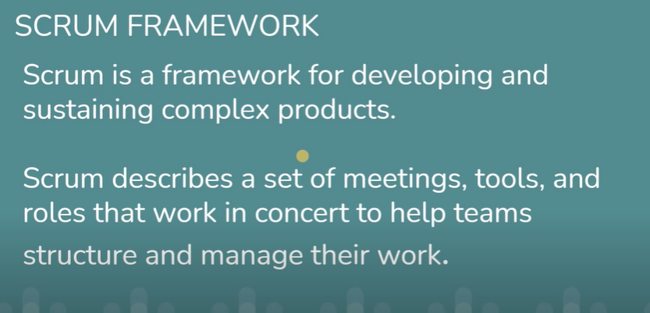

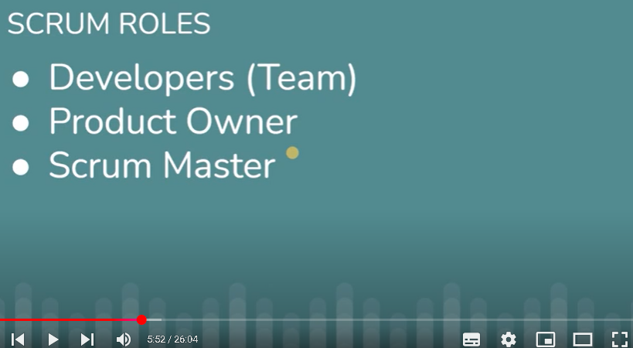

Team ->it will include all dev, tester

Product owner ->all doubts regarding to the product/req, need to check with product owner

All the requirement will be available in jira board

Backlog -> End user requirement

Product Backlog ->Initially all the req will be under product backlog only

Sprint Planning ->Team(Developer, tester) will discuss with product owner and identified important requirement to be taken for development/testing

Sprint Backlog(Tasks) -> identified important requirement from the sprint planning meeting move to sprint backlog

1 Sprint ->small interval time..usually 1 to 4 weeks..mainly 2 weeks to delivery a small feature of the product

Standup meeting/scrum meeting daily ->daily it will happen , in the meeting they will discuss 3 items

What i have done yesterday

What am going to do today

Any blocker

Scrum master(coach) will conduct the Standup meeting/scrum meeting daily...it will make sure all scrum principle and methodologies followed

After 1 sprint ->product will be ready

Sprint review meeting ->to review the developed product performance

Sprint retrospective meeting: to review the team performance , what went well, what need to improve , what tool can be implement

Eg, if the team not completed all the requirement, then particular req will go again to product backlog and in the next sprint planning will discuss and take it for next sprint..Note: they will not extent the sprint days if the req not completed, only they move to product backlog
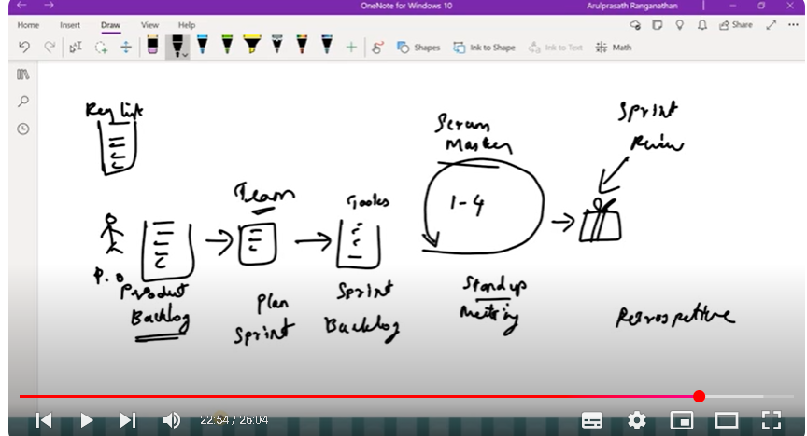

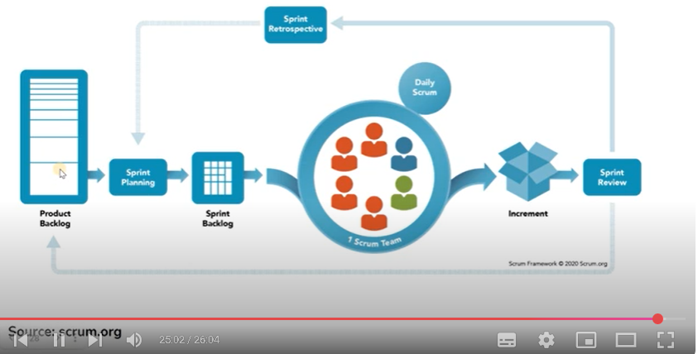

Agile Tutorials | Absolute Beginner Guide | Tamil | Scrum Roles | 03 | LAO

In this video, we will take a look at the different scrum roles as well as their roles and responsibilities

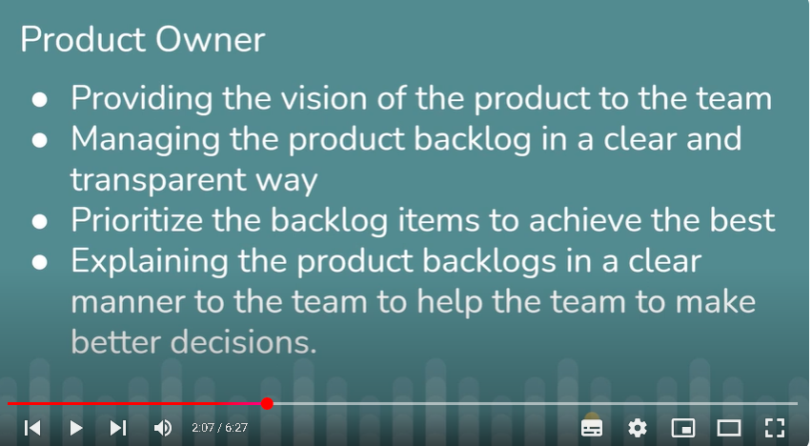

Project owner just tell this and all important req and need to complete first. But team only discuss and take req & commit

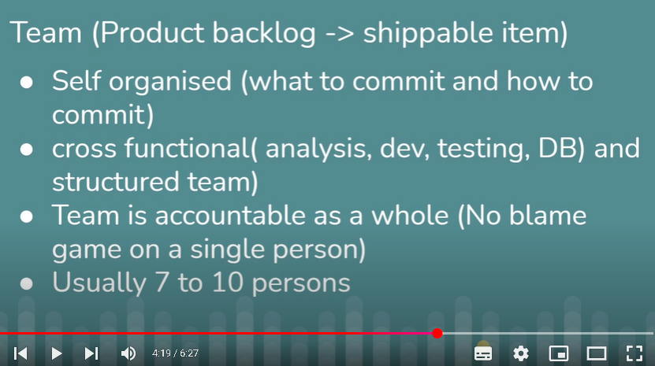

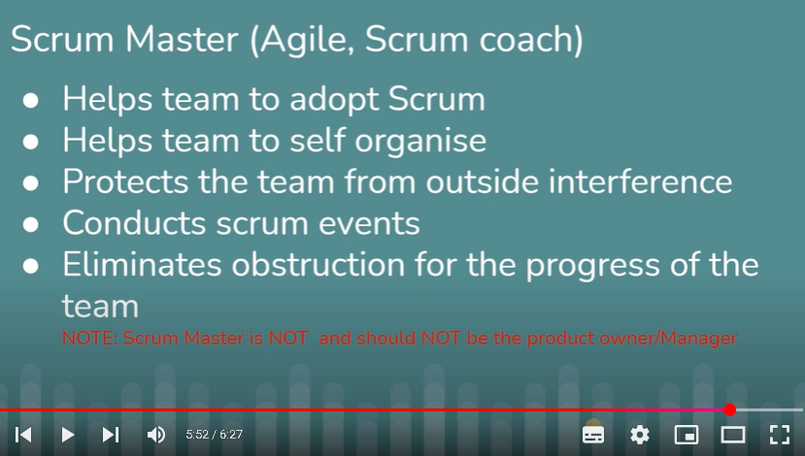

Agile Tutorials | Absolute beginner guide | Tamil | Scrum Ceremonies| 04 | LAO

Scrum ceremonies or Scrum events are the place where the actual work and work plan takes place. In this video, we will learn about the different types of scrum events, duration of each scrum events and when will it take place. Also, we will be learning about the outcome of each of the scrum events.

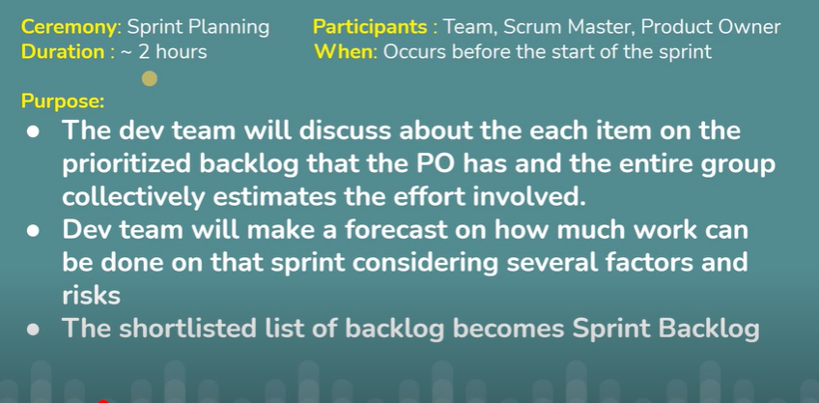

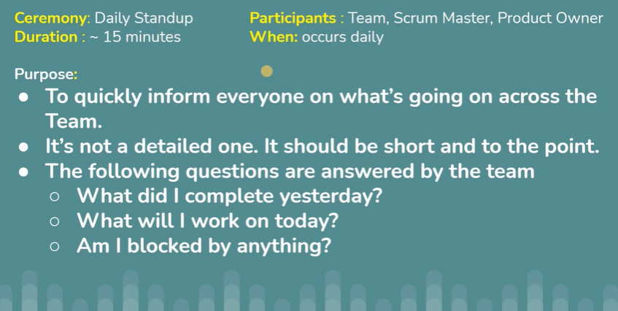

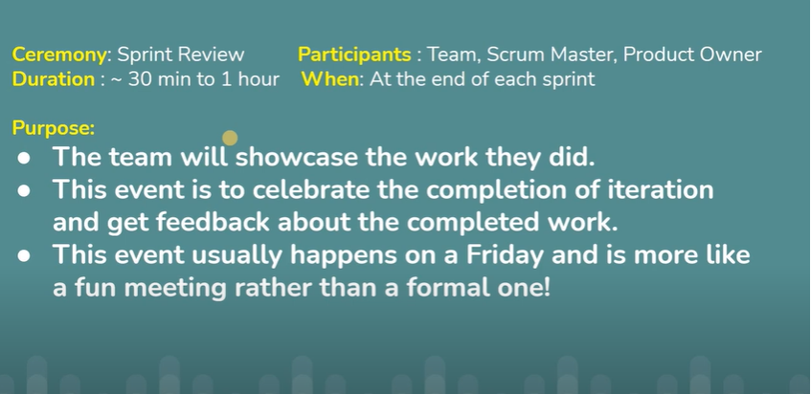

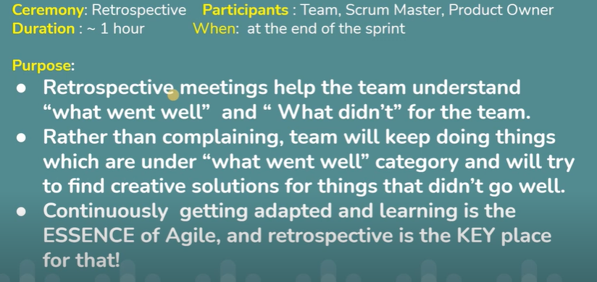

Agile Tamil Tutorial | Scrum Artifacts | Scrum Values | 05 | LAO

In this video, we will learn about Scrum Artifacts and Scrum values. The video, got ended suddenly, as I accidentally pressed the escape button. What I meant to say in the is, "If you want to learn more about scrum, use this as reference https://scrumguides.org/index.html".

Scrum Artifacts->like a document about the product details being developed in each stage
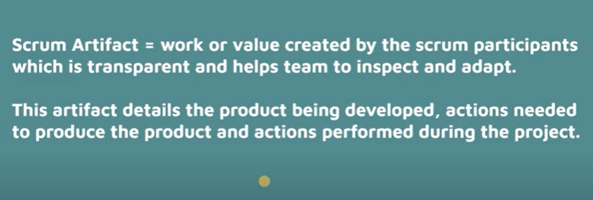

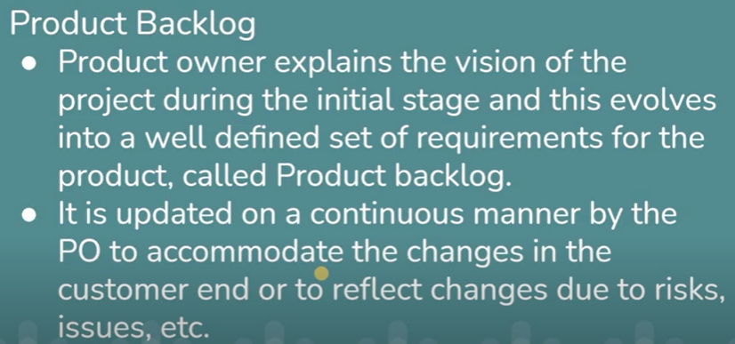

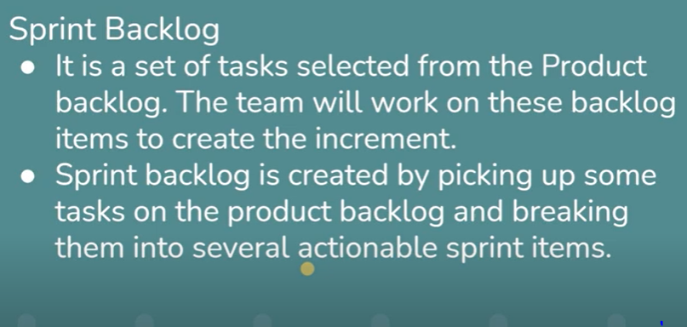

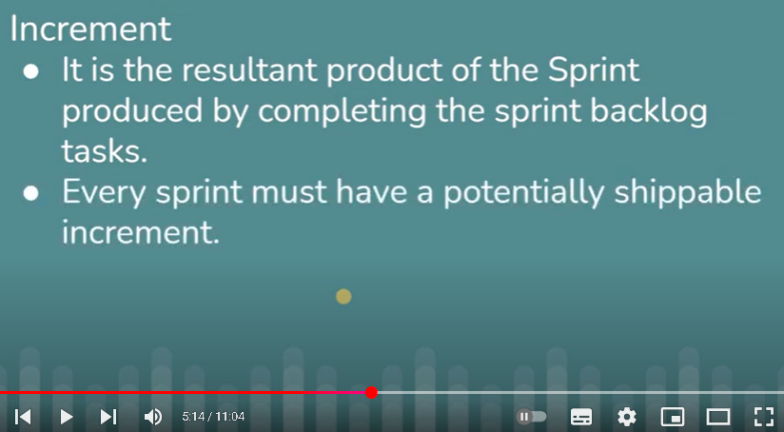
Scrum Values
