XPath

Xpath | Absolute Beginner Guide | PART-1 | Intro | Writing XPath with Elements & Attributes | Tamil

One of the most anticipated topics on Learn Automation Online is writing Xpath. There is no wonder why this is the most expected topic. Because XPath play a major role in test automation projects and they are very crucial in the interview as well. This has two parts and this is the part one of the XPath tutorials.

What will we learn in this video?
1. Why do we need XPATH? Why not other locators? -> For some element ->ID, name are not present in that case we need to reply on xpath only..even name and ID present some times its changed continually then we can go with xpath only
2. Can we rely on browser plugins alone?
3. What is XPATH? -> XPATH means XML Path [Extensible Markup Language], used to locating an element in a web page
4. How XML PATH and its functions handle HTML elements ?
Webpage is HTML, then how xml is able to read the value from html because of SGML(std generalised markup lang)
For both HTMl & xml the parent is SGML(std generalised markup lang)..
5. Types of XPath
Absolute: start from root node & with start single “/”
Eg :/ html/body/div
Relative: start from current node & with start single “//”
6. Identification strategies:
a) Locating Elements with Known Attribute
b) Locating Elements with known Element and Attributes
c) Locating Elements with Known Visible Text (exact match)
d) Locating Elements when part of the visible text (partial match)
e) Locating Elements with Multiple Attributes
f) Locating elements when starting visible text is known
g) Locating Elements with Dynamic Attribute values

Xpath can be bidirectional navigation [going forward and backward]
Element is input
Attributes is class, name, placeholder
Value is username
a) Locating Elements with Known Attribute & unknown element name
unknown element so using *
Syntax: //*[@attribute=’value’]
Eg: //*[@name='username']
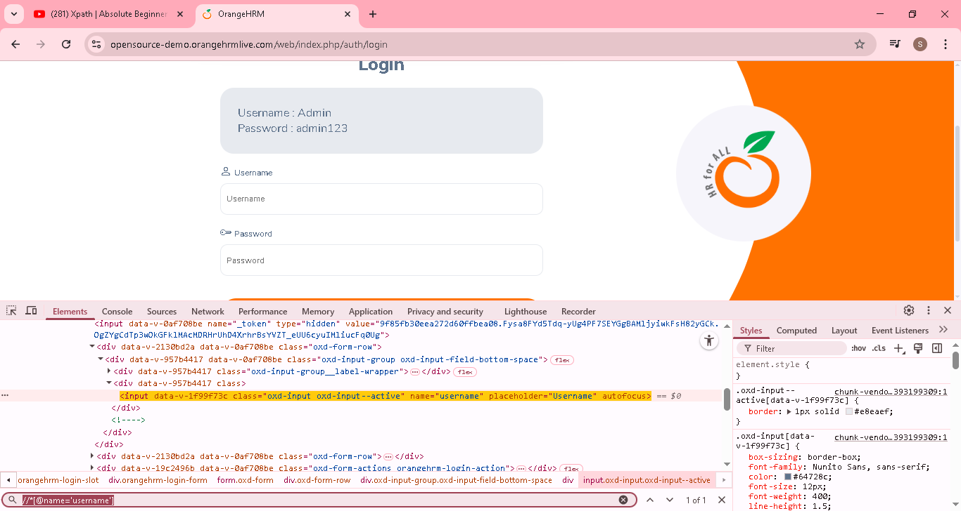
b) Locating Elements with known Element and Attributes
Syntax: //elementname[@attribute=’value’]
Eg: //input[@name='username']
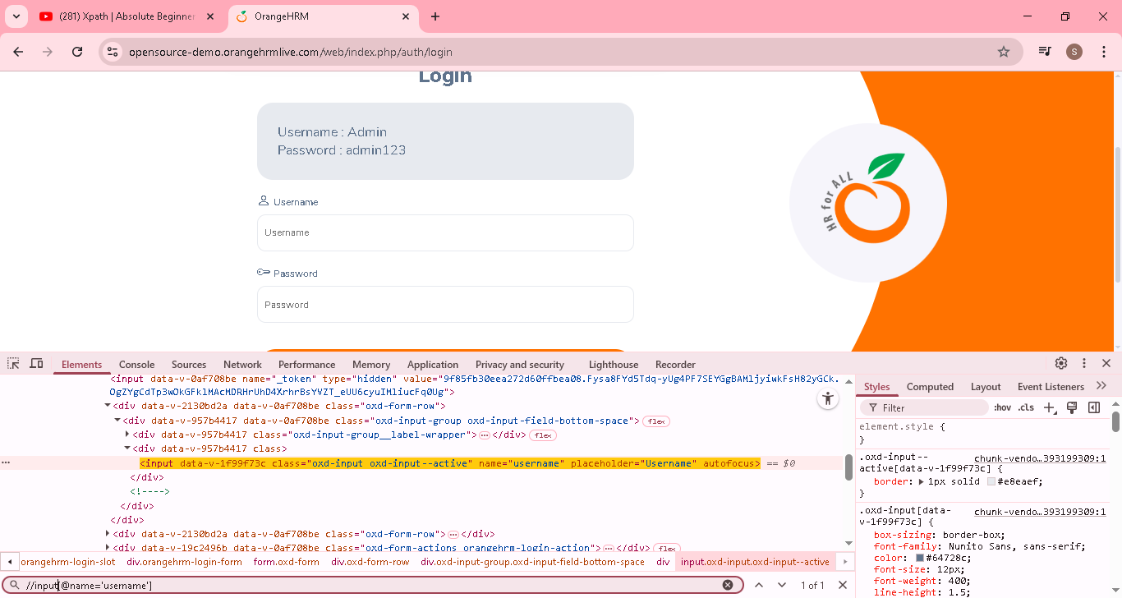
c) Locating Elements with Known Visible Text (exact match)
Syntax: //elementname[text()=’Exact text’]
EG: //*[text()='Login'] or //h5[text()='Login']
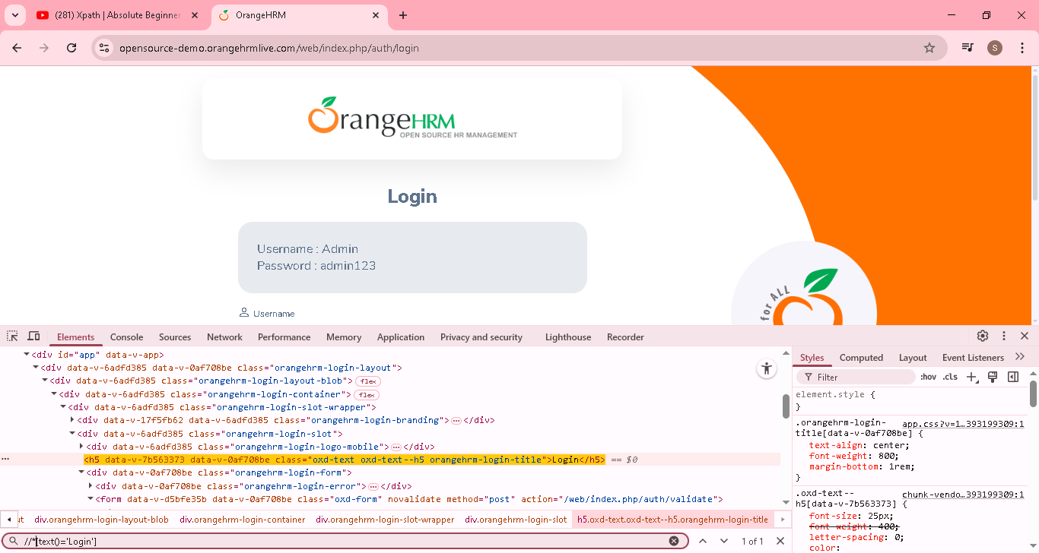
d) Locating Elements when part of the visible text (partial match)
Syntax: //elementname[contains(text(), ’part of the text’)]
EG: //a[contains(text(),'OrangeHRM')]
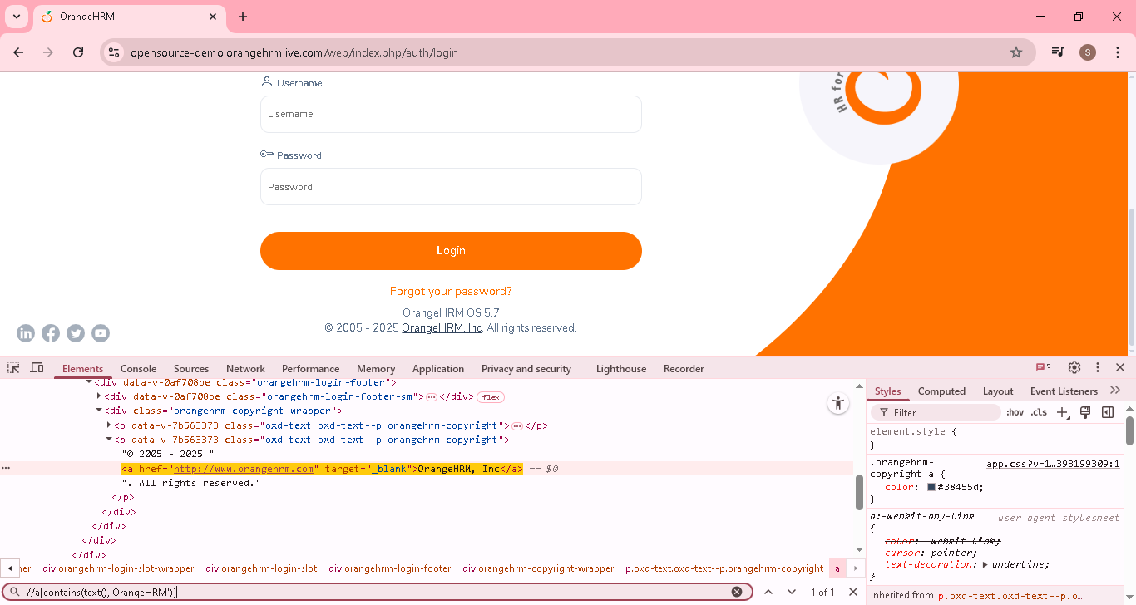
e) Locating Elements with Multiple Attributes
Syntax: //*[@attribute1=’value’][@attribute2=’value’][@attribute3=’value’] so on
EG: //*[@name='username'][@Class='oxd-input oxd-input--active']
For eg...some elements, they have common attributes value in that case we need to add additional attributes condition to find unique element..
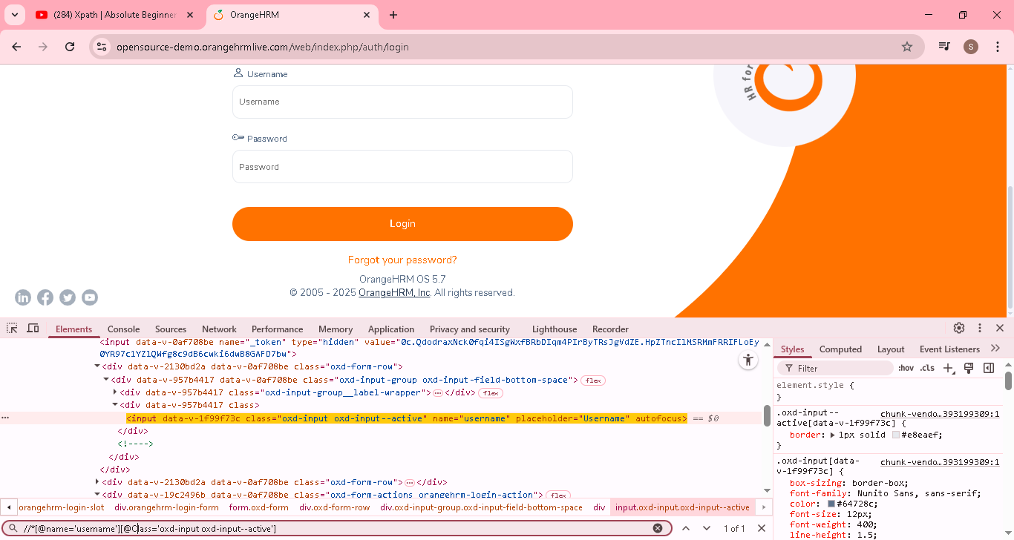
f) Locating elements when starting visible text is known
Syntax: //elementname[starts-with (text(), ’starting text’)]
EG: //a[starts-with(text(),'OrangeHRM')]

Eg element have id value as “Agni123” and next time the value changed to “Agni456” and so on on that case we can use starts-with
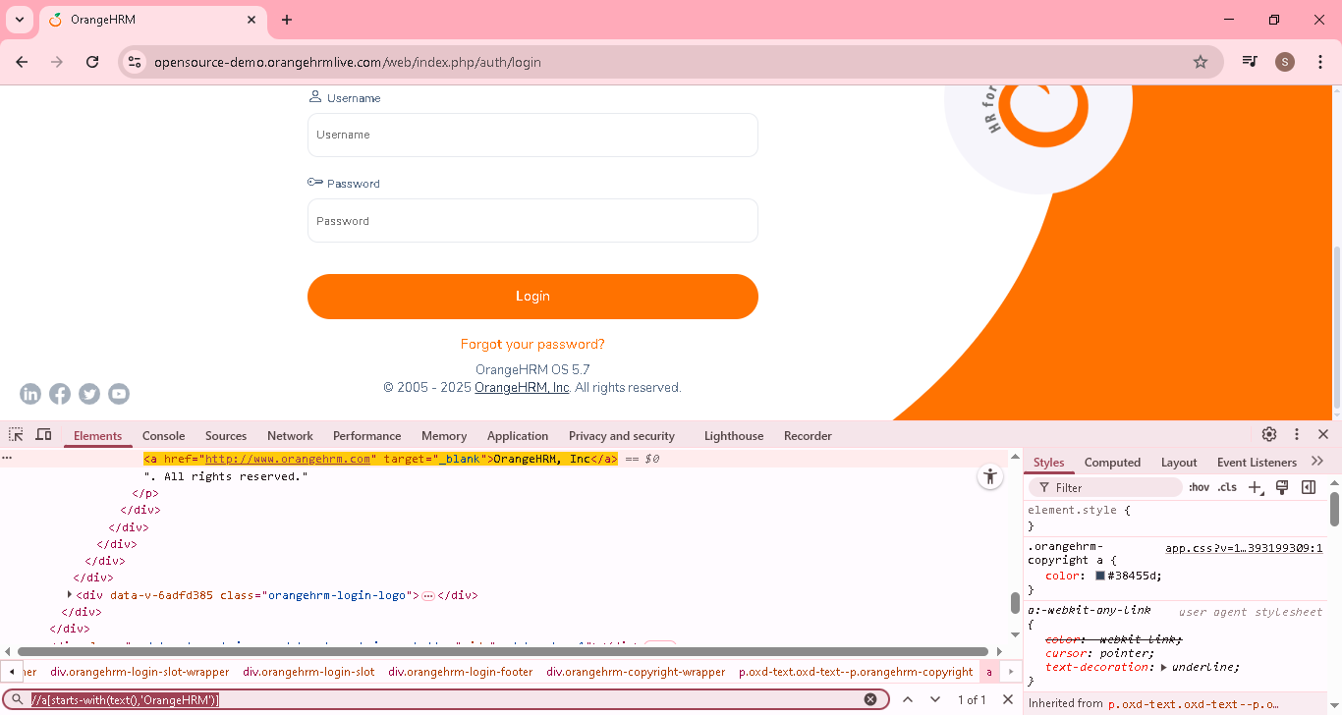

g) Locating Elements with Dynamic Attribute values
1.Syntax: //elementname[starts-with (@attributes, ‘fixed prefix of the value’)]
EG: //*[starts-with(@name,'user')]
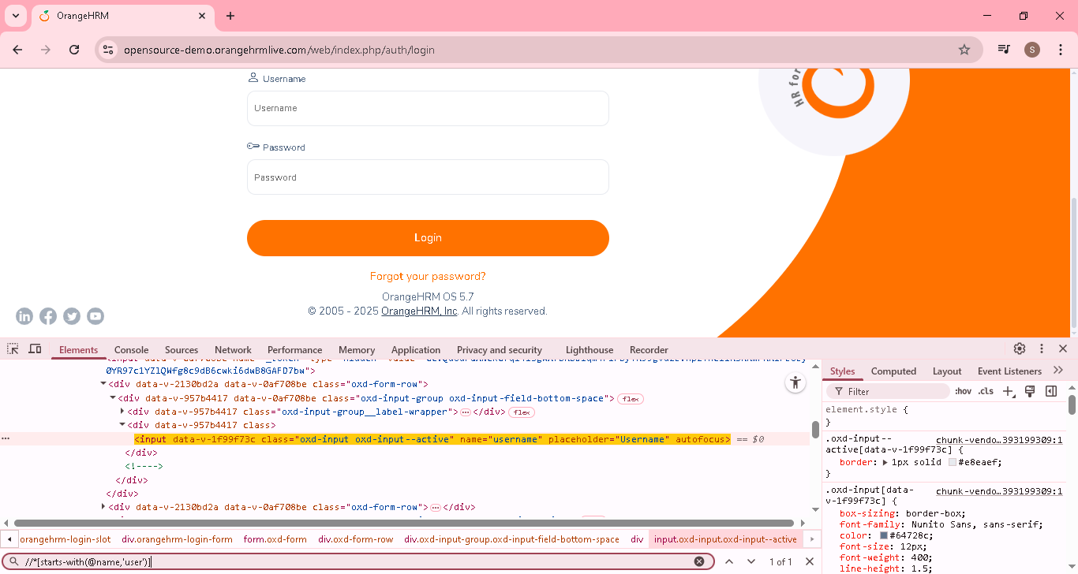
2.Syntax: //elementname[contains (@attributes, ‘part of the value’)]
EG: // //*[contains(@name,'user')]

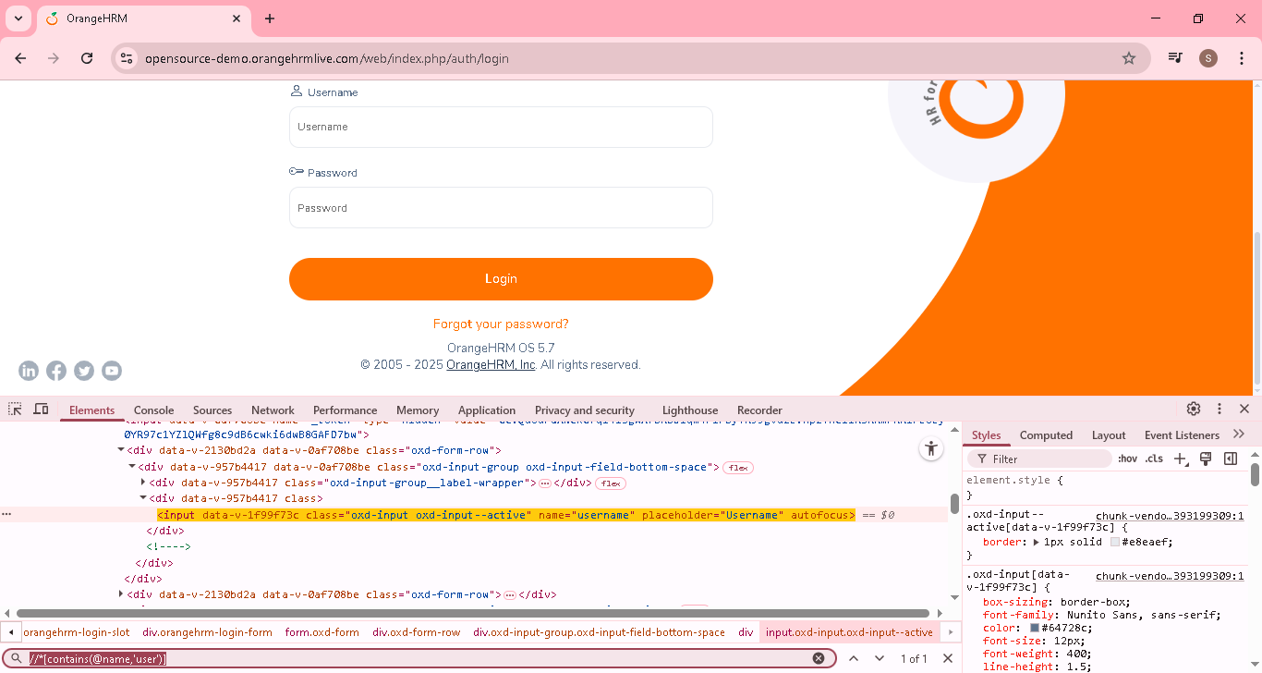

Xpath | Absolute Beginner Guide | PART-2 | Locating elements relative to a known element
One of the most anticipated topics on Learn Automation Online is writing Xpath. There is no wonder why this is the most expected topic. Because XPath play a major role in test automation projects and they are very crucial in the interview as well. This has two parts and this is the part TWO of the XPath tutorials.

1.Locating a parent element
2.Locating a child element
3.Locating ancestors of a known element
4.Locating the following elements
5.Locating preceding element
6.Locating the following sibling
7.Locating preceding sibling

1.Locating a parent element [show immediate parent of particular element]
Syntax:<knownxpath>/parent::elementname
EG: //*[@name='username']/parent::div or //*[@name='username']/parent::*
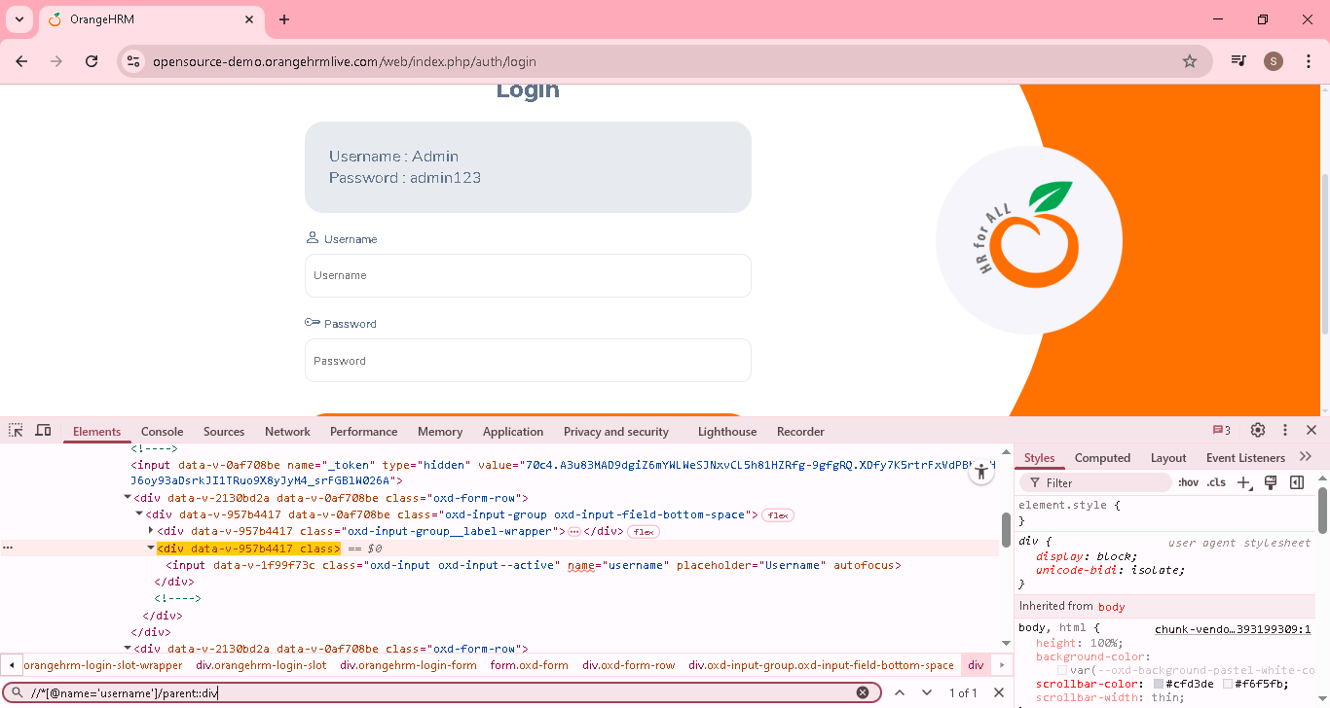

2.Locating a child element [show the child of particular element]
Syntax: :<knownxpath>/child::elementname
EG: //*[@name='username']/child::p or //*[@name='username']/ child::*
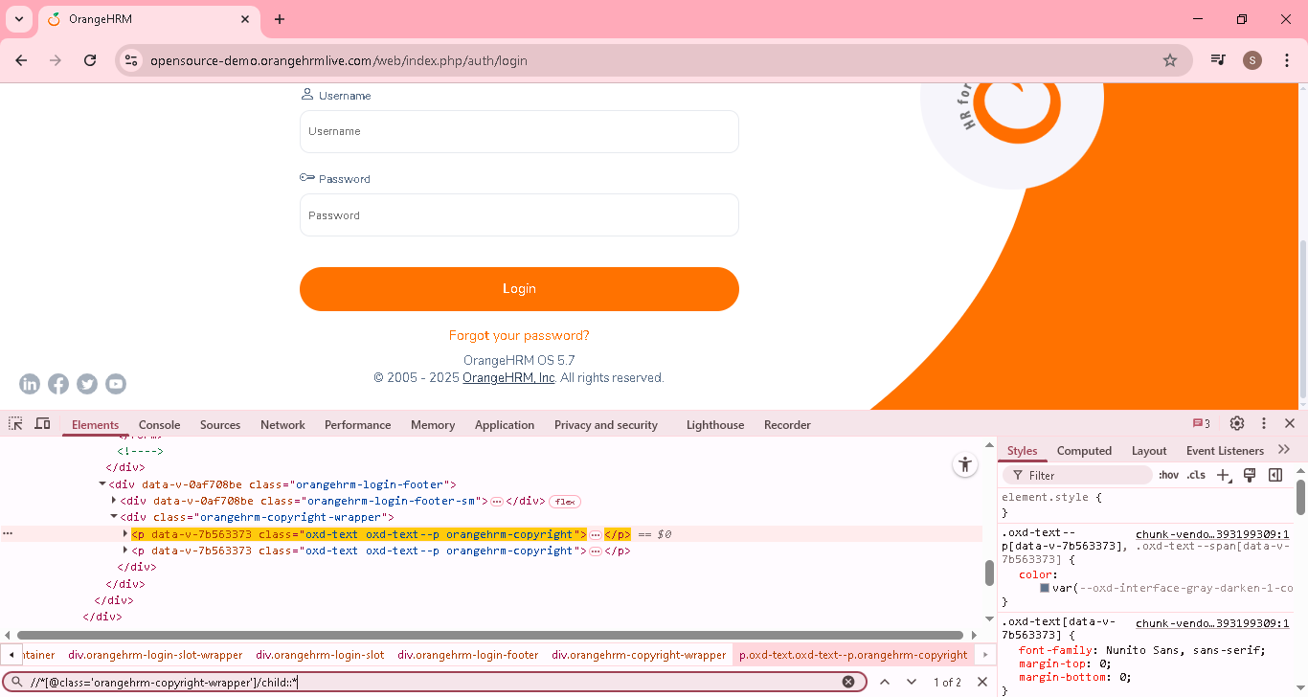
3.Locating ancestor of a known element [will show all parent of particular element from root node]
Parent, grandparent so on
Syntax: :<knownxpath>/ancestor::elementname
EG: //*[@name='username']/ancestor::* or //*[@name='username']/ancestor::form

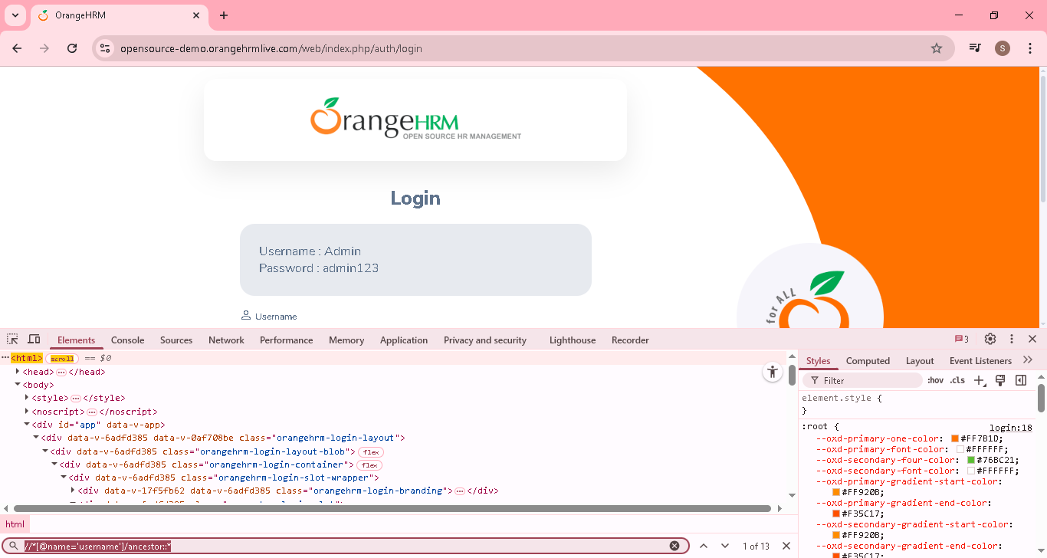
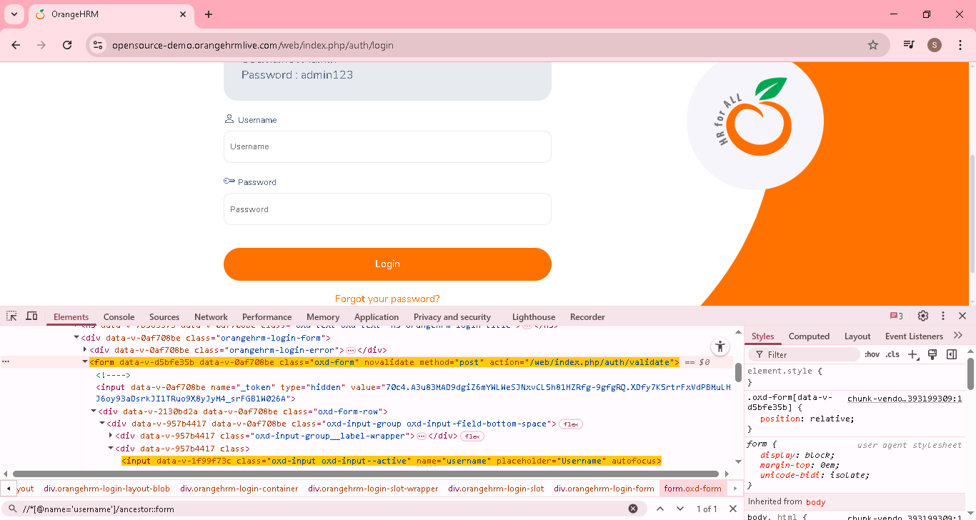
4.Locating the following elements [ will show all the following elements for the particular element]
Syntax: :<knownxpath>/ following::elementname
EG: //*[@name='username']/following::* or //*[@name='username']/following::i
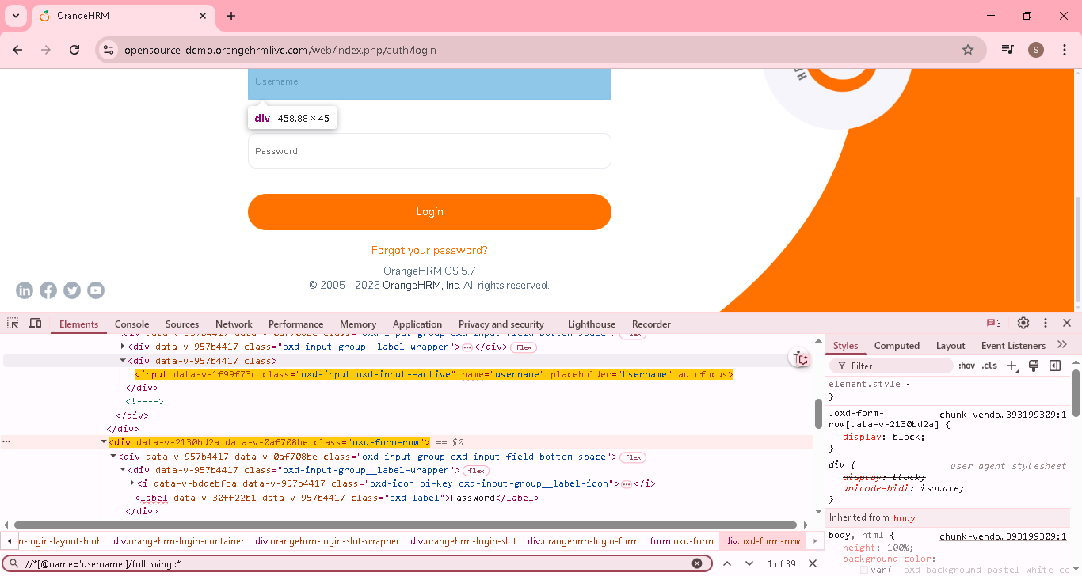
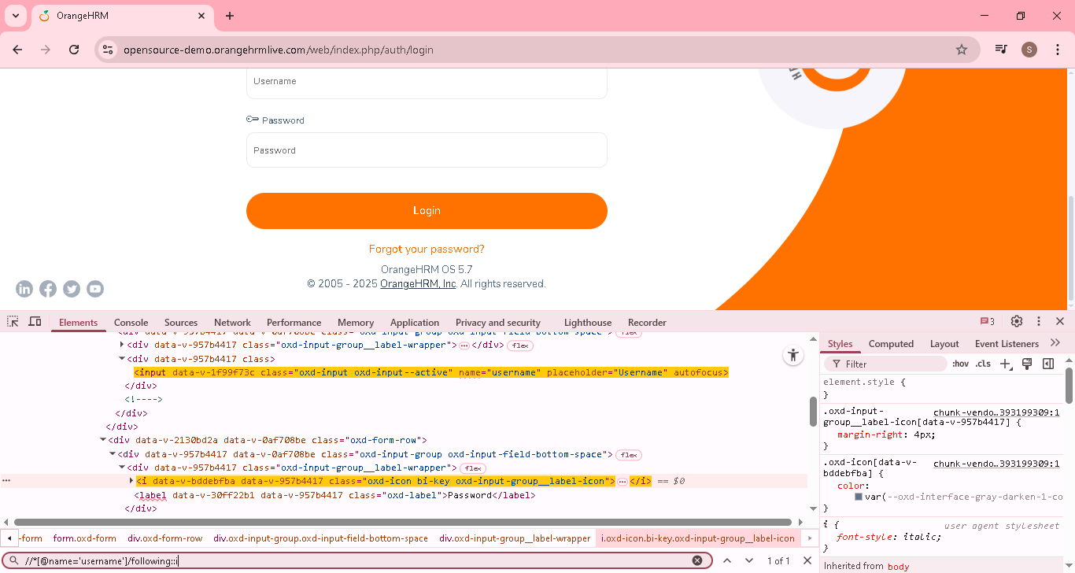
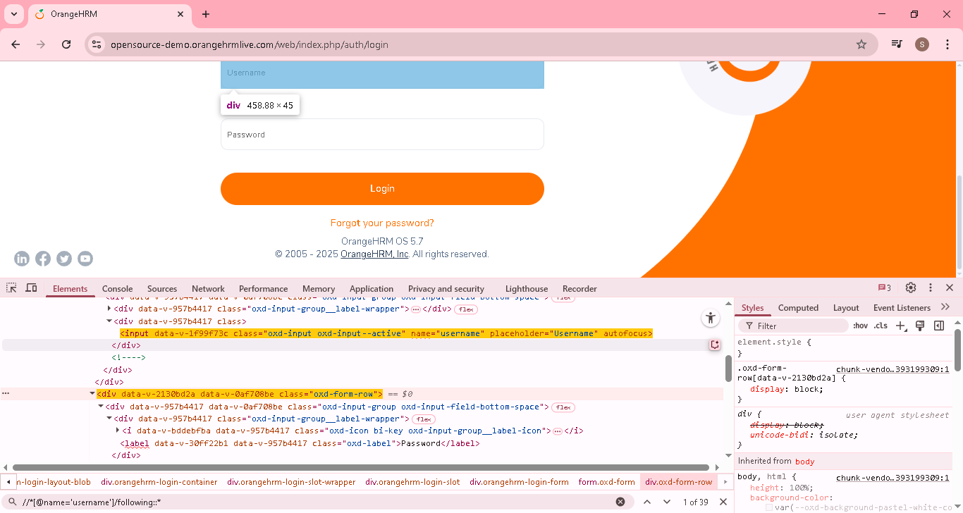

If more than one element, then mention the position to find unique element
//*[@name='username']/following::div[1]
//*[@name='username']/following::input ->it will all input element from the current xpath element

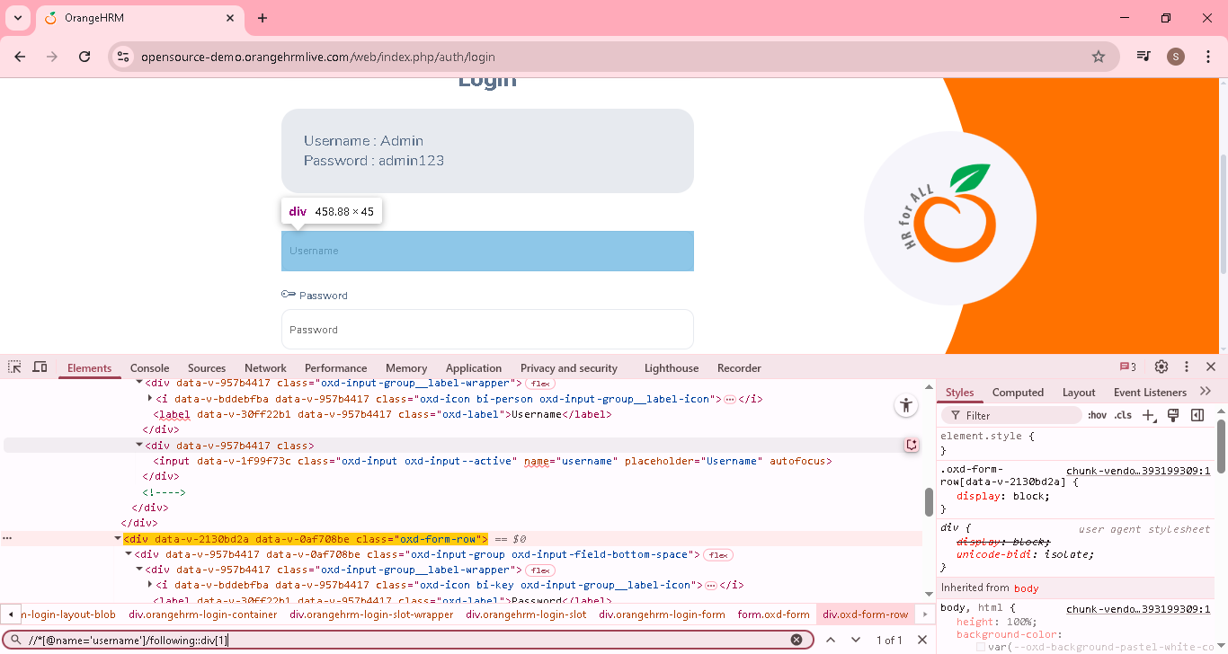

5.Locating preceding element [ will show all the preceding elements[before] for the particular element]
Preceding ->before or above, following>after or below
Syntax: :<knownxpath>/preceding::elementname
EG: //*[@name='username']/preceding::* or //*[@name='username']/preceding::label
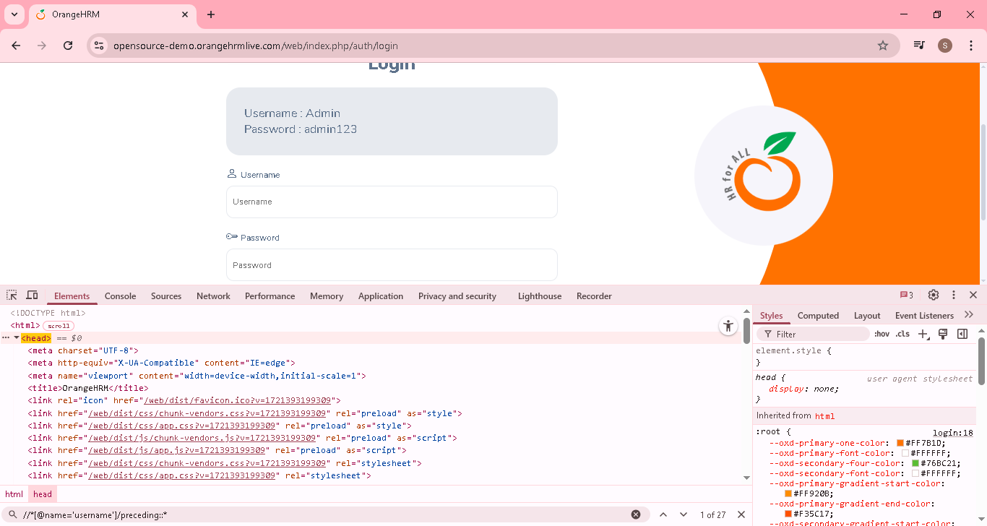

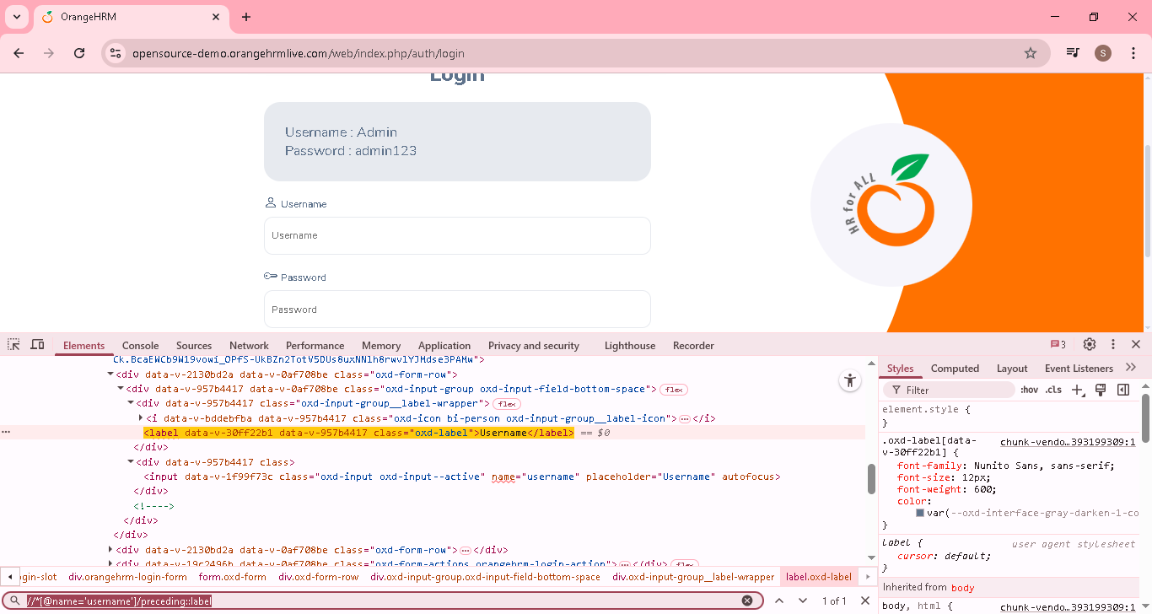

6.Locating the following sibling [To locate the elements comes after to a known element within a same parents hierarchy]
Syntax: :<knownxpath>/ following-sibling::elementname
EG: //a[@href='https://www.facebook.com/OrangeHRM/']/following-sibling::*
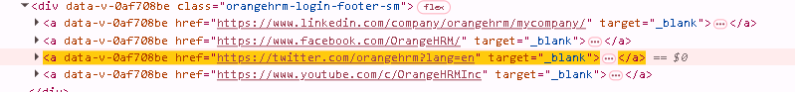

In the above html, am finding the particular element(facebook), then using following-sibling
following-sibling of facebook is 2..[ twitter & YouTube]
Here following-sibling is twitter & YouTube getting find as expected
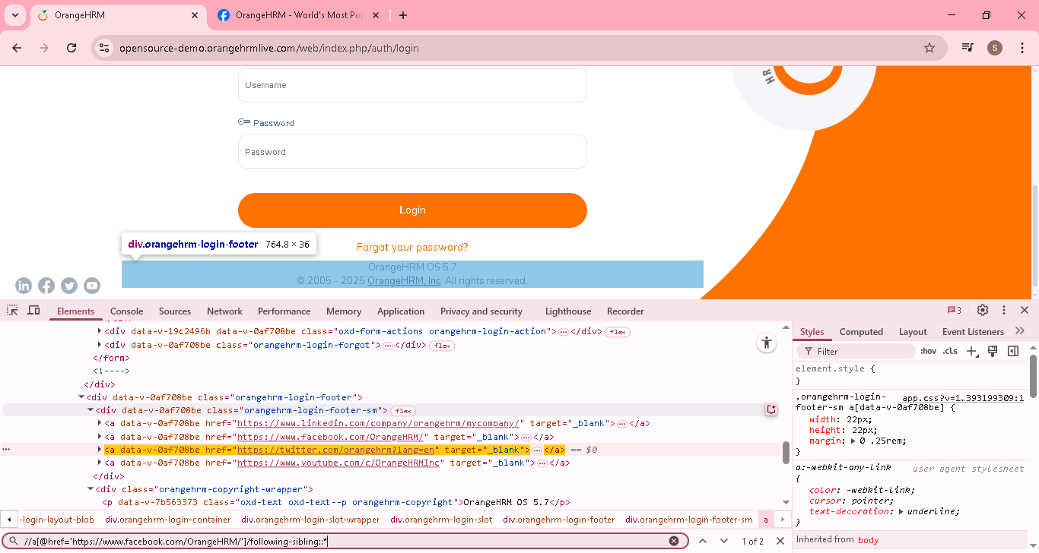

7.Locating preceding sibling [To locate the elements comes before to a known element within a same parents hierarchy]

Syntax: :<knownxpath>/ preceding-sibling::elementname
EG: //a[@href='https://www.facebook.com/OrangeHRM/']/preceding-sibling::*
Same eg used here
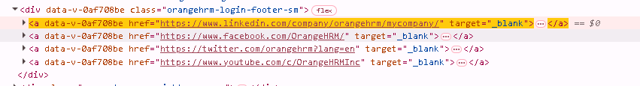

In the above html, am finding the particular element(facebook), then using preceding-sibling
preceding -sibling of facebook is 1..[ linkednin]

Here preceding -sibling is linkedin & getting find as expected
