SQL

https://balanced-quince-db1.notion.site/SQL-7347f5956fe347f887b4132c716cd236#17bc403a1add453db519621da47c1de3 -> contain detailed of SQL learning
mysql db password-> 1234

Introduction to SQL | Structured Query Language (SQL) in Tamil | Database | DBMS | Installing mysql

Introduction to structured query language with mysql. Installing mysql and getting started, datatypes in mysql are explained in detail.
Database -> collection of data
SQL(Structured Query Language) is used to store a data/modify/read/delete in a database..not case sensitive
DBMS -> Data base management system-> its a software[eg Mysql,oracle sql, sql server ect]
SQL->DBMS->Database
We need to write a sql query in any of the DBMS system , it will uses to connect the sql query with database
DBMS:[its like a compiler eg eclipse]
- Interface between database and end user
- Software to store,read and manage data in database

Different type of database
1.Hierarchical database
2.network database
3.Relational database [table format, mostly used]->its called as RDBMS
RDBMS
1.mysql ->open source
2.sql server
3.oracle
Note: we are leanring sql, we can use same sql in mysql or sql server or oracle..it will work it may need small modification depends on diff type

Data type:
To store a character like name we can use char or varchar
char - eg:char(5) stores fixed length string of length 5. Max 255 bytes.
varchar - eg:varchar(5) stores variable length string of length 5. Max 65535 bytes.
char(5)-> fixed length we are storing only 3 char, it will store as “ABC “[2 space will present]
varchar(5)-> variable length we are storing only 3 char, it will store as “ABC“[2 space will not present]..modify based on the input
Number
Int
Decimal(5,2) -> 999.99
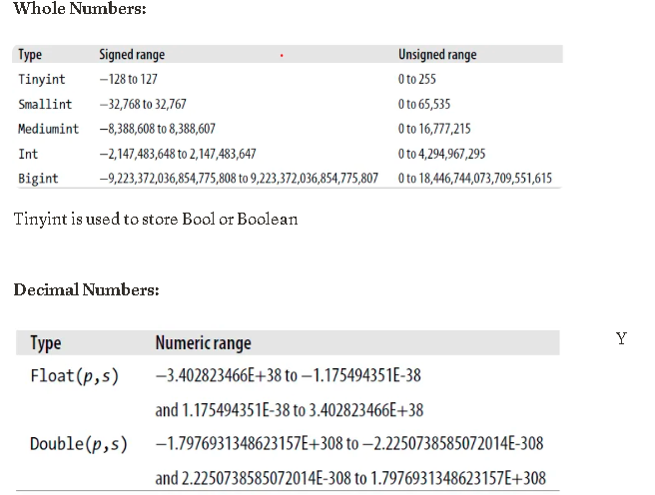
Date:
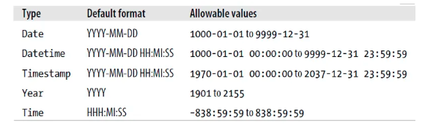

https://dev.mysql.com/downloads/

click the Mysql installer for window
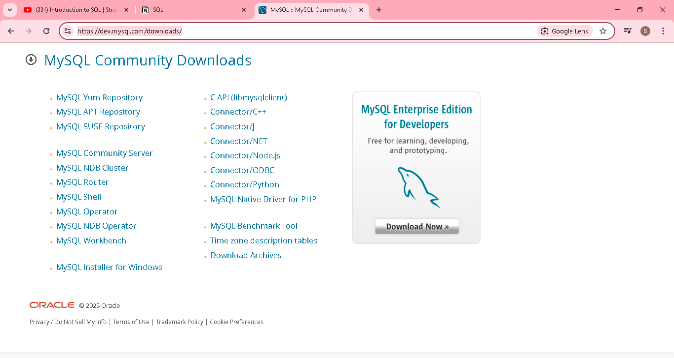

Click the first download button
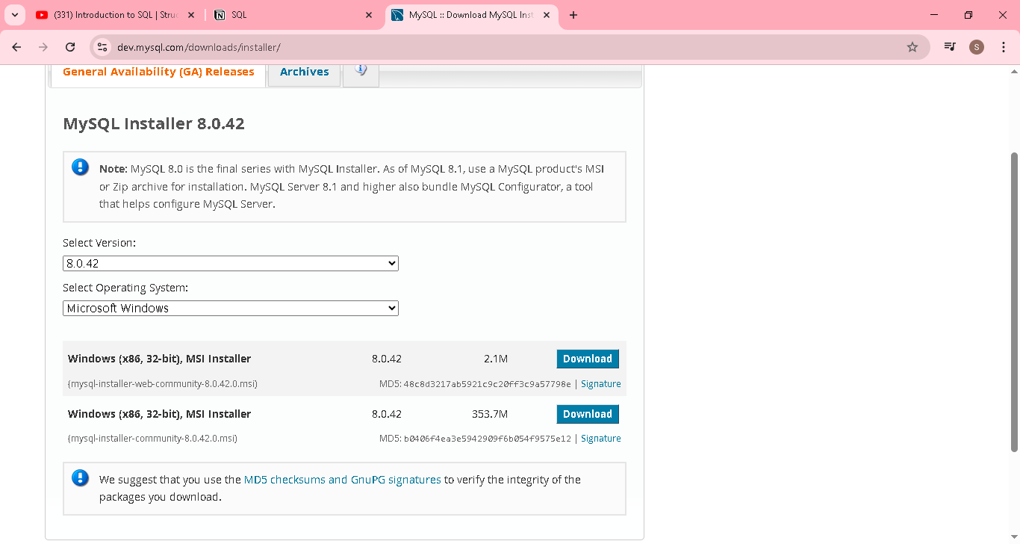
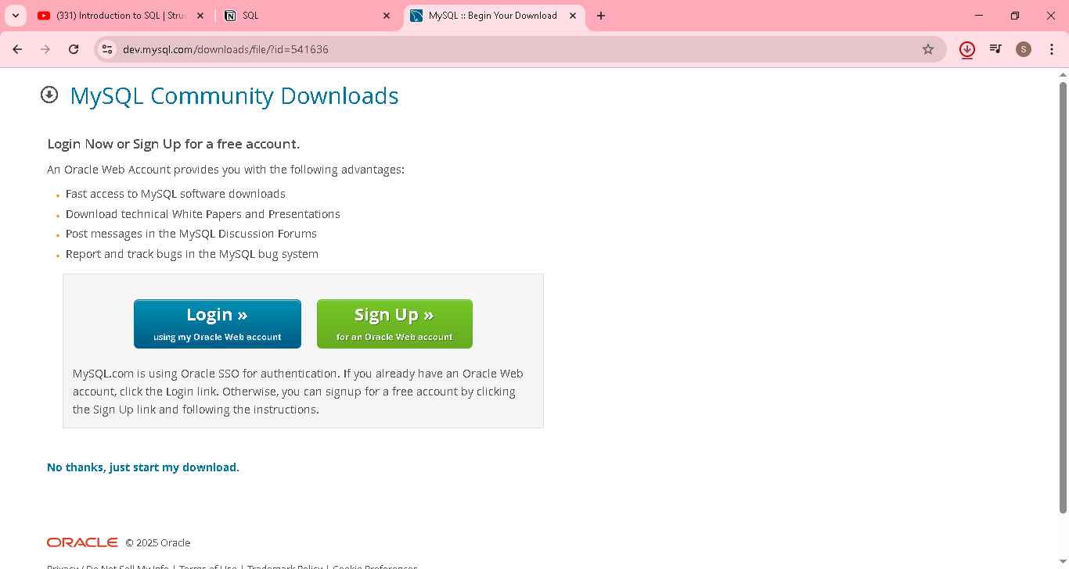


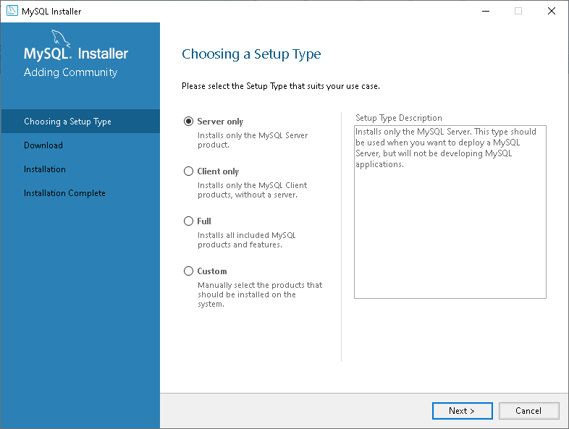

Select custom and click next
In that, selected only below 3
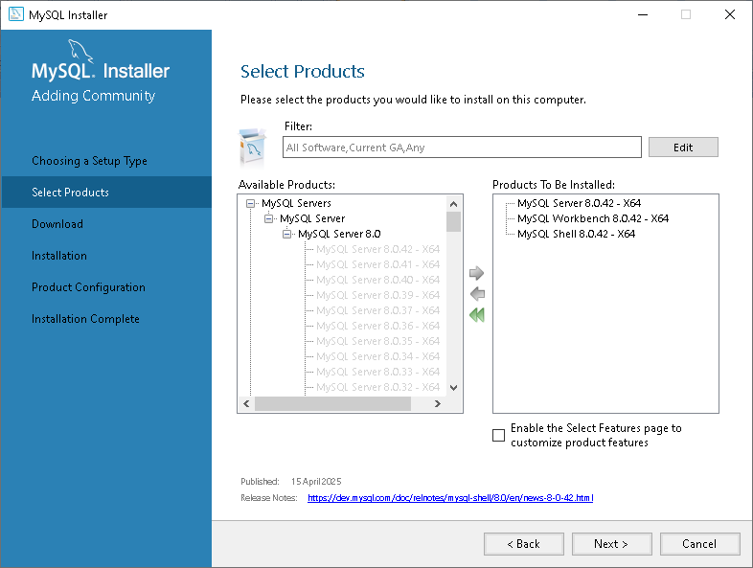

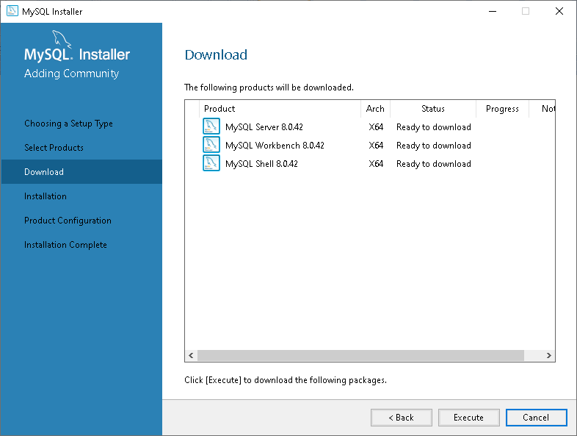

Click execute
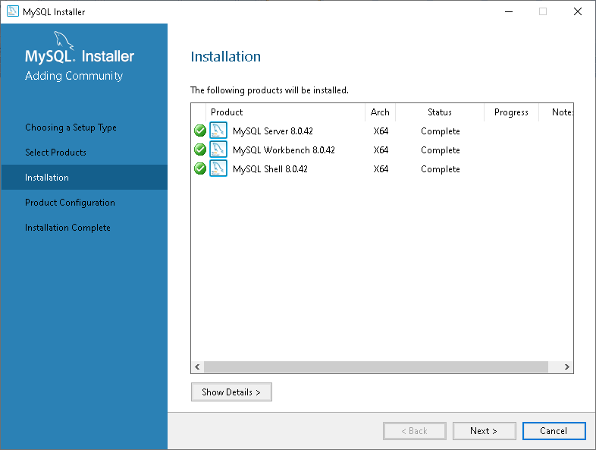
Provide password ->1234
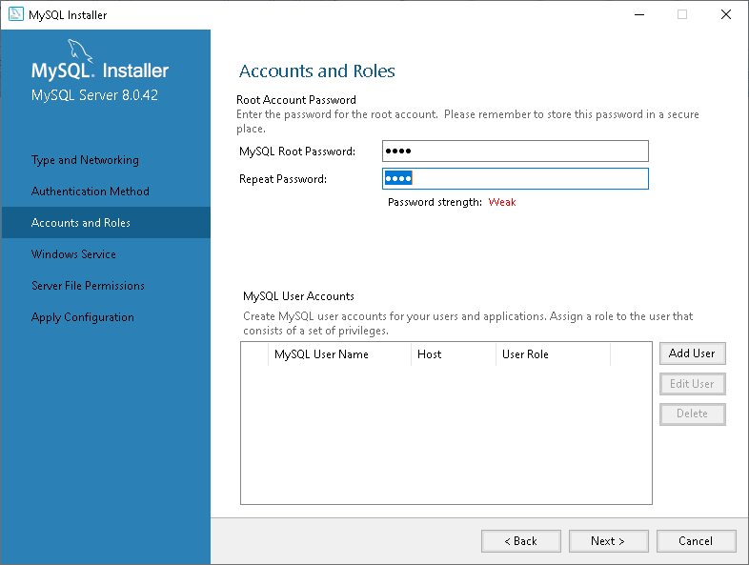

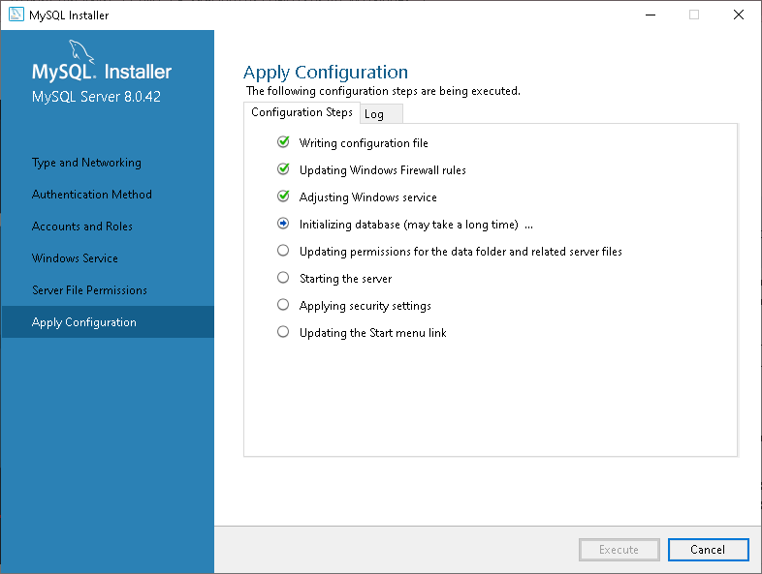
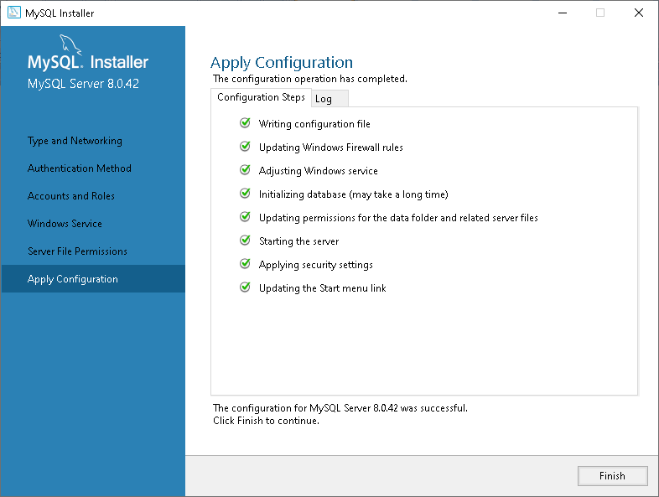

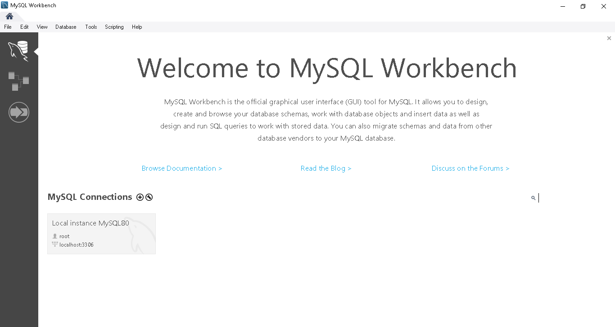

Click local instance an provide password as 1234
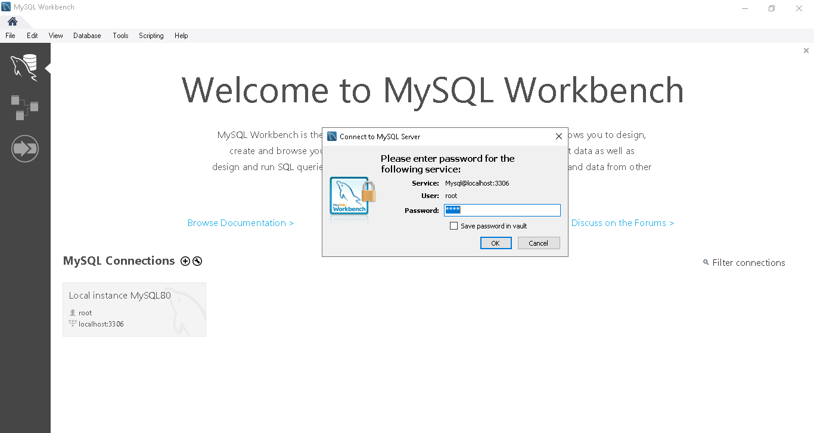

Basic SQL Queries | Create Table | Alter | Delete | Insert | SQL in Tamil | Logic First Tamil

Creating and dropping database - create table - alter table - delete table - insert values to table - basic select

Create a database
create database suku;

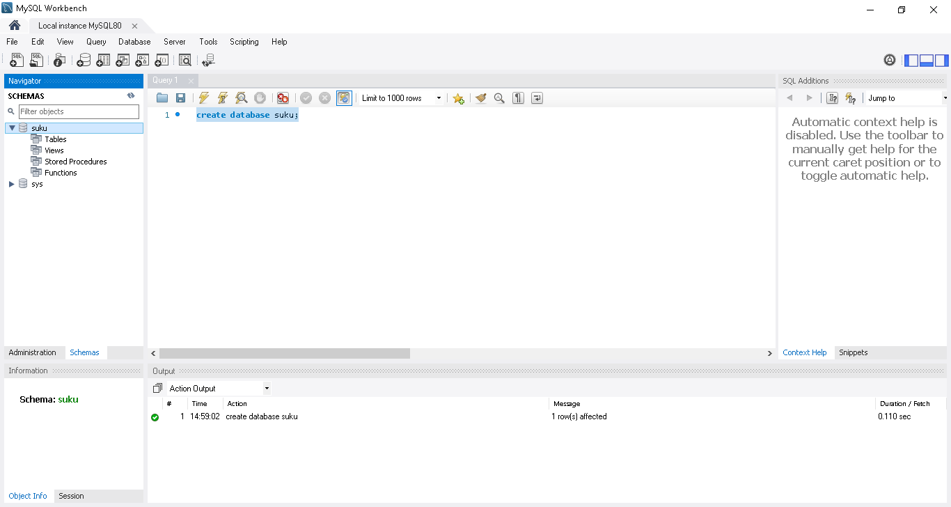

Delete a database
drop database suku;

we can use schema also
drop schema if exists suku;
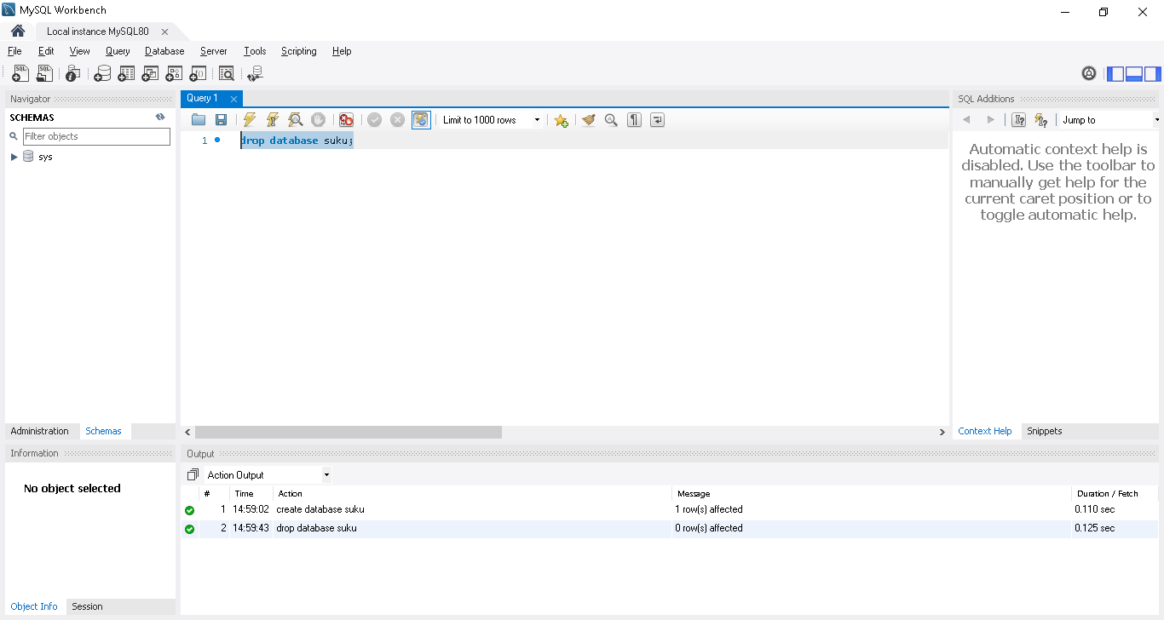

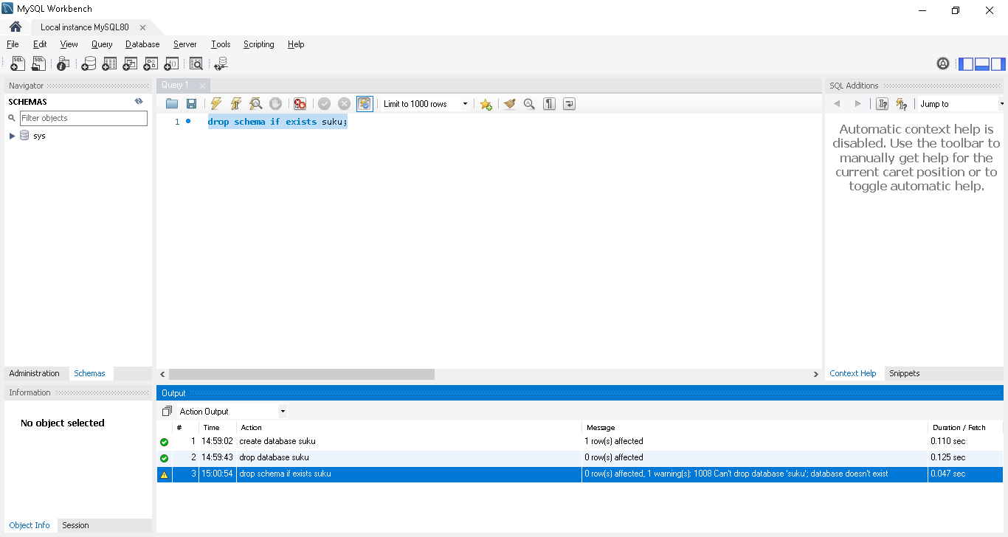

If multiple database present, then we use below condition to point to particular DB so that we update, read etc for that particular DB
Use database name;
Use suku;
show tables;
it wil use show all the tables present under suku database
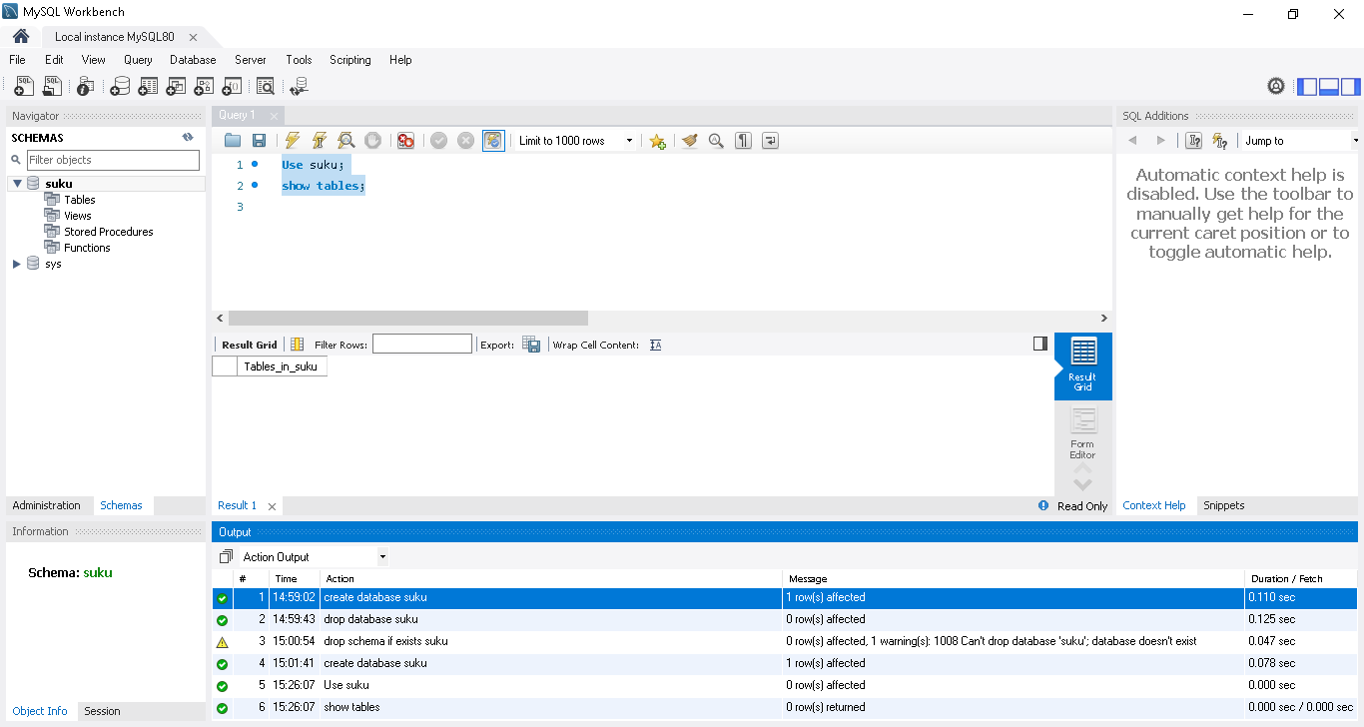
Create a table
create table Student(ID int Primary key, Name varchar(10), GPA Decimal(2,1));

we need to mention primary key in a table
here ID->primary key
describe student; -> it will show the table structure after creating
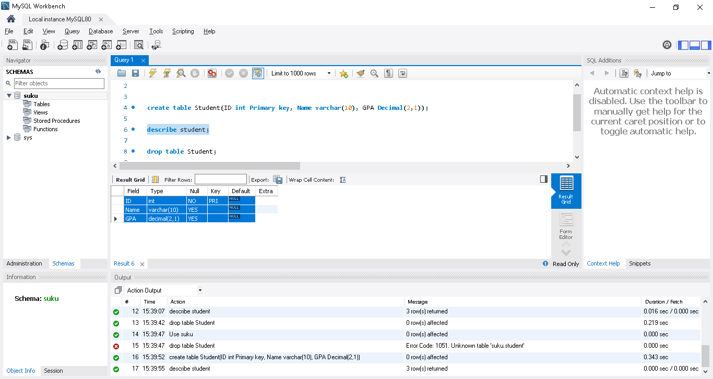
Drop table
drop table Student;

Alter table-> like add new column in a existing table
Alter table student add department varchar(10); or
Alter table student add column department varchar(10);

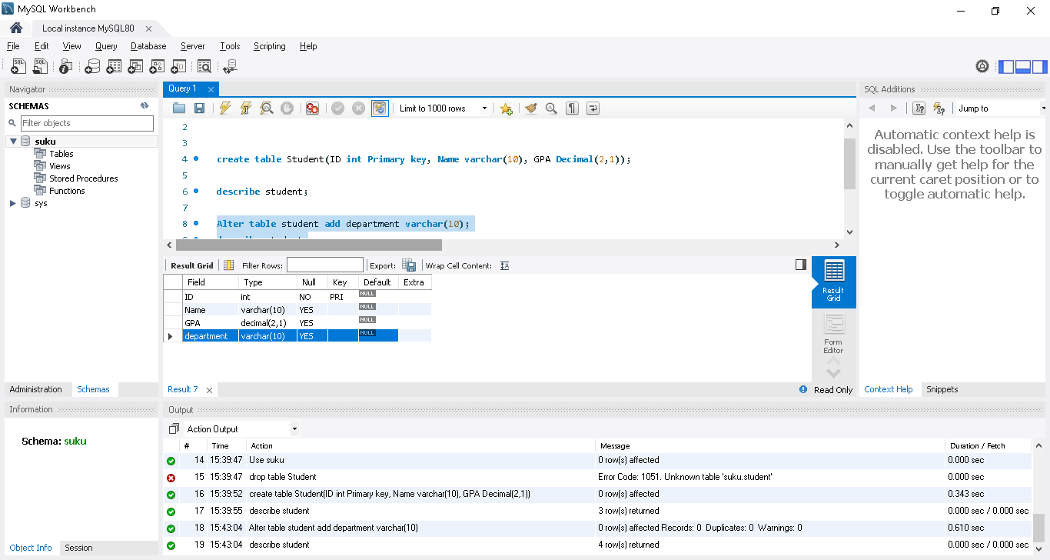
Delete department column
Alter table student drop department ; or
Alter table student drop column department ;

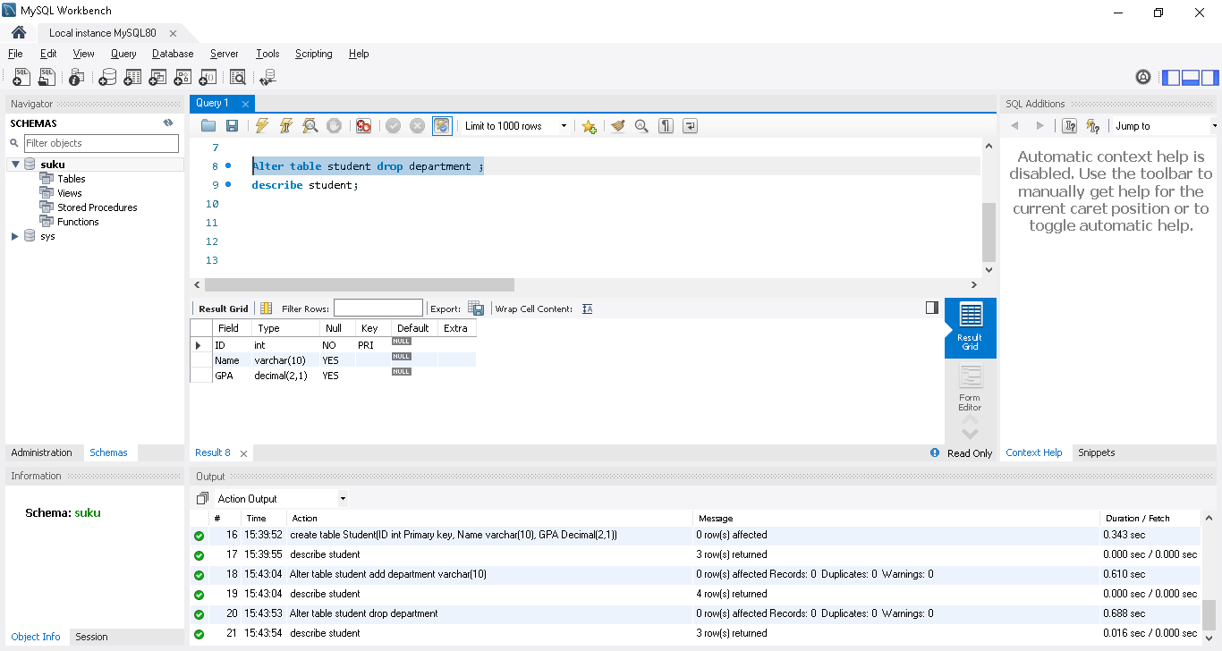

Insert the value in a table
Value same order as column present in the table
Varchar need to provide in “ ”
insert into student value(1,"suku",9.9);
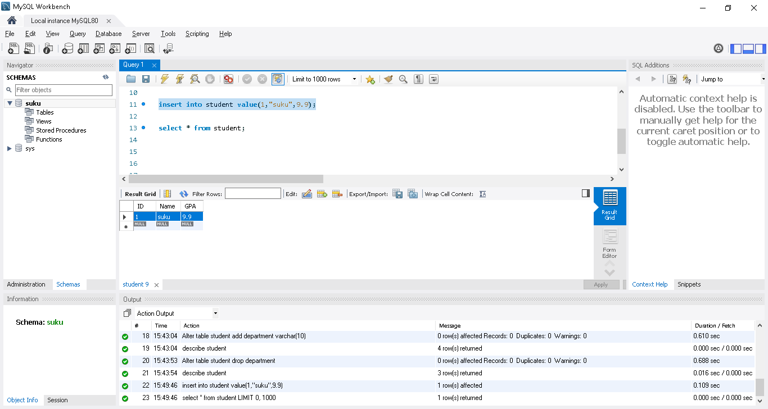

Add 2 more value
insert into student value(2,"kiru",9.8);
insert into student value(3,"kirsh",9.7);
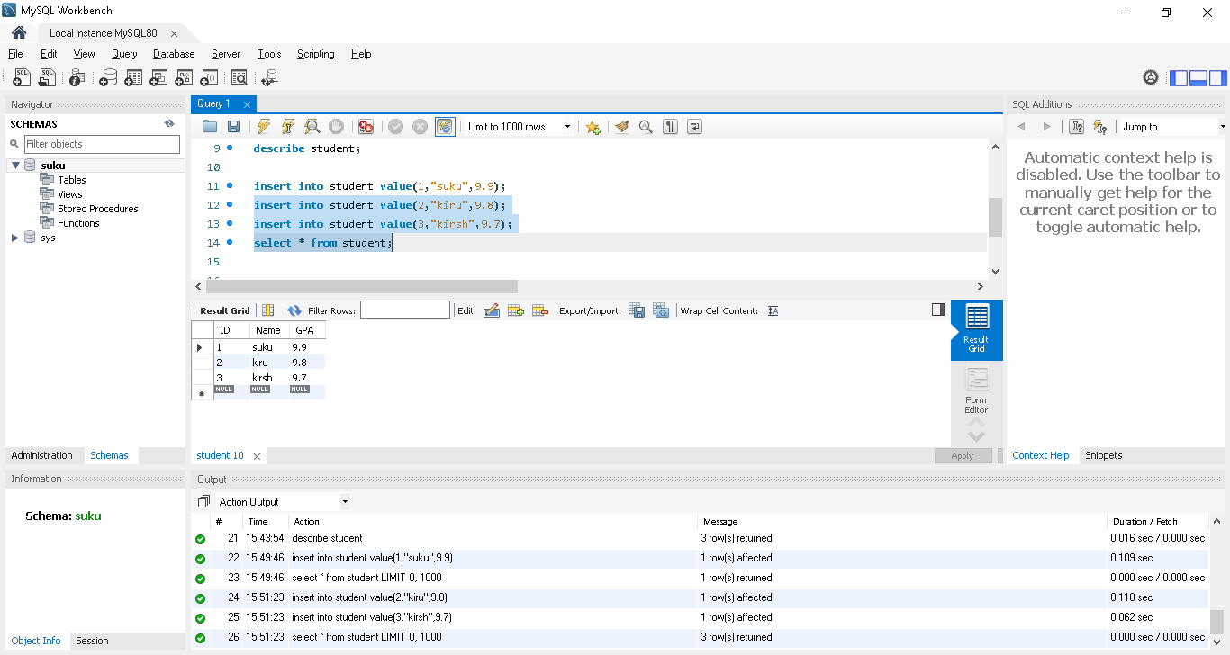

Another way to add multiple value in single line
insert into student value(4,"jothi",9.6),(5,"Hari",9.5);
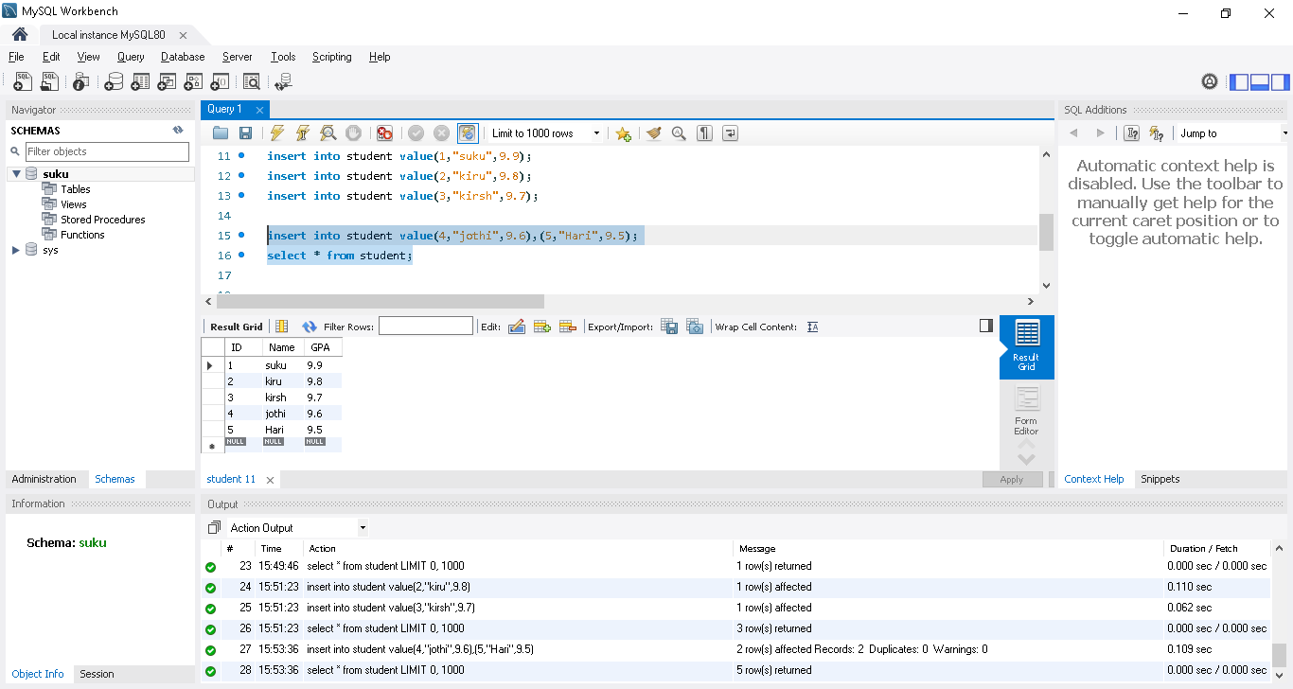

Insert only ID and name in a student table
insert into student(ID,Name) value(6,"savi");
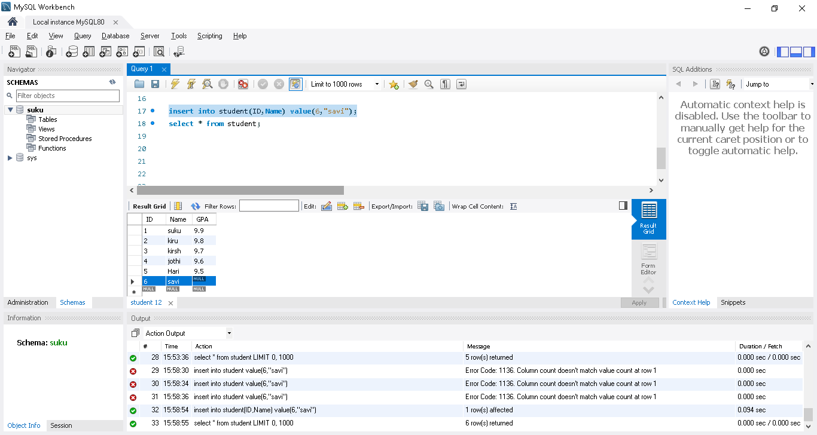

Select used to the value from the table
select * from student; -> all values
select id from student; -> only ID values

SQL Where | Like | Update | Delete | SQL in Tamil | Logic First Tamil

Filtering rows using Where - Giving conditions using relational operators - Like and wildcard examples - Updating rows - deleting rows
where is used to filter the records. The rows are filtered based on conditions.
Create a employee table and load the values
Use suku;
CREATE TABLE employee (
emp_id INT PRIMARY KEY,
ename VARCHAR(30),
job_desc VARCHAR(20),
salary INT );

INSERT INTO employee VALUES(1,'Ram','ADMIN',1000000);
INSERT INTO employee VALUES(2,'Harini','MANAGER',2500000);
INSERT INTO employee VALUES(3,'George','SALES',2000000);
INSERT INTO employee VALUES(4,'Ramya','SALES',1300000);
INSERT INTO employee VALUES(5,'Meena','HR',2000000);
INSERT INTO employee VALUES(6,'Ashok','MANAGER',3000000);
INSERT INTO employee VALUES(7,'Abdul','HR',2000000);
INSERT INTO employee VALUES(8,'Ramya','ENGINEER',1000000);
INSERT INTO employee VALUES(9,'Raghu','CEO',8000000);
INSERT INTO employee VALUES(10,'Arvind','MANAGER',2800000);
INSERT INTO employee VALUES(11,'Akshay','ENGINEER',1000000);
INSERT INTO employee VALUES(12,'John','ADMIN',2200000);
INSERT INTO employee VALUES(13,'Abinaya','ENGINEER',2100000);

select * from employee;
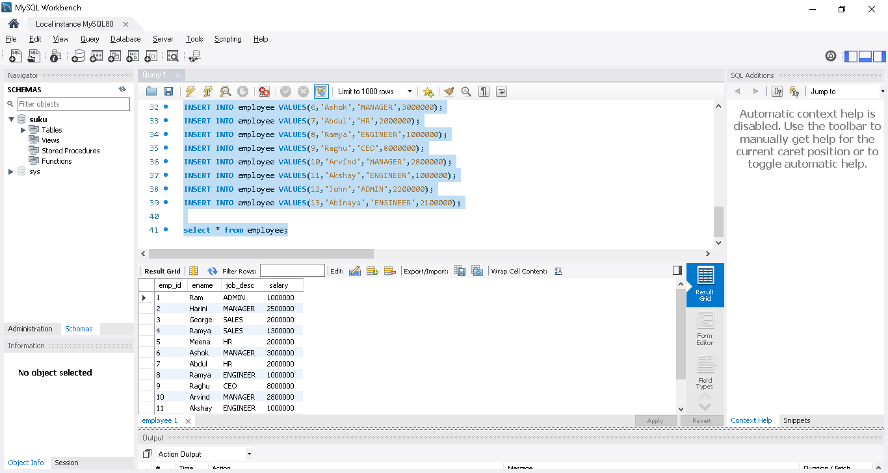

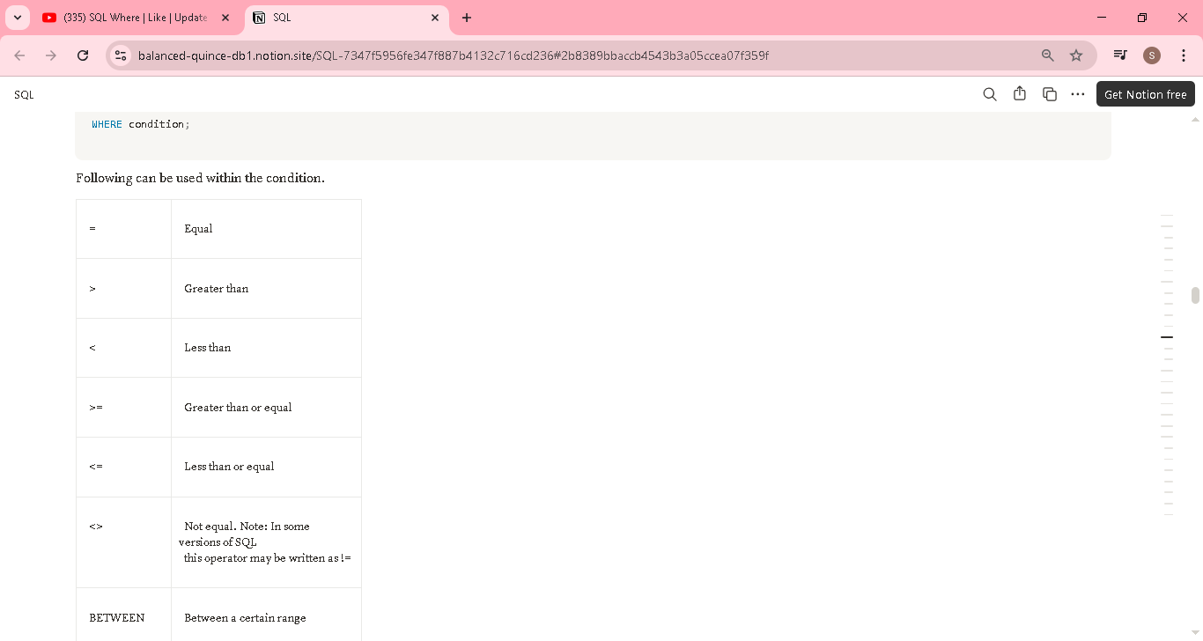

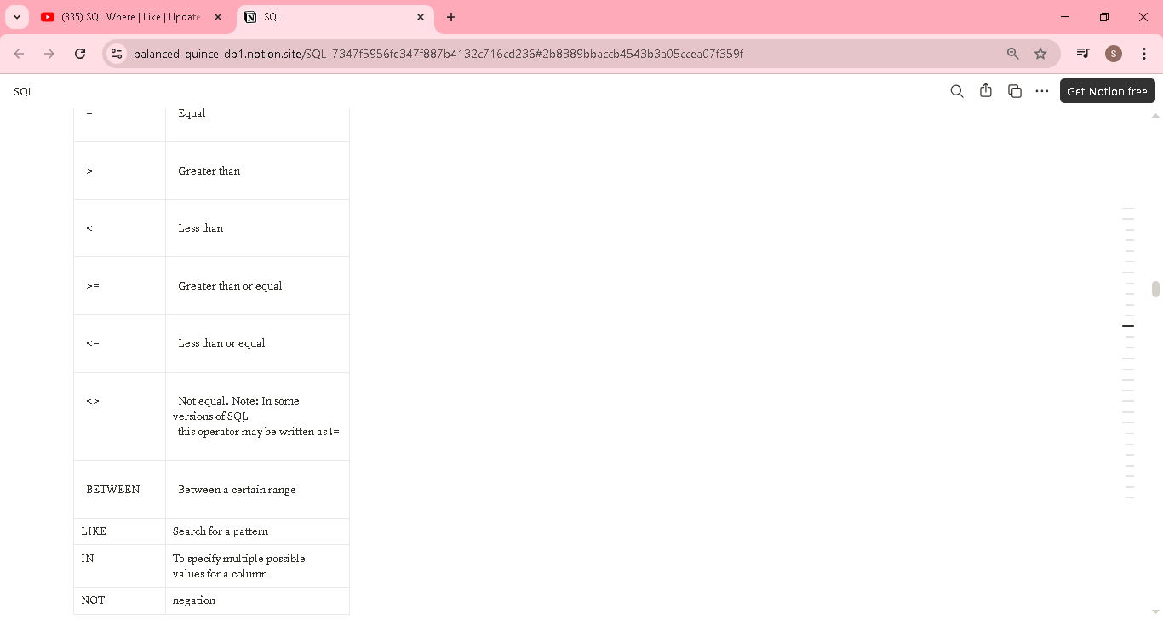

SELECT * FROM employee
WHERE ename = 'Ramya';

SELECT emp_id,ename,salary FROM employee
WHERE salary>2000000;

SELECT emp_id,ename,salary FROM employee
WHERE salary<2600000 AND job_desc = 'MANAGER';

SELECT * FROM employee
WHERE job_desc='ADMIN' OR job_desc='HR'; -- though this works next command is a much better choice

SELECT * FROM employee
WHERE job_desc IN ('ADMIN','HR');

SELECT * FROM employee
WHERE job_desc NOT IN ('MANAGER','CEO');

SELECT * FROM employee
WHERE salary BETWEEN 2000000 AND 3000000

LIMIT 5; --limits the records shown ->it will show first 5 records in emp table
SELECT * FROM employee
LIMIT 5; -- Different syntax in oracle/sql server

Using Like and wildcards
LIKE is used with WHERE clause for searching a specific pattern in a column. It is used along with the following wild cards
% represents zero or more characters
_ represents exactly one character
SELECT * FROM employee
WHERE ename LIKE 'A%'; -- filters name starting with A
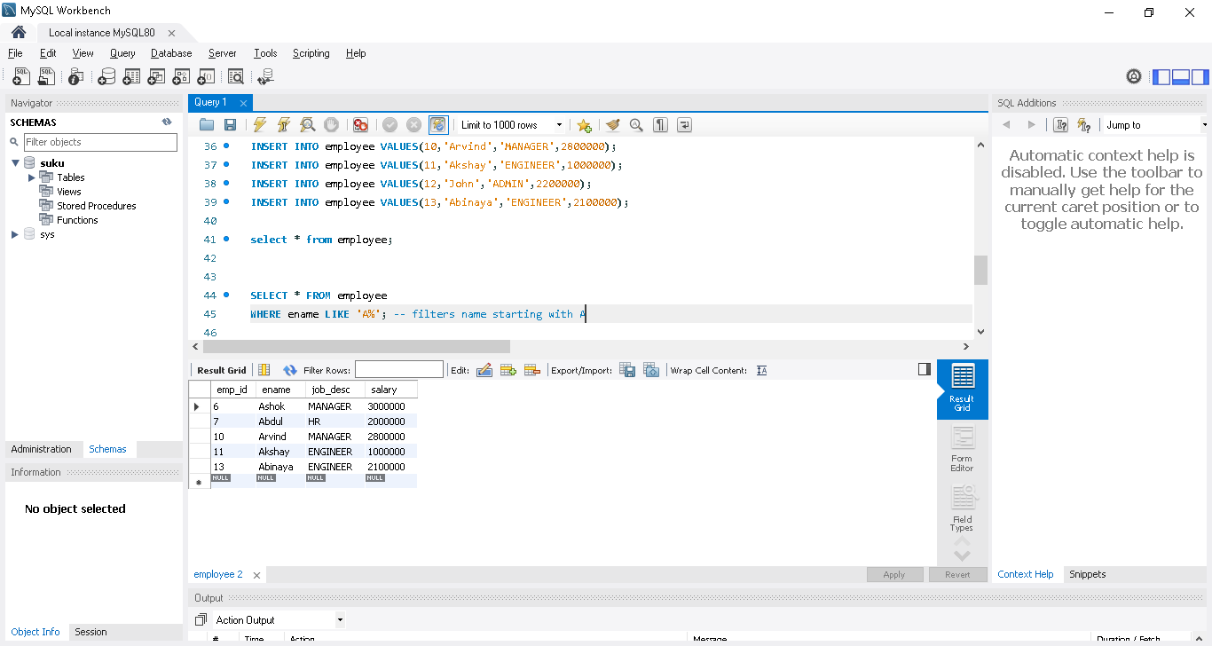

SELECT * FROM employee
WHERE ename LIKE 'R%a'; -- filters name starting WITH R AND ending with a
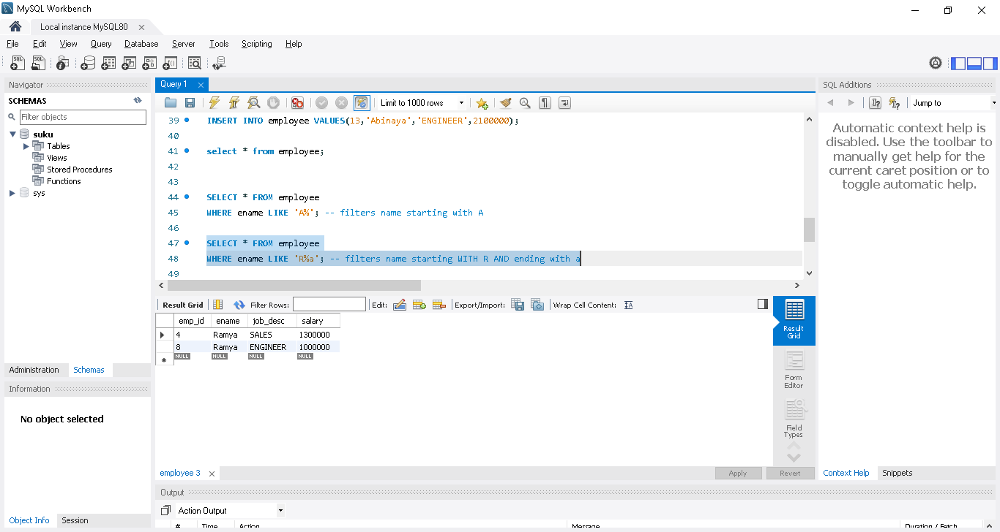
SELECT * FROM employee
WHERE ename LIKE '%I%'; -- filters name containing I
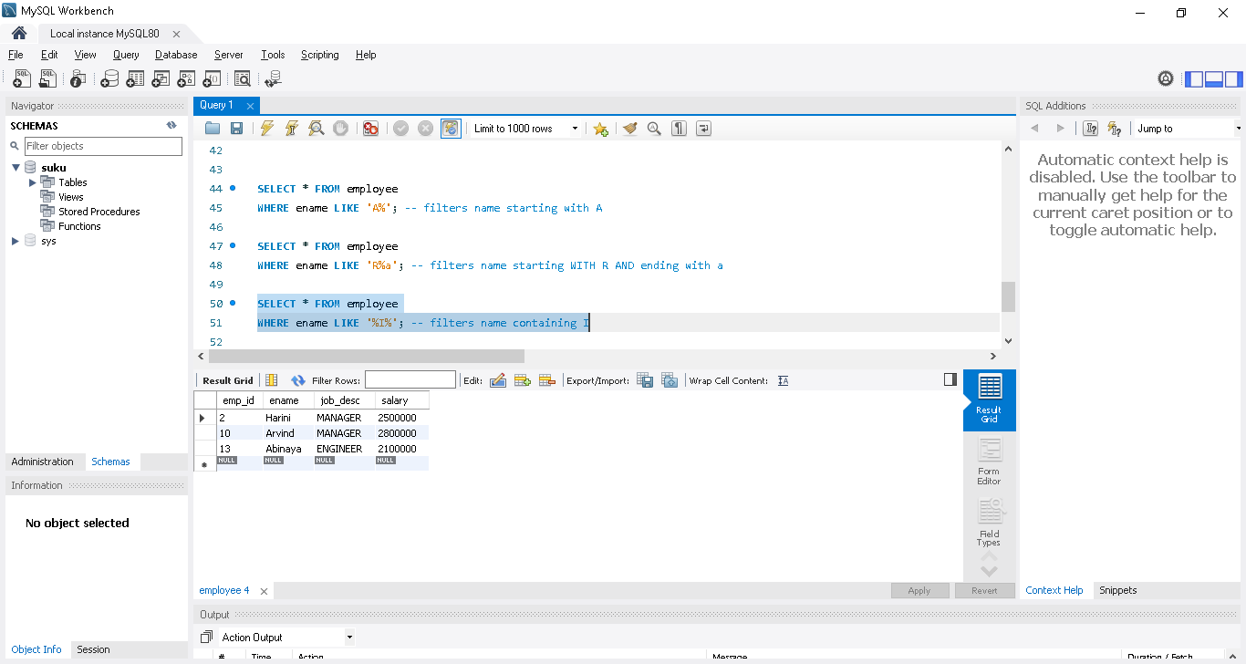

SELECT * FROM employee
WHERE ename LIKE '__I%'; -- filters name with i as third character
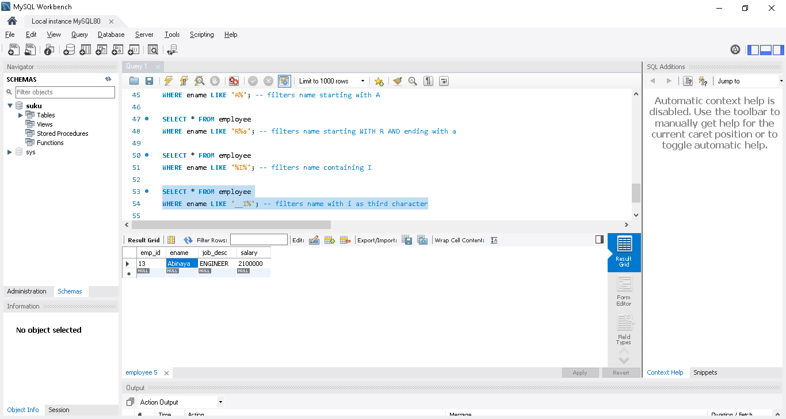
SELECT * FROM employee
WHERE ename LIKE 'R\%'; -- filters name starting with R%. \ is the escape character.
Incase % itself present in names, then use \, then only it will identify.
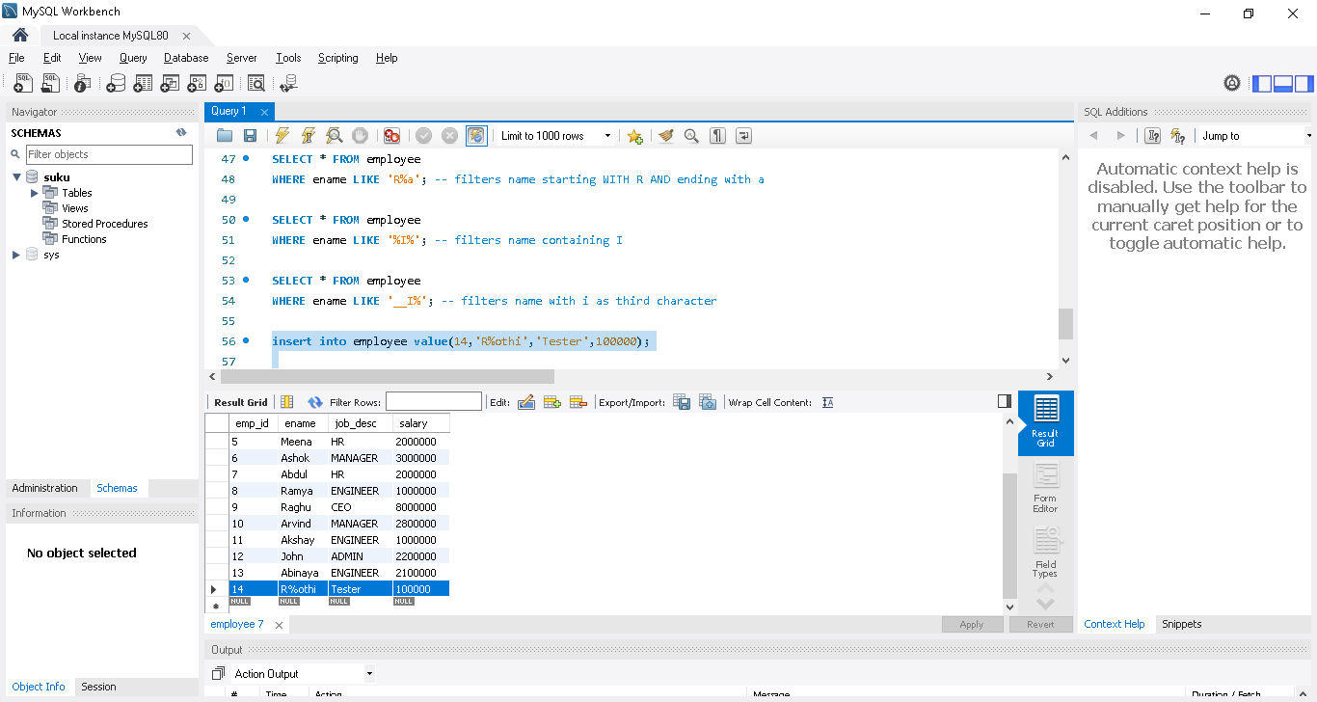
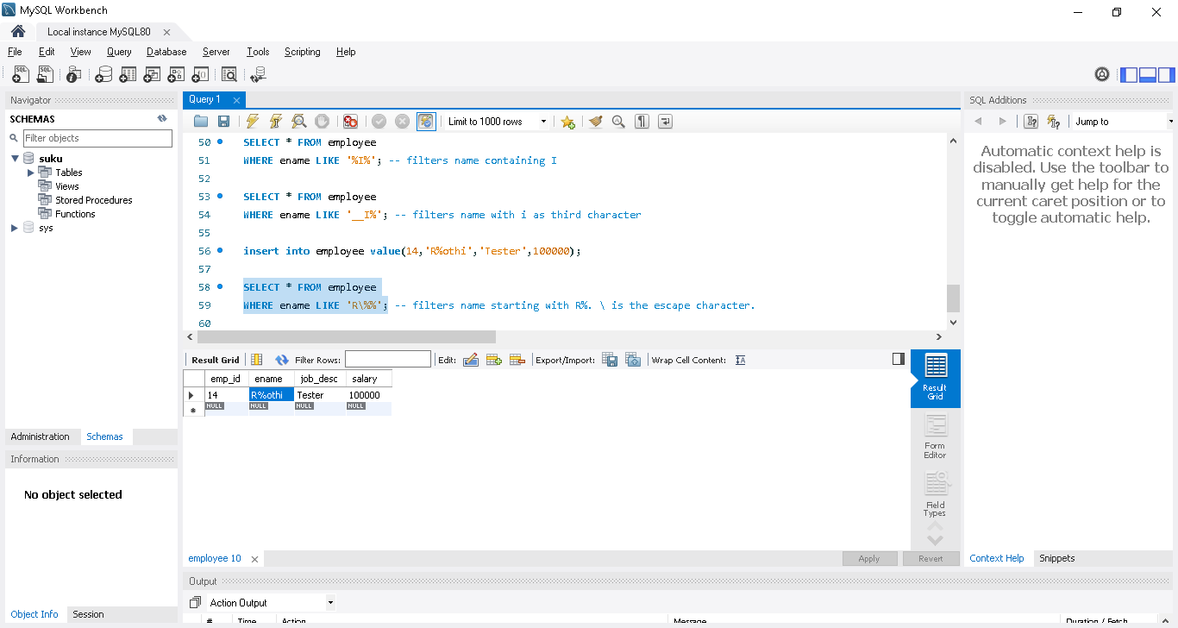
Update and Delete

UPDATE employee
SET job_desc = "Analyst"; -- updates all job_desc of all rows to "Analyst" when safe update not enabled[ where condition not provided so it will update all records]

UPDATE employee
SET job_desc = "Analyst"
WHERE job_desc = "Engineer"; -- changes Engineer to Analyst in all applicable rows

UPDATE employee
SET job_desc = "Analyst"
WHERE emp_id=1;
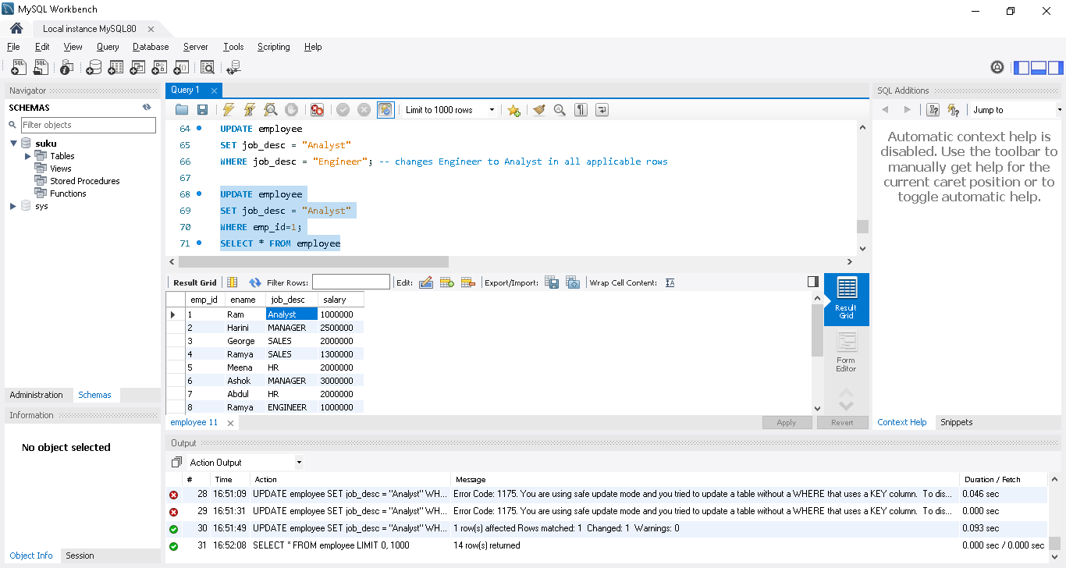
DELETE FROM employee; -- deletes all rows

DELETE from employee
WHERE emp_id = 12;

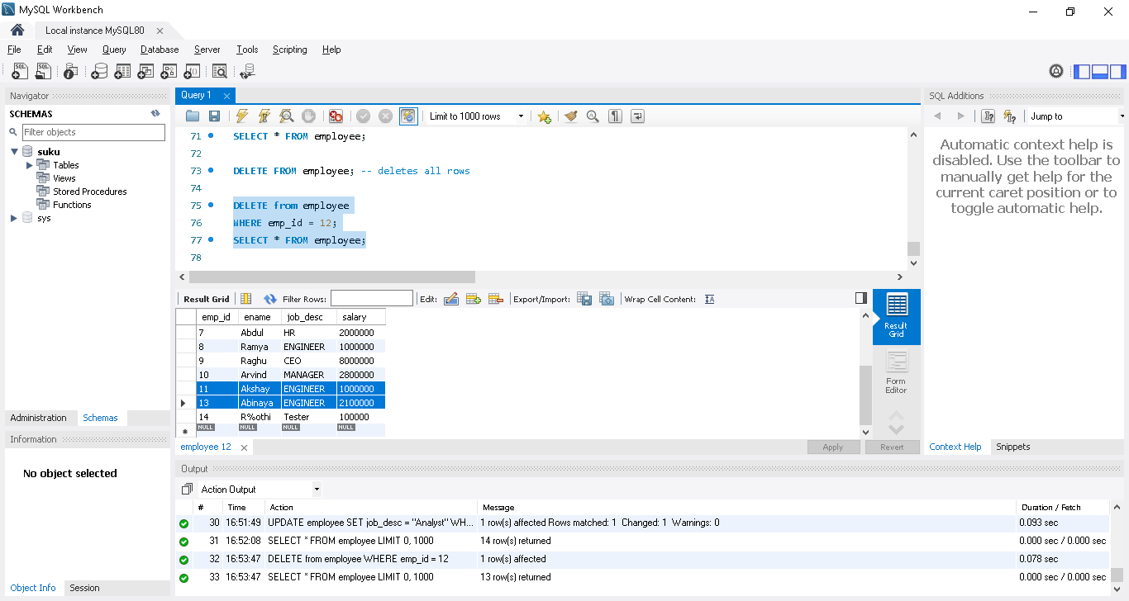

Distinct | Order By in SQL | SQL in Tamil | Logic First Tamil

How to filter distinct elements in the column - How to use order by to sort the results in ascending, descending and custom order using when and then.
SELECT * FROM employee
ORDER BY salary; -- order by salary asc
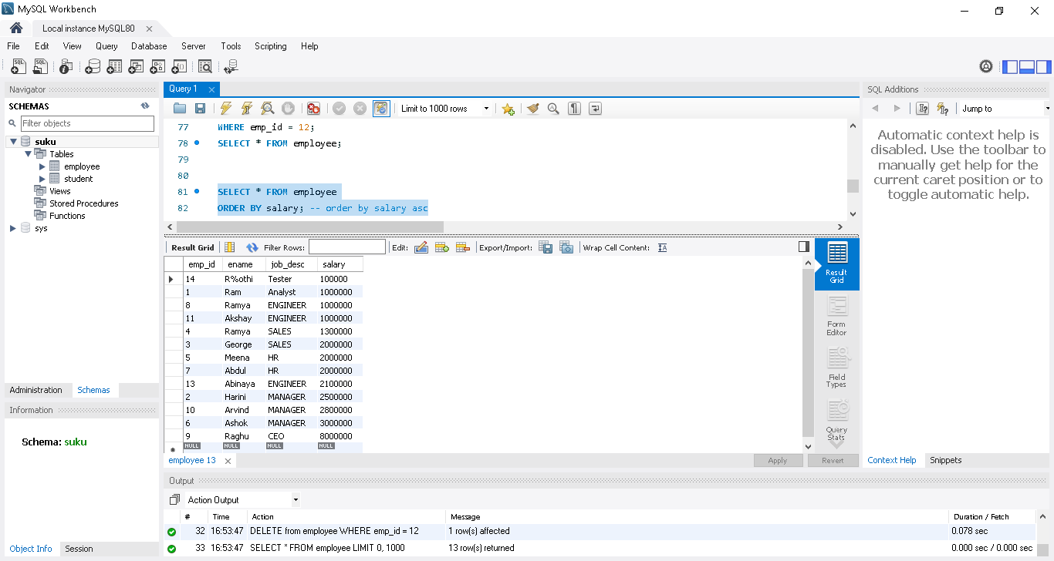
SELECT * FROM employee
ORDER BY salary ASC; -- order by salary asc
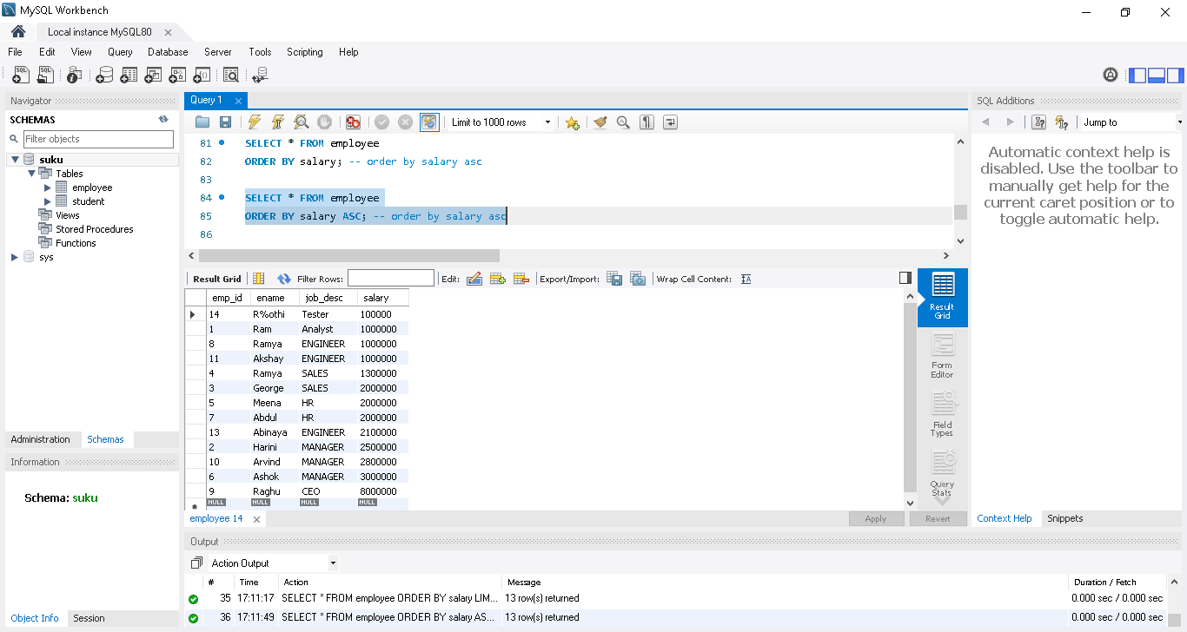
SELECT * FROM employee
ORDER BY salary DESC; -- order by salary desc
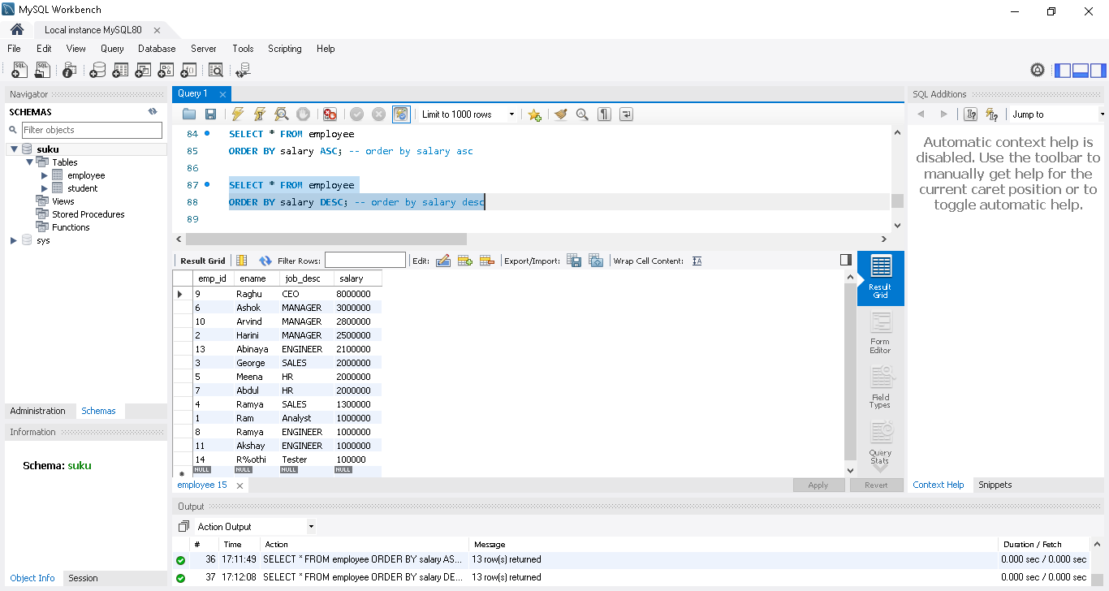
SELECT * FROM employee
WHERE job_desc="MANAGER"
ORDER BY salary DESC; -- order the manager salaries in desc order
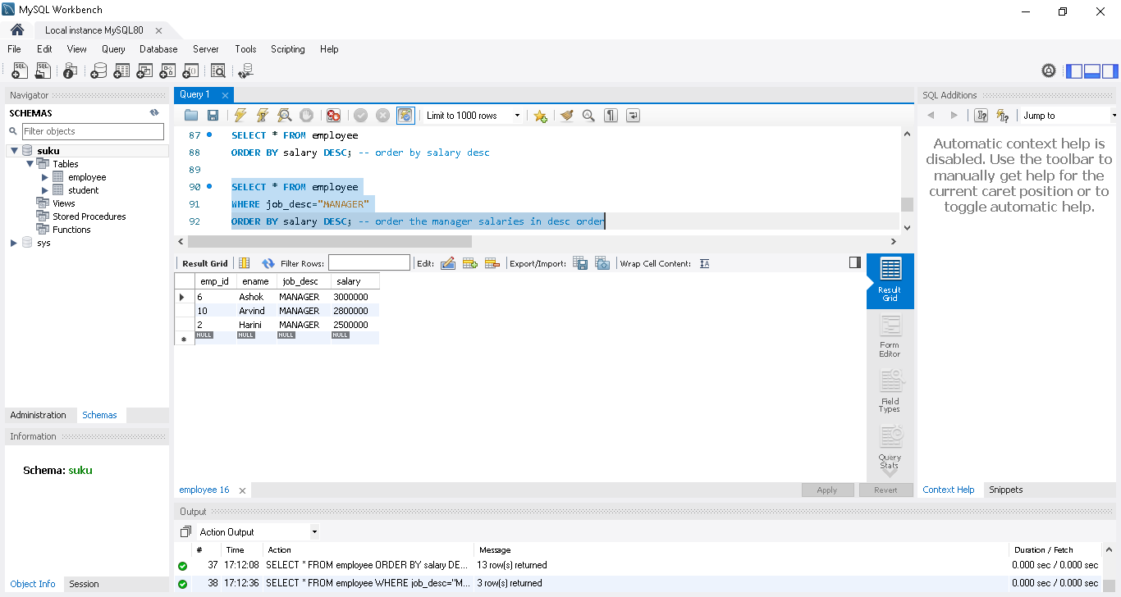
SELECT * FROM employee
ORDER BY job_desc,ename; -- first sorts by job_desc and then by ename
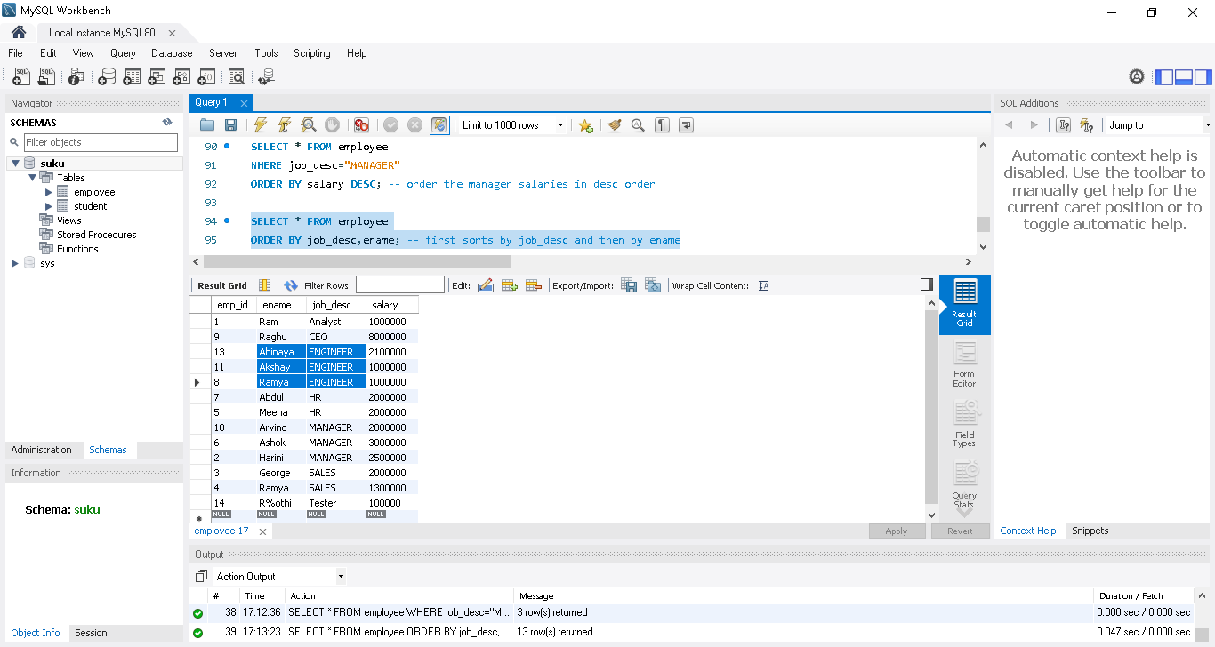

SELECT * FROM employee
ORDER BY (CASE job_desc -- specific order
WHEN 'CEO' THEN 1
WHEN 'MANAGER' THEN 2
WHEN 'HR' THEN 3
WHEN 'ANALYST' THEN 4
WHEN 'SALES' THEN 5
ELSE 100 END);

User custom order, user want CEO first and followed by Manager etc
ELSE 100 END ->we have not define Enginner and Tester job desc, so use else 100, so that remaining job desc will come at the last
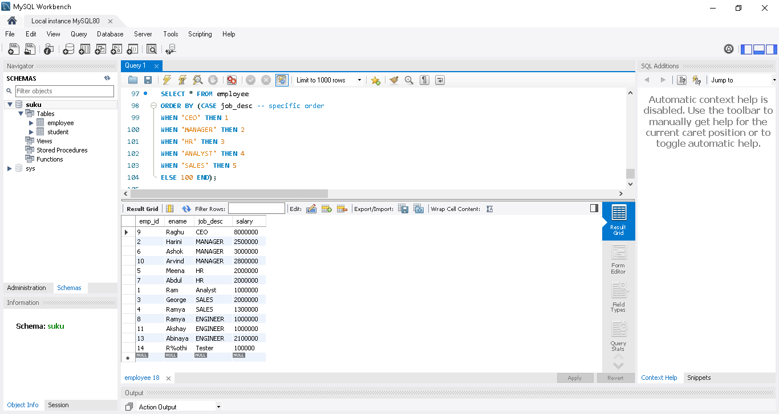

Functions in SQL | Aggregate Functions| Math and String | SQL in Tamil | Logic First Tamil

Math aggregate functions - sum,count,min,max,avg and

String functions - ucase,format,concat,char_length and

left functions are explained with examples

Math aggregate functions

SELECT COUNT(*) FROM employee; -- total count of entries in the table

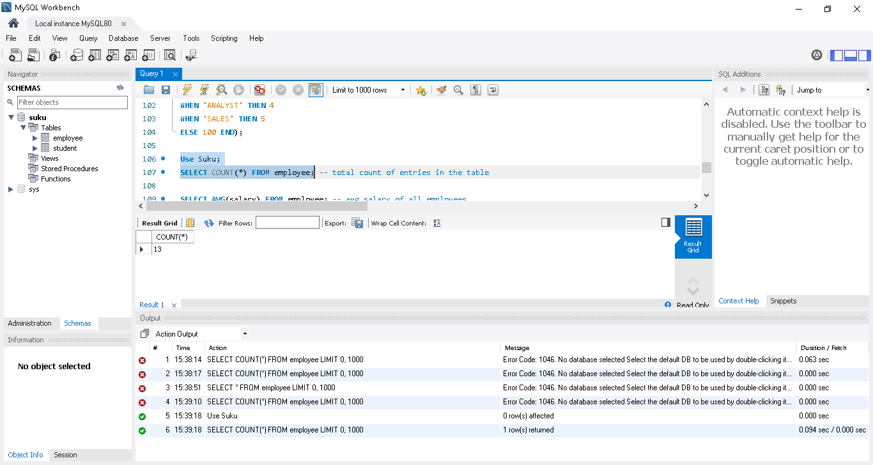

SELECT AVG(salary) FROM employee; -- avg salary of all employees

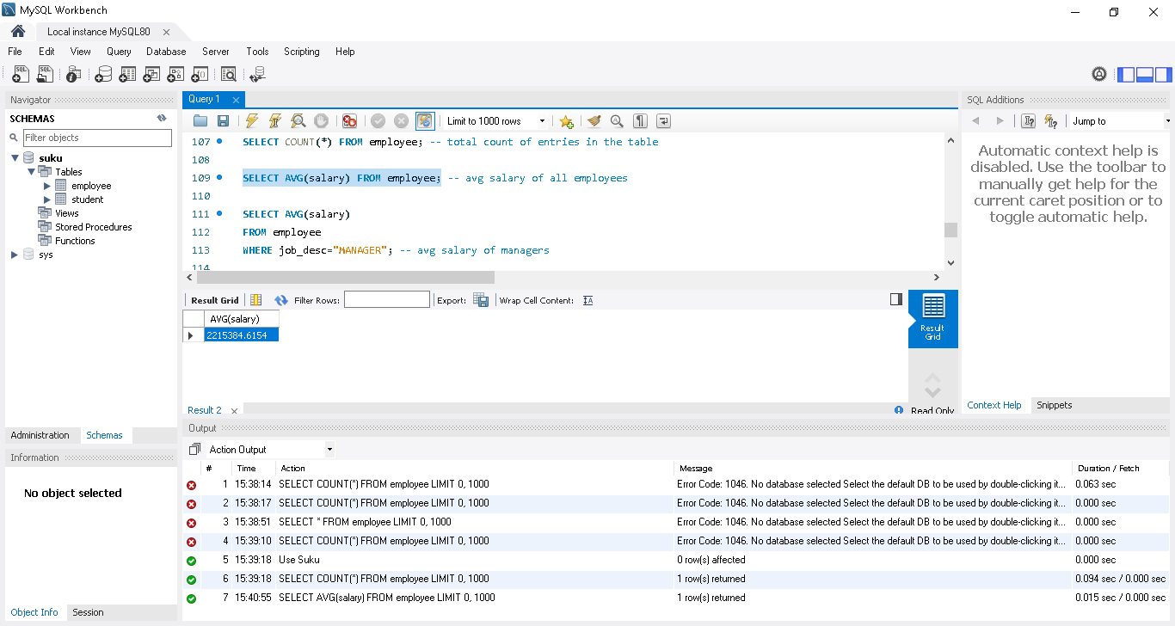

SELECT AVG(salary)

FROM employee

WHERE job_desc="MANAGER"; -- avg salary of managers

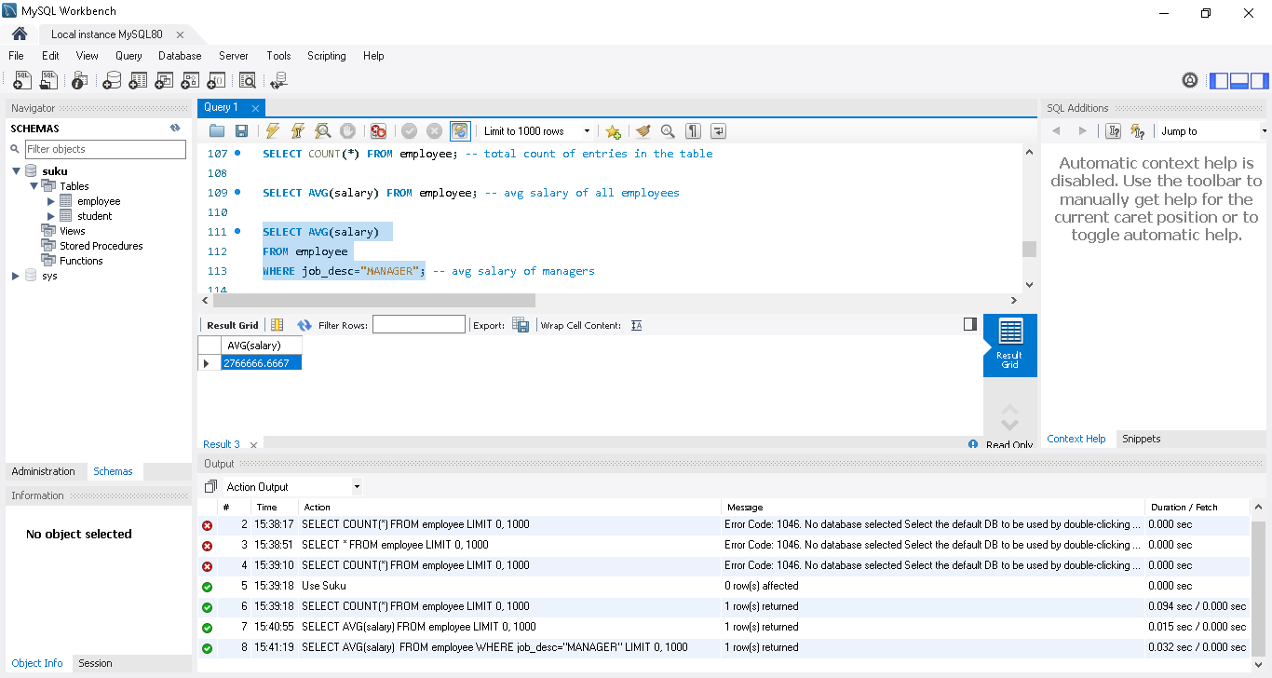

SELECT SUM(salary)

FROM employee

WHERE job_desc="ANALYST"; -- total salary given to all analysts

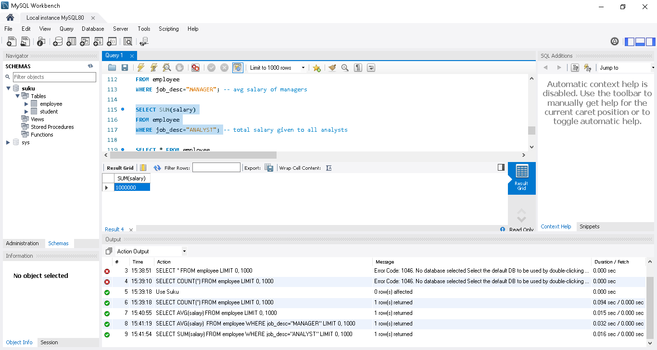

SELECT SUM(salary) Total

FROM employee

WHERE job_desc="ANALYST";

SUM(salary) Total -> in output, column will display as Total

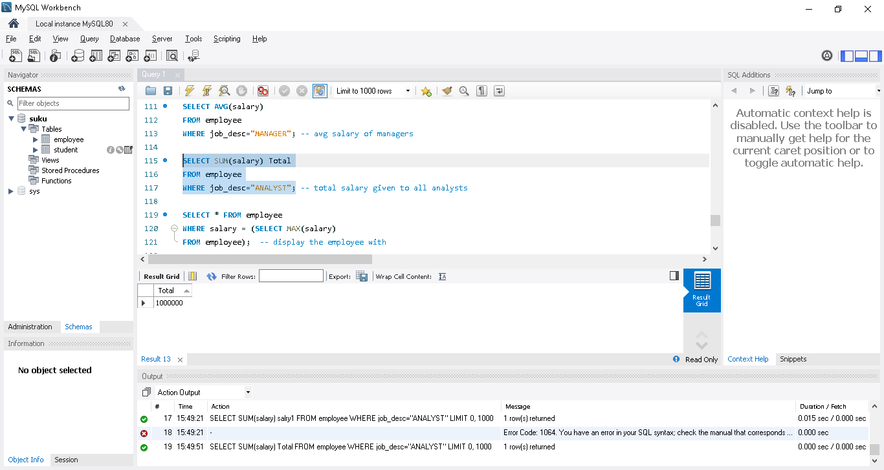

SELECT * FROM employee

WHERE salary = (SELECT MAX(salary)

FROM employee); -- display the employee with

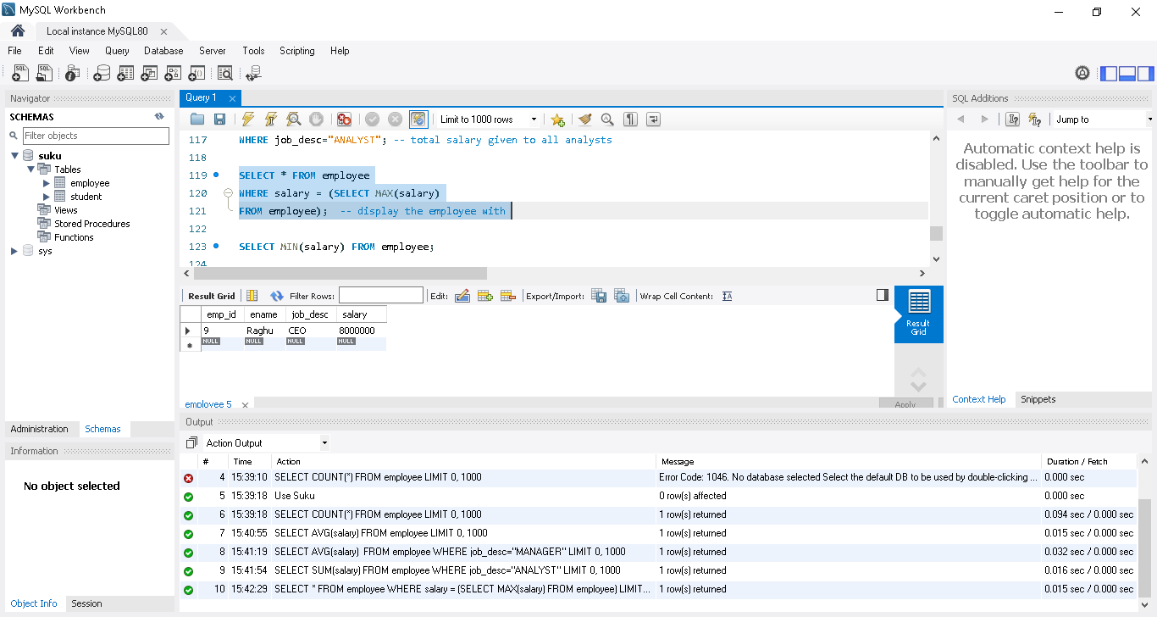

SELECT MIN(salary) FROM employee;

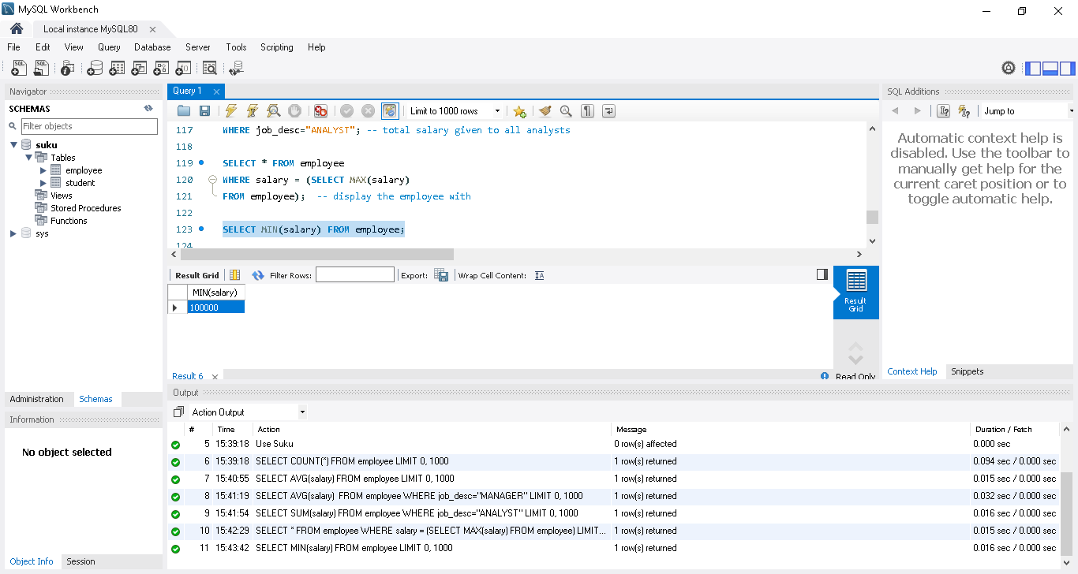

String functions - ucase,format,concat,char_length

SELECT UCASE(ename),salary

FROM employee; -- uppercase

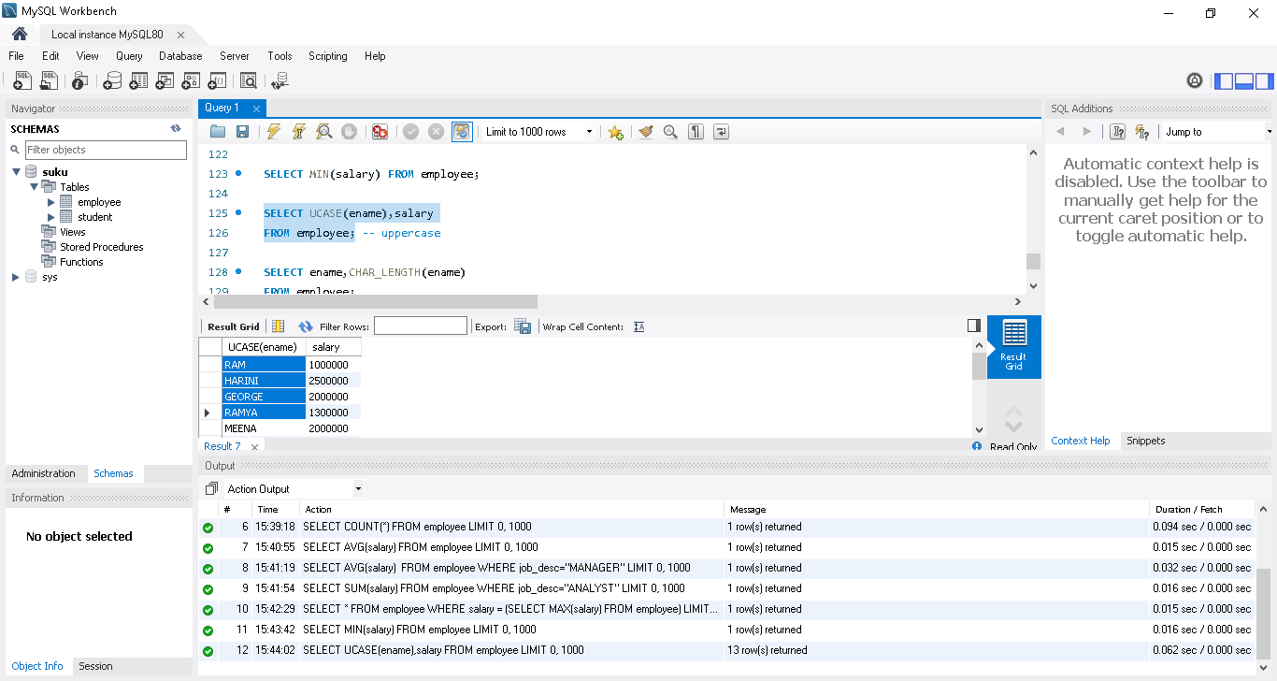

SELECT ename,CHAR_LENGTH(ename)

FROM employee;

In below result, CHAR_LENGTH column added based on the function used..Note: in original this column will not present

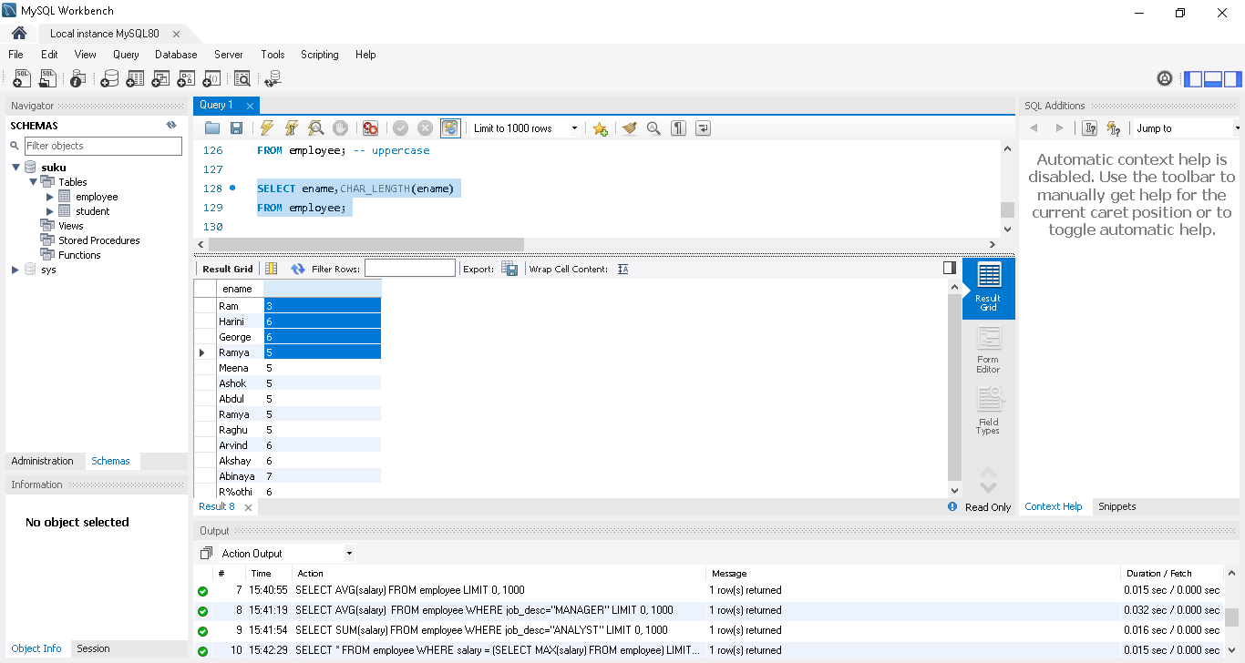

SELECT ename,CONCAT("Rs.",salary)

FROM employee; -- adds Rs. to the beginning of salary

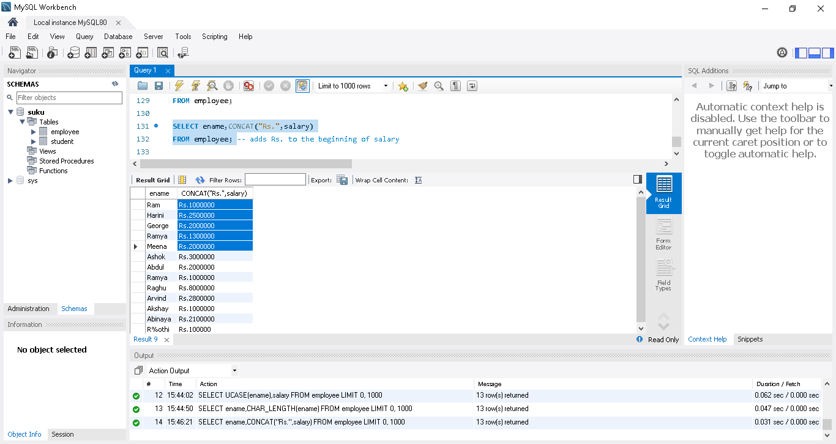

SELECT ename,CONCAT("Rs.",FORMAT(salary,0))

FROM employee; -- formats the number to add comma. The second argument(0 here) represents digits to round off after decimal

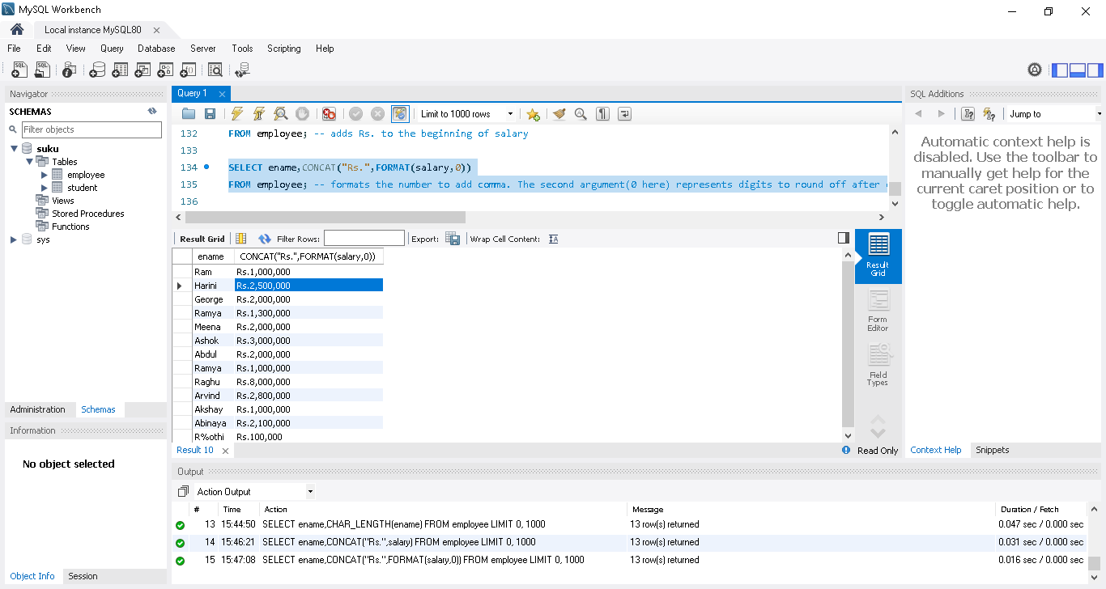

SELECT ename,LEFT(job_desc,4)

FROM employee; -- returns only the first 4 characters of the ename

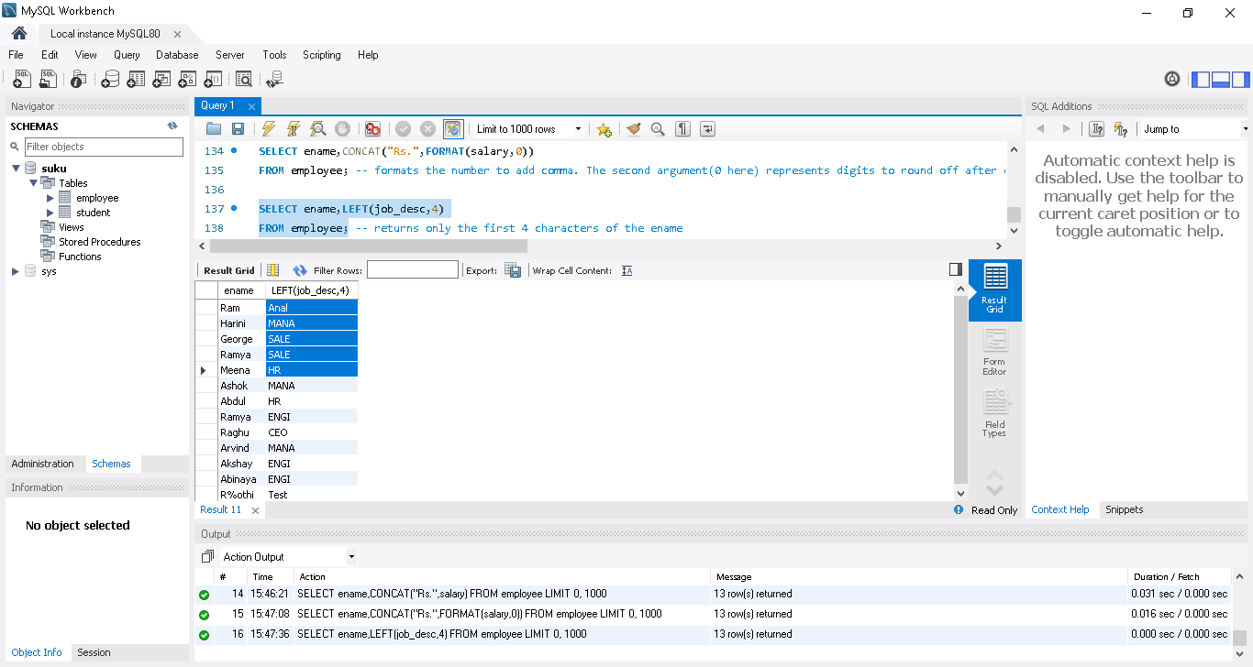

Date in SQL | Date Functions | SQL in Tamil | Logic First Tamil

Adding date column in a table - adding date values - date functions : now, date_format, curdate, datediff, date_add
ALTER TABLE employee ADD COLUMN Hire_Date DATE; -- adding hire_date column
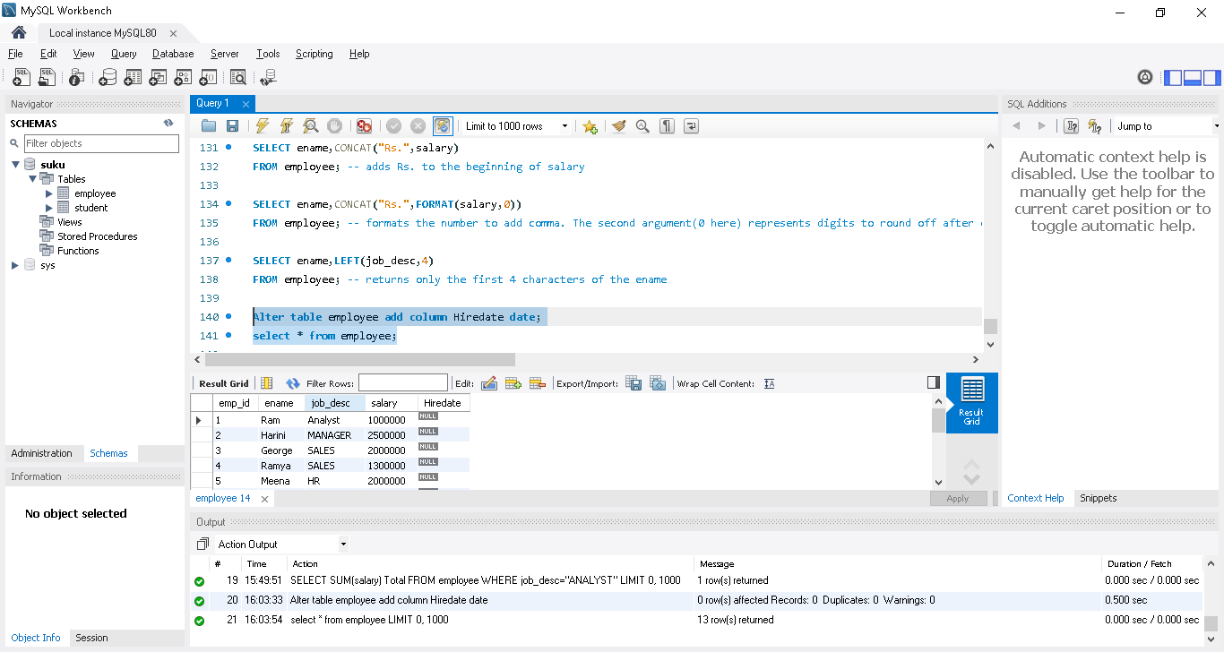

UPDATE employee
SET Hire_Date="2012-10-05"; -- updating hire_date
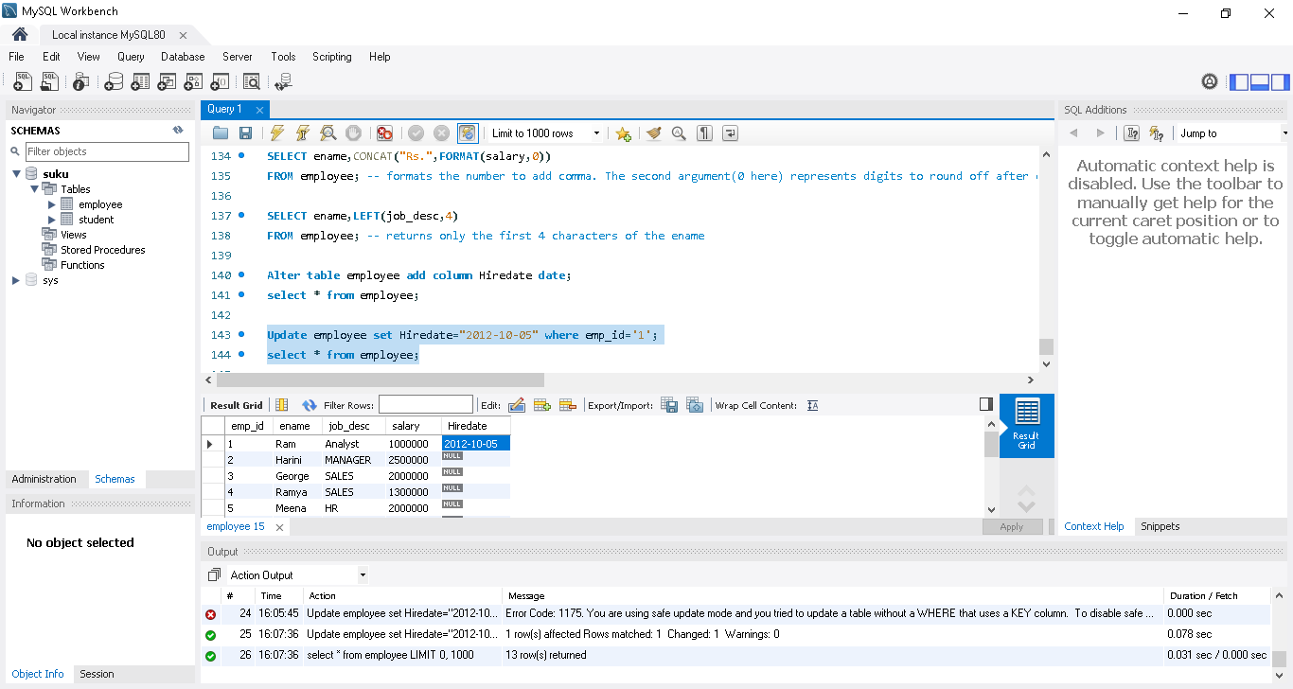
UPDATE employee
SET Hire_Date="2014-10-05"
WHERE job_desc = "ANALYST"; -- updating hire_date

SELECT NOW(); -- Current date and time
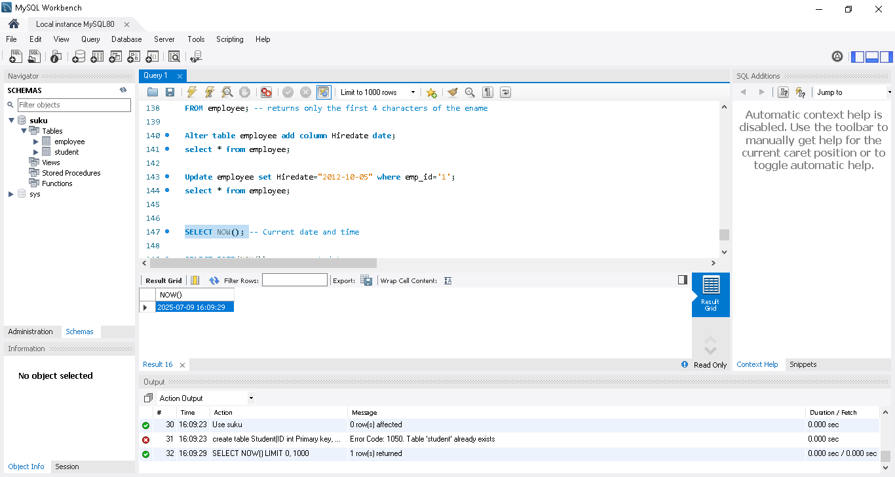
SELECT DATE(NOW()); -- current date
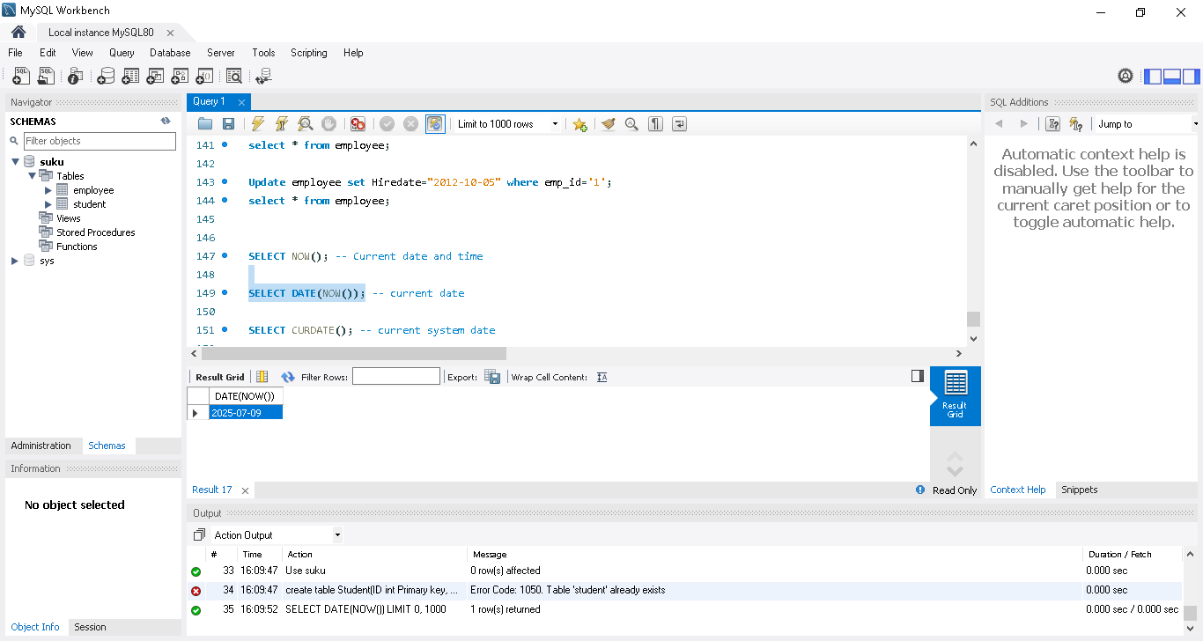
SELECT CURDATE(); -- current system date
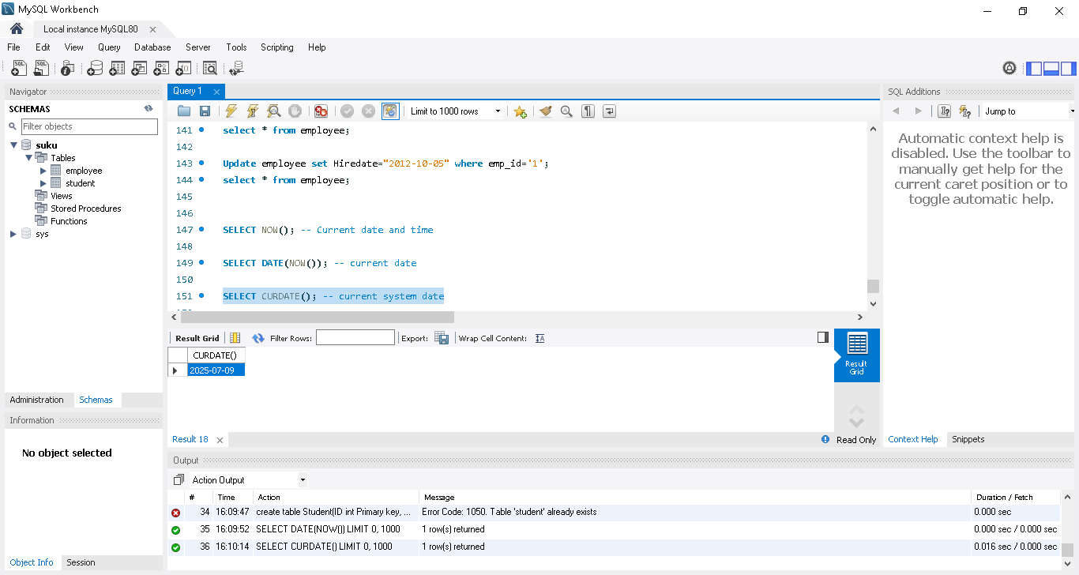
SELECT DATE_FORMAT(CURDATE(),'%d/%m/%Y'); -- to change the display format. use %d %m and %y or %Y in required format.
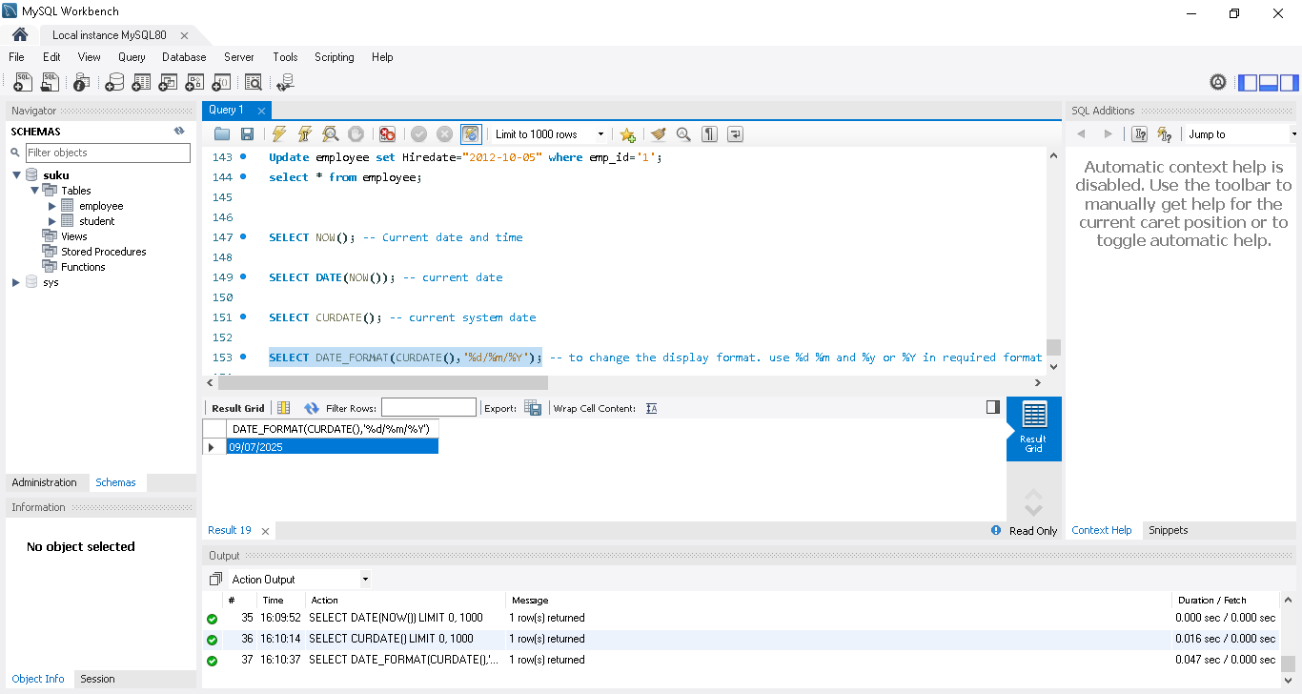
SELECT DATEDIFF(CURDATE(),'2020-01-01') DAYS; -- to calculate date difference
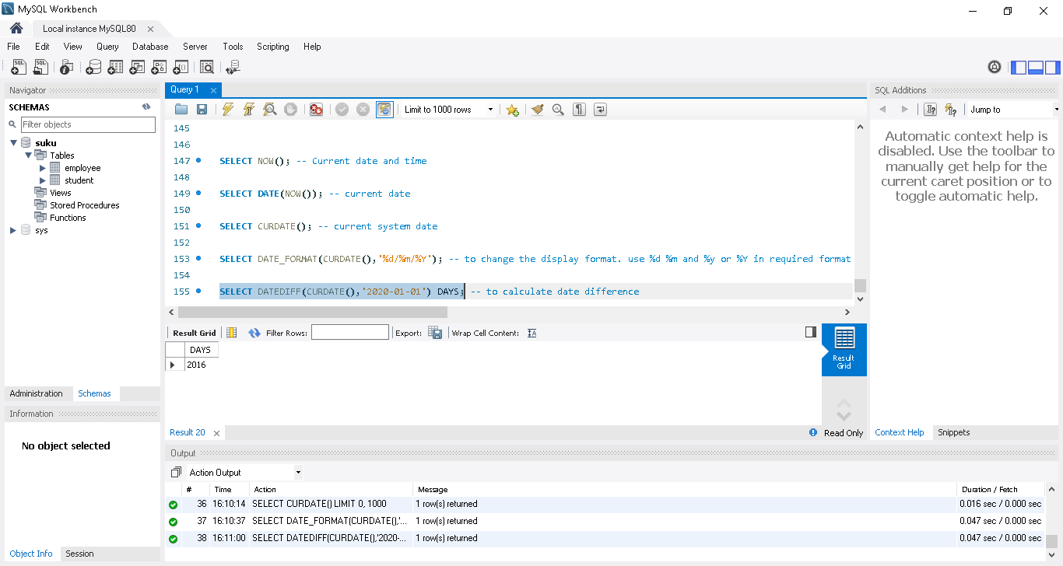

SELECT CURDATE() 'start date',
DATE_ADD(CURDATE(),INTERVAL 1 DAY) 'one day later',
DATE_ADD(CURDATE(),INTERVAL 1 WEEK) 'one week later',
DATE_ADD(CURDATE(),INTERVAL 1 MONTH) 'one month later',
DATE_ADD(CURDATE(),INTERVAL 1 YEAR) 'one year later';

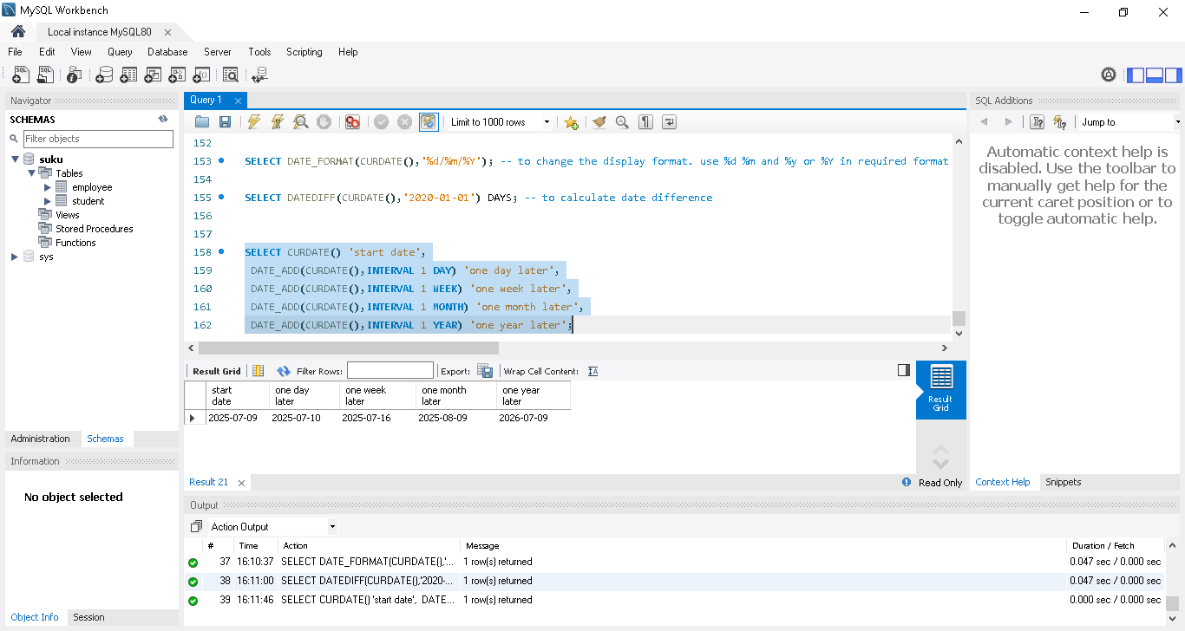

Group By | Having | SQL in Tamil | Logic First Tamil

When and how to use group by and having with examples
Group by is used to group the table based on conditions and analyze values within the group using aggregate functions.
Where is used to filter the rows before grouping. Having is used to filter the groups.
Group By ->used to group the particular rows
Having ->used to apply for filter in groups whereas where is used to apply for filter the rows
Order By->always used at the last condition
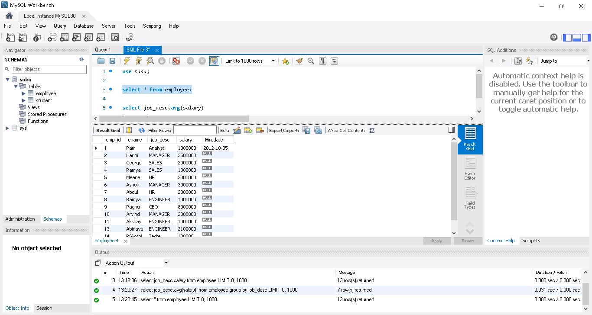
Condition1: shows avg salary of each category within job_desc
select job_desc,avg(salary)
from employee
group by job_desc;
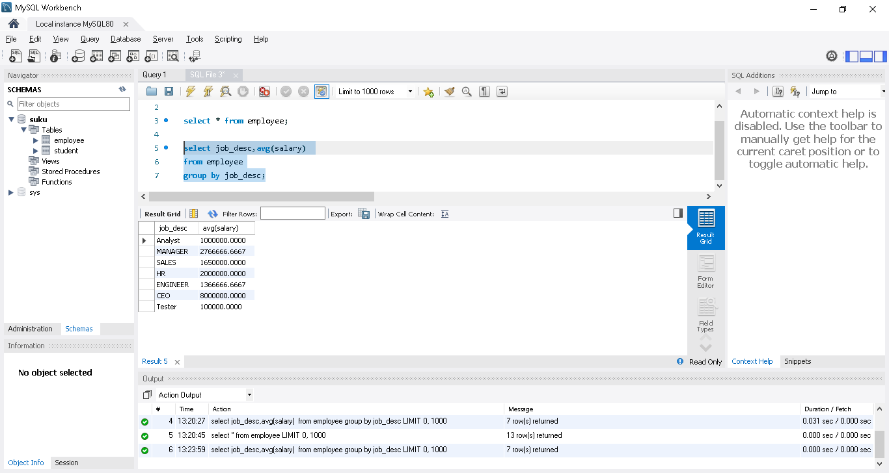

Condition2: displays number of employees count in each job_desc category
select job_desc,count(emp_id)
from employee
group by job_desc;
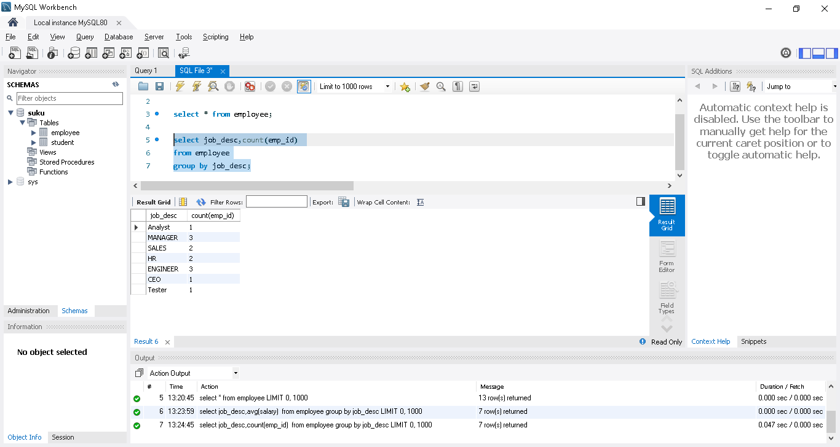
Condition3:displays number of employees count in each job_desc category only when count is greater than 1.
select job_desc,count(emp_id)
from employee
group by job_desc
having count(emp_id) >1;
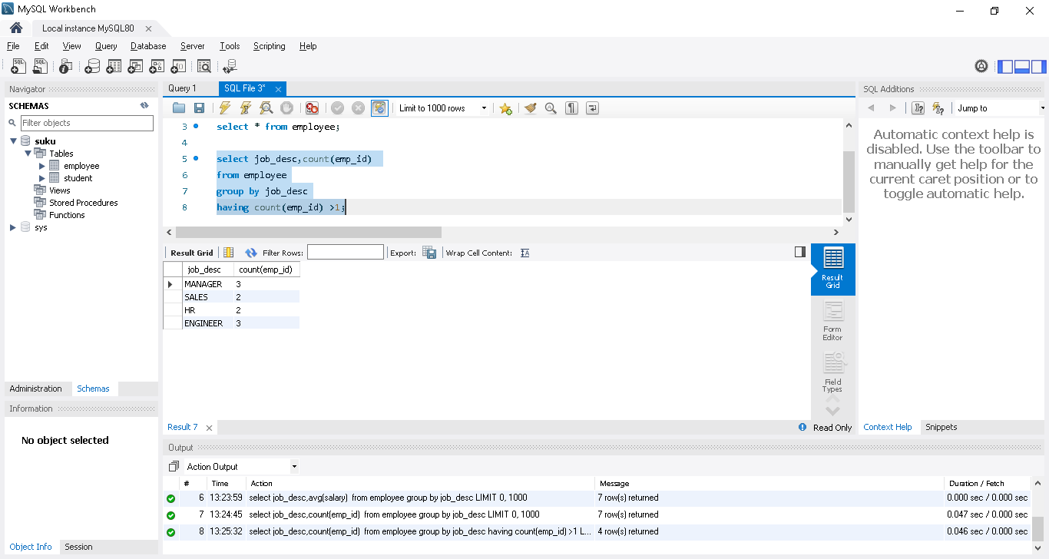
Condition4: same as above ordered by job_desc asc
select job_desc,count(emp_id)
from employee
group by job_desc
having count(emp_id) >1
order by job_desc;
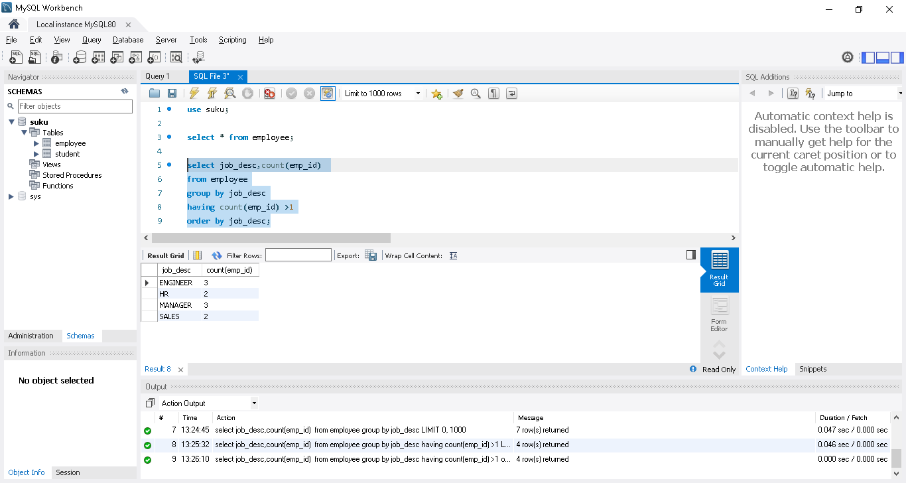
Condition5: same but ordered by Desc order of COUNT in each group
select job_desc,count(emp_id)
from employee
group by job_desc
having count(emp_id) >1
order by count(emp_id) desc;
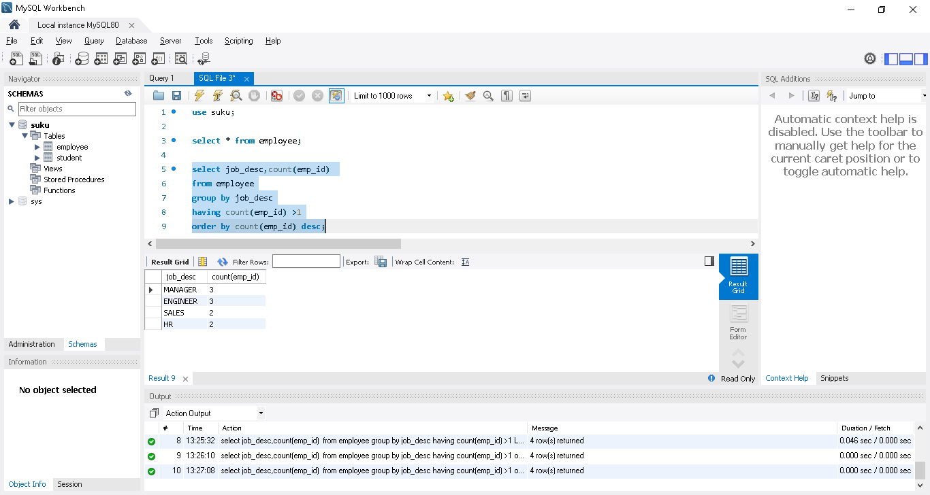
Condition6: with additional filtering of salary> 15L. Only those with sal more than 15L is considered for grouping
select job_desc,avg(salary)
from employee
where salary>1500000
group by job_desc
having count(emp_id) >1;

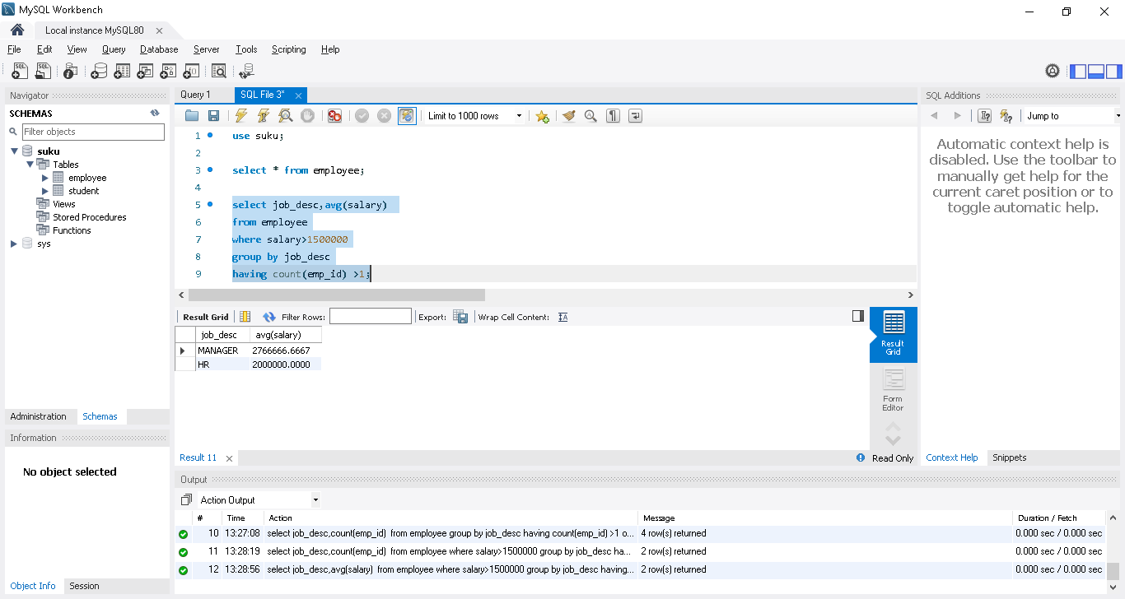

Constraints in MySQL | Not Null, Default, Check, Unique| SQL in Tamil | Logic First Tamil

Not Null, Default, Check, Unique and autoincrement explained with examples for create alter and dropping.\
Not Null, Default, Check, Unique and autoincrement are all called as Constraints in sql
While creating a table we need to define each column with Constraints if needed.
CREATE TABLE employee (
emp_id INT PRIMARY KEY auto_increment,
ename VARCHAR(30) Not null,
job_desc VARCHAR(20) default "unassigned",
salary INT,
Pan VARCHAR(20) unique,
check (salary>100000));

emp_id INT PRIMARY KEY auto_increment -> id will be auto incremented for new rows
ename VARCHAR(30) NOT NULL, -- null value cannot be inserted for the column, if inserted it will throw error
ob_desc VARCHAR(20) DEFAULT 'unassigned', -- sets default value('unassigned') when not mentioned while updating the value
pan VARCHAR(10) UNIQUE,-- cannot contain duplicates
check (salary>100000)->condition only insert the row when salary>100000
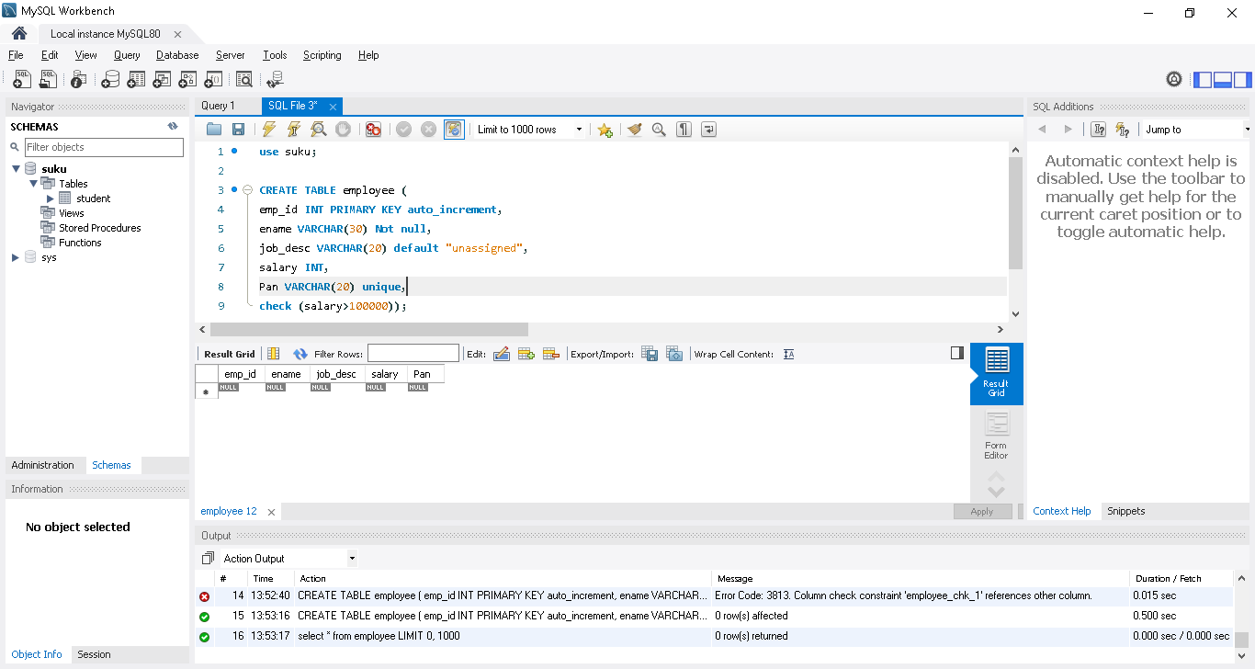

insert into employee(ename,salary) value('suku',150000);
only inserted name and salary, but emp_id having auto increment value , job_desc got default value
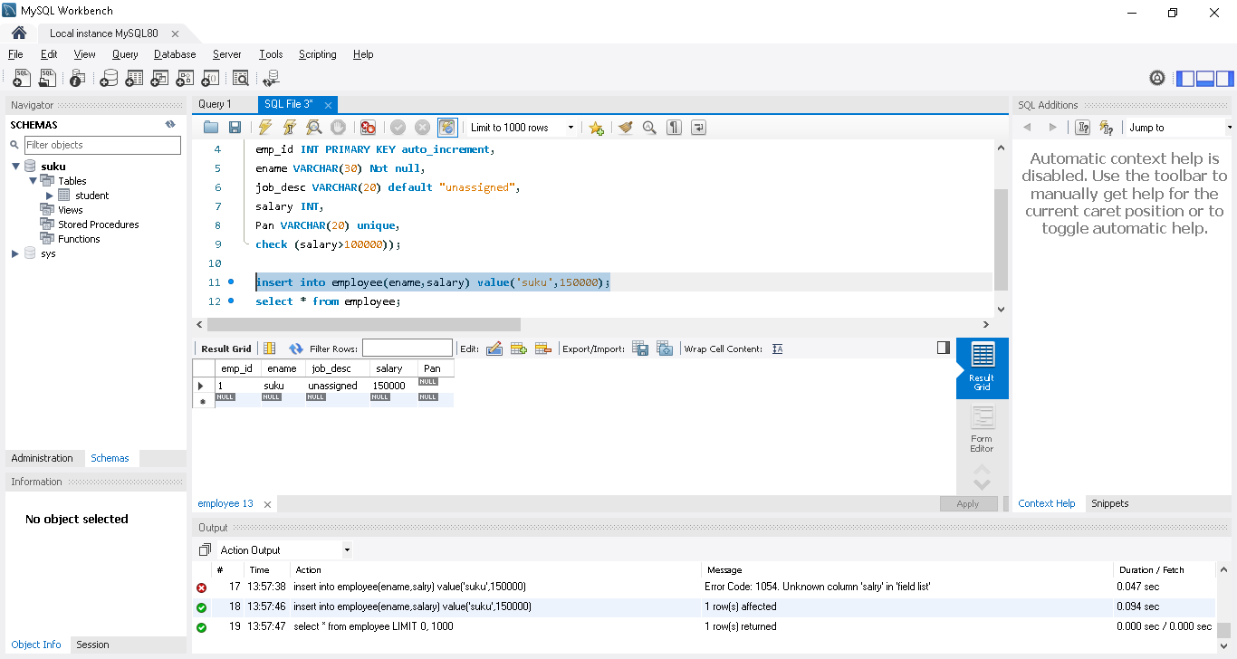

insert into employee(salary) value(150000);
unable to insert the row without ename value bec of below condition
ename VARCHAR(30) NOT NULL, -- null value cannot be inserted for the column, if inserted it will throw error
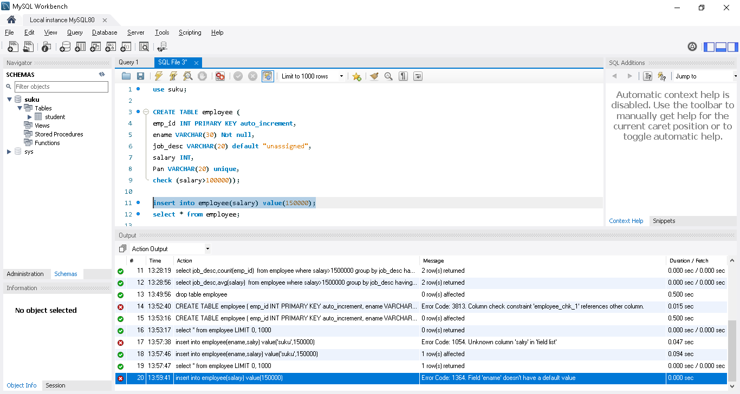
insert into employee(ename,salary) value('jothi',10000);
unable to insert the row bec of below condition
check (salary>100000)->condition only insert the row when salary>100000
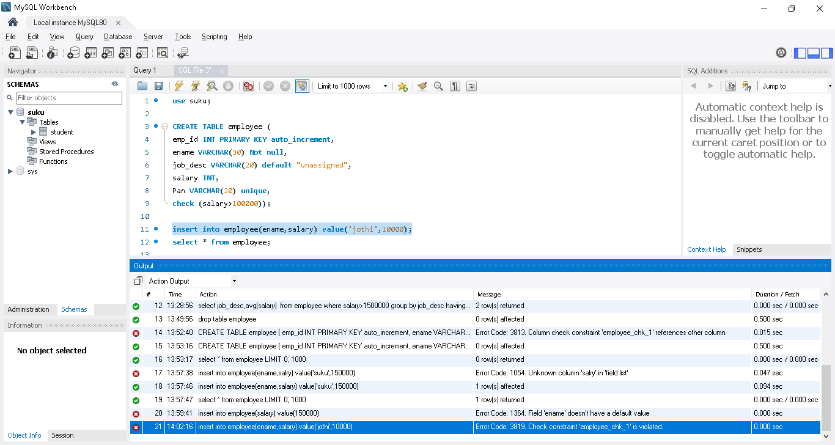
Now created a table without Constraints condition..
After user need to modify to add the Constraints condition
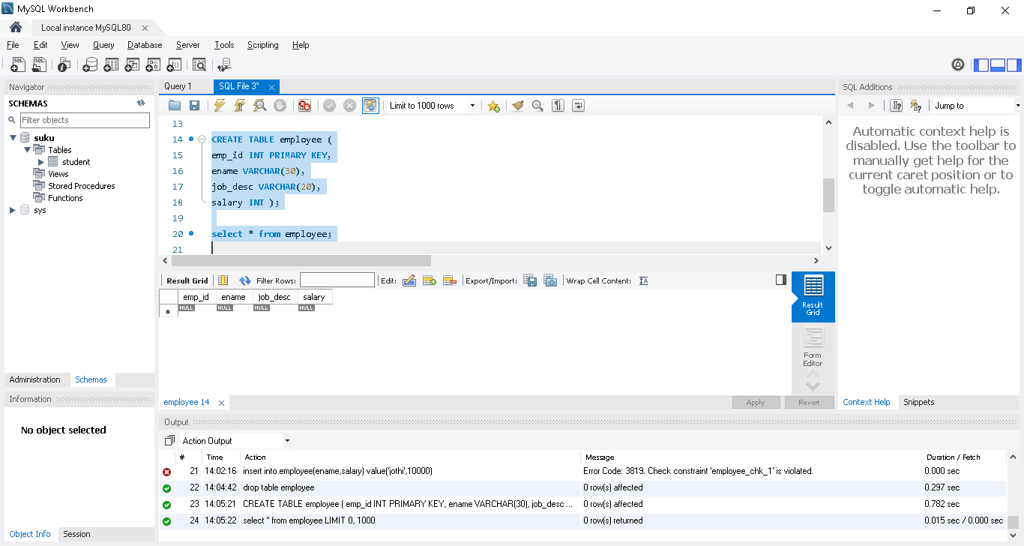
Add Not null Constraints
Alter table employee
modify ename VARCHAR(30) not null;
drop Not null Constraints
Alter table employee
modify ename VARCHAR(30);

Add default Constraints
Alter table employee
alter job_desc Set default 'unassigned';
drop default Constraints
Alter table employee
alter job_desc drop default ;

Add check Constraints
Alter table employee
add check(salary>150000) ;
or
Alter table employee
add constraint checkname check(salary>150000) ;
constraint name is checkname, so easy to drop as below
Drop check Constraints
Alter table employee
drop checkname;

Foreign Key | SQL in Tamil | Logic First Tamil
Foreign Key explained with examples
Foreign key is a field in one table referring to the primary key of another table.
Like Combine 2 tables
Table have n no of foreign key, that foreign key be the primary key of another table

-- drop previously created tables and create a branch table
CREATE TABLE branch (
branch_id INT PRIMARY KEY AUTO_INCREMENT,
br_name VARCHAR(30) NOT NULL,
addr VARCHAR(200) );
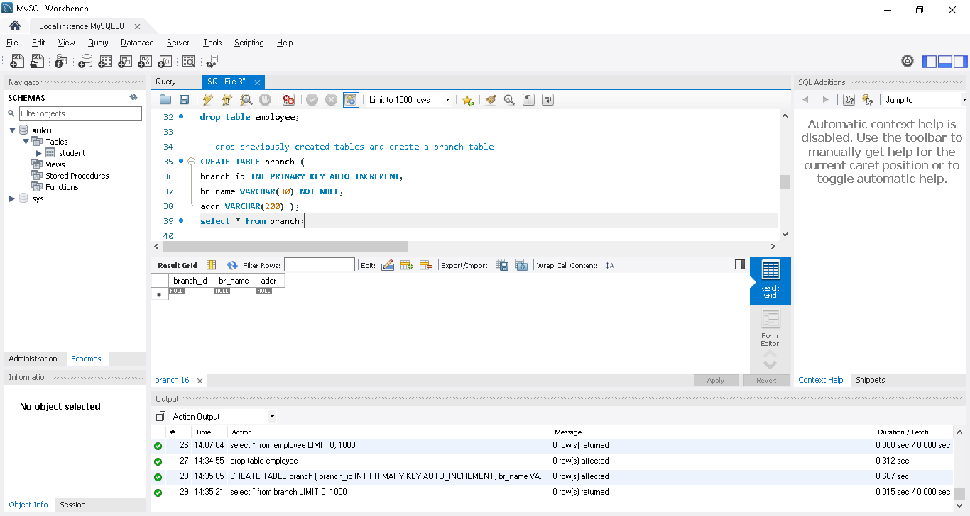
-- create employee table with branch_id as foreign key. It refers to the branch_id of branch table.
CREATE TABLE employee (
emp_id INT PRIMARY KEY,
ename VARCHAR(30),
job_desc VARCHAR(20),
salary INT,
branch_id INT,
CONSTRAINT FK_branchId FOREIGN KEY(branch_id) REFERENCES branch(branch_id));
Or
CREATE TABLE employee (
emp_id INT PRIMARY KEY,
ename VARCHAR(30),
job_desc VARCHAR(20),
salary INT,
branch_id INT,
FOREIGN KEY(branch_id) REFERENCES branch(branch_id));

CONSTRAINT FK_branchId FOREIGN KEY(branch_id) REFERENCES branch(branch_id));
CONSTRAINT FK_branchId ->giving name as FK_branchId, easy to drop if needed
FOREIGN KEY(branch_id)->setting branch_id as foreign key and then need to reference in which table its present
REFERENCES branch(branch_id)); -> need to reference in which table its present

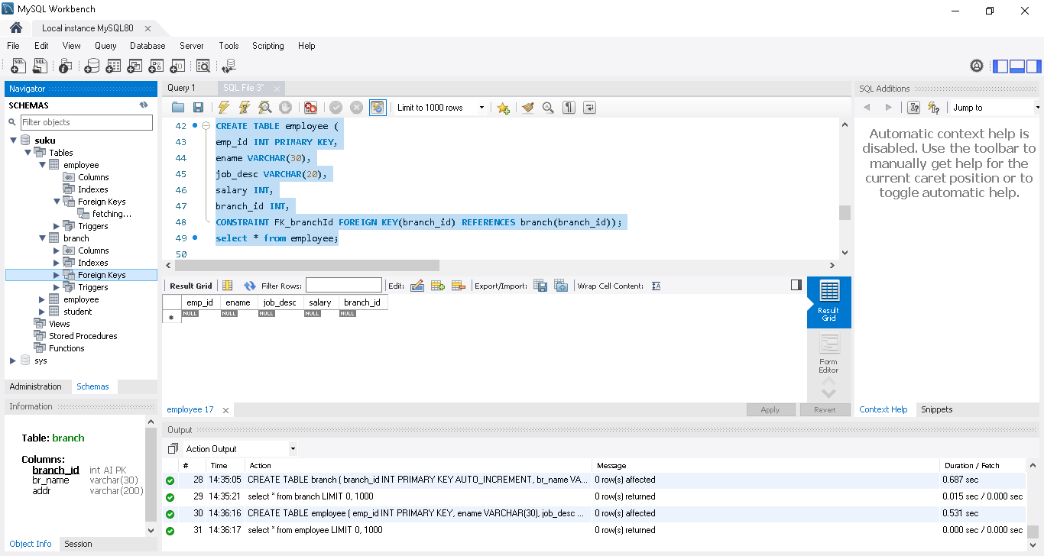
-- droping FK
ALTER TABLE employee
DROP FOREIGN KEY FK_branchId;

Index | SQL in Tamil | Logic First Tamil

What is an index and why we need index - How to add and drop index?
Index are used for fast lookups. Speeds up select query but delays insert/update. Also take up more memory.

By default primary key, foreign key field, (Unique field if any) comes under Index..In backend it will store as table and structure , so easy to filter based on query
SHOW INDEX FROM employee; -- show current indices as below
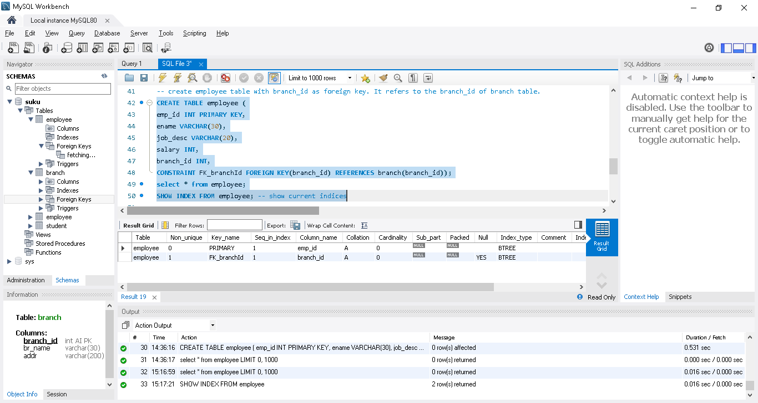
In some time, user always use ename in the query to filter..in that case we can create index for ename as below
CREATE INDEX name_index ON employee(ename); -- creates a new index
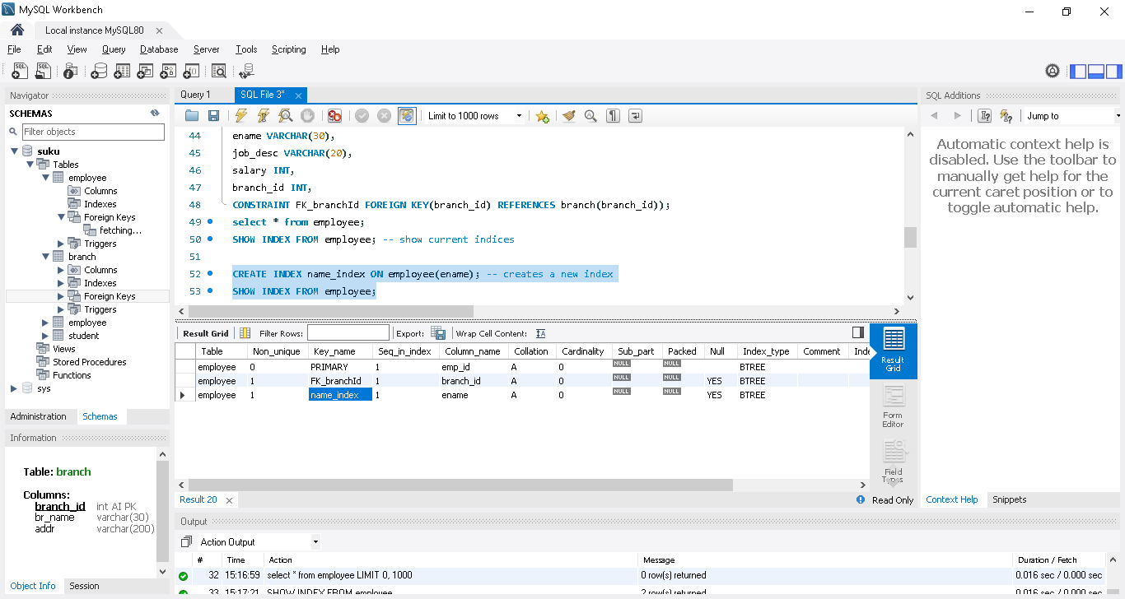
ALTER TABLE employee
DROP INDEX name_index; -- drop index
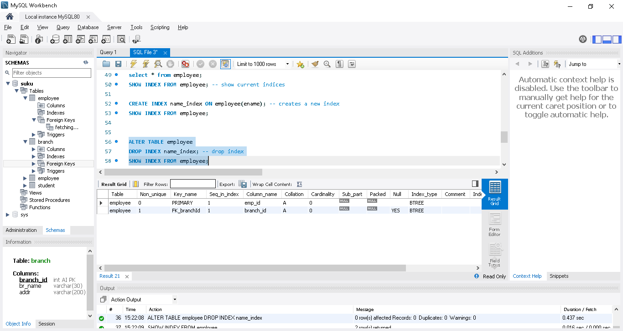
ALTER TABLE employee
ADD INDEX(ename); -- another way to create index using alter command

On Delete | Cascade | Set Null | SQL in Tamil | Logic First Tamil

Deleting rows with foreign key constraint explained

CREATE TABLE branch (
branch_id INT PRIMARY KEY AUTO_INCREMENT,
br_name VARCHAR(30) NOT NULL,
addr VARCHAR(200) );

insert into branch value(1,"Suku","Chennai");
insert into branch value(2,"krish","bangloare");
insert into branch value(3,"kiru","mumbai");
insert into branch value(4,"savi","pune");
select * from branch;

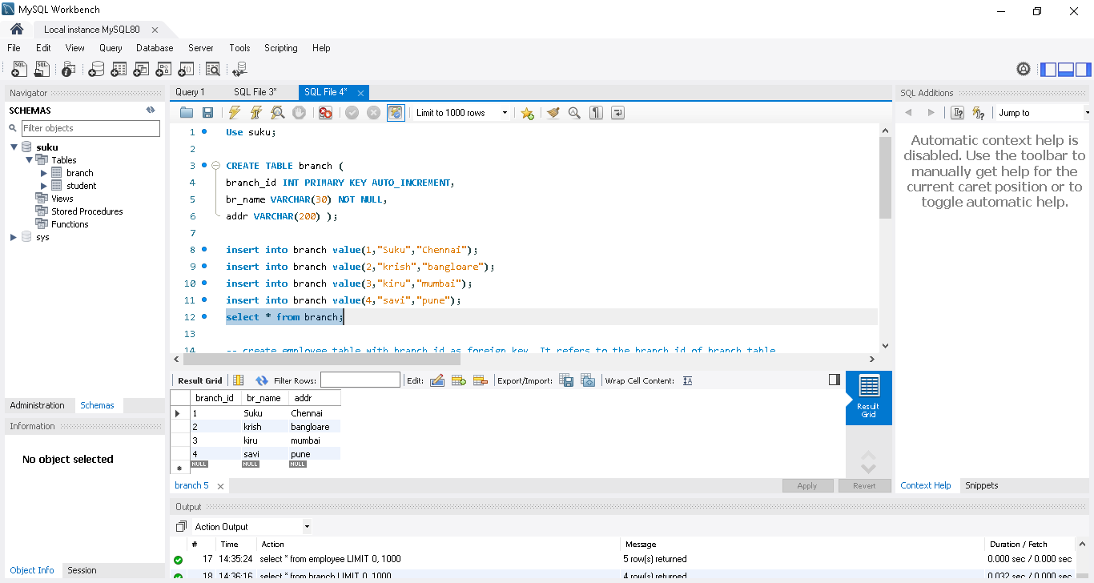
Another table, branch_id is a foreign ket in this table

CREATE TABLE employee (
emp_id INT PRIMARY KEY,
ename VARCHAR(30),
job_desc VARCHAR(20),
salary INT,
branch_id INT,
CONSTRAINT FK_branchId FOREIGN KEY(branch_id) REFERENCES branch(branch_id));

insert into employee value(1,"Suku","Tester",10000,1);
insert into employee value(2,"krish","QA",20000,3);
insert into employee value(3,"kiru","Developer",30000,1);
insert into employee value(4,"savi","Manager",40000,2);
insert into employee value(5,"savi","Support",50000,3);

select * from employee;

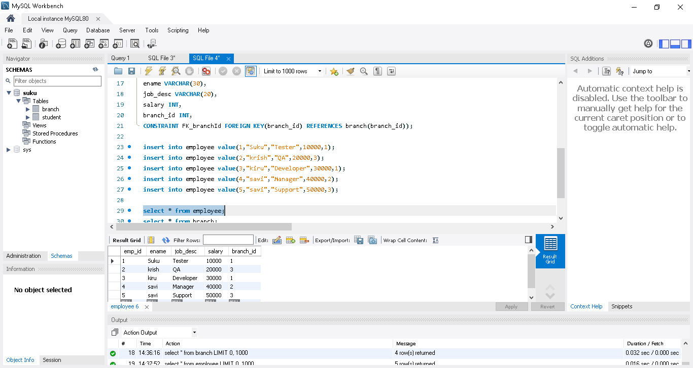

Try to delete the any branch in branch table
Unable to delete bec of foreigh key constraint
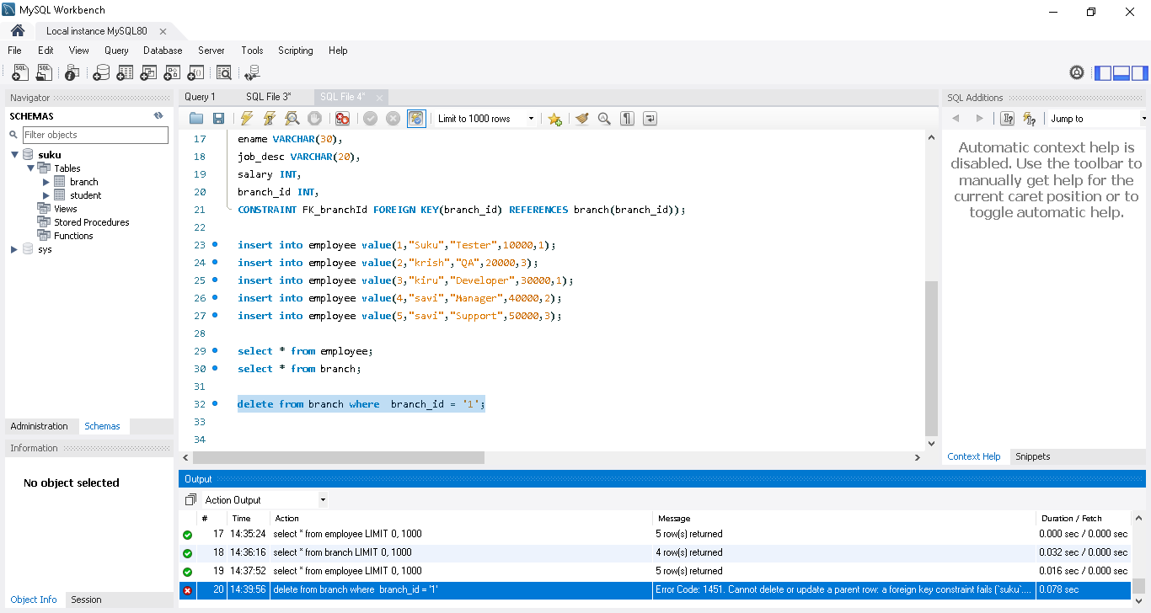

To overcome this we need to use On delete with set null or cascade
ON DELETE SET NULL -- on deleting a row in branch table, the branchid corresponding entries in employee table will be made null
ON DELETE CASCADE -- on deleting a row in branch table, the corresponding entries in employee table will be deleted

1.ON DELETE SET NULL

CREATE TABLE employee (
emp_id INT PRIMARY KEY AUTO_INCREMENT,
ename VARCHAR(30) NOT NULL,
job_desc VARCHAR(20),
salary INT,
branch_id INT,
CONSTRAINT FK_branchId FOREIGN KEY(branch_id) REFERENCES branch(branch_id)
ON DELETE SET NULL -- on deleting a row in branch table, the branchid corresponding entries in employee table will be made null
);

Again delete the branch 1 in branch table
Successfully deleted in branch table & in employee table branch ID for 1 set as “null”
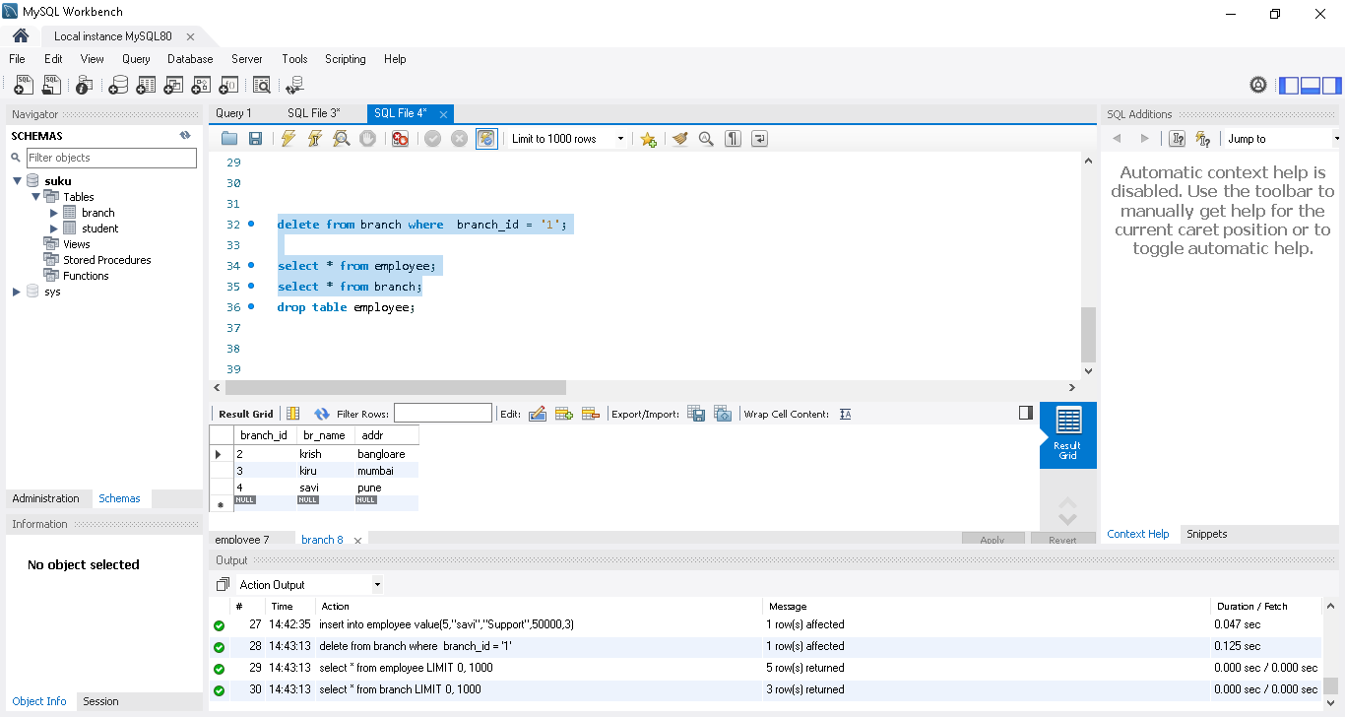

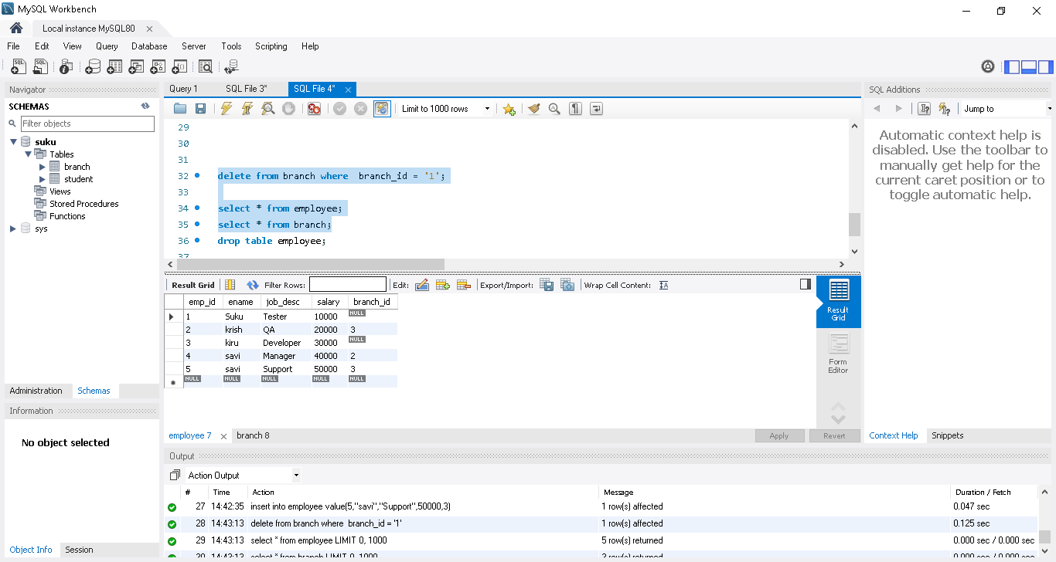
2. ON DELETE CASCADE
CREATE TABLE employee (
emp_id INT PRIMARY KEY AUTO_INCREMENT,
ename VARCHAR(30) NOT NULL,
job_desc VARCHAR(20),
salary INT,
branch_id INT,
CONSTRAINT FK_branchId FOREIGN KEY(branch_id) REFERENCES branch(branch_id)
ON DELETE CASCADE -- on deleting a row in branch table, the corresponding entries in employee table will be deleted
);

on deleting a row in branch table, the corresponding entries in employee table also be deleted

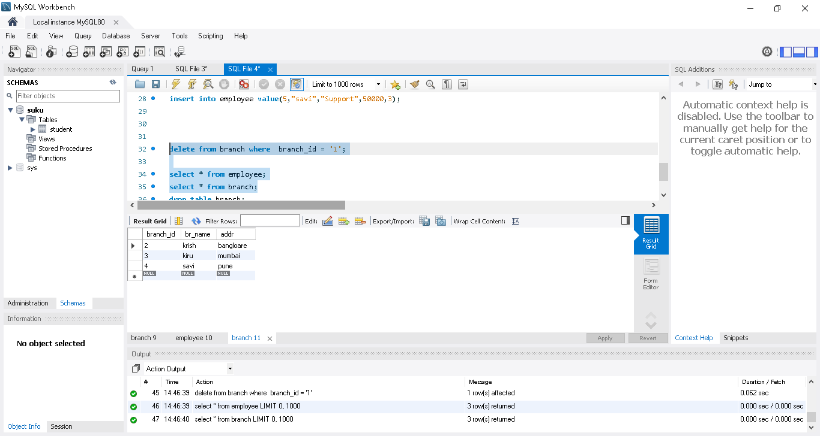

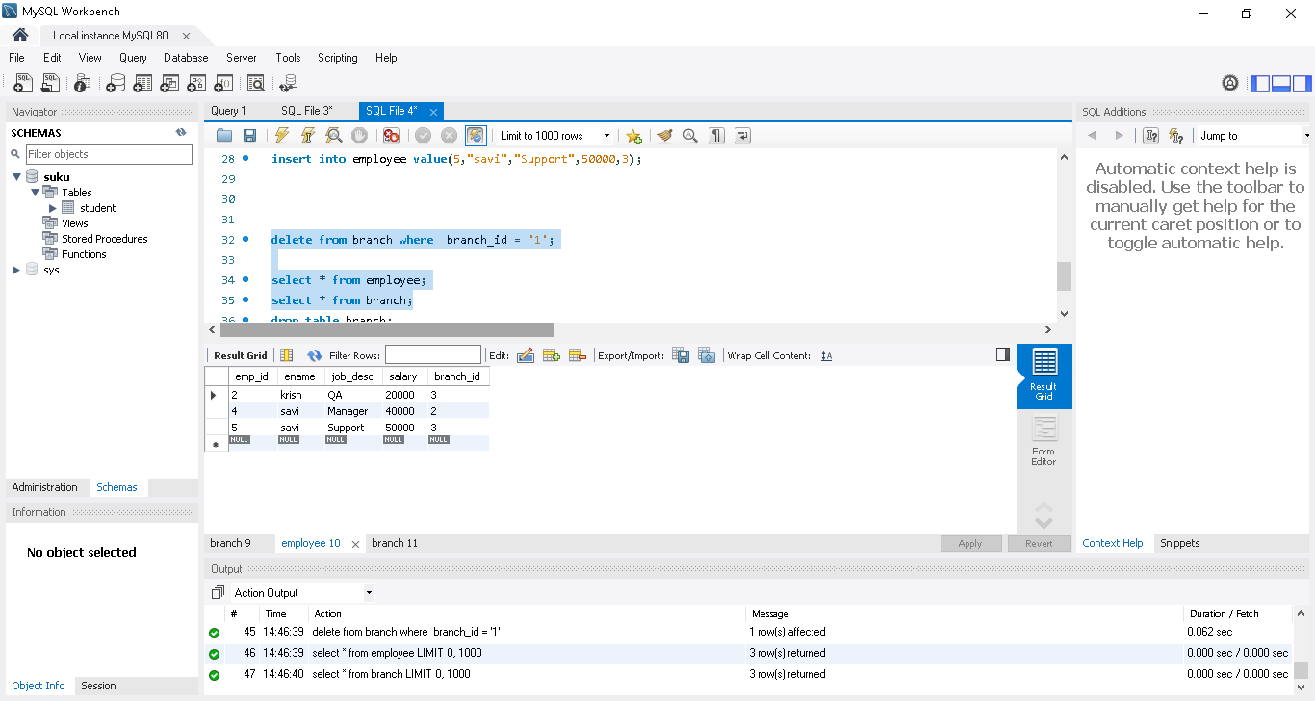

Joins - Inner, Left, Right and Cross | Union | Mysql| SQL in Tamil | Logic First Tamil

Various types of joins and union explained with simple examples.

Create a fresh 2 table and load the values

DROP TABLE employee; -- drop and freshly create

DROP TABLE branch;

CREATE TABLE branch (

branch_id INT PRIMARY KEY AUTO_INCREMENT,

br_name VARCHAR(30) NOT NULL,

addr VARCHAR(200) );

CREATE TABLE employee (

emp_id INT PRIMARY KEY AUTO_INCREMENT,

ename VARCHAR(30) NOT NULL,

job_desc VARCHAR(20),

salary INT,

branch_id INT,

CONSTRAINT FK_branchId FOREIGN KEY(branch_id) REFERENCES branch(branch_id)

);

INSERT INTO branch VALUES(1,"Chennai","16 ABC Road");

INSERT INTO branch VALUES(2,"Coimbatore","120 15th Block");

INSERT INTO branch VALUES(3,"Mumbai","25 XYZ Road");

INSERT INTO branch VALUES(4,"Hydrabad","32 10th Street");

INSERT INTO employee VALUES(1,'Ram','ADMIN',1000000,2);

INSERT INTO employee VALUES(2,'Harini','MANAGER',2500000,2);

INSERT INTO employee VALUES(3,'George','SALES',2000000,1);

INSERT INTO employee VALUES(4,'Ramya','SALES',1300000,2);

INSERT INTO employee VALUES(5,'Meena','HR',2000000,3);

INSERT INTO employee VALUES(6,'Ashok','MANAGER',3000000,1);

INSERT INTO employee VALUES(7,'Abdul','HR',2000000,1);

INSERT INTO employee VALUES(8,'Ramya','ENGINEER',1000000,2);

INSERT INTO employee VALUES(9,'Raghu','CEO',8000000,3);

INSERT INTO employee VALUES(10,'Arvind','MANAGER',2800000,3);

INSERT INTO employee VALUES(11,'Akshay','ENGINEER',1000000,1);

INSERT INTO employee VALUES(12,'John','ADMIN',2200000,1);

INSERT INTO employee VALUES(13,'Abinaya','ENGINEER',2100000,2);

INSERT INTO employee VALUES(14,'Vidya','ADMIN',2200000,NULL);

INSERT INTO employee VALUES(15,'Ranjani','ENGINEER',2100000,NULL);

SELECT * FROM employee;

SELECT * FROM branch;

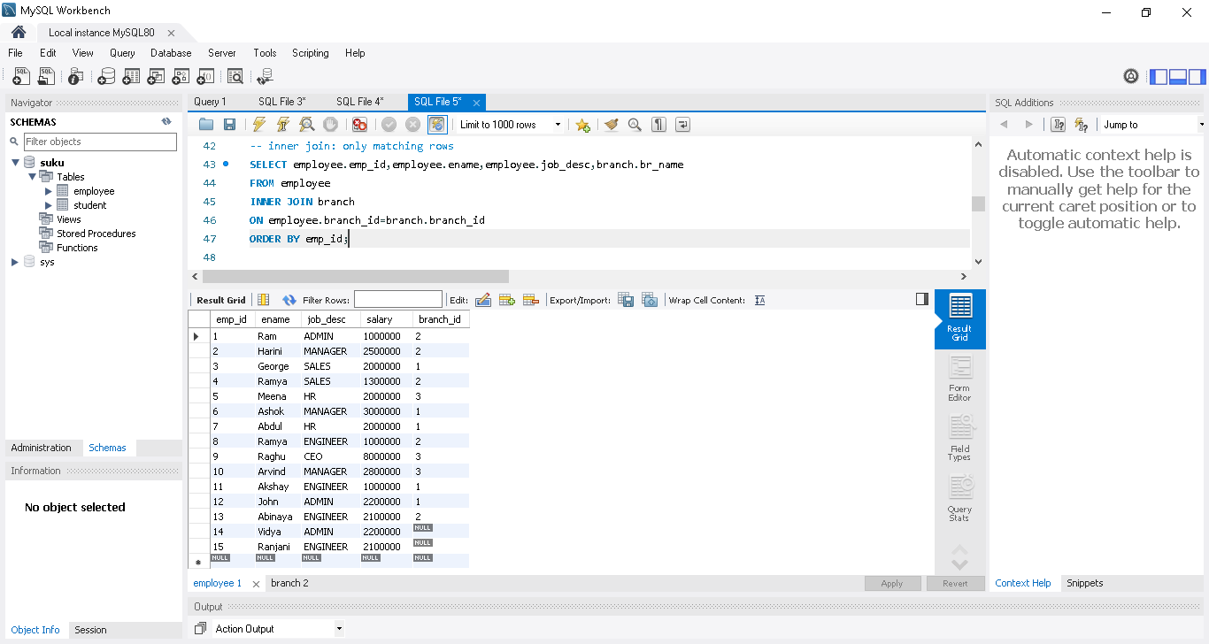

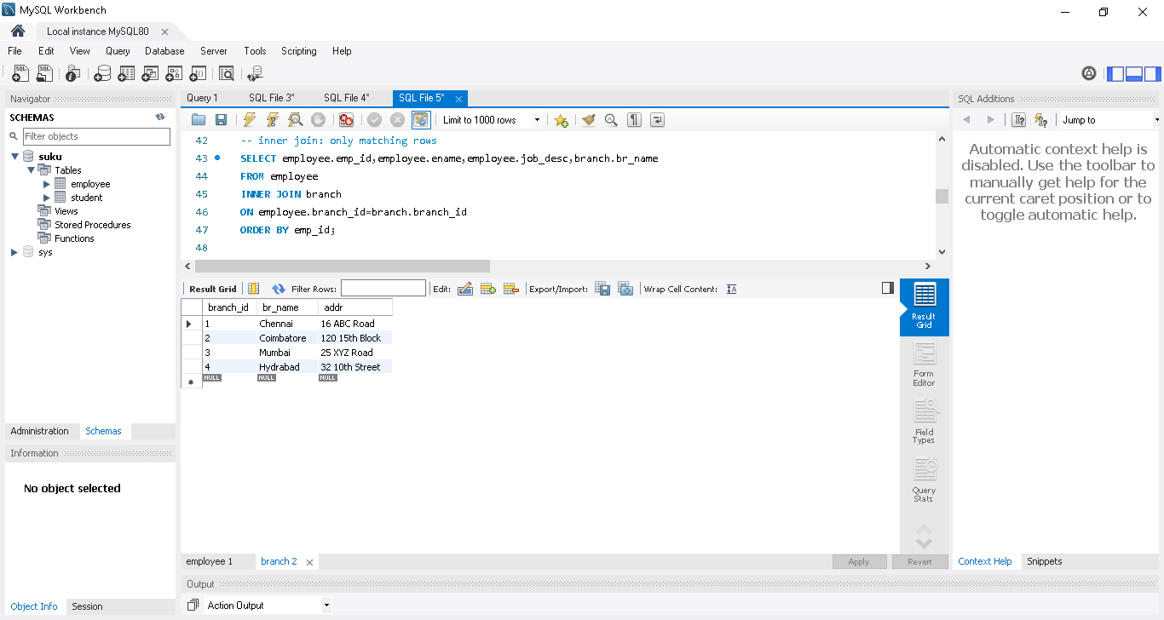

Read the empid , ename,job_desc from employee table and also brname from branch table based on branch_id match between 2 tables

Use inner join -> will display only matching rows

SELECT employee.emp_id,employee.ename,employee.job_desc,branch.br_name

FROM employee

INNER JOIN branch

ON employee.branch_id=branch.branch_id

ORDER BY emp_id;

Use inner join -> will display only matching rows

In employee table total 15 employee present , but display only 13 employee

14 & 15 employee branch id is null ..so only matching rows

In order to display all rows use left join

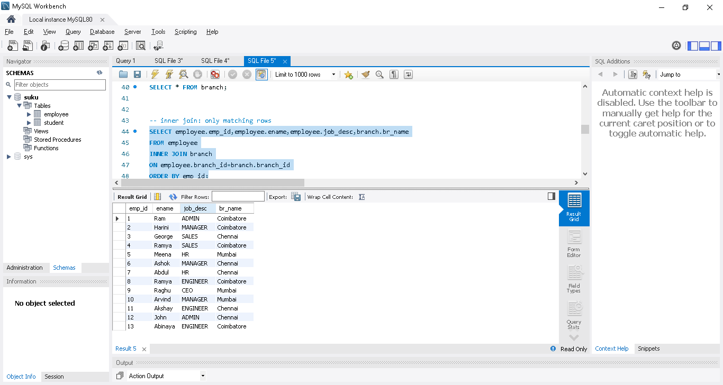

Left join
-- Left join is matched rows with all other rows in left table
SELECT employee.emp_id,employee.ename,employee.job_desc,branch.br_name
FROM employee
LEFT JOIN branch
ON employee.branch_id=branch.branch_id
ORDER BY emp_id;

Note: here first used table (employee) is called as left and second used table(branch) is called as right
14 & 15 rows also displayed
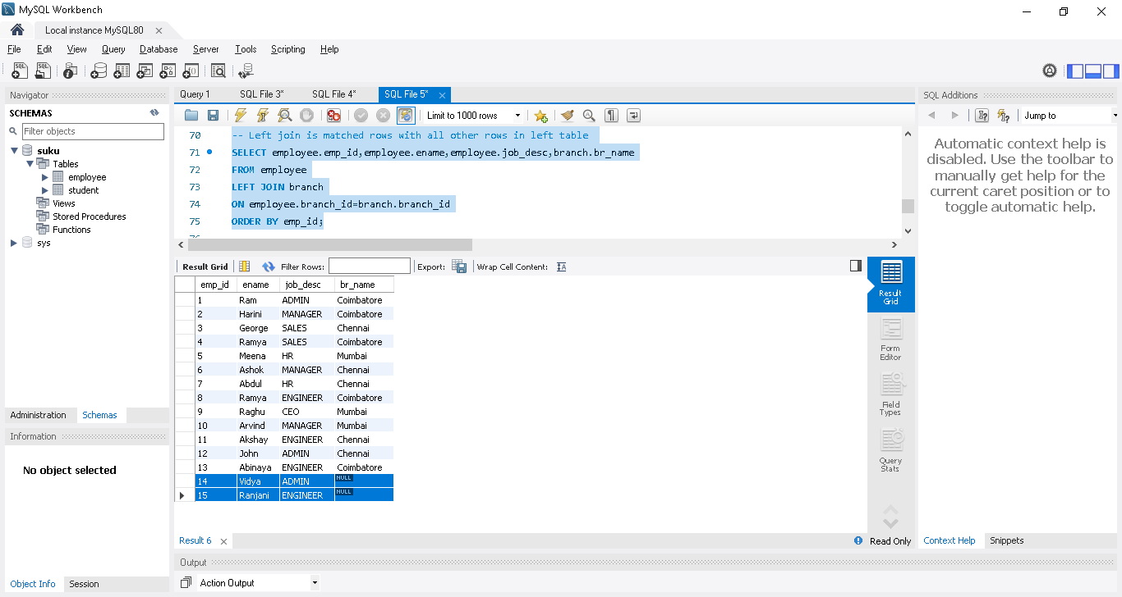

-- Right join is matched rows + all other rows in right table



In above table, branch_id ->4 not present in employee table branch_id
SELECT employee.emp_id,employee.ename,employee.job_desc,branch.br_name
FROM employee
RIGHT JOIN branch
ON employee.branch_id=branch.branch_id
ORDER BY emp_id;
In result, first row will display that branched 4 and then remaining match
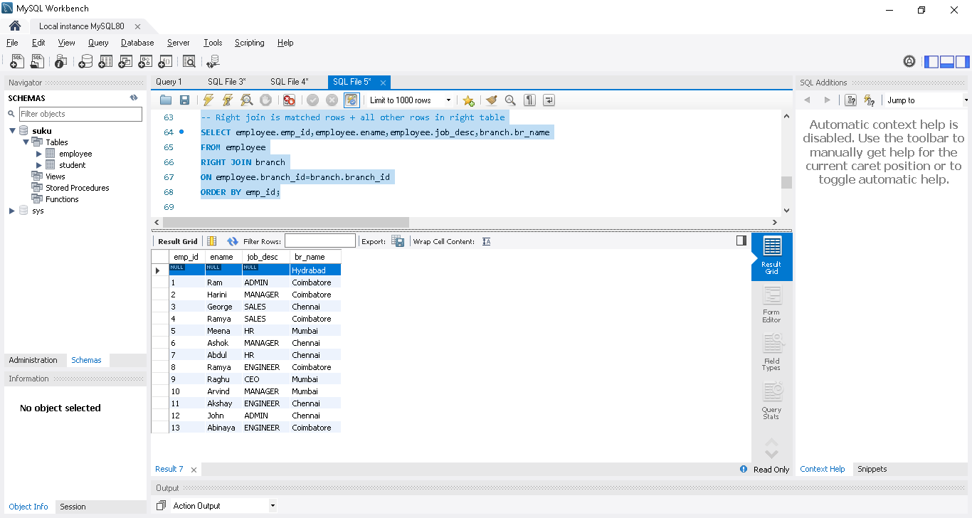
Note: Full join also available in oracle DBMS, sql server DBMS not in mysql DBMS...display a both employee row 14 & 15 (left join) and branch_id as 4(right join)
-- using table name alias [like employee AS e] easy to type the query
SELECT e.emp_id,e.ename,e.job_desc,b.br_name
FROM employee AS e
INNER JOIN branch AS b
ON e.branch_id=b.branch_id
ORDER BY e.emp_id;

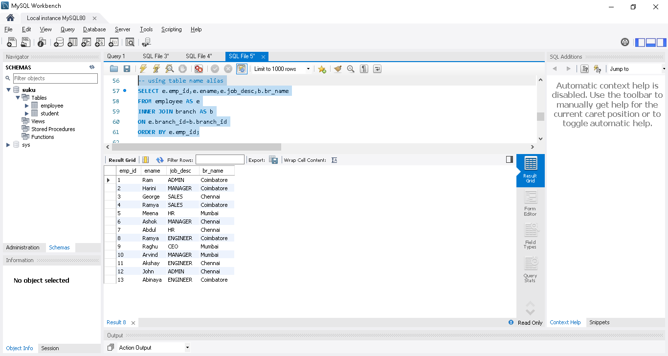

-- below query gives same result without using join keyword
SELECT employee.emp_id,employee.ename,employee.job_desc,branch.br_name
FROM employee,branch
WHERE employee.branch_id=branch.branch_id
ORDER BY emp_id;
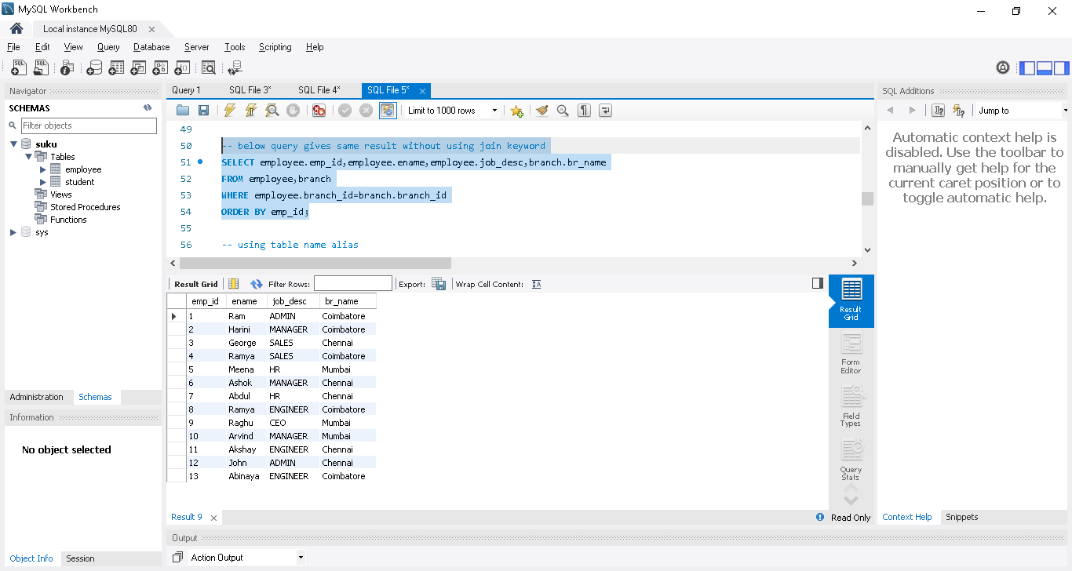
-- Cross join joins each row of first table with every other row of second table
Cross join wont use mostly
SELECT employee.emp_id,employee.ename,employee.job_desc,branch.br_name
FROM employee
CROSS JOIN branch;
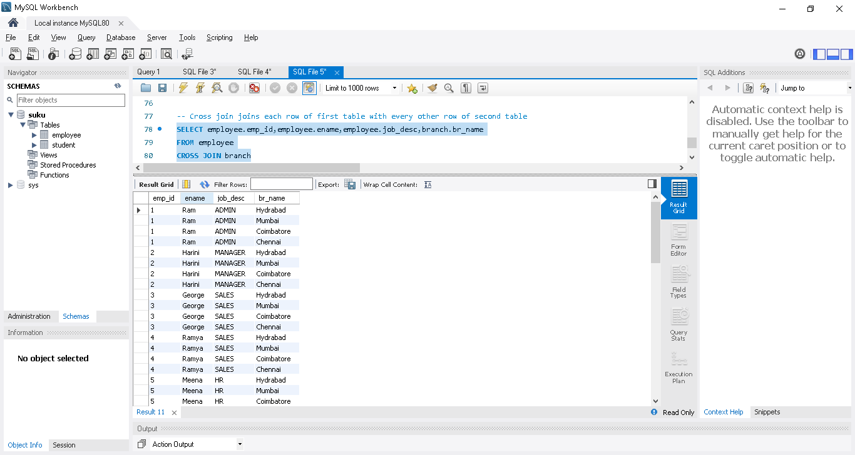

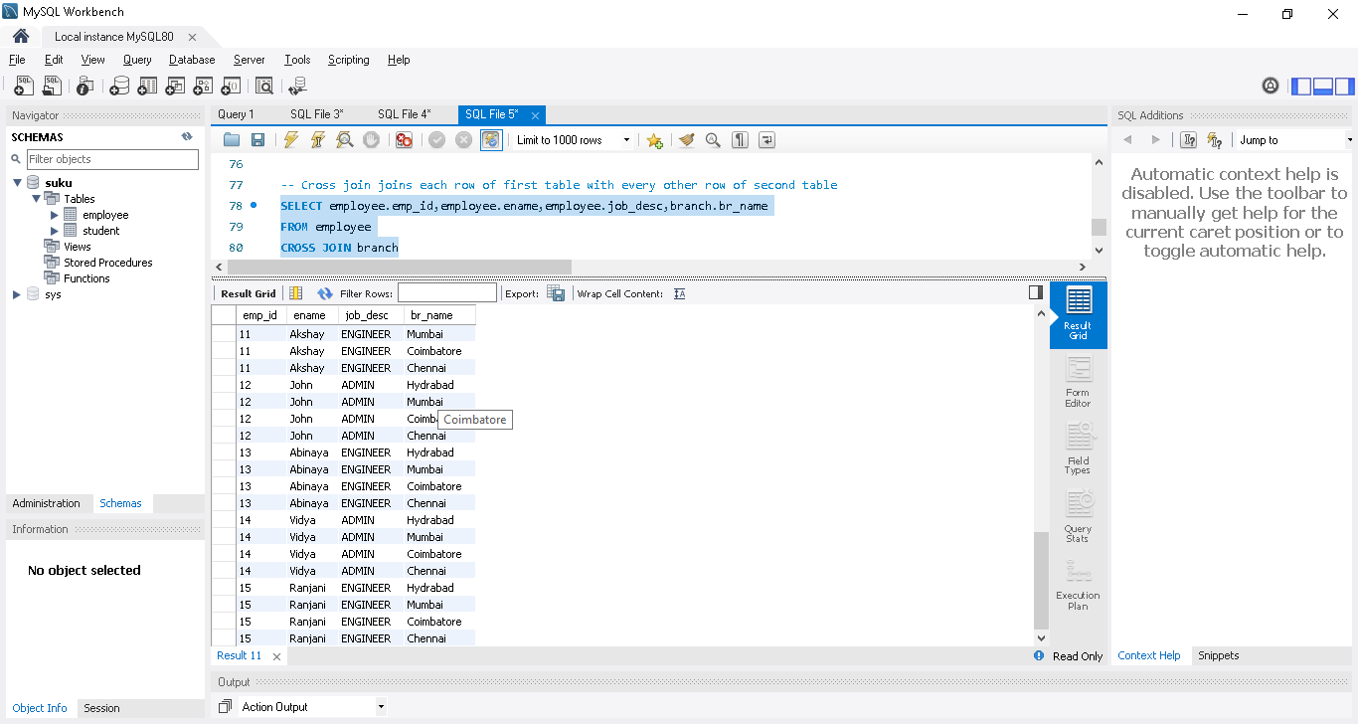
SELECT employee.emp_id,employee.ename,employee.job_desc,branch.br_name
FROM employee
CROSS JOIN branch
ON employee.branch_id=branch.branch_id
ORDER BY emp_id;

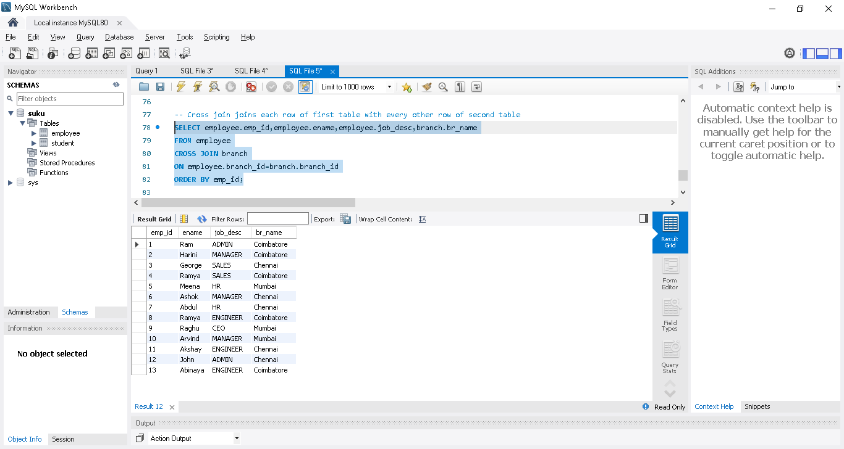

-- displays the employee count in each branch
SELECT b.br_name,COUNT(e.emp_id)
FROM branch as b
JOIN employee as e
ON b.branch_id = e.branch_id
GROUP BY e.branch_id;
Note: COUNT(e.emp_id) used so group by need to use at the last.
And also we need to use group by in employee table of branch_id column..in that branch_id column only we have 1,1,1,1 or 2,2,2,2 values against each employee..so that we can group easily

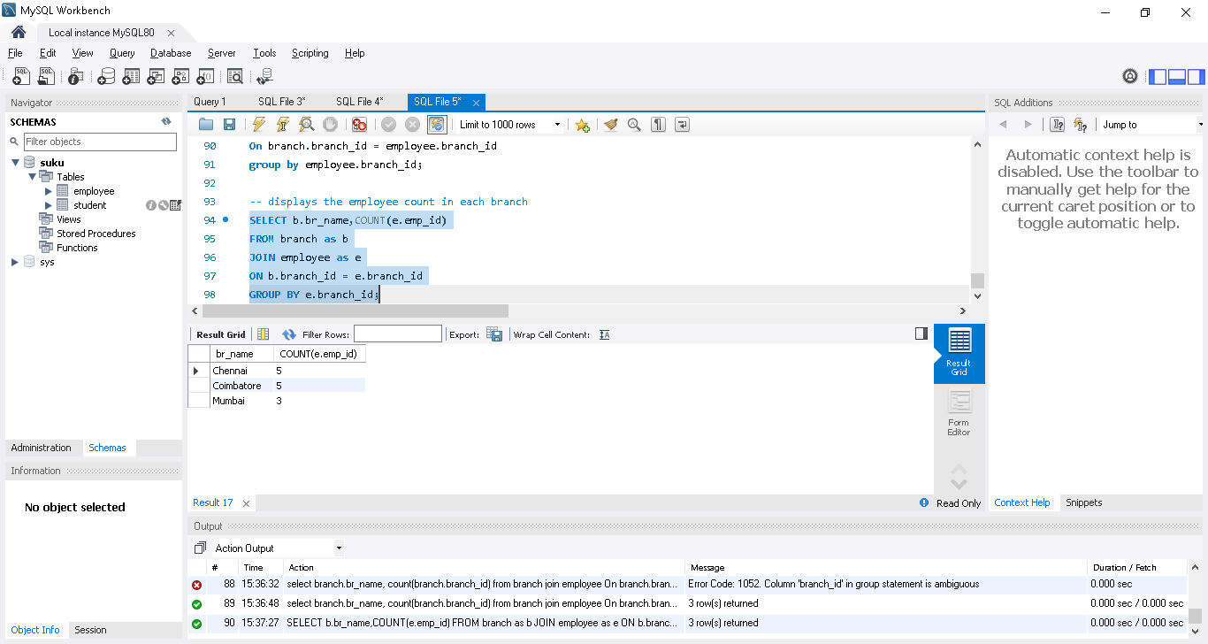
Union
union combines two table having equal number of columns and matching datatypes..then only we can union the 2 tables
create 2 table
CREATE TABLE clients (
client_id INT PRIMARY KEY AUTO_INCREMENT,
location VARCHAR(30) NOT NULL,
addr VARCHAR(200) );

INSERT INTO clients VALUES(1,"NewYork","25 10th Block");
INSERT INTO clients VALUES(2,"Coimbatore","120 15th Block");
INSERT INTO clients VALUES(3,"London","21 ABC Road");

select * from branch;
select * from clients;

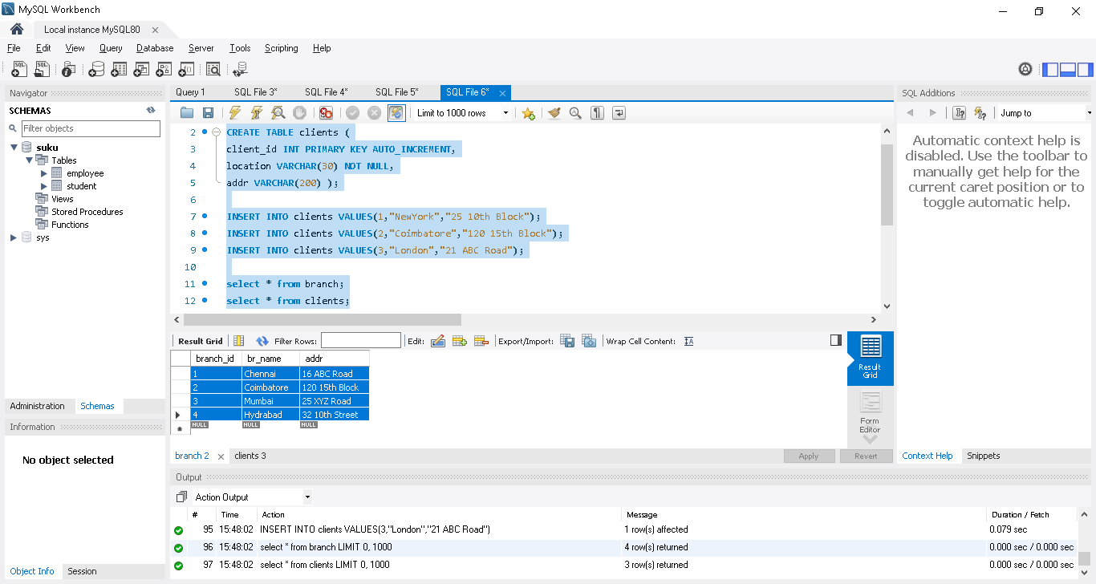

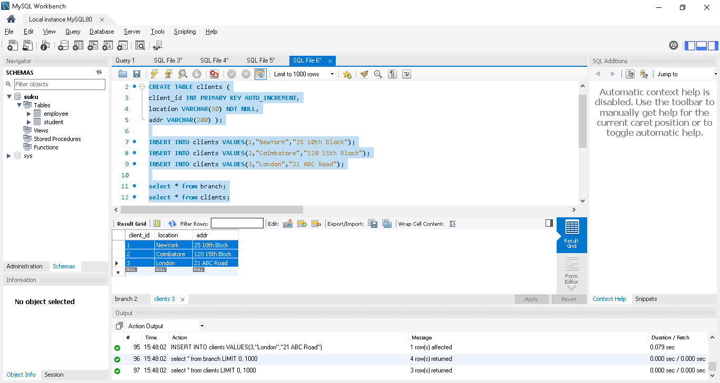
-- combines the two tables removing duplicates
SELECT * FROM branch
UNION
SELECT * FROM clients;

Cbe have 2 entry with same value so removed the duplicate
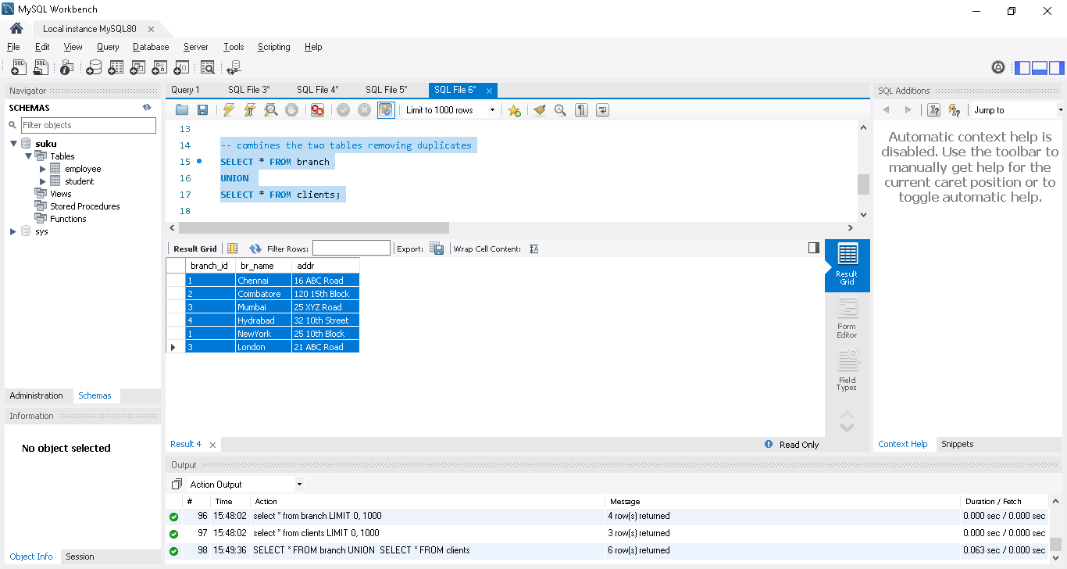

-- combines the two tables without removing duplicates
SELECT * FROM branch
UNION ALL
SELECT * FROM clients;

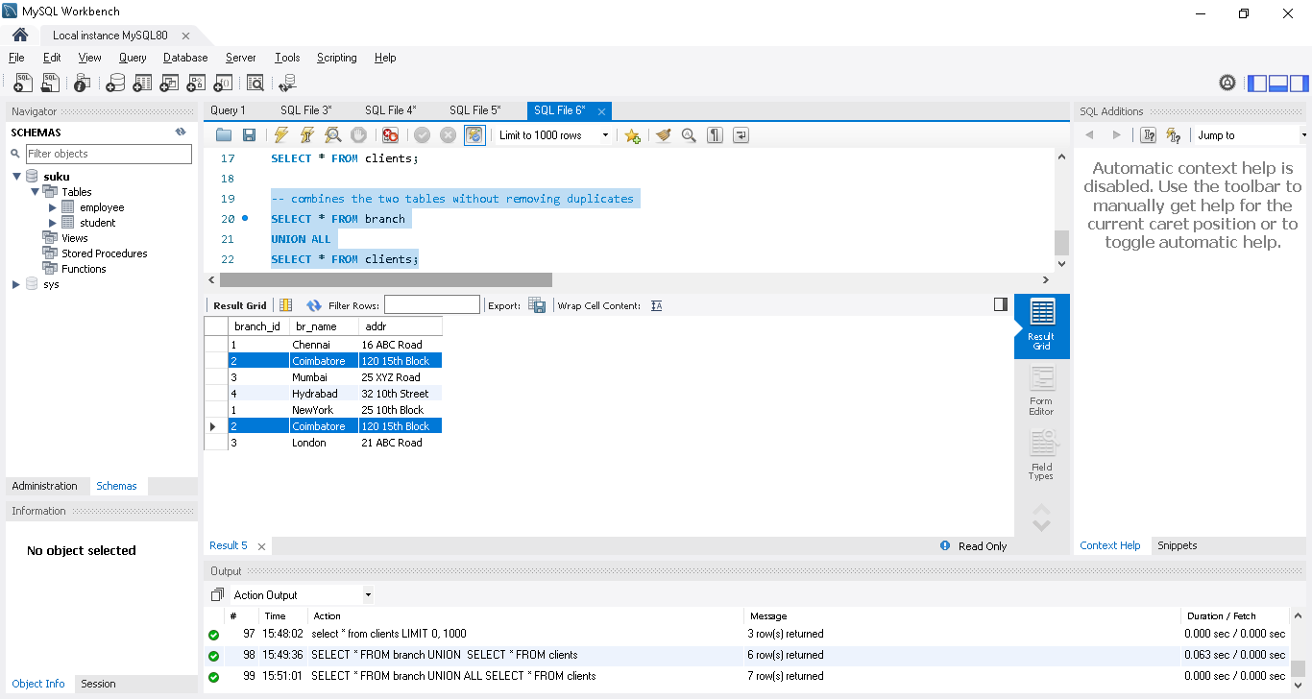

Subqueries | Exists | Any | All | SQL in Tamil | Logic First Tamil

Subqueries combine more than 2 queries.
Condition: -- Displays employee list in Chennai Branch
select * from employee where branch_id=(select branch_id from branch where br_name='chennai');
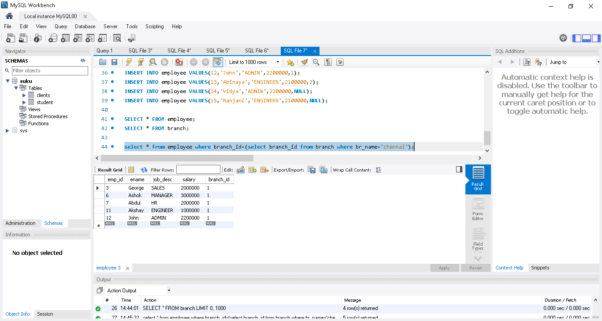
Condition:-- Displays the employees with min salary
select * from employee where salary=(select min(salary) from employee);
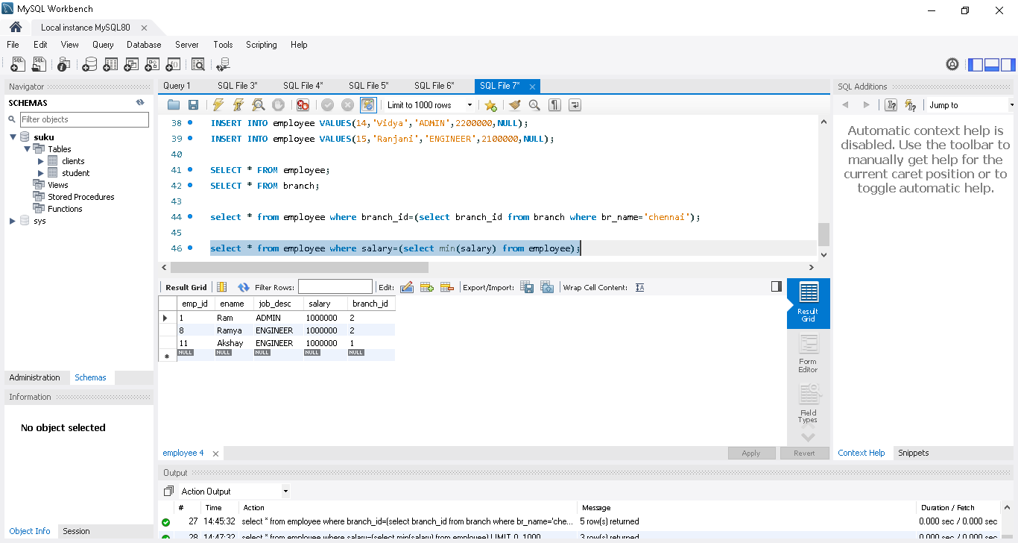
Exist always used with subquery
Condition: - displays the branches containing atleast one admin
select * from branch
where exists (select * from employee where job_desc='Admin' and branch.branch_id=employee.branch_id);
Any
Condition- displays the branch info in which any employee gets more than 25L

select branch_id from employee where salary>2500000;
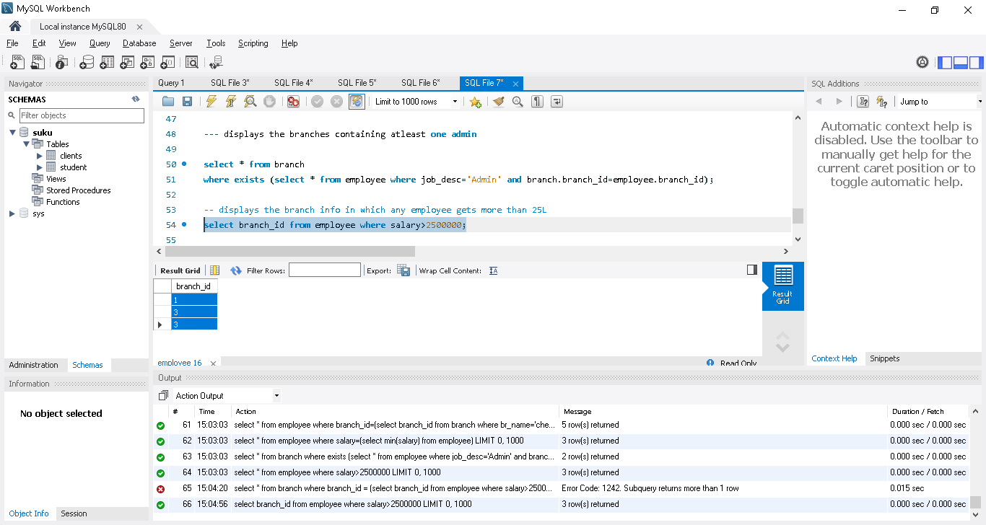

select * from branch
where branch_id = (select branch_id from employee where salary>2500000);
Error ->subquery return more than 1 row[1,3,3] so in that case we need to use any[it will take any one value at a time]
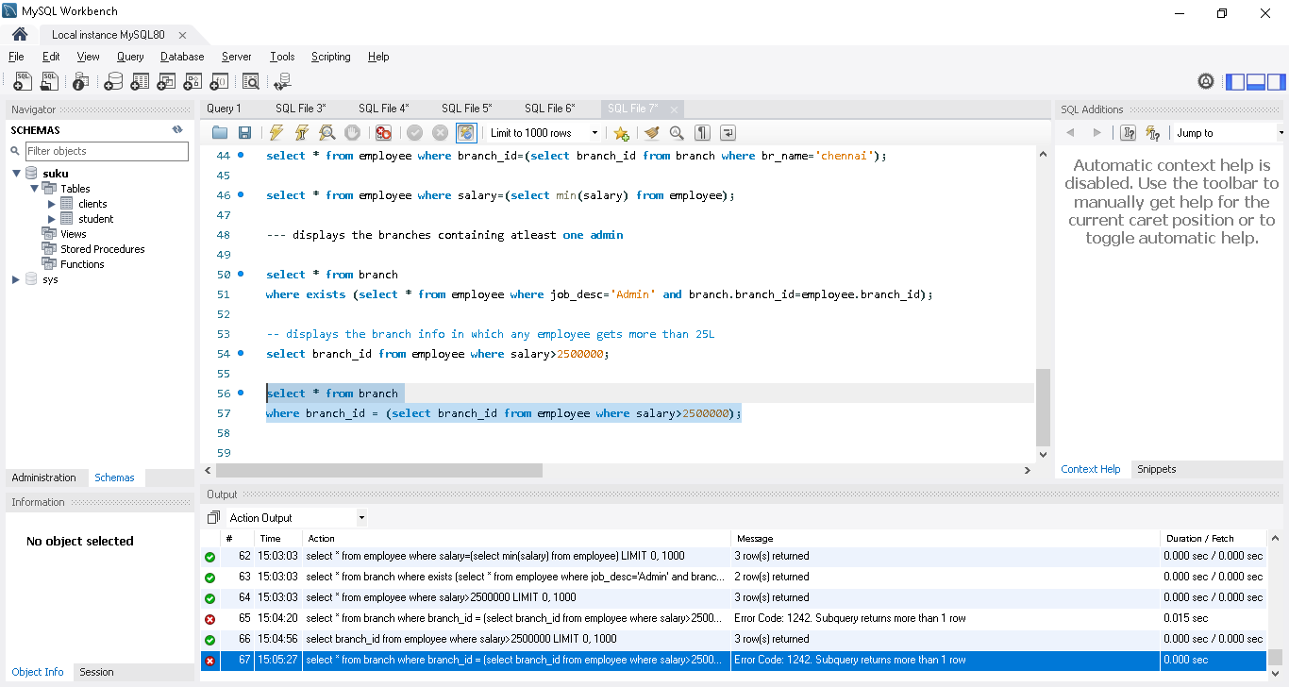

select * from branch
where branch_id = any (select branch_id from employee where salary>2500000);
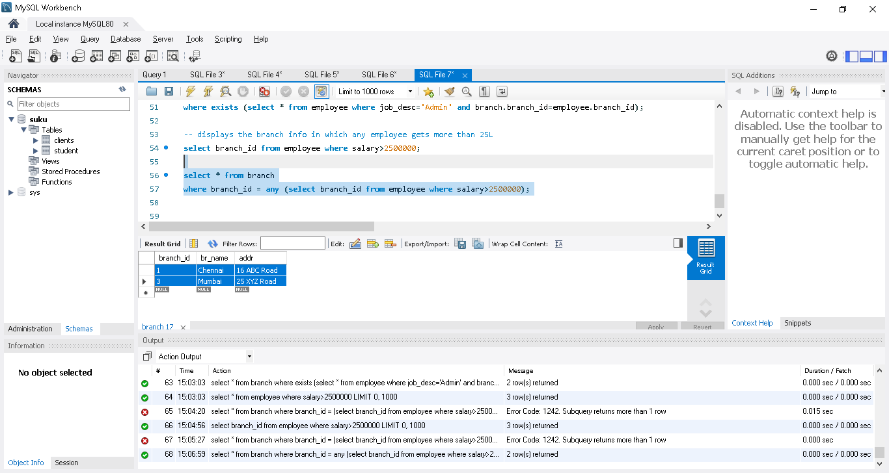

All
Condition: -- displays employees not working in chennai or Coimbatore

select branch_id from branch where br_name in ('chennai','coimbatore');
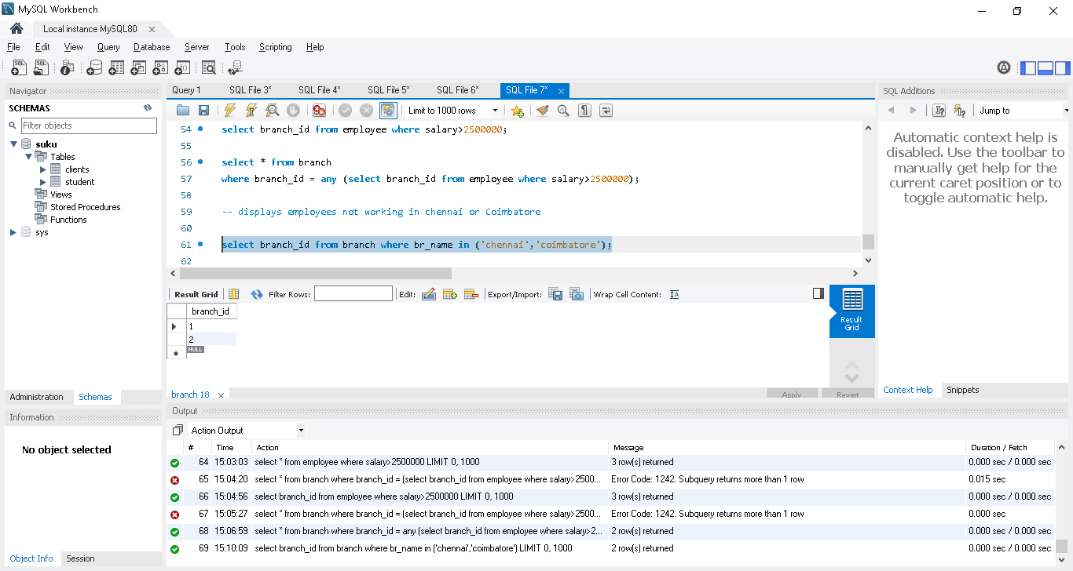
select * from employee
where branch_id <> all
(select branch_id from branch where br_name in ('chennai','coimbatore'));
In result not contains Chennai , cbe employees
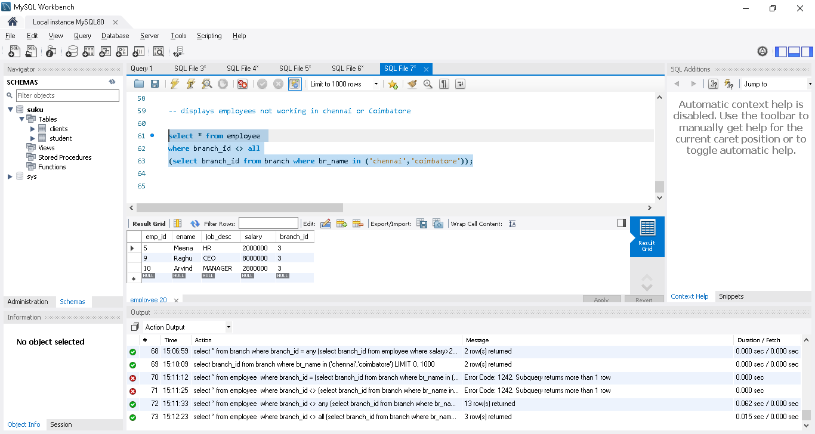

Views | Create, Modify and Drop | SQL in Tamil | Logic First Tamil

What is a view in sql - create/modify/delete view

In project if we need to run the specific query often then we can create view for that specific query & use it whenever needed

CREATE VIEW emp_br

AS

SELECT employee.emp_id,employee.ename,employee.job_desc,branch.br_name

FROM employee

INNER JOIN branch

ON employee.branch_id=branch.branch_id

ORDER BY emp_id;

SELECT * FROM emp_br; -- selecting all rows from view

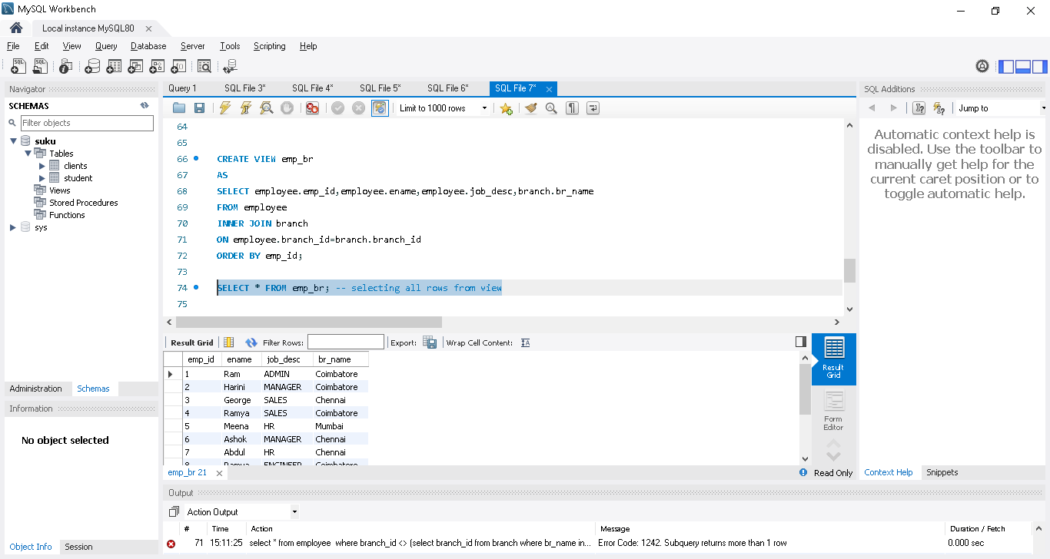

We can apply filter in that view also

SELECT * FROM emp_br where job_desc='manager';

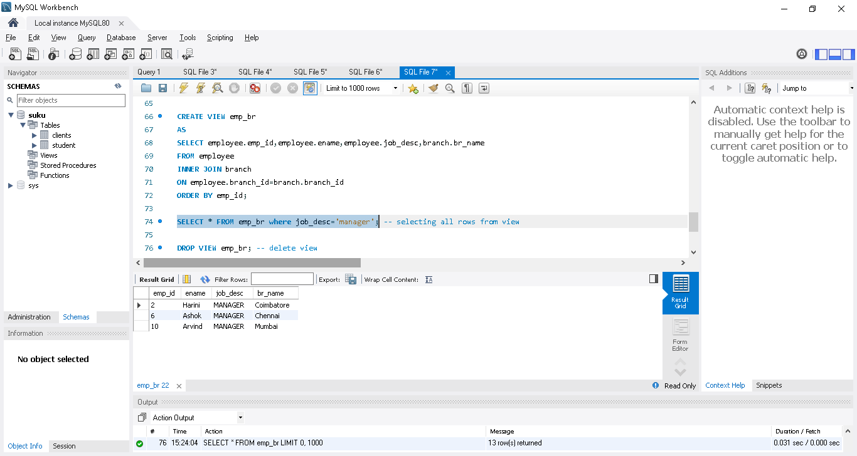

DROP VIEW emp_br; -- delete view

CREATE OR REPLACE VIEW emp_br -- (modify view to removed the order by)

AS

SELECT employee.emp_id,employee.ename,employee.job_desc,branch.br_name

FROM employee

INNER JOIN branch

ON employee.branch_id=branch.branch_id;

Stored procedure
Query that is saved in DB is called as Stored procedure..
if we have n no of line sql query we can save in Stored procedure & called it whenever its needed
Create procedure
storing simple query in Stored procedure
in sql always “;” is used to end the line of code..as we are storing multiple query(which condition “;” in each line) in between Begin and end statement..
But we need sent all the line at one go to server in order to store in Stored procedure..we are changing the Delimiter to // for this process

Delimiter //
Create procedure getbranches() --- getbranches() ->any name need to provide
Begin
select * from branch;
End //
Read the table value using the name
Delimiter ; --once done change the delimiter to ;
call getbranches();
Note: in left side structure, getbranches created under stored procedure
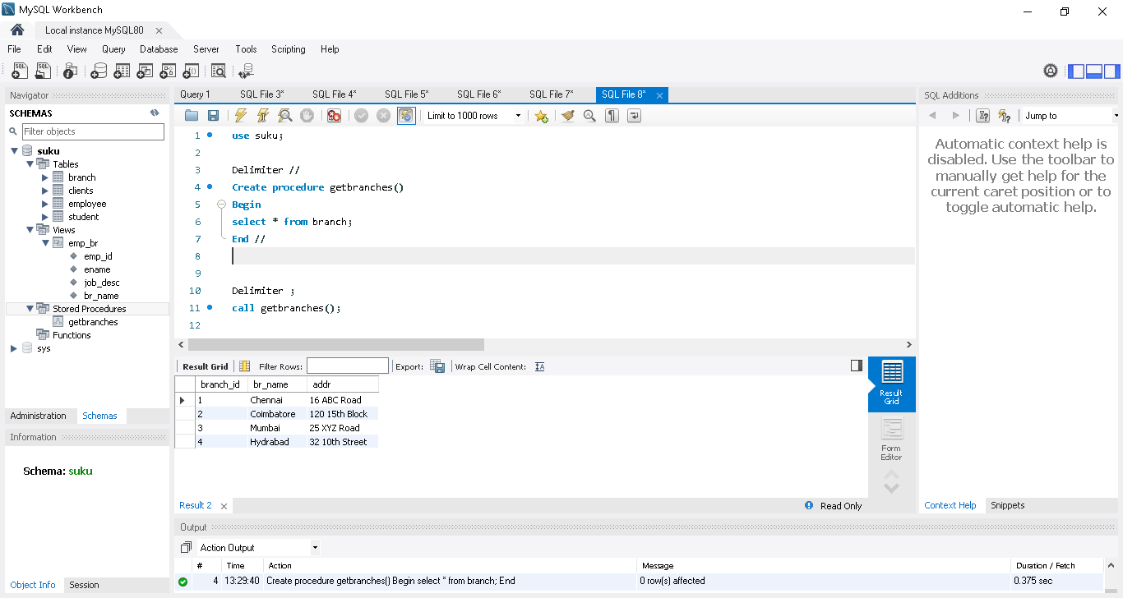

Drop stored procedure

drop procedure getbranches;
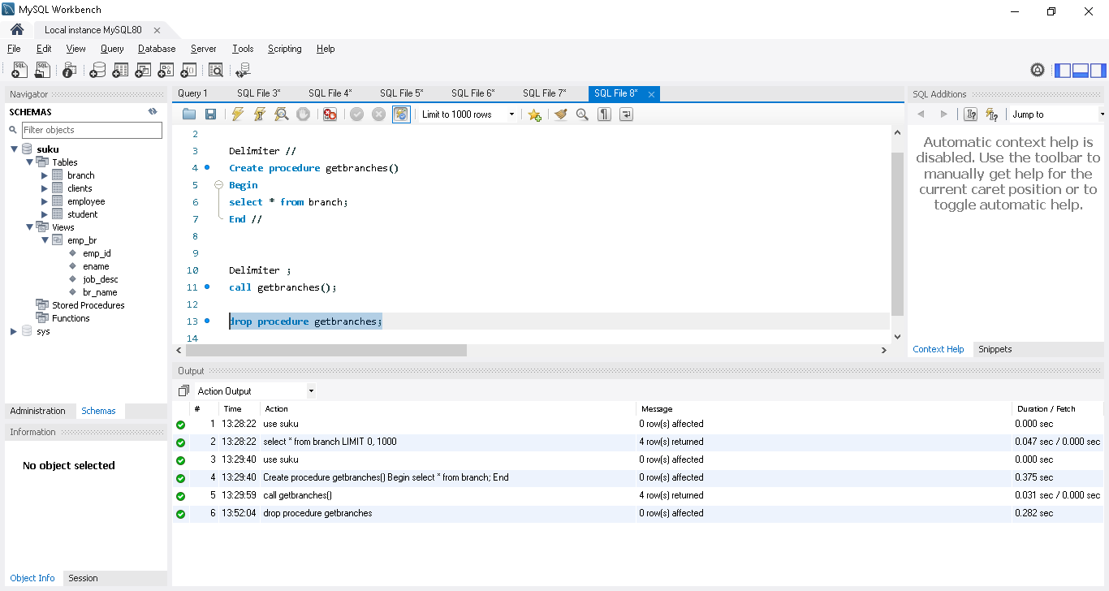

Variables in Mysql
We can create variables in mysql using stored procedure...
use suku;

Delimiter //
Create procedure getbranchescount()
Begin
declare Total int; -- declaring Total variable as int
select count(branch_id)
into Total ---using into keyword to store the result in Total variable
from branch;
select Total; while calling from outside, it wil show the result count as below
End //

Delimiter ;
call getbranchescount();
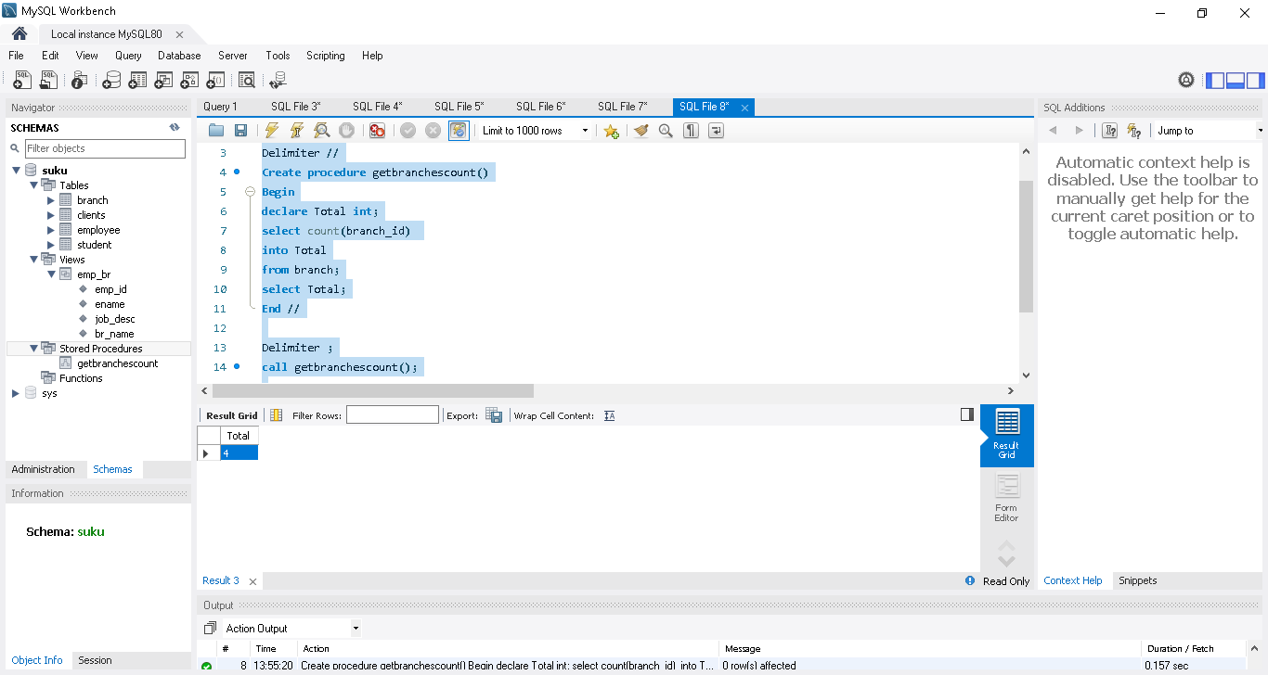

Passing parameters IN, OUT and INOUT
3 type of passing parameter in stored procedure
IN, OUT, INOUT
1.IN ->just a input parameter to the stored procedure
Eg..in a employee table..just get the count of employee who job desc as ‘Admin’
use suku;

Delimiter //
Create procedure geEmployeecount(
In jdec varchar(10) --declaring a In parameter with name as jdec & type
)
Begin
declare Total int;
select count(emp_id)
into Total
from employee
where job_desc=jdec; --passing the parameter to filter the records
select Total;
End //

Delimiter ;
call geEmployeecount('Admin');
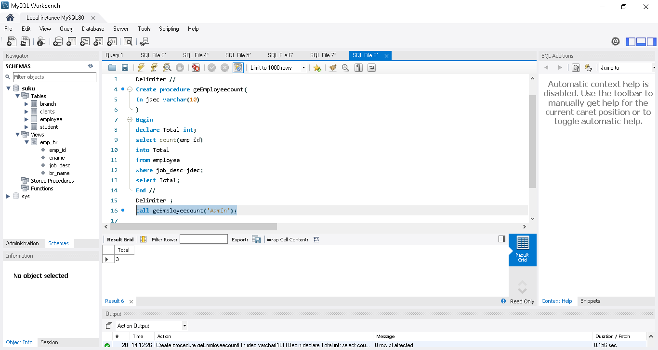
2.OUT ->output of the stored procedure [like query result]
In above example, we declare Total variable inside procedure..here we are sending from outside
@total ->session variables & will be active throughout the session

use suku;
Delimiter //
Create procedure geEmployeecount(
In jdec varchar(10), OUT Total int ->Including Out parameter with variable and type
)
Begin
select count(emp_id)
into Total
from employee
where job_desc=jdec;
End //

Delimiter ;
call geEmployeecount('Admin', @Total); -> passing output parameter to procedure..it wil have the output value of the procedure
select @Total; -> it will show the result
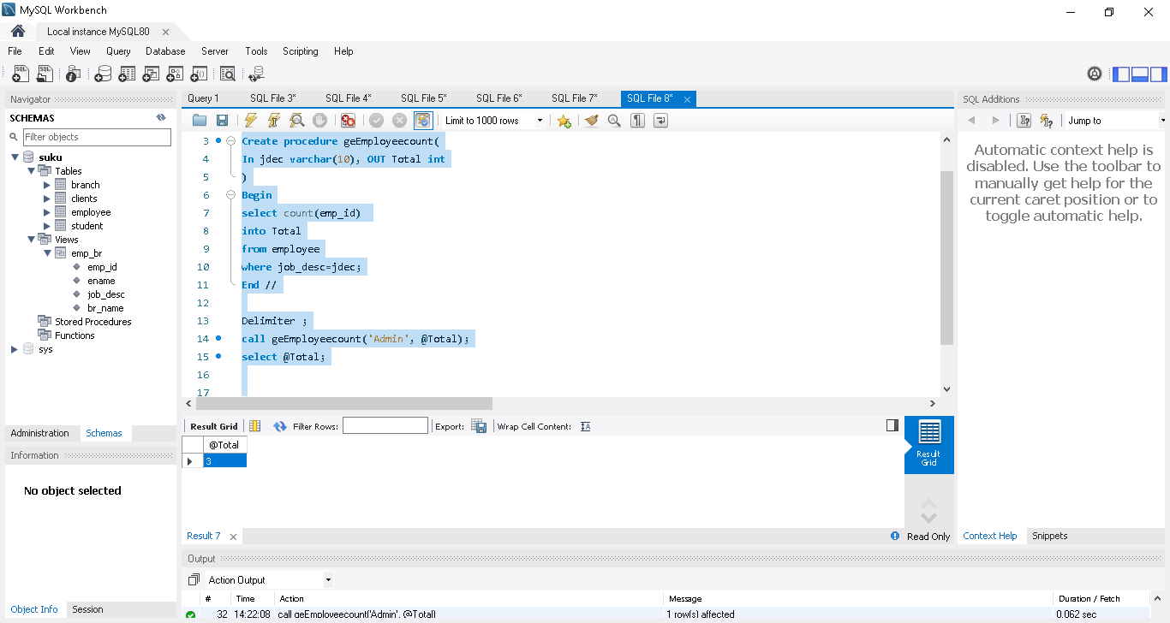

3.INOUT ->Parameter act as both input and output in stored procedure

@Counter ->act as input and also output in below eg
use suku;
Delimiter //
Create procedure Incrementcount(
Inout Counter int, In inc int --Counter act as input and also output
)
Begin
Set Counter = Counter + inc;
End //
Delimiter ;
set @Counter=5;
call Incrementcount(@Counter, 2);
select @Counter;
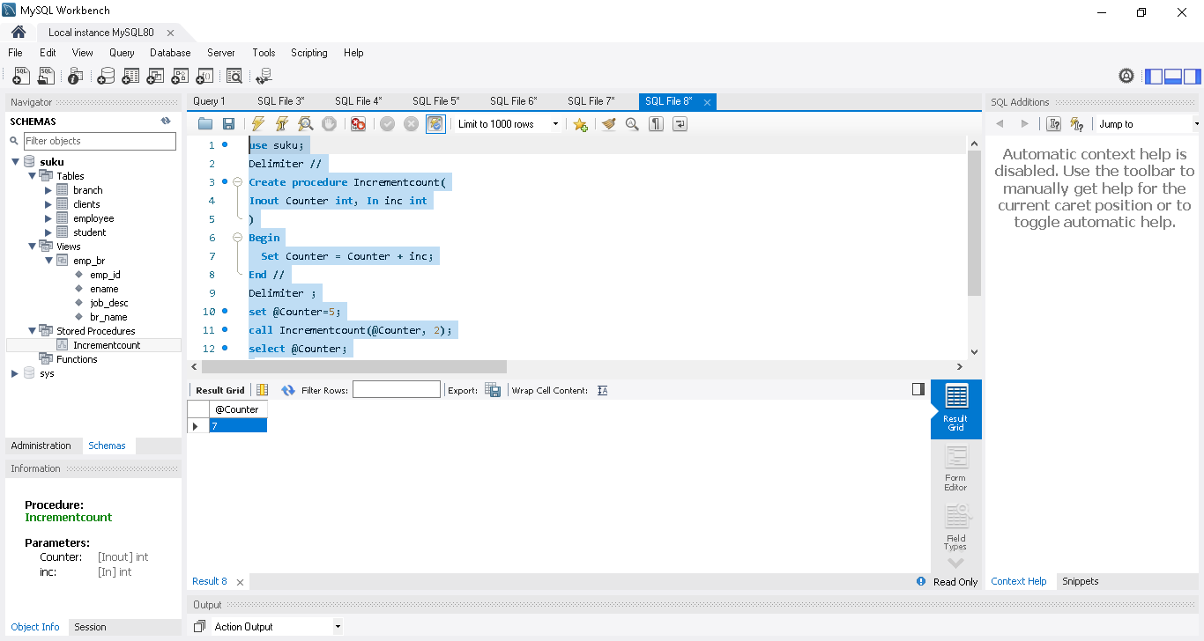
If Else
use suku;

Delimiter //
Create procedure getstate(IN ID int)
begin
if ID=1 or ID = 2 then
select "Tamilnadu";
elseif ID=3 then
select "Maharashtra";
else
select "Adhra";
End if;
End //
Delimiter ;
call getstate(2);

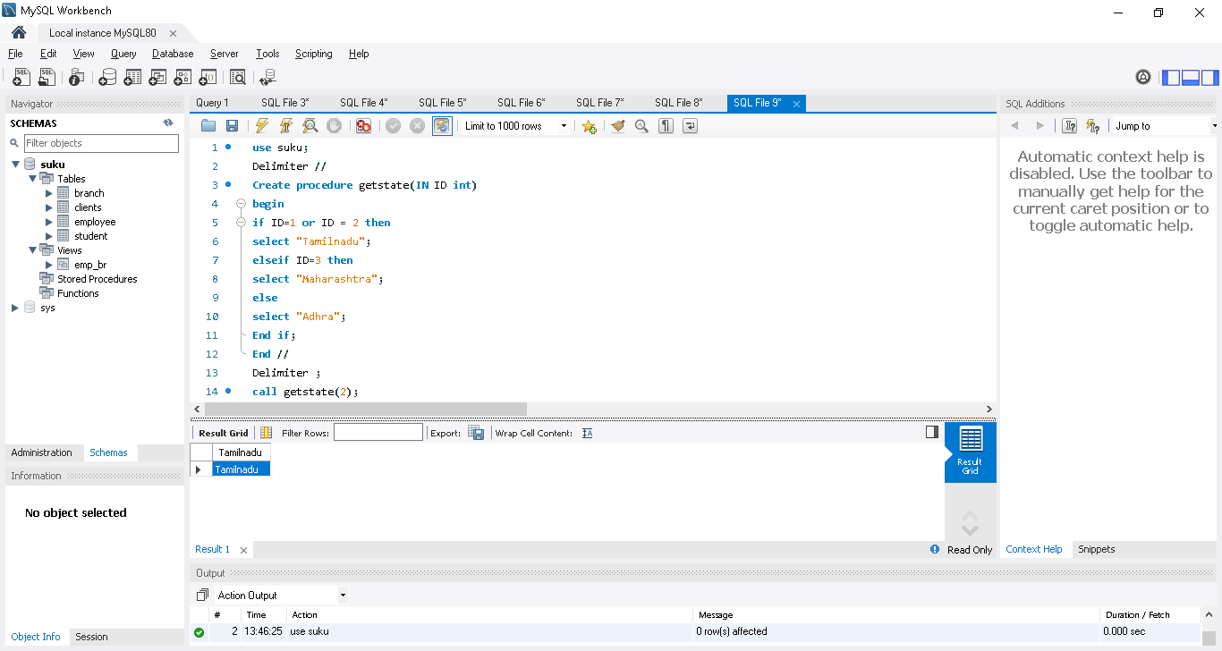

Switch case
use suku;
Delimiter //
Create procedure getstate(IN ID int)
begin
case ID
when 3 then
select "Mumbai";
when 2 then
select "chennai";
else
select "Delhi";
end case;
End //
Delimiter ;
call getstate(2);
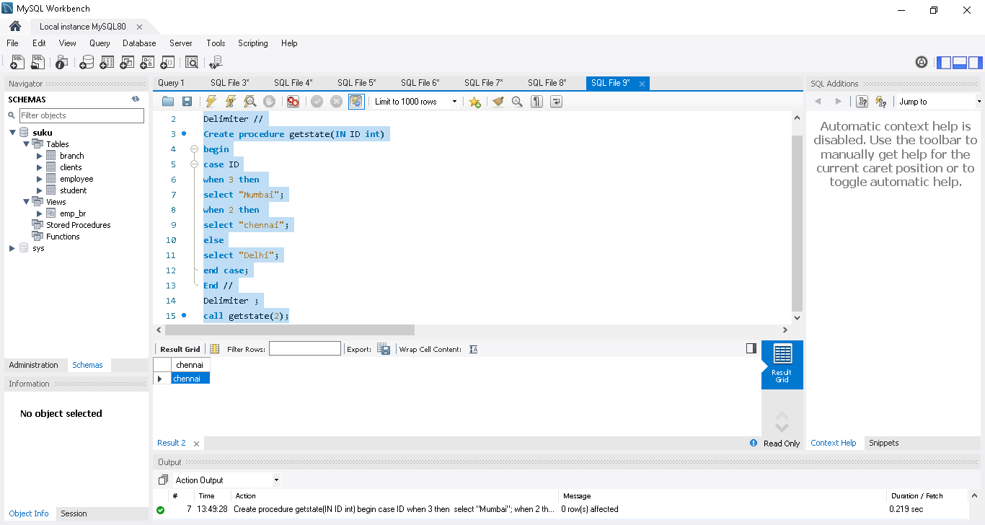
00:36:18 - Loop using loop and leave
use suku;
Delimiter //
create procedure normalloop()
Begin
Declare i int;
Declare str varchar(20);
Set i = 1;
set str = '';
loop1: Loop --providing the loop name as loop1 , so easy to leave if condition match
if i>10 then
leave loop1; ->leave the loop
end if;
set str = concat(str,i,""); ->using cancat function to store the all the values one by one
Set i = i + 1;

end loop;
select str ; ->once come out of the loop we are printing the values
end //
Delimiter ;
call normalloop();
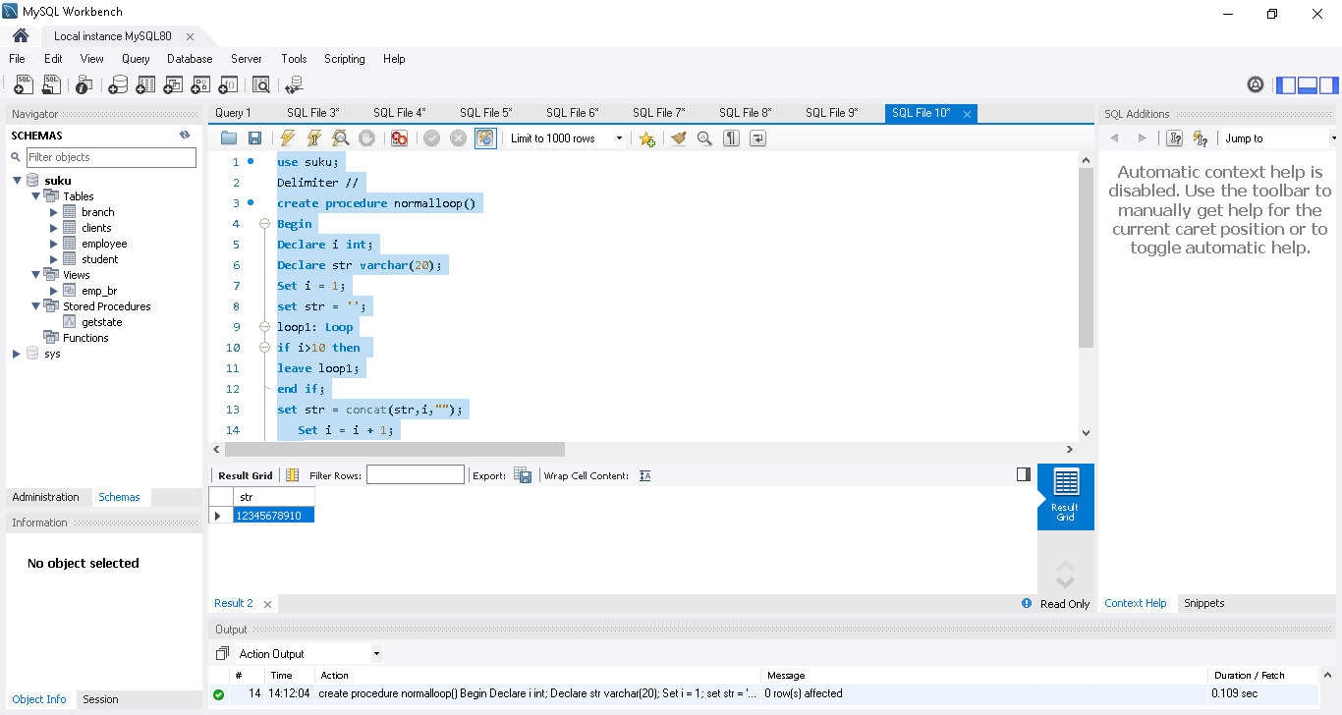
00:41:49 - Loop using while
Delimiter //
create procedure normalloop1()
Begin
Declare i int;
Declare str varchar(20);
Set i = 1;
set str = '';
while i<=10 do
set str = concat(str,i,"");
Set i = i + 1;
end while;
select str ;
end //
Delimiter ;
call normalloop1();
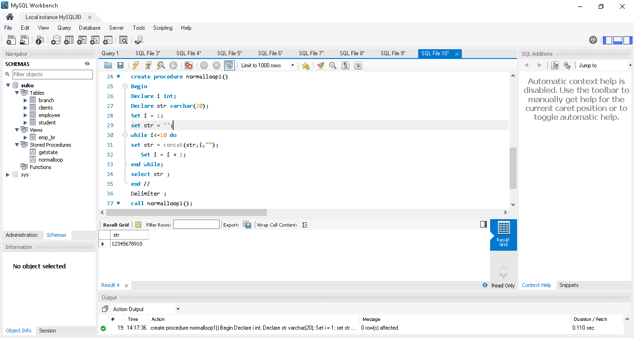
00:43:00 - Loop using repeat
Delimiter //
create procedure normalloop2()
Begin
Declare i int;
Declare str varchar(20);
Set i = 1;
set str = '';
Repeat
set str = concat(str,i,"");
Set i = i + 1;
until i>10
end Repeat;
select str ;
end //
Delimiter ;
call normalloop2();
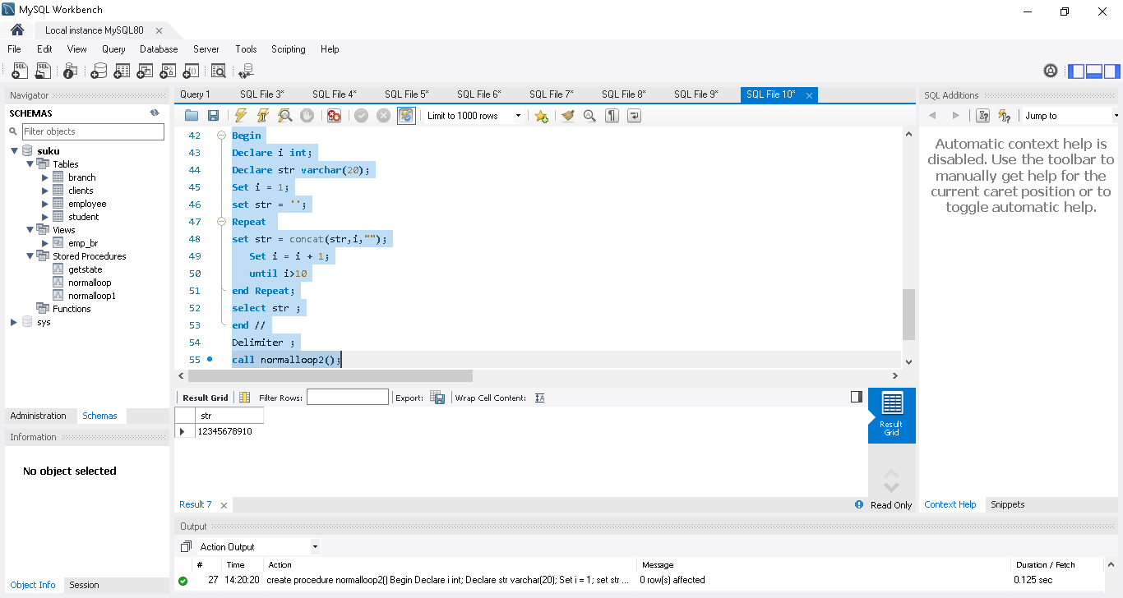

00:44:46 - User defined functions in stored procedure
Min, max, length etc are inbuilt functions in my sql
We can write our own function based on the need and stored under function section
Left side, under function section user defined function are present
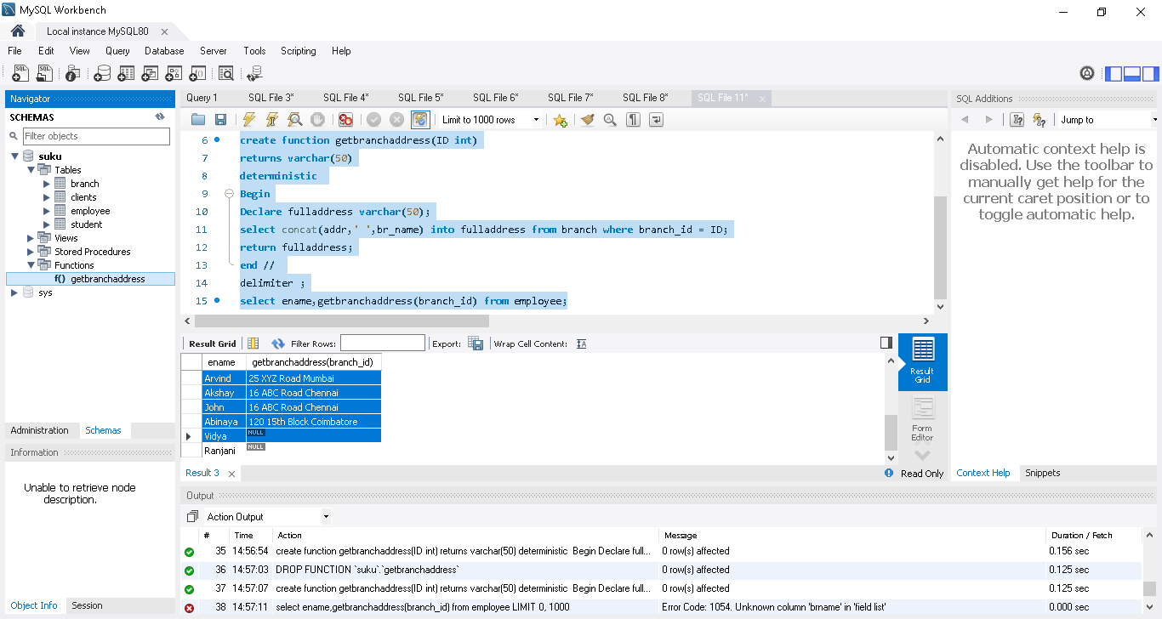
Eg
delimiter //
create function getbranchaddress(ID int)
returns varchar(50)
deterministic ->we need to call out deterministic or Non deterministic
Begin
Declare fulladdress varchar(50);
select concat(addr,' ',br_name) into fulladdress from branch where branch_id = ID; ->result stored in fulladdress varibale
return fulladdress; -> passing into main query
end //
delimiter ;
select ename,getbranchaddress(branch_id) from employee;

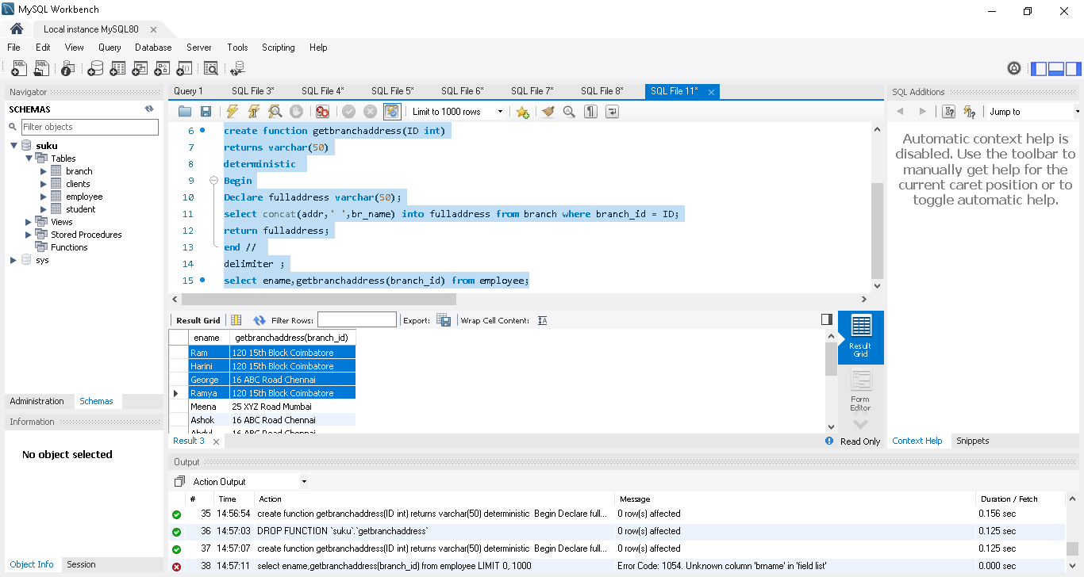

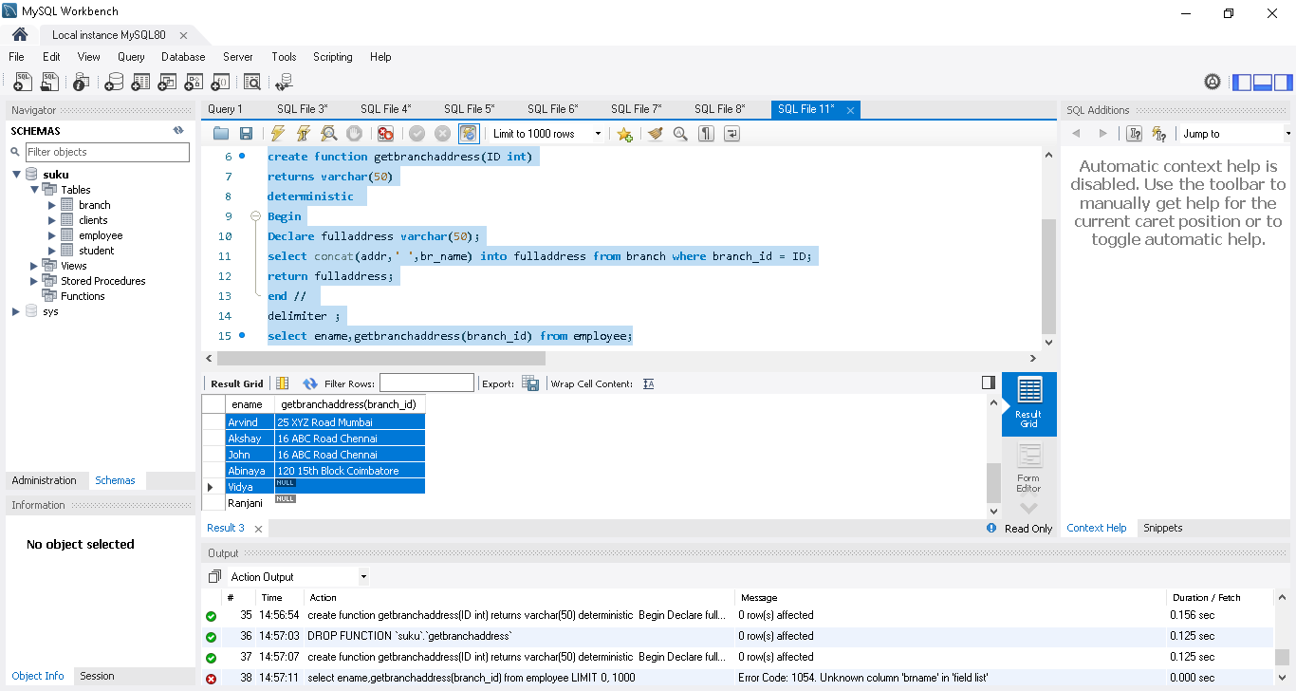
00:51:51 - Deterministic vs not deterministic function
In user defined function, we need to call out Deterministic or not deterministic function
Deterministic will be used when same set of return value from the query... Deterministic will store the result in backend and from that backend it wll shw result..will not call same querty to DB to get the values again and again
Not deterministic function will be used when return value is different from the query..Time and date can be stored in some column..and change ofen

00:56:51 - Functions vs stored procedure
Functions -> can be called in a select statement itself.. getbranchaddress() is a function
Eg select ename,getbranchaddress(branch_id) from employee;
Stored procedure -> need to call separately ‘
call Incrementcount(@Counter, 2);
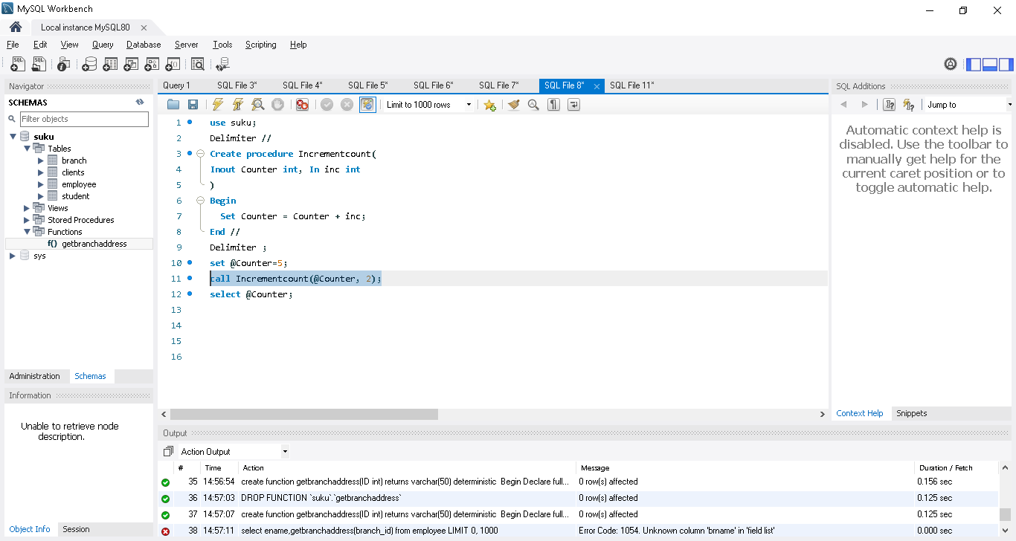
00:57:40 - Error handing using handler
In selenium, we wil use error handing mechanism(eg try catch) when error occur during run time..same way we wil use handler in my sql
In branch table, try to entry the duplicate value thru procedure and show the error
use suku;
Delimiter //
create procedure insertbranch(
id int, name1 varchar(20), addr varchar(20)
)
Begin
insert into branch value(id,name1,addr);
select * from branch;
End //

Delimiter ;
call insertbranch(1,'chennai','16 ABC Road');

showing error message when insert into line executed..so next select * from branch not executed
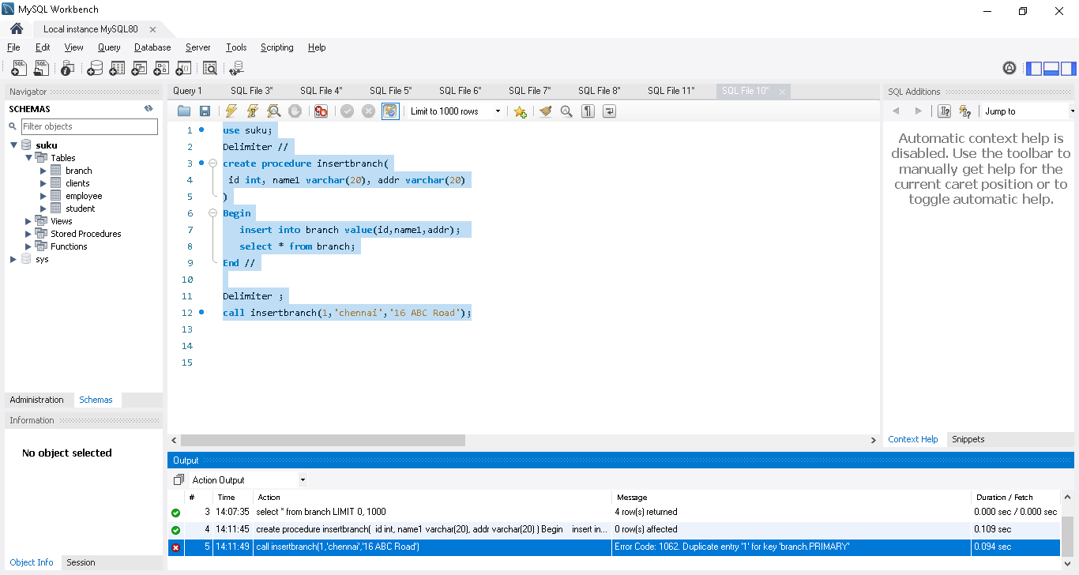

To overcome this we can use Handler..it will continue the execution even any error
1. Declare continue handler for 1062
It will execute the select * from branch, even error occur
\ use suku;
Delimiter //
create procedure insertbranch(
id int, name1 varchar(20), addr varchar(20)
)
Begin
Declare continue handler for 1062
insert into branch value(id,name1,addr);
select * from branch;
End //

Delimiter ;
call insertbranch(1,'chennai','16 ABC Road');

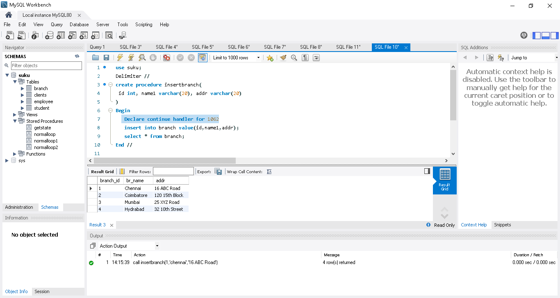
2. Declare continue handler for sqlexception ->it will handle all error number during run time
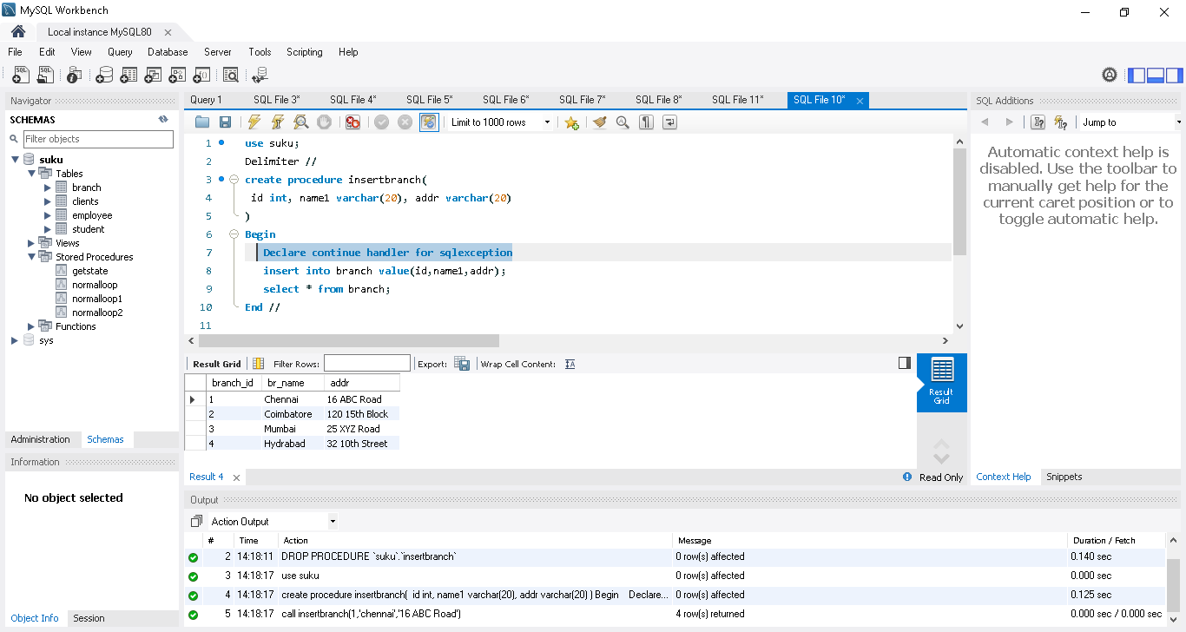
01:08:48 - Signal and Resignal
Resignal ->if user wants to see the exception number then use resignal it will print in console area

use suku;
drop procedure if exists insertbranch
Delimiter //
create procedure insertbranch(
id int, name1 varchar(20), addr varchar(20)
)
Begin
Declare continue handler for sqlexception
resignal;
insert into branch value(id,name1,addr);
select * from branch;
End //

Delimiter ;
call insertbranch(1,'chennai','16 ABC Road');
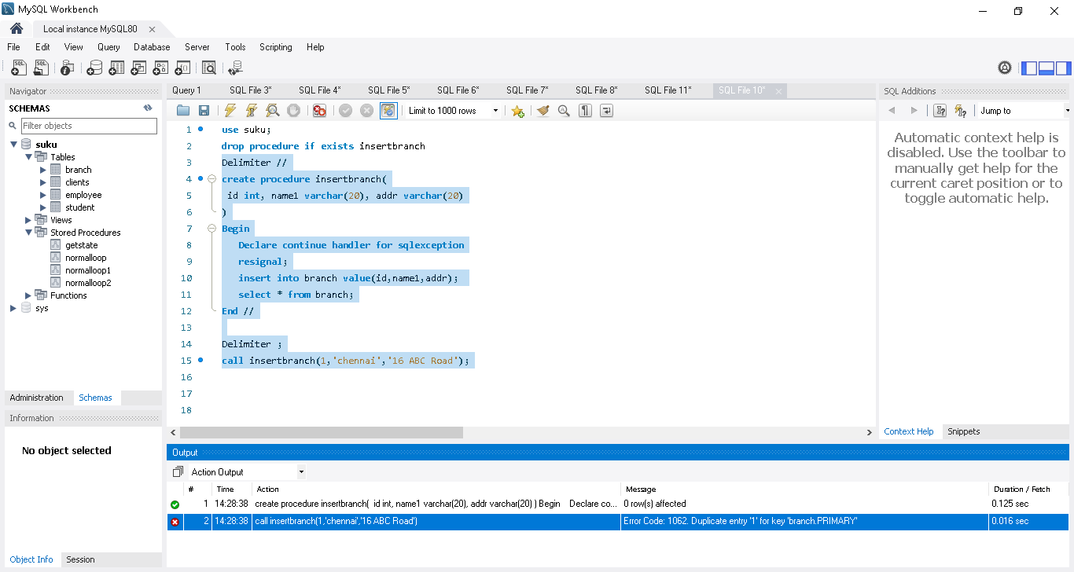
Signal -> user want to print exception out of execution based on condition he set in the code
Eg throw exception when branch name char less than 3 & come out
use suku;
drop procedure if exists insertbranch
Delimiter //
create procedure insertbranch(
id int, name1 varchar(20), addr varchar(20)
)
Begin
Declare continue handler for sqlexception
if char_length(name1) < 4 then
signal sqlstate '45000'
set message_text = 'Branch name too short';
End if;
insert into branch value(id,name1,addr);
select * from branch;
End //

Delimiter ;
call insertbranch(5,'che','16 ABC Road');

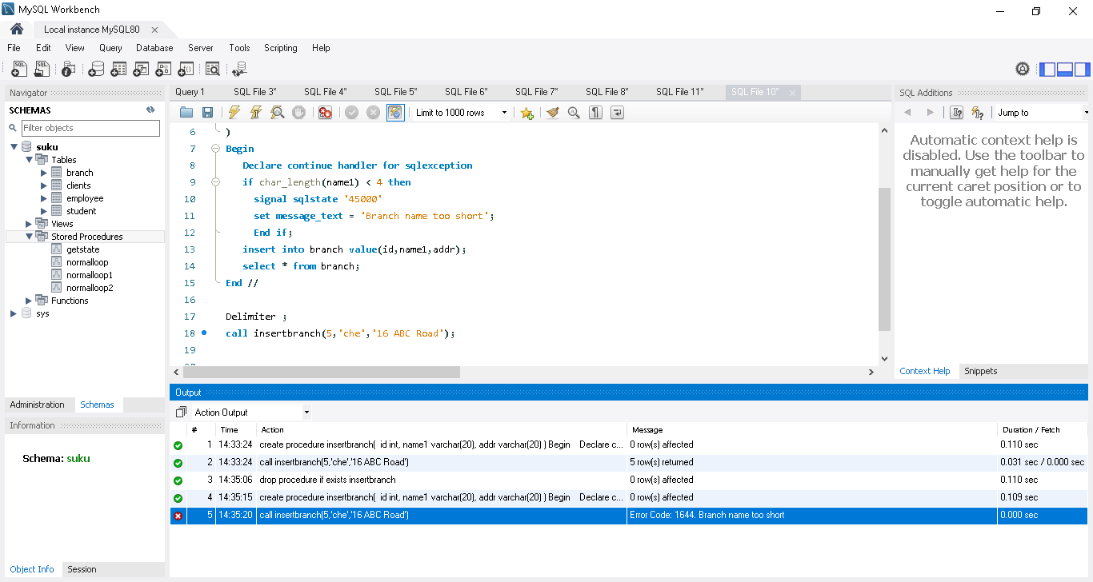
01:13:59 - Cursor
if we need to copy the employee table value into employeebackup table, we need to fetch the each row in employee table using cursor & store in employeebackup table.
Create a employeebackup table:
use suku;

CREATE TABLE employeebackup (
emp_id INT PRIMARY KEY,
ename VARCHAR(30),
job_desc VARCHAR(20),
salary INT,
branch_id INT
);
select * from employeebackup;
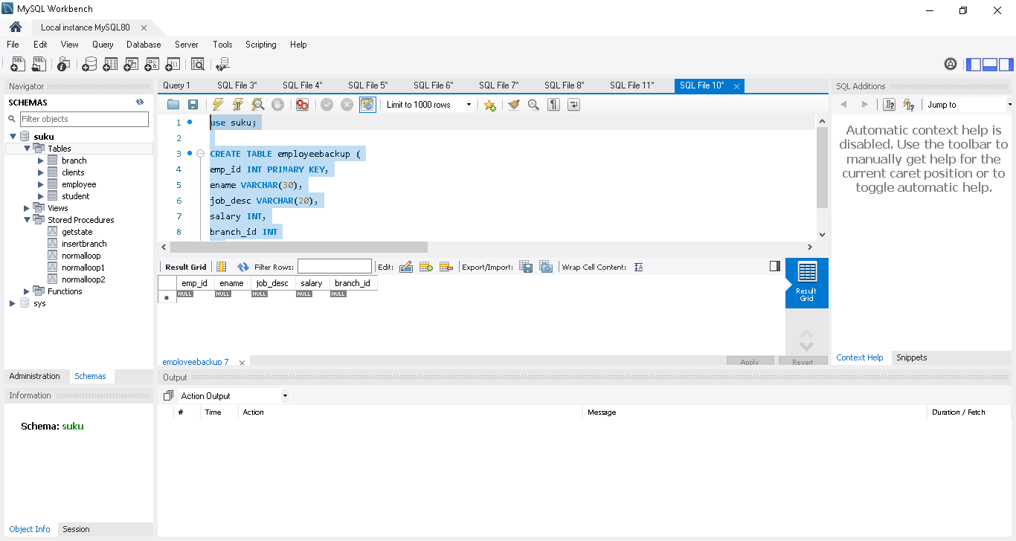
Create a storedprocedure to copy from employee to employeebackup table
delimiter //
create procedure copytable()
begin
declare Done int default 0; ->for loop close when done is 1
declare id,salary,branchid int;
declare name1,jdesc varchar(20);
declare cur cursor for select * from employee; ->Cur will read full first row from employee
declare exit handler for not found set done = 1; ->cur will read one by one..once reached last line it will show not found exception so we are using handler & also set done = 1
delete from employeebackup; ->every time need to delete employeebackup & load freshly
open cur;
lable1 : loop ->using loop it will read all rows one by one and load in employeebackup table
if done = 1 then
leave lable1;
end if ;
fetch cur into id,name1,jdesc,salary,branchid;
insert into employeebackup values(id,name1,jdesc,salary,branchid);
end loop ;
close cur;
end //
delimiter ;
call copytable();
select * from employeebackup;

--
All values copied from from employee to employeebackup table
