Jira | Scrum | Absolute Beginner Tutorial | 01 | Tamil | Important Terminologies

In this video we will looking at the most essential topics that every Scrum project will revolve around. The topics discussed are Epics, User stories, Acceptance criteria, Product backlog, Sprint backlog, story points.
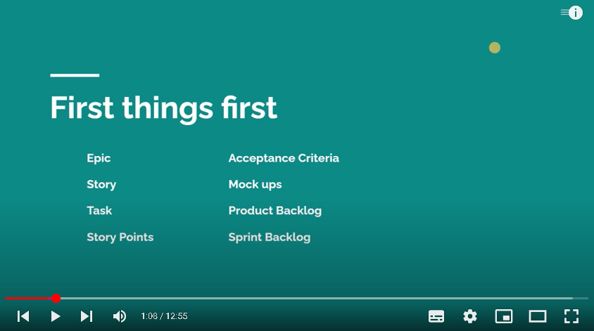

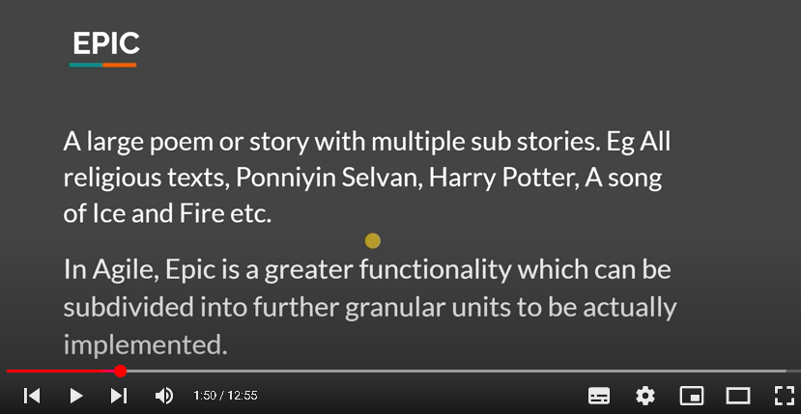
Story or user story both same only
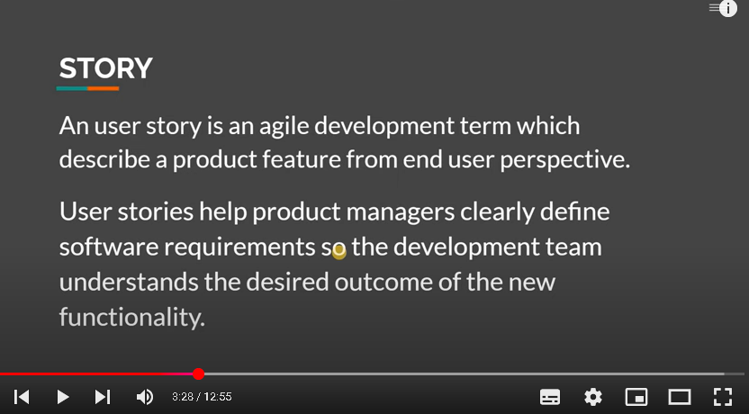

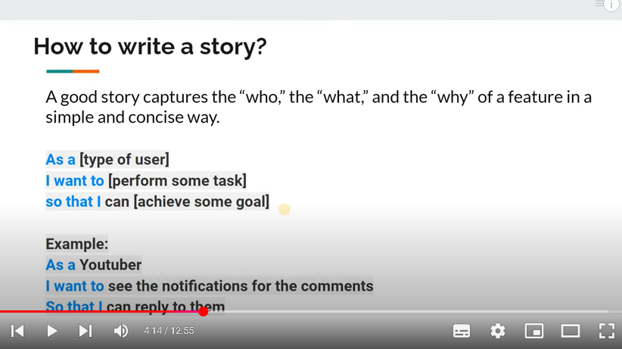
Note: we can write user story in another way level..above one is best practice
After the feature ready based on the user story..then acceptance criteria will come in a picture..
Its a set of question to validate the user story completed correctly as per req.
set of question be in BDD style
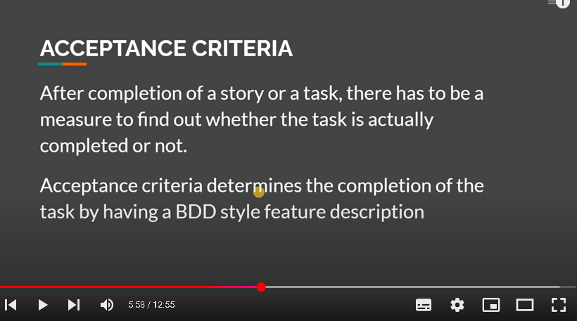

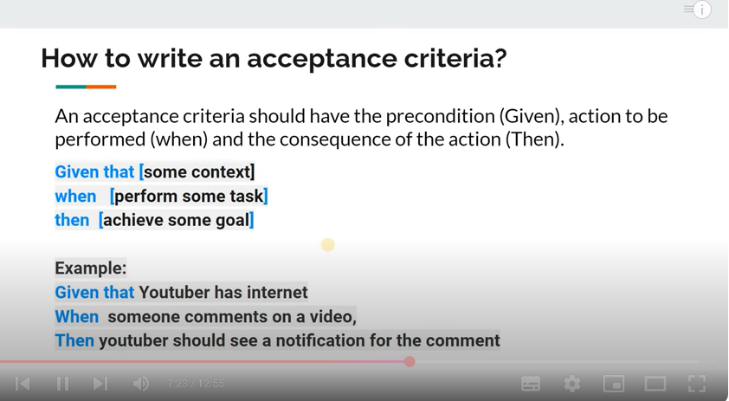

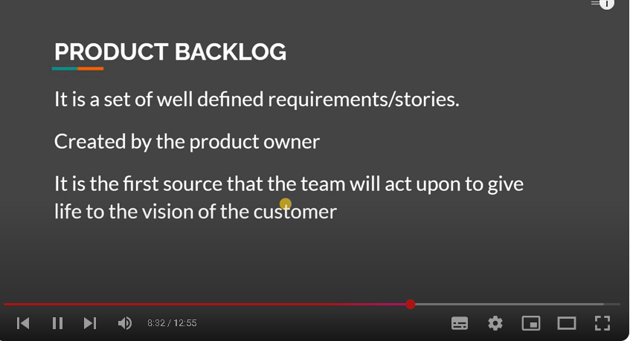

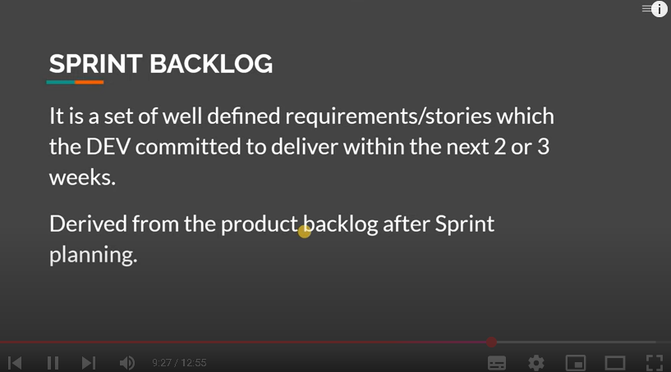
Story points->each story we wil need to provide the efforts in order to complete the story
How much efforst needed to complete the story which is available in the backlog
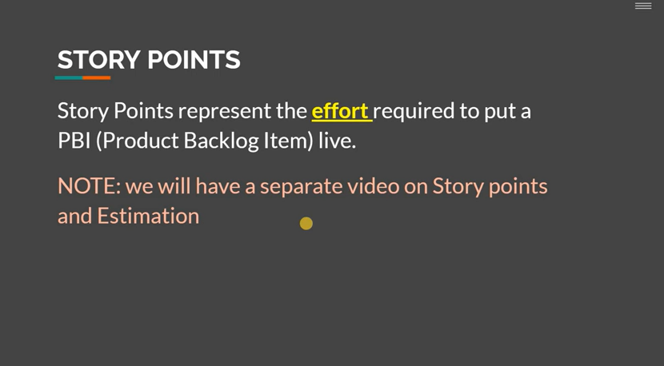
Mockup ->pictorial represent of the product/features
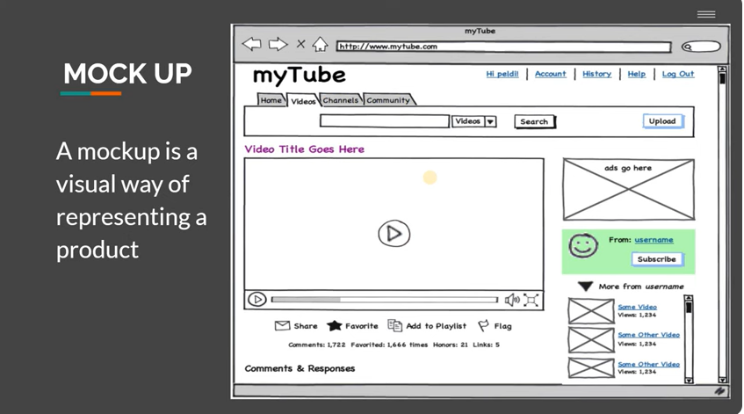

Jira | Scrum | Absolute Beginner Tutorial | 02 | Tamil | Sign up | Project template | Menus

In this video, we will be looking at how to sign up Jira for free and set up our cloud Jira instance and we will also be looking at the different project templates that Jira provides and the most used Menus under a Scrum project.
Create a account in jira..free version
https://www.atlassian.com/software/jira/pricing
click get it free button
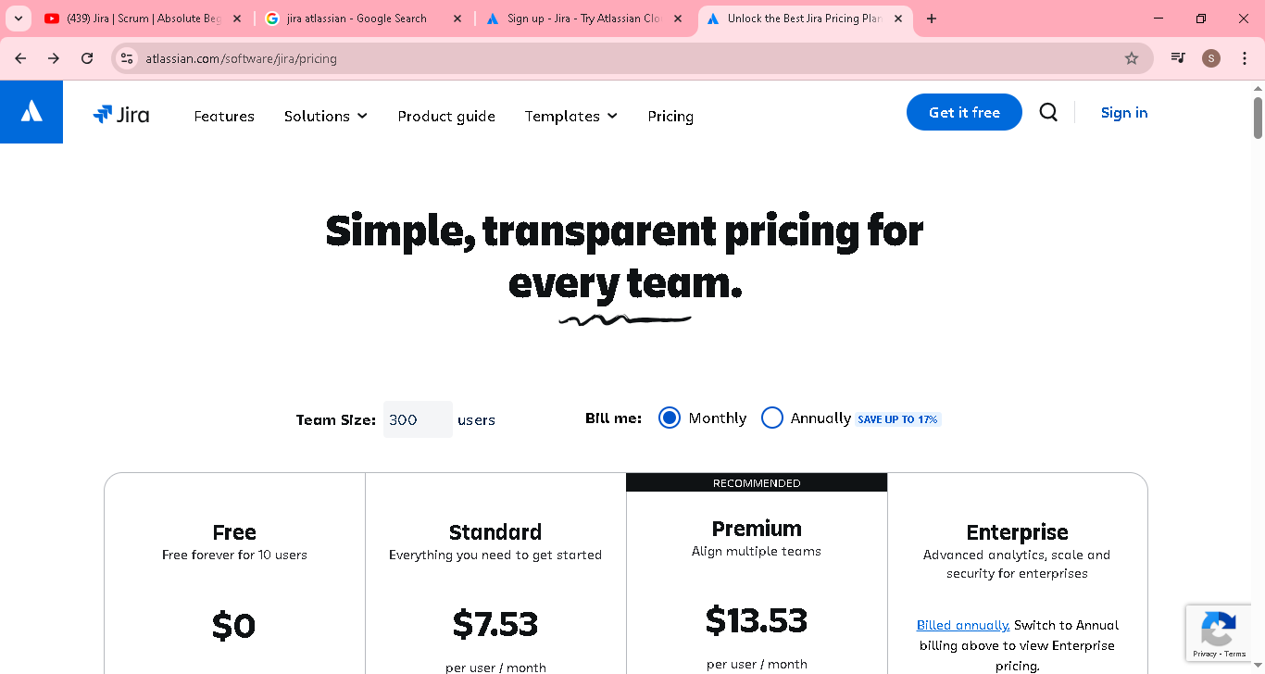

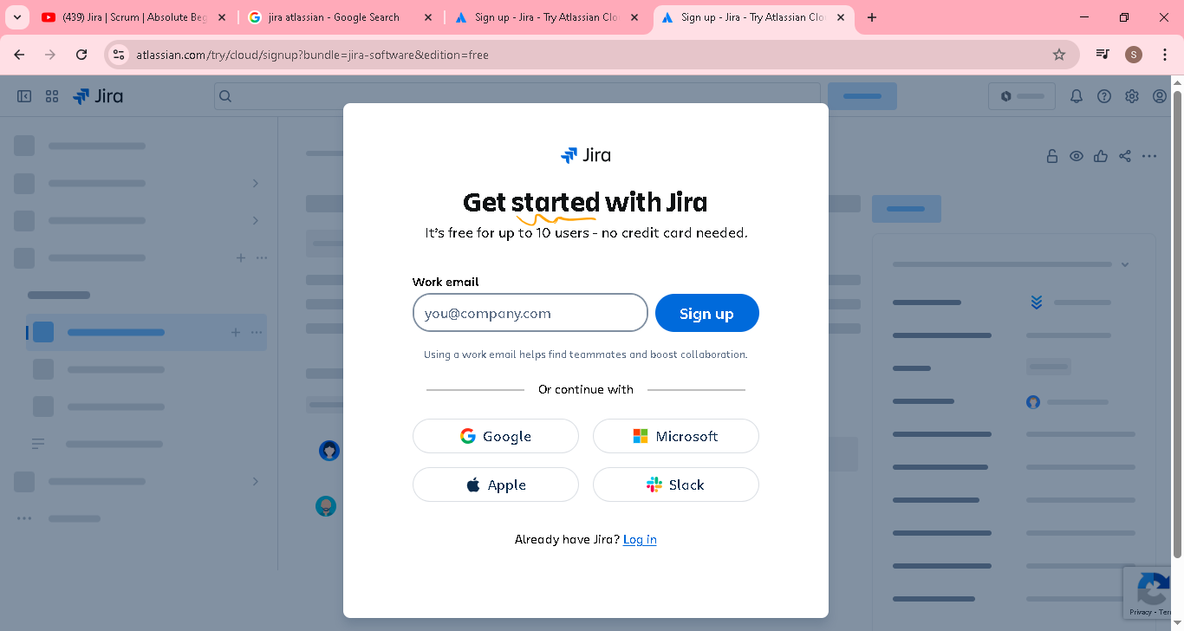
Click continue with google
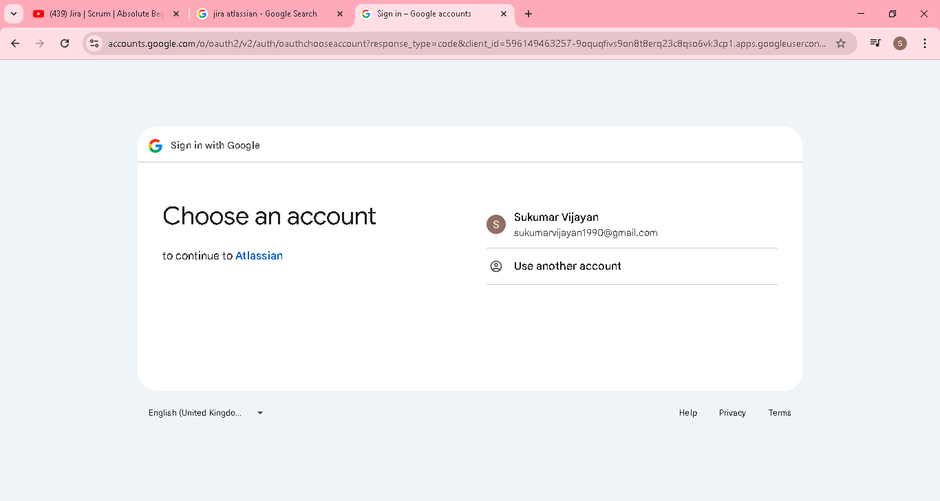
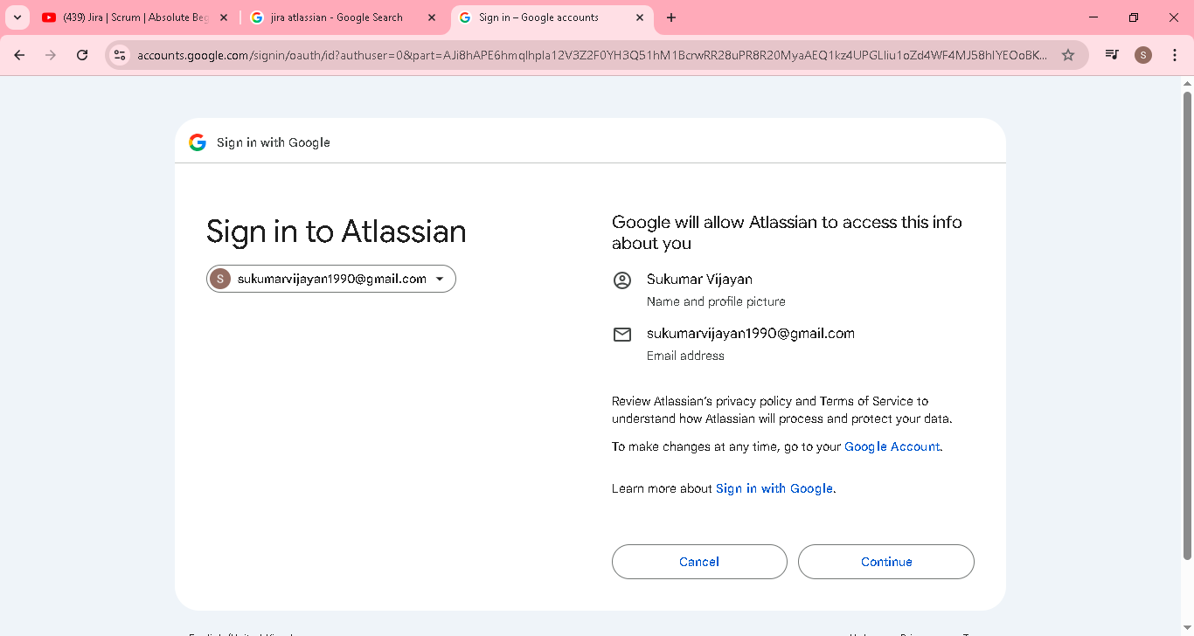

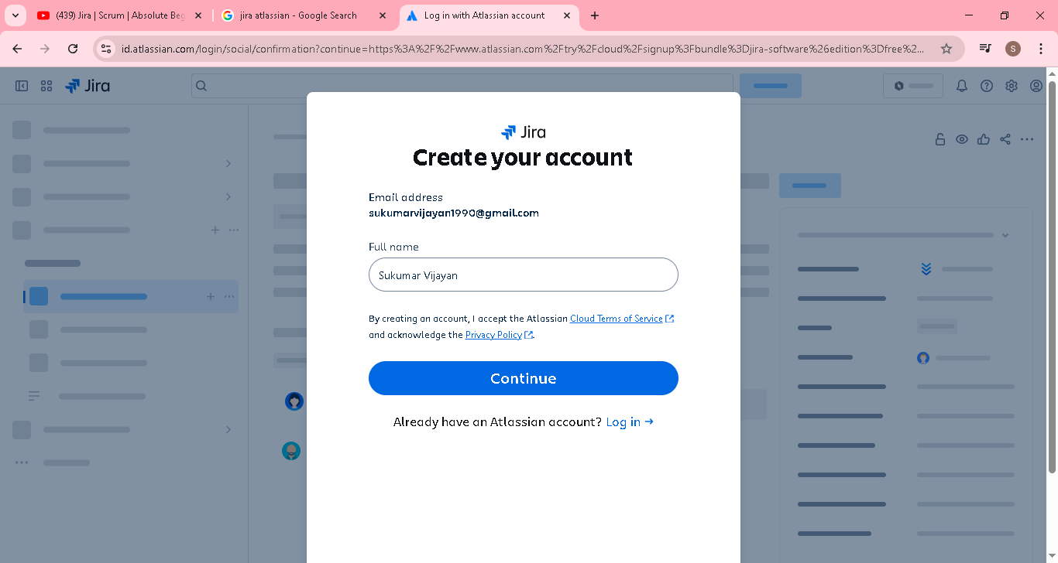

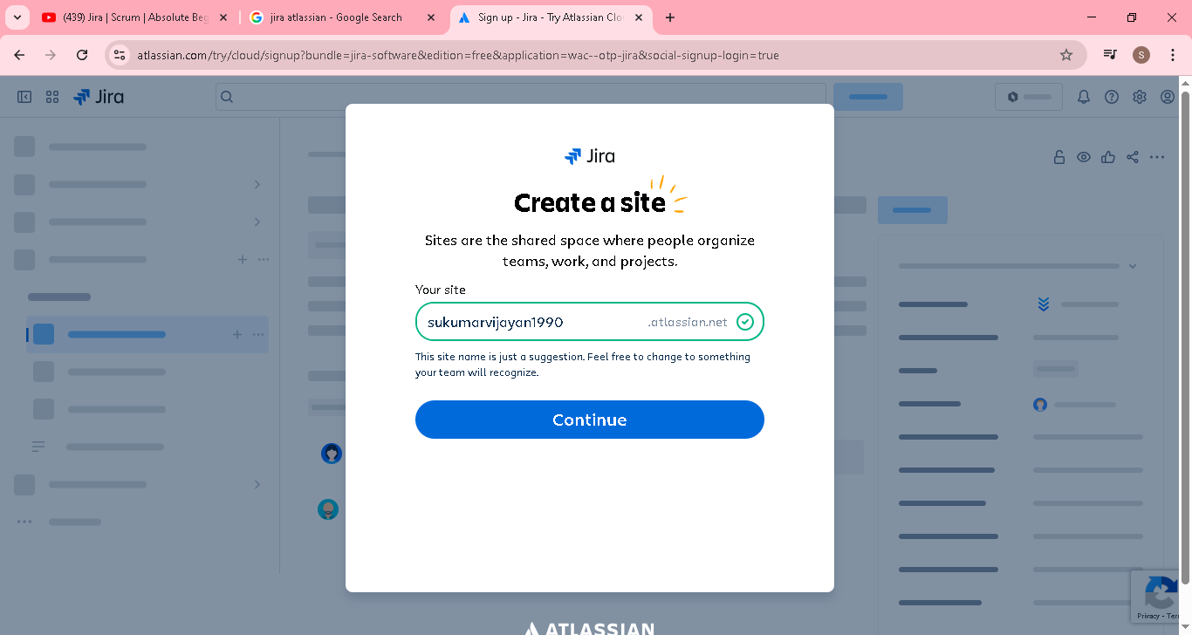
Select project management
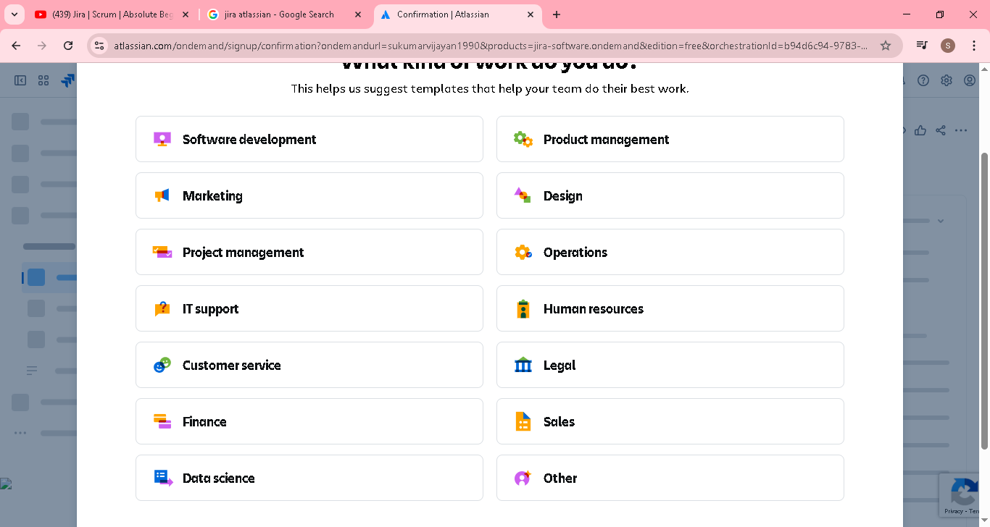
Select Scurm
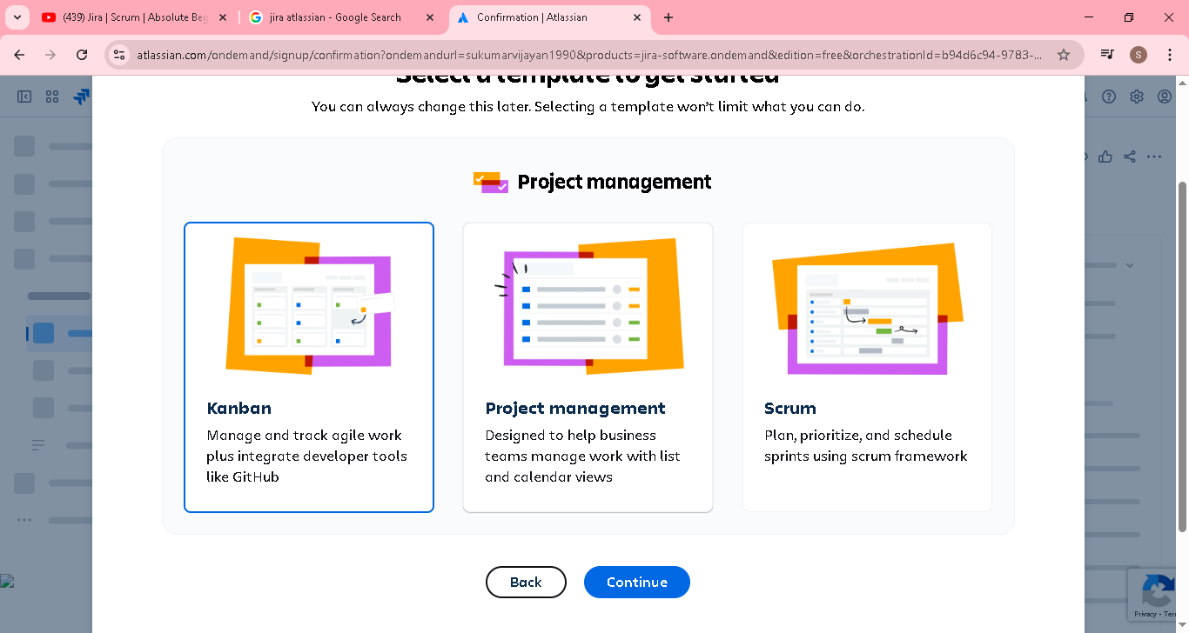

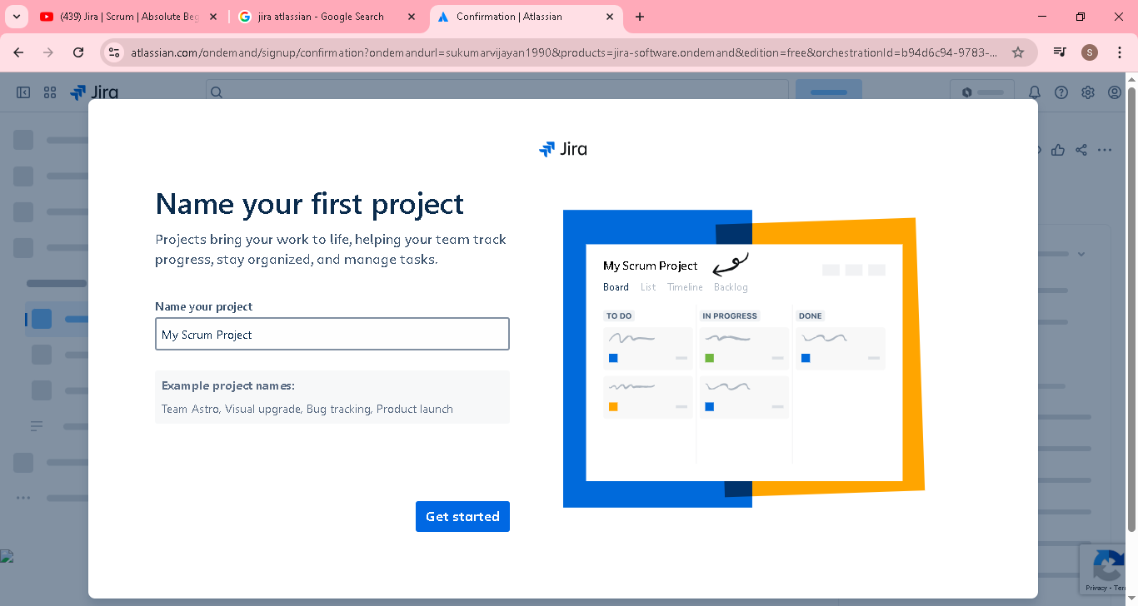

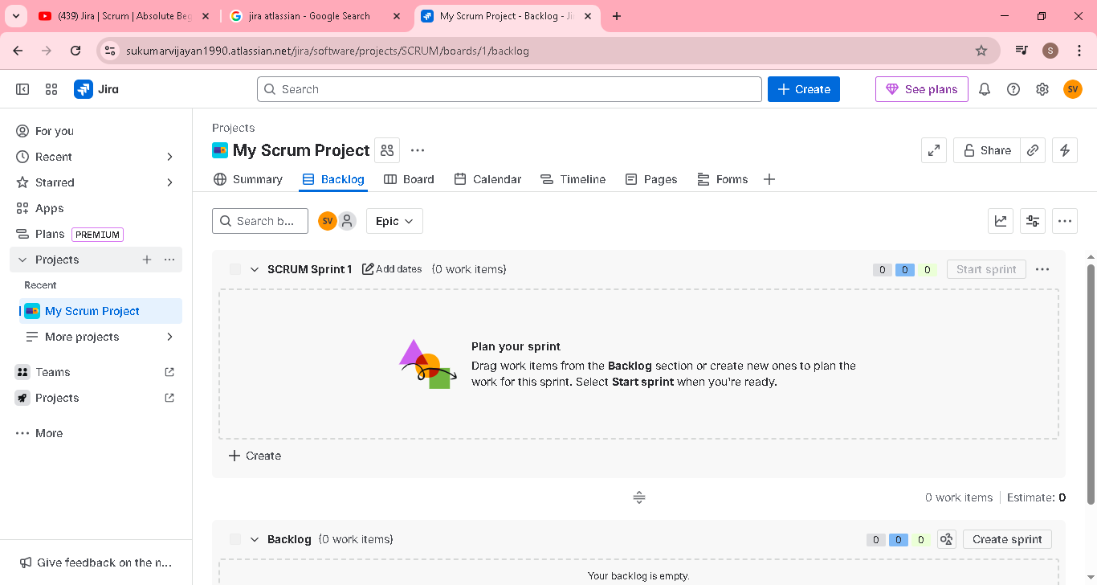

Jira | Scrum | 03 | Getting the requirements | Creating the Epic and User story mapping | Tamil

In this video, we will be looking at how the product owner will be collecting the requirements from the clients and how he/she will be converting the product requirements into a Epic and story map.

The Epic and Story map will be the first place where the product owner will be referring in case of any doubts. Based on this map only, the product owner will be creating the product backlog.

Product owner will interact with client to get all the requirement & write in below format/mapping

Here Browse, order, Payment, Track ->Epic

Under Browse search products, Product details ->User story

Note: User story should be in small and do one function..its a complex then it will come as epic

Pink color items are high important based on the discussion with client

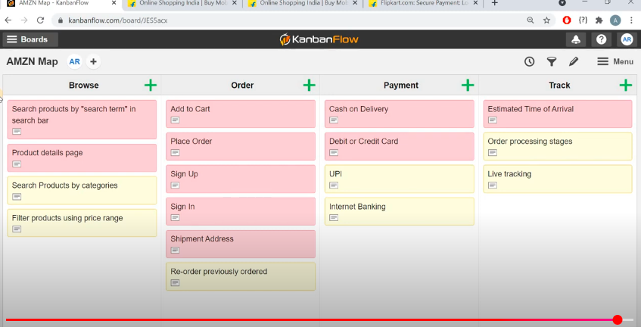

From the above mapping only product owner create a epic and user stoy, priority in Jira board

Jira | Scrum | 04 | Creating backlogs | Epics | Writing user stories | Acceptance Criteria | Tamil

In this video, we will get to know how to create product backlog, writing stories, acceptance criteria for the stories created. It is the product owner's responsibility to create the set of well defined stories by providing proper description, acceptance criteria and including mock ups to better explain the story to the team.

When you practice this hands on, it is recommended to fill out the necessary fields with suitable description and details instead of just giving random sample texts.


Going to create a epic and user story for above diagram

Here Browse, order, Payment, Track ->Epic

Under Browse search products, Product details ->User story

Click create button and select the work type as epic and summary as Browse & submit
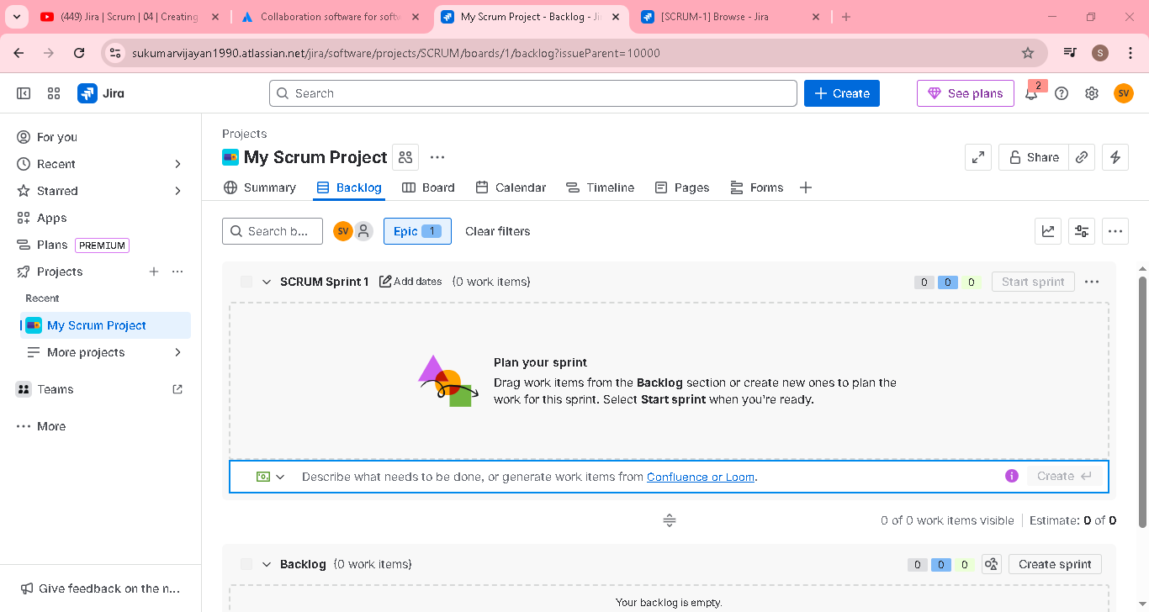

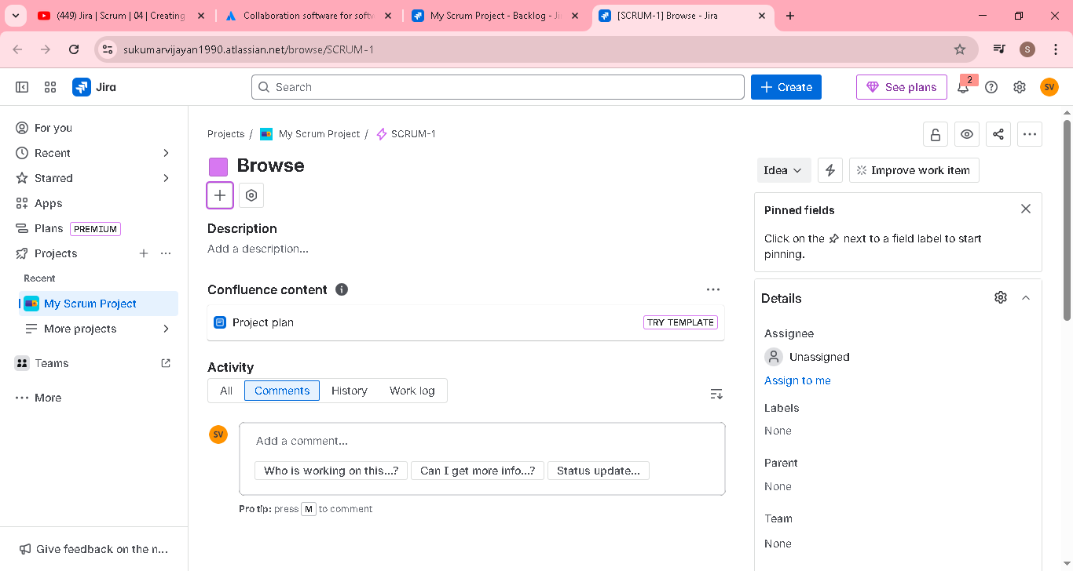
Click create & type as story, provide summary & submit
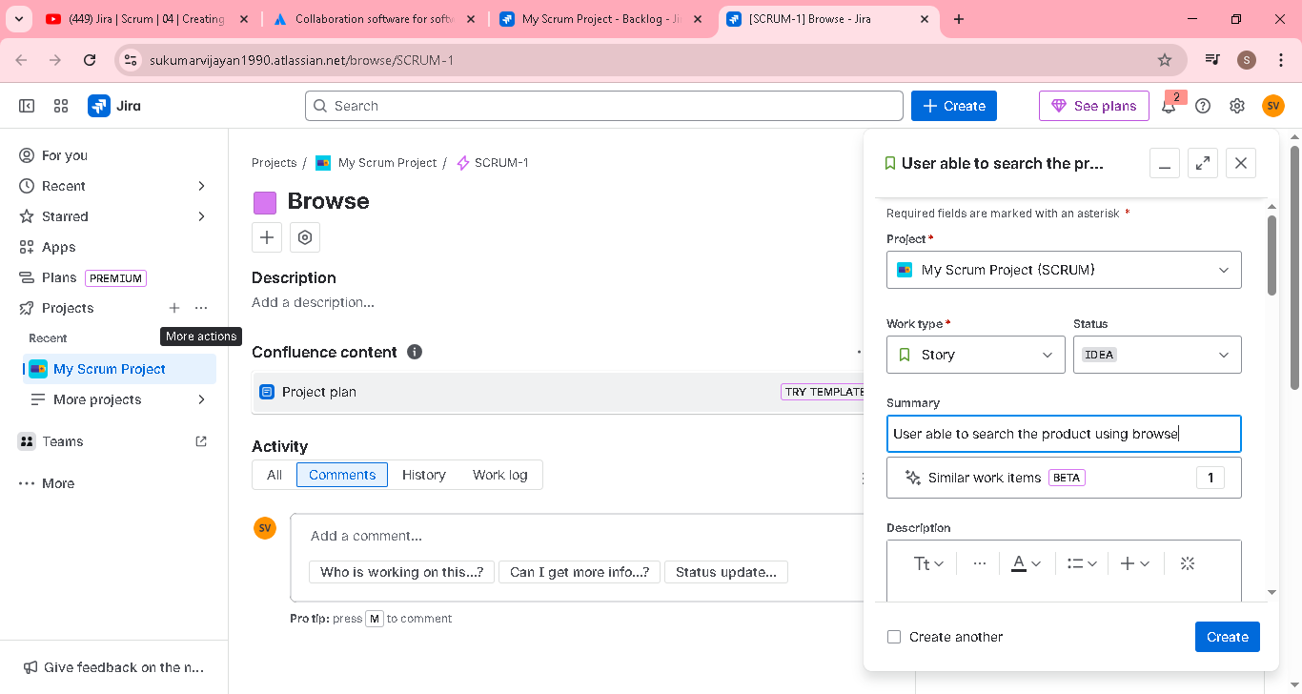
Parent select epic browse
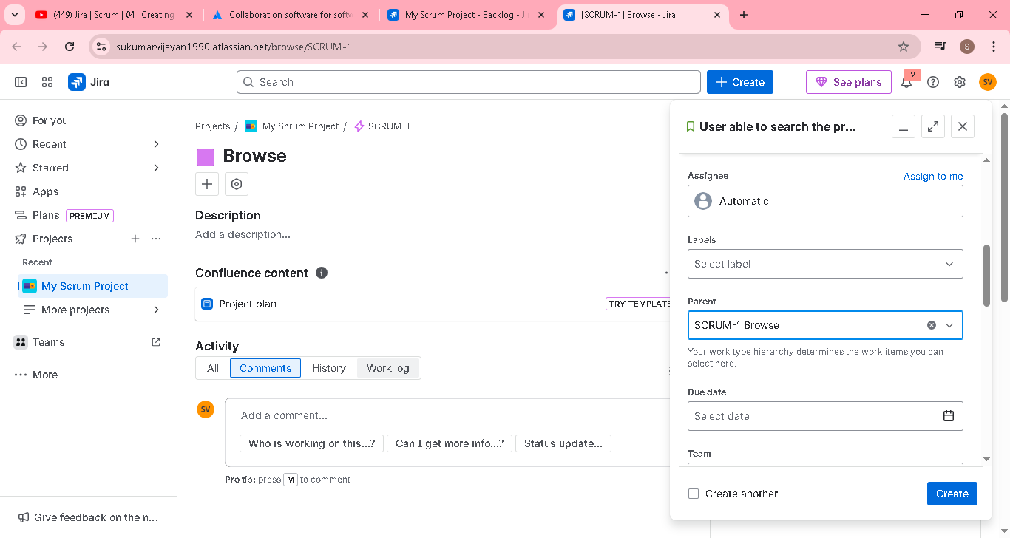
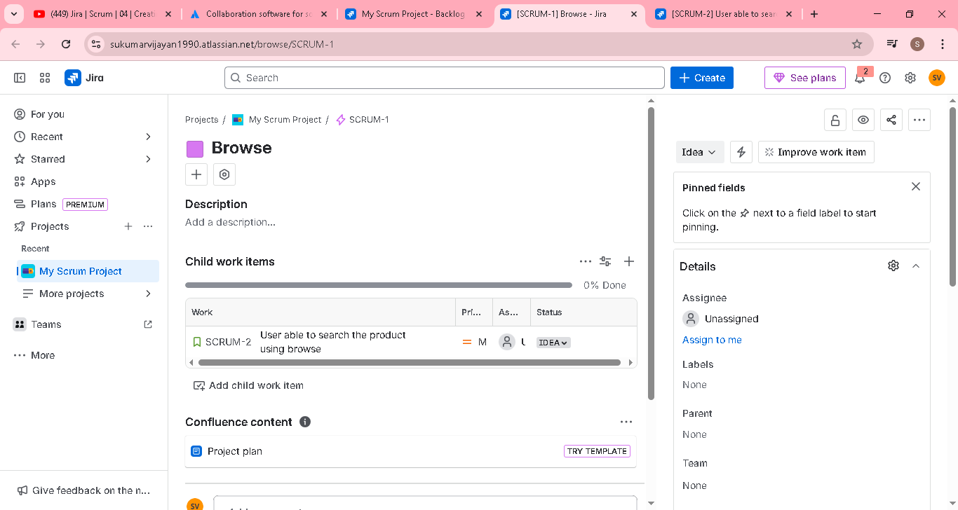

Added in the backlog for epic browse
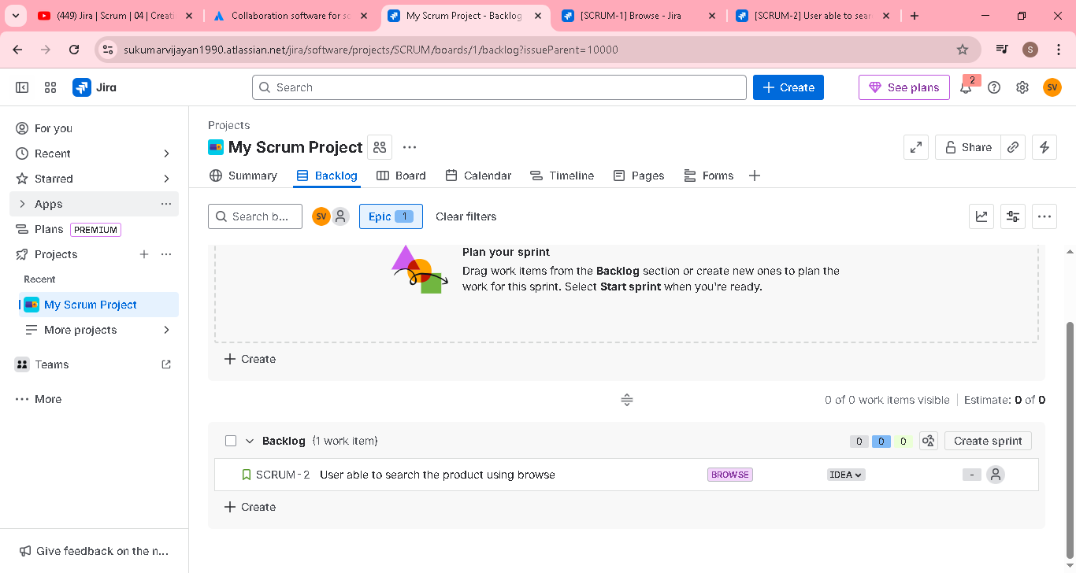

Then in the user story..provide requirement and acceptance criteria
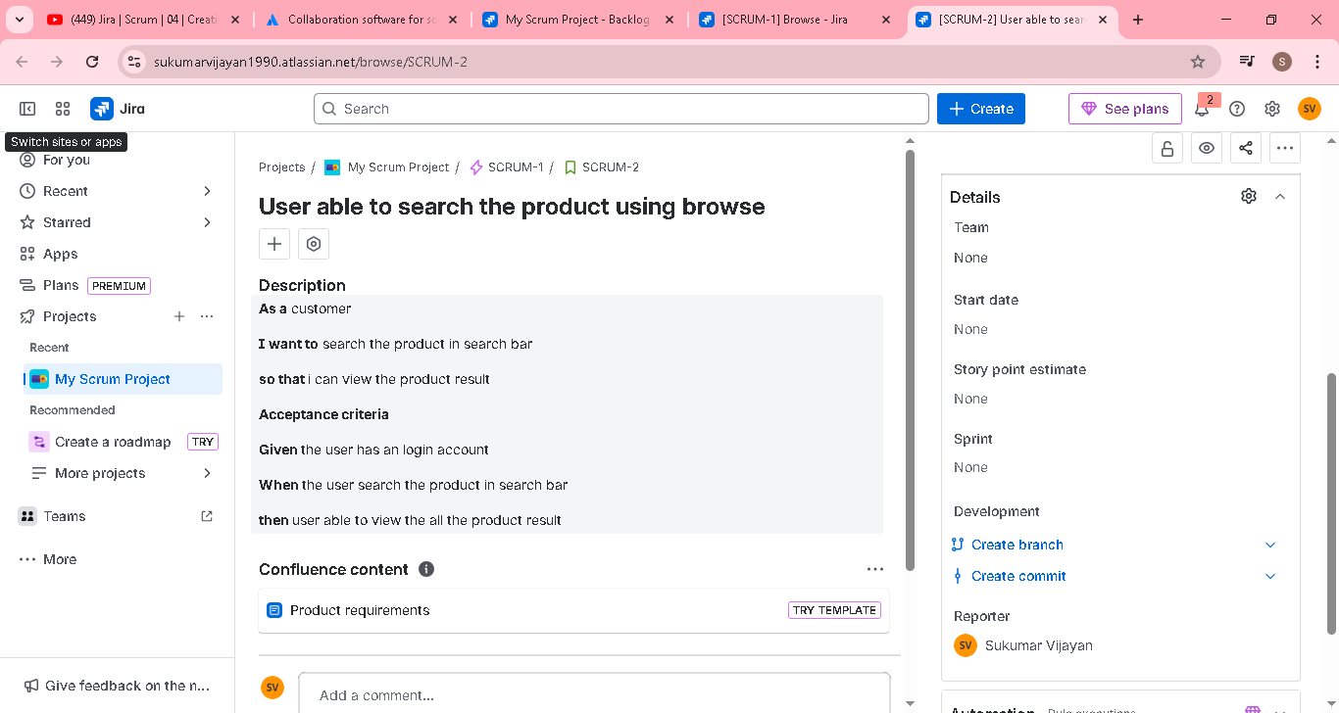
We can attach the mock up picture for browse product in the user story
Priority also we can set the user story, based on the discussion with client, product owner wi, provide the high, medium , low etc
Note: acceptance criteria we can write multiple like positive or negative to validate the user story feature outcomes (like AC1, AC2, etc) if all the AC pass then only user story completed
So that both dev and tester will cover this validation during development & testing

Jira | Scrum | Story Point Estimation | 05 | Tamil | Absolute Beginner Guide

In this video, we will be learning one of the most important and difficult process on Agile product development which is story point estimation. There is no concrete steps or methodology to arrive at the story points for a given story. Like everything else in Agile, story point also comes from experience.

Story Points represent the effort required to put a PBI (Product Backlog Item) live. For example,1 Story Point could represent a range of 4–12 hours, 2 Story Points 10–20 hours, and so on. This time distribution is unknown during estimation. By using reference PBI’s relative to which to estimate, it is not necessary to know how much time it takes. You just want to have a rough indication of how much time the PBI will take to complete.

Why do we need estimation at all?

1. Arrive at a shared understanding among the team members,

2. Organize the Product Backlog based on value and effort,

3. Plan upcoming work,

4. Slice the stories and work smaller.

Story points vs Hours

Traditional software teams give estimates in a time format: days, weeks, months. However, many agile teams have transitioned to story points.

Story point === overall effort required to fully implement the PBI (product backlog Item).

Why not dates?

It may sound easier if we provide the estimate on time. But what stopping us?

Dates don’t account for the non-project related work that inevitably creeps into our days: emails, meetings, and interviews that a team member may be involved in.

• For you it can take only 3 days for but for me it will take 5 days.

• We already mentioned story point is effort and Effort is not equal to time.

Story points are abstract, relative, and about effort.

What should the story point estimate?

Starting from the start of the sprint until the definition of done is met for the backlog, the story point should consider everything as effort.

How do we estimate?

• Estimation should be done by people who are actually doing the work.

• Get multiple estimates from all the people involved in the team. The average of the estimate should be a correct one.

• Don't use subjective measures, use objective measures. Use relative estimate techniques instead of absolute estimation. . Fibonacci series: It's not accurate, but on an average 20 points roughly equates to 16 hours.

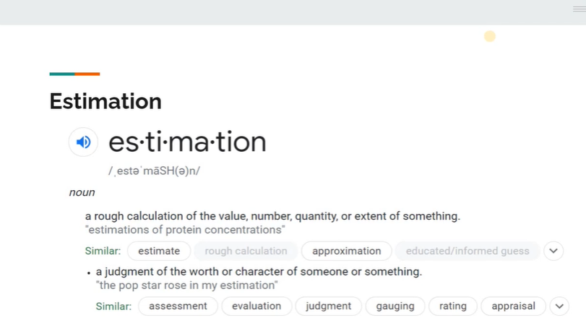

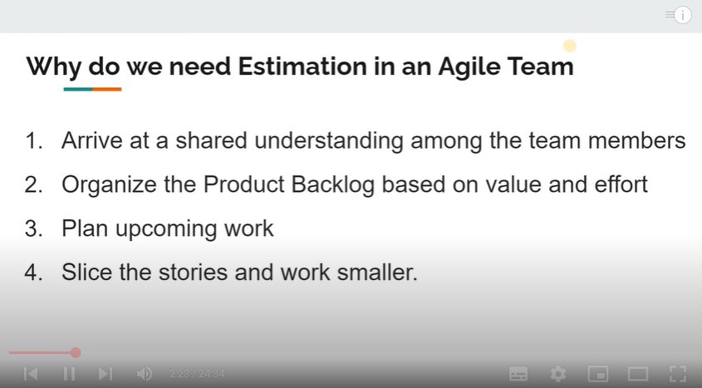

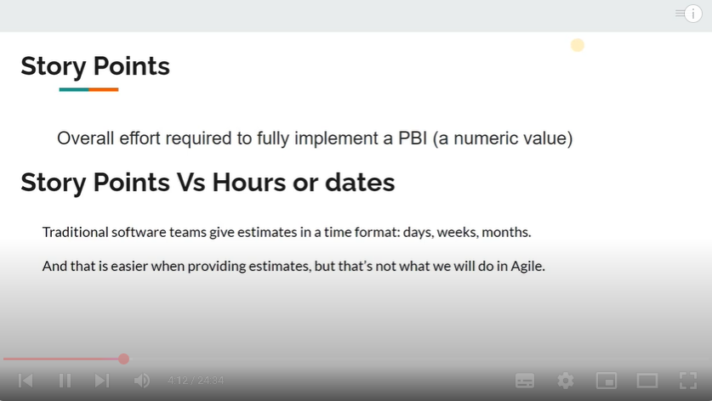

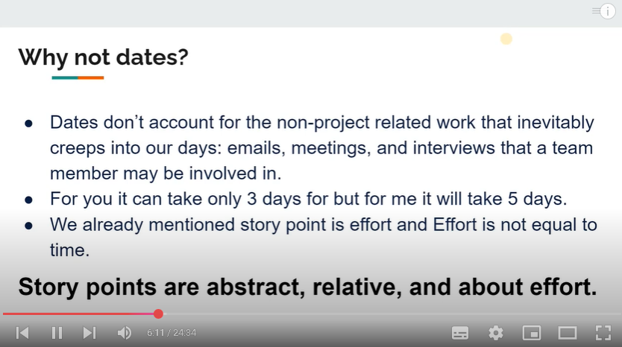

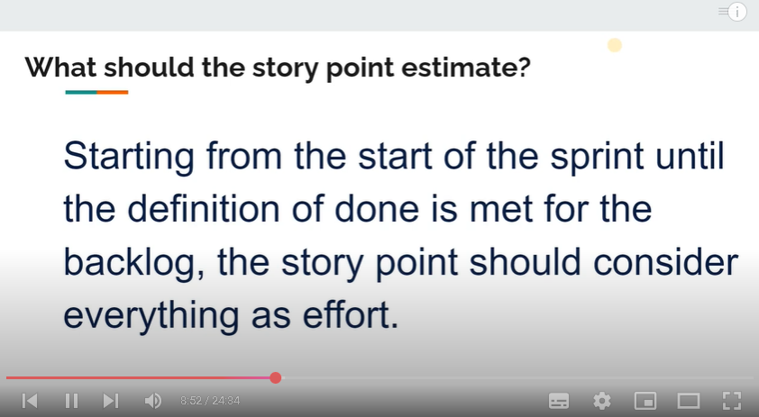

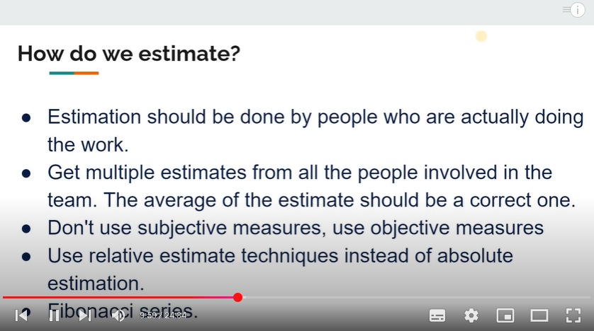

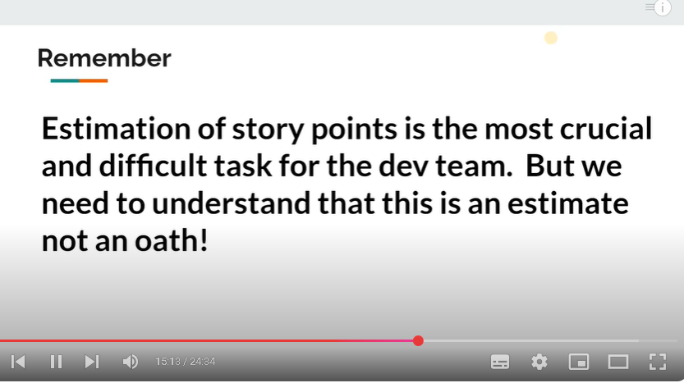

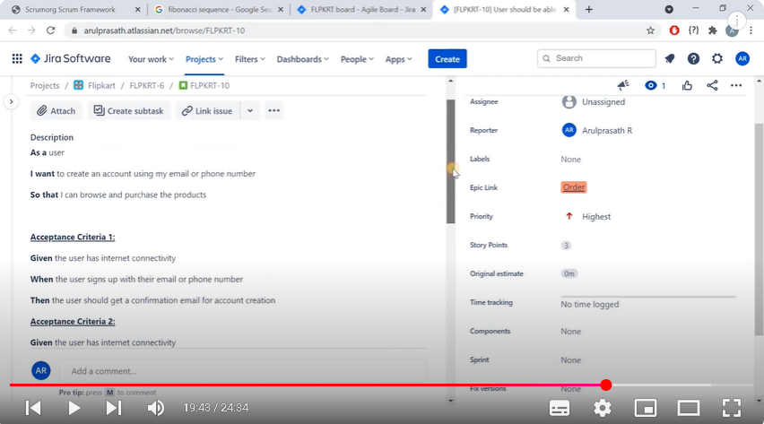

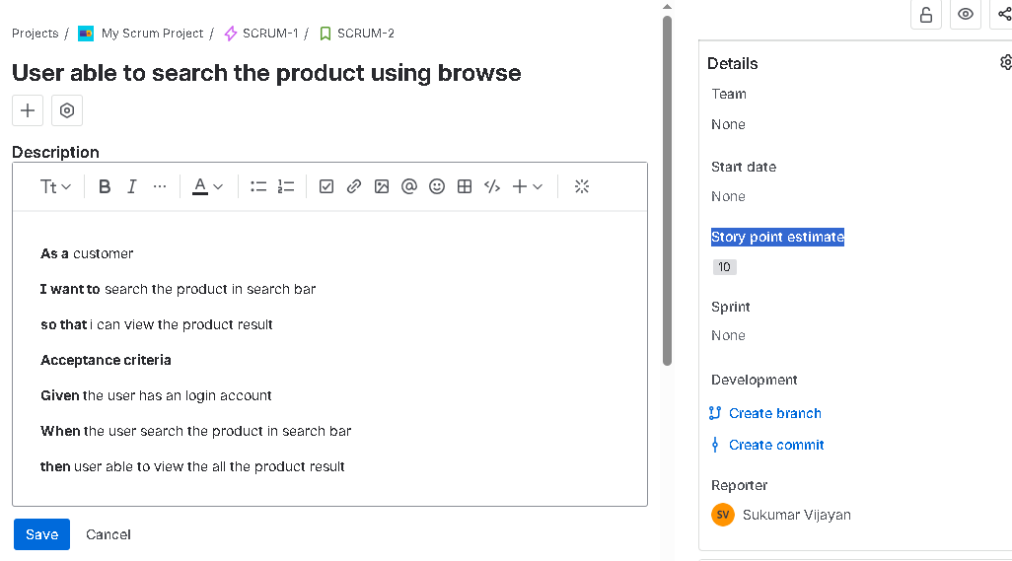

In real project, card given with a number, user story will be explain and then each one have show the card in the group..based on that average we can consider to estimation

JIRA | Scrum | Sprint planning | Sprint backlog | 06 | Tamil | Absolute Beginner Guide

In this video, we will be looking at one more example of estimating the story points to a given story and then, we will create sprint backlog. Later we will be learning how to create the sprint.

Moving a product backlog to sprint backlog

Click the create sprint button near to backlog section

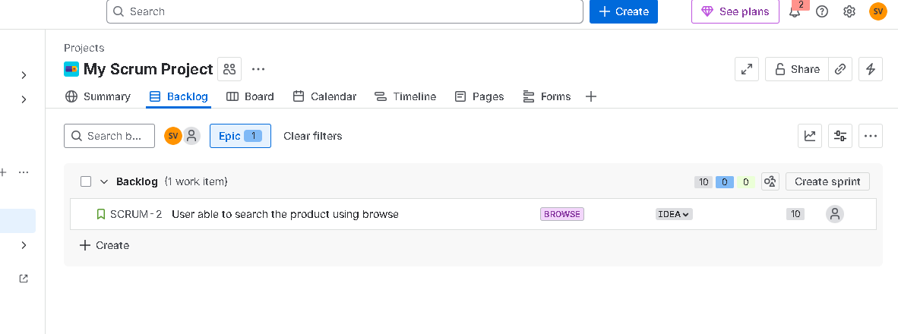

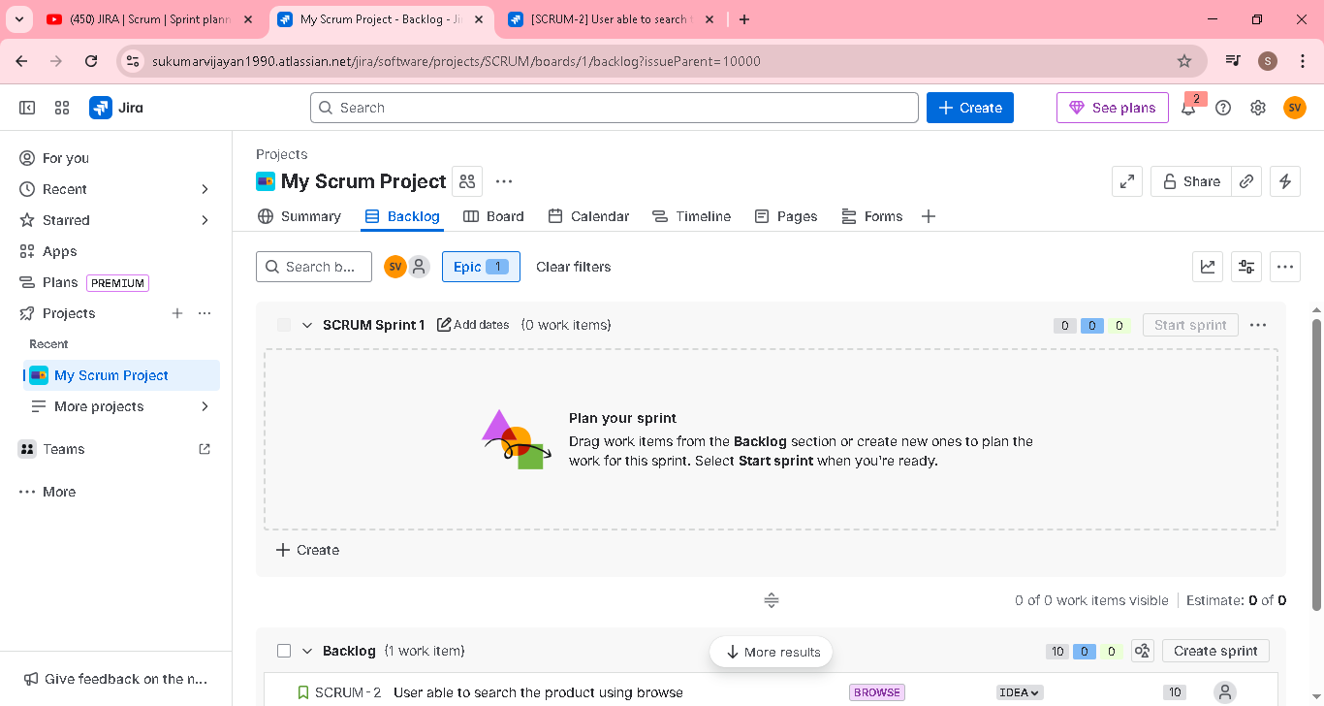

Scrumn sprint 1 created
Add dates 7 sprint duration
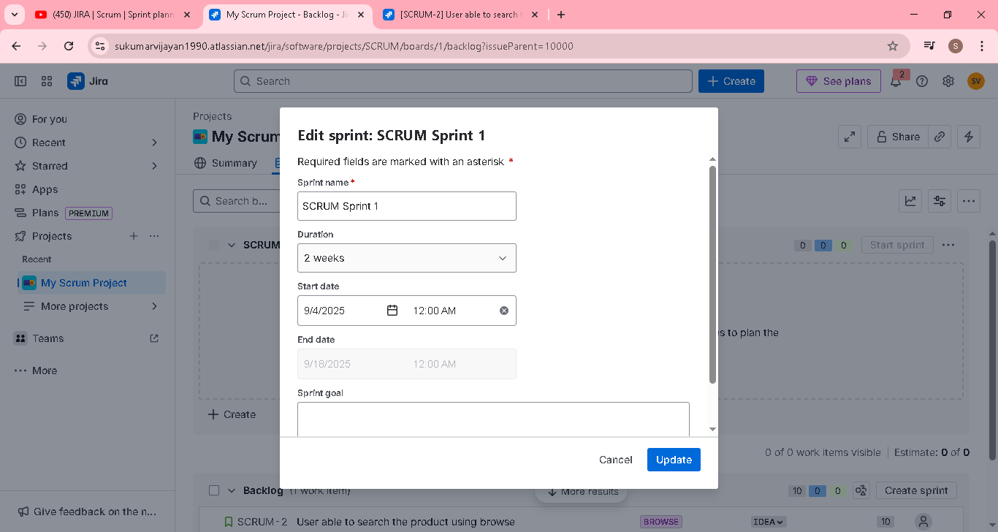

Just drag and drop the user story from product backlog to sprint backlog
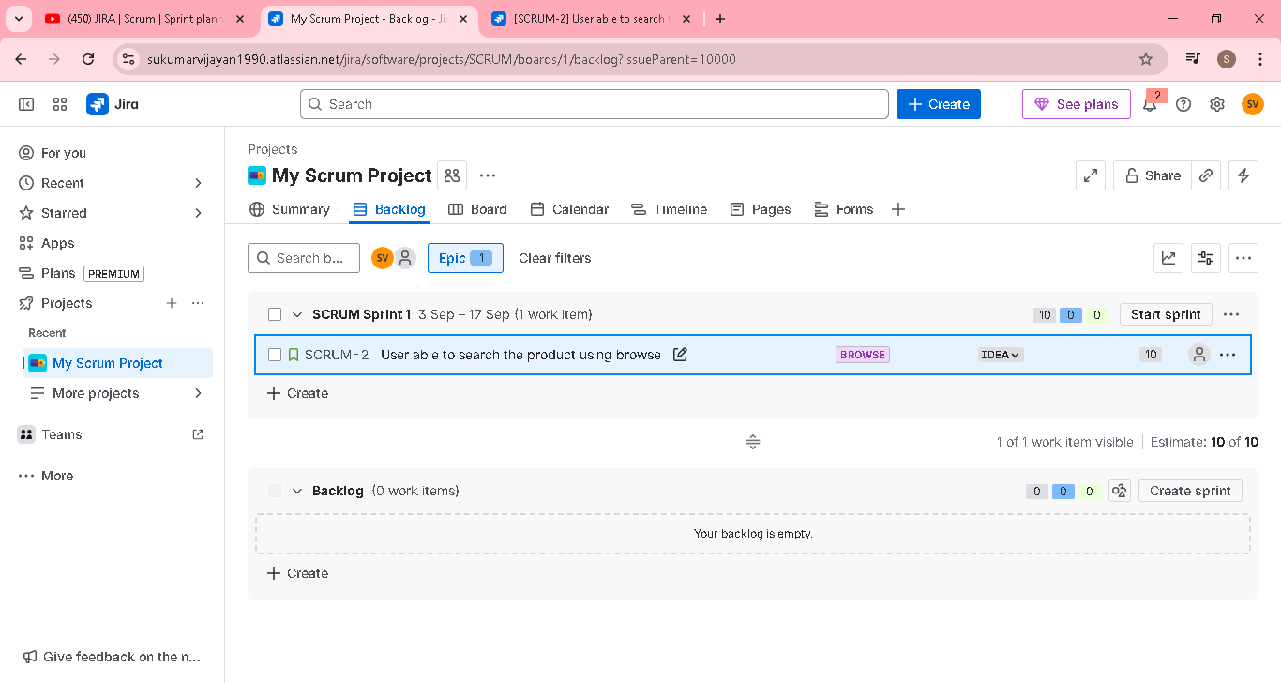

JIRA | Scrum | Components | Sub Tasks | 07 | Tamil Tutorial | Absolute Beginner Guide

In this video, I have explained how we can use the components for our work and how stories can be further split into sub tasks which then be acted upon by the team to create an increment.
Under each story point, we have multiple subtask
Eg one subtask for UI developer
Another subtask for developer for logic
Another subtask for manual tester
Another subtask for automation tester

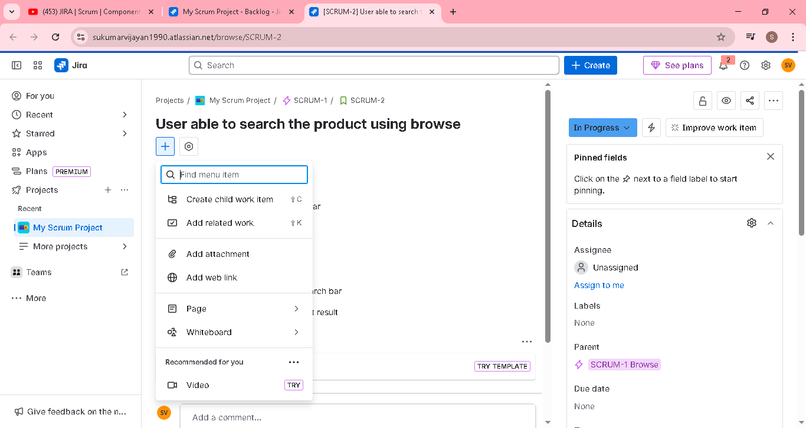
All subtask created and it wil assign to respective team to work
Once all subtask completed by each team , then we can close subtack and user story as well
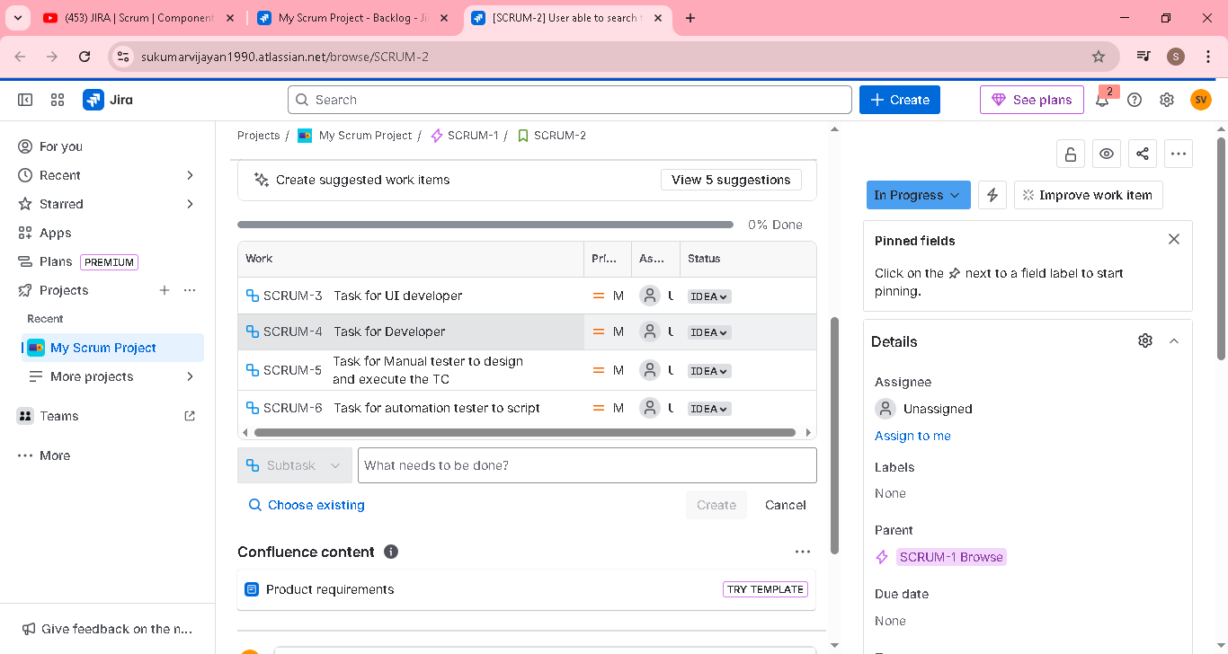

Component and label we can use to jira to filter the projects into sub group based on the need

JIRA | Scrum | Active Sprint | Daily Scrum | Sprint Closure | 08 | Tamil | Absolute beginner guide

In this video, we will be learning how to start a sprint, moving tasks from one state to another like from To do to In progress and then to Done section.

we will also learn how daily scrum or stand up meeting helps in smoother progression for the sprint backlog items

Once all ready, click start sprint

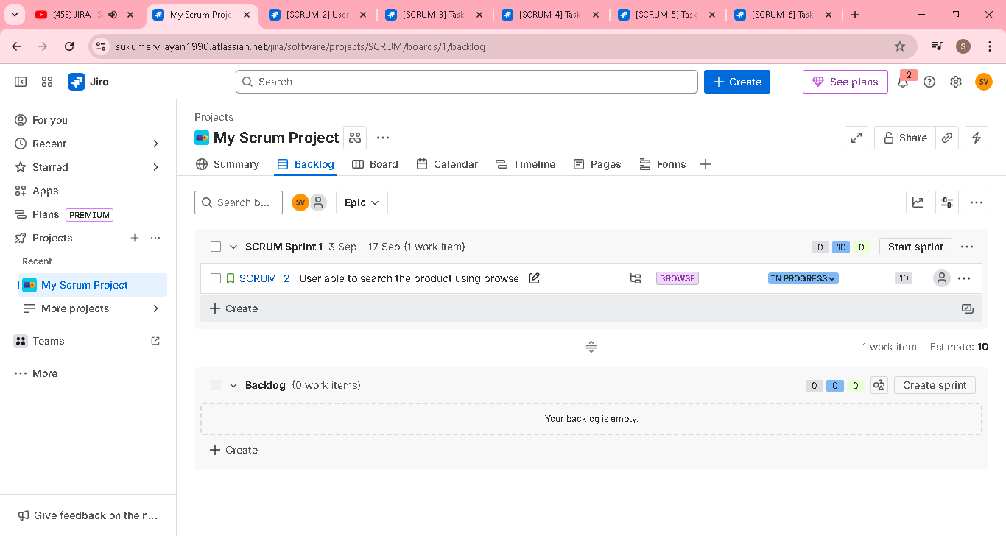

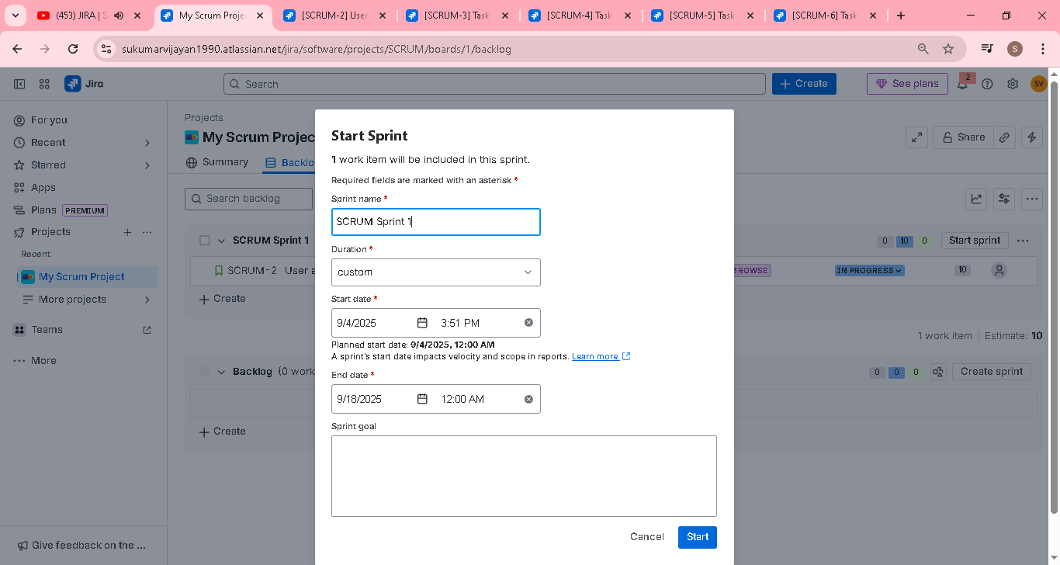

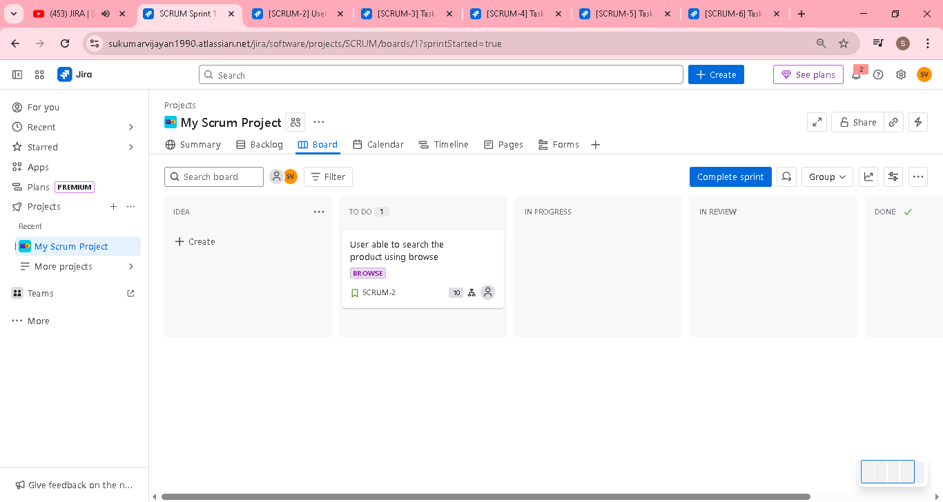

Move the task from to do to done on daily basic work

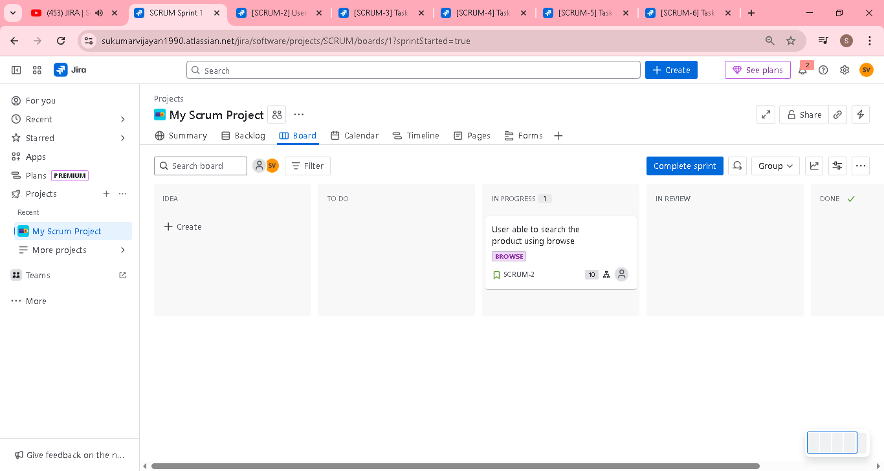

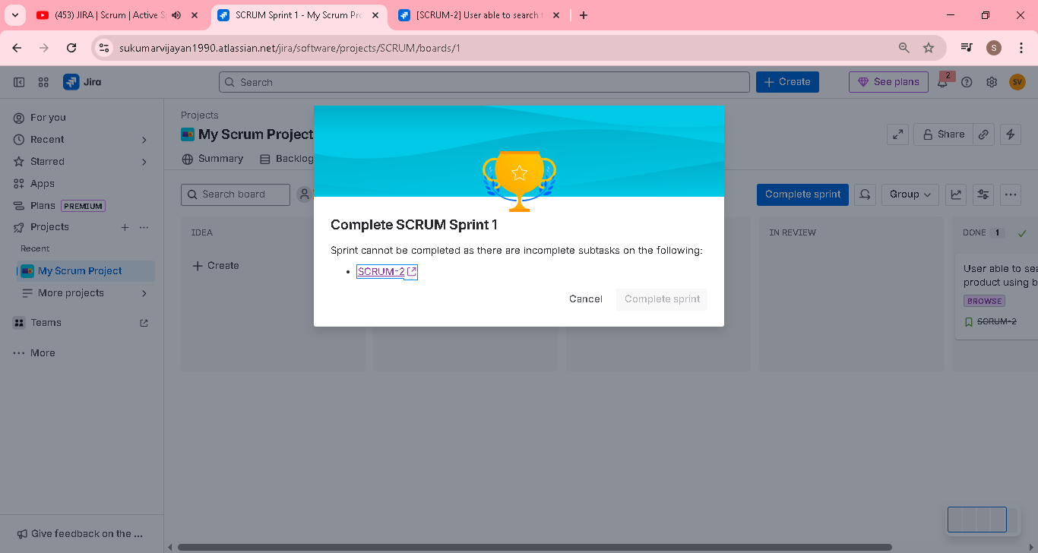

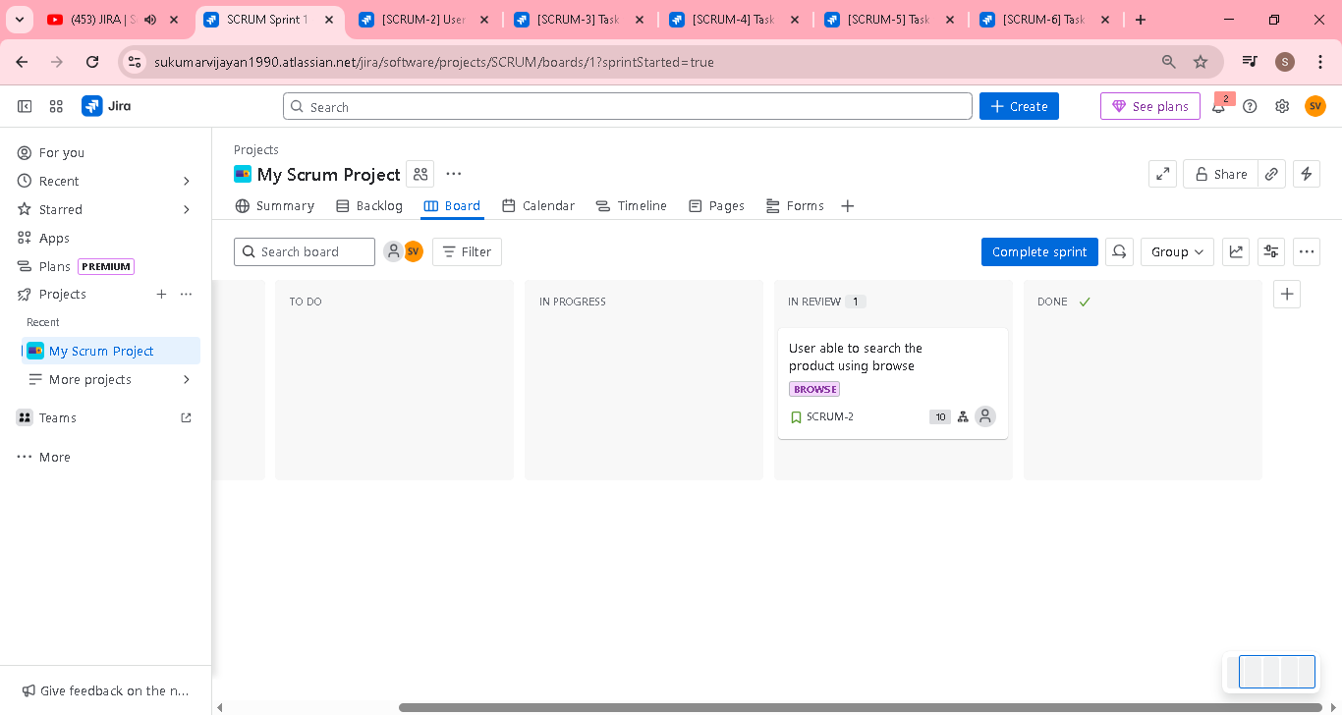

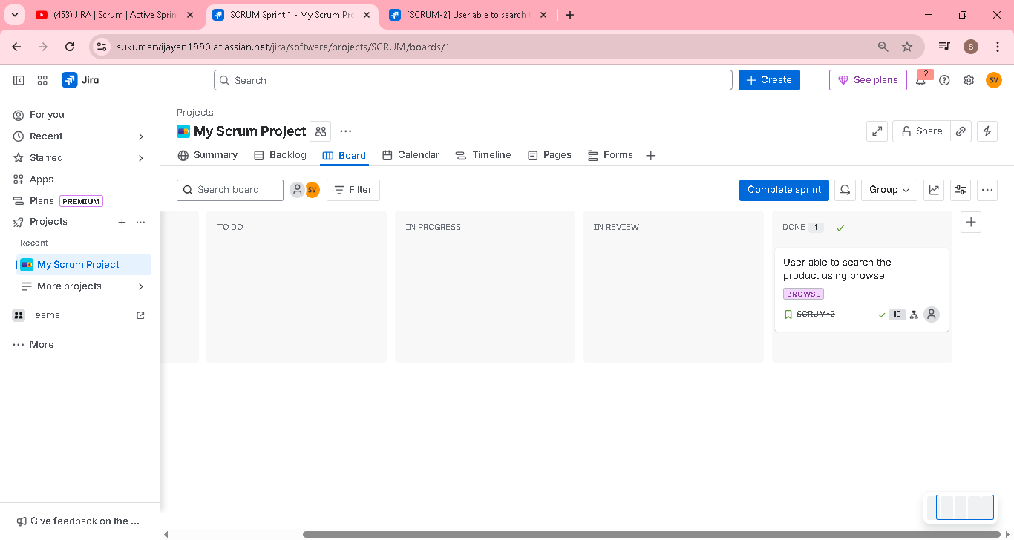

Once all done, click complete sprint



Mark all subtask to done

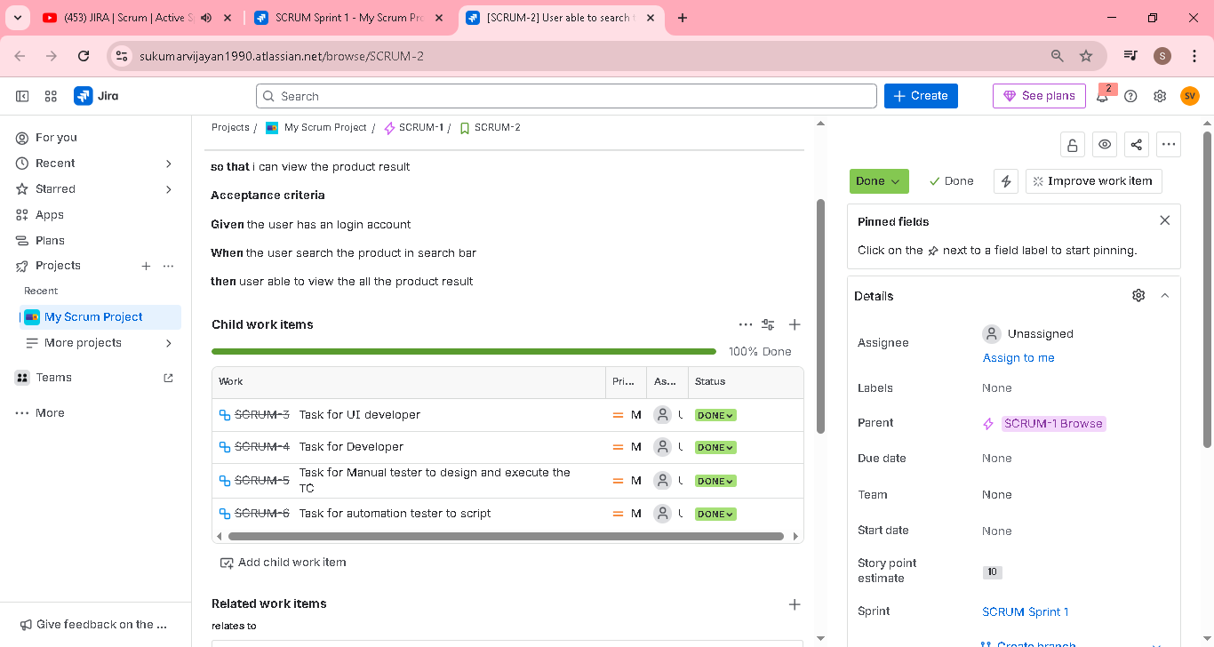

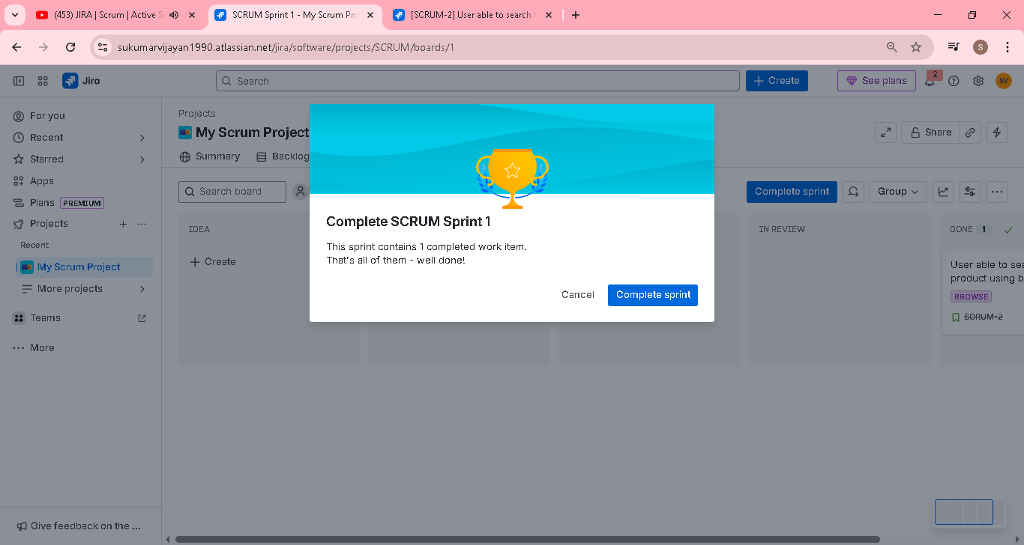

Successfully sprint completed

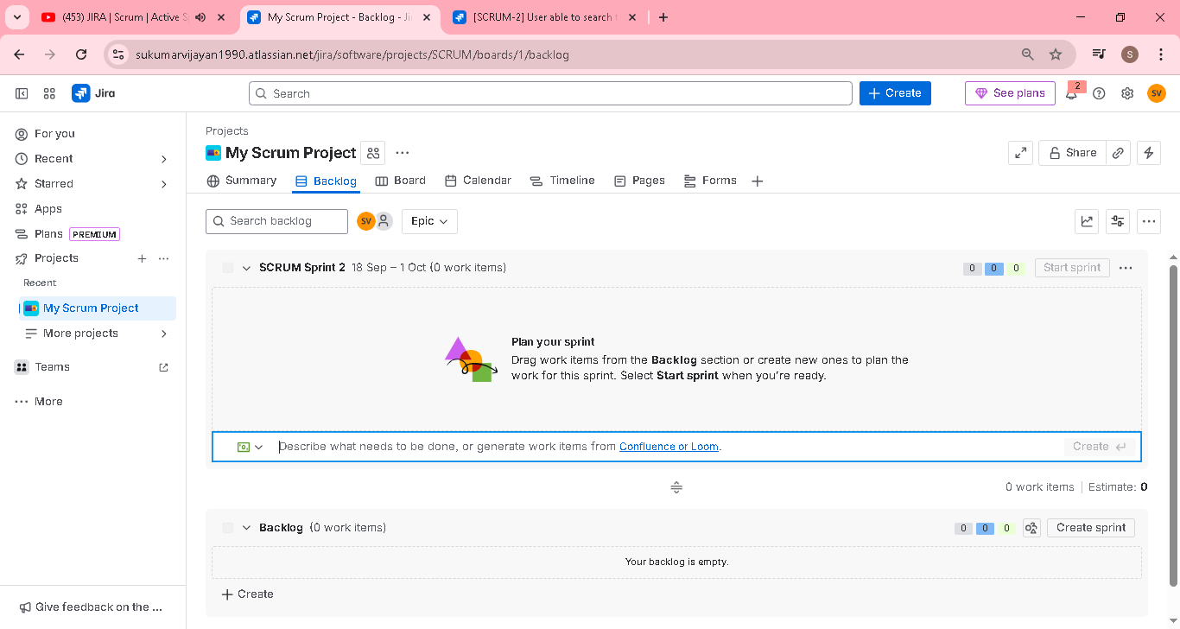

Then view the reports [burndown and velocity chart]

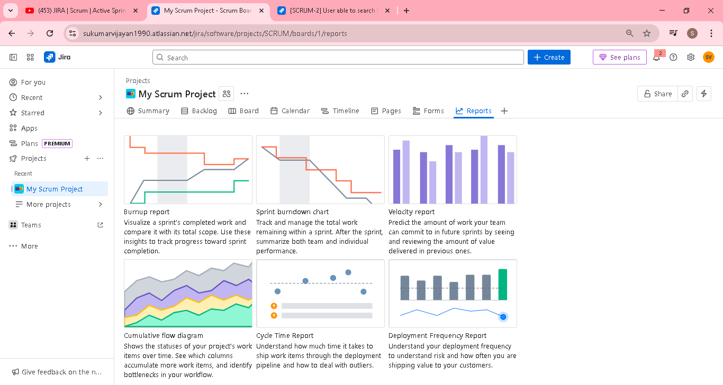

In velocity chart , will show the committed and completed

One story having 10 story pint estimation..that why showing 10 in chart

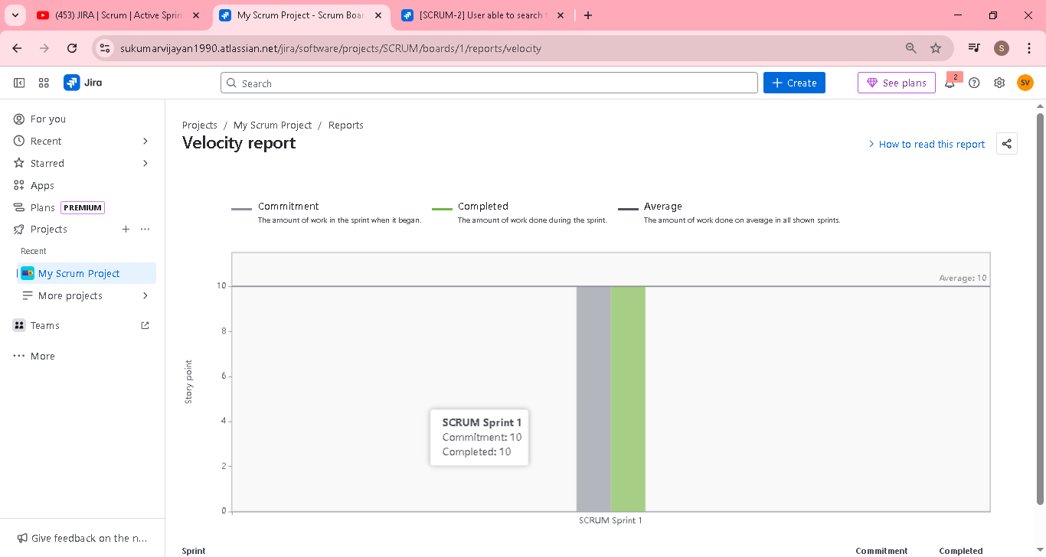

Datewise progress of the work in 2 weeks sprint

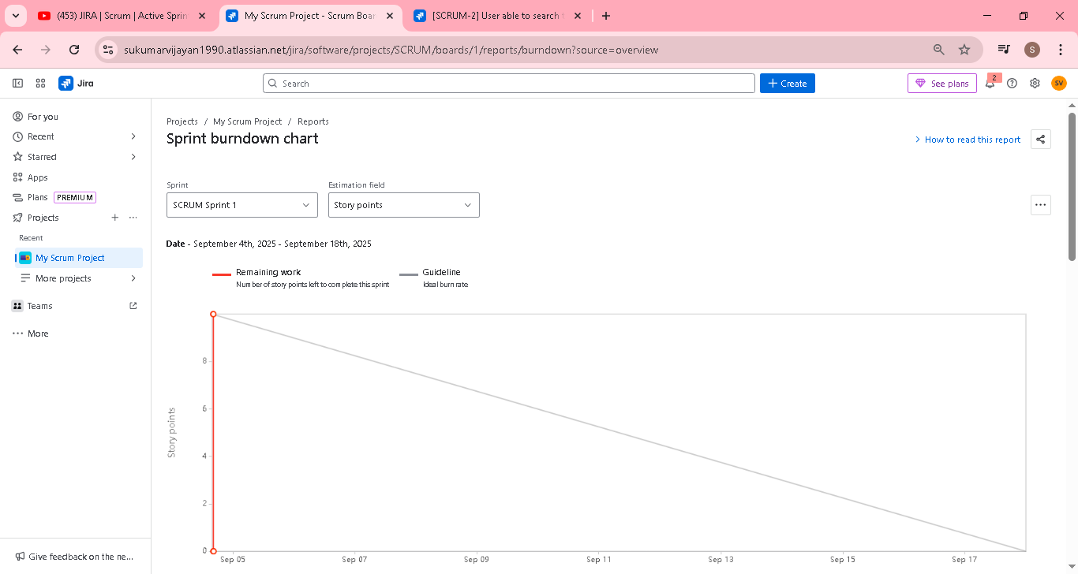

JIRA | Scrum | Sprint Reports | Burndown & Velocity chart | 09 | Tamil | Absolute beginner Guide

In this video, we will learn how to understand the sprint reports like burndown chart and velocity chart.

Lot of graph available, imp only Burndown & Velocity chart

Burndown chart

We have started and completed same days..that why line highlighted in sep 05

Verticcular represesnt ->story point estimation (0 to 100 etc)

Horticaular ->sprint week days

Guideline line ->planned work to complete in each days

Remaining work line -> actual work on each days

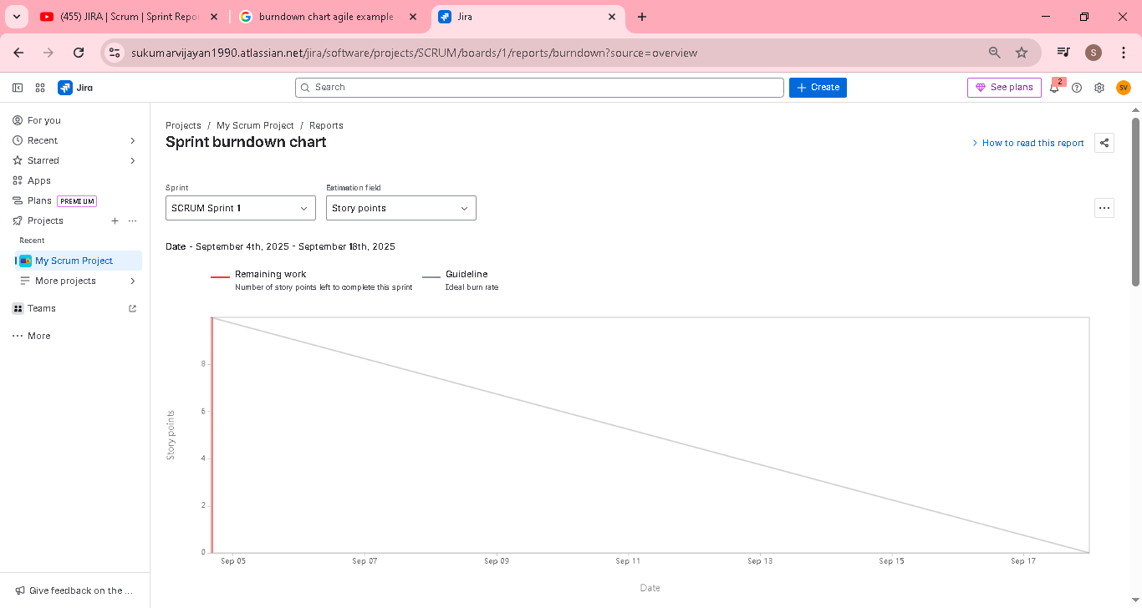

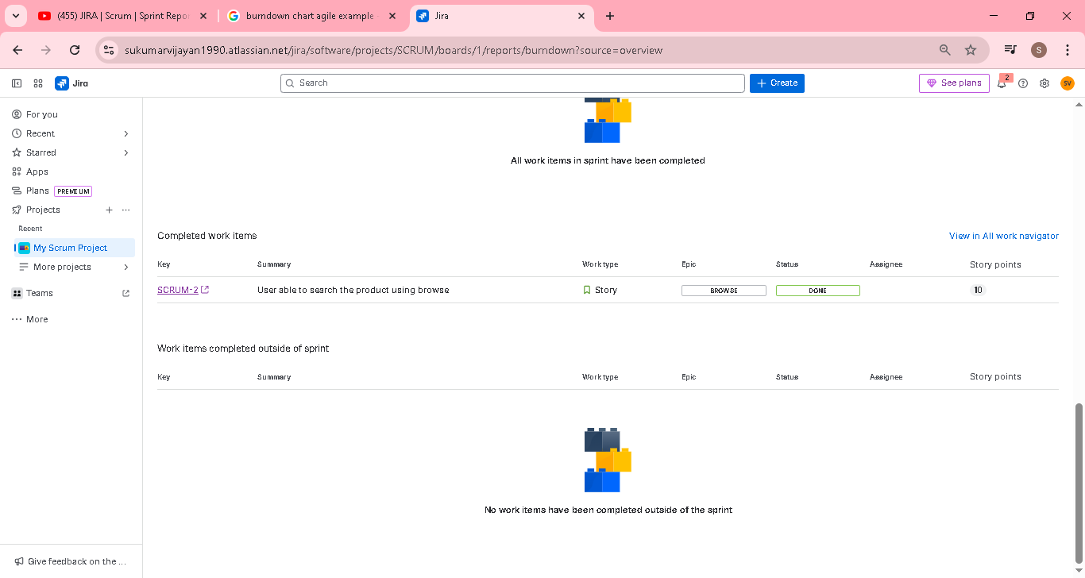

Sample graph from google
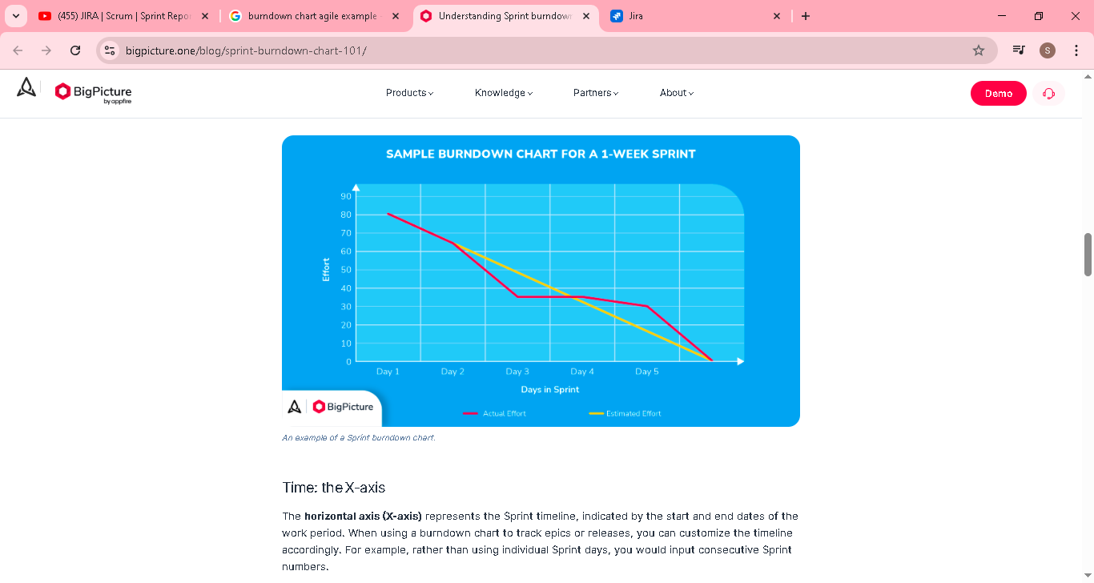

Velocity chart
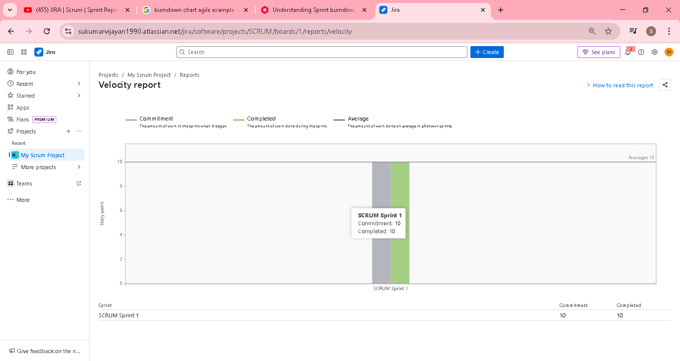

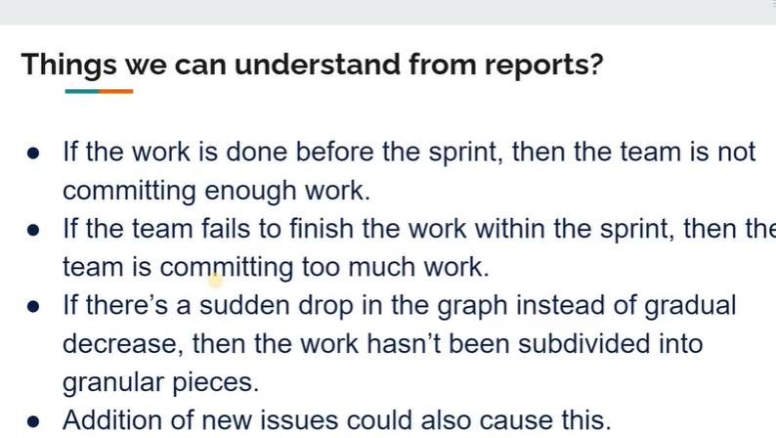

JIRA | Scrum | Creating a bug | Tamil | Absolute Beginner Guide

Already u knw how to create a bug, just below to include while logging a defect

summary

Expected result

Actual result

Steps to reproduce

Screenshot

Priority

Parent ticket

Components & label

Environment

Provide linked issue and issue

Bug will block the user story(Xxx)

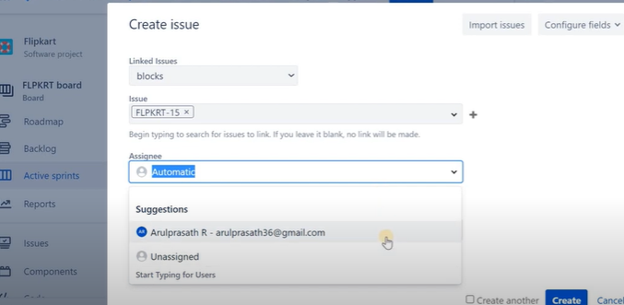

JIRA | Scrum | Sprint Retrospective | Confluence | 11 | Tamil | Absolute Beginner Guide

In this video, we will learn how the Sprint retrospectives will be happening. Also, we will be learning how to use confluence as a tool for conducting retrospectives.
Usually, there will be three key points
Stop doing
Start Doing
Keep doing
Sprint Review -> Discuss about the product and demo will happen
Sprint Retrospective -> Discuss the team performance in the sprint
Confluence ->Its a document contains the information (project) etc
Here all Sprint Retrospective details will store in Confluence
Select blank page
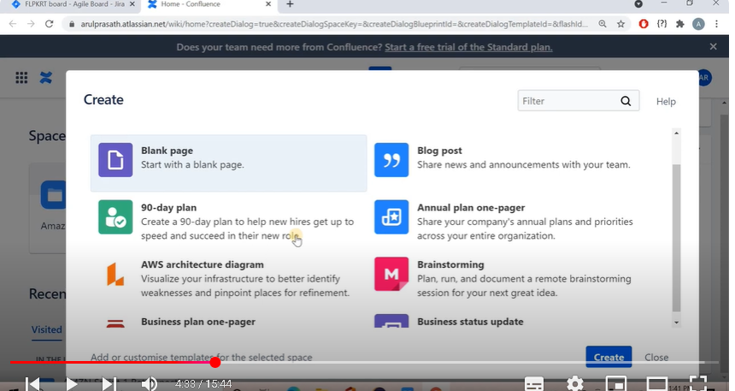

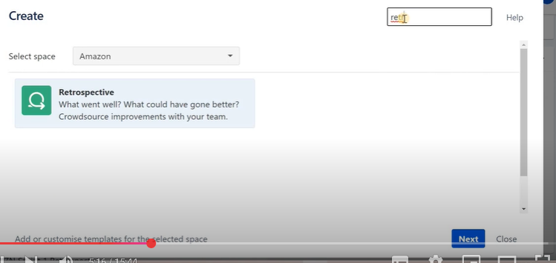
Stop doing
Start Doing
Keep doing
Above points is main in the sprint retrospectives

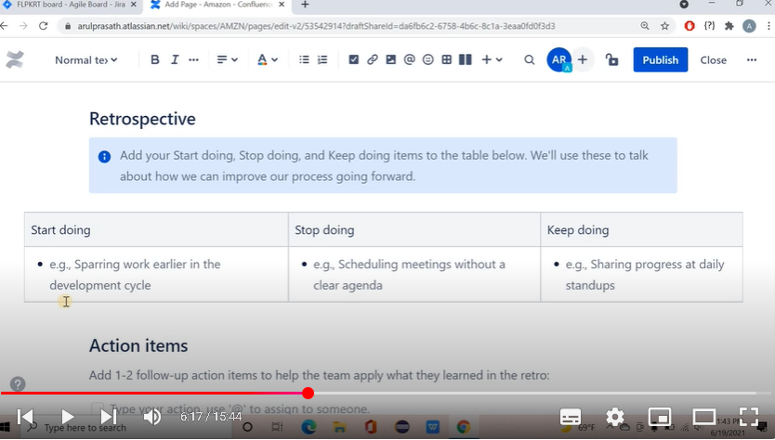
Note: all points updated after the meeting
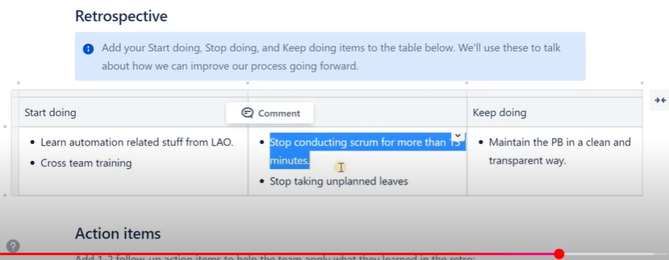
Need to include action idem for above points
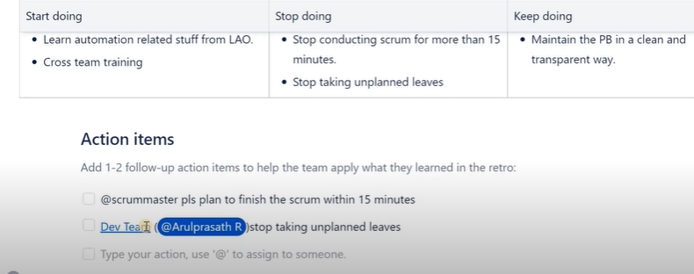

JIRA | Kanban | Introduction | 12 | Absolute beginner guide | Tamil

Kanban is one of the widely used frameworks of Agile next to Scrum. Unlike Scrum, Kanban doesn't have any time boxed events or the ceremonies.
Kanban is just a visualization of work and it's core philosophy is limiting the work in progress. In this video, I have tried to explain Kanban in a simple way with several examples.
Scrum -> 2 weeks time box
Kanban ->no time box
Agile framework
1.Scrum
2.Kanban
Other framework also there, mostly scrum n kanban used
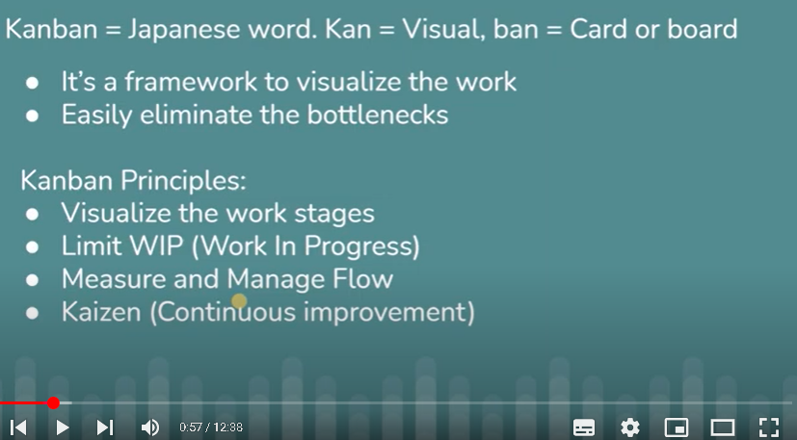

Kanban board ->Visualize of work in board
In below board , we can set the target/WIP limit in each section (To do, To today, Inprogress)
Eg in Progress section , the target is 3 only, if we add more than 3 then it will show warning ..so only limit the WIP
Completed fully as per target as per day..
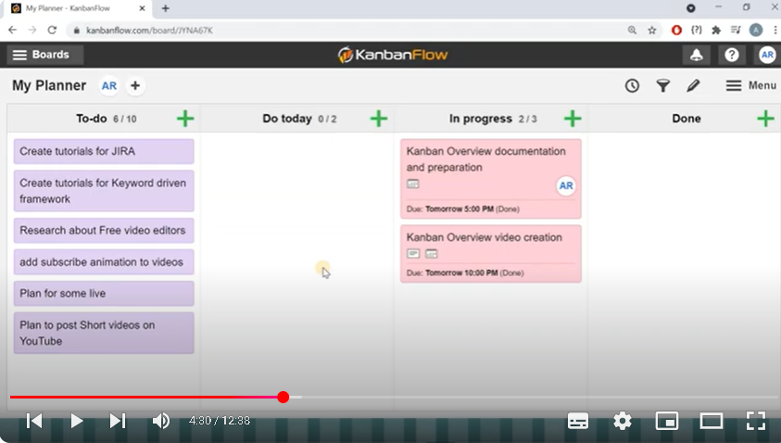
How to set the target/WIP limit
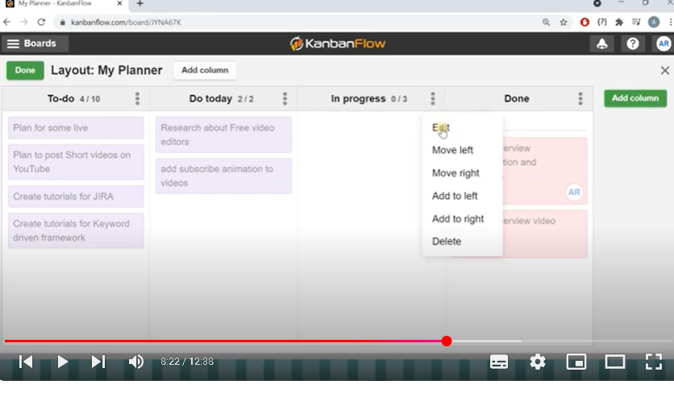
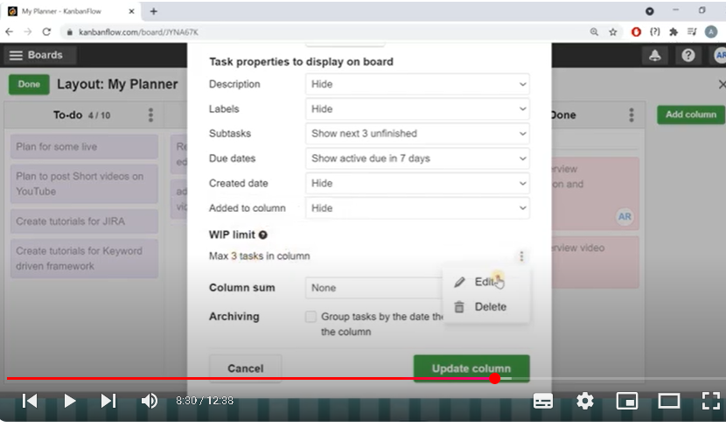

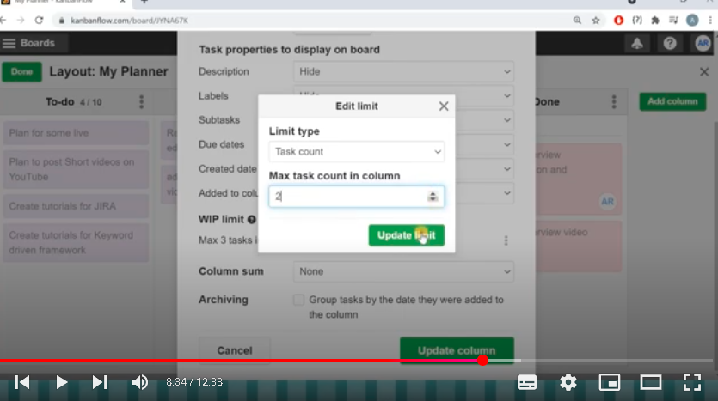

JIRA | Kanban | Important Terminologies | 13 | Lead vs Cycle Time | WIP | Pull System | Tamil

In this video, I have explained the important terminologies with respect to Kanban. Unlike Scrum, we don't have much to discuss in Kanban.
Pull system
Work In Progress
Lead Time
Cycle Time are the terminologies discussed in this video with examples.
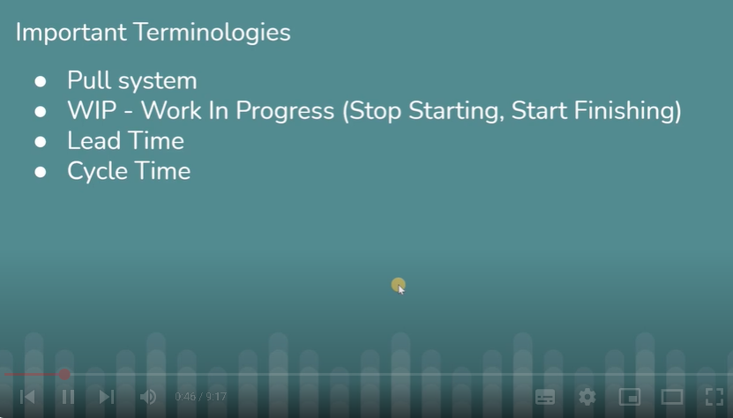
Pull system -> all task will be available in one place (here To do)
User need to pull the task from the to do list & start working..that why pull system

WIP (stop starting, start finishing)
stop starting -> more task will be available in TO Do list, so stop starting all task simultaneously
start finishing -> start finishing one task and take the next one in pipeline
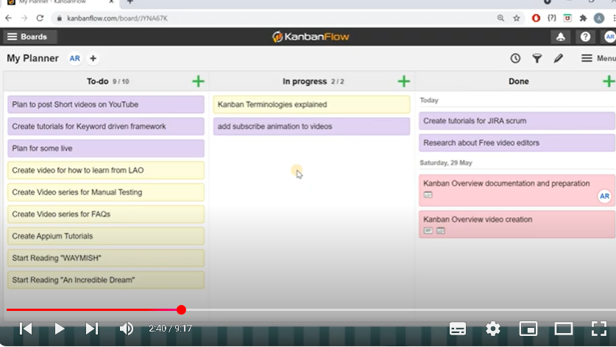

Lead time vs cycle time
Team performance will be calculated based on cycle time to actual time to complete the work
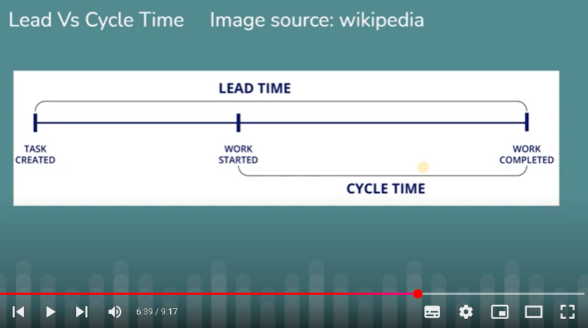

JIRA | Kanban Board with Jira and Microsoft DevOps | 14 | Tamil

In this video, we will learn how to create Kanban projects in Jira, also we will be looking at a sample Kanban board from Microsoft Azure. Personally I feel like Azure's Kanban board is aligning more with the Kanban principles.

Create a kanban board in jira
Create ->Project ->Kanban
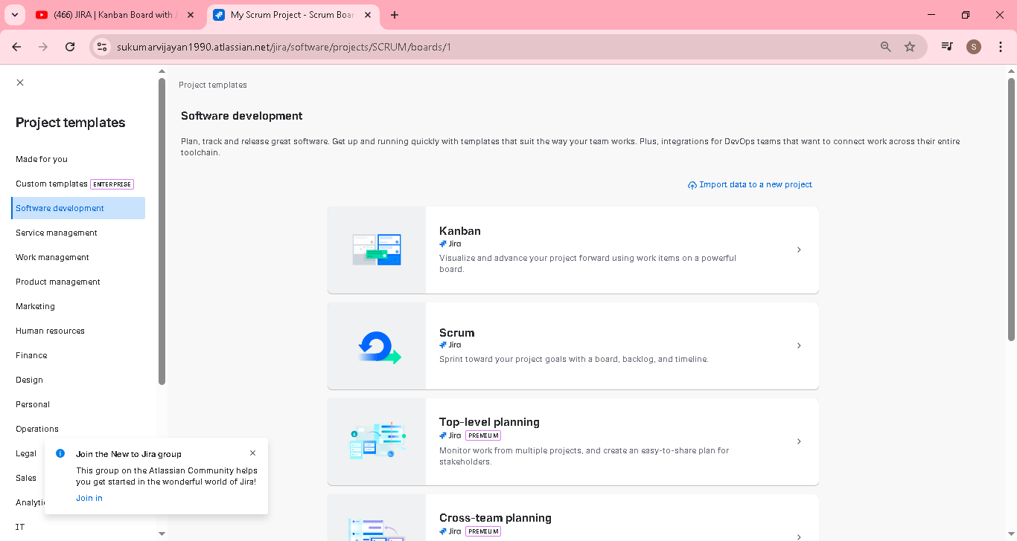

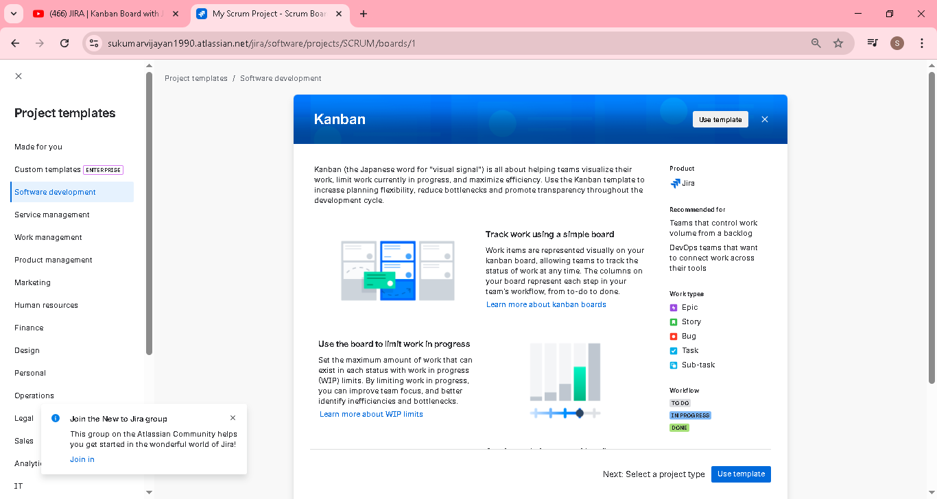
Go with company
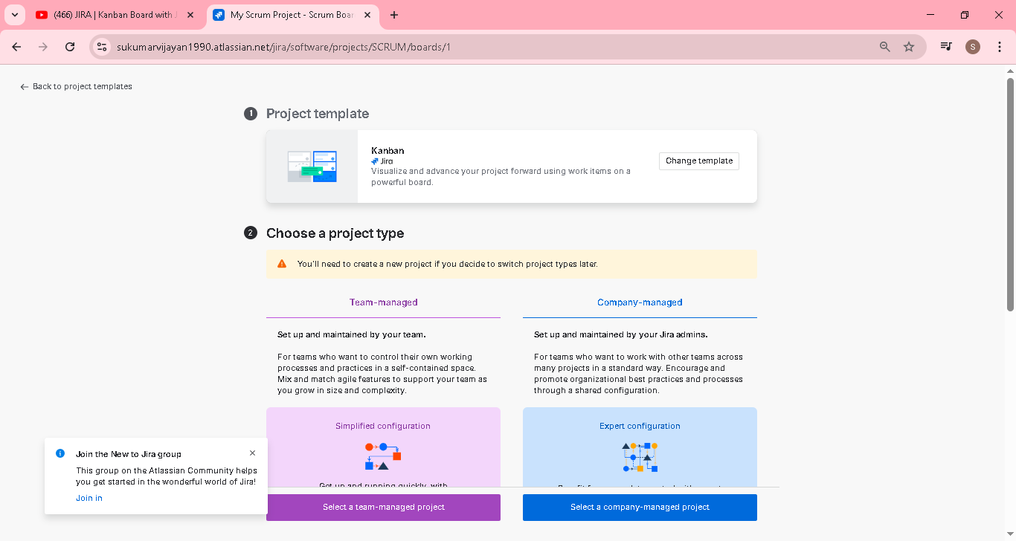
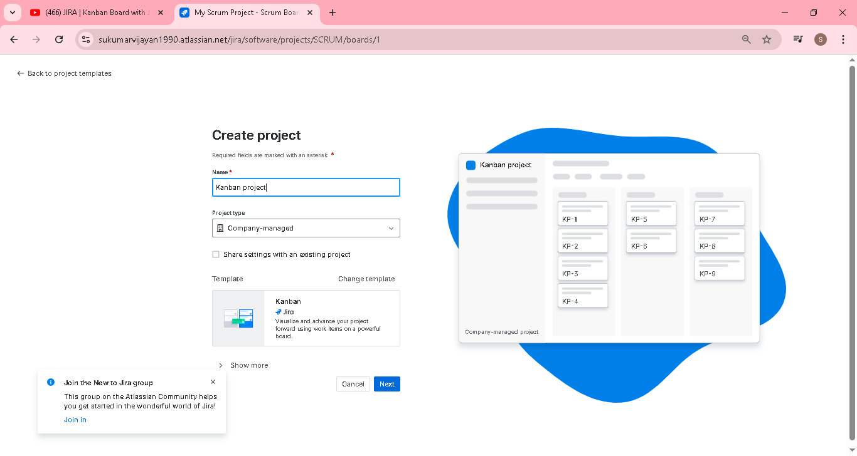

Below is a kanbon board in jira
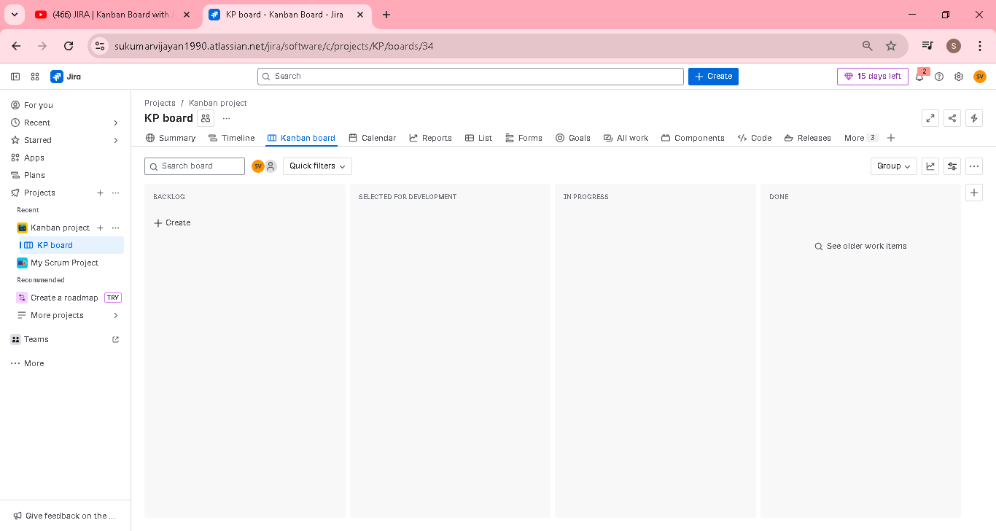

Create a task and keep in backlog
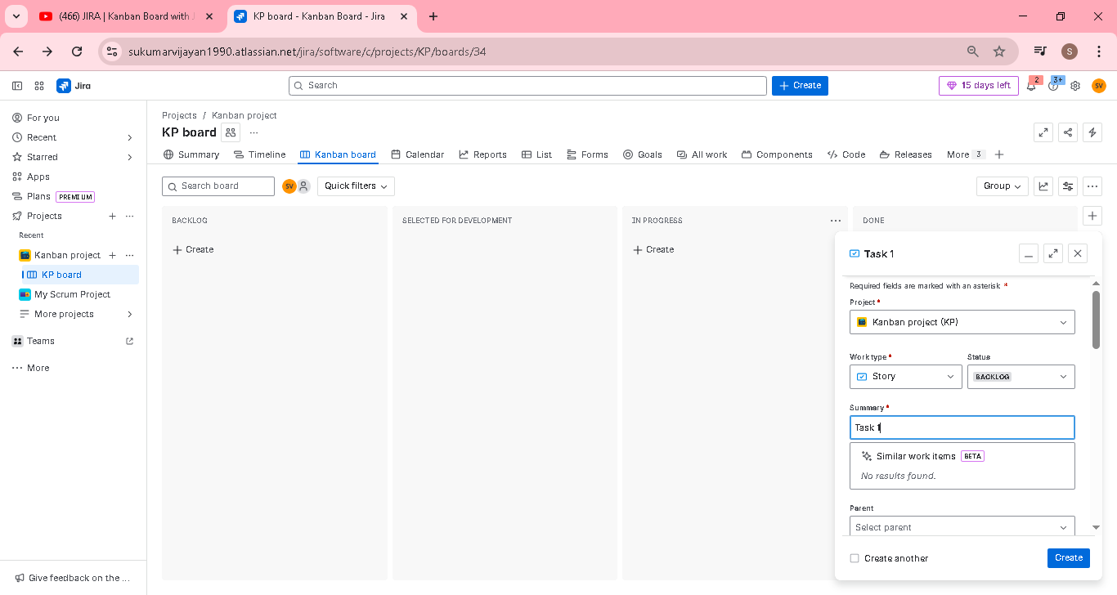

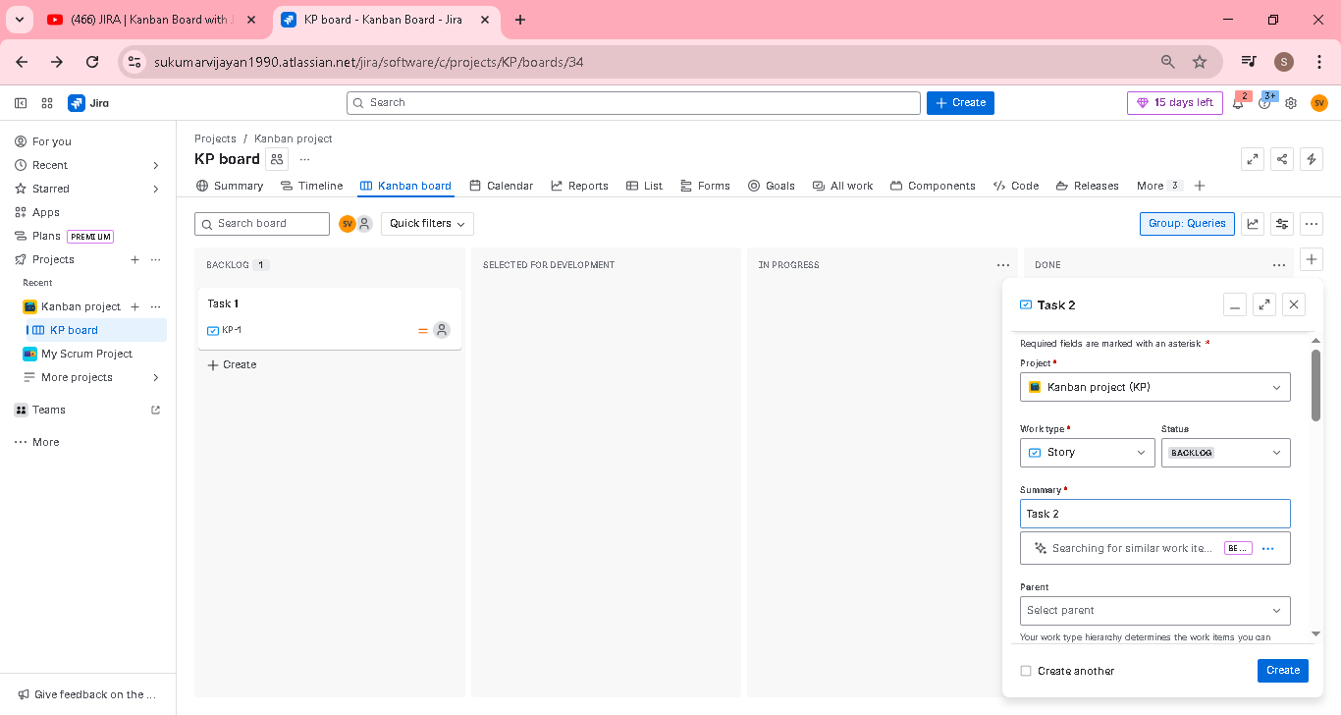

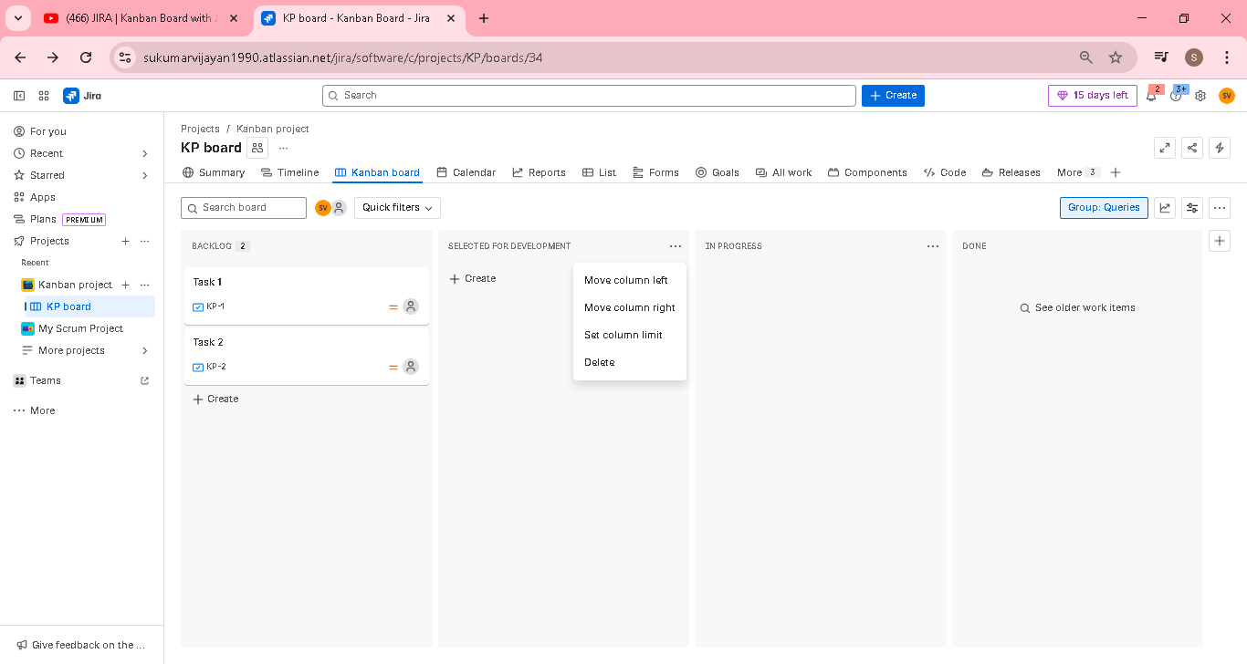
We can set the WIP limit as below
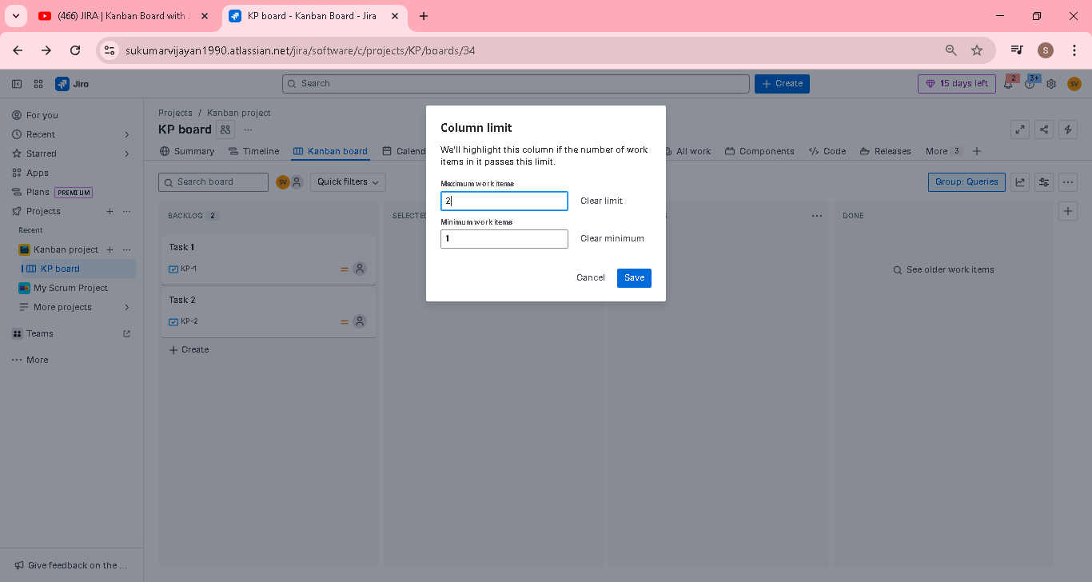
Column highlighted when exceed the limit
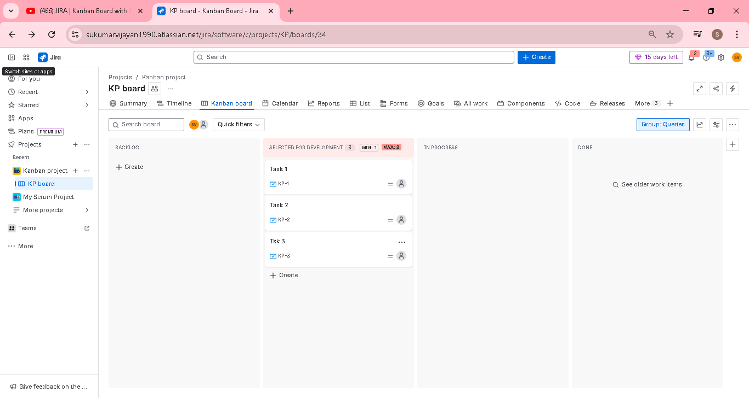

Highlight removed
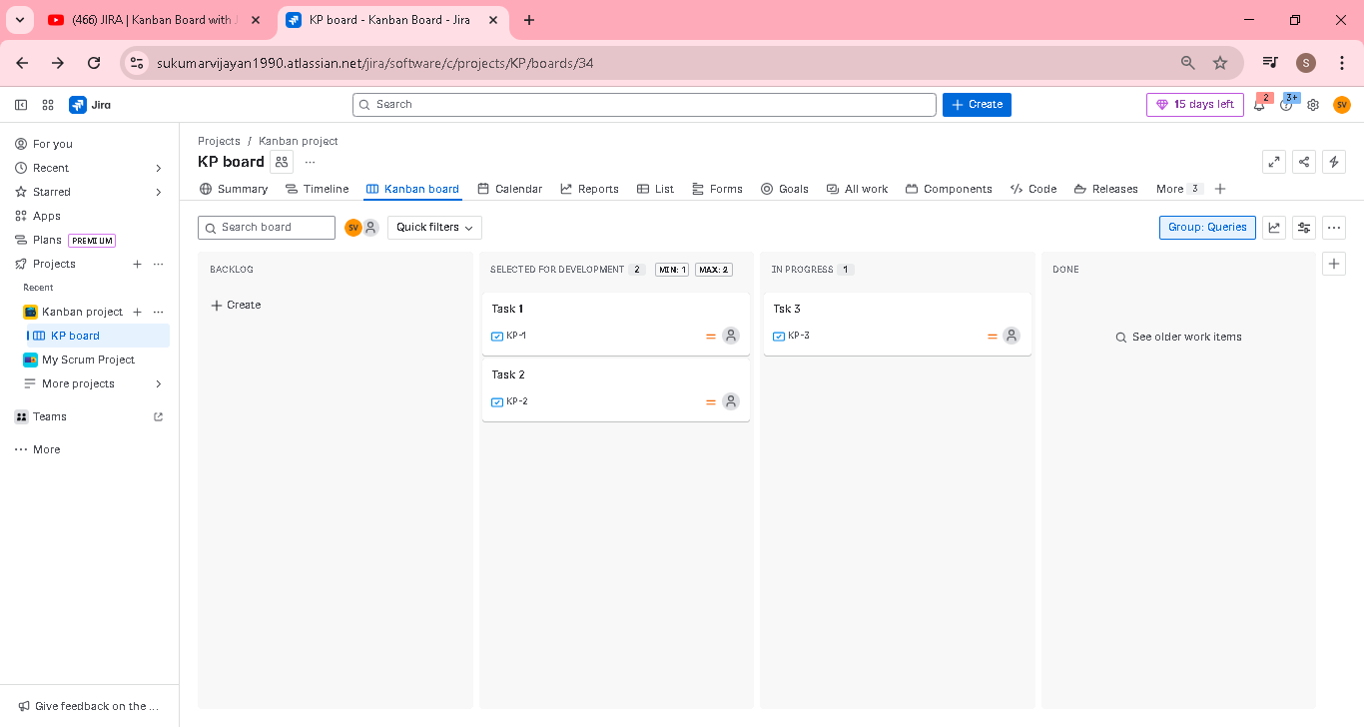

We can add new column if needed and delete available column based on the need
Scrumban ->take the key feature in kanban and scrum framework and start working

Eg using Kanban visualize board with scrum daily standup, sprint review, sprint retrospective.

