JobSheet - UTS

Nama: Sulthan Faazaa Akbar Riyandoro
NIM: 251524088
Kelas / Semester: 1C-D4 / Dua
Mata Kuliah: Teknik Pemrograman Praktek

Jawablah pertanyaan berdasarkan diagram kelas dibawah ini

Yang merupakan multiple inheritance melalui single inheritance dan interface implementation adalah kelas interface Koperasi yang mewariskan kelas Employee diwariskan kembali kepada kelas FullTime. Penerapan interface yang dimaksud adalah pewarisan kelas Koperasi kepada kelas FullTime.
// Koperasi.java:
1. abstract class Koperasi{
2. public double loan;
3. public abstract double loanMonthly();
4. }
5.
6.

// FullTime.java
1. public class FullTime extends Koperasi{
2. public FullTime(){
3. this.salary = 0;
4. }
5.
6. public double getSalary(double salary){
7. return salary + getTunjanganLembur() + getTunjanganJabatan() + getTunjanganAnak() + getTunjanganKomunikasi() + getBonusProduktivitas() - loanMonthly();
8. }
9.
10. public double loanMonthly(){
11. return loan;
12. }
13. }

// Employee.java
1. public class Employee extends Department {
2. private String namaPekerja;
3. private int idDepartment;
4. private int projekSelesai;
5. private int lamaBekerjaBulan;
6. private int jumlahAnak;
7. private String statusHari;
8. private int totalJam;
9. private double gajiPokok;
10.
11. public Employee(String namaPekerja, int idDepartment, int projekSelesai, int lamaBekerjaBulan, int jumlahAnak, String statusHari, int totalJam){
12. super(idDepartment);
13.
14. setNamaPekerja(namaPekerja)
15. }
16.
17. public String getNamaPekerja(){
18. return this.namaPekerja;
19. }
20.
21. public void setNamaPekerja(String namaPekerja){
22. this.namaPekerja = namaPekerja;
23. }
24.
25. public double getGajiPokok(){
26. return this.gajiPokok;
27. }
28.
29. public double getTunjanganKomunikasi(){
30. return 500000;
31. }
32.
33. public double getTunjanganLembur(String statusHari, int totalJam){
34. double value = 50000;
35.
36. if(statusHari == "Weekday"){
37. value = 30000;
38. }
39.
40. return totalJam * value;
41. }
42.
43. public double getTunjanganAnak(int totalAnak){
44. if(totalAnak > 3){
45. totalAnak = 3;
46. }
47.
48. return totalAnak * 500000;
49. }
50.
51. public double getBonusProduktivitas(int totalJam, double gajiPokok){
52. return totalJam > 200 ? (gajiPokok * 10) / 100 : 0;
53. }
54.
55. public double getBonusProyek(int projekSelesai){
56. return projekSelesai * 200000;
57. }
58. }

- Bagian kelas department [+departmentName()] yang terhubung ke Employee[+getSalary()]. Ini diartikan bahwa Employee memiliki sebuah department, yaitu suatu hubungan has-a.
1. public class Department{
2. private int id;
3. private String name;
4. private Double salary;
5.
6. public Department(int id){
7. if(id == 0){
8. setDepartmentName("Staf Manager");
9. setDepartmentSalary(5000000);
10. }
11. else if(id == 1){
12. setDepartmentName("Staf Programmer");
13. setDepartmentSalary(3000000);
14. }
15. else if(id == 2){
16. setDepartmentName("Staf Analisis");
17. setDepartmentSalary(3000000);
18. }
19.
20. setDepartmentId(id);
21. }
22.
23. public int getDepartmentId(){
24. return this.id;
25. }
26.
27. public void setDepartmentId(int id){
28. this.id = id;
29. }
30.
31. public String getDepartmentName(){
32. return this.name;
33. }
34.
35. public void setDepartmentName(String name){
36. this.name = name;
37. }
38.
39. public Double getDepartmentSalary(){
40. return this.salary;
41. }
42.
43. public void setDepartmentSalary(double salary){
44. this.salary = salary;
45. }
46. }

// Employee.java
1. public class Employee extends Department {
2. private String namaPekerja;
3. private int idDepartment;
4. private int projekSelesai;
5. private int lamaBekerjaBulan;
6. private int jumlahAnak;
7. private String statusHari;
8. private int totalJam;
9. private double gajiPokok;
10.
11. public Employee(String namaPekerja, int idDepartment, int projekSelesai, int lamaBekerjaBulan, int jumlahAnak, String statusHari, int totalJam){
12. super(idDepartment);
13.
14. setNamaPekerja(namaPekerja)
15. }
16.
17. public String getNamaPekerja(){
18. return this.namaPekerja;
19. }
20.
21. public void setNamaPekerja(String namaPekerja){
22. this.namaPekerja = namaPekerja;
23. }
24.
25. public double getGajiPokok(){
26. return this.gajiPokok;
27. }
28.
29. public double getTunjanganKomunikasi(){
30. return 500000;
31. }
32.
33. public double getTunjanganLembur(String statusHari, int totalJam){
34. double value = 50000;
35.
36. if(statusHari == "Weekday"){
37. value = 30000;
38. }
39.
40. return totalJam * value;
41. }
42.
43. public double getTunjanganAnak(int totalAnak){
44. if(totalAnak > 3){
45. totalAnak = 3;
46. }
47.
48. return totalAnak * 500000;
49. }
50.
51. public double getBonusProduktivitas(int totalJam, double gajiPokok){
52. return totalJam > 200 ? (gajiPokok * 10) / 100 : 0;
53. }
54.
55. public double getBonusProyek(int projekSelesai){
56. return projekSelesai * 200000;
57. }
58. }
59.
60.

Buatlah program java dari diagram kelas di atas
// App.java
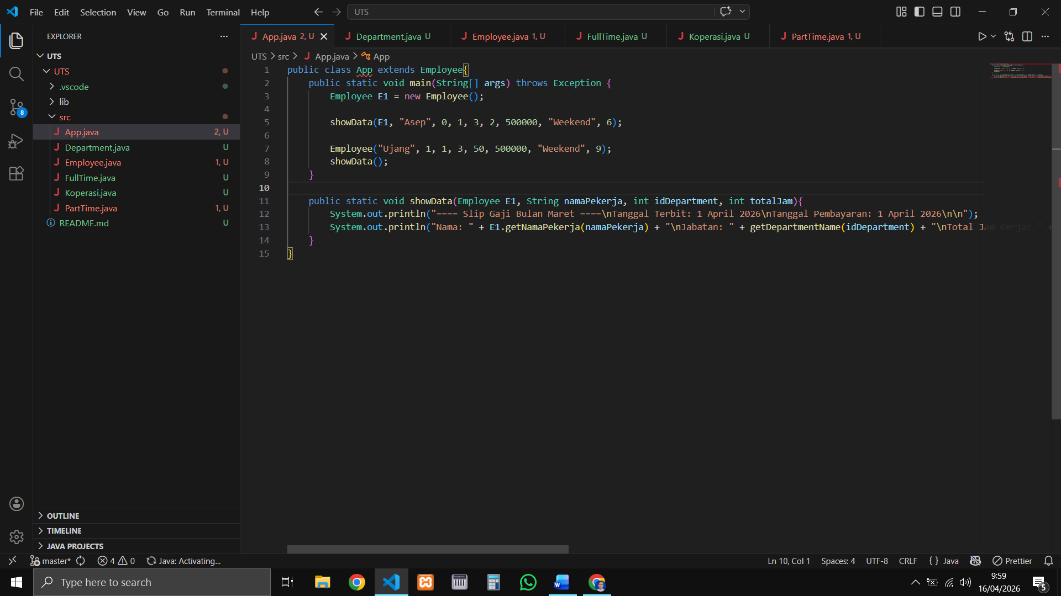

// Department.java
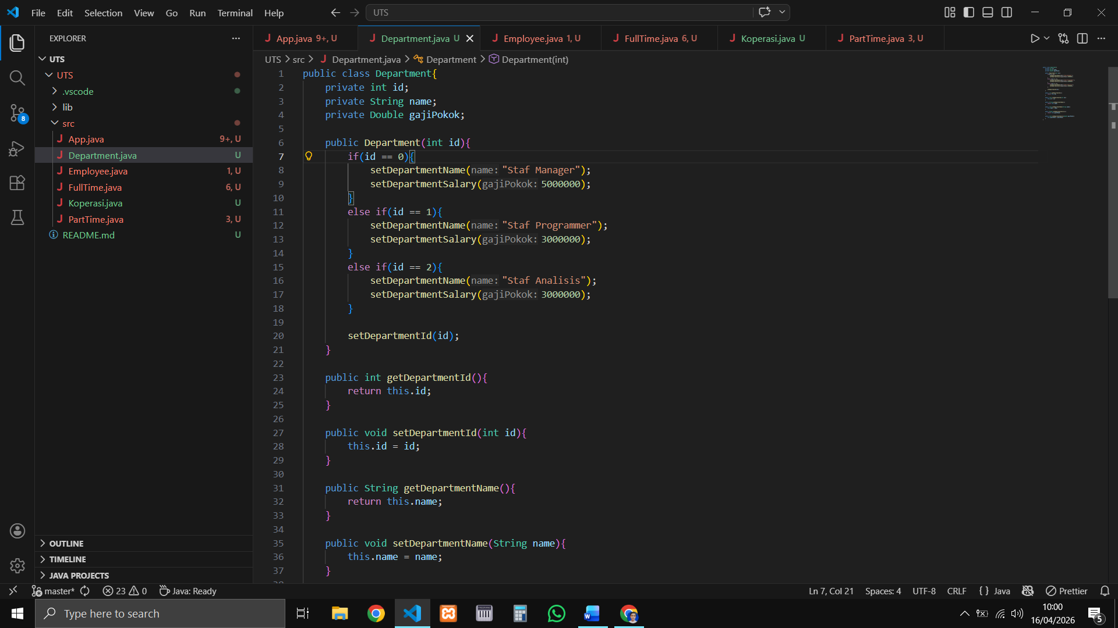
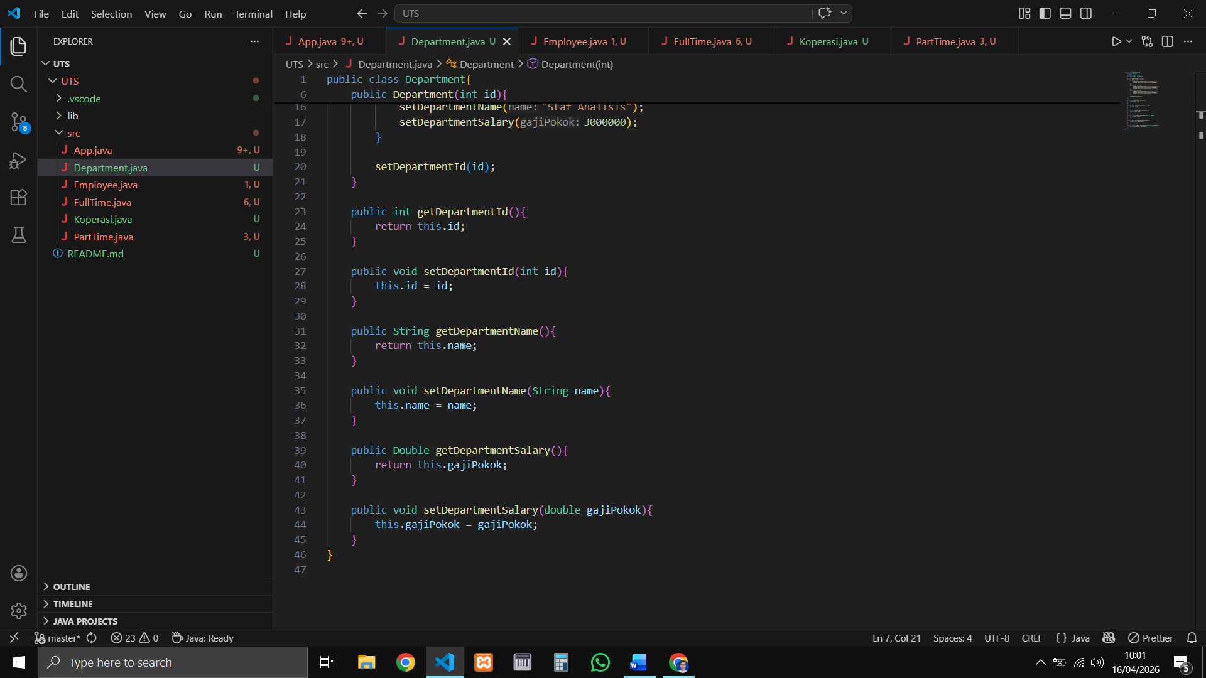

// Employee.java
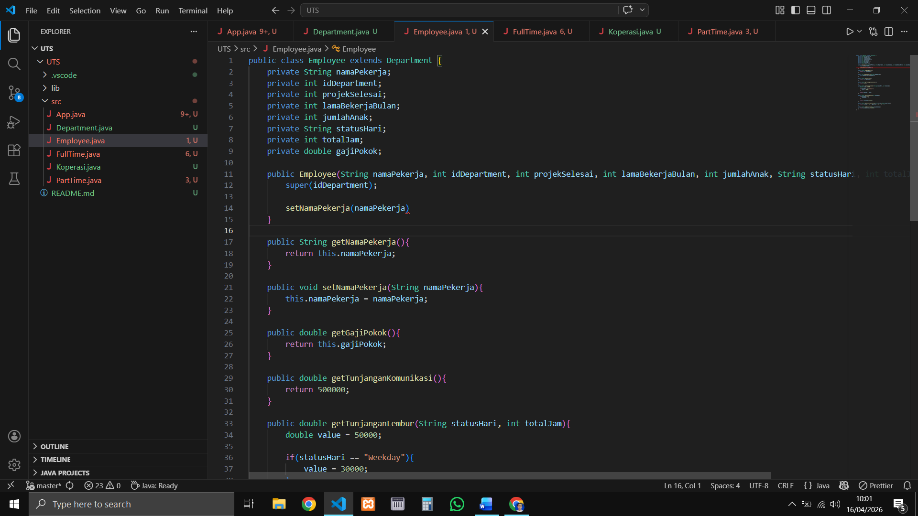
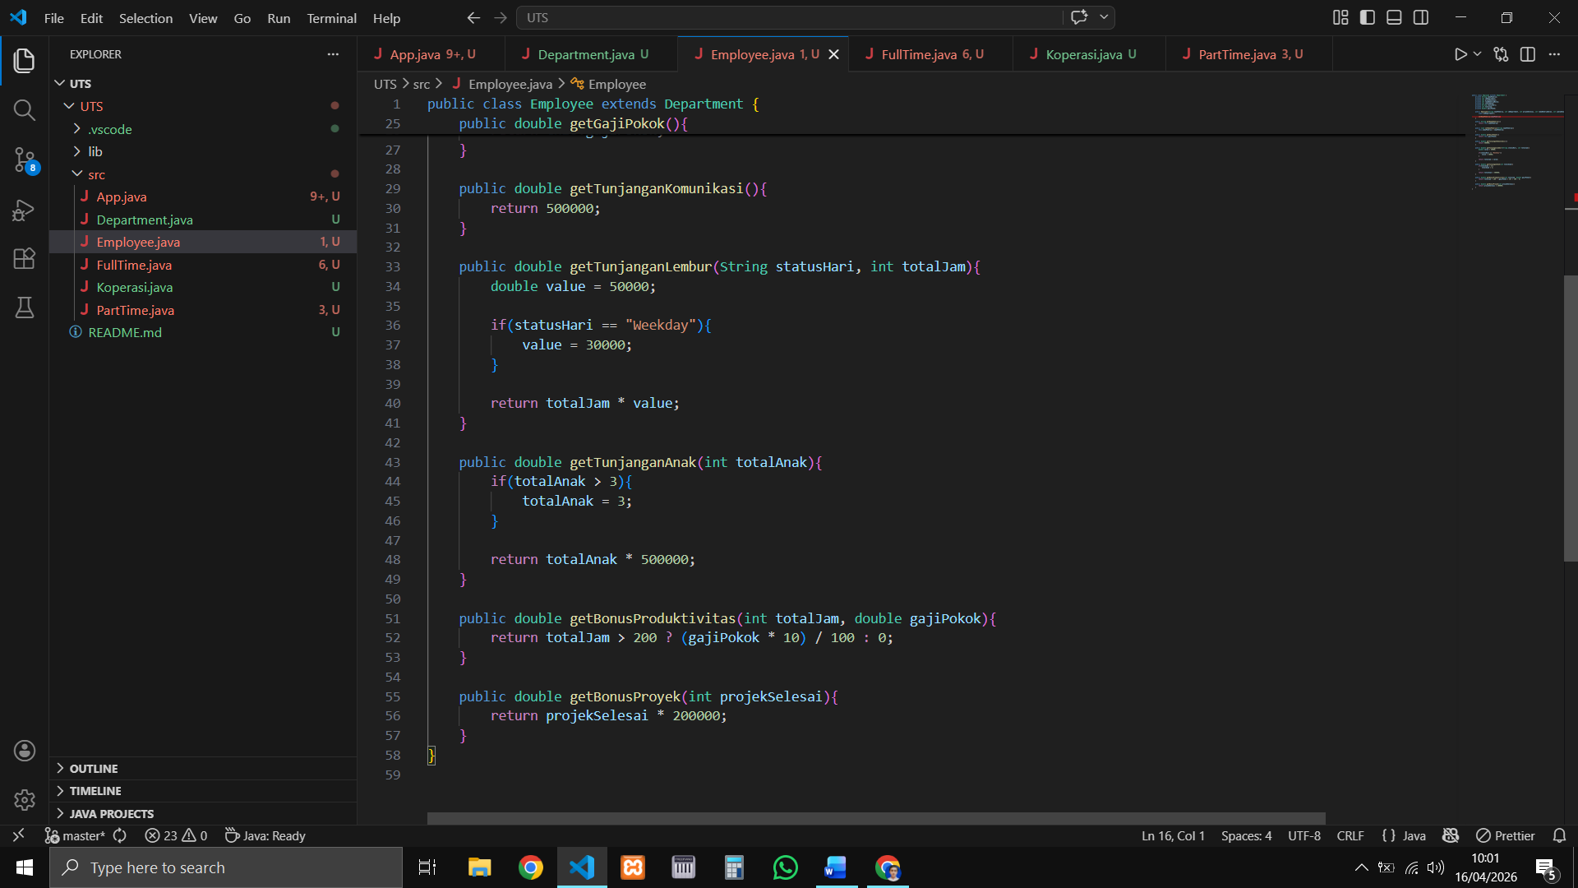

// FullTime.java
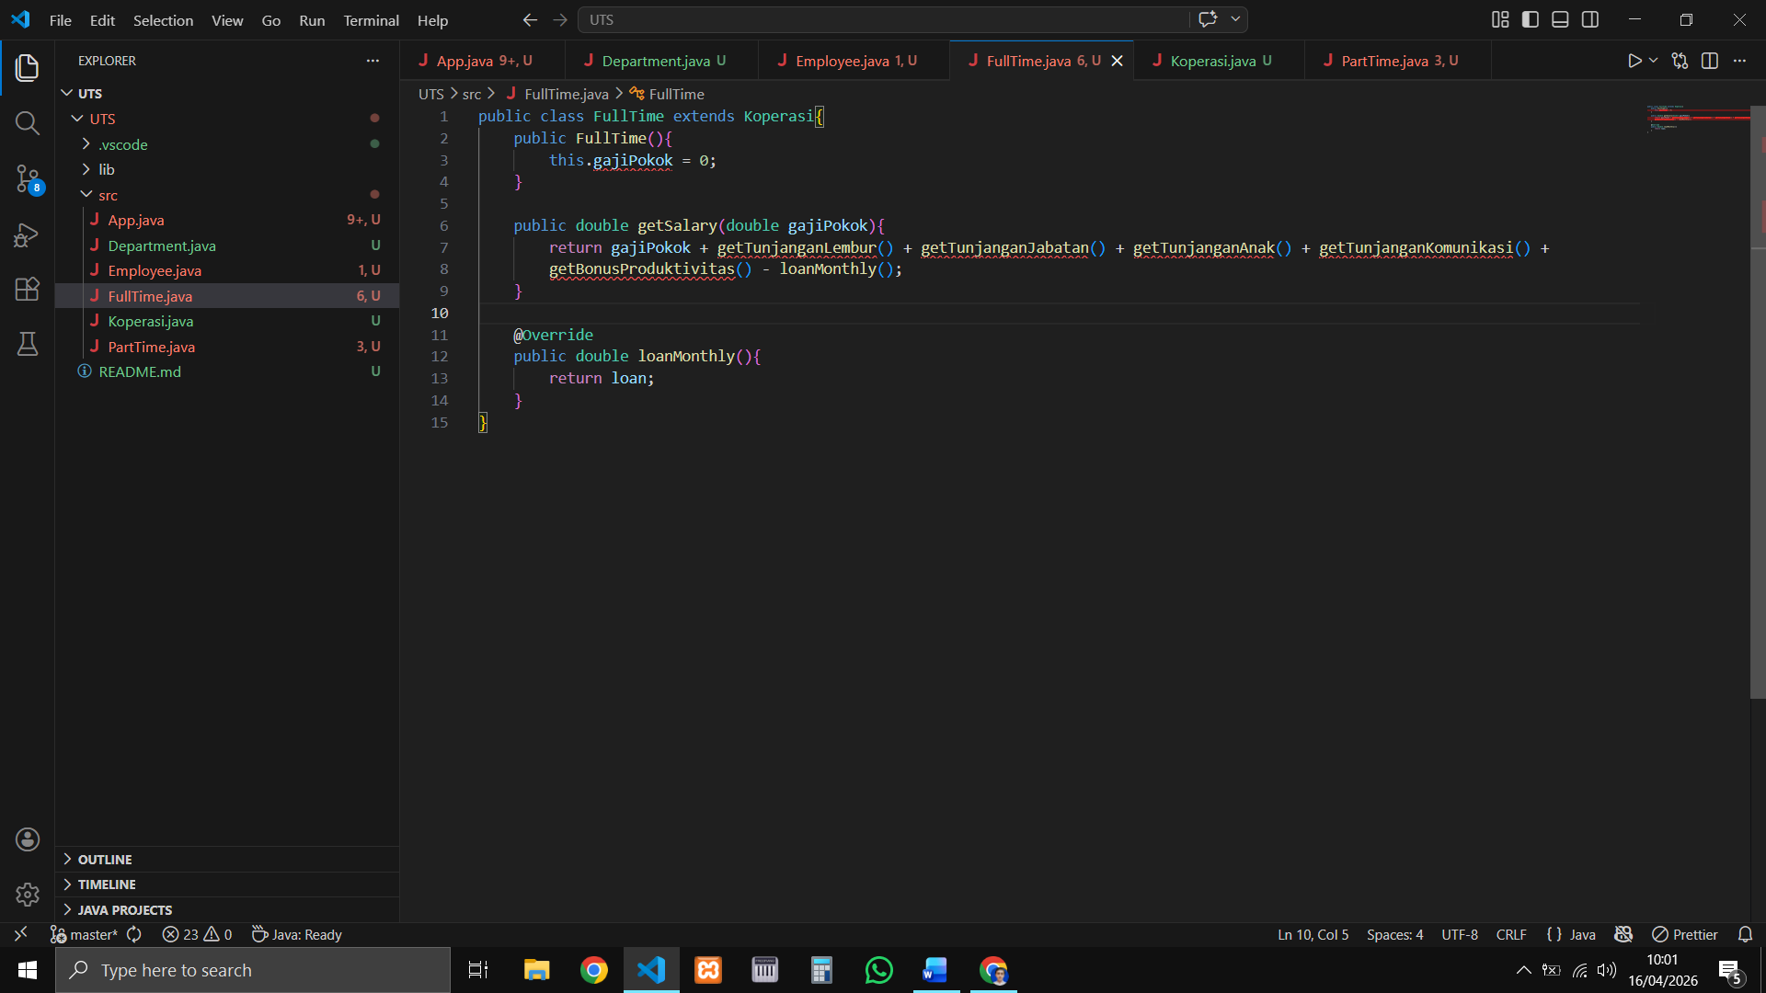

// Koperasi.java
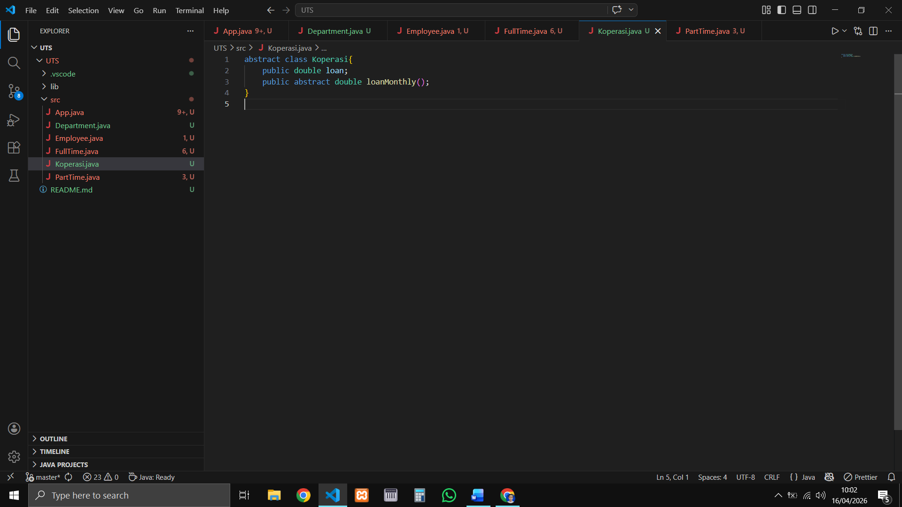

// PartTime.java
