PERCENTAGES
- A batsman scored 110 runs which included 3 boundaries and 8 sixes. What percent of his total score did he make by running between the wickets?
45%
45 | 5 | %
 | 11
54 | 6 | %
 | 11
55%

- Two students appeared at an examination. One of them secured 9 marks more than the other and his marks was 56% of the sum of their marks. The marks obtained by them are
39, 30
41, 32
42, 33
43, 34
- A fruit seller had some apples. He sells 40% apples and still has 420 apples. Originally, he had:
588 apples
600 apples
672 apples
700 apples

- What percentage of numbers from 1 to 70 have 1 or 9 in the unit's digit?
1
14
20
21

- If A = x% of y and B = y% of x, then which of the following is true?
A is smaller than B.
A is greater than B
Relationship between A and B cannot be determined.
If x is smaller than y, then A is greater than B.
None of these
- If 20% of a = b, then b% of 20 is the same as:
4% of a
5% of a
20% of a
None of these
.
- In a certain school, 20% of students are below 8 years of age. The number of students above 8 years of age is of the number of students of 8 years of age which is 48. What is the total number of students in the school?
72
80
120
150
100
.
- Two numbers A and B are such that the sum of 5% of A and 4% of B is two-third of the sum of 6% of A and 8% of B. Find the ratio of A : B.
2 : 3
1 : 1
3 : 4
4 : 3
- A student calculated a number with 3/5 instead of 5/3
.What is the percentage error in the calculation?
34%
44%
54%
64%
- In an election between two candidates, one got 55% of the total valid votes, 20% of the votes were invalid. If the total number of votes was 7500, the number of valid votes that the other candidate got, was:
2700
2900
3000
3100
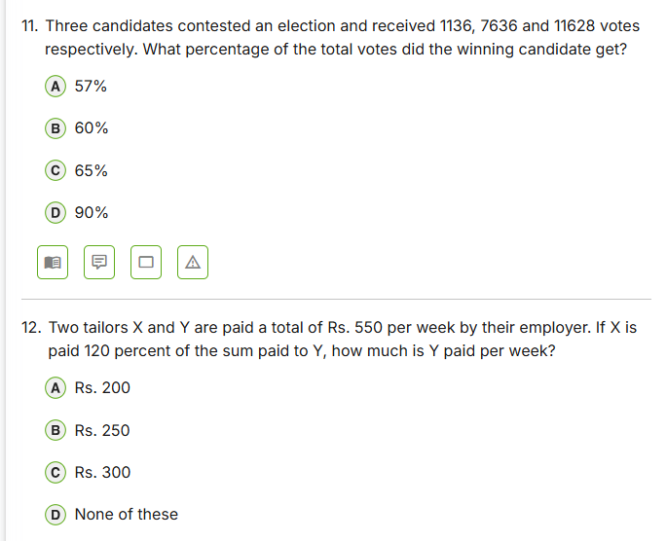
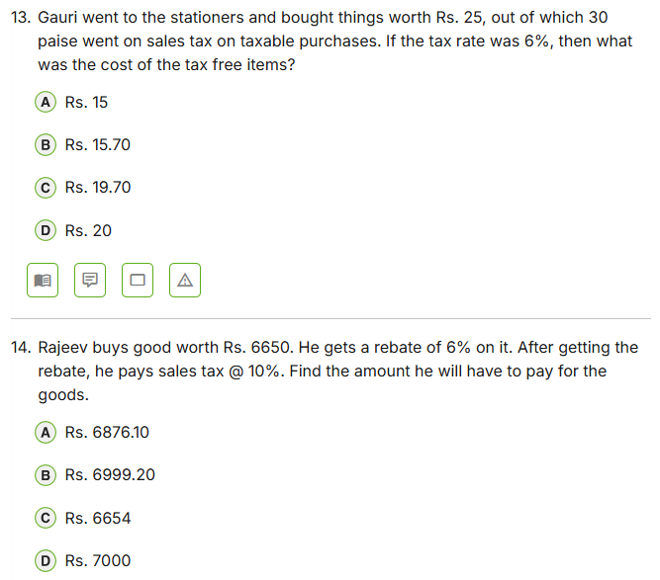
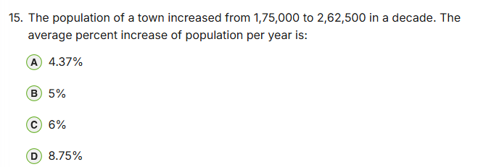
16 : A defect-finding machine rejects 0.085% of all cricket bats. Find the number of bats manufactured on a particular day if it is given that on that day, the machine rejected only 34 bats.
Solution:
Let the total number of bats on that day be
17 : 25 % of a number is 8 less than one-third of that number. Find the number.
Solution:
Lus, 96 is the required number.
18: Difference of two numbers 'x' and 'y' (x > y) is 100. Also, 10 % of 'x' is equal to 15 % of 'y'. Find the numbers.
Solution :
We are given that x - y = 1numbers are 300 and 200.
19: In a gaming event, 75 % of the registered participants actually turned up. Out of those, 2 % were declared unfit for participation. The winner defeated 9261 participants which are 75 % of the total valid participation. Find the number of registered participants.
Solution:
Let the number of registered participants be n.
20: In a test, a geek could answer 70 % C++ questions, 40 % C questions and 60 % Java questions correctly. The test had a total of 75 questions, 10 from C++, 30 from C and 35 from Java. A minimum of 60 % in aggregate was required to be considered for interview. The geek could not clear the test and was not shortlisted for interview. Find by how much marks did the geek miss the interview call, given that each question was of 1 mark and there was no negative marking for incorrect answers.
Solution:
We are given that the geek could answer 70 % C++ questions, 40 % C
21: A geek gave 40% of his retirement money to his wife. He also gave 20 % of the remaining amount to each of his 3 sons. 50 % of the amount now left was spent on miscellaneous items and the remaining amount of Rs. 1,20,000 was deposited in the bank. How much money did the geek get as retirement money?
Solution:
22: A broker charges a commission of 5% on all orders up to Rs.10,000 and 4% on all orders exceeding Rs. 10,000. He remits Rs. 31,100 to his client after deducting his commission. Find the order amount.
Solution:
32,500
23: A seller marked up the price of an article by 20 % and then gave a discount of 20 %. Find what percent did he lose in the transaction.
Solution:

24: The price of a commodity(A Product Price) increased by 25 %. By what percent should the consumption be reduced so as to keep the expenditure same?
Solution:
We know that if price of increases by P %, the necessary reduction in
25: If the numerator of a fraction is decreased by 15% and its denominator is diminished by 10%, the value of the fraction is 2 / 9. Find the original fraction.
Solution:
Let the fraction be N / D, where N is the numerator and D is the denomina
26: The population of a town is 1,60,000 in the current year. If it increases at the rate of 5% per annum, what will be the population 3 years from now?
Solution:
We know that if the population is currently P and it increases by R % every
27: The value of a car is Rs 1,60,000 in the current year. If it depreciates at the rate of 5% per annum, what will be the value of the car 3 years from now?
Solution:
We know that if the value is currently P and it depreciates by R % every year,
28: How much sugar (in KG) must be added to 50 KG of a 2 % sugar solution so as to make the concentration 10 % ?
Solution:
Sugar in initial solution = 2 % of 50 KG = 1 KG
29: In an examination, 80% of the students passed in English, 85% in Mathematics, and 75% in both English and Mathematics. If 40 students failed in both subjects, find the total number of students who appeared in the examination.
Solution:

