22RP07955 28/01/2024

DATABE ADMINISTRATION WORK

Sulaiman BYIRINGIRO

1. DESCRIBE ORACLE MEMORY STRUCTURES AND BACKGROUND PROCESSES.

Introduction to Oracle Database Memory Structures

When an instance is started, Oracle Database allocates a memory area and starts background processes.

The memory area stores information such as the following:

* Program code
* Information about each connected [session](https://docs.oracle.com/en/database/oracle/oracle-database/21/cncpt/glossary.html#GUID-0F44C072-9841-4E2E-B846-FB16A2E54139), even if it is not currently active
* Information needed during program execution, for example, the current state of a [query](https://docs.oracle.com/en/database/oracle/oracle-database/21/cncpt/glossary.html#GUID-CCF91C9F-A98A-498F-A84B-58A0FA16CD6E) from which rows are being fetched
* Information such as [lock](https://docs.oracle.com/en/database/oracle/oracle-database/21/cncpt/glossary.html#GUID-6D016291-A487-4F88-BE0B-ACF8FA2AE72C) data that is shared and communicated among processes
* Cached data, such as data blocks and redo records, that also exists on disk

"[Process Architecture](https://docs.oracle.com/en/database/oracle/oracle-database/21/cncpt/process-architecture.html#GUID-85D9852E-5BF1-4AC0-9E5A-49F0570DBD7A)"

Basic Memory Structures

Oracle Database includes several memory areas, each of which contains multiple subcomponents.

The basic memory structures associated with Oracle Database include:

* System global area (SGA)

The SGA is a group of shared memory structures, known as *SGA components*, that contain data and control information for one Oracle Database instance. All server and background processes share the SGA. Examples of data stored in the SGA include cached data blocks and shared SQL areas.

* Program global area (PGA)

A PGA is a nonshared memory region that contains data and control information exclusively for use by an Oracle process. Oracle Database creates the PGA when an Oracle process starts.

One PGA exists for each [server process](https://docs.oracle.com/en/database/oracle/oracle-database/21/cncpt/glossary.html#GUID-E660AC1C-B704-4DC1-A35A-DB49EFB34F4A) and background process. The collection of individual PGAs is the total instance PGA, or [instance PGA](https://docs.oracle.com/en/database/oracle/oracle-database/21/cncpt/glossary.html#GUID-8341392A-07AD-45A0-8E71-E330584EEE74). Database initialization parameters set the size of the instance PGA, not individual PGAs.

* User global area (UGA)

The UGA is memory associated with a user session.

* Software code areas

Software code areas are portions of memory used to store code that is being run or can be run. Oracle Database code is stored in a software area that is typically at a different location from user programs—a more exclusive or protected location.

The following figure illustrates the relationships among these memory structures.

Oracle Database Memory Structures

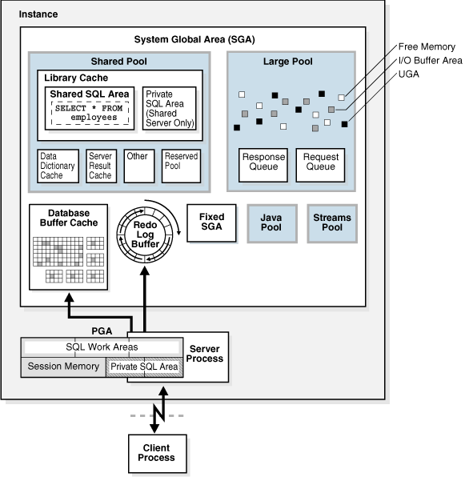

Oracle Database Memory Management

Memory management involves maintaining optimal sizes for the Oracle instance memory structures as demands on the database change. Oracle Database manages memory based on the settings of memory-related initialization parameters.

The basic options for memory management are as follows:

* Automatic memory management

You specify the target size for the database instance memory. The instance automatically tunes to the target memory size, redistributing memory as needed between the SGA and the instance PGA.

* Automatic shared memory management

This management mode is partially automated. You set a target size for the SGA and then have the option of setting an aggregate target size for the PGA or managing PGA work areas individually.

* Manual memory management

Instead of setting the total memory size, you set many initialization parameters to manage components of the SGA and instance PGA individually.

If you create a database with Database Configuration Assistant (DBCA) and choose the basic installation option, then automatic memory management is the default.

the definition of a background process?

In computing terms, we define a background process as any process that doesn't interact with the user. As in the breathing example, background processes run independently from other tasks and do not require us to do anything. They just happen on their own

## What is a background process used for?

Background processes have a multitude of uses. They handle tasks such as memory management, system updates, virus scans, and running software applications that do not require direct user interaction. By running these tasks in the background, the computer system ensures that the user experience remains uninterrupted and seamless.

## How do background processes work?

The functioning of background processes is quite fascinating. The operating system schedules these processes based on priority and available resources. Once initiated, these processes run independently, using system resources but not interfering with the user’s work. They communicate with other processes and the operating system to ensure everything runs smoothly.

## Different types of background processes

### Daemon processes

Daemon processes are a type of background process that start when the system boots up and run continuously without any intervention until the system shuts down. They handle tasks like network connections, printing services, and email delivery.

### Scheduled processes

Scheduled processes perform specific tasks at predetermined times. They can be set up to run daily, weekly, or at any other interval. Examples include [automatic patching](https://www.ninjaone.com/blog/automated-patch-management-is-critical-for-modern-it-operations/), updates, and backups.

### Service processes

Service processes are those that provide services to other software. They run in the background and are usually started and stopped by the operating system as needed. For example, a database service process might run in the background to manage access to a database.

### System processes

System processes are responsible for managing and controlling hardware and system resources. They are vital for the functioning of the operating system.

## The background process: A critical part of any IT system

Background processes are a crucial part of any computer system. While they may remain unseen, their role in ensuring smooth and efficient computer operations cannot be understated. As technology continues to advance, the role of these background processes will only become more integral in maintaining the seamless user experience we have come to expect.

1. DEXCRIBE ORACLE LOGICAL AND PHYSICAL STORAGE STRUCTURE?

Physical structures are those that can be seen and operated on from the operating system, such as the physical files that store data on disk. Logical structures are created and recognized by the Oracle database server and are not known to the operating system.

**Logical Database structures**  
Logical structures include tablespaces, schema objects, data blocks, extents and segments.  
  
**Tablespaces**  
Database is logically divided into one or more tablespaces. Each tablespace creates one or more datafiles to physically store data.  
  
**Schema objects**  
Schema objects are the structure that represents database's data. Schema objects include structures such as tables, views, sequences, stored procedures, indexes, synonyms, clusters and database links.  
  
**Data Blocks**  
Data block represents specific number of bytes of physical database space on disk.  
  
**Extents**  
An extent represents continuous data blocks that are used to store specific data information.  
  
**Segments**  
A segment is a set of extents allocated for a certain logical structure.  
  
**Physical database structure**  
The physical database structure comprises of datafiles, redo log files and control files  
  
**Datafiles**  
Datafiles contain database's data. The data of logical data structures such as tables and indexes is stored in datafiles of the database. One or more datafiles form a logical unit of database storage called a tablespace.  
  
**Redo log files**  
The purpose of these files is to record all changes made to data. These files protect database against failures.  
  
**Control files**  
Control files contain entries such as database name, name and location of datafiles and redo log files and time stamp of database creation

**Archived Redo Logs:**

Archived redo logs are copies of redo log files that have been archived to secondary storage. They are used for database recovery and backup purposes.