LAB 6

**Task 1**

Use **do-while** loop to print “**Welcome to City University”** 5 times?

**Task 2**

Use **do-while** loop to print first 10 integers with tab space?

**Task 3**

Modify task 2? Write program that takes an integer input from user & display number till that integer?

**Task 4**

Write a program using **do-while** loop that prints even number (from number 0-100)

**Task 5**

Write program that generate table of 2 using ***do-while*** loop?

**Task 6**

Write program that produce first 10 integers in descending order?

**Task 7**

Write a program that product following result

**+*+*+*+*+*+*+*+*+*+*+\***

**Task 8**

Write a program that produce following result

**\*\*\*\*\*\***

**\*\*\*\*\*\***

**\*\*\*\*\*\***

**\*\*\*\*\*\***

***Hint: Use nested do-while loop to complete structure?***

**Task 9**

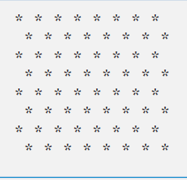Write a program that product following result

***********

***********

***********

***********

***********

***********

***Hint: Use nested do-while loop to complete structure?***

**Task 10**

Write a program for ***guess character game***and give user 5 chances to guess a character?

**Task 11**

Modify task 10 for ***guess character game***and give user 5 chances to guess a character but while loop should end when guess is write false youe while statement?

**Task 12**

Modify task 10 for ***guess character game***and program compare small and capitals characters both?

**Task 13**

Program that takes record from user until user is pressing ‘y’.