Contents

LAB 1 6

Step 1 6

Step 2: 7

Step 3: 8

LAB 2: Input/Output stream & Variables 9

Task 1 9

Task 2 9

Task 3 9

Task 4 9

Task 5 9

Task 6 9

Task 7 10

Task 8 10

Task 9 10

Task 10 10

Task 11 10

Task 12 11

LAB 3 (Decision Structure and Precedence) 12

Task 1 12

Task 2 12

Task 3 12

Task 4 12

Task 4 13

Task 5 13

Task 6 13

Task 7 13

Task 8 14

Task 9 14

Task 10 14

Task 11 14

Task 12 14

Task 13 15

Task 14 15

LAB 4 Repetitive structure(while) 16

Task 1 16

Task 2 16

Task 3 16

Task 4 16

Task 5 17

Task 5a 17

Task 6 17

Task 7 17

Task 8 17

Task 9 17

Task 10 17

Task 11 17

Task 12 17

Task 13 17

Task 14 18

Task 15 18

Task 16 18

19

Task 17 19

19

Task 17 19

LAB 5 Repetitive structure(for loop) 20

Task 1 20

Task 2 20

Task 3 20

Task 4 20

Task 5 21

Task 6 21

Task 7 21

Task 8 21

Task 9 21

Task 10 21

Task 11 21

Task 12 21

Task 13 21

Task 14 21

Task 14 b 22

Task 15 22

Task 16 22

Task 17 23

Task 18 23

Task 19 23

LAB 6: Repetitive structure(do while) 24

Task 1 24

Task 2 24

Task 3 24

Task 4 24

Task 5 24

Task 6 24

Task 7 24

Task 8 24

Task 9 25

Task 10 25

Task 11 25

Task 12 25

Task 13 25

LAB 7: Switch 26

Task 1 26

Task 2a 26

Task 2b 26

Task 2c 26

Task 3a 27

Task 3b 27

Task 4a 27

Task 4b 27

Task 5 27

Task 6a 27

Task 6b 28

Task 6c 28

Task 6d 28

Task 7 28

Task 8a 28

Task 8b 29

Task 8c 29

Task 8d 29

LAB 8: Conditional operator 30

Task 1 30

Task 2 30

Task 3 30

Task 4 30

LAB 9: break- continue-goto 31

Task 1 31

Task 2 31

Task 3a 31

Task 3a 31

Task 4b 31

Task 5 31

Task 6 31

LAB 10: Functions 32

Task 1 32

Task 2 32

Task 3 33

Task 4 33

Task 5 33

Task 6 33

Task 7 33

Task 8 33

LAB 11: Arrays 34

Task 1 34

Task 2 34

Task 3 34

Task 4 34

Task 5 34

Task 6 34

Task 7 35

Task 8 35

Task 8 35

Task 9 35

# LAB 1: Introduction to Dev-C++

How to Install Dev-C++ V-5.4.0?

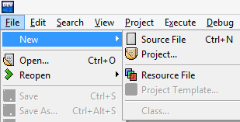Click **Start Program Bloodshed-Dev-C++ Dev-C++**

Step 1**: Source File**

1. To Open New Source file
2. Click **File** menu.
3. Bring mouse pointer to **New.**
4. Click on **Source File.**
5. New Source file will open.

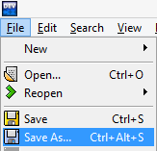

1. To Save New Source file
2. Click **File** menu.
3. Click on **Save-As.**
4. **Save file** window will pop up.
5. Naming Source File
6. Select Program path to save your **Source file.**
7. 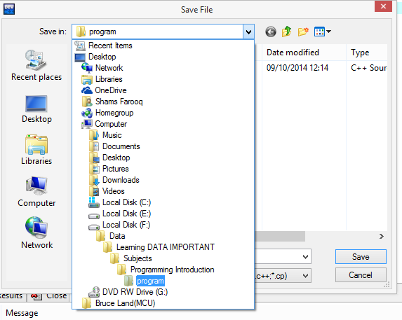Create **New Folder**.
8. Name your source file.
9. Save source file by clicking **Save**.

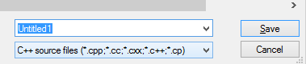

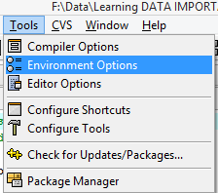Step 2:**Settings for Dev C**

1. Setting Directories.
2. Click **Tools** Menu.
3. Click on **Environment Options.**
4. **Environment Options** window should pop-up.
5. Select **Directories** Tab.
6. Give path in **User’s default directory.**
7. Press **OK.**

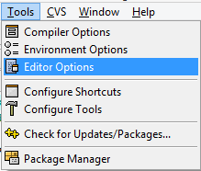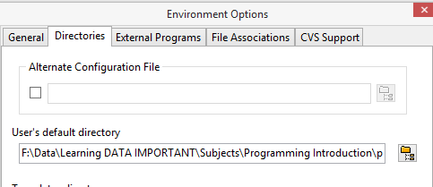

1. Setting Tab Size.
2. Click **Tools** Menu.
3. Click on **Editor Options.**
4. **Editor Options** window should pop up.
5. Select **General** tab.
6. Check **Use tab character.**
7. Press **OK** to close window.

C:\Users\Shams\AppData\Local\Microsoft\Windows\INetCache\Content.Word\New Picture.bmp

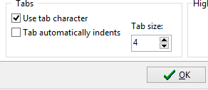

1. Inserting Default Source Code.
2. Click **Tools** Menu.
3. Click on **Editor Options.**
4. **Editor Options** window should pop up.
5. Select **Code Insertion** tab.
6. Select **Default Source** tab.
7. Check **Insert the following code in every new empty file.**
8. Write the code.
9. Press **OK.**

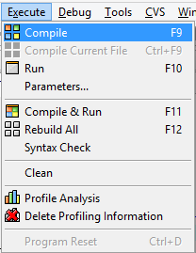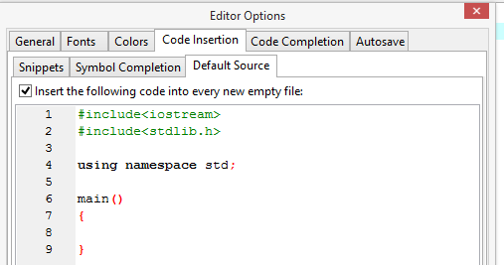

Step 3:**Run Your Program**

1. How to Compile
2. Click on **Execute** Menu**.**
3. Click on **Compile.**
4. **Compile Progress** window will pop-up.
5. How to Run
6. Click on **Execute** Menu**.**
7. Click on **Run.**

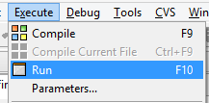

# LAB 2:Input/Output stream & Variables

## Task 1

Write a program that generates following result?

**“Welcome to City University”**

## Task 2

Write a program that generates following result?

**Welcome**

**To**

**City University**

## Task 3

Write a program that generates following result?

**Welcome**

**To**

**“City University”**

## Task 4

Write program that add 2 integers? Arithmetic’s

## Task 5

Write program that subtract 2 integers? Arithmetic’s

## Task 6

Write program that multiply 2 integers? Arithmetic’s

## Task 7

Write program that divide 2 integers? Arithmetic’s

## Task 8

Write program that modules 2 integers? Arithmetic’s

## Task 9

Produce following results using just cout statement?

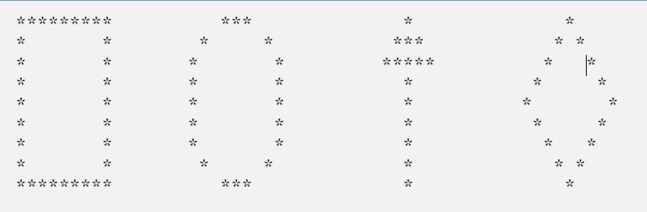

## Task 10

Produce following results using just cout statement?

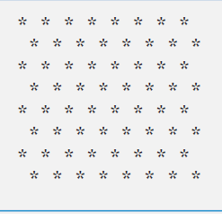

## Task 11

Check following statement?

cout<<“*\n**\n***\n****\n*****\n”;

## 

## Task 12

What is your opinion about code as follow

If( x>5)

If(y>5)

cout<<”x and y are >5”;

else

cout<<”x is <=5”;

If( x>5)

{

If(y>5)

cout<<”x and y are >5”;

}

else

cout<<”x is <=5”;

# LAB 3 (Decision Structure and Precedence)

## Task 1

Calculate the average age of class of five students prompt user to enter the age of each student?

## Task 2

Write a program that takes four digits integer from user and shows the digits on the screen separately?

## Task 3

Write a program that takes radius of a circle from the user and calculates the diameter, circumference and area of the circle and display the results?

Diameter = radius*2 $2r$

Area= 3.14*radius* radius $=π r^{2}$

Circumference= 2*3.14*radius $=2πr$

## Task 4

Rules of Precedence

Enter three integers & implement the following & notice results?

$$=(a*\left(b+c\right))$$

$$=(\left(a*b\right)+c)$$

$$\frac{a+b+c+d+e}{5}$$

## Task 5

State order of evaluation of the operators in each of the following C++ statements and show value of x after each statement is performed?

1. x=7+3*6/2-1
2. x=2%2+2*2-2/2
3. x=(3*9*(3+(9*3/(3) ) ) );

## Task 6

Program test the age of Amir and Amara ?decision using if condition

1. Using one if condition? cout<<”Amir age is greater than Amara”
2. Using two if condition? Find out who is elder amir or amara
3. Using if and else condition? Find out who is elder amir or amara

## Task 7

Compare two integers using if statements? (Useall relational operators and equality operators)

## Task 8

Take a number from user and tell user whether number is odd or even?

***Hint***:*Use of modules operator might help..*

## Task 9

Take a number from user and tell user whether number is odd or even?

***Hint:****Do not use modules operator, think of using divide operation instead… also think about integer truncation..*

## Task 10

Make a program that take student grade & tells you whether he is passing?

***Hint:****Use if statement. Passing marks are 60 or more, then modify that no one can put more than 100.*

## Task 11

Modify ***task 9*** take student marks & tells you whether he is pass or fail?

***Hint:****Use if-else statement. Passing marks are 60 or more.*

## Task 12

Modify ***task 10*** take student marks & tell him what grade he/she has achieved?

***Hint:****Use if-else statement. Grade A (90-100), Grade B (80-89),Grade C (70-79), Grade C (60-69), Grade F (if marks are less than 60)*

## Task 13

Write program that reads 2 integers and determine & prints if first is multiple of second?

***Hint:****Use the modules operator*

## Task 14

Write a program that reads in five integers and determines and print largest and smallest integer in the group?*.*

## Task 15

What is your opinion about code as follow?

If( x>5)

If(y>5)

cout<<”x and y are >5”;

else

cout<<”x is <=5”;

If( x>5)

{

If(y>5)

cout<<”x and y are >5”;

}

else

cout<<”x is <=5”;

# LAB 4: Repetitive structure(while)

## Task 1

Use **while** loop to print “**Welcome to City University”** 5 times?

## Task 2

Use **while** loop to print first 10 integers with tab space?

## Task 3

Modify task 2? Write program that takes an integer input & display number till that integer?

## Task 4

Write program using **while** Loop and display following result

**Number Square Cube**

1 1 1

2 4 16

3 9 27

4 16 64

5 25 125

6 36 216

## Task 5

Write a program using **while** loop that prints even number (from number 0-100)

## Task 5a

Modify program in task-5 and print first 50 odd numbers separately and even numbers separately?

## Task 6

Modify task 5 and produce sum of first 50 odd numbers from(0-100) and also produce sum of first 50 even numbers(0-100)?

## Task 7

Write a program that generate table of 2 using while loop?

## Task 8

Modify Task 7 take input from user and generate table for number user has requested?

## Task 9

Modify task 8 take two inputs from user one for table & one for multiple of table and produce results?

## Task 10

Write program that produce first 10 integers in descending order?

## Task 11

Modify task10 to produce factorial of a number entered by user?

## Task 12

Write a program that product following result

**+*+*+*+*+*+*+*+*+*+*+\***

## Task 13

Write a program that product following result

1 2 3 4

5 6 7 8

910 11 12

13 14 15 16

## 

## Task 14

Write a program that produce following result

**\*\*\*\*\*\***

**\*\*\*\*\*\***

**\*\*\*\*\*\***

***Hint: Use nested while loop to complete structure?***

## Task 15

Write a program that product following result

***********

***********

***********

***********

***********

***********

***Hint: Use nested while loop to complete structure?***

## Task 16

Write a program that product following result

***Hint: Use nested while loop to complete structure?***

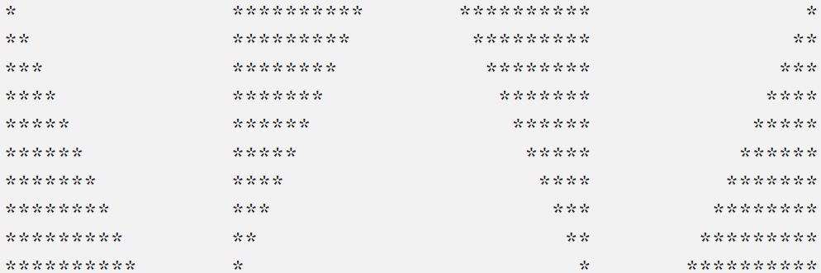

## C:\Users\Shams\AppData\Local\Microsoft\Windows\INetCache\Content.Word\New Picture.bmp

## Task 17

Write a program that product following result

***Hint: Use nested while loop to complete structure?***

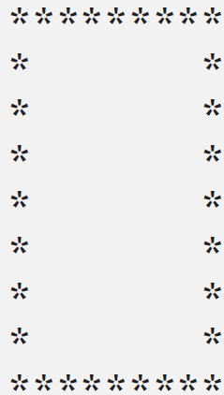

## Task 17

Write a program that product following result

***Hint: Use nested while loop to complete structure?***

# LAB 5: Repetitive structure(for loop)

## Task 1

Use**for** loop to print “**Welcome to City University”** 5 times?

## Task 2

Use **for** loop to print first 10 integers with tab space?

## Task 3

Modify task 2? Write program that takes an integer input from user & display number till that integer?

## Task 4

Write program using **for** Loop and display following result

**Number Square Cube**

1 1 1

2 4 16

3 9 27

4 16 64

5 25 125

6 36 216

## Task 5

Write a program using **for** loop that prints even number (from number 0-100)

## Task 6

Modify program in task-5 and print first 50 odd numbers separately and even numbers separately?

## Task 7

Modify task 6 and produce sum of first 50 odd numbers from (0-100) and also produce sum of first 50 even numbers (0-100)?

## Task 8

Write a program that generate table of 2 using ***for*** loop?

## Task 9

Modify Task 8 take input from user and generate table for number user has requested?

## Task 10

Modify task 9 take two inputs from user one for table & one for multiple of table and produce results?

## Task 11

Write program that produce first 10 integers in descending order?

## Task 12

Modify task11 to produce factorial of a number entered by user?

## Task 13

Write a program that product following result

**+*+*+*+*+*+*+*+*+*+*+\***

## Task 14

Write a program that product following result

1 2 3 4

5 6 7 8

910 11 12

13 14 15 16

## Task 14 b

Write a program that product following result using nested for loop

1 2 3 4

5 6 7 8

910 11 12

13 14 15 16

## Task 15

Write a program that produce following result

**\*\*\*\*\*\***

**\*\*\*\*\*\***

**\*\*\*\*\*\***

**\*\*\*\*\*\***

***Hint: Use nested for loop to complete structure?***

## Task 16

Write a program that product following result

***********

***********

***********

***********

***********

***********

***Hint: Use nested for loop to complete structure?***

## Task 17

Write a program that product following result ***Hint: Use nested for loop to complete structure?***

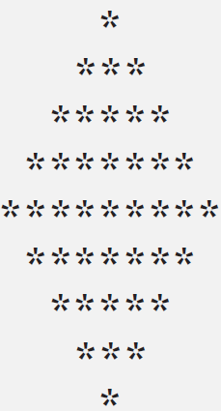

## Task 18

Write a program that product following result

***Hint: Use nested for loop to complete structure?***



## Task 19

Write a program that product following result

***Hint: Use nested for loop to complete structure?***

# LAB 6: Repetitive structure(do while)

## Task 1

Use**do-while** loop to print “**Welcome to City University”** 5 times?

## Task 2

Use **do-while** loop to print first 10 integers with tab space?

## Task 3

Modify task 2? Write program that takes an integer input from user & display number till that integer?

## Task 4

Write a program using **do-while** loop that prints even number (from number 0-100)

## Task 5

Write program that generate table of 2 using ***do-while*** loop?

## Task 6

Write program that produce first 10 integers in descending order?

## Task 7

Write a program that product following result

**+*+*+*+*+*+*+*+*+*+*+\***

## Task 8

Write a program that produce following result

**\*\*\*\*\*\***

**\*\*\*\*\*\***

**\*\*\*\*\*\***

**\*\*\*\*\*\***

***Hint: Use nested do-while loop to complete structure?***

## Task 9

Write a program that product following result

***********

***********

***********

***********

***********

***********

***Hint: Use nested do-while loop to complete structure?***

## Task 10

Write a program for ***guess character game***and give user 5 chances to guess a character?

## Task 11

Modify task 10 for ***guess character game***and give user 5 chances to guess a character but while loop should end when guess is write false youe while statement?

## Task 12

Modify task 10 for ***guess character game***and program compare small and capitals characters both?

## Task 13

Program that takes record from user until user is pressing ‘y’.

# 

# LAB 7: Switch

## Task 1

Write a program that calculates average marks of students using**do-while**

## Task 2a

Program that takes grade from student & tell him how did he hasperformed?

A excellent

B very good

C good

D poor

F fail

## Task 2b

Modify task 2 Program that takes grade from student & tell him how did he performed for capital and small

A excellent

B very good

C good

D poor

F fail

## Task 2c

Modify Program that takes grade from student & tell him how did he performed for capital and smallUse if-else to make program effective

A excellent

B very good

C good

D poor

F fail

## Task 3a

Time table

Write a program that selects a according to selection of day

## Task 3b

Time table

Modify task 3a that generates your time table according to selection of day

## Task 4a

Alphabets

Write a program that takes character from a user a-d tell him which character he has pressed

## Task 4b

**Vowels**

Modify task 4 and ask user to enter a vowels a,e,i,o,u?

## Task 5

Write a program that takes number 0-9 from user?

## Task 6a

Program that takes grades from user & tell you how did you performed using switch statement

## Task 6b

Modify task 6a take grade(as C is case sensitive your program should work for small and capital letters as well from user & tell you how did you performed using switch statement

## Task 6c

Modify task 6b take grade(but if user enter wrong grade should tell user that he has entered a wrong grade)from user & tell you how did you performed using switch statement

***Hint*** use of default might help

## Task 6d

Modify task 6c take grade from user & tell you how did you performed using switch statement

*** Please see o/p of your last program when you have selected grade 'A'

Program prints excellent and then very good,good,poor, fail after wards

***Hint***: Use break keyword & sees how program performs

## Task 7

Write a program to create a simple calculator for addition, subtraction, multiplication and division?

## Task 8a

Tax calculator using switch statement

Please use of char as choice selector

1 Salary Below 10,000 no tax detection

2 salary 10,000 to 19,999 2% tax detection

3 salary 20,000 to 29,999 4% tax detection

4 salary 30,000 to 39,999 6% tax detection

5 salary 40,000 to 49,999 8% tax detection

6 salary above 50,000 10% tax detection

## Task 8b

Modify Task 7 take choice as an integer value?

## Task 8c

Modify Task 8 take salary from user as well and calculate tax and his final salary?

## Task 8d

Modify Task 9 take salary from user and also check if he has entered a write salary according to case?

# LAB 8: Conditional operator

## Task 1

Take 2 values from user and find larger between them using conditional operator

## Task 2

Write program takes value from user if value is divisible by 2 print even if not than odduse conditional operator

## Task 3

Take student marks & tells you whether he is pass or fail?

## Task 4

Modify task 3 take student marks & tells you whether he is pass or fail.if marks should be in between 0 and 100?

# LAB 9: break- continue-goto

## Task 1

Write a program using while loop that produce number 1-5? Change program when value loop variable value is equal to 3 loops stops?

***Hints:***  Use of break might help.

## Task 2

Modify guess character program done is do-while loops by use of break?

## Task 3a

Write a program using for loop where your for loops run 1-5 but only print values 1 2 3?

## Task 3a

Write a program using nested for loop, where external and internal loops both runs 5 times but internal loop terminates when loop variable equal to 3?

## Task 4b

Write a program using while loop that produce number 1-5? Change program when value loop variable value is equal to 3, loop should not print 3?***Hints:***  Use of continue might help.

## Task 5

Write a program using for loop that produce number 1-5? Change program when value loop variable value is equal to 3, loop should not print 3?

## Task 6

Write a program using goto statement and see how it work?

# LAB 10: Functions

Task 1 **(No Argument, No return type)**

1. Write a program that displays message “Inside Function” using functions?
2. Modify 1A use two message functions one display “inside message1” and “inside message1” call them both from main?
3. Write a program with three functions named as Brazil, Italy and Argentina call them one by one from main function?
4. Modify 1C .Call Italy function from main, call Brazil function from Italy and call Argentina function from Brazil.
5. Write a program which has three functions named shallow, deep, deeper where shallow is called by main, where as deep is called by shallow and then deeper is called by deep all messages displaying messages and in end control passing back to main ?

Task 2 **(Square)**

1. Write program that calculate square of a value using function(no arguments, no return).
2. Modify 2A, Take value from user and calculate square inside square(no arguments, no return).
3. Modify 2b, Take value from user inside main and calculate square(single argument pass to function square of type int, no return)
4. Modify task 2c and take value from user inside main and calculate its square(by passing single argument and return result back to main)
5. Modify task2d and take a float value from user and calculate square using inline function.
6. Modify task 2e, Try to define two functions using same name but pass them argument with different variable type see results?

Task 3**(Raise to Power)**

1. Write a program using function that calculates raise to power of any value and return result to main. (argument and return type should be double as well).
2. Modify 3A for negative powers as well.

Task 4**(Area of Ring)**

1. Write a program calculate area of ring using function?
2. Modify 4A, use square function to calculate radius square?
3. Modify 4b,use of #define to define a constant?

## Task 5

1. Write a program that detects whether number is even or not using just one function on bases of return value?
2. Write program that takes two numbers from user and return greater value? (solve it on bases of return value)

## Task 6

Design a calculator using functions

## Task 7

1. Write a program that calculates a factorial of a number enter by a user?
2. Modify 6a, using recursion function?

## Task 8

1. Write a task using same named variable in function1 and in main & check scope of variable?

# LAB 11: Arrays

Task 1 **(Introduction to Array)**

1. Write a program that declares array of size four and assign values to it?
2. Modify 1A and store values in an array taken from user?
3. Write a program that declares array of size 10? Practice three ways to initialize array with zero?

Task 2 **(Array Entry)**

1. Write a program to fill array with data, when entry in an array is equal to '-1' array entry should terminate.

Task 3**(Copying Of Array)**

1. Write a program that with two arrays of same size. Enter values in array 1 and then copy content of array1 to array copy.

Task 4**(Sum content of Array)**

1. Write a program that takes values in an array and sum all the content in an array?
2. Modify 4A, sum square of the content in an array?

## Task 5

1. Write a program that finds the largest value saved in an array?
2. Modify 5A that finds the smallest value saved in an array?
3. Write a program and find two arrays are equal or not?

Hint: compare each element of array separately.

## Task 6

1. Write a program that assign values random values to an array?
2. Modify task 6A use random array and sort array in ascending order?
3. Modify task 6A use random array and sort array in descending order?

## Task 7

1. Write a program that creates a random array in main() function and pass array to a user defined function and print array in user defined function?
2. Modify 7a, pass array from main and sort array in user defined function?

Task 8**(Character Array Entry and Initialization)**

1. Write a program that create three characters array and initialize them with your name using different initialization procedures?
2. Write a program that copy content of character one character array to another array in reverse order?
3. Modify 8a and use function that takes two arrays and copy content of character one character array to another array in reverse order?

Task 8**(Multi-Dimensional array)**

1. Write a program that declare, initialize and display a multi-dimensional array?
2. Modify task8A that sums up all the content of multi-dimensional array?
3. Modify 8A and pass multi-dimensional array to a function that sums up all content of multi-dimensional array?

Task 9**(Multi-Dimensional array)**

1. Write a program that randomly assigns values to a multi-dimensional array using random function and copy array one to another array?
2. Modify 9a and copy rows of array one to columns of other array?