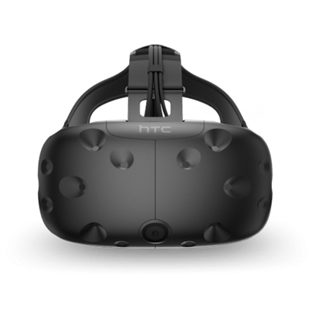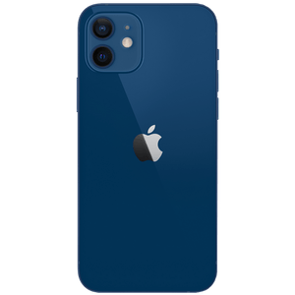 Mood Board

Electronics





& Tips

Reviews