Student ID: 102176657

Name: Sulaiman Mohamed

# Setup Screenshot

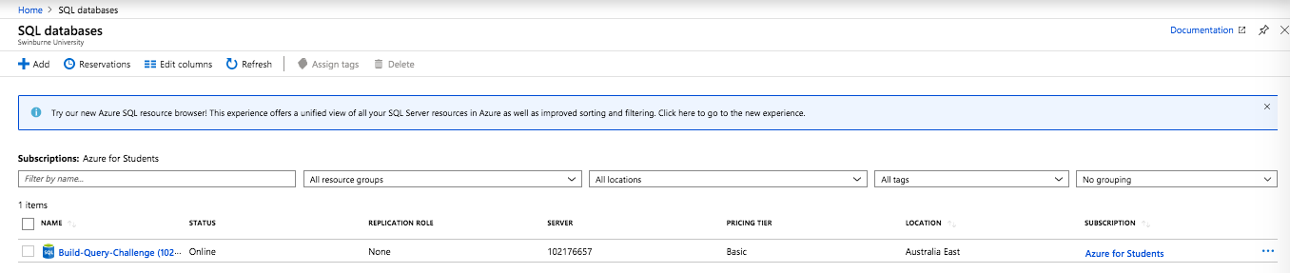

# Task 2 Screenshot

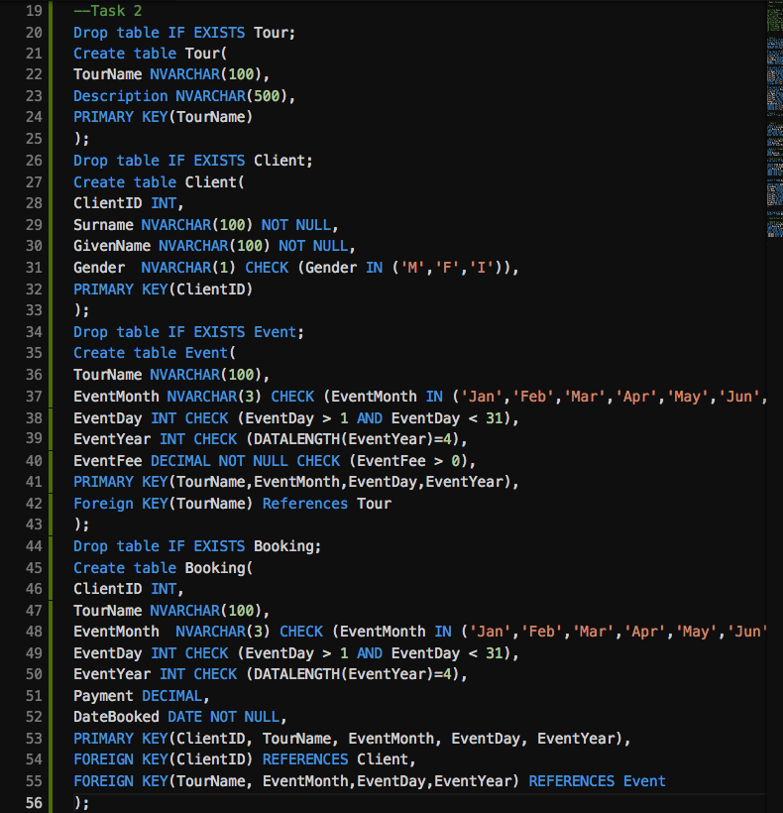

# Task 3 Screenshot

