Sulakshana Mehta
CS 499 Computer Science Capstone
August 1, 2026
Enhancement Three: Databases
Final ePortfolio Revision: August 2026
Artifact Description
The selected artifact is the Travlr Full Stack Application, a travel management system that I created during CS 465 Full Stack Development I in May and June 2026. The project combines an Express and Node.js server, Handlebars views for the public site, a REST API, MongoDB with Mongoose, and an Angular administrative application (Mehta, 2026). Public users can review available trips, while an authenticated administrator can add and update trip records. Milestone Two improved the administrator workflow, input handling, protected routes, API responses, security controls, and automated verification. Milestone Three retained that work and added a catalog-processing layer in the Angular client for search, filtering, sorting, indexed lookup, and pagination. The Milestone Four version preserves the user-facing capabilities but moves the active catalog operations into MongoDB. For the Milestone Four comparison, the completed Milestone Three artifact served as the immediate baseline. In the final ePortfolio, the original CS 465 artifact and the final enhanced version show the complete progression from the initial full-stack application to the database-driven result.
Rationale for Inclusion and Database Improvements
I selected Travlr for the database category because the same working application can show a clear progression from interface behavior to algorithm design and then to persistent data management. Before this enhancement, the trip collection supported basic storage, but important values were not modeled for reliable database operations. The price field was stored as text, and the number of nights existed only inside a display value such as 4 nights / 5 days. A review of the live Milestone Three collection confirmed that all 12 prices were strings, the separate nights field was missing, and the only catalog indexes were the default identifier index plus simple code and name indexes. Those choices were sufficient for a small demonstration, but they limited numeric sorting, range queries, data integrity, and efficient server processing.
The enhanced Mongoose model stores perPerson as a number and nights as a required integer. It rejects negative or implausible values, fractional nights, prices with more than two decimal places, malformed codes, missing fields, and unexpected document properties. Trip codes are trimmed, normalized to uppercase, and protected by a unique index. The original length value remains available for readable display, while nights provides an explicit value for database queries. This creates a small amount of deliberate duplication, but it avoids repeatedly parsing presentation text and makes the meaning of the stored data clear. Mongoose schemas define document shape, casting, and validation rules, while document validation checks required values, numeric limits, and custom validators before data is accepted (Mongoose, n.d.).
Seven named indexes were added for the catalog access patterns. They support unique lookup by code, deterministic ordering by name, numeric price sorting, departure sorting, resort and price filtering, nights filtering, and text search across code, name, resort, and description. MongoDB indexes organize selected field values so equality matches, range operations, and sorted results can avoid unnecessary collection work (MongoDB, n.d.-a). Field order is especially important in a compound index because MongoDB stores the keys in the order defined by the index (MongoDB, n.d.-b). The secondary code field provides a stable order when two trips share the same primary value. The descending comparison was aligned with the primary sort direction so the same compound index can support both forward traversal and complete reverse traversal. This avoided adding duplicate indexes that would consume storage and add cost to writes.
A controlled migration was necessary because changing the schema alone would not convert the existing records. The new migration command performs an analysis first and changes nothing unless an explicit apply option is supplied. It checks every legacy value, converts the price, derives nights from the existing length text, normalizes codes, detects possible collisions, and validates the transformed document. The local analysis inspected all 12 records and reported 12 ready records with no errors. Apply mode created a separate backup collection, used an ordered bulk update, removed the obsolete code and name indexes, synchronized the new definitions, and validated every migrated document. The final type summary confirmed that all 12 records stored both perPerson and nights as numeric BSON values. This process demonstrates that database improvement includes safe transition planning, not only a revised schema.
Catalog retrieval now uses a dedicated query service rather than loading every trip with Trip.find({}). The service accepts only scalar parameters, applies maximum lengths and numeric limits, validates real calendar dates, checks range order, and uses allowlists for sort fields, sort directions, and page sizes. Arrays and nested objects are rejected before a filter is created, so user input cannot be copied directly into MongoDB operators. OWASP identifies unsafe construction of NoSQL queries as a common failure mode and recommends strong validation and controlled query construction (OWASP Foundation, n.d.). A complete normalized trip code is checked through the unique index. Other terms use the catalog text index, while resort, price, date, and nights criteria are combined in the same filter. Text indexes support queries across selected string fields, although they add index entries and therefore create a write cost that must be considered (MongoDB, n.d.-c).
Pagination and sorting are also performed by MongoDB. The service uses countDocuments to determine the match count and then applies find, sort, skip, limit, and lean to return only the requested page. The response includes the total number of matches, page count, active page, visible range, page size, and search path. A separate distinct query supplies the full resort list without downloading the complete collection. The Angular administrator sends typed criteria to this API and uses the returned metadata rather than counting or slicing records in the browser. The interface also reports whether a search used the unique code index or the catalog text index. The public Handlebars site was adapted to the new response contract and combines controlled database pages before rendering its complete catalog, which preserves earlier public behavior while the administrator benefits from true database pagination.
Verification combined several forms of evidence. The server suite passed 42 tests. Angular type checks completed successfully, and 46 tests passed across 17 specification files. The live database audit validated 12 of 12 documents, verified seven of seven required indexes, and passed five of five query scenarios. MongoDB explain output identified the intended indexes for exact code lookup, price sorting, resort and price filtering, nights filtering, and catalog text search. Seven HTTP checks passed for the default page, lowercase code lookup, text search, combined filters, page extraction, a controlled invalid range response, and resort options. The Angular production build completed successfully. Browser checks then confirmed database pagination, numeric sorting, protected editing, and controlled validation feedback.
Course Outcomes
This enhancement made the strongest progress toward the outcome on using sound techniques, skills, and tools to implement computing solutions that deliver value. The artifact no longer treats MongoDB as a passive place to store records. The schema expresses business meaning, the migration protects existing data, the indexes correspond to actual access paths, and the query service performs filtering, ordering, counting, and page extraction in the database. These decisions improve the administrator experience and provide a design that can support a larger collection without transferring every document to the browser.
The work also supports the outcome on designing and evaluating computing solutions while managing design tradeoffs. Numeric nights were added even though a readable length field already existed because query correctness was more important than avoiding one small duplicate value. Seven targeted indexes improve reads but add storage and write overhead, so unnecessary reverse direction indexes were avoided. Database text search provides useful local search without adding another service, but its write cost and feature limits are acknowledged. The public catalog combines pages to preserve its original complete view, while the administrator uses server pagination for efficiency. Automated tests, query reports, explain plans, production build output, and browser behavior evaluate the solution from different perspectives.
Progress is also visible in the security and communication outcomes. Query parameters are validated before they reach MongoDB, raw objects are rejected, ranges are bounded, sort choices are allowlisted, and invalid requests receive predictable HTTP 400 responses. The actual environment file is excluded from the submitted package, an example file documents the required settings, and the final local secret was generated separately. Existing authentication continues to protect add and edit operations. Documentation explains the schema, migration commands, query contract, local verification procedure, and evidence files for an instructor or future employer. I met the database goals planned in Module One, including MongoDB modeling, migration, integrity rules, indexes, and query execution. The broader outcome coverage plan does not require revision.
For the final ePortfolio, I consider Course Outcomes 2, 3, 4, and 5 fully supported by this enhancement. Outcome 3 is demonstrated through explicit trade-offs involving duplicated query-ready data, index coverage versus write cost, text search limitations, public-site compatibility, and server-side pagination. Outcome 4 is supported through the coordinated use of MongoDB, Mongoose, Express, Angular, migration tooling, query plans, and automated verification. Outcome 5 is supported through controlled query construction, validation, environment-secret handling, and protected write operations. Outcome 1 is not directly met by this individual artifact; collaboration and organizational decision-making evidence is addressed through the broader program experience and professional self-assessment.
Reflection on the Modification Process
The modification process showed me that a database enhancement begins with the meaning of the stored values. The original price looked numeric in the interface, but its string type prevented the database from treating it as a reliable number. The original duration was convenient for display, but it forced every consumer to extract the number of nights from text. Adding nights as an explicit integer made the query contract much clearer. I learned that a schema should represent how the application needs to compare, validate, and retrieve values, not only how the user sees them on a card.
Migration design was the most important data safety challenge. Replacing the seed file would have demonstrated the new schema, but it would not have shown how an existing application can move forward without discarding data. The analysis mode, collision checks, backup collection, ordered update, index synchronization, and final type audit created a sequence that could be reviewed before any permanent change. The first local analysis produced deprecation warnings from synchronous Mongoose validation. I replaced that call with asynchronous document validation, reran the syntax check and all 42 server tests, and repeated the analysis. The final output was clean and still reported all 12 records ready with no errors. This reinforced the value of responding to warnings before they become future failures.
Index design required more reasoning than simply indexing every field. The catalog needed predictable results when prices, names, or dates were equal, so code was included as a secondary key. I initially used an ascending code direction even when the primary sort was descending. Reviewing the query plan showed that matching the secondary direction allows one ascending compound index to support a complete reverse traversal. The final database audit confirmed the intended named indexes in the explain results. I also learned that the optimizer may make different choices for a very small collection, so the verification report records the observed plans rather than assuming that an index definition alone proves its use.
Connecting Angular to the database query contract created another boundary to manage. The browser previously owned the complete collection and could calculate every result locally. After the change, it had to trust server metadata, request a new page after criteria changes, load resort values separately, and preserve the last valid page when a request failed. A request sequence identifier prevents an older slow response from replacing a newer result. Browser verification demonstrated that a reversed price range produced a controlled message while the previous page remained visible. The authenticated edit test also loaded nights and the numeric price from MongoDB, saved a temporary price change, and showed the updated value in the catalog. The original value was restored after the persistence check.
The milestone received full marks, and the instructor did not request additional technical correction beyond continuing the same standard of work. I incorporated that feedback by preserving the verified database behavior and concentrating the final ePortfolio revision on clarity rather than unnecessary code churn. The final presentation makes the migration sequence, data-integrity decisions, index rationale, query-plan evidence, API behavior, Angular integration, and relationship to the earlier in-memory algorithms enhancement easier for another developer or employer to review.
The final artifact provides stronger database evidence than the earlier version because the important work is visible in both the code and the stored data. The active collection was transformed, the obsolete indexes were replaced, query plans named the new indexes, and the interface reflected database results. Server tests, Angular tests, API checks, database reports, build output, and screenshots each answer a different question about correctness. Future work could test the same design with a much larger catalog, measure query latency under load, and define a formal backup retention policy. A production deployment should also enable MongoDB authentication, least privilege accounts, network restrictions, and encrypted transport. The milestone nevertheless demonstrates a complete local path from legacy data through safe migration to validated database behavior.
References
Mehta, S. (2026). Travlr Full Stack Application [Source code]. GitHub. https://github.com/SulakshanaRaneMehta/CS-465
MongoDB. (n.d.-a). Indexes. Retrieved August 1, 2026, from https://www.mongodb.com/docs/manual/indexes/
MongoDB. (n.d.-b). Compound indexes. Retrieved August 1, 2026, from https://www.mongodb.com/docs/manual/core/indexes/index-types/index-compound/
MongoDB. (n.d.-c). Text indexes on self managed deployments. Retrieved August 1, 2026, from https://www.mongodb.com/docs/manual/core/indexes/index-types/index-text/
Mongoose. (n.d.). Validation. Retrieved August 1, 2026, from https://mongoosejs.com/docs/validation.html
OWASP Foundation. (n.d.). NoSQL security cheat sheet. Retrieved August 1, 2026, from https://cheatsheetseries.owasp.org/cheatsheets/NoSQL_Security_Cheat_Sheet.html
AI Use Acknowledgment
OpenAI ChatGPT 5.6 was used to support brainstorming, code review, refactoring, documentation, image redaction, and Word document formatting. Final local verification was completed on a macOS environment. The submitted source, migration output, database reports, automated tests, API checks, production build result, browser behavior, screenshots, and final narrative content were reviewed before submission.
Appendix A
Verification Evidence
The final local record includes 42 passing server tests, 46 passing Angular tests across 17 files, successful application and test type checks, seven passing API checks, and a successful Angular production build. The migration converted 12 legacy records, created a backup collection, removed obsolete indexes, and validated numeric BSON storage. The database audit then validated 12 of 12 documents, verified seven of seven required indexes, and passed five of five query scenarios. The figures below document the browser behavior and local verification used to confirm the database enhancement. Personal user names, computer names, and full local paths were obscured in terminal images, while the technical results remain visible.
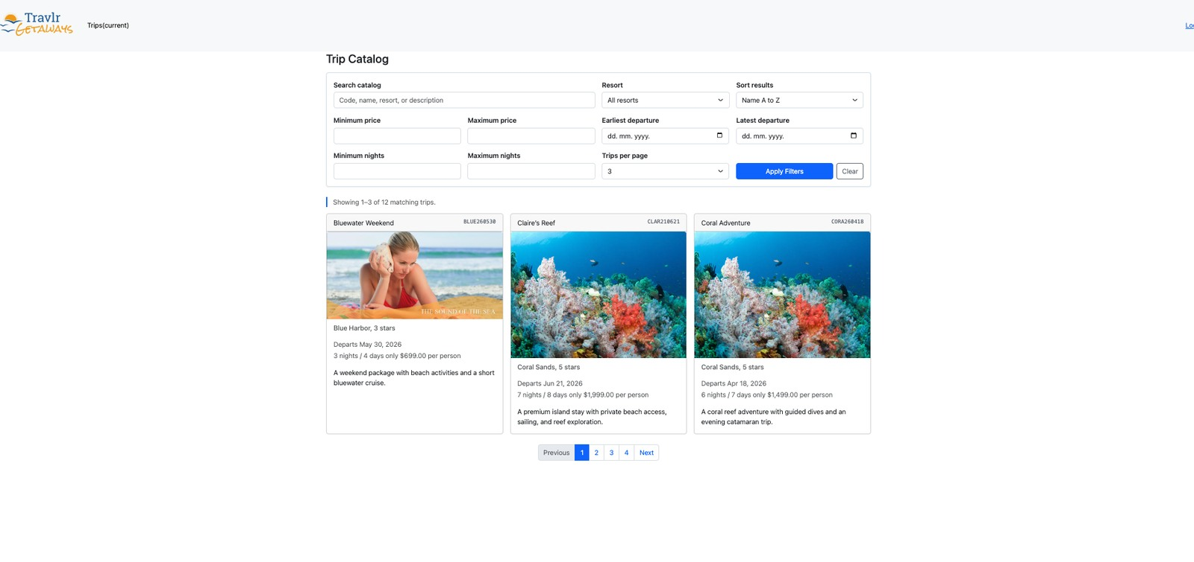
Figure A1. The database returned the first three of 12 trips with a page size of three, a visible result range, and four numbered pages.

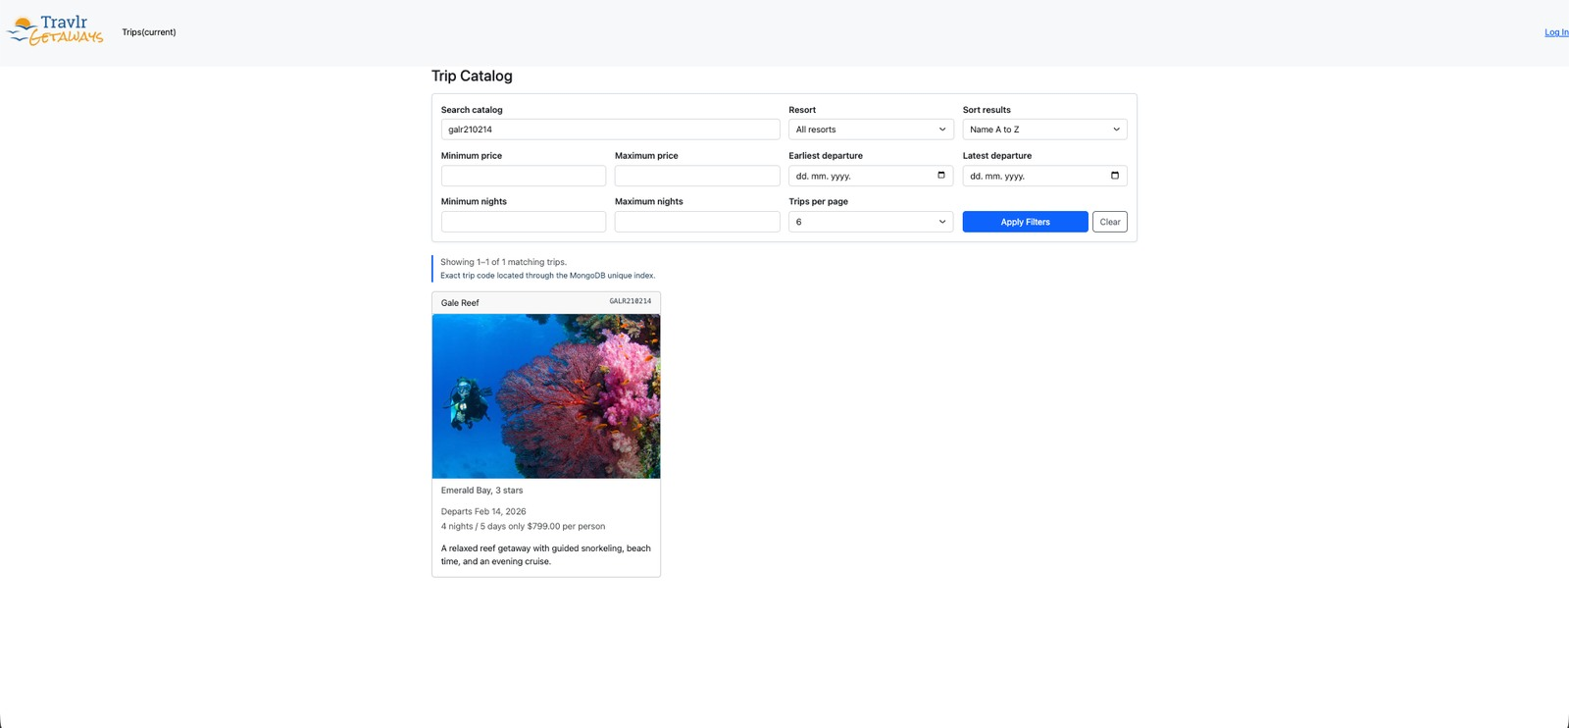
Figure A2. Lowercase input was normalized and resolved through the MongoDB unique code index.
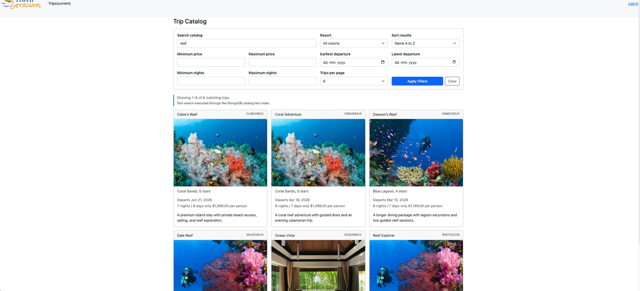
Figure A3. The term reef was processed through the MongoDB catalog text index.
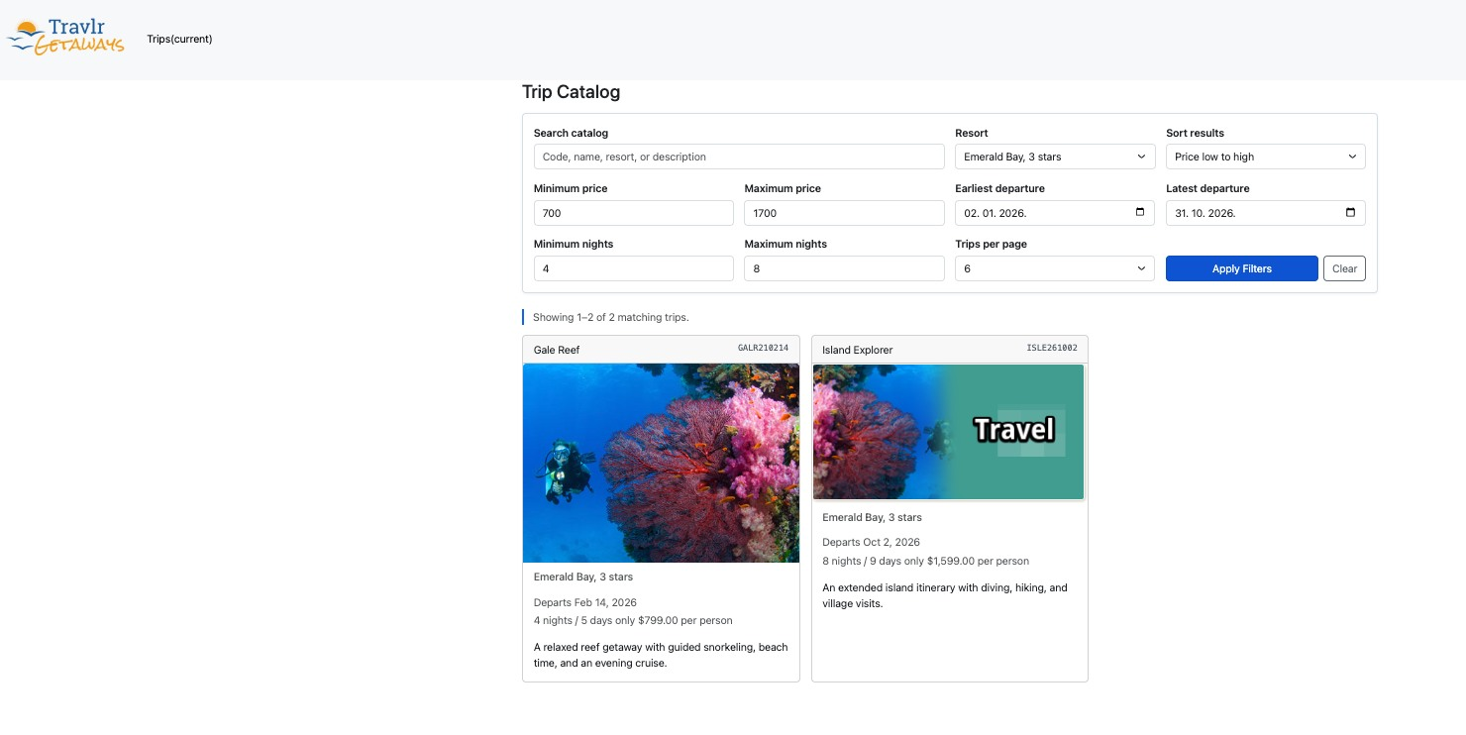
Figure A4. Combined resort, price, date, and nights criteria returned two ordered matches.

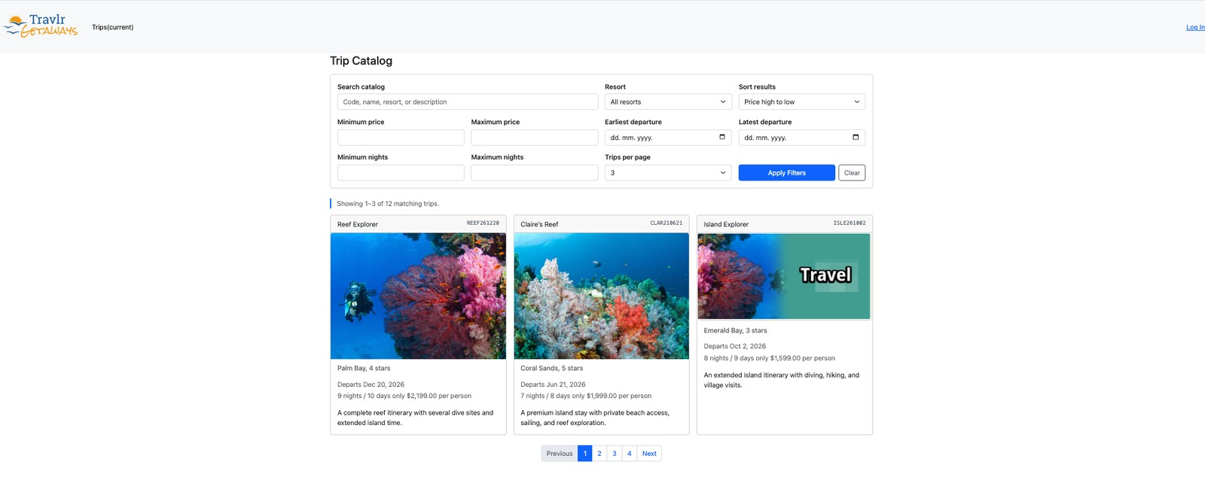
Figure A5. Numeric price sorting placed the three highest prices first.
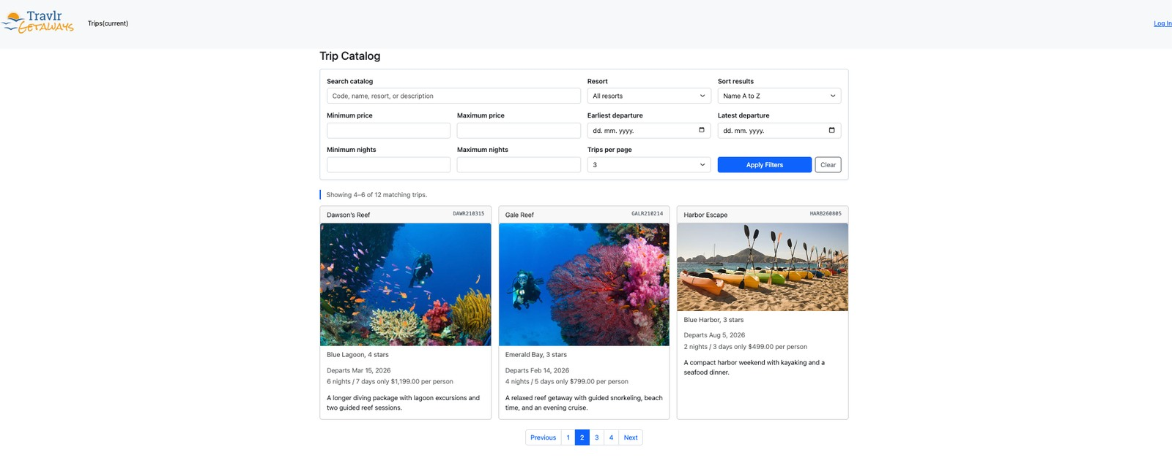
Figure A6. The second database page displayed records four through six.
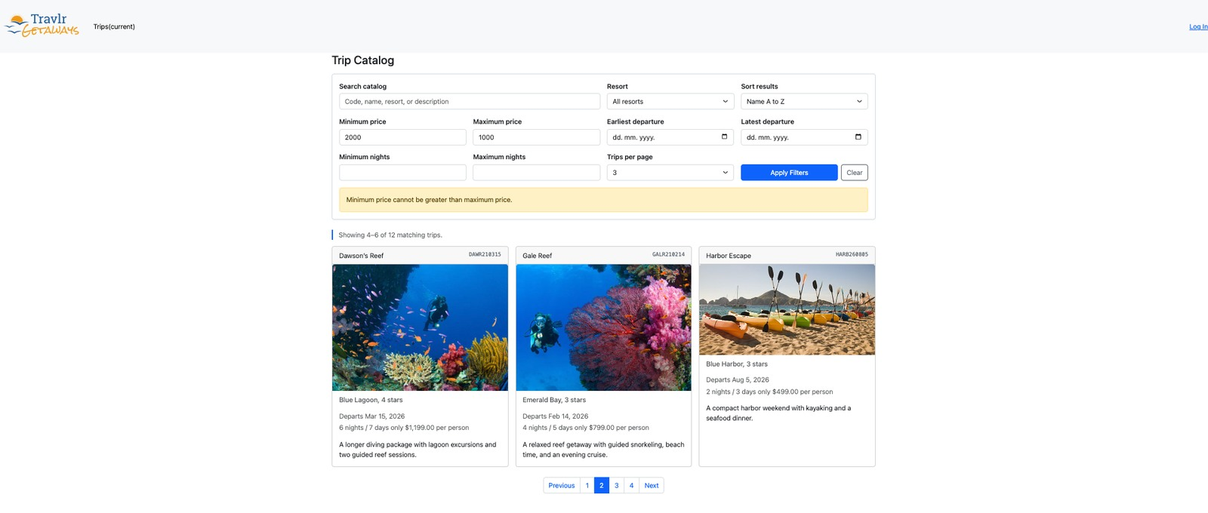
Figure A7. A reversed price range produced controlled feedback while preserving the prior page.

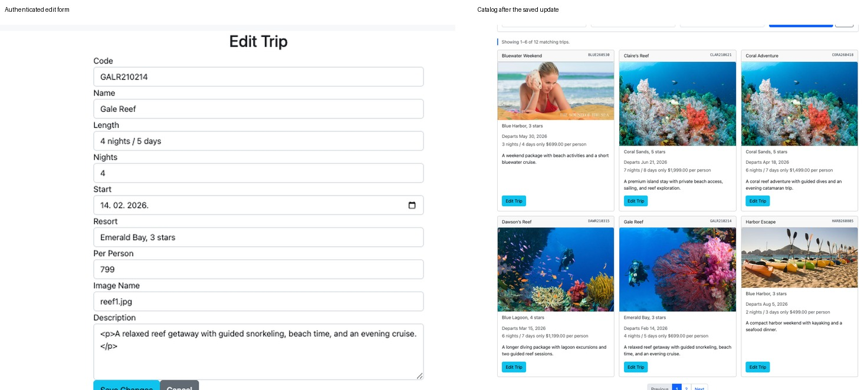
Figure A8. The protected edit form loaded the numeric price and explicit nights value from MongoDB. After a temporary price update was saved, the catalog displayed the persisted value.
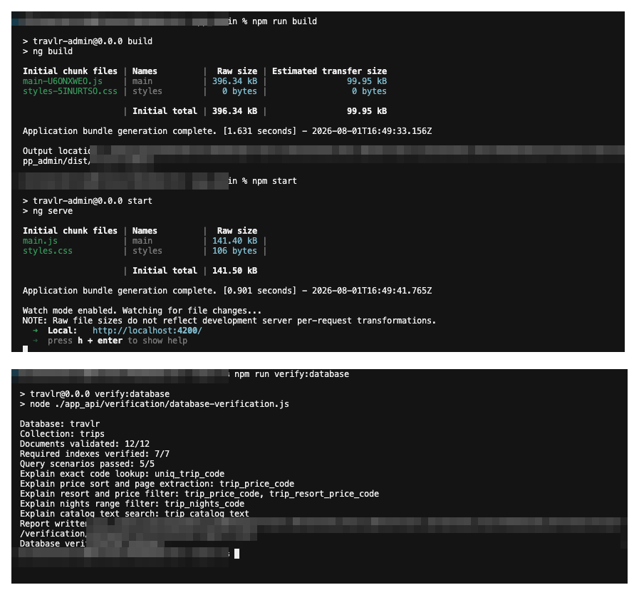
Figure A9. The Angular production build completed successfully, and the database audit confirmed 12 validated documents, seven required indexes, and five passing query scenarios. Local identity and path details were obscured.

