Assignment Title: Personal Portfolio Website
Objective
Build a multi-page Personal Portfolio Website using only HTML.
This assignment is designed to practice all core HTML tags, including text formatting, images, lists, tables, links, semantic tags, and form elements.
What You’ll Create
A complete personal portfolio website consisting of:
- Home page
- Education page
- Skills page
- Projects page
- Contact page (with a form)
All pages must be connected using internal navigation.
Project Structure
personal-portfolio/
│── index.html
│── education.html
│── skills.html
│── projects.html
│── contact.html
│── images/
Detailed Requirements
1. Main Page: index.html
- Use <header> to wrap:
  - Your name in <h1>
  - A short tagline using <h3>
- Write a brief introduction using <p>
- Highlight important words using <strong>, <em>, or <mark>
- Add a profile image using <img> with alt attribute
- Create a navigation menu using:
  - <nav>
  - <ul> and <li>
  - <a> tags linking to all pages
- Use <section> to divide content logically
- Add a <footer> with copyright text
2. Education Page: education.html
- Use <h2> for section heading
- Display education details using:
  - <p> for descriptions
  - <hr> to separate qualifications
- Use a table to show:
  - Qualification
  - Institution
  - Year-
  - Percentage / Grade
- Use <table>, <tr>, <th>, <td>
- Add a link back to index.html
3. Skills Page: skills.html
- Use <h2> for heading
- Use an unordered list (<ul>) for technical skills
- Use an ordered list (<ol>) to show learning priority
- Highlight key skills using <strong> or <mark>
- Use <span> inside text where appropriate
- Add a link back to index.html
4. Projects Page: projects.html
- List at least 2–3 projects
- Projects may be real or dummy/practice projects
- For each project include:
  - Project title using <h3>
  - Short description using <p>
  - Line breaks using <br>
- Highlight project names using <mark>
- Use <article> for each project
- Add a link back to index.html
5. Contact Page: contact.html (Form Mandatory)
Contact Information
- Display email and phone using <p>
- Use <a> tag for: GitHub / LinkedIn profile/other social media
Contact Form Requirements
Create a contact form using <form> that includes:
- Text input for Name
<input type="text">
- Email input
<input type="email">
- Phone number input
<input type="tel">
- Dropdown using <select> and <option> (country)
- Radio buttons for Gender
- Checkboxes for Skills / Interests/ hobbies
- Textarea for message
- Submit button using <button> or <input type="submit">
- Use <label> properly for each field
- Group related fields using <fieldset> and <legend>
Below is the screenshot of this requirements:
Index.html page
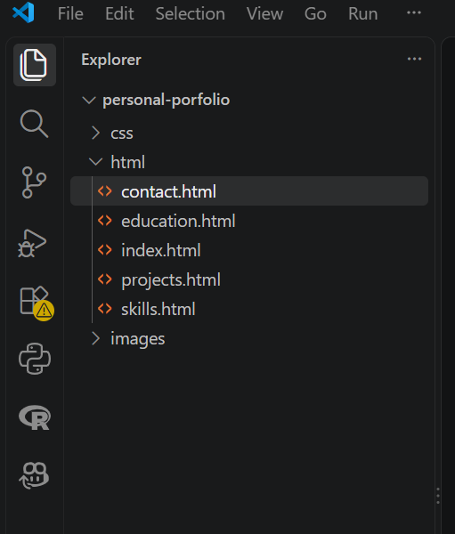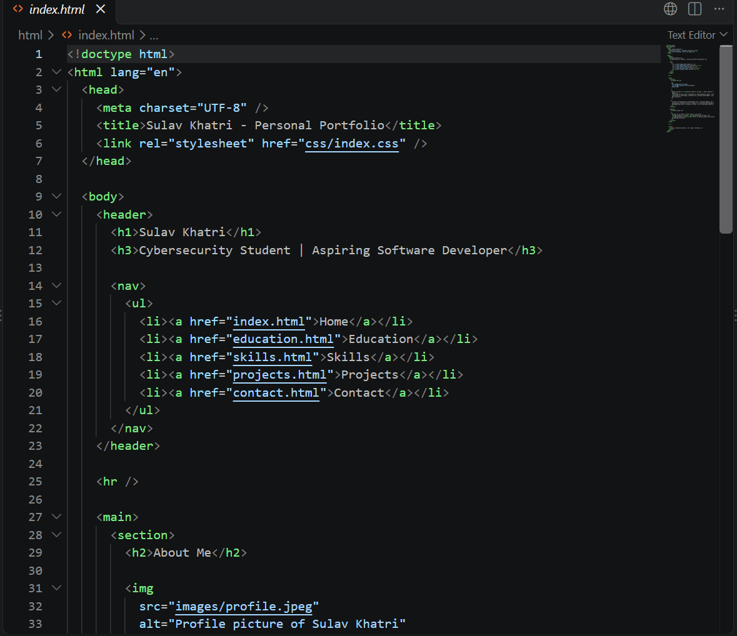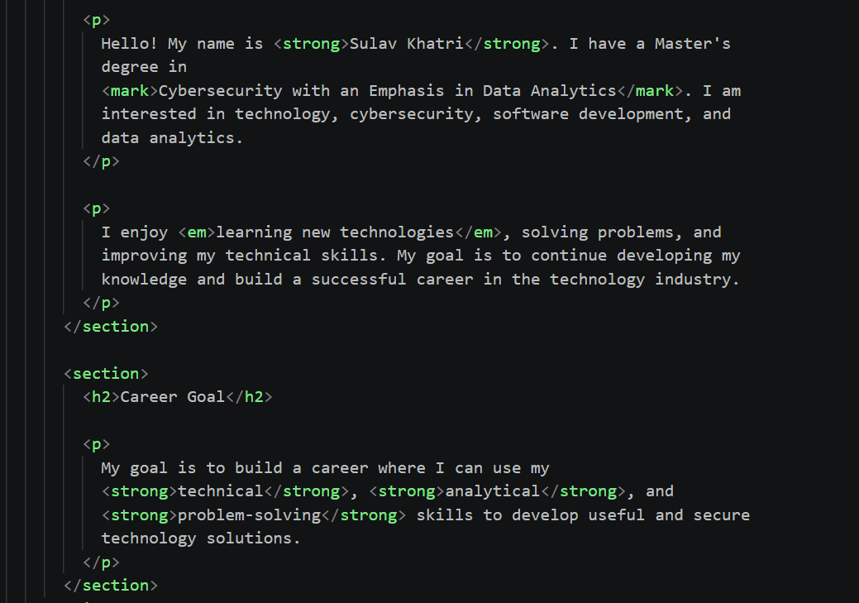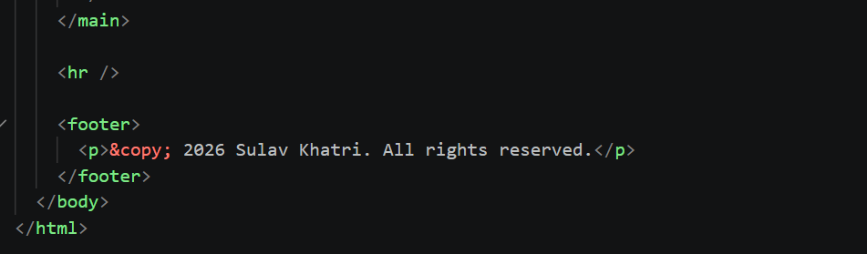
Education.html page
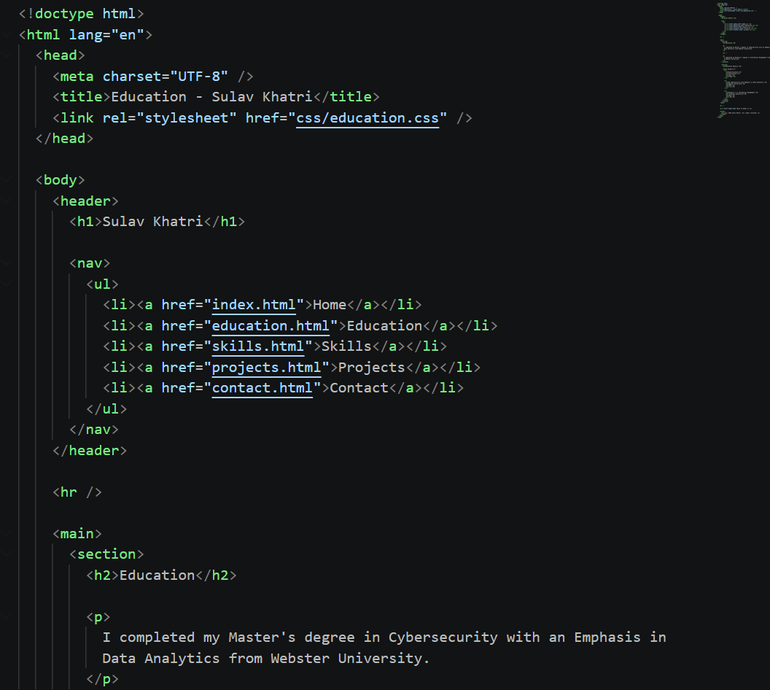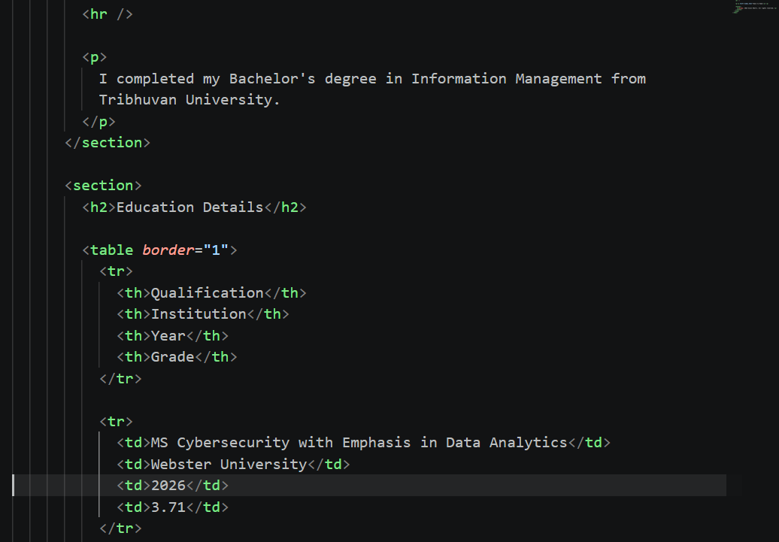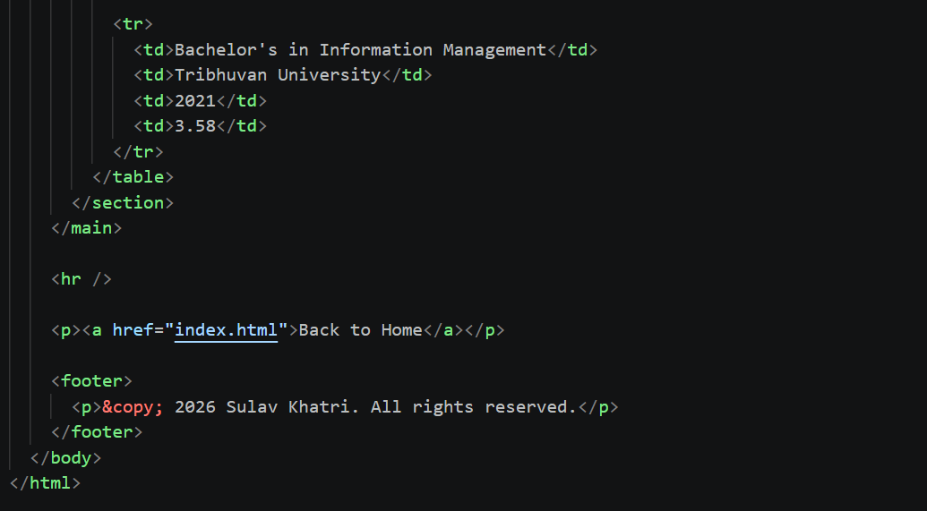
Skills.html page
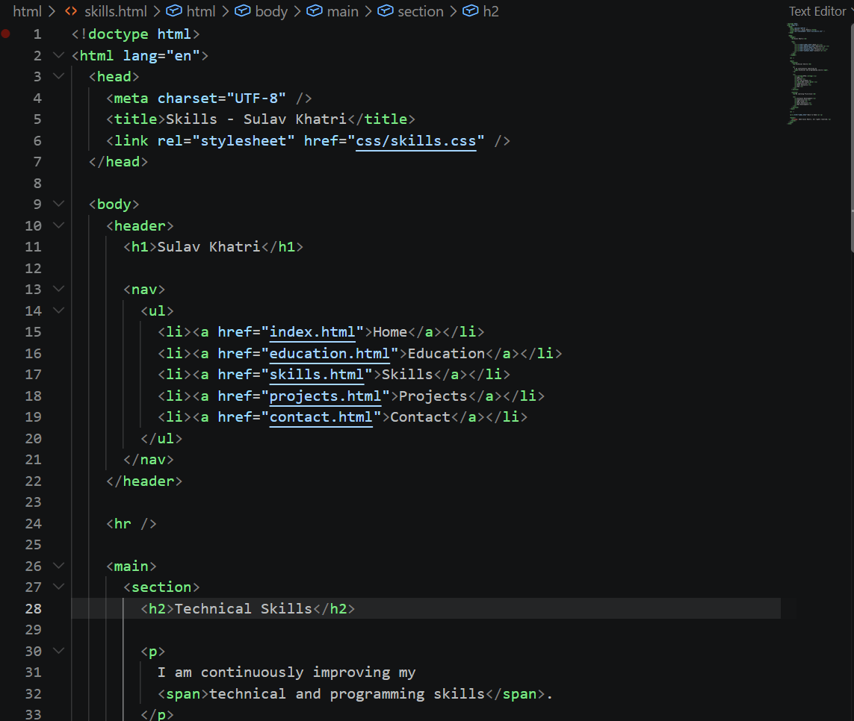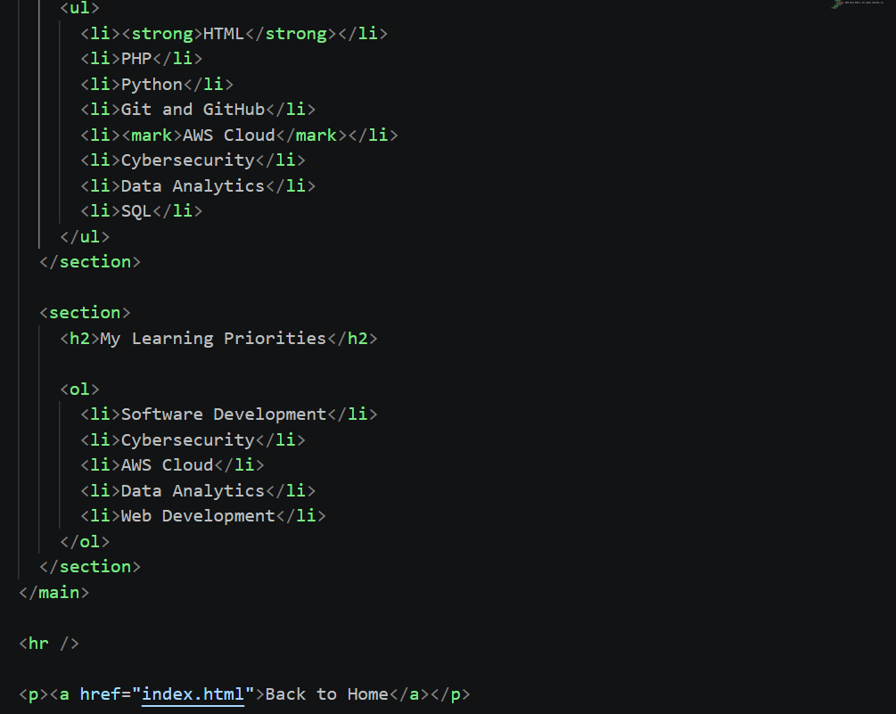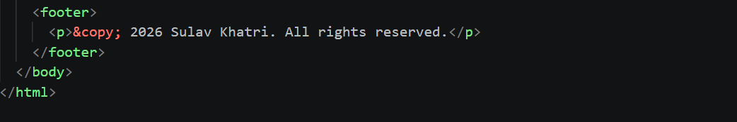
Projects.html page
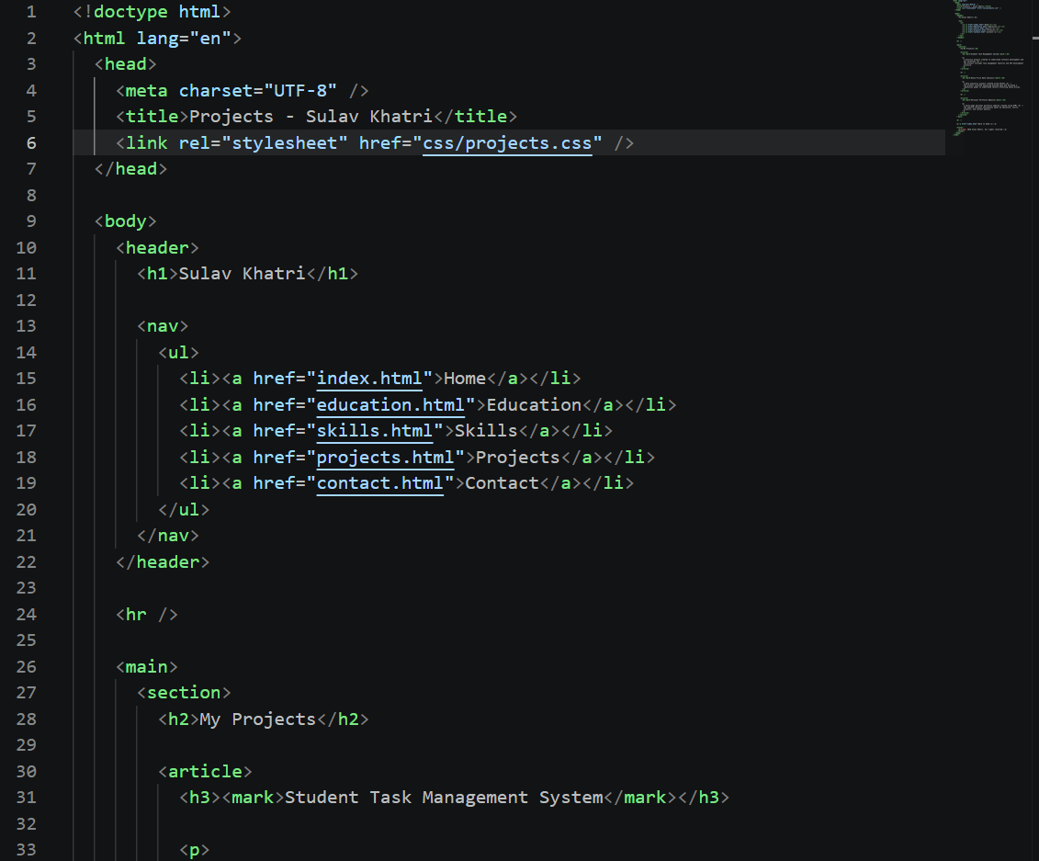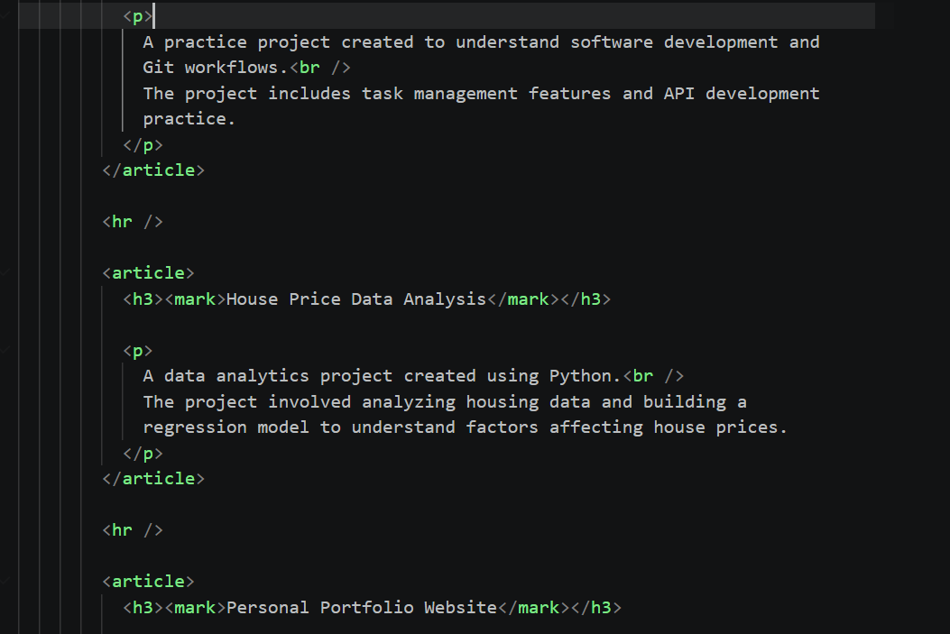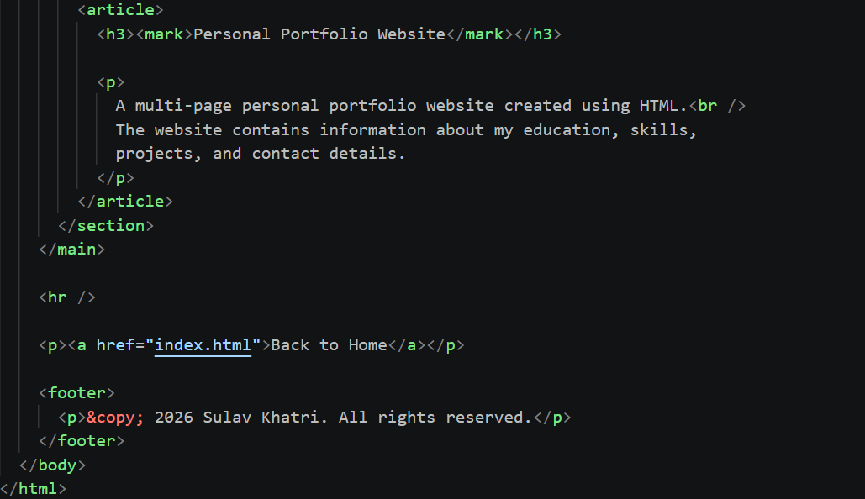
Contact.html Page
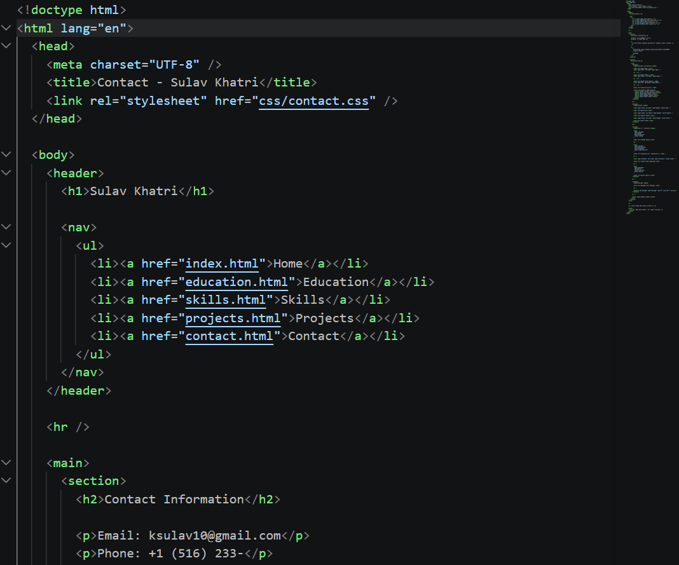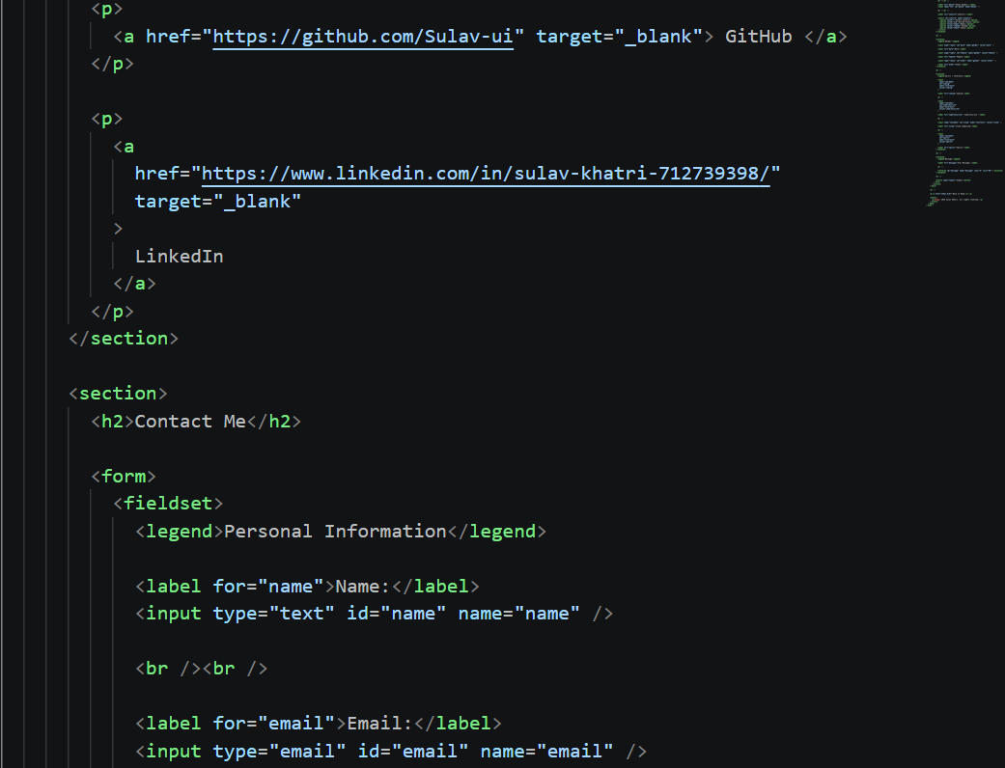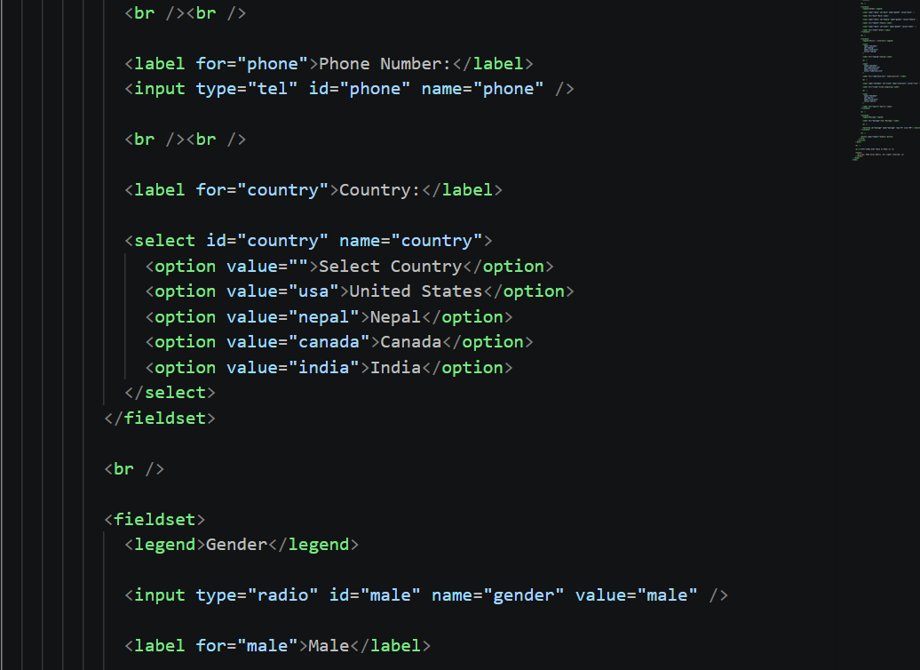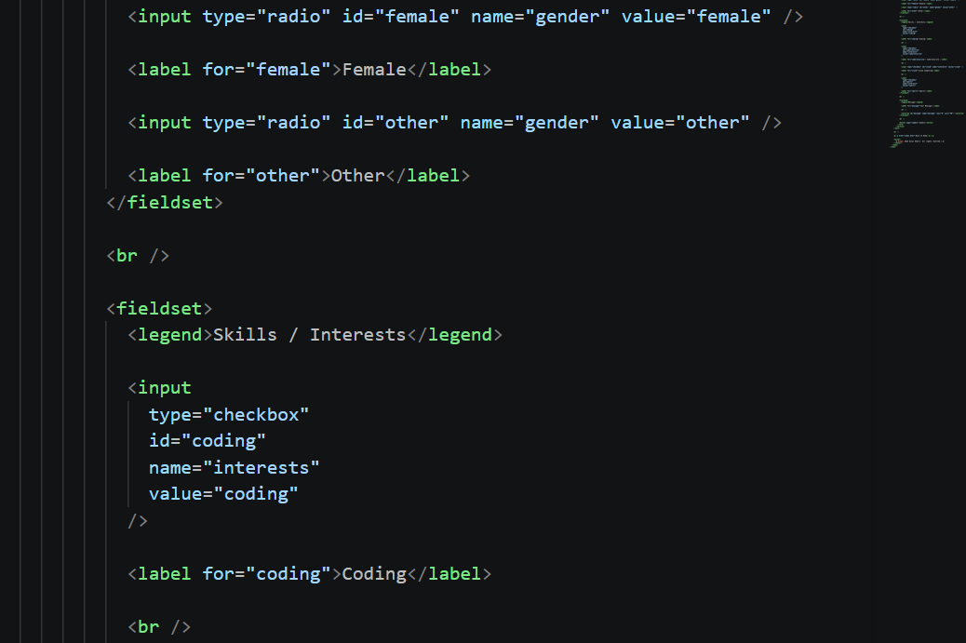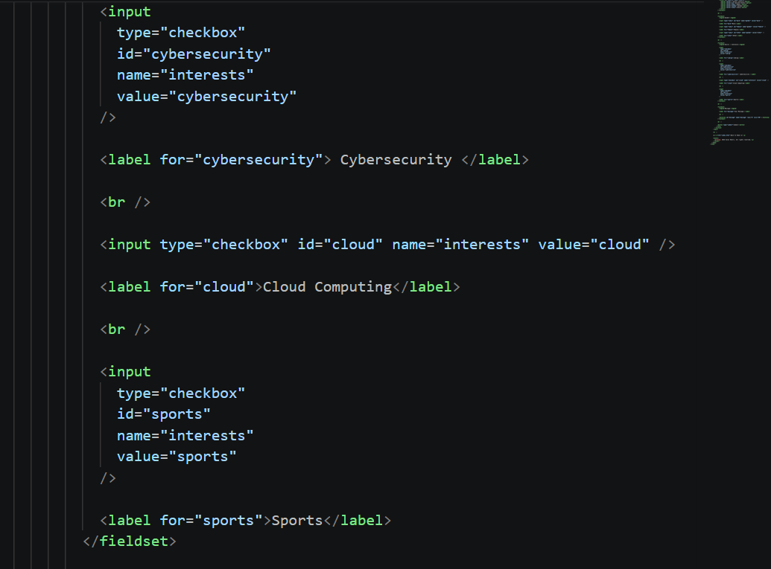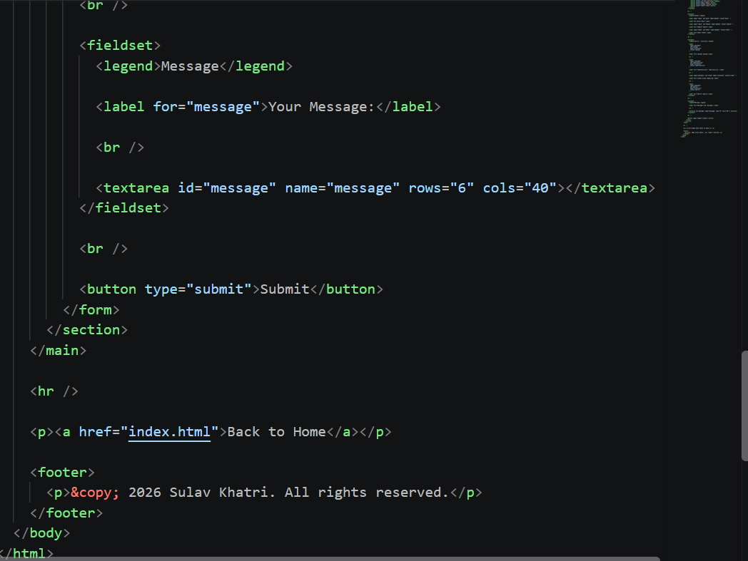
Here is GitHub link for this project.
https://github.com/Sulav-ui/student-web-project/tree/development/personal-portfolio

