You are tasked with building a simple webpage that shows 3 profile cards in a row. Each card will display a person's photo, name, bio, and a button. You will also add a fixed header and use relative/absolute positioning for a small "badge" on the card. Tasks:
1. Page Layout (Display Properties)
- Use a parent container with display: block.
- Inside it, use display properties to show 3 profile cards side by side.
- Set width/height and spacing using margin and padding.
2. Card Content (Display & Layout)
Each card must include:
- A photo (use a placeholder)
- A name (e.g., <h2>)
- A short paragraph(bio)
- A button (e.g., "Contact")
3. Header (Fixed and Sticky Positioning)
- Create a header at the top using position: fixed or sticky
- It should stay visible as the user scrolls
- Add some scrollable content below the cards to demonstrate sticky/fixed behavior.
4. Badge on Cards (Relative + Absolute)
- On each card, add a small "NEW" badge using position: absolute
- Use position: relative on the card to contain the absolute positioning
The html and css files are below:
HTML file
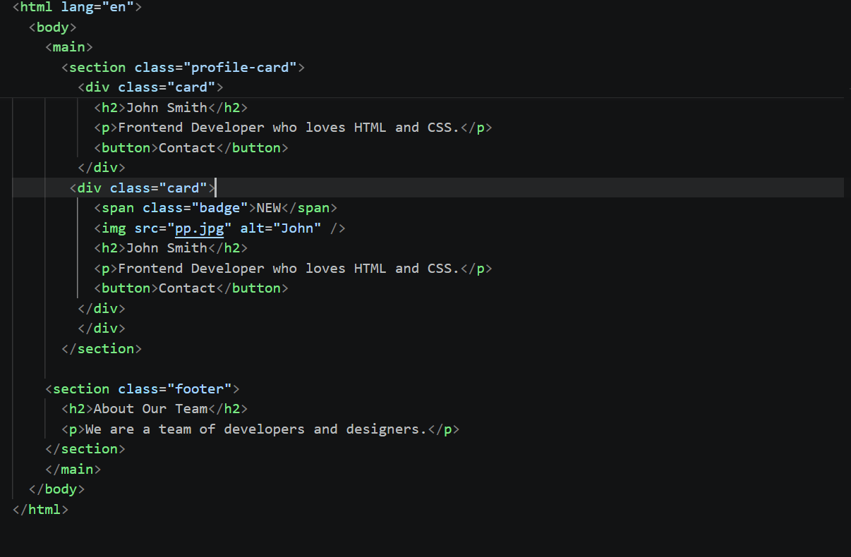
CSS files:
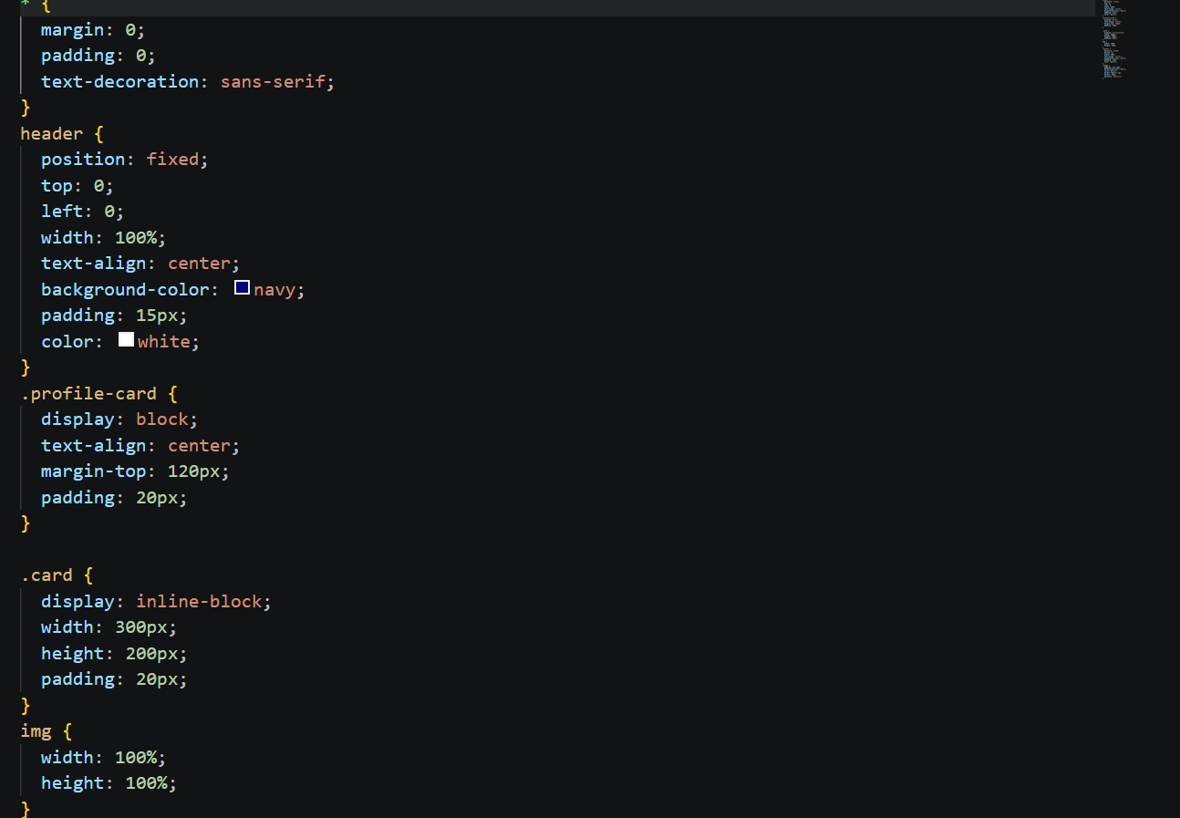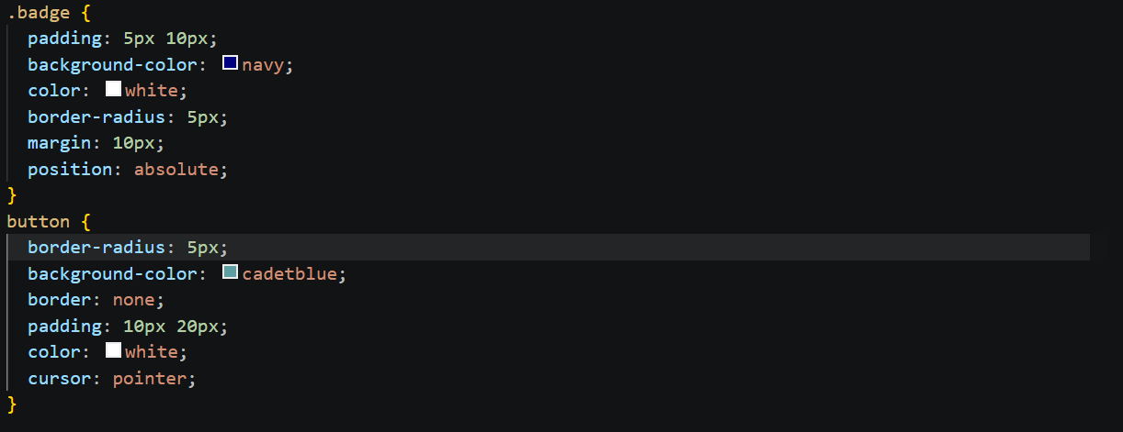
Output
