**程序报告**

学号：2213410 姓名：徐俊智

1. **问题重述**

（简单描述对问题的理解，从问题中抓住主干，必填）

====================================================================

本次实验的目标是使用基础搜索算法和 Deep QLearning 算法，完成机器人自动走迷宫。

1. **设计思想**

（所采用的方法，有无对方法加以改进，该方法有哪些优化方向（参数调整，框架调整，或者指出方法的局限性和常见问题），伪代码，理论结果验证等… **思考题，非必填**）

====================================================================

基础搜索算法：我使用的是广度优先搜索算法，维护了一个队列来存储节点。

Deep QLearning 算法：我使用的是DQN算法

优化方向：

main.py

1.调整参数batch_size从32改为128，提供更稳定的梯度估计

2.调整目的地奖励destination从-50改为-maze.maze_size ** 2 * 4，更快地引导机器人学习到达目的地的策略

3.调整Replay Memory 的 max_size 从 max(self.maze_size ** 2 * 3, 1e4) 改为 max(self.maze_size ** 2 * 10, 1e4)，让网络有更多的数据来学习

4.新增 self.memory.build_full_view(maze)

5.ε-greedy 探索策略的更新规则从 self.epsilon = max(0.01, self.epsilon * 0.995) 改为 self.epsilon = max(0.08, self.epsilon * 0.43)，加快了 ε 的衰减速率

QNetwork.py

把  
self.input_hidden = nn.Sequential(

nn.Linear(state_size, 512), # 从状态维度映射到512维的隐藏层

nn.ReLU(False), # 激活函数

nn.Linear(512, 512), # 第二个512维的隐藏层

nn.ReLU(False), # 激活函数

)

self.final_fc = nn.Linear(512, action_size) # 从最后一个隐藏层映射到动作值

修改为  
self.input_hidden = nn.Sequential(

nn.Linear(state_size, 1024), # 从状态维度映射到1024维的隐藏层

nn.ReLU(False), # 激活函数

nn.Linear(1024, 1024), # 第二个1024维的隐藏层

nn.ReLU(False), # 激活函数

)

self.final_fc = nn.Linear(1024, action_size) # 从最后一个隐藏层映射到动作值

原先的网络有两个大小为 512 的全连接层，修改为两个大小为 1024 的全连接层后可以提供更多的容量，有助于特征捕捉。

1. **代码内容**

（能体现解题思路的主要代码，有多个文件或模块可用多个"===="隔开，必填）

====================================================================

**main.py**

# 导入相关包

import os

import random

import numpy as np

from Maze import Maze

from Runner import Runner

from QRobot import QRobot

from ReplayDataSet import ReplayDataSet

from torch_py.MinDQNRobot import MinDQNRobot as TorchRobot # PyTorch版本

from keras_py.MinDQNRobot import MinDQNRobot as KerasRobot # Keras版本

import matplotlib.pyplot as plt

# 机器人移动方向

move_map = {

'u': (-1, 0), # up

'r': (0, +1), # right

'd': (+1, 0), # down

'l': (0, -1), # left

}

# 迷宫路径搜索树

class SearchTree(object):

def __init__(self, loc=(), action='', parent=None):

"""

初始化搜索树节点对象

:param loc: 新节点的机器人所处位置

:param action: 新节点的对应的移动方向

:param parent: 新节点的父辈节点

"""

self.loc = loc # 当前节点位置

self.to_this_action = action # 到达当前节点的动作

self.parent = parent # 当前节点的父节点

self.children = [] # 当前节点的子节点

def add_child(self, child):

"""

添加子节点

:param child:待添加的子节点

"""

self.children.append(child)

def is_leaf(self):

"""

判断当前节点是否是叶子节点

"""

return len(self.children) == 0

def expand(maze, is_visit_m, node):

"""

拓展叶子节点，即为当前的叶子节点添加执行合法动作后到达的子节点

:param maze: 迷宫对象

:param is_visit_m: 记录迷宫每个位置是否访问的矩阵

:param node: 待拓展的叶子节点

"""

can_move = maze.can_move_actions(node.loc)

for a in can_move:

new_loc = tuple(node.loc[i] + move_map[a][i] for i in range(2))

if not is_visit_m[new_loc]:

child = SearchTree(loc=new_loc, action=a, parent=node)

node.add_child(child)

def back_propagation(node):

"""

回溯并记录节点路径

:param node: 待回溯节点

:return: 回溯路径

"""

path = []

while node.parent is not None:

path.insert(0, node.to_this_action)

node = node.parent

return path

def my_search(maze):

"""

任选深度优先搜索算法、最佳优先搜索（A*)算法实现其中一种

:param maze: 迷宫对象

:return :到达目标点的路径 如：["u","u","r",...]

"""

# -----------------请实现你的算法代码--------------------------------------

start = maze.sense_robot()

root = SearchTree(loc=start)

queue = [root] # 节点队列，用于层次遍历

h, w, _ = maze.maze_data.shape

is_visit_m = np.zeros((h, w), dtype=np.int) # 标记迷宫的各个位置是否被访问过

peek = 0

while True:

current_node = queue[peek] # 栈顶元素作为当前节点

if current_node.loc == maze.destination: # 到达目标点

path = back_propagation(current_node)

break

if current_node.is_leaf() and is_visit_m[current_node.loc] == 0: # 如果该点存在叶子节点且未拓展

is_visit_m[current_node.loc] = 1 # 标记该点已拓展

expand(maze, is_visit_m, current_node)

peek+=1 # 开展一些列入队操作

for child in current_node.children:

queue.append(child) # 叶子节点入队

else:

queue.pop(peek) # 如果无路可走则出队

peek-=1

return path

from QRobot import QRobot

import numpy as np

import random

import torch

import torch.nn.functional as F

from torch import optim

from QRobot import QRobot

from Maze import Maze

from ReplayDataSet import ReplayDataSet

from torch_py.QNetwork import QNetwork

from Runner import Runner

class Robot(QRobot):

valid_action = ['u', 'r', 'd', 'l']

''' QLearning parameters'''

epsilon0 = 0.5 # 初始贪心算法探索概率

gamma = 0.94 # 公式中的 γ

EveryUpdate = 1 # the interval of target model's updating

"""some parameters of neural network"""

target_model = None

eval_model = None

batch_size = 128

learning_rate = 1e-2

TAU = 1e-3

step = 1 # 记录训练的步数

"""setting the device to train network"""

device = torch.device("cuda:0") if torch.cuda.is_available() else torch.device("cpu")

def __init__(self, maze):

"""

初始化 Robot 类

:param maze:迷宫对象

"""

super(Robot, self).__init__(maze)

maze.set_reward(reward={

"hit_wall": 10.,

"destination": -maze.maze_size ** 2 * 4.,

"default": 1.,

})

self.maze = maze

self.maze_size = maze.maze_size

"""build network"""

self.target_model = None

self.eval_model = None

self._build_network()

"""create the memory to store data"""

max_size = max(self.maze_size ** 2 * 10, 1e4)

self.memory = ReplayDataSet(max_size=max_size)

self.memory.build_full_view(maze)

def _build_network(self):

seed = 0

random.seed(seed)

"""build target model"""

self.target_model = QNetwork(state_size=2, action_size=4, seed=seed).to(self.device)

"""build eval model"""

self.eval_model = QNetwork(state_size=2, action_size=4, seed=seed).to(self.device)

"""build the optimizer"""

self.optimizer = optim.Adam(self.eval_model.parameters(), lr=self.learning_rate)

def target_replace_op(self):

"""

Soft update the target model parameters.

θ_target = τ*θ_local + (1 - τ)*θ_target

"""

# for target_param, eval_param in zip(self.target_model.parameters(), self.eval_model.parameters()):

# target_param.data.copy_(self.TAU * eval_param.data + (1.0 - self.TAU) * target_param.data)

""" replace the whole parameters"""

self.target_model.load_state_dict(self.eval_model.state_dict())

def _choose_action(self, state):

state = np.array(state)

state = torch.from_numpy(state).float().to(self.device)

if random.random() < self.epsilon:

action = random.choice(self.valid_action)

else:

self.eval_model.eval()

with torch.no_grad():

q_next = self.eval_model(state).cpu().data.numpy() # use target model choose action

self.eval_model.train()

action = self.valid_action[np.argmin(q_next).item()]

return action

def _learn(self, batch: int = 16):

if len(self.memory) < batch:

#print("the memory data is not enough")

#return

state, action_index, reward, next_state, is_terminal = self.memory.random_sample(len(self.memory))

else:

state, action_index, reward, next_state, is_terminal = self.memory.random_sample(batch)

""" convert the data to tensor type"""

state = torch.from_numpy(state).float().to(self.device)

action_index = torch.from_numpy(action_index).long().to(self.device)

reward = torch.from_numpy(reward).float().to(self.device)

next_state = torch.from_numpy(next_state).float().to(self.device)

is_terminal = torch.from_numpy(is_terminal).int().to(self.device)

self.eval_model.train()

self.target_model.eval()

"""Get max predicted Q values (for next states) from target model"""

Q_targets_next = self.target_model(next_state).detach().min(1)[0].unsqueeze(1)

"""Compute Q targets for current states"""

Q_targets = reward + self.gamma * Q_targets_next * (torch.ones_like(is_terminal) - is_terminal)

"""Get expected Q values from local model"""

self.optimizer.zero_grad()

Q_expected = self.eval_model(state).gather(dim=1, index=action_index)

"""Compute loss"""

loss = F.mse_loss(Q_expected, Q_targets)

loss_item = loss.item()

""" Minimize the loss"""

loss.backward()

self.optimizer.step()

"""copy the weights of eval_model to the target_model"""

self.target_replace_op()

return loss_item

def train_update(self):

state = self.sense_state()

action = self._choose_action(state)

reward = self.maze.move_robot(action)

next_state = self.sense_state()

is_terminal = 1 if next_state == self.maze.destination or next_state == state else 0

self.memory.add(state, self.valid_action.index(action), reward, next_state, is_terminal)

"""--间隔一段时间更新target network权重--"""

if self.step % self.EveryUpdate == 0:

self._learn(batch=len(self.memory))

"""---update the step and epsilon---"""

self.step += 1

self.epsilon = max(0.08, self.epsilon * 0.43)

return action, reward

def test_update(self):

state = np.array(self.sense_state(), dtype=np.int16)

state = torch.from_numpy(state).float().to(self.device)

self.eval_model.eval()

with torch.no_grad():

q_value = self.eval_model(state).cpu().data.numpy()

action = self.valid_action[np.argmin(q_value).item()]

reward = self.maze.move_robot(action)

return action, reward

====================================================================

**QNetwork.py**

from abc import ABC

import torch.nn as nn

import torch

class QNetwork(nn.Module, ABC):

"""Actor (Policy) Model."""

def __init__(self, state_size: int, action_size: int, seed: int):

"""Initialize parameters and build model.

Params

======

state_size (int): Dimension of each state

action_size (int): Dimension of each action

seed (int): Random seed

"""

super(QNetwork, self).__init__()

self.seed = torch.manual_seed(seed)

self.input_hidden = nn.Sequential(

nn.Linear(state_size, 1024),

nn.ReLU(False),

nn.Linear(1024, 1024),

nn.ReLU(False),

)

self.final_fc = nn.Linear(1024, action_size)

def forward(self, state):

"""Build a network that maps state -> action values."""

x = self.input_hidden(state)

return self.final_fc(x)

if __name__ == "__main__":

# os.environ["CUDA_LAUNCH_BLOCKING"] = "1"

device = torch.device("cuda:0") if torch.cuda.is_available() else torch.device("cpu")

# device = torch.device("cpu")

net = QNetwork(2, 4, 0).to(device)

x = torch.tensor([1, 1]).float().unsqueeze(0).to(device)

#

# torch.nn.DataParallel(net, device_ids=[0])

print(net(x))

1. **实验结果**

（实验结果，必填）

====================================================================

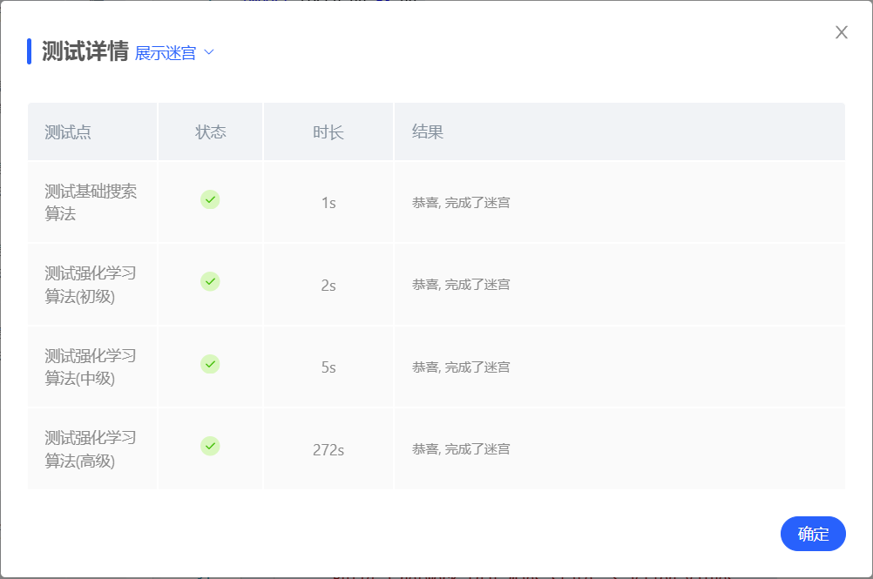

1. **总结**

（自评分析（是否达到目标预期，可能改进的方向，实现过程中遇到的困难，从哪些方面可以提升性能，模型的超参数和框架搜索是否合理等），**思考题，非必填**）

====================================================================

在本次实验中，我使用了广度优先搜索算法和DQN算法，最后成功实现了机器人自动走迷宫。

可能改进的方向：

1.对基础搜索算法，可以引入更高效的搜索策略，如A*算法

2.对DQN算法，可以继续调整模型的超参数，如通过调整学习率和折扣因子等来提升性能。

实现过程中的困难：主要困难是超参数的选择，特别是学习率和折扣因子，它们对模型性能有显著影响。最后通过多次试验确定了一组合适的超参数，但这个过程相当耗时。

提升性能：模型的超参数和框架搜索在一定程度上是合理的，但仍有改进空间。通过更细致的调整和更深入的分析，可以进一步提升模型的性能。