RESEARCH DOSSIER / NO. 001

The Income Distribution
of Independent Apps
How Many Indie App Developers Make $1,000 a Month?
LOWER | CENTRAL | UPPER
8.4% | 15.4% | 25.0%
Share of serious independent developers with at least $1,000 in current monthly gross app revenue across their owned portfolio
Provisional answer
About one in six serious independent app developers generate at least $1,000 in a current month across apps they own. A defensible plausible interval is about one in twelve to one in four. Requiring three consecutive months lowers the central estimate to about 12%. The result is a transparent model, not a store census.

Prepared for sulayman-bowles.dev
Research cut-off: 14 July 2026
Primary basis: gross monthly revenue, trailing 30 days
Model: 500,000 Monte Carlo draws; seed 20260714

Research status and evidence labels
OBSERVED FACT A numerical statement copied from an identifiable source and limited to that source’s population.
DERIVED CALCULATION Arithmetic performed on observed or explicitly assumed inputs.
MODELED ESTIMATE A probability or distribution generated from the documented scenario model. Intervals are plausible uncertainty ranges, not frequentist confidence intervals.
INTERPRETATION A judgment about what the evidence means, without pretending it is directly measured.
SPECULATION A possible mechanism where the evidence is too weak for a stable estimate. Speculation is kept out of headline figures.
Input-file audit
The ZIP uploaded in this conversation was a Google Search Console performance export, not an app-economics dataset. The research dossier was found in the user’s File Library. No separate app-level evidence dataset was available, so the case table was reconstructed from the dossier and extended with current primary and directly attributable sources. Case frequencies are never used as prevalence estimates.

Contents
1. Direct answer and denominator ladder
2. Definitions
3. Methodology and source hierarchy
4. What is directly observed
5. Estimated revenue distribution
6. App-level versus developer-level outcomes
7. Monetization, platform, category, and maturity
8. Anatomy of the $1,000-per-month app
9. Representative and low-revenue cases
10. Survivorship and reporting bias
11. Sensitivity analysis
12. Limitations and unresolved questions
13. Original contribution
14. Publication architecture and chart plan
15. Reproducibility and downloadable appendix
16. Source table
17. Claim-by-claim evidence ledger

1. Direct answer and denominator ladder
Direct answer
Under this report’s primary definition - independent developers making a meaningful commercial attempt - the estimated share generating at least $1,000 of current gross monthly app revenue across all apps they own is 15.4%, with a plausible range of 8.4% to 25.0%. At the individual-app level, the estimate is 10.2% (5.3%-17.4%). [M01]

MODELED ESTIMATE The three-month-sustained estimate is 12.0% of developers and 7.3% of apps. [M01]
INTERPRETATION Counting every store listing gives a very different answer: 1.5% of developers/publishers and 1.0% of apps in a current month. This is mostly a denominator result, not a contradiction. [M01]
OBSERVED FACT RevenueCat reports that 17.3% of newly launched apps in its selected subscription cohort ever reached $1,000 monthly revenue within two years; 4.6% reached $10,000. Its cohort excludes non-subscription apps, apps without active subscription revenue, and apps below inclusion thresholds. [S07]
OBSERVED FACT The CMA reports that more than 90% of developers distributing on Google Play generated no revenue through Google Play Billing. This does not cover ads, external billing, physical goods, or revenue on another platform. [S06]
Denominator | $1k+ apps, current | $1k+ developers, current | Status
A. All listed apps | 1.0%  (0.3%-2.7%) | 1.5%  (0.5%-4.2%) | Modeled [M01]
B. Active apps | 3.3%  (1.6%-6.0%) | 5.1%  (2.6%-9.2%) | Modeled [M01]
C. Active monetized apps | 7.7%  (4.4%-12.4%) | 11.7%  (6.8%-18.3%) | Modeled [M01]
D. Independently owned active apps | 4.5%  (2.4%-7.9%) | 7.0%  (3.9%-12.0%) | Modeled [M01]
E. Serious commercial attempts | 10.2%  (5.3%-17.4%) | 15.4%  (8.4%-25.0%) | Modeled [M01]
F. Maintained for at least 12 months | 12.3%  (6.2%-21.4%) | 18.2%  (9.8%-30.0%) | Modeled [M01]

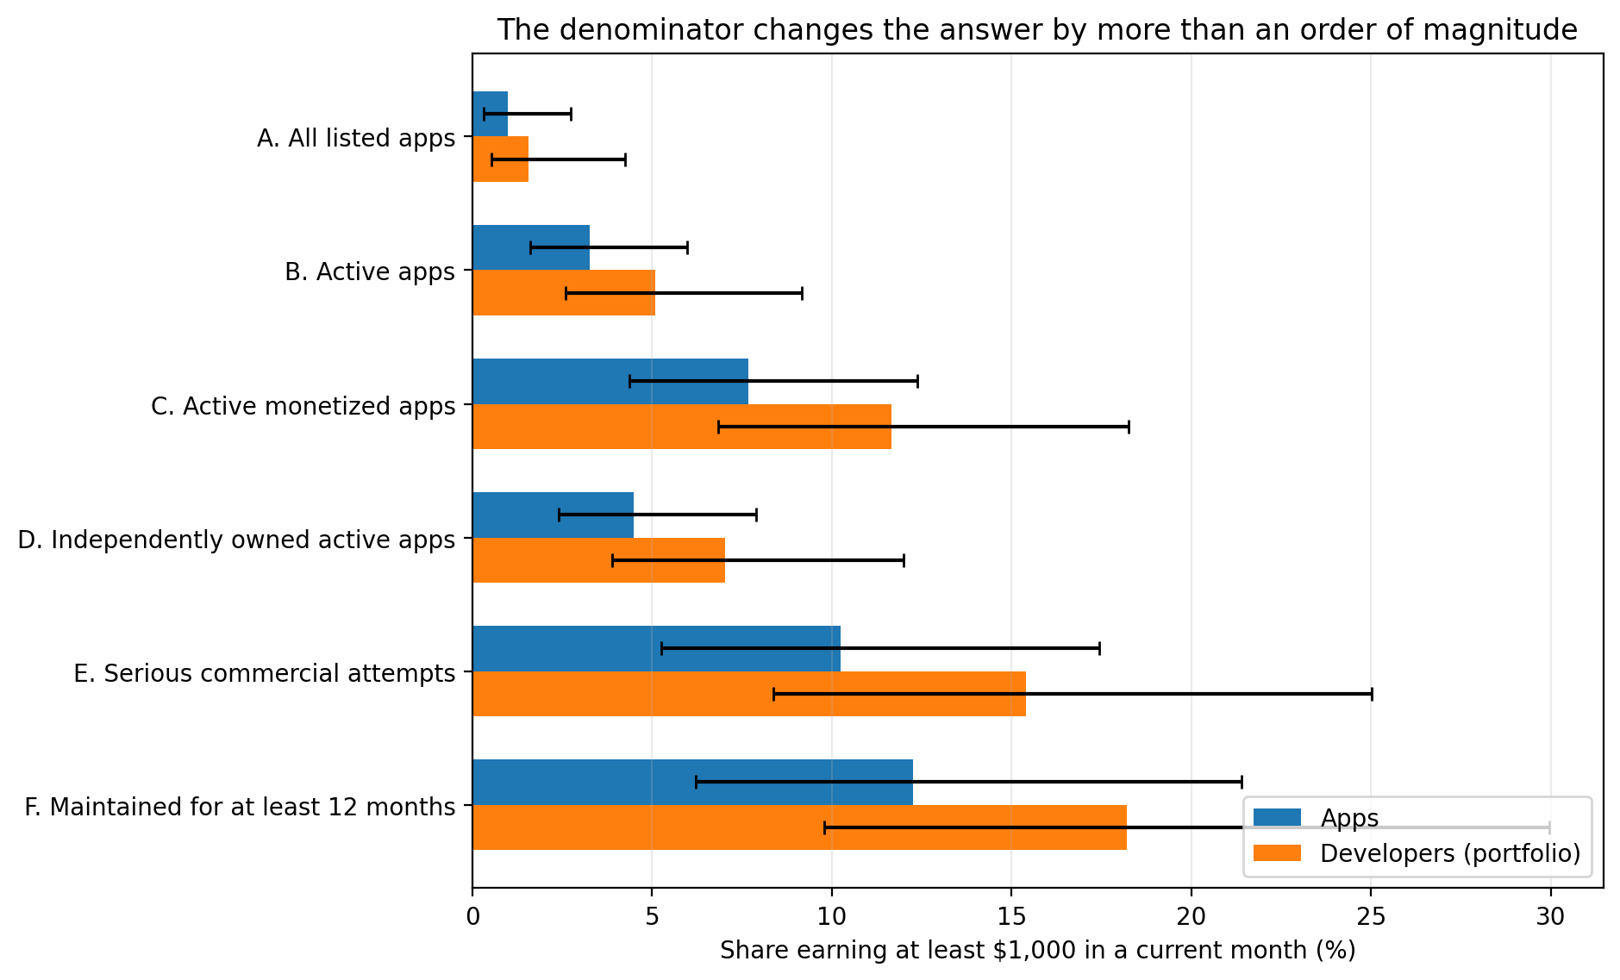
Figure 1. The $1,000-per-month estimate rises as the denominator narrows to economically active apps and developers.
Source: model [M01]. Error bars are plausible ranges.

What the headline does and does not say
- It measures gross revenue, not take-home pay. A developer with $1,000 gross may receive roughly $850 before operating costs under a 15% fee schedule, and less after hosting, APIs, support, refunds, or acquisition. [S11-S12; M02]
- It measures a current trailing-30-day run rate. Reaching the threshold once is easier than maintaining it.
- It counts revenue across all apps the developer economically owns. The app-level estimate is lower because a portfolio can combine several sub-threshold apps.
- It excludes contract apps, client-owned products, internal enterprise tools, and products controlled by a parent company or institutional investor.
- It is not a statement that the remaining developers “failed.” Many apps are hobbies, portfolio pieces, companions to other businesses, or intentionally free.

2. Definitions
The estimate is only meaningful if the population and revenue basis are fixed before looking at outcomes. The following definitions are the publication standard.
Term | Operational definition | Analytic note
Independent developer | A person or team of no more than five full-time-equivalent workers that has economic control of the app, owns or controls the IP and revenue rights, and is not controlled by a parent company, public company, client, employer, or institutional investor. Contractors are allowed. | Primary analytical population; tighter than “small developer.”
Small app publisher | A publisher with no more than 10 FTEs and less than $1 million of trailing-12-month gross app revenue, with no controlling parent. | Broader than independent; includes small funded companies.
Consumer mobile app | A native or hybrid iOS or Android product whose primary user is an individual consumer. Excludes internal enterprise tools, client-owned apps, mobile web products, and apps that merely facilitate physical-goods sales. | Keeps app economics distinct from commerce enabled by an app.
Active app | An app that is available and functional and either was updated in the prior 24 months or had a substantive usage, search, download, rating, or review signal in the prior 12 months. | Sensitivity: 12-month update rule vs. 24 months.
Commercial app | An app with a live monetization path, or documented external monetization attributable to the app. | Includes subscription, paid download, IAP, advertising, and commission models.
Meaningful commercial attempt | An independent consumer app live for at least 90 days with functional monetization and at least one of: 1,000 lifetime installs; 10 ratings/reviews; $100 lifetime revenue; $500 launch or marketing spend; or 100 documented post-launch founder hours. | Excludes templates, tests, abandoned prototypes, brand companions, and client work.
Monthly revenue | Trailing-30-day customer receipts attributable to digital app access or use, in-app advertising, or app-mediated commission, net of refunds and indirect tax but before platform/payment fees and operating costs. | The report’s default headline basis: gross revenue.
Sustained monthly revenue | The threshold is met in each of three consecutive calendar months. | Six-month persistence is shown as a sensitivity, not the default.
Gross revenue | Customer billings attributable to the app, net of refunds and indirect tax, before store/payment fees and operating costs. | Comparable to consumer spend only when tax/refund treatment is explicit.
Developer proceeds | Gross revenue less app-store/payment fees and withholding, before hosting, APIs, support, contractors, acquisition, and personal tax. | Apple and Google also use “proceeds” or “earnings” in program-specific ways.
Profit | Developer proceeds less hosting, APIs, support, contractors, paid acquisition, content, and tools. Founder labor and personal tax are excluded from accounting profit; an economic-profit sensitivity values founder labor at market rates. | Public revenue screenshots rarely establish profit.
Full-time replacement income | $5,000 per month of owner profit before personal tax. | Sensitivity points: $3,000 and $8,333 per month.

Denominator definitions used in the estimate
Code | Population | Purpose
A | All listed apps | A store-universe upper bound. Includes abandoned, invisible, noncommercial, test, and hobby listings.
B | Active apps | Available and functional, with recent update or observable use/search/rating signals.
C | Active monetized apps | Active apps with paid access, IAP, subscription, advertising, commission, or attributable off-store monetization.
D | Independently owned active apps | Active apps whose economics are controlled by an independent person or small team.
E | Serious commercial attempts | The primary causal/economic population: live >=90 days, functional monetization, plus a minimum effort or traction signal.
F | Maintained for at least 12 months | A mature subset of E that survived and continued receiving maintenance for at least one year.

INTERPRETATION A, B, and C are primarily app denominators. D, E, and F can be mapped to developers only after publisher ownership and portfolios are resolved. App stores do not expose an “independent” field.

3. Methodology and source hierarchy

3.1 Triangulation without averaging incompatible data
- Official store and regulatory records set hard or quasi-hard denominators, fee rules, and billing-channel facts. They do not reveal app-level income.
- Subscription platforms supply the strongest direct milestone and distribution evidence, but only inside selected subscription cohorts.
- App-intelligence sources help characterize store inventory and visibility. Their small-app coverage and revenue-estimation methods are incomplete.
- Verified dashboards and acquisition marketplaces provide attributable current revenue, subscriber, cost, and outcome records. They are selected on disclosure and saleability.
- Founder surveys, postmortems, and academic work provide mechanisms and left-tail evidence. Many are old, self-selected, or category-specific.
METHOD RULE No cross-source arithmetic average is taken. Each evidence class constrains a different piece of the model: denominator composition, milestone probability, persistence, portfolio aggregation, or unit economics.

3.2 Source-quality hierarchy
Rank | Source class | Best use | Primary failure mode
A1 | Official store / administrator | Inventory, removals, fee rules, program definitions | No independent flag or app-level income
A2 | Regulatory / compelled evidence | Narrow but less disclosure-biased platform facts | Jurisdiction and billing-channel scope
B1 | Transaction platform cohort | Revenue milestones, retention, conversion, category/platform cuts | Subscription and inclusion selection
B2 | Academic / defined survey | Behavior, historical distribution, causal/category analysis | Staleness or response/sample selection
C1 | App intelligence / directory | Activity proxies, ratings, paid/IAP inventory, relative ranks | Modeled estimates; weak tiny-app coverage
C2 | Verified dashboard / marketplace | App-specific revenue, subscriptions, costs, operating context | Severe disclosure and sale-selection bias
D | Founder self-report / postmortem | Age, team, launch, acquisition, failure mechanisms | Unverified or incomplete basis/period/costs
E | Unattributed roundup | Search leads only | Unknown population and duplicated claims

3.3 Evidence-class audit
Class | Represents | Excludes | Success bias | Unit | Time | Use
Official store / administrator data | Store-wide listings, submissions, developer accounts, fee schedules | Independence, realized app revenue, ads/external payments | Low success bias; denominator may include dead or noncommercial listings | Apps or accounts | Annual snapshot / current rule | Best for denominators and definitions; cannot answer income alone.
Regulatory evidence | Compelled platform data and market evidence | Often redacted; geography and billing channel narrow | Lower disclosure bias; metric can be narrow | Developers and apps | Specific year / investigation period | CMA’s “no Play Billing revenue” is not “no app revenue.”
Subscription platform cohort | Apps with integrated subscription infrastructure and observable transactions | Non-subscription apps, zero-revenue apps, apps below minimum thresholds | Overrepresents commercial and subscription success | Apps/projects | Cohort and annual windows | Strong within-cohort benchmark; poor store-wide denominator.
Academic / representative survey | Defined sample with disclosed methods | Often old, category-limited, or self-selected | Varies; publication and response bias remain | Apps or developers | Cross-section / panel | Useful for structure and historical checks, not current prevalence alone.
App-intelligence estimate | Apps visible to vendor models, rankings, panels, or SDK detection | Tiny apps and off-store/external revenue; estimation error | Can miss low-activity tail; success bias depends on product | Apps/publishers | Monthly or annual estimate | Good for relative ranking; not a census of tiny apps.
Verified dashboard / marketplace | Voluntary listings with linked Stripe, RevenueCat, or Superwall data | Unsellable apps, undisclosed apps, many failures and nonparticipants | Severe success and sale-selection bias | App, startup, or founder portfolio | Current 30-day / lifetime | High attribution for the listed case; unusable for prevalence without denominator.
Founder survey | Respondents in developer communities | Nonrespondents, hobbyists or firms depending recruitment | Commercial ambition and memory bias | Often developer, sometimes per app | Survey period | Can estimate developer-level patterns only when recruitment and unit are clear.
Founder disclosure / postmortem | A named app or portfolio with narrative context | Non-disclosers and disappeared apps | Strong success or grievance bias | App or developer | Point-in-time or lifetime | Best for mechanisms, age, workload, and failure modes; not incidence.

3.4 Formal model
M01 Serious-app current probability: p_serious = p_RC_ever_hit x k_current_given_hit x k_transfer_to_all_serious. Inputs: p_RC ~ triangular(0.13,0.173,0.22); persistence ~ triangular(0.35,0.75,0.95); transfer ~ triangular(0.45,0.85,1.35). Rationale: RevenueCat selected cohort is the only large, direct milestone dataset; two separate discounts/adjustments bridge it to current, all-model indie apps.
M02 Unit economics: Required units = target / net contribution per unit. Inputs: Common 15% fee, plus scenario-specific fixed and variable costs. Rationale: Arithmetic model; outputs are conditional, not prevalence estimates.
M03 Denominator mixture: p_D = sum_j w_Dj p_j. Inputs: Latent states: inactive, active-light, active monetized-light, serious, mature; weights drawn from Dirichlet distributions. Rationale: Encodes uncertainty around how much of each store denominator is economically meaningful.
M04 Developer portfolio uplift: p_dev = p_app + d x (sum_n w_n[1-(1-p_app)^n] - p_app) + portfolio_sum_bonus. Inputs: App-count weights: 58% one, 22% two, 10% three, 5% four, 3% five, 2% eight; diversification d ~ triangular(0.40,0.65,0.95). Rationale: Allows multiple owned apps while dampening independence because app outcomes share developer skill, audience, and category exposure.
M05 Sustained revenue: p_sustained = p_current x persistence factor. Inputs: App factor triangular(0.50,0.75,0.90); developer factor triangular(0.60,0.80,0.95). Rationale: No representative store-wide persistence panel exists; interval intentionally wide.
M06 Uncertainty: Reported intervals are plausible uncertainty intervals, not frequentist confidence intervals.. Inputs: 500,000 Monte Carlo draws; seed 20260714. Rationale: Captures model/denominator uncertainty, not sampling error alone.
Central bridge from the subscription benchmark
The modal bridge is 17.3% ever-hit in the RevenueCat launch cohort x 75% probability of still being above the threshold in a current month x 85% transfer from selected subscription apps to all serious independent commercial apps = 11.0% at the app level. The Monte Carlo median is 10.23% because the product of asymmetric distributions is not the product of their modes. Portfolio aggregation produces 15.41% at the developer level. [S07; M01]

UNCERTAINTY The lower and upper figures are the 2.5th and 97.5th percentiles of 500,000 draws. They express model and denominator uncertainty. They do not imply that the model contains a representative random sample of all independent apps.

4. What is directly observed

4.1 Store inventory and observable activity
OBSERVED FACT Apple reported 2,172,472 apps on the App Store in 2025. Of those, 1,365,649 appeared in the top 10 results for at least 1,000 searches during the year. Search appearance is not revenue, but it provides a more meaningful activity/discoverability proxy than raw listings. [S02]
OBSERVED FACT AppBrain counted 1,887,487 available Google Play apps on 14 July 2026. Only 321,598 had any rating, 83% had fewer than three ratings, 3.5% were paid, and 337,943 were detected with in-app billing. These are third-party directory statistics, not Google’s official app census. [S03-S05]
OBSERVED FACT Apple’s sponsored small-developer study classified more than 90% of App Store developers as small under its definition, while excluding developers that never exceeded 1,000 annual downloads. That exclusion is evidence that even Apple avoided treating every dormant or ultra-low-activity account as an economically meaningful developer. [S10]

4.2 Direct subscription distribution evidence
OBSERVED FACT RevenueCat’s 2026 report covers more than 115,000 apps, more than $16 billion of revenue, and more than one billion transactions. Inclusion requires RevenueCat integration, active subscription revenue, and minimum install or revenue thresholds. [S07]
Metric | Observed value | Population / caveat
New apps ever hitting $1,000 monthly revenue within two years | 17.3% | Selected newly launched subscription apps [S07]
New apps ever hitting $10,000 within two years | 4.6% | Same cohort [S07]
Median days to $1,000 / $10,000 | 58 / 109 | Only apps that reach each threshold [S07]
Year-one monthly revenue P25 / median / P75 / P90 | $16 / $72 / $429 / $2,574 | Selected subscription apps [S07]
D60 revenue per install, all / North America / India-SE Asia | $0.34 / $0.55 / $0.11 | Cohort monetization, not MRR [S07]
D60 RPI, App Store / Google Play | $0.42 / $0.16 | Subscription cohort [S07]
D35 paid conversion, App Store / Google Play | 2.6% / 0.9% | Subscription cohort [S07]
Payer LTV, App Store / Google Play | $23.38 / $21.62 | Longer-run payer economics converge [S07]

DERIVED CALCULATION RevenueCat’s P90-to-median ratio is $2,574 / $72 = 35.8x. Even inside a selected, monetized subscription cohort, the typical app and the right tail are far apart. [S07]
OBSERVED FACT Adapty reports a $492 monthly median and that the top 10% of apps capture 94.5% of observed subscription revenue. Its report covers more than 16,000 apps and $3 billion, but its inclusion rules and lifetime/monthly statistics are not identical to RevenueCat’s. [S08-S09]
DERIVED CALCULATION If the top 10% receive 94.5% of revenue, the average top-decile app receives about 154.6 times the revenue of the average app in the bottom 90%: (94.5/10) / (5.5/90). This compares group averages, not medians. [S08-S09]

4.3 Why a market-wide mean is not reported
A store-wide mean would be numerically dominated by a small number of global games and subscription products, while the denominator would include millions of inactive and noncommercial listings. No public source supplies a current, ownership-resolved revenue census. The report therefore uses medians, threshold shares, revenue bands, and concentration measures rather than a pseudo-precise “average app revenue.”

5. Estimated revenue distribution

5.1 Threshold survival among serious commercial attempts
Threshold | Apps | Developers | Basis
Any revenue | 77.7% (67.8%-87.3%) | 85.9% (76.6%-94.3%) | Modeled from the serious-attempt revenue-band calibration.
$100/month | 46.5% (35.2%-58.5%) | 56.8% (44.5%-69.0%) | Modeled survival curve anchored to founder survey and subscription cohorts.
$1,000/month | 10.2% (5.3%-17.4%) | 15.4% (8.4%-25.0%) | Monte Carlo denominator model anchored to RevenueCat 2026.
$5,000/month | 4.2% (2.3%-6.8%) | 6.5% (3.7%-10.4%) | Modeled right-tail continuation; constrained by RevenueCat and Adapty milestones.
Full-time replacement income | 3.0% (1.3%-5.3%) | 4.7% (2.2%-8.2%) | Owner profit >=$5,000/month before personal tax; not gross revenue.
$10,000/month | 2.9% (1.6%-4.7%) | 4.5% (2.5%-7.2%) | Modeled right-tail continuation; RevenueCat reports 4.6% ever-hit within two years in its selected cohort.
$25,000/month | 1.1% (0.5%-2.0%) | 1.7% (0.9%-3.0%) | Modeled tail; no representative direct census.
$100,000/month | 0.2% (0.1%-0.5%) | 0.4% (0.1%-0.8%) | Modeled extreme tail; highly sensitive to games and large publishers.

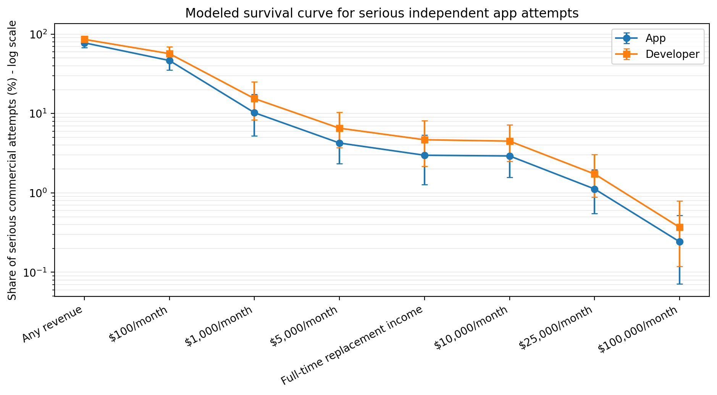
Figure 2. Modeled threshold survival among serious independent commercial attempts.
Source: model [M01]. Full-time replacement is $5,000 monthly owner profit, not gross revenue.
INTERPRETATION The $1,000 threshold lies above the distribution’s middle but below the extreme right tail. The model places about 46.5% of serious apps above $100/month, 10.2% above $1,000, 4.3% above $5,000, and 1.1% above $25,000. The developer shares are higher because portfolios aggregate apps. [M01]

5.2 Revenue bands by denominator
Population | $0 | $1-99 | $100-999 | $1k-4,999 | $5k-24,999 | $25k-99,999 | $100k+
A. All listed apps | 86.00% | 7.00% | 6.02% | 0.65% | 0.24% | 0.08% | 0.01%
C. Active monetized apps | 8.00% | 44.00% | 40.32% | 5.00% | 2.00% | 0.58% | 0.10%
E. Serious commercial attempts | 22.00% | 32.00% | 35.78% | 6.50% | 2.70% | 0.80% | 0.22%
F. Maintained for at least 12 months | 18.00% | 27.00% | 42.74% | 7.40% | 3.50% | 1.10% | 0.26%

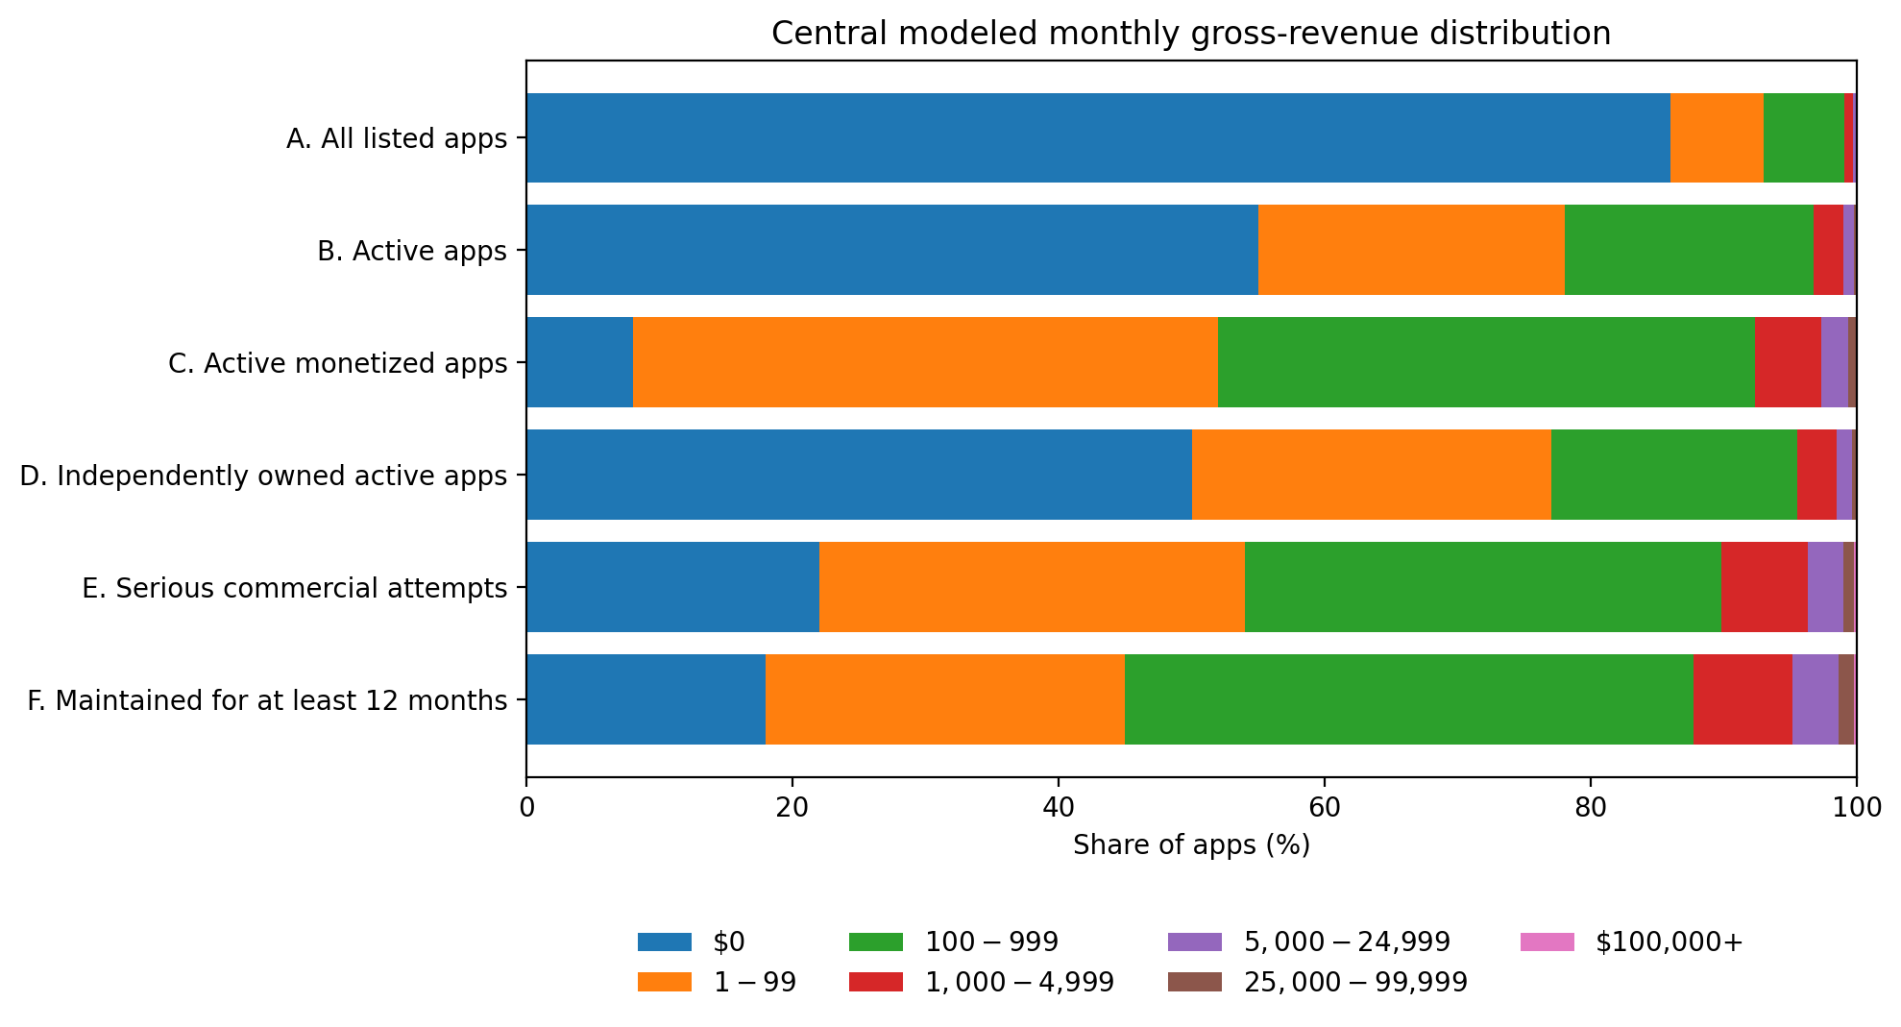
Figure 3. Central revenue-band calibration by denominator.
Source: model [M01]. Gross monthly revenue; rounded distributions, not a store census.
INTERPRETATION The mass at zero does not disappear when the denominator narrows. It falls from an estimated 86% of all listed apps to 22% of serious attempts and 18% of apps maintained for at least a year. The survival filter raises the share above $1,000, but it also creates survivorship bias by definition. [M01]

6. App-level versus developer-level outcomes
MODELED ESTIMATE For serious attempts, the developer-level share above $1,000 is 15.4%, compared with 10.2% per app. [M01]

Portfolio model
Assumption / output | Value | Status
Mean apps owned | 1.83 | Model assumption
Successful developers with top app >=70% of portfolio revenue | 55%-75% | Modeled range, not observed census
Developers over $1k with at least one app individually over $1k | 75%-83% | Modeled range
Developers crossing $1k only by summing sub-threshold apps | 17%-25% | Modeled range

- The assumed developer portfolio distribution has a mean of 1.83 owned apps: 58% own one, 22% two, 10% three, 5% four, 3% five, and 2% eight. [M04]
- Independent-app outcomes are positively correlated because the same developer skill, audience, category choice, and acquisition channel affect multiple apps. The model therefore dampens the naive “at least one hit” probability. [M04]
- An explicit portfolio-sum bonus allows a developer to cross $1,000 with several smaller products even when no single app does.
MODELED ESTIMATE Among developers above $1,000, about 75%-83% are modeled to own at least one app individually above $1,000. Roughly 17%-25% cross only by summing apps that are individually below the threshold. [M04]
MODELED ESTIMATE About 55%-75% of successful developers are modeled to receive at least 70% of portfolio revenue from their top app. Publicly visible “portfolio builders” should not be interpreted as evidence that revenue is evenly diversified. [M04]

Observed portfolio contrast
OBSERVED CASE Mehroz Sheikh’s disclosed 16-product portfolio reported $855 in the latest 30 days and $555 aggregate MRR, with several products at $0 and only a few above $100. The owner had many launches without crossing $1,000 in aggregate. [S20]
INTERPRETATION This is the economically important distinction between “number of apps built” and “developer income.” A developer can have a large product count and a weak portfolio, or a small product count dominated by one app. Case records illustrate mechanisms; they do not estimate how common either pattern is.

7. Monetization, platform, category, and maturity
Segment | Observed evidence | What can be inferred | What cannot be inferred
Subscription | RevenueCat: 17.3% ever hit $1k; 4.6% hit $10k in selected launch cohort. Adapty reports heavy concentration. [S07-S09] | Best-measured path; recurring revenue makes milestones observable. | Store-wide subscription success rate; zero-revenue and tiny apps are excluded.
Advertising | CMA evidence says Play reach is material to ad-funded developers; store billing records do not observe ad revenue. [S06] | Requires meaningful usage; model with MAU, sessions, fill, and eCPM. | Representative ad-income distribution; mediated ad data are private.
Paid download | Only 3.5% of Play listings were paid in AppBrain’s July 2026 snapshot. [S04] | Simple unit economics; ongoing acquisition is needed without recurring payment. | Revenue distribution by price or platform.
IAP / games | In RevenueCat’s subscription subset, Gaming had 20.0% ever hit $1k and 8.9% hit $10k, with 32 median days to $1k. [S07] | Games can have faster and heavier tails. | All games: many monetize mainly through non-subscription IAP or ads.
Non-game consumer apps | Business hit $1k less often than Gaming in the same cohort, and took longer. [S07] | Category matters even inside one monetization system. | A universal “non-game” rate.
iOS | D60 RPI $0.42 and D35 conversion 2.6% in RevenueCat cohort. [S07] | Earlier subscription monetization in this cohort. | Causal platform advantage independent of geography/category/acquisition.
Android | D60 RPI $0.16 and D35 conversion 0.9%; payer LTV later approaches iOS. [S07] | Lower early monetization, not necessarily lower long-run payer value. | A complete Android-income picture, especially ads.
Mature apps | RevenueCat reports apps launched before 2020 produce a large share of cohort revenue. [S07] | The right tail contains old survivors; launch cohorts are censored. | Survival-adjusted causal effect of age.

Distribution channel and prior audience
OBSERVED CASE lovelee reached $2,413 MRR with 280 active subscriptions nine months after launch; its founder profile showed roughly 148,800 followers. That is a different acquisition starting point from an unknown developer with no audience. [S16]
OBSERVED CASE 3AK Track & Field reported $10,082 MRR seven months after launch, with founder claims of mostly organic acquisition, $50-$100 per day of Meta spend, and about 80% margin. RevenueCat verification supports the revenue account, not the acquisition or margin claims. [S18]
OBSERVED CASE TrackAI reported $20,342 MRR, 4,865 active subscriptions, and more than 327,000 installs at 13 months, with the founder attributing traction to organic rankings and claiming profitability from month two. [S17]
LIMITATION The public record is too selected to estimate the causal lift from an existing audience, organic search, or paid acquisition. The article can distinguish those channels in cases; it cannot assign population probabilities to them.

8. Anatomy of the $1,000-per-month app

8.1 Subscription requirements
Price | Target | Required | Unit | Assumptions
$4.99/month | $1,000 gross/month | 201 | active monthly subscribers | No refunds or tax.
$4.99/month | $1,000 proceeds/month | 236 | active monthly subscribers | 15% platform/payment fee.
$4.99/month | $1,000 owner profit/month | 289 | active monthly subscribers | 15% fee, $150 fixed cost, $0.25 variable cost per active subscriber.
$9.99/month | $1,000 gross/month | 101 | active monthly subscribers | No refunds or tax.
$9.99/month | $1,000 proceeds/month | 118 | active monthly subscribers | 15% platform/payment fee.
$9.99/month | $1,000 owner profit/month | 140 | active monthly subscribers | 15% fee, $150 fixed cost, $0.25 variable cost per active subscriber.
$19.99/month | $1,000 gross/month | 51 | active monthly subscribers | No refunds or tax.
$19.99/month | $1,000 proceeds/month | 59 | active monthly subscribers | 15% platform/payment fee.
$19.99/month | $1,000 owner profit/month | 69 | active monthly subscribers | 15% fee, $150 fixed cost, $0.25 variable cost per active subscriber.

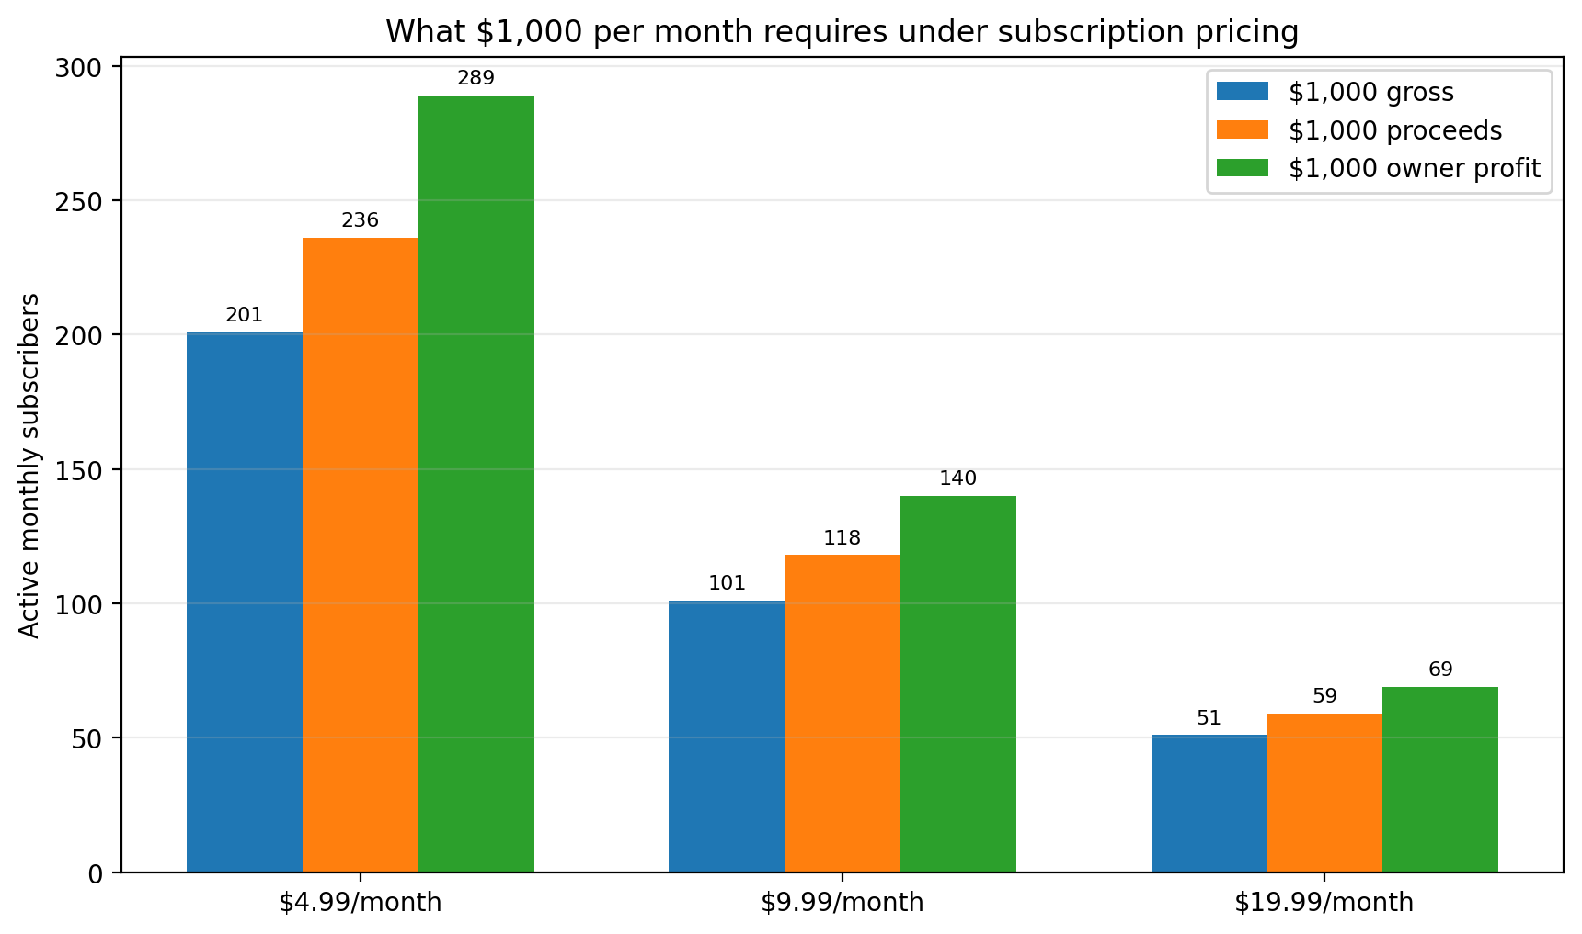
Figure 4. Active monthly subscribers required at common price points.
Source: arithmetic model [M02]. Profit assumes 15% fee, $150 fixed monthly cost, and $0.25 per active subscriber.
DERIVED CALCULATION $9.99/month requires 101 active subscribers for $1,000 gross, 118 for $1,000 of developer proceeds after a 15% fee, and 140 for $1,000 owner profit under the lean cost model. [S11-S12; M02]
OBSERVED COMPARISON The disclosed MRR per active subscription is about $8.62 for lovelee, $5.00 for Bibly, $4.18 for TrackAI, and $3.49 for 3AK. These ratios mix monthly and annual plans and may differ from recognized store revenue, but they show why subscriber count alone is not comparable across apps. [S16-S18; S21]

8.2 Annual plans and download conversion
Annual price | Active annual subscribers for $1k monthly recognized revenue | Assumption
$29.99/year | 401 | Straight-line revenue recognition; ignores cash timing.
$49.99/year | 241 | Straight-line revenue recognition; ignores cash timing.
$79.99/year | 151 | Straight-line revenue recognition; ignores cash timing.

Paid conversion | Downloads required | Target | Note
0.7% download-to-paid | 16,858 | 118 active subscribers at $9.99 (about $1k proceeds) | No churn in acquisition count; at 10% monthly churn and 2% conversion, about 590 new downloads/month are needed to maintain 118 subscribers.
2.0% download-to-paid | 5,900 | 118 active subscribers at $9.99 (about $1k proceeds) | No churn in acquisition count; at 10% monthly churn and 2% conversion, about 590 new downloads/month are needed to maintain 118 subscribers.
2.8% download-to-paid | 4,215 | 118 active subscribers at $9.99 (about $1k proceeds) | No churn in acquisition count; at 10% monthly churn and 2% conversion, about 590 new downloads/month are needed to maintain 118 subscribers.

DERIVED CALCULATION At 2.0% download-to-paid conversion, recruiting 118 active subscribers requires about 5,900 downloads before churn. At 10% monthly subscriber churn, maintaining 118 subscribers requires about 12 new subscribers per month, or roughly 590 new downloads per month at the same conversion rate. [M02]

8.3 Revenue per install
D60 RPI | Installs required | Target | Population
D60 RPI $0.11 | 9,091 | $1,000 cumulative D60 revenue | RevenueCat selected subscription-app cohort; cumulative cohort revenue, not monthly recurring revenue.
D60 RPI $0.34 | 2,942 | $1,000 cumulative D60 revenue | RevenueCat selected subscription-app cohort; cumulative cohort revenue, not monthly recurring revenue.
D60 RPI $0.55 | 1,819 | $1,000 cumulative D60 revenue | RevenueCat selected subscription-app cohort; cumulative cohort revenue, not monthly recurring revenue.
D60 RPI $0.66 | 1,516 | $1,000 cumulative D60 revenue | RevenueCat selected subscription-app cohort; cumulative cohort revenue, not monthly recurring revenue.

DERIVED CALCULATION At RevenueCat’s overall D60 RPI of $0.34, about 2,941 installs are required to accumulate $1,000 by day 60. The equivalent is 1,819 at North America’s $0.55 and 9,091 at India/SE Asia’s $0.11. This is cumulative cohort revenue, not monthly recurring revenue. [S07; M02]

8.4 Advertising, paid downloads, and commissions
Ad scenario | Required MAU | Unit | Assumptions
Conservative | 69,445 | monthly active users | 8 sessions/MAU/month, 1.5 ads/session, 80% fill, $1.50 eCPM. Explicit scenario, not an observed universal rate.
Base | 9,260 | monthly active users | 12 sessions/MAU/month, 2 ads/session, 90% fill, $5.00 eCPM. Explicit scenario, not an observed universal rate.
Strong | 1,462 | monthly active users | 20 sessions/MAU/month, 3 ads/session, 95% fill, $12.00 eCPM. Explicit scenario, not an observed universal rate.

Paid price | Downloads for $1k gross | Downloads for $1k proceeds | Assumption
$0.99 | 1,011 | 1,189 | 15% fee.
$2.99 | 335 | 394 | 15% fee.
$4.99 | 201 | 236 | 15% fee.
$9.99 | 101 | 118 | 15% fee.

Take rate | Required monthly GMV | Unit | Assumptions
3% take rate | $33,333 | monthly GMV | Before payment losses, support, disputes, and incentives.
5% take rate | $20,000 | monthly GMV | Before payment losses, support, disputes, and incentives.
10% take rate | $10,000 | monthly GMV | Before payment losses, support, disputes, and incentives.
15% take rate | $6,667 | monthly GMV | Before payment losses, support, disputes, and incentives.

MODELED ESTIMATE The base ad scenario requires about 9,260 monthly active users: 12 sessions per user, two ads per session, 90% fill, and $5 eCPM. A low-engagement, low-eCPM app needs about 69,445 MAU; a strong scenario needs about 1,462. These are scenario outputs, not observed universal benchmarks. [M02]

8.5 Gross revenue required for $1,000 of owner profit
Cost structure | Gross revenue required | Assumptions
Lean | $1,438 | 15% platform/payment fee, 5% variable operating/acquisition cost, $150 fixed monthly cost.
API-heavy | $2,143 | 15% platform/payment fee, 15% variable operating/acquisition cost, $500 fixed monthly cost.
Paid acquisition | $2,727 | 15% platform/payment fee, 30% variable operating/acquisition cost, $500 fixed monthly cost.
High fee / high UA | $3,750 | 30% platform/payment fee, 30% variable operating/acquisition cost, $500 fixed monthly cost.

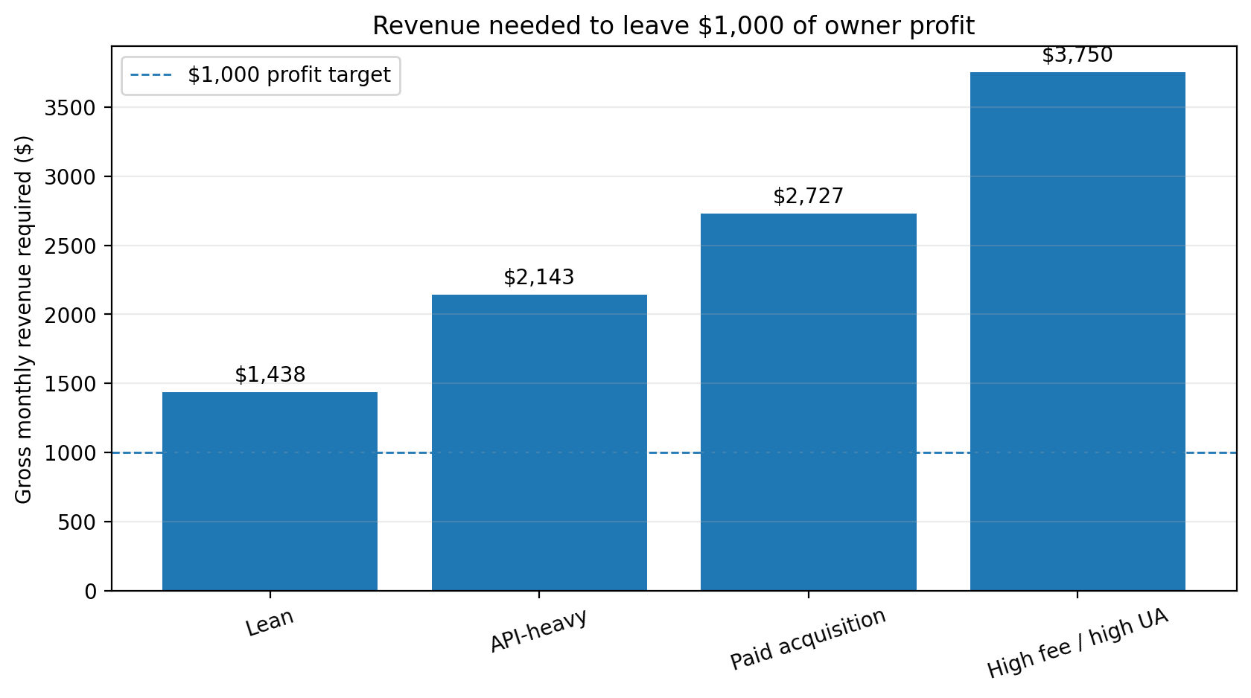
Figure 5. Gross monthly revenue required to produce $1,000 of owner profit.
Source: arithmetic model [M02]. Founder labor and personal tax are excluded.
INTERPRETATION A $1,000 revenue screenshot does not establish a $1,000 income stream. Under the modeled scenarios, $1,000 of owner profit requires roughly $1,438-$3,750 of gross monthly revenue, depending on platform/payment fees, fixed costs, APIs, and paid acquisition. [M02]

9. Representative and low-revenue cases
METHOD Cases are selected to cover the distribution, monetization mechanisms, portfolio behavior, and failures. They are not random and are excluded from prevalence calculations.
Case | Unit | Model | Age mo. | Last 30d | MRR | Scale | Outcome / status | Src
lovelee | Single app | Subscription | 9 | $2,657 | $2,413 | Not disclosed | Current; sustained history not established | S16
TrackAI | Single app | Subscription | 13 | $24,365 | $20,342 | 327k+ installs | Profitable since month two per founder; ~95% margin claim | S17
3AK Track & Field | Single app | Subscription | 7 | $14,448 | $10,082 | Not disclosed | Seasonal dip; ~80% margin claim; for sale | S18
GurjarApp | Single app | Mixed / ads potential | 77 | $0 | $0 | 212k users | Zero current revenue; $100-$150 monthly costs; for sale | S19
Mehroz Sheikh portfolio | 16-product portfolio | Mixed | - | $855 | $555 | 16 startups | Many products at $0-$50 monthly; aggregate below $1k | S20
Noise Reducer | Portfolio app | Subscription or IAP | - | $144 | $137 | Not disclosed | Low but nonzero current revenue | S20
Revo Reminder | Portfolio app | Unknown | - | $0 | $0 | Not disclosed | Zero revenue | S20
Bibly | Single app | Subscription | 7 | $3,306 | $5,264 | Not disclosed | Founder claims $138k annual revenue and 70% margin | S21
Habit Pixel | Single app | Subscription | 8 | $1,000 | $1,000 | Not disclosed | Reached $1k MRR after ~8 months | S01

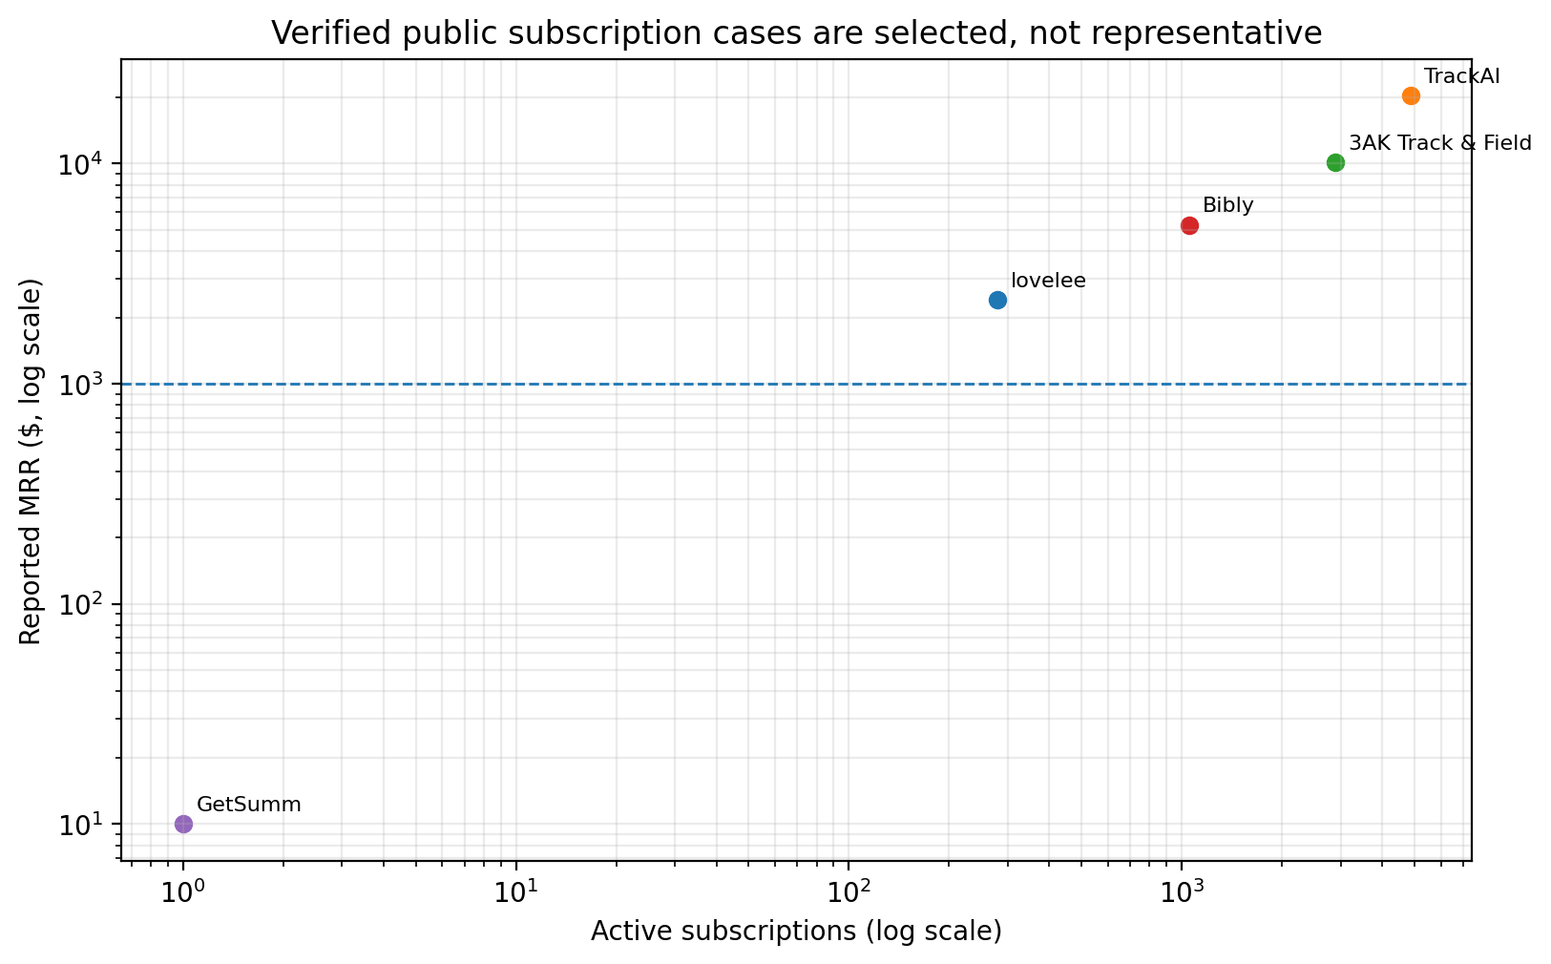
Figure 6. Publicly disclosed cases: scale versus monthly revenue.
Source: case evidence [S16-S21] and dossier cases. Selection is severe; the chart is descriptive only.

Cases around the threshold
- Habit Pixel reportedly moved from $28 MRR shortly after launch to $1,000 MRR in eight months. This is milestone self-reporting with limited cost and continuity disclosure. [Dossier case]
- lovelee at $2,413 MRR and 280 subscriptions implies a portfolio-level average of $8.62 MRR per active subscriber. The founder’s large prior audience changes the distribution problem. [S16]
- Bibly reported roughly $5,264 MRR with 1,053 active subscriptions and a founder-stated 70% margin. The RevenueCat linkage supports the account, while margin and annualization remain founder claims. [S21]
- A sale listing for an iOS call-recording utility reported roughly $2,080-$2,900 monthly profit, 7,800 monthly downloads, and a 93% margin. Sale-ready cases are strongly selected and may use promotional periods or definitions. [Dossier case]

Failed and low-revenue evidence
- GurjarApp reported 212,000 users, $2,071 all-time revenue, no active subscriptions, and $100-$150 monthly costs. User scale did not translate into current revenue. [S19]
- Mehroz Sheikh’s disclosed portfolio had multiple apps at $0, several in single or low double digits, and only a few above $100. Sixteen launches still produced less than $1,000 in the latest month. [S20]
- Revo Reminder and TCG Battle Cards reported $0 in the latest 30 days and $0 MRR. MuslimFocus reported $2 MRR; Invoice Maker $9; QR Scanner $18; Noise Reducer $137. [S20 / dossier case table]
- A disclosed Android tic-tac-toe app reported more than 50,000 installs but only about $700 monthly revenue and $373 monthly profit. Install count alone did not imply replacement income. [Dossier case]
INTERPRETATION Low-revenue cases are especially valuable because they reveal the large mass below $1,000, portfolio experimentation, and weak conversion. They still cannot repair denominator bias by themselves: founders who publish tiny products are also selected.

10. Survivorship and reporting bias

How public evidence distorts the perceived distribution
Bias mechanism | Direction of distortion | Treatment in this report
Successful developers disclose revenue more often | Raises visible success rates | Case frequencies excluded from prevalence; use cases only for mechanisms.
Acquisition marketplaces exclude unsellable apps | Raises revenue, profit, and operational quality | Listings inform cost/margin anatomy, not population shares.
Subscription reports require active revenue and integrations | Raises commercial maturity; excludes zero and non-sub apps | Use as a conditional benchmark with transfer and persistence adjustments.
Intelligence platforms miss tiny apps and off-store revenue | Can raise or lower estimates depending on model | Use for inventory/activity proxies and relative comparisons.
Founder communities attract ambitious commercial builders | Raises effort and success relative to all publishers | Treat surveys and postmortems as selected.
Failed apps disappear from stores and search results | Raises observed survival and revenue | Keep broad listed-app denominator and archived left-tail cases.
Revenue screenshots omit costs, fees, time periods, and prior audiences | Conflates gross revenue with income and repeatability | Store basis, period, continuity, costs, and audience separately.
Developers may publish many failures before one hit | Makes winner stories look like one-shot probabilities | Separate app and developer units; model portfolios and top-app dependence.

Credibility score for app-revenue claims
METHOD Score each claim 0-2 on eight dimensions: identity/ownership, direct data connection, revenue basis, time period, continuity, costs, population/denominator, and reproducibility. Total 14-16 = A; 10-13 = B; 6-9 = C; 0-5 = D.
- A RevenueCat-linked MRR screenshot with an identifiable app and explicit month may score well on direct data and period, but poorly on costs and continuity.
- A marketplace listing with verified profit may score better on costs, yet still receive a selection-bias warning.
- A founder tweet that says “$10k MRR” without date, app identity, basis, or dashboard should never anchor a prevalence estimate.
ORIGINAL CONTRIBUTION The credibility rubric turns common ambiguities into fields rather than footnotes. The downloadable workbook preserves the score dimensions and source links for audit and expansion.

11. Sensitivity analysis
Variable | Case | Apps | Developers | Interpretation
Full stochastic model | All assumptions varied jointly | 10.2% | 15.4% | Central estimate
RevenueCat milestone rate | 13.0% ever-hit | 8.3% | 11.8% | Lower anchor
RevenueCat milestone rate | 22.0% ever-hit | 14.0% | 19.1% | Upper anchor
Current persistence after ever-hit | 35% | 5.1% | 7.6% | Low persistence
Current persistence after ever-hit | 95% | 14.0% | 19.1% | High persistence
Transfer from subscription cohort | 45% | 5.8% | 8.5% | Large subscription-success penalty
Transfer from subscription cohort | 135% | 17.5% | 23.4% | Non-subscription models perform better than anchor
Denominator | All listed apps | 1.0% | 1.5% | Broadest denominator
Denominator | Maintained at least 12 months | 12.3% | 18.2% | Narrow mature denominator

Replacement-income sensitivity
Monthly owner profit | Apps | Developers | Status
$3,000 | 4.4% (2.0%-7.5%) | 6.8% (3.2%-11.5%) | Modeled sensitivity
$5,000 | 3.0% (1.3%-5.3%) | 4.7% (2.2%-8.2%) | Primary replacement-income definition
$8,333 | 1.9% (0.8%-3.5%) | 3.1% (1.4%-5.5%) | Modeled sensitivity

INTERPRETATION The headline is most sensitive to (1) how much RevenueCat’s selected subscription cohort overstates or understates all serious apps, (2) how often an ever-hit app remains above the threshold in a current month, and (3) the denominator definition. The direction of the denominator effect is robust; the exact percentages are not.
SPECULATION A representative ad-revenue panel could move the transfer factor materially in either direction. Ad-funded apps are underobserved in subscription benchmarks, but a large share of them may also monetize weakly.

12. Limitations and unresolved questions
1. No public dataset links app ID, publisher, economic ownership, monetization model, monthly revenue, costs, and time continuity across both stores.
2. Advertising and external-payment revenue are mostly invisible to store billing data. This is the largest measurement gap.
3. App stores expose legal publisher names, not a reliable independent/acquired/VC-backed classification.
4. Cross-platform products create duplicate app listings, while portfolio developers create multiple apps per owner. Both require entity resolution.
5. Public sources mix gross consumer spend, developer proceeds, MRR, annualized revenue, and profit. Unclear claims remain marked “unclear,” rather than silently normalized.
6. Most public MRR pages show one current snapshot. A three- or six-month continuity panel is rare.
7. The “meaningful commercial attempt” filter is necessarily judgmental. The report exposes the rule and provides denominator sensitivity instead of hiding it.
8. Portfolio app outcomes are correlated. The model dampens independence, but the true correlation structure is unobserved.
9. Platform fee rules vary by region, program, payment route, and date. Unit economics use a common 15% benchmark and display assumptions.
10. Games, utilities, health apps, and social products have different distributions. Public samples are too selected for a clean store-wide category matrix.
11. Launch-cohort evidence is censored: some apps will reach the threshold after two years; many disappear before disclosure.
12. The separate app-level evidence dataset requested by the user was not present in the uploaded ZIP or found as a standalone file. The case appendix is therefore a reconstructed evidence table, not an audit of a supplied dataset.
What would most improve the estimate
The highest-value missing input is an ownership-resolved app panel containing app/store IDs, publisher, independence status, monetization model, trailing monthly gross revenue, developer proceeds, operating cost, and at least six monthly observations. A stratified random sample of developer console exports would be more valuable than thousands of additional success stories.

13. Original contribution
- A bounded estimate for serious independent developers: 15.4% current-month and 12.0% three-month sustained, with explicit plausible ranges.
- Separate app-level and developer-level probabilities, including a transparent portfolio model.
- A denominator ladder from all listings to maintained serious attempts, showing why “success rate” claims disagree.
- A full revenue-distribution model rather than a success/failure binary.
- A gross revenue / proceeds / profit distinction and replacement-income sensitivity.
- Unit-economic requirements for subscriptions, annual plans, ads, paid downloads, commissions, and cost structures.
- A public case and evidence ledger that includes $0 and low-revenue apps alongside winners.
- A claim-credibility rubric that scores what revenue screenshots ordinarily omit.
- An explicit distinction between ever reaching $1,000, being above it now, and sustaining it.
NOVELTY BOUNDARY The underlying transaction-platform statistics, store counts, and founder disclosures are not new. The contribution is the denominator design, source-specific triangulation, app-versus-developer model, persistence adjustment, and reproducible evidence ledger. The estimate should not be described as a representative survey result.

14. Publication architecture and chart plan

Recommended article opening
“About one in six serious independent app developers appear to generate at least $1,000 in a current month across apps they own. A defensible range is roughly one in twelve to one in four. Count every app-store listing, and the answer falls to roughly one in sixty publishers and one in one hundred apps. The denominator is not a technical footnote. It is most of the question.”

Article outline
1. The provisional answer: one in six serious developers, with a wide interval.
2. Why “all apps” is the wrong denominator for a business-outcome question.
3. Observed facts: store inventory, ratings/search activity, and subscription milestones.
4. The estimation bridge: ever-hit to current, subscription cohort to all models, app to developer.
5. The revenue distribution: zero mass, median versus mean, and the right tail.
6. What $1,000 actually requires under subscriptions, ads, paid downloads, and commissions.
7. Portfolio economics: one hit, many small apps, and repeated failed launches.
8. Case evidence from $0 through $25,000+ monthly revenue.
9. How public founder stories distort perceived odds.
10. What the data cannot resolve and the dataset that would.

Recommended charts and tables
Priority | Exhibit | Purpose | Data file
1 | Denominator ladder with app and developer ranges | Makes the main answer conditional on population visible | denominator_estimates.csv
2 | Threshold survival curve | Shows the full distribution rather than a binary $1k outcome | threshold_estimates.csv
3 | Revenue bands by denominator | Displays the zero mass and tail | revenue_bands.csv
4 | Subscriber requirements by price and income basis | Turns $1k into concrete customer counts | unit_economics.csv
5 | Gross revenue required for owner profit | Prevents revenue/profit conflation | unit_economics.csv
6 | Case scatter: scale versus monthly revenue | Shows that users/downloads do not map cleanly to revenue | cases.csv
7 | Observed fact / model bridge waterfall | Separates RevenueCat’s 17.3% from the final 10.2% app estimate | methodology_assumptions.csv
8 | Source-bias matrix | Shows why evidence classes cannot be averaged | evidence_classes.csv

15. Reproducibility and downloadable-data appendix

Files in the appendix
File | Contents
definitions.csv | Operational definitions and analytic notes.
denominator_estimates.csv | Lower, central, and upper estimates by A-F, app/developer, and current/3-month/6-month status.
threshold_estimates.csv | Any revenue through $100,000/month and replacement-income ranges.
revenue_bands.csv | Central seven-band distribution under each denominator.
cases.csv | App and developer case records with date, basis, verification, scale, outcome, and bias note.
sources.csv | Source registry with dates, quality class, key use, and direct URL.
claim_ledger.csv | Every major claim with type, trace, confidence, and caveat.
evidence_classes.csv | Population, exclusions, unit, geography, time basis, and bias by source class.
unit_economics.csv | Formula-level subscription, ad, conversion, commission, paid-download, and cost models.
methodology_assumptions.csv | M01-M06 model equations and assumptions.
sensitivity_analysis.csv | One-way and denominator sensitivities.
source_quality_rubric.csv | Eight-dimension claim credibility score.
model_reproduction.py | Standalone Monte Carlo reproduction script.
model_summary.json | Seed, draw count, and headline outputs.

Reproduction steps
1. Run model_reproduction.py with Python and NumPy. The random seed is fixed at 20260714.
2. Compare output quantiles with model_summary.json and denominator_estimates.csv.
3. Recalculate unit_economics.csv formulas in the workbook or from the displayed equations.
4. Filter the source and claim ledgers by source class, quality rank, revenue basis, or confidence before changing assumptions.
5. When adding cases, never use case counts as prevalence weights unless the collection process becomes representative.
CALCULATION AUDIT The workbook delivered with this report contains the source tables, formulas, input assumptions, ranges, and chart data in editable form. Hardcoded research inputs are colored blue, formulas black, and cross-sheet links green.

16. Source table
ID | Source / publisher / date | Class / quality | Key use and caveat | Direct source
S01 | Research Dossier on Independent Mobile App Economics  User-supplied dossier | 2026-07-14 | Internal research dossier / Mixed | Starting map of evidence, definitions, and cases. No standalone app-level dataset was available. | File Library document
S02 | 2025 App Store Transparency Report  Apple | 2025 | Official store data / A1 | 2,172,472 apps; 166,899 removals; 1,365,649 apps appeared in top-10 results for at least 1,000 searches during the year. | Open source
S03 | Number of Android apps on Google Play  AppBrain | 2026-07-14 | App directory / intelligence / C1 | 1,887,487 available apps; 66.6k launched and 27.7k removed in June 2026. | Open source
S04 | Android and Google Play statistics  AppBrain | 2026-07-14 | App directory / intelligence / C1 | 321,598 apps had any rating; 83% had fewer than three ratings; 3.5% were paid. | Open source
S05 | Android apps with in-app billing  AppBrain | 2026-07-14 | App directory / intelligence / C1 | 337,943 apps detected with in-app billing; library detection can miss apps. | Open source
S06 | Strategic Market Status Investigation into Google mobile platform - final decision  UK Competition and Markets Authority | 2025-10-22 | Regulatory decision / A2 | More than 90% of Play-distributing developers generated no revenue through Google Play Billing; ad-funded reach is material. | Open source
S07 | State of Subscription Apps 2026  RevenueCat | 2026 | Subscription transaction cohort / B1 | 115k+ apps, $16b+, 1b+ transactions; only active subscription-revenue apps meeting thresholds. 17.3% of new apps ever hit $1k monthly revenue in first two years. | Open source
S08 | State of In-App Subscriptions 2026  Adapty | 2026 | Subscription platform report / B1/C1 | 16k+ apps and $3b; median $492/month; top 10% capture 94.5%; lifetime bands for new apps. | Open source
S09 | Subscription revenue concentration analysis  Adapty | 2026-03-19 | Vendor analysis / C1 | Top 10% capture 94.5%; new-app lifetime revenue bands. Marketing interpretation and report-page inconsistency require caution. | Open source
S10 | Small Business Developers and App Creators on the App Store in 2022  Analysis Group / Apple | 2023-05 | Sponsored economic study / B2 | More than 90% small under <1m downloads and <$1m earnings; excludes developers never above 1,000 annual downloads. | Open source
S11 | App Store Small Business Program  Apple Developer | Current 2026 | Official fee rule / A1 | 15% reduced commission on paid apps and IAP for qualifying developers. | Open source
S12 | Google Play service fees  Google Play Console Help | Current 2026 | Official fee rule / A1 | Current regional fee schedules; common first-$1m/subscription effective rate around 15%, with material regional/program variation. | Open source
S13 | The App Economy Consolidates Before the Next Gold Rush  Developer Nation / VisionMobile | 2014 | Founder survey analysis / B2/C2 | 24% of commercially interested respondents earned zero; 23% under $100 per app/month; stale and self-selected. | Open source
S14 | Google Play Is Not a Long Tail Market  Zhong and Michahelles | 2013 | Academic transaction study / B2 | Historical evidence that app adoption/revenue behaves as a superstar market. | Open source
S15 | Impact of Revenue Models on Mobile App Market Performance  Academic study | 2022 | Academic app-level study / B2 | About two years of 330 newly launched US iOS games and productivity apps; monetization model effects differ by category. | Open source
S16 | lovelee revenue profile  TrustMRR | 2026-07-14 | Verified dashboard / marketplace / C2 | $2,413 MRR, 280 active subscriptions, $48,002 all-time; Superwall-linked; founder had 148.8k followers. | Open source
S17 | TrackAI revenue profile  TrustMRR | 2026-07-14 | Verified dashboard / marketplace / C2 | $24,365 last 30 days; $20,342 MRR; 4,865 active subscriptions; 327k+ installs; for-sale and founder claims. | Open source
S18 | 3AK Track & Field revenue profile  TrustMRR | 2026-07-14 | Verified dashboard / marketplace / C2 | $14,448 last 30 days; $10,082 MRR; 2,885 active subscriptions; founder claims mostly organic and ~80% margins. | Open source
S19 | GurjarApp revenue profile  TrustMRR | 2026-07-14 | Verified dashboard / marketplace / C2 | $2,071 all-time, no active subscriptions, 212k users, $100-$150/month stated costs. | Open source
S20 | Mehroz Sheikh founder portfolio  TrustMRR | 2026-07-14 | Verified dashboard / portfolio / C2 | 16 startups; $3,878 total revenue, $855 last 30 days, $555 aggregate MRR; many apps at zero or low revenue. | Open source
S21 | Bibly revenue profile  TrustMRR | 2026-07-14 | Verified dashboard / marketplace / C2 | Case near $5k MRR with 1,053 active subscriptions; selection bias remains. | Open source

17. Claim-by-claim evidence ledger
ID | Type | Claim | Value | Trace | Calculation | Confidence | Caveat
CL01 | Modeled estimate | About 15.4% of serious independent app developers generate at least $1,000 of current gross monthly revenue across their owned portfolio. | 15.41% | M01; S07 | Monte Carlo: selected subscription ever-hit rate x persistence x transfer factor, then portfolio aggregation. | Medium | 8.36%-25.02% plausible interval; not a census.
CL02 | Modeled estimate | About 10.2% of serious independent apps generate at least $1,000 of current gross monthly revenue. | 10.23% | M01; S07 | Same model before portfolio aggregation. | Medium | 5.26%-17.44% plausible interval.
CL03 | Modeled estimate | Across all listed apps, roughly 1.0% clear $1,000 in a current month. | 0.98% | M01; S02-S05; S07 | Mixture of inactive, active-light, monetized-light, serious, and mature app states. | Low-Medium | 0.31%-2.74%; denominator composition is uncertain.
CL04 | Modeled estimate | Sustaining $1,000 for three consecutive months is less common than touching it once. | Developer 12.00%; app 7.28% | M01 | Current-month draws multiplied by persistence factors. | Medium-Low | Three-month persistence is assumed, not directly observed store-wide.
CL05 | Observed fact | RevenueCat reports that 17.3% of newly launched apps in its selected cohort hit $1,000 monthly revenue within two years. | 17.3% | S07 | Direct report statistic. | High within cohort | It is ever-hit, subscription-only, RevenueCat-integrated, active, and minimum-threshold selected.
CL06 | Observed fact | Only 4.6% of that RevenueCat launch cohort hit $10,000 monthly revenue within two years. | 4.6% | S07 | Direct report statistic. | High within cohort | Not a store-wide prevalence estimate.
CL07 | Observed fact | The RevenueCat year-one monthly-revenue median is about $72, versus $2,574 at the 90th percentile. | $72; $2,574 | S07 | Direct report statistic. | High within cohort | Selected subscription apps; median versus right tail.
CL08 | Observed fact | Adapty reports the top 10% of observed subscription apps capture 94.5% of subscription revenue. | 94.5% | S08-S09 | Direct vendor report statistic. | Medium | Vendor cohort and marketing framing; denominator/exclusions matter.
CL09 | Derived calculation | Adapty’s concentration statistic implies the average top-decile app produces about 155 times the revenue of the average bottom-90% app. | 154.6x | S08-S09 | (94.5/10)/(5.5/90). | Medium | Ratio of group averages, not median app performance.
CL10 | Observed fact | More than 90% of Play-distributing developers generated no revenue through Google Play Billing in CMA evidence. | >90% | S06 | Regulatory evidence. | High for metric | Does not mean no ad, external-payment, physical-goods, or cross-platform revenue.
CL11 | Observed fact | Apple listed 2,172,472 apps in 2025, but 1,365,649 appeared in top-10 results for at least 1,000 searches during the year. | 2,172,472; 1,365,649 | S02 | Official report. | High | Search visibility is an activity proxy, not monetization.
CL12 | Observed fact | On Google Play, 83% of listed apps had fewer than three ratings as of July 14, 2026. | 83.0% | S04 | AppBrain directory statistic. | Medium | Ratings are a noisy activity proxy and AppBrain is not Google.
CL13 | Interpretation | The denominator changes the answer by more than an order of magnitude. | App: 0.98% all listed vs. 10.23% serious; developer: 1.55% vs. 15.41% | M01 | Compare denominator model rows. | Medium | The contrast is modeled; direction is robust, exact magnitude is not.
CL14 | Derived calculation | $9.99/month requires about 101 active subscribers for $1,000 gross, 118 for $1,000 proceeds at a 15% fee, and 140 for $1,000 owner profit under a lean cost model. | 101; 118; 140 | M02; S11-S12 | Ceiling calculations in unit-economics table. | High conditional on assumptions | Ignores tax/refunds; profit model assumes $150 fixed and $0.25/subscriber variable cost.
CL15 | Derived calculation | At RevenueCat’s overall D60 RPI of $0.34, a launch cohort needs about 2,941 installs to accumulate $1,000 by day 60. | 2,941 installs | M02; S07 | CEILING(1000/0.34). | High conditional on metric | Cumulative cohort revenue, not monthly recurring revenue.
CL16 | Modeled estimate | A base advertising app needs about 9,259 MAU for $1,000 monthly ad revenue. | 9,259 MAU | M02 | 1000/(12 sessions x 2 ads x 90% fill x $5 eCPM / 1000). | Low-Medium | All ad inputs are scenarios; actual eCPMs and engagement vary widely.
CL17 | Observed fact | iOS monetizes subscription installs earlier than Google Play in the RevenueCat cohort. | $0.42 vs. $0.16 D60 RPI; 2.6% vs. 0.9% D35 conversion | S07 | Direct cohort statistics. | High within cohort | Long-run payer LTV narrows to $23.38 vs. $21.62.
CL18 | Interpretation | Public case studies cannot estimate prevalence because they are selected on disclosure, verification, or saleability. | N/A | S16-S21 | Selection mechanism analysis. | High | Cases are retained for mechanisms and unit economics only.
CL19 | Observed case | A 16-product disclosed portfolio generated $855 in the latest 30 days and $555 aggregate MRR, with multiple apps at zero. | $855; $555 | S20 | Verified portfolio page. | Medium-High for current listing | Not representative; some products may not be mobile apps.
CL20 | Observed case | GurjarApp reported 212k users but no current revenue and $100-$150 monthly costs. | 0 current revenue; 212k users | S19 | Verified revenue listing plus founder statement. | Medium | User count and cost are founder-supplied; revenue account is linked.

Research conclusion
What can be said honestly
The strongest defensible publication answer is not “99% fail” or a single store-wide percentage. It is a range conditional on population: approximately 15.4% (8.4%-25.0%) of serious independent developers generate at least $1,000 in current monthly gross app revenue across their portfolio, compared with 10.2% (5.3%-17.4%) of serious independent apps. Sustaining the threshold for three months is modeled at 12.0% of developers and 7.3% of apps. The uncertainty is real and should remain visible in the headline, charts, and prose.

OBSERVED FACT No public dataset currently supports a precise global census of independent app income. [S01-S10]
INTERPRETATION The estimate is publishable because its denominator, bridge assumptions, evidence classes, and failure modes are exposed. It should be updated when a representative ownership-resolved revenue panel becomes available.

