FINANCIAL INVESTIGATION

How Airlines Borrow
Against Future Loyalty
The hidden financial system inside airline loyalty programs

Primary case: American AAdvantage
Comparators: Delta SkyMiles, United MileagePlus and Air Canada Aeroplan
Evidence cutoff: 23 July 2026. Operating comparisons use fiscal 2025 unless noted; current American balances are updated through 31 March 2026.
1  CASH  When the bank pays | 2  ACCOUNTING  When revenue is recorded | 3  FULFILLMENT  When the award is delivered | 4  FINANCING  When lenders can trap cash
Public filings, governing financing documents, transaction records and a reconstructed point-level model.

CONTENTS

The investigation
Executive answer What the system does and where the risk sits
1. The point is created A $1,000 card transaction and the first cash movement
2. The bank is purchasing more than points The commercial bundle behind the issuer payment
3. Cash today, obligation tomorrow The accounting split and contract liability
4. The economics of waiting Redemption curves, breakage and operating float
5. What an award seat costs Retail value, accounting value, cash cost and displacement
6. The controlled inflation of points Dynamic pricing, devaluation and member behavior
7. Turning the program into collateral The American and United financing structures
8. Is the loyalty program worth more than the airline? Matching-date valuation and debt capacity
9. When the bank relationship breaks Aeroplan and the modeled issuer-loss scenario
10. How much airline profit comes from points? A set of measures, not one percentage
11. The final life of one point Three outcomes for the opening transaction
Methodology and source ledger Definitions, assumptions, gaps and primary sources
Exhibits
Exhibit 1. The parties and the money
Exhibit 2. One point's cash conversion cycle
Exhibit 3. Cash is not revenue
Exhibit 4. Loyalty-program balance sheets
Exhibit 5. What a point is worth to each party
Exhibit 6. Loyalty-backed financing structures
Exhibit 7. Loyalty value versus airline value
Exhibit 8. Partnership-termination stress test
Exhibit 9. Profit-attribution bridge
Exhibit 10. The final life of 1,000 points

THE PRECISE ANSWER
Executive answer
When a consumer earns an airline point:
The card issuer pays cash under a commercial contract; the airline or loyalty entity records part of that payment as current revenue and part as a contract liability; the airline or a redemption partner owes the future award; the airline controls award pricing and inventory; and, when the program has been financed, lenders can receive the pledged cash before the airline receives a distribution.

The ordinary co-brand transaction is neither a deposit nor a simple advance purchase of a future seat. A bank buys a bundle: points, brand access, marketing and acquisition channels, customer-list or data rights, airport and in-flight placements, and travel benefits. The airline receives cash on the issuer's contractual settlement schedule, usually monthly or shortly after the month of mileage sale. It can therefore hold and use cash well before the member redeems. The accounting does not let the airline call all of that cash revenue on day one. [AA-25K; DL-25K; UA-25K]
American illustrates the split. In 2025 it reported $6.2 billion of cash remuneration from co-branded cards and other partners. The same year it added $4.445 billion to its loyalty contract liability and released $3.935 billion from that liability. It ended the year owing $10.564 billion of deferred loyalty consideration, including a one-time payment linked to the new Citi agreement that begins amortizing over the contract life in 2026. These amounts belong to different clocks: cash collection, revenue recognition and award fulfillment. [AA-25K]
The economic advantage comes from timing and control. The airline may receive partner cash within weeks, recognize some marketing consideration immediately, and wait roughly two years for most redemptions. It decides how many points an award requires and how much seat inventory is available. Breakage reduces the awards ultimately delivered. An empty off-peak seat may cost little in incremental cash; a constrained premium seat can displace a fare worth thousands of dollars. The accounting liability is therefore not the expected cash cost of redemption, and the member's redemption value is not the airline's cost. [AA-25K; DL-25K; UA-25K]
Borrowing against loyalty is a separate step. American and United created bankruptcy-remote entities, contributed or licensed loyalty intellectual property, directed partner and intercompany payments into pledged accounts, funded reserves and tested debt-service coverage. Under American's documents, at least 90% of AAdvantage revenue was targeted for direct deposit into the collection account. Fees, interest, principal and reserves came before excess cash could move to the airline. A coverage or reserve failure could switch the structure into early amortization. [AA-CREDIT; AA-21PRES; UA-20FIN; UA-CREDIT]
The analogy that airlines are banks fails at the point where it sounds most literal. Members have not deposited money with the loyalty program; their points are not a fixed-dollar claim, generally are not treated as property under program rules, and can be repriced. The loyalty entity does not finance itself by taking deposits. The closer analogy is a merchant with recurring prepaid performance obligations and contractual control over the unit of account. The financing structure then turns the merchant's recurring partner receipts into collateral. [AA-RULES; AA-25K]
Three mechanisms that are often collapsed into one
Mechanism | What creates cash today | How it is recorded | What the cash provider can claim
Operating float | Recurring monthly point sales and related co-brand consideration | Immediate revenue for delivered obligations plus a contract liability for future awards | Commercial rights under the partner agreement; no principal-and-interest claim
Explicit partner prepayment | Upfront consideration for renewals, exclusivity, portfolio transition or future mile purchases | Contract liability amortized over the agreement or applied against later purchases | Future services or purchase credits defined in the partner contract
Loyalty-backed debt | Loan or note proceeds from lenders | Financial debt with interest, maturities and covenants | Liens on contracts, IP, data rights, accounts, reserves and SPV equity

CLOCK 1: CASH
1. The point is created
At 8:17 a.m., an AAdvantage cardholder pays a $1,000 hotel bill. Assume the card earns one mile per dollar on that purchase. The hotel sells the room. The payment network carries authorization, clearing and settlement messages. The merchant's acquirer settles with the hotel, net of merchant fees. The issuer records the cardholder receivable. American is not a party to that merchant settlement.
A second transaction follows under the co-brand agreement. The issuer calculates the miles associated with the account and pays the airline or its loyalty structure. American states that partner payment terms are typically within 30 days after the month of mileage sale; Delta describes monthly payments based on miles sold. For the reconstructed model, 1,000 points produce $12 of cash, or 1.2 cents per point. That price is estimated, not disclosed. Public filings establish the bundle and the settlement cadence, but not the effective net purchase price after fixed payments, benefits and other contract terms. [AA-25K; DL-25K]
The member sees 1,000 miles. The issuer sees a reward cost and a customer-retention asset. The airline sees cash, several performance obligations and a future award claim. The lender, if the program is encumbered, may see a pledged collection entering a controlled account. The same point therefore starts four clocks at once, but no clock determines the others. [AA-CREDIT]
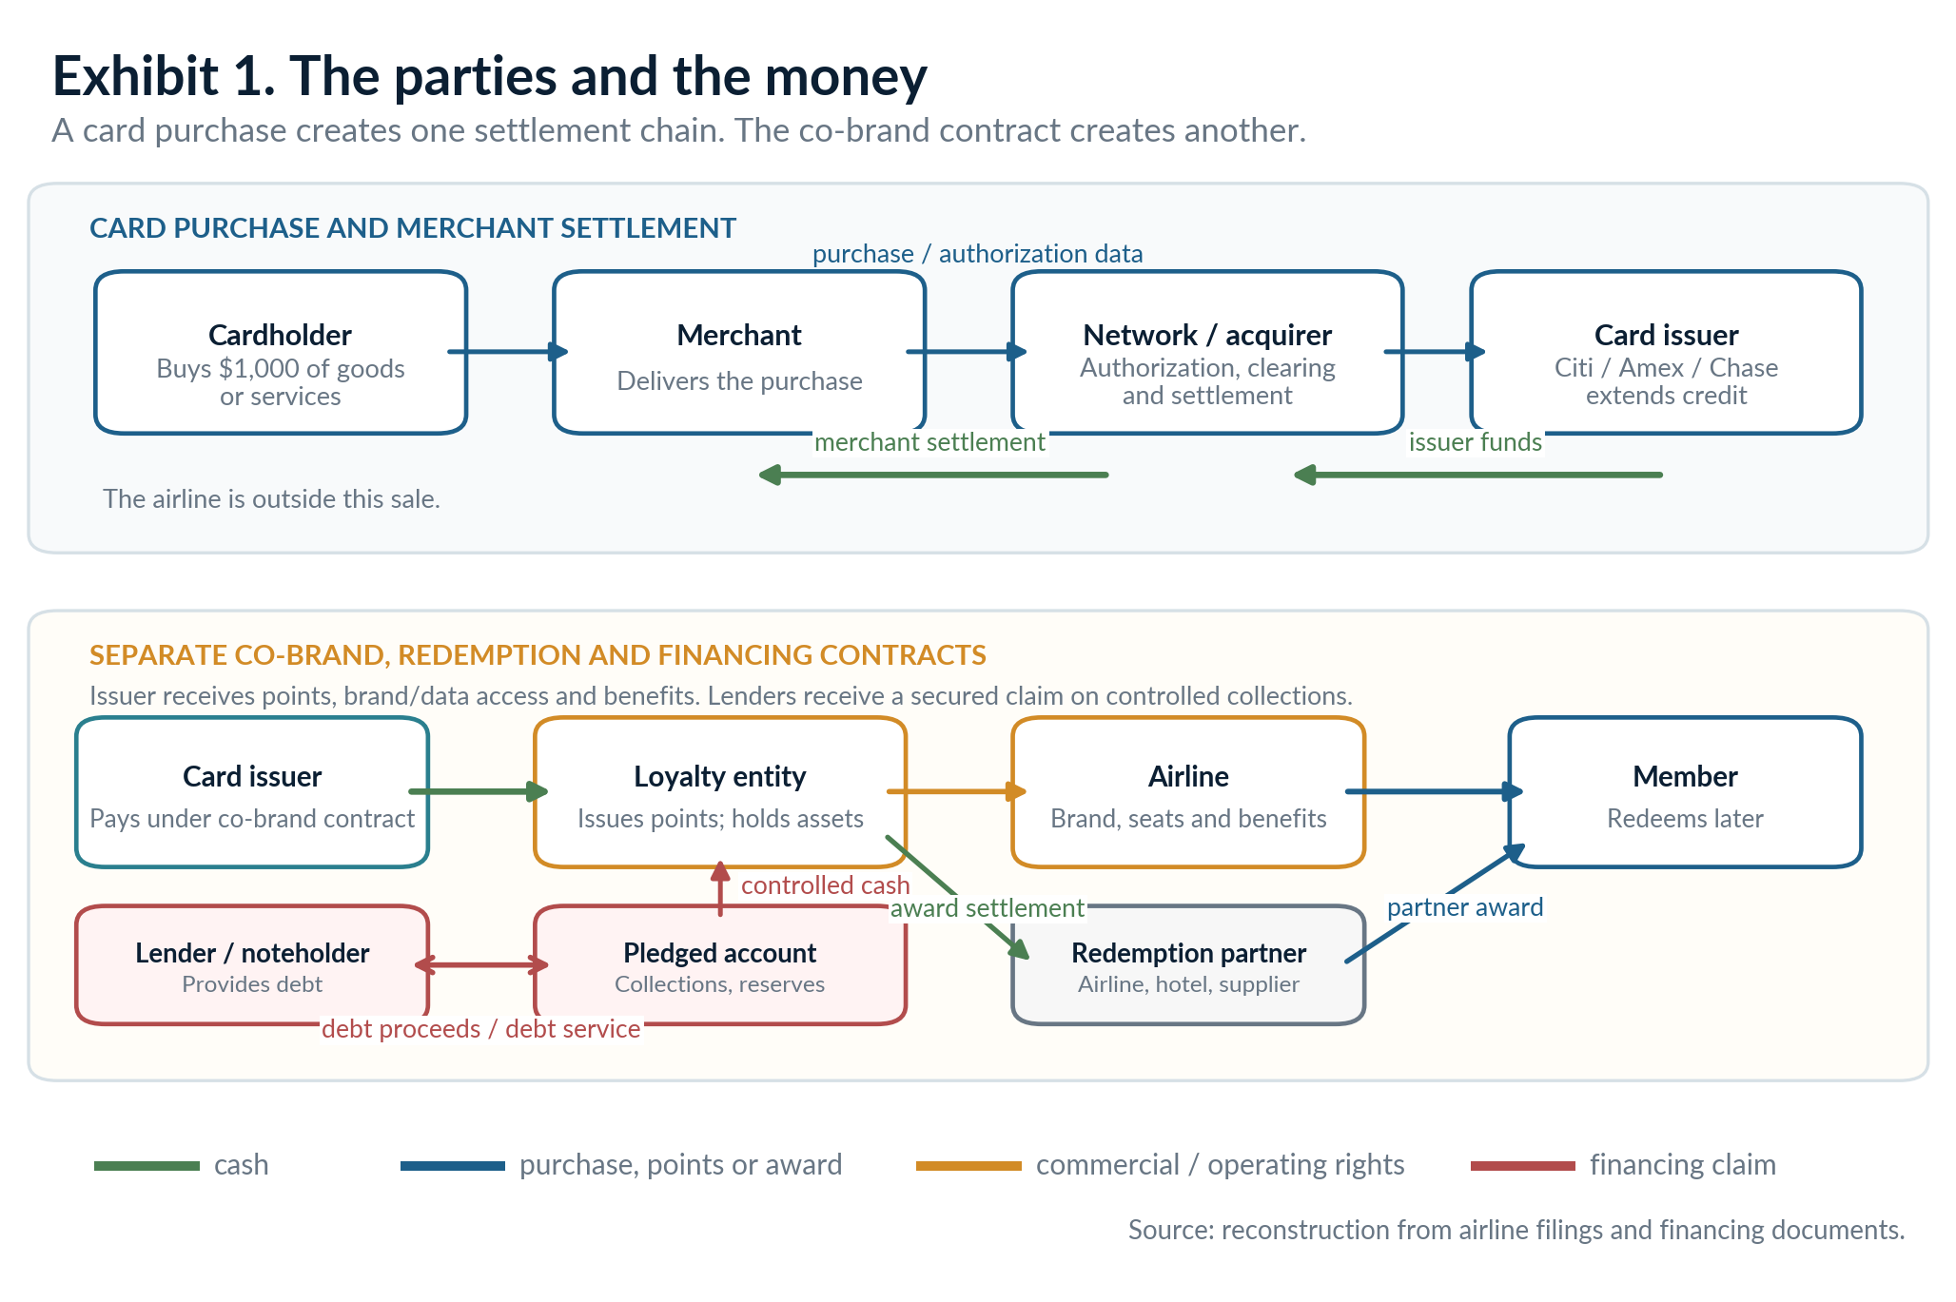
Cash from the issuer reaches the loyalty system through a commercial agreement, not through the merchant settlement.
The opening transaction also exposes a common error. Interchange is not the cash American reports as partner remuneration. Interchange and card fees sit primarily in the issuer's economics. The issuer then uses a separate portion of its card economics to pay the loyalty partner for the commercial package. On the other side, American's $6.2 billion 2025 partner-cash figure is not the gross card spending generated by AAdvantage members and not the issuer's total revenue from the portfolio. [AA-25K; AMEX-25AR]
The time gap can be long. Delta and United both say the majority of new miles are redeemed within two years. American classified $3.7 billion, about 35% of its year-end 2025 loyalty liability, as current. A model consistent with those disclosures places 25% of a cohort in Year 0, 35% in Year 1, 20% in Year 2, 8% later and 12% as expected breakage. Conditional on redemption, that curve produces an expected wait of about 1.7 years. The cardholder may not fly until long after the bank has paid. [AA-25K; DL-25K; UA-25K]
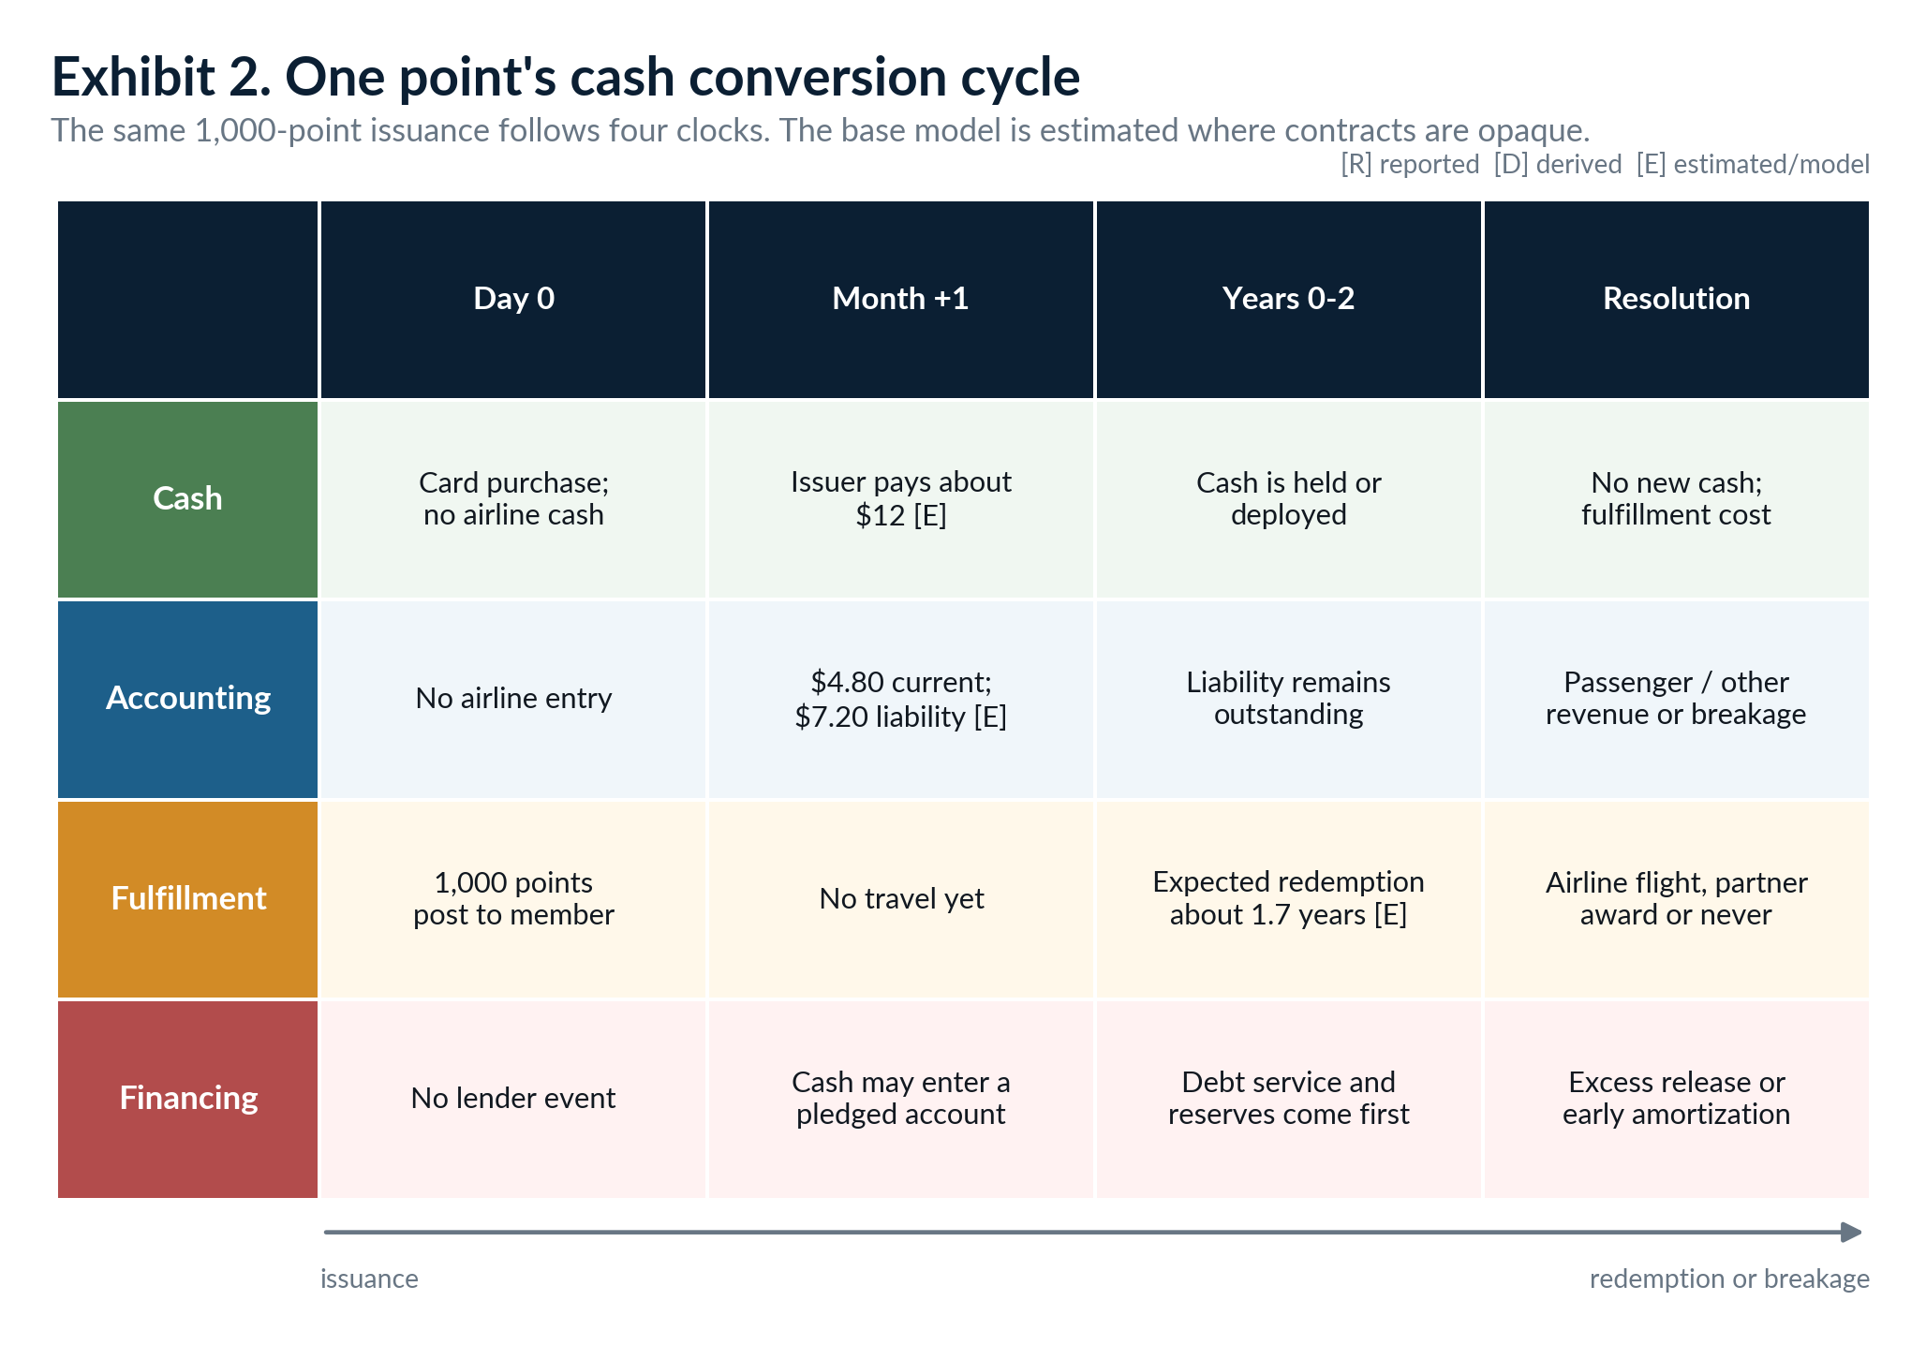
The airline can receive and deploy cash before the accounting liability is released or the seat is delivered.

THE CONTRACT BUNDLE
2. The bank is purchasing more than points
A point count is the most visible unit in the agreement, but it is not the entire product. American describes its co-brand arrangements as including mileage credits, use of the American brand, access to customer lists, free checked bags, priority boarding and other travel benefits. Delta adds joint marketing, access to its customer database, lounge access and brand use. United lists miles, marketing, advertising and travel-related benefits such as bag waivers, seat upgrades and lounge passes as separate performance obligations. [AA-25K; DL-25K; UA-25K]
The distinction changes the interpretation of every cents-per-point estimate. Suppose an issuer pays $12 when 1,000 points are issued. That $12 can include a royalty-like payment for the brand, compensation for customer acquisition, access to an affluent traveler base, marketing placements, cardholder benefits and the award currency itself. Dividing $12 by 1,000 and calling 1.2 cents the wholesale price of a mile makes the bundle look more precise than the contract allows. [AA-25K; DL-25K]
The issuer has reasons to pay for the bundle. It earns merchant discount or interchange-related revenue, annual fees, finance charges and customer-lifetime value. It also gets an airline brand, acquisition channels and a reward that can change cardholder behavior. American Express reported that the Delta co-brand portfolio represented about 13% of worldwide billed business and about 21% of worldwide Card Member loans at year-end 2025. The relationship is material to the issuer as well as the airline. [AMEX-25AR]
The payment formula can mix volume-based and fixed elements. American says its issuer consideration includes monthly amounts based on miles sold and card usage plus a portion fixed annually. Delta says payments are typically due monthly based on miles sold and that substantially all loyalty marketing-agreement cash sales relate to American Express. These are recurring operating receipts, not automatically prepayments. [AA-25K; DL-25K]
Explicit upfront money belongs in a separate category. Air Canada's Aeroplan acquisition materials disclose C$1.212 billion received from TD, CIBC, Visa and American Express in connection with long-term commercial agreements. Air Canada deferred that amount and amortized it over the agreement terms. The same materials separately disclose C$400 million of TD and CIBC prepayments to be applied against future monthly purchases of Aeroplan miles. One payment bought participation and future services; the other was a purchase credit against future miles. Neither was ordinary monthly point-sale cash. [AC-AERO-19]
What the bank actually buys
A reward currency plus a distribution and marketing system: brand rights, customer access, card acquisition, exclusivity, advertising inventory, travel benefits and a long-duration relationship with frequent travelers. The point is the unit that makes the package measurable, not the whole package.

This is also where partner concentration enters. The richer the bundle and the deeper the integration, the harder it is to replace the issuer without disrupting acquisition, benefits, data-sharing and card servicing. American's new arrangement makes Citi the exclusive U.S. AAdvantage issuer starting in 2026 and transfers the Barclays portfolio to Citi. The reset may improve economics and consistency, but it replaces a dual-issuer model with a larger single-counterparty exposure. [AA-24CITI; AA-25K]

CLOCK 2: ACCOUNTING
3. Cash today, obligation tomorrow
The first accounting entry does not treat the bank payment as one product. The airline estimates the relative standalone selling prices of the obligations in the commercial package. Consideration assigned to brand, marketing or benefits already delivered can be recognized in the current period. Consideration assigned to future award transportation is placed in a contract liability and recognized when the member redeems and travel occurs. Other awards follow their own service timing. [AA-25K; DL-25K; UA-25K]
For the 1,000-point model, the $12 cash receipt is allocated 40% to current marketing and benefits and 60% to the future award. The illustrative journal entry is: debit cash $12; credit current revenue $4.80; credit loyalty contract liability $7.20. On an airline-operated redemption, the later entry is debit the contract liability and credit passenger revenue. On a non-travel award, the release can move through other revenue and may be recorded net of the supplier cost if the airline acts as agent. On expected breakage, the liability is released proportionally with redemptions rather than waiting for a formal expiration date. [AA-25K; UA-25K; AC-AERO-19]
Those allocation percentages are estimated. American discloses the method but not the current contract-specific split. Delta explains that it uses discounted cash flow estimates, equivalent ticket values, expected redemption, breakage, published service prices, royalty-style brand values and volume discounts. United separately identifies the performance obligations. The filings reveal the architecture but not enough data to reproduce the exact allocation. [DL-25K; UA-25K]
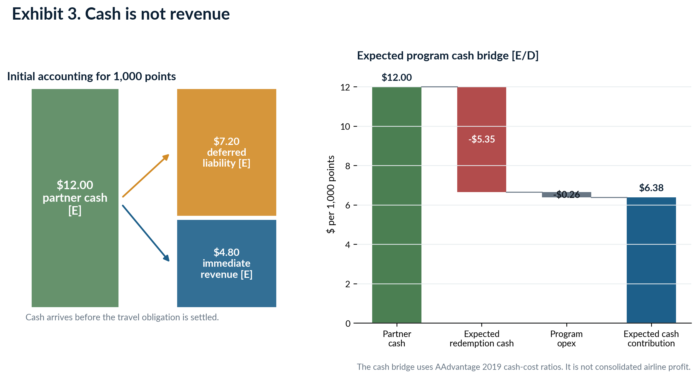
The accounting bridge and the cash-contribution bridge use the same $12 receipt but answer different questions.
American's reported 2025 figures show the scale. Partner cash was $6.2 billion. The loyalty liability absorbed $4.445 billion of new deferral and released $3.935 billion into revenue, ending at $10.564 billion. Separately, American reported $3.511 billion of loyalty marketing-services revenue and $4.036 billion of loyalty travel revenue. The two revenue categories are not the current-year partner payment split: the travel number includes releases from prior cohorts, while the marketing number includes current-period performance obligations. [AA-25K]
Delta's numbers make the timing mismatch visible from another angle. In 2025 Delta recorded $8.0 billion of cash sales from loyalty marketing agreements and $8.2 billion of remuneration from American Express, a definition difference the filing does not fully reconcile. It added $4.892 billion to loyalty deferred revenue, recognized $4.237 billion for travel awards and $219 million for non-travel redemptions, and ended with a $9.262 billion liability. Its other-revenue loyalty line was $3.362 billion. None of those figures is a substitute for another. [DL-25K]
United reported a $7.777 billion year-end liability, $3.883 billion of additions, $3.414 billion of travel releases, $133 million of non-travel releases and $3.2 billion of partner-related other operating revenue. Again, the immediate marketing and advertising revenue is separated from the deferred mile obligation. Lounge passes, bag waivers and upgrades can have different recognition points. [UA-25K]
Exhibit 4 detail: accounting categories are similar, but not identical
Program / 2025 | Ending liability [R] | Additions [R] | Releases [R] | Current / partner-related revenue [R]
American AAdvantage | $10.564bn | $4.445bn | $3.935bn | $3.511bn marketing services; $4.036bn loyalty travel
Delta SkyMiles | $9.262bn | $4.892bn | $4.456bn total | $3.362bn other-revenue loyalty; $4.237bn award travel
United MileagePlus | $7.777bn | $3.883bn | $3.547bn total | $3.2bn marketing, advertising, non-travel and benefits

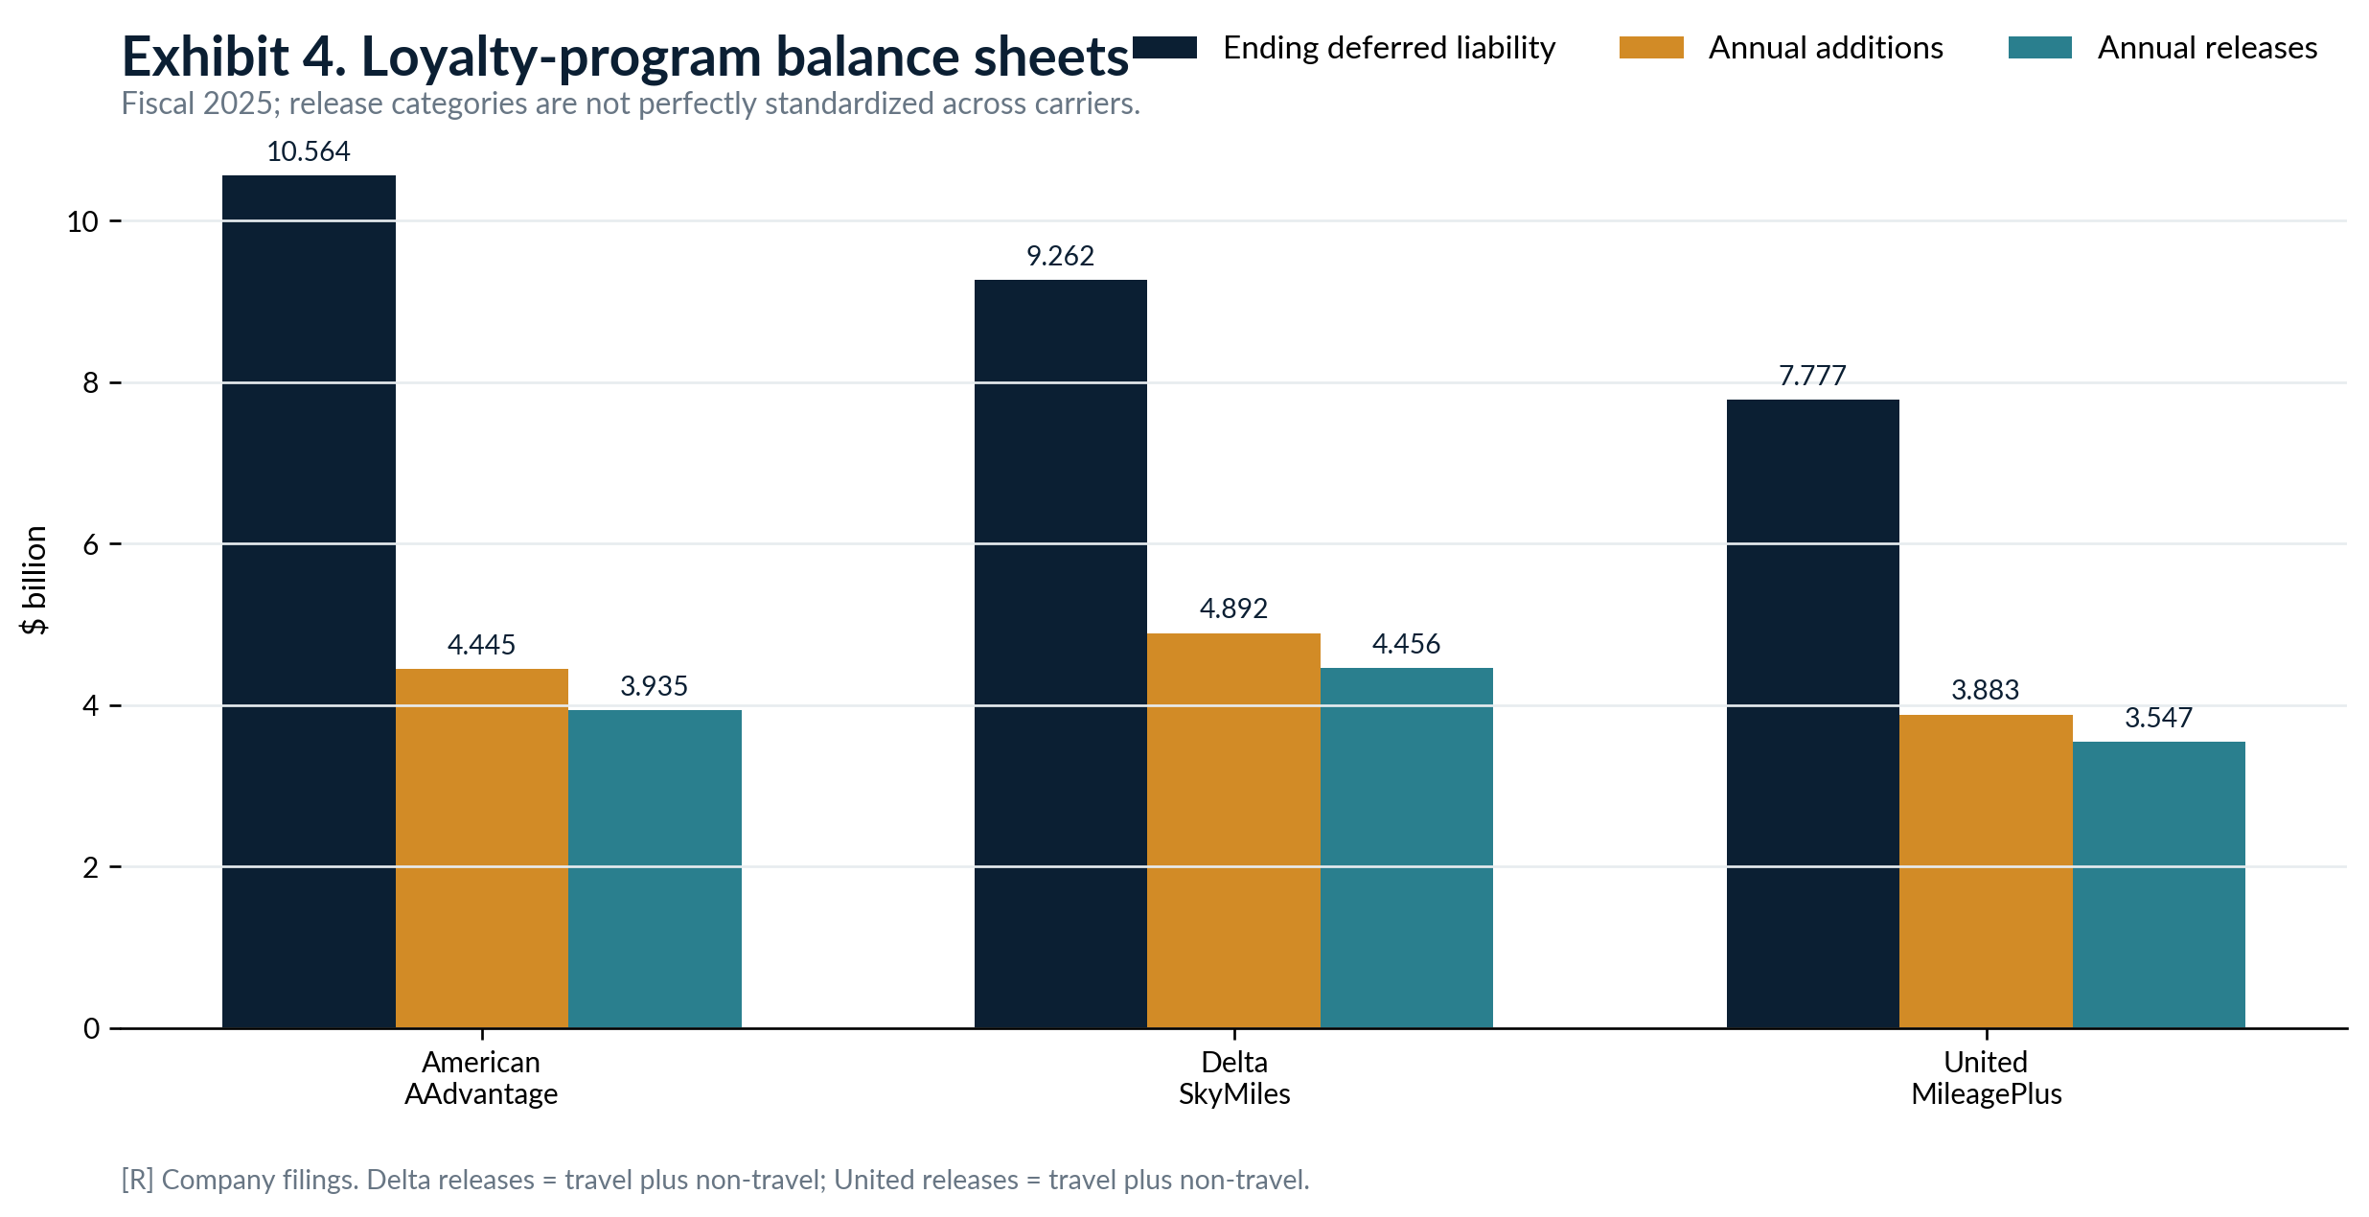
Ending liabilities are roughly two years of annual release at Delta and United and 2.7 years at American, where the balance includes upfront Citi consideration.
A contract liability is not conventional borrowing. It does not carry a fixed coupon or principal maturity and is normally settled by performance, not cash repayment. It can still be economically valuable funding. The airline has received cash while the cost of the award is deferred. The amount on the balance sheet measures allocated consideration and expected redemption, not the cash that will leave the company when members fly. [AA-25K; DL-25K; UA-25K]

TIMING, BREAKAGE AND FLOAT
4. The economics of waiting
The period between issuance and redemption is the system's operating float. It comes from ordinary sales of the commercial bundle, not from a loan. The longer the point remains outstanding, the longer the airline holds the cash before incurring fulfillment cost. In the base point model, $7.20 per 1,000 points is deferred. Delaying fulfillment by one additional year has about $0.43 of gross funding value at a 6% cost of capital. That is a timing benefit, not revenue. [POINT-MODEL]
A simple liability-duration proxy divides the ending balance by annual releases. It produces 2.68 years for American, 2.08 years for Delta and 2.19 years for United. These are derived measures, not contractual maturities. American's proxy is inflated by the one-time Citi payment in the liability. Delta and United's statements that most new miles redeem within two years are a better description of cohort behavior than the ratio alone. [AA-25K; DL-25K; UA-25K]
Breakage is the portion of outstanding points that the airline expects will never be redeemed. It is an estimate, not the same thing as legal expiration. American generally keeps miles active with qualifying activity or while the member holds a co-brand card; Delta and United market no-expiration policies. The accounting models therefore use statistical unlikelihood of redemption, account behavior and forfeiture rules rather than waiting for a calendar date. [AA-25K; AA-RULES; DL-25K; UA-25K]
The model assumes 12% breakage, with a 5% to 20% sensitivity range because the U.S. carriers do not disclose a current headline rate. Air Canada offers a useful scale check: in 2020 it said a hypothetical one-percentage-point change in the number of Aeroplan points expected to be redeemed would affect revenue by about C$33 million on a C$3.256 billion points liability. Applying the same mechanical 1% test to 2025 U.S. balances gives about $106 million for American, $93 million for Delta and $78 million for United. Those U.S. figures are derived, not company sensitivities. [AC-20AR; AA-25K; DL-25K; UA-25K]
Breakage can improve economics in two ways. Fewer awards require fulfillment, and the related contract liability is eventually recognized as revenue. The revenue recognition may occur proportionally as the redeeming cohort progresses; it is not necessarily a one-time windfall when a member disappears. A change in the estimate can move current revenue, but it also changes the amount of future obligation believed to remain. [AA-25K; UA-25K; AC-AERO-19]
Dormant balances can be helpful until they are not. A member-confidence shock can turn a long-duration balance into a redemption wave. The airline would then release more deferred revenue, which can make accounting revenue look strong, while cash costs and seat displacement rise. The cash clock and the accounting clock would move in opposite directions: no new partner cash, more liability release, and more fulfillment demand.
The float is valuable, but it is not free of risk
Longer redemption timing gives the airline more time with the cash. It also leaves a larger population of members who can redeem into a future period of high load factors, weak issuer spending or constrained liquidity.

CLOCK 3: FULFILLMENT
5. What an award seat costs
Five values are often called the value of a point. They are not the same. The bank's cost is the commercial bundle price. The accounting value is the consideration allocated to the award obligation. The consumer's value is the cash fare or alternative reward avoided. The airline's incremental cost is the cash cost of carrying one more award passenger. The opportunity cost is the cash contribution lost if the award displaces a paying traveler. [AA-25K; DL-25K; UA-25K]
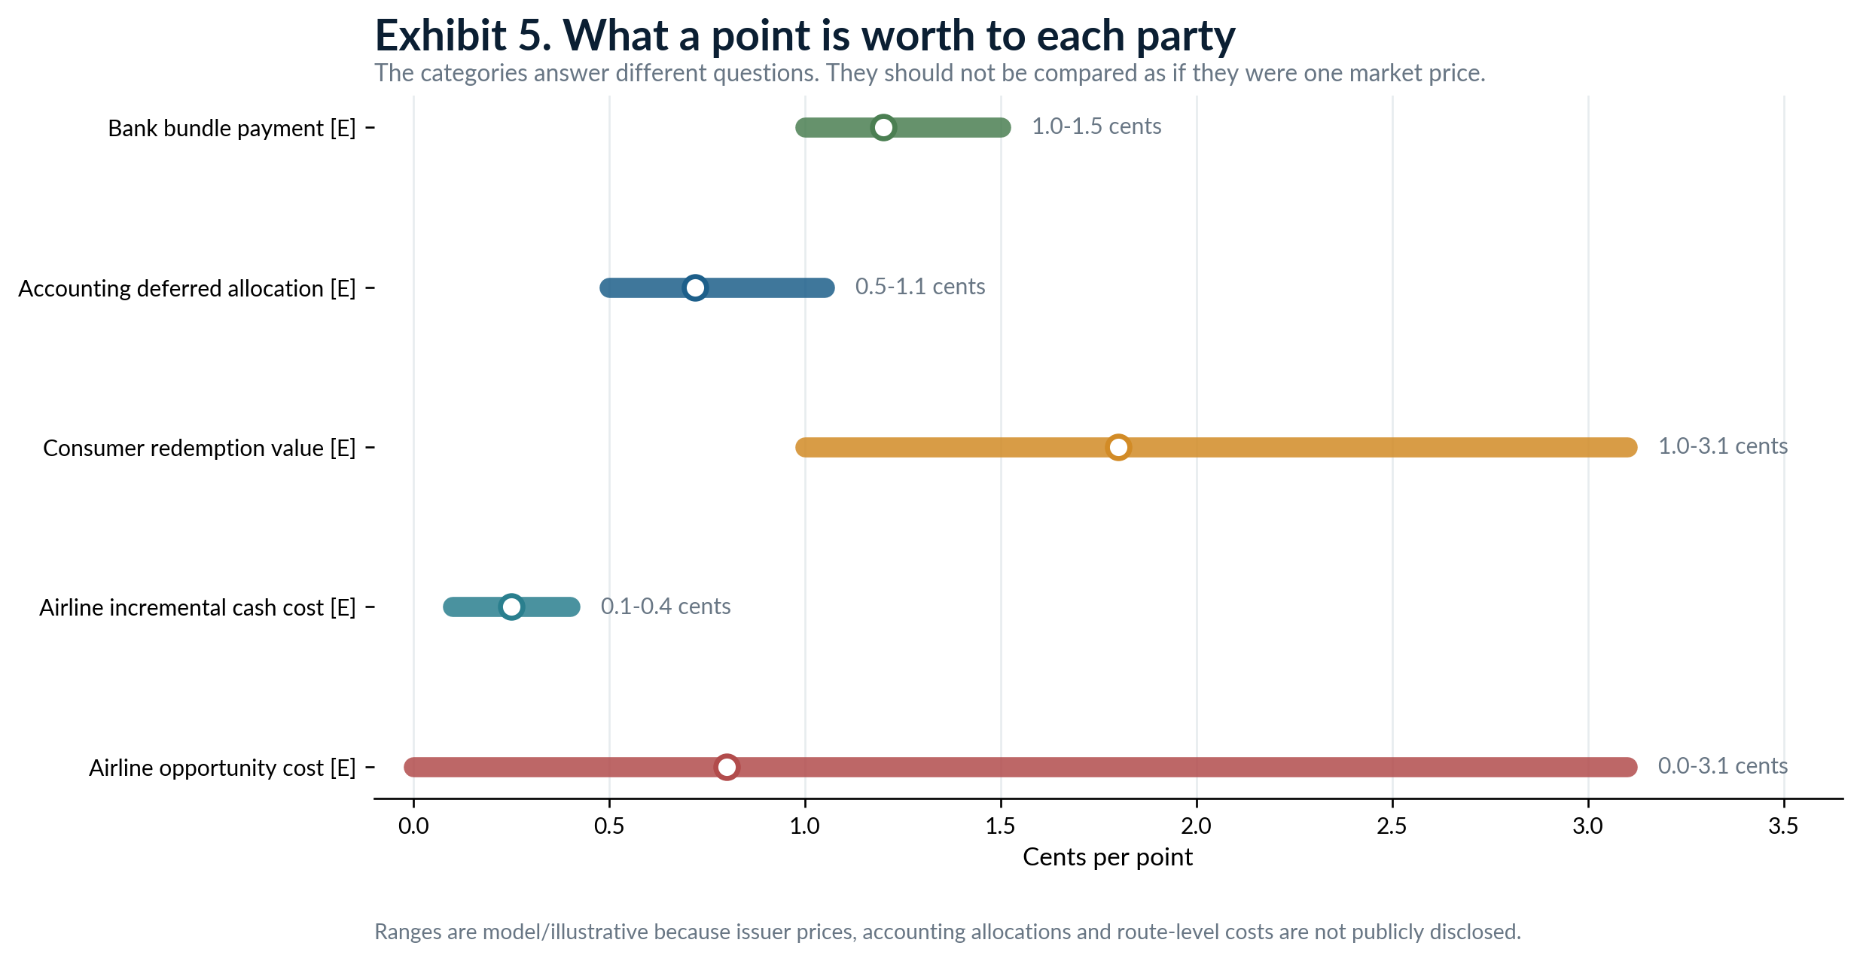
The ranges are intentionally wide. Public disclosures do not reveal the current net bank price, contract allocation or route-level fulfillment cost.
Consider an off-peak economy seat that would sell for $150 and is offered for 15,000 points. The member receives 1.0 cent per point of apparent value. If the seat would otherwise depart empty, the airline's incremental cash cost may be $25 to $60 for taxes, catering, handling and small operating effects, or roughly 0.17 to 0.40 cents per point. The opportunity cost is near zero. The accounting release can still be based on a much higher equivalent-ticket or standalone-selling-price estimate. [POINT-MODEL]
Now consider a constrained premium seat with a $2,500 cash fare and an 80,000-point award. The member sees 3.1 cents per point. The direct incremental cost may still be only $100 to $250, but the opportunity cost can approach the fare contribution if the seat would have sold. The same program can therefore deliver an award at a small cash cost on Tuesday afternoon and an expensive economic cost on Friday night. [POINT-MODEL]
Partner awards add another cost layer. The issuing program may reimburse the operating airline under a confidential transfer-price or award table. Non-travel awards may be recorded on a net-margin basis when the airline acts as agent, but the supplier still has to be paid. A hotel night, merchandise redemption and American-operated flight can release similar deferred consideration while producing different cash outflows. [UA-25K; AC-AERO-19]
American's 2019 financing presentation provides the best public program-level cash proxy. AAdvantage reported $5.912 billion of cash sales, $2.637 billion of cash paid for redemptions and $130 million of operating expense. Redemption cash was 44.6% of cash sales. Applied to the $12 point model, expected redemption cash is $5.35 per 1,000 points and operating expense is $0.26, leaving $6.38 of expected program cash contribution. After dividing by the 88% expected redemption rate, the redemption-cash proxy is about $6.08 per 1,000 points actually redeemed. [AA-21PRES; POINT-MODEL]
That $6.08 is not a seat-level incremental cost. The 2019 presentation includes a mix of American awards, partner awards, non-travel redemptions and intercompany cash mechanics. It is useful as a program cash ratio because it is observed. It cannot tell us what American spends to put one additional passenger in one particular seat. The route, cabin, load factor, partner and award type determine that answer. [AA-21PRES]

AWARD PRICING
6. The controlled inflation of points
The airline controls the unit in which the award is priced. Dynamic pricing allows the required number of points to move with demand, fare levels, member behavior and displacement risk. This makes the point unlike a fixed-dollar liability. The program can reduce the purchasing power of an outstanding balance without changing the nominal number of points in the account. [AA-21PRES; AA-RULES]
A 20% increase in award prices means a fixed pool of points can buy 16.7% fewer awards, assuming members do not change behavior. In the point model, if redemption cash falls proportionally, expected redemption cost declines from $5.35 to $4.46 per 1,000 points and expected cash contribution rises by about $0.89. That is a pro forma sensitivity, not a forecast. It assumes no redemption rush, no change in issuer pricing and no loss of card spend. [POINT-MODEL]
The accounting liability does not automatically fall 16.7% on the day the chart changes. The liability is based on allocated standalone selling prices, expected redemption and the carrier's accounting model. A new award schedule can change equivalent ticket values, redemption behavior and breakage estimates, but those inputs must be reassessed. Devaluation and breakage are related through member behavior; they are not the same accounting concept. [AA-25K; DL-25K; UA-25K]
Short-term economics can improve when point prices rise. Fewer awards may settle the same nominal pool, scarce seats can be protected, and partner reimbursement can be reduced. The long-term contract can deteriorate if members respond by spending less on the card, transferring flexible points elsewhere, redeeming rapidly or valuing the brand less. The bank is paying for engagement, not just for a cheap unit of issuance. [AMEX-25AR]
The control is therefore constrained by an ecosystem. The airline sets award prices, but the bank can renegotiate purchase rates or marketing commitments; members can change cards; partners can reduce participation; and lenders can impose contract-maintenance covenants. A devaluation that raises current contribution but reduces future card volume can lower the value of the pledged cash flow. [AA-CREDIT; UA-CREDIT]
Why "controlled inflation" is the right description
The airline can change the number of points required for a benefit. It cannot assume the change is costless. The same action affects fulfillment demand, accounting estimates, member trust, bank economics and collateral value on different timelines.

CLOCK 4: FINANCING
7. Turning the program into collateral
Operating float creates the recurring cash stream. Loyalty-backed debt puts a legal claim on that stream. American's 2021 transaction did not simply promise lenders that AAdvantage would remain profitable. It reorganized the rights and cash paths around the program: AAdvantage Loyalty IP Ltd. and American Airlines were borrowers or issuers; Cayman holding entities and the parent provided guarantees; loyalty IP and data rights were contributed or licensed; and collection and reserve accounts were pledged. [AA-21PRES; AA-CREDIT]
The collateral package included AAdvantage agreements and payments under them, intercompany and IP-license payments, deposit accounts, reserve accounts, SPV equity and substantially all other loyalty-issuer assets. The credit agreement defined transaction revenue broadly enough to include partner cash, American's own intercompany payments and other cash received by the loyalty issuer. The lender claim was attached to specific contracts and accounts, not to a vague estimate of future airline profit. [AA-CREDIT; AA-25K]
Cash control was the core protection. American was required to use commercially reasonable efforts to have at least 90% of AAdvantage revenue paid directly into the collection account each quarter. Money that landed elsewhere had to be swept in within three business days. Intercompany and IP-license payments also had to go directly to the controlled account. The reserve account was pledged collateral. [AA-CREDIT]
The waterfall worked in plain language. Partner and intercompany cash entered the collection account. Administrative and servicing amounts were paid. Interest and required principal were trapped. The reserve was topped up. Only excess cash was released to the loyalty issuer and then to American. If the peak debt-service coverage ratio or reserve test failed, the structure could enter early amortization and direct more cash to accelerated paydown. [AA-CREDIT; AA-21PRES]
The peak coverage test eventually stepped up to 2.0x. American's presentation described monthly trapping of one-third of quarterly interest and fees, with one-third of scheduled amortization trapped under specified liquidity and ratings conditions. The contractual numerator was based on designated collections and the denominator on maximum quarterly debt service. Program EBITDA was informative, but it was not the covenant itself. [AA-CREDIT; AA-21PRES]
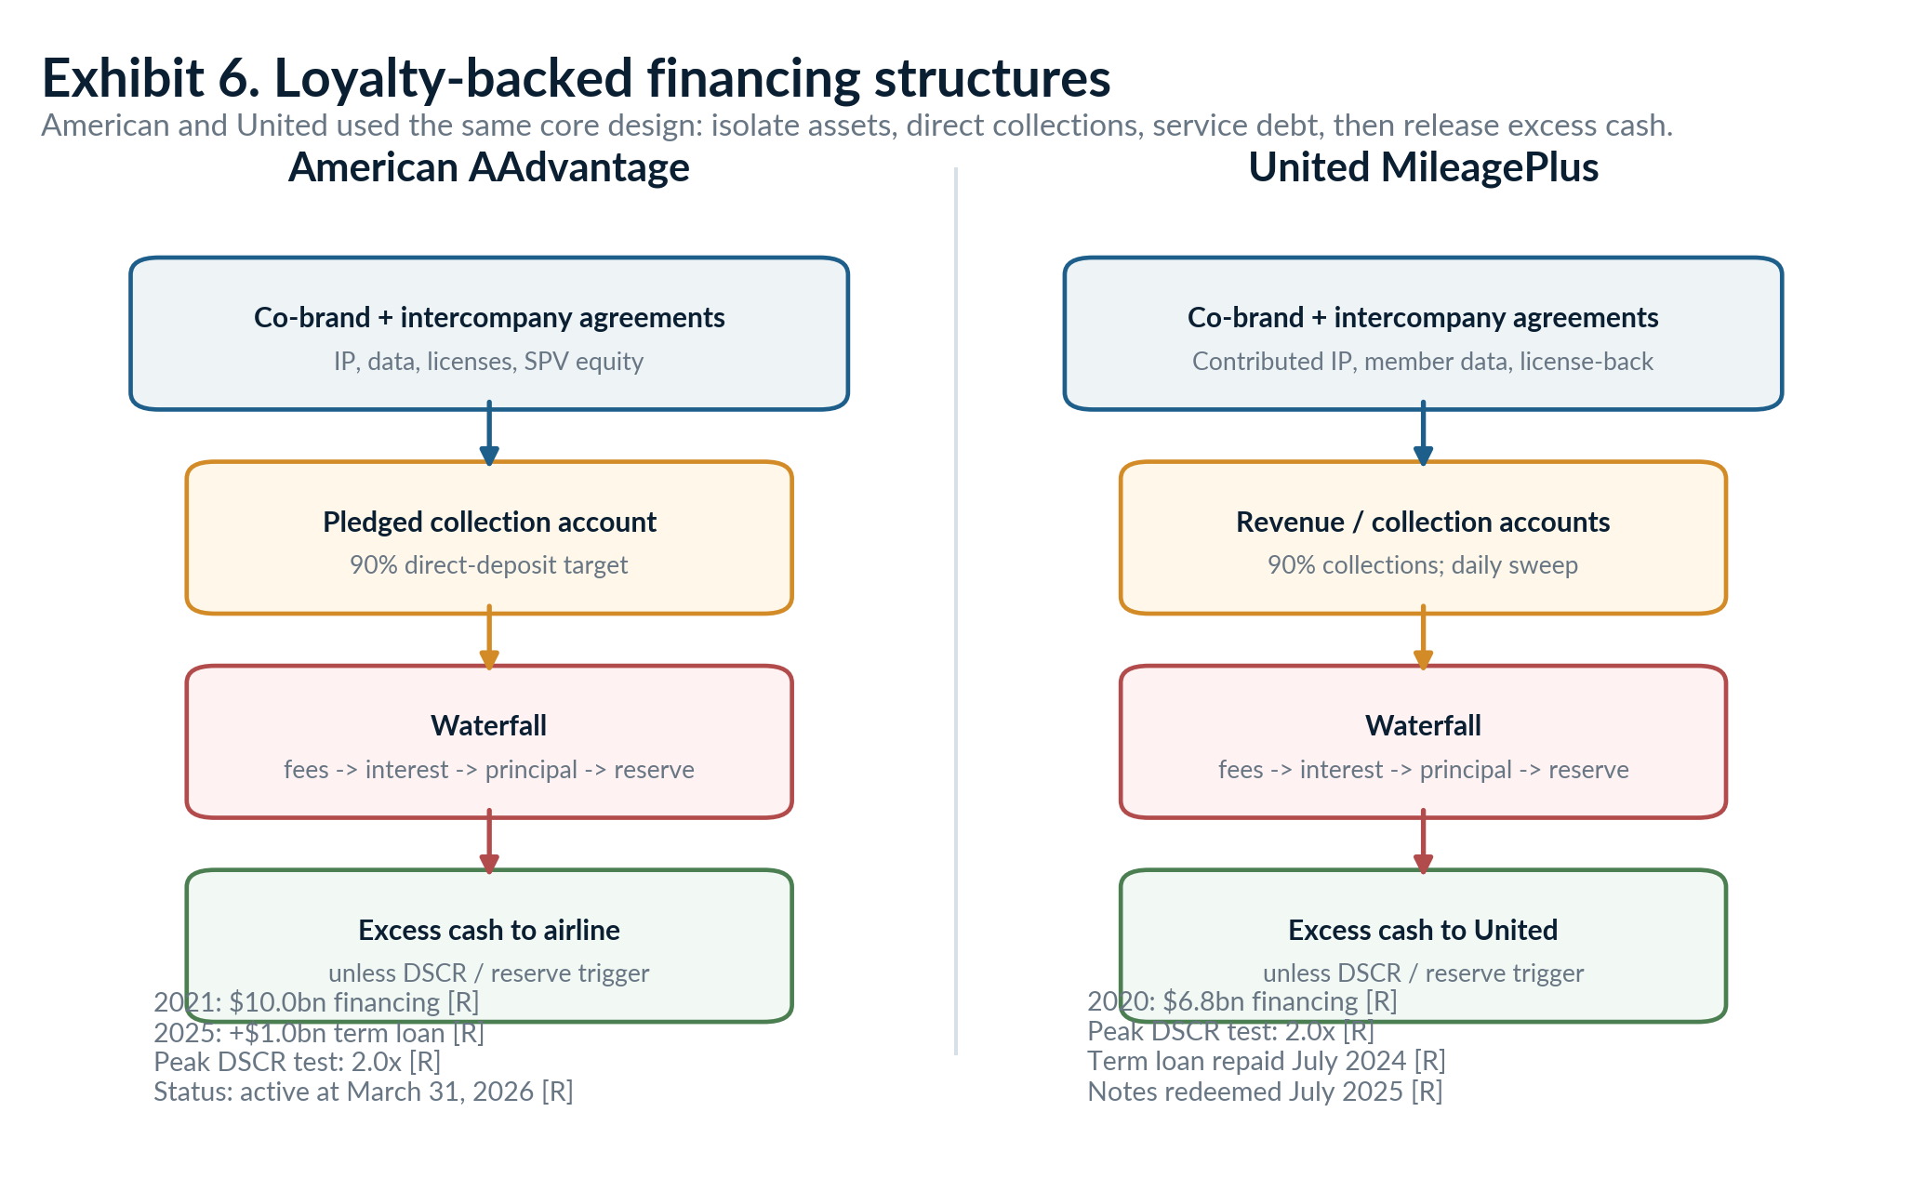
United later repaid its loyalty-backed debt; American continued to use the channel and added a $1.0 billion term loan in 2025.
American initially raised $10.0 billion in 2021: $3.5 billion of 5.50% notes, $3.0 billion of 5.75% notes and a $3.5 billion term loan. It added a $1.0 billion incremental AAdvantage term loan in 2025. At 31 March 2026, disclosed AAdvantage balances were approximately $292 million of 5.50% notes, $3.0 billion of 5.75% notes, $2.258 billion on the 2021 term loan and $993 million on the 2025 term loan. The visible stack remained a live claim on program cash. [AA-25K; AA-26Q1]
United used nearly the same design in 2020. It raised $6.8 billion through $3.8 billion of 6.50% notes and a $3.0 billion term loan, secured by substantially all assets of the issuing entities, including accounts receiving MileagePlus partner and United payments. At least 90% of collections flowed into controlled accounts, the DSCR ramped to 2.0x, and the documents restricted changes to intercompany agreements, transfer pricing and redemption-seat availability. United prepaid the term loan in July 2024 and redeemed the remaining $1.52 billion of MileagePlus notes in July 2025. By then the loyalty assets were no longer supporting that debt. [UA-20FIN; UA-CREDIT; UA-25K]
Lenders were willing to advance billions during the pandemic because card spending and partner contracts did not fall in the same way as passenger flying. American's 2019 pro forma AAdvantage collections were $5.912 billion and net cash from operations was $3.145 billion. The original $10 billion financing equaled 1.69x gross collections, 3.18x net program cash from operations and 3.44x management-defined program EBITDA. The legal controls reduced leakage risk while the cash engine reduced debt-service risk. [AA-21PRES]
The collateral still depended on the airline. United licensed contributed MileagePlus IP back to the operating company and protected the intercompany agreement that determined how many seats were available and what United paid for miles. American likewise protected the exclusive right of the loyalty vehicle to issue miles, the payment path and key intercompany terms. A lender can control accounts, contracts, liens and IP rights after default. It cannot operate a flight schedule, produce airport service or preserve member demand without the airline platform. [AA-CREDIT; UA-20FIN; UA-CREDIT]
Collateral value is not standalone viability
The lender package is designed to keep the airline and loyalty system tied together through a restructuring. It is not evidence that a creditor could separate the program and run it indefinitely without routes, seats, employees, airport access and the airline brand experience.

VALUATION
8. Is the loyalty program worth more than the airline?
The comparison is only meaningful when dates and definitions match. American's March 2021 AAdvantage financing presentation showed an airline enterprise value of $49.521 billion and an equity market capitalization of $14.182 billion. The same presentation reported 2019 pro forma AAdvantage adjusted EBITDA of $2.911 billion. The equity market cap reflected airline distress and leverage; enterprise value included debt. A gross loyalty enterprise value should be compared with the latter, not the former. [AA-21PRES]
Applying an estimated 7x to 10x multiple to the program EBITDA gives a gross value of $20.4 billion to $29.1 billion. That equals 41% to 59% of American's same-date enterprise value, but 1.44x to 2.05x its equity market cap. The slogan that the program was worth more than the airline is therefore arithmetically possible only if "airline" means distressed equity and "program value" means gross enterprise value. Those are different claims on the same corporate system. [AA-21PRES; POINT-MODEL]
A separate DCF uses normalized post-tax free cash flow of $2.1 billion to $2.5 billion, five-year growth of 2% to 3%, a 10% to 11% discount rate and 1.5% to 2.5% terminal growth. It produces an estimated range of $22.9 billion to $34.9 billion, with a base case of $28.2 billion. The result is driven less by seat cost than by the durability of card spending, partner concentration, contract pricing and the risk that member economics deteriorate. [POINT-MODEL]
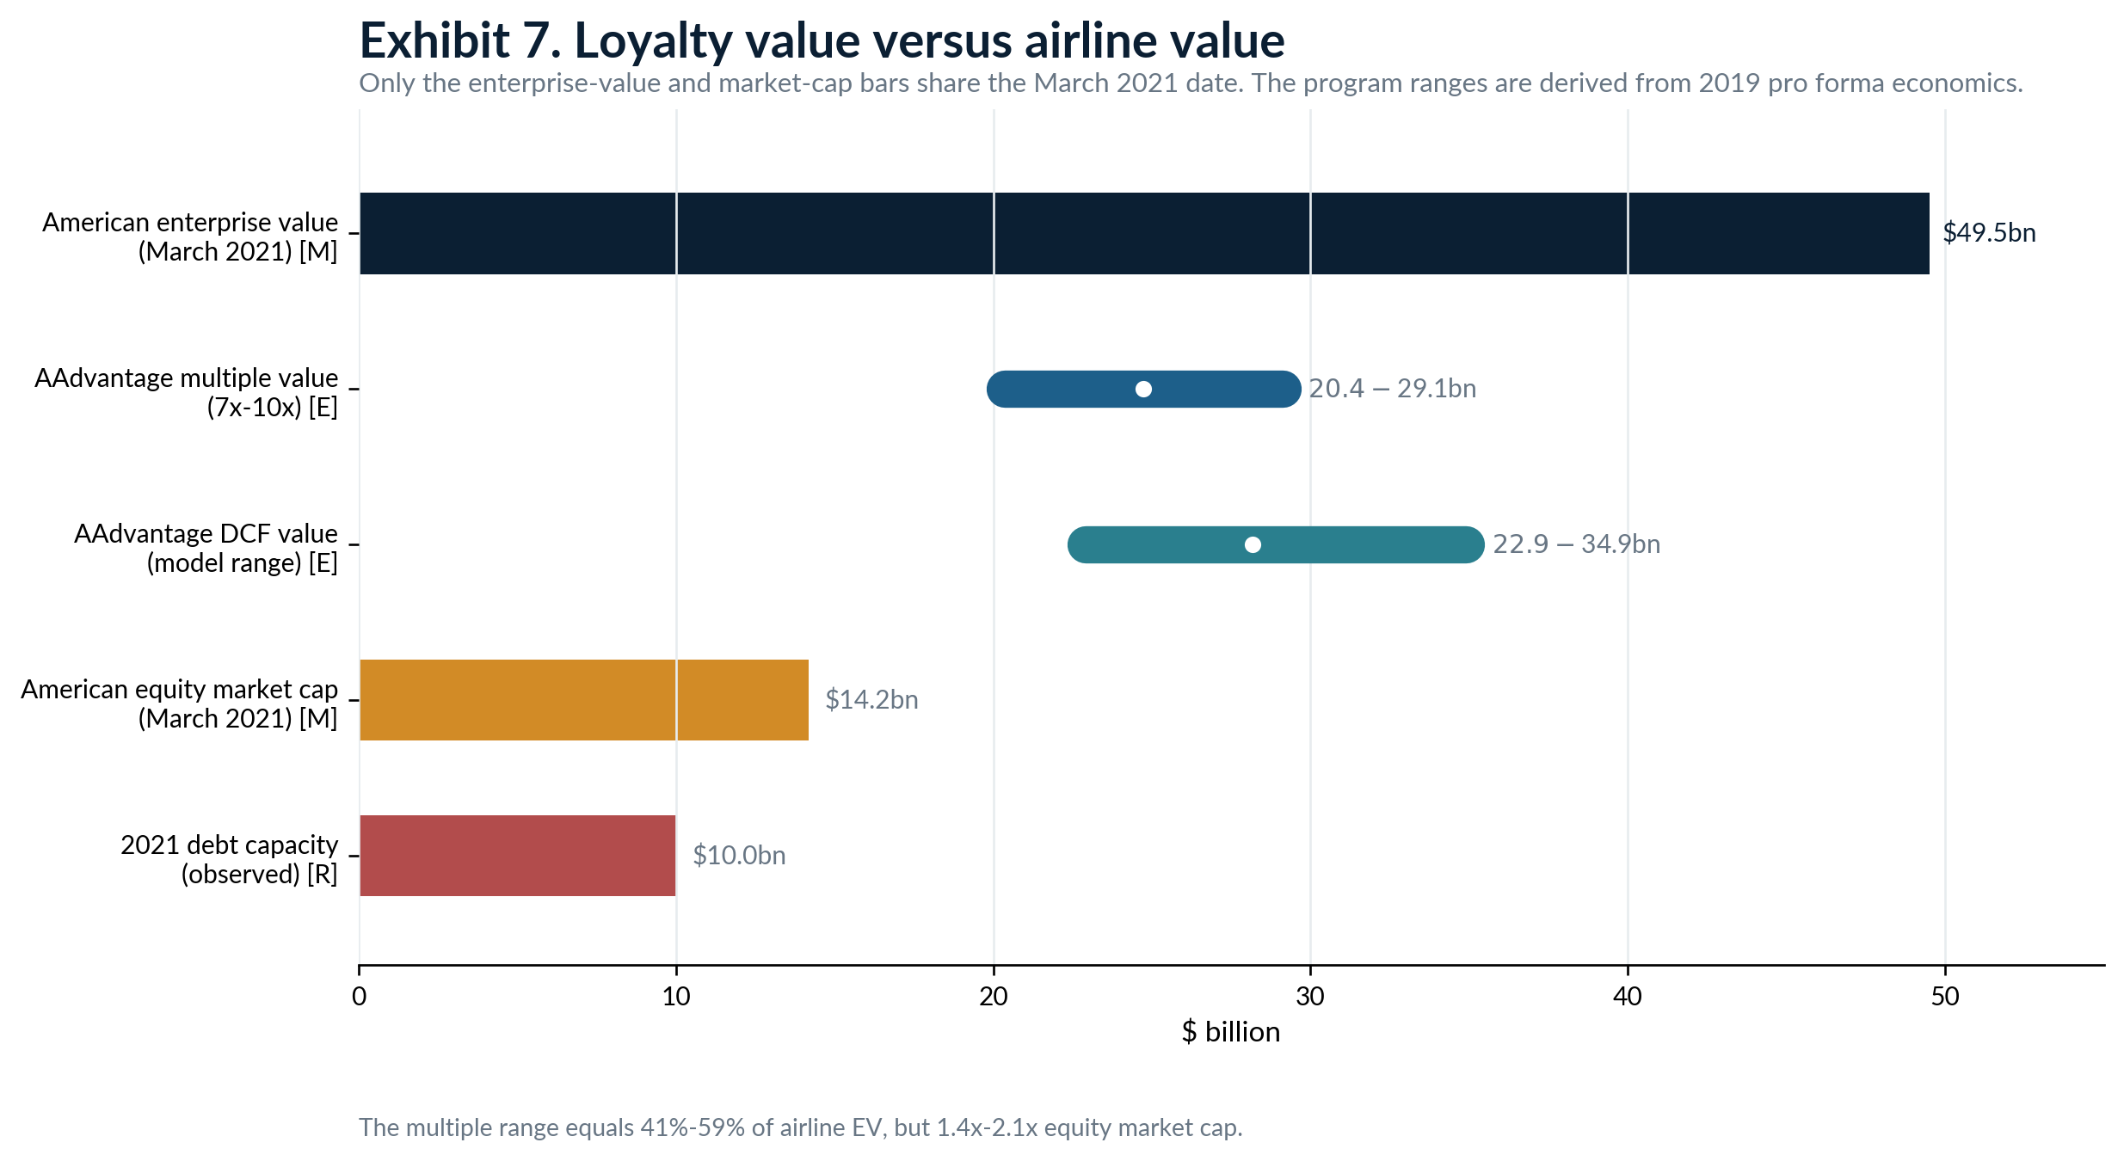
Gross program value can exceed airline equity value while remaining well below airline enterprise value. Loyalty-backed debt must still be deducted to reach program equity value.
Observed debt capacity supplies a floor of a different kind. Lenders advanced $10.0 billion against AAdvantage in 2021 and American added another $1.0 billion in 2025. That does not prove a program enterprise value of $11.0 billion. It proves that designated cash flows and collateral supported at least that much secured borrowing under reserves, covenants and cash trapping. Debt capacity is not equity value and not liquidation value. [AA-21PRES; AA-25K]
The program can command a high value because card spending is recurring, partner contracts can last a decade, capital needs are lower than an airline fleet, and cash collection is less volatile than ticket revenue. The discount comes from dependence on a few banks, the airline's operational platform, member behavior, the accounting estimates embedded in liability and EBITDA, and secured debt already sitting ahead of airline equity. [AA-24CITI; AA-CREDIT]
Management valuations are useful as financing evidence, not independent market prices. United's 2020 presentation used a 12x multiple to imply about $21.9 billion for MileagePlus. The number was prepared to support a secured financing during a liquidity crisis. It shows how the company and lenders framed the cash stream; it does not show what an unaffiliated buyer paid for the whole program. [UA-20FIN]

COUNTERPARTY AND TRANSITION RISK
9. When the bank relationship breaks
Aeroplan shows what happens when the airline, loyalty operator and financial partners do not share control. Air Canada had separated Aeroplan into an externally owned loyalty company. In May 2017 it announced that Aeroplan would stop being its loyalty program when their commercial agreement expired on 30 June 2020. The announcement threatened the value of the operator's core redemption platform and reset bargaining power across Aimia, Air Canada and the card partners. [AC-EXIT-17]
The dispute ended with Air Canada buying Aeroplan back. The announced terms were C$450 million in cash plus assumption of roughly C$1.9 billion of miles-related redemption liability; purchase accounting later put consideration at C$497 million after adjustments. The liability did not disappear because ownership changed. The members still held outstanding miles, and the operating airline had to provide or arrange the future awards. [AIMIA-18; AC-AERO-19]
The bank and network partners helped finance continuity. Air Canada received C$1.212 billion of deferred partner consideration and C$400 million of separate mile-purchase prepayments. The structure answered several transition questions at once: who would operate the program, which bank portfolios would remain attached, which network would process the cards, who would own the brand and data, and who would carry the outstanding award liability. [AC-AERO-19]
A co-brand break therefore has at least five moving pieces. The airline may own the loyalty brand but not the credit-card receivables. The issuer owns or services the card portfolio and can sell or transfer it subject to contract and regulatory terms. The program operator owes the points. The airline controls most of the high-value redemption inventory. The outgoing issuer can stop creating new cash long before the last point it funded is redeemed. [AA-24CITI; AC-AERO-19]
American's Citi transition is designed to avoid a disorderly break: Citi becomes the exclusive U.S. issuer and acquires the Barclays American portfolio. The arrangement reduces the need to rebuild acquisition and servicing from zero. It also concentrates future partner cash in one issuer. If that relationship later failed, a larger share of AAdvantage collections would be exposed at once. [AA-24CITI; AA-25K]
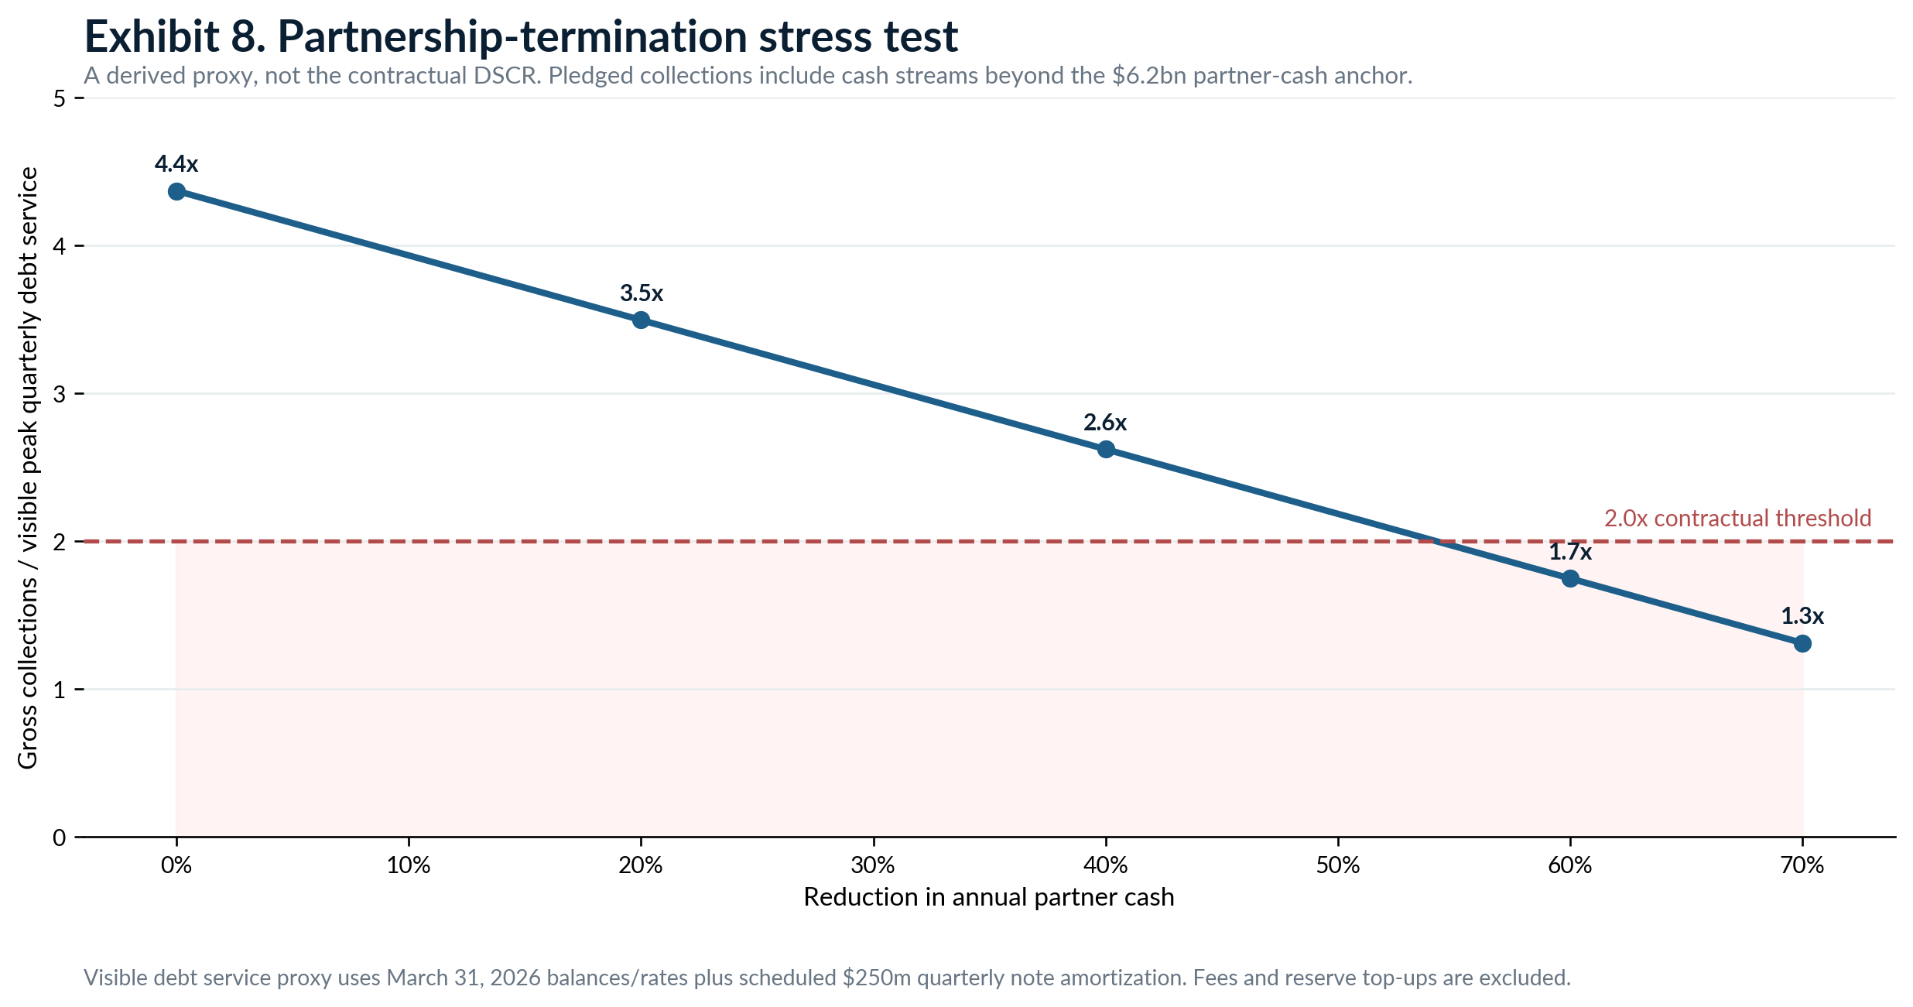
The gross-coverage line crosses below the 2.0x contractual threshold between a 40% and 60% loss of the $6.2 billion partner-cash anchor.
The stress test is deliberately mechanical. It uses American's $6.2 billion 2025 partner cash as a lower-bound annual collections anchor and March 2026 disclosed debt balances and rates. It assumes about $250 million of quarterly note amortization plus term-loan amortization and visible interest, producing roughly $355 million of peak quarterly debt service before fees and reserve top-ups. The resulting coverage proxy is 4.4x at base, 3.5x after a 20% cash reduction, 2.6x after 40% and 1.7x after 60%. This is not the contractual DSCR calculation. [AA-25K; AA-26Q1; POINT-MODEL]
Modeled partnership-loss scenario
Scenario | Partner cash [PF] | Gross coverage [D] | Program cash contribution [PF] | Ending loyalty liability [PF]
Base | $6.20bn | 4.4x | $3.30bn | $11.07bn
Recession | $4.96bn | 3.5x | $1.79bn | $9.79bn
Severe spend shock | $3.72bn | 2.6x | $0.50bn | $8.82bn
Issuer disruption | $2.48bn | 1.7x | -$0.82bn | $7.82bn
Near-termination | $1.86bn | 1.3x | -$1.58bn | $7.18bn

The liquidity effect arrives faster than the liability disappears. In the issuer-disruption case, modeled partner cash falls to $2.48 billion while redemption cash rises 15%. Program cash contribution turns negative by about $0.82 billion, yet the ending loyalty liability remains about $7.82 billion. The program would still owe awards after the current cash engine had been damaged. [POINT-MODEL]
For loyalty-backed debt, the danger is not only lower EBITDA. A material partner termination can reduce deposits to the pledged account, impair a material agreement, breach maintenance covenants, produce a DSCR failure and trigger early amortization. Cash that the airline would otherwise use for operations can be trapped to pay lenders while members continue to redeem. The financing clock can therefore tighten precisely when the operating clock is under stress. [AA-CREDIT; UA-CREDIT]

ATTRIBUTION
10. How much airline profit comes from points?
There is no defensible single percentage. The public record supplies several measures with different numerators and denominators. Each captures part of the system. None measures the counterfactual profit American would lose if AAdvantage vanished.
First, partner cash. American's $6.2 billion of co-brand and other partner cash in 2025 equaled 11.3% of total operating revenue. This measures the cash engine's scale. It includes amounts that may be deferred and, in 2024, included an upfront payment with no immediate earnings effect. It is not current-period profit. [AA-25K; POINT-MODEL]
Second, recognized marketing revenue. American reported $3.511 billion of loyalty marketing-services revenue in 2025. That was 239% of consolidated operating income of $1.467 billion. The ratio is intentionally jarring but not a profit share: it compares a revenue line with a profit line after fuel, labor, aircraft, airport and other costs. Marketing revenue can exceed operating profit without the loyalty business generating more than 100% of profit. [AA-25K; POINT-MODEL]
Third, award-travel revenue. American recognized $4.036 billion of loyalty travel revenue in 2025. That is mostly a release of contract liability when awards were flown. It is passenger revenue, not a fresh bank receipt. The related cash may have been collected in earlier years; the related fulfillment cost appears in the airline operating system rather than as a neat loyalty expense line. [AA-25K]
Fourth, standalone program EBITDA. The 2021 financing presentation reported $2.911 billion of 2019 AAdvantage adjusted EBITDA. Derived 2019 consolidated GAAP operating EBITDA was about $5.383 billion, using $3.065 billion of operating income plus $2.318 billion of depreciation and amortization. On that mixed basis, AAdvantage EBITDA was 54.1% of consolidated operating EBITDA. The numerator is management-defined and pro forma; intercompany payments that support the loyalty subsidiary can be expenses elsewhere in the group. [AA-21PRES; AA-19K; POINT-MODEL]
Fifth, program cash conversion. AAdvantage's $3.145 billion of 2019 net cash from operations was 53.2% of its $5.912 billion of cash sales. This is the cleanest public measure of cash retained after redemption cash and program operating expense on the presentation's definitions. It is still not consolidated incremental profit because internal mile purchases and transfer prices affect where cash and expense appear. [AA-21PRES]
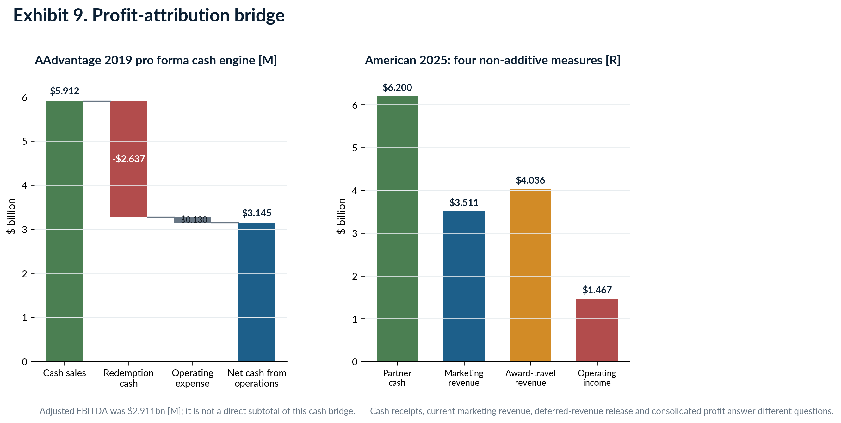
The left panel is a program cash bridge. The right panel puts four 2025 categories next to one another precisely because they are not additive.
The point-level model translates the cash conversion into an expected contribution of $6.38 for each 1,000 points sold for $12. That is a program cash estimate. It should not be called profit from points. A full consolidated contribution model would need the bank's net point price, contract allocation, flight- and partner-award mix, route-level displacement, customer acquisition cost, status benefits, incremental ticket demand, intercompany transfer pricing, breakage and corporate overhead. [POINT-MODEL]
What can be said with confidence is narrower. Selling the commercial bundle creates a large, recurring cash inflow. A material portion is recognized as marketing or other revenue before the member flies. The remainder funds a future award obligation whose cash cost is generally below the member's perceived value but can become expensive on constrained inventory. The retained spread is real. Public filings do not isolate its consolidated counterfactual amount. [AA-25K; DL-25K; UA-25K]

THE OPENING TRANSACTION RESOLVED
11. The final life of one point
Return to the $1,000 hotel purchase. The member earned 1,000 points. The model assumes the issuer paid $12, American recognized $4.80 for current obligations and deferred $7.20. The path now splits. The initial cash is identical; the revenue line, fulfillment cost and timing are not. [POINT-MODEL]
Exhibit 10. The final life of 1,000 points
Outcome | Airline-operated flight | Partner / non-travel award | Never redeemed
Bank payment | $12.00 [E] | $12.00 [E] | $12.00 [E]
Initial accounting | $4.80 current; $7.20 deferred [E] | $4.80 current; $7.20 deferred [E] | $4.80 current; $7.20 deferred [E]
Time outstanding | About 1.7 years in base cohort [E] | Varies with award and partner [E] | Released proportionally through breakage estimate
Final revenue | Deferred amount becomes passenger revenue when travel occurs | Deferred amount becomes passenger or other revenue; non-travel can be net as agent | Deferred amount recognized through proportional breakage
Fulfillment cost | About $6.08 per 1,000 redeemed as program cash proxy [D]; route-level cost varies widely | Modeled $5-$12 per 1,000 redeemed [E]; reimbursement terms are confidential | $0 redemption cash; program operating cost remains
Program contribution | $5.66 per 1,000 before wider airline effects [E/D] | $3.74 base; range about -$0.26 to $6.74 [E] | $11.74 after modeled program operating cost [E]
Main risk | Seat displacement and redemption surge | Partner reimbursement, availability and contract economics | Breakage estimate reverses if member activity returns

Outcome 1: an American-operated flight. At travel, American releases the $7.20 contract liability to passenger revenue. The program-level redemption-cash proxy is $6.08 per 1,000 redeemed points, leaving about $5.66 after modeled operating cost. If the award uses an empty seat, consolidated incremental cost may be much lower. If it displaces a high-fare passenger, opportunity cost can be much higher. [AA-21PRES; POINT-MODEL]
Outcome 2: a partner or non-travel award. The liability is released when the relevant service is delivered. The loyalty program pays the operating airline or supplier. Public reimbursement matrices are unavailable, so the model uses a $5 to $12 cost range and an $8 base. The base contribution is $3.74. The accounting may show net other revenue for agent transactions even though cash still leaves the system to pay the supplier. [UA-25K; AC-AERO-19; POINT-MODEL]
Outcome 3: never redeemed. No flight or partner reimbursement occurs. The $7.20 deferred amount is recognized through the breakage model as the redeeming cohort progresses. After $0.26 of modeled program operating expense, contribution approaches $11.74. This is not proof that every unused point is pure profit: acquisition, benefits, servicing and the initial bundle still cost money, and breakage was estimated before the final outcome was known. [AA-25K; POINT-MODEL]
Across all three outcomes, the expected contribution is $6.38 per 1,000 points because the model weights redemption and breakage. A 10% change in the bank payment changes cash and expected contribution by $1.20 if costs are fixed. A 20% award devaluation adds about $0.89 of modeled contribution if redemption costs fall proportionally. A one-year delay adds about $0.43 of temporary funding value at 6%. These sensitivities show why the contract price, redemption curve and award pricing matter more than a single consumer cents-per-point estimate. [POINT-MODEL]
The bank pays first. The airline recognizes revenue in pieces. The member chooses when to claim the award. The airline controls the award's price and inventory. The lender, when present, controls the cash path.
That is the financial system inside the point. Future loyalty becomes cash today through recurring partner purchases. It becomes borrowable when those purchases, the supporting contracts and the program's intellectual property are moved into a structure that gives lenders first claim on designated collections. The risk moves over time: from bank contract economics, to airline accounting estimates, to member redemption, to seat displacement, and finally to lender cash trapping if the partner stream fails. [AA-25K; AA-CREDIT; UA-CREDIT]

HOW THE ANALYSIS WAS BUILT
Methodology and source ledger

Source selection
The supplied executive memo, dossiers, ledgers and reconstructed point model were treated as the primary research record. The investigation traced material claims back to governing financing documents, audited annual reports, quarterly filings and transaction materials. Limited current verification was added for American's March 2026 balances, American's 2025 filings, United's repayment of MileagePlus-secured debt and American Express's 2025 Delta portfolio exposure. Investor presentations are used only with their company-defined and pro forma labels. [EVIDENCE-MEMO; POINT-MODEL]

Calculation choices
- Cash received per 1,000 points: estimated at $10-$15, with a $12 base, because current issuer purchase prices and side payments are confidential.
- Initial revenue allocation: estimated at 30%-50% immediate and 50%-70% deferred, with a 40% / 60% base. Filings disclose the method, not the contract split.
- Redemption cohort: 25% in Year 0, 35% in Year 1, 20% in Year 2, 8% later and 12% never redeemed. This is consistent with the carriers' two-year timing statements and American's current-liability share, but is not disclosed by any carrier.
- Redemption cash and operating cost: derived from AAdvantage's 2019 pro forma cash sales, redemption cash and program operating expense. The ratios are applied to the point model and 2025 stress test.
- Valuation: a 7x-10x EBITDA multiple and a DCF using $2.1-$2.5 billion of normalized free cash flow, 2%-3% five-year growth, 10%-11% discount rates and 1.5%-2.5% terminal growth.
- Stress coverage: annual partner cash divided by a derived visible peak quarterly debt-service proxy. It is not the indenture-defined Peak DSCR and excludes fees, reserve top-ups and some pledged collections.

Definition and uncertainty labels
Label | Meaning
Reported [R] | Directly disclosed in an audited filing, transaction document or company record.
Derived [D] | Arithmetic using reported inputs.
Estimated [E] | Model input or range used because public disclosure is unavailable.
Inferred [I] | Conclusion drawn from the interaction of disclosed facts, stated as an inference.
Pro forma [PF] | Scenario output or company presentation adjusted outside audited consolidated results.
Management-defined [M] | Company metric, valuation or presentation definition that is not an independent market measure.
Rating-agency-defined | No rating-agency value is used in the core model; future use should preserve the agency's instrument, date and stress case.

Missing information and conflicts
- The net bank price per point, fixed annual payments, minimum purchase commitments, escalators and detailed termination thresholds are not public in the retrieved contracts.
- Current program-level breakage rates, route-level incremental cost, seat-displacement curves and partner reimbursement matrices are not disclosed.
- American does not separately disclose the current immediate-revenue allocation from each dollar of partner cash. Delta reports $8.2 billion of Amex remuneration and $8.0 billion of loyalty marketing-agreement cash sales for 2025 without a full reconciliation.
- AAdvantage 2019 EBITDA and cash flows are pro forma management presentation measures. They include intercompany mechanics and should not be treated as audited standalone financials.
- The American 2025 liability includes upfront Citi consideration. Simple duration measures therefore mix ordinary earn-and-burn points with a longer contract prepayment.
- The supplied evidence memo described United's MileagePlus notes as still referenced in a 2025 filing; the current 2025 Form 10-K states that the remaining $1.52 billion of notes were redeemed in July 2025. This investigation uses the later filing.
Master source ledger
ID | Source | Use in this investigation
EVIDENCE-MEMO | The Hidden Financial System Inside Airline Loyalty Programs  Supplied evidence memo and ledgers, 2026  Supplied file | Primary synthesis record used to identify claims, source paths, contracts, diagrams and research gaps. The final analysis cites underlying sources wherever possible.
POINT-MODEL | Reconstructing the Financial Life of an Airline Point  Supplied point-level and valuation model, 2026  Supplied file | Base assumptions, unit economics, duration proxies, valuation ranges and stress-testing framework. All modeled values are labeled estimated, derived or pro forma.
AA-25K | American Airlines Group / American Airlines 2025 Form 10-K  Filed 18 February 2026; audited annual report  Open source | 2025 partner cash, loyalty revenue, liability roll-forward, current liability, Citi upfront payment, co-brand accounting, debt balances and partner terms.
AA-26Q1 | American Airlines Group / American Airlines Form 10-Q for quarter ended 31 March 2026  Filed April 2026; quarterly filing  Open source | Current AAdvantage debt balances and rates, 2026 liability and revenue update, term-loan repricing.
AA-21PRES | AAdvantage Financing Investor Presentation  3 March 2021; management financing presentation  Open source | 2019 pro forma AAdvantage cash sales, redemption cash, operating expense, net cash from operations, adjusted EBITDA, financing structure and matching-date American valuation.
AA-CREDIT | AAdvantage 2021 Term Loan Credit Agreement  24 March 2021; governing transaction document  Open source | Borrowers and guarantors, collateral, collection-account deposits, 90% test, reserve account, Peak DSCR, early amortization and contract protections.
AA-19K | American Airlines Group / American Airlines 2019 Form 10-K  Filed 2020; audited annual report  Open source | 2019 consolidated revenue, operating income and depreciation/amortization used for the EBITDA comparison.
AA-24CITI | American and Citi Exclusive Co-brand Agreement Announcement / Form 8-K  5 December 2024; transaction announcement  Open source | Ten-year exclusive Citi arrangement, 2026 transition and Barclays portfolio acquisition.
AA-RULES | AAdvantage Terms and Conditions  Effective 1 March 2026; program rules  Open source | Member legal rights, program changes, non-property language, forfeiture and activity rules.
DL-25K | Delta Air Lines 2025 Form 10-K  Filed 12 February 2026; audited annual report  Open source | Amex remuneration, marketing-agreement cash sales, bundle components, relative selling price model, liability roll-forward, award travel and other loyalty revenue.
AMEX-25AR | American Express Company 2025 Annual Report  25 March 2026; audited annual report  Open source | Issuer-side dependence: Delta portfolio share of billed business and Card Member loans.
UA-25K | United Airlines Holdings / United Airlines 2025 Form 10-K  Filed 18 February 2026; audited annual report  Open source | MileagePlus performance obligations, liability roll-forward, partner-related revenue, redemption timing and repayment of the loyalty-backed debt.
UA-20FIN | United MileagePlus Financing Form 8-K and Investor Materials  2 July 2020; financing disclosure  Open source | Original $6.8 billion financing, collateral package, IP contribution and license-back, intercompany dependence and management valuation.
UA-CREDIT | United MileagePlus Credit Agreement  2 July 2020; governing transaction document  Open source | 90% collections, controlled accounts, DSCR, early amortization, prepaid-mile limits and intercompany restrictions.
AC-AERO-19 | Air Canada Aeroplan Acquisition Accounting Presentation  6 May 2019; company transaction presentation  Open source | Purchase consideration, liability assumption, C$1.212 billion partner proceeds, C$400 million prepayments, deferred revenue and breakage accounting.
AC-EXIT-17 | Air Canada to Launch Its Own Loyalty Program in 2020  11 May 2017; company announcement  Open source | Air Canada's planned exit from Aeroplan and the anchor-airline bargaining shock.
AIMIA-18 | Aimia and Air Canada Definitive Aeroplan Sale Agreement  26 November 2018; transaction announcement  Open source | C$450 million cash sale and transfer of miles-related redemption liability.
AC-20AR | Air Canada 2020 Annual Report  2021 publication; audited annual report  Open source | Aeroplan breakage sensitivity and proportional revenue recognition.
Source note: URLs point to the governing or official document used. The two supplied working papers are delivered alongside this investigation and are not public web sources. No consumer travel-blog valuations are used.

